title: “multiple linear regression” author: “Rania Ahmed” date: “September 5, 2019” output: html_document: df_print: paged pdf_document: default word_document: default

library(knitr)

muliple <- read.csv(file.choose(), header= T)  
attach(muliple)  
View(muliple)

library(dplyr)  
newdata <- mutate(muliple, dummy_sex= ifelse(muliple$SEX=="Male", 1,0), dummy_outcome =ifelse(muliple$outcome=="Success", 1,0), dummy_treatment = ifelse(muliple$Treatment=="Newdrug", 1,0))   
View(newdata)

corelations <- cor(newdata[ ,4:7])  
library(corrplot)

## corrplot 0.84 loaded

corrplot(corelations, method = "circle")

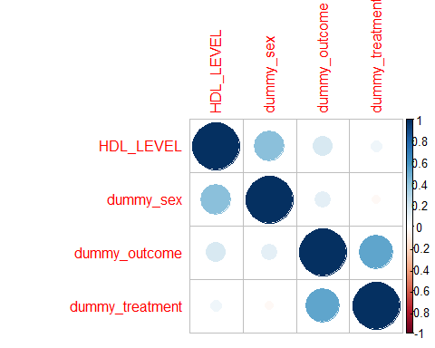

corelations

## HDL_LEVEL dummy_sex dummy_outcome dummy_treatment  
## HDL_LEVEL 1.00000000 0.41327986 0.1673886 0.06320816  
## dummy_sex 0.41327986 1.00000000 0.1175019 -0.03494283  
## dummy_outcome 0.16738857 0.11750194 1.0000000 0.52041650  
## dummy_treatment 0.06320816 -0.03494283 0.5204165 1.00000000

# there is statistically significant only between outcome and treatment so the sex and hdl level don’t affect the outcome

# the interpertation

newdata <- within(newdata, Treatment <- relevel(Treatment, ref = "Placebo"))  
logisticmodel <- glm(outcome~ Treatment+SEX+HDL_LEVEL, family = binomial, data = newdata)  
summary(logisticmodel)

##   
## Call:  
## glm(formula = outcome ~ Treatment + SEX + HDL_LEVEL, family = binomial,   
## data = newdata)  
##   
## Deviance Residuals:   
## Min 1Q Median 3Q Max   
## -1.8707 -0.6796 -0.5550 0.8054 1.8880   
##   
## Coefficients:  
## Estimate Std. Error z value Pr(>|z|)   
## (Intercept) -4.00643 2.80069 -1.431 0.153   
## TreatmentNewdrug 2.38664 0.48757 4.895 9.83e-07 ***  
## SEXMale 0.90217 0.94601 0.954 0.340   
## HDL_LEVEL 0.06643 0.07149 0.929 0.353   
## ---  
## Signif. codes: 0 '***' 0.001 '**' 0.01 '*' 0.05 '.' 0.1 ' ' 1  
##   
## (Dispersion parameter for binomial family taken to be 1)  
##   
## Null deviance: 138.47 on 99 degrees of freedom  
## Residual deviance: 106.57 on 96 degrees of freedom  
## AIC: 114.57  
##   
## Number of Fisher Scoring iterations: 4

library(Greg)

## Loading required package: forestplot

## Loading required package: grid

## Loading required package: magrittr

## Loading required package: checkmate

## Loading required package: Gmisc

## Loading required package: Rcpp

## Loading required package: htmlTable

printCrudeAndAdjustedModel(logisticmodel)[-1,]

Crude

Adjusted

Variable

OR

2.5 % to 97.5 %

OR

2.5 % to 97.5 %

Newdrug

10.09

4.15 to 26.41

10.88

4.35 to 29.76

Male

2.33

0.58 to 11.59

2.46

0.41 to 17.85

HDL_LEVEL

1.10

0.99 to 1.23

1.07

0.93 to 1.24

# First interpertation for cruded value which means the value of OR in the presence of other variables

1- the odds of success for patient recieving newdrug taking the considration the sex and HDL level is 10.09 2- the odds of success for a male patient who is recieving newdrug and has HDL level is 2.33 3- the odds of success for a patient in the presence of HDL level taking the considration the sex and receiving new drug is 1.10 # second interpretation for Adjusted values which mean the value of OR of variables regardless the presences of other variables. 1- the odds of the success for the patient recieving new drug is 10.88 2- the odds of the success for a male patient is 2.46 3- the odds of success for a patient with HDL level is 1.07