t.test task

Rania Ahmed

October 12, 2019

library(knitr)  
library(dplyr)

tutorial <- read.csv(file.choose(), header = T)  
attach(tutorial)

x <- group_by(tutorial, tutorial$Drug)%>% summarise(count= n(), mean= mean(tutorial$heamoglobin), sd=sd(tutorial$heamoglobin), var= var(tutorial$heamoglobin))  
x

## # A tibble: 2 x 5  
## `tutorial$Drug` count mean sd var  
## <fct> <int> <dbl> <dbl> <dbl>  
## 1 A 50 9.94 1.65 2.73  
## 2 B 50 9.94 1.65 2.73

# check normality

library(moments)  
skewness(tutorial$heamoglobin)

## [1] -0.07040083

shapiro.test(tutorial$heamoglobin)

##   
## Shapiro-Wilk normality test  
##   
## data: tutorial$heamoglobin  
## W = 0.99259, p-value = 0.8621

boxplot(heamoglobin~ Drug)

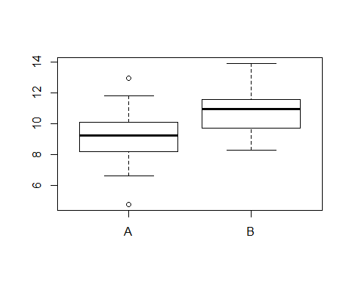

#p-value of shapiro test is more than 0.05 so the sample is normally distributed and we will apply parameteric test(independent t test)

t.test(heamoglobin~ Drug, mu=0 , alternative= "two.sided", var.equal= T, data = tutorial)

##   
## Two Sample t-test  
##   
## data: heamoglobin by Drug  
## t = -5.7731, df = 98, p-value = 9.151e-08  
## alternative hypothesis: true difference in means is not equal to 0  
## 95 percent confidence interval:  
## -2.225397 -1.086838  
## sample estimates:  
## mean in group A mean in group B   
## 9.11248 10.76860

# p-value is less than 0.05 so the sample is highly significant so we will reject null hypothesis