**Brief Description:**

Once the plugin is activated the table is created in the backend automatically. The data’s on contact form will be inserted to the table. Onclick of submit button the new page will be opened to show the Quote premium value

**Hippo Contact Form**

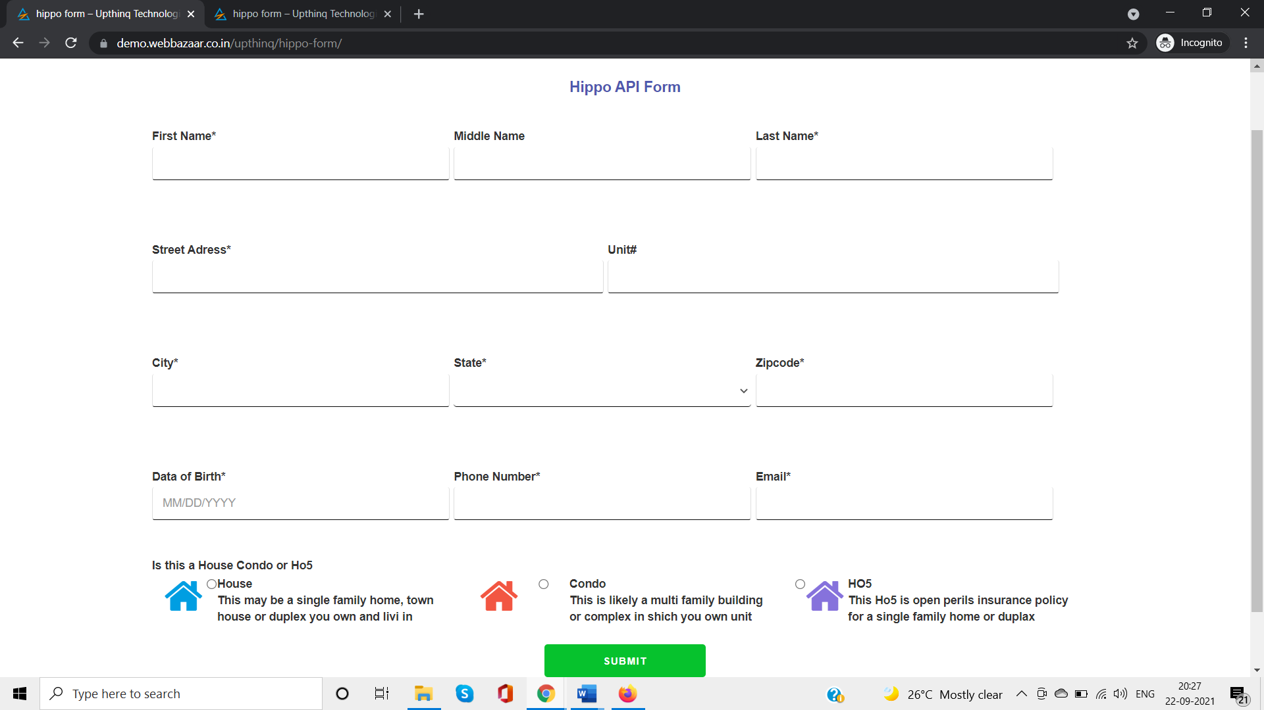

**Hippo Contact Form with data’s**

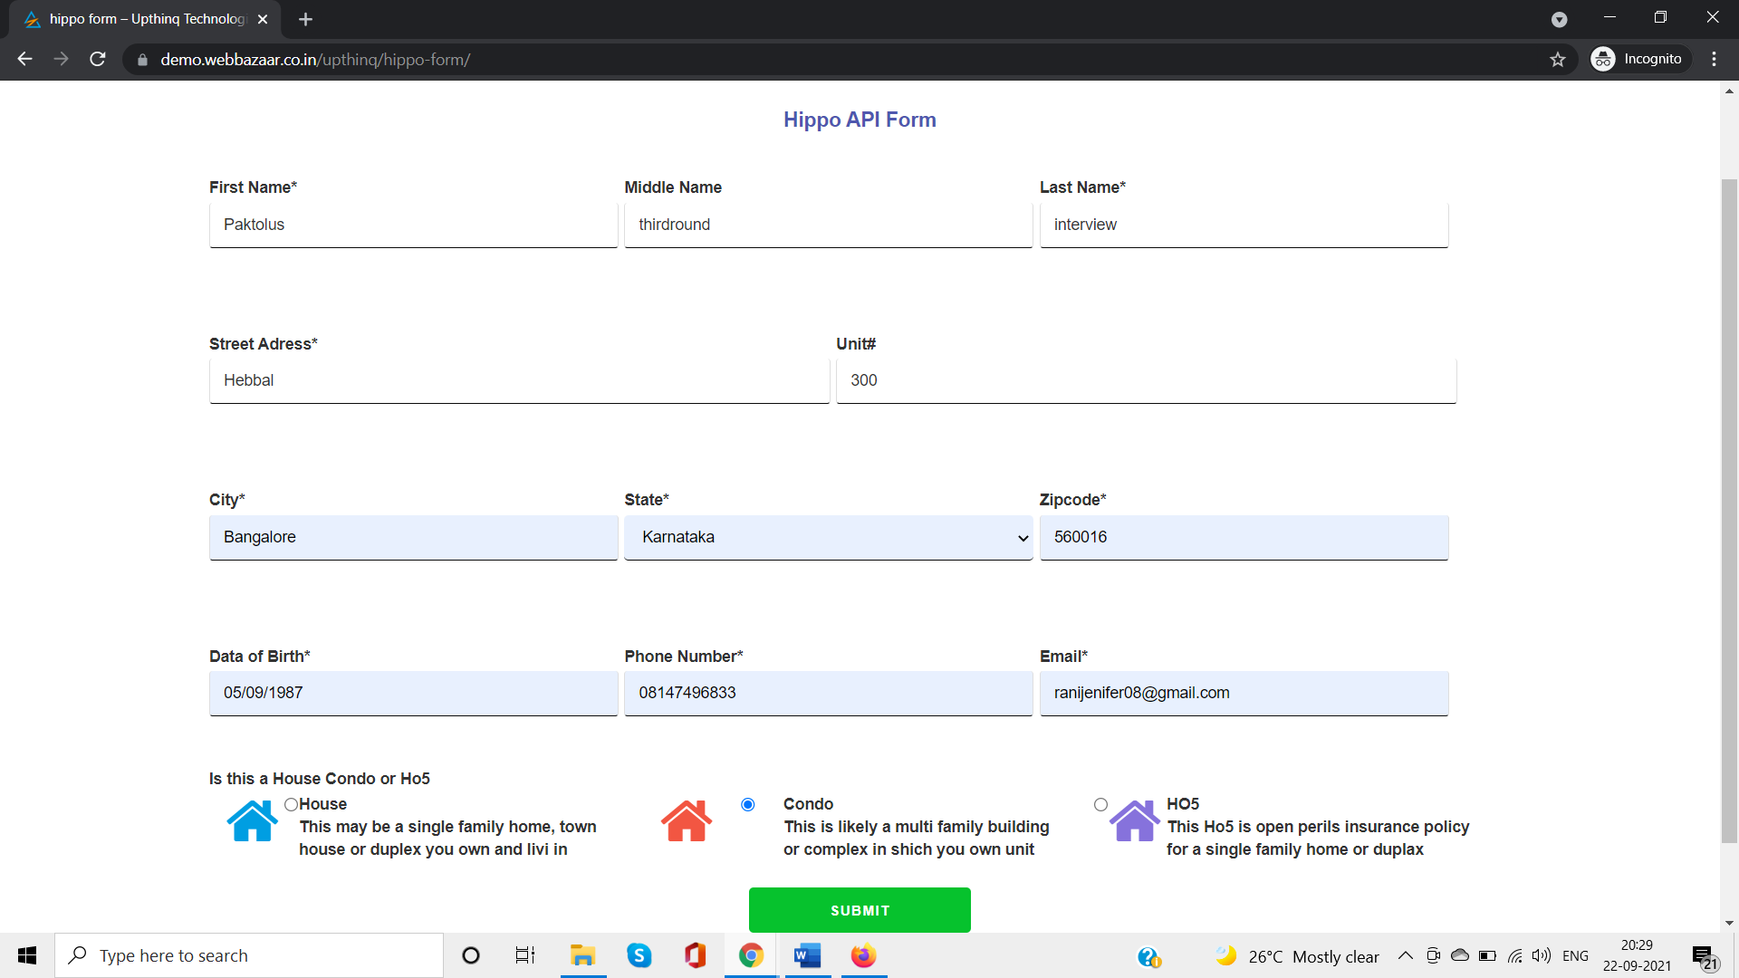

**The data’s are inserted in the table**

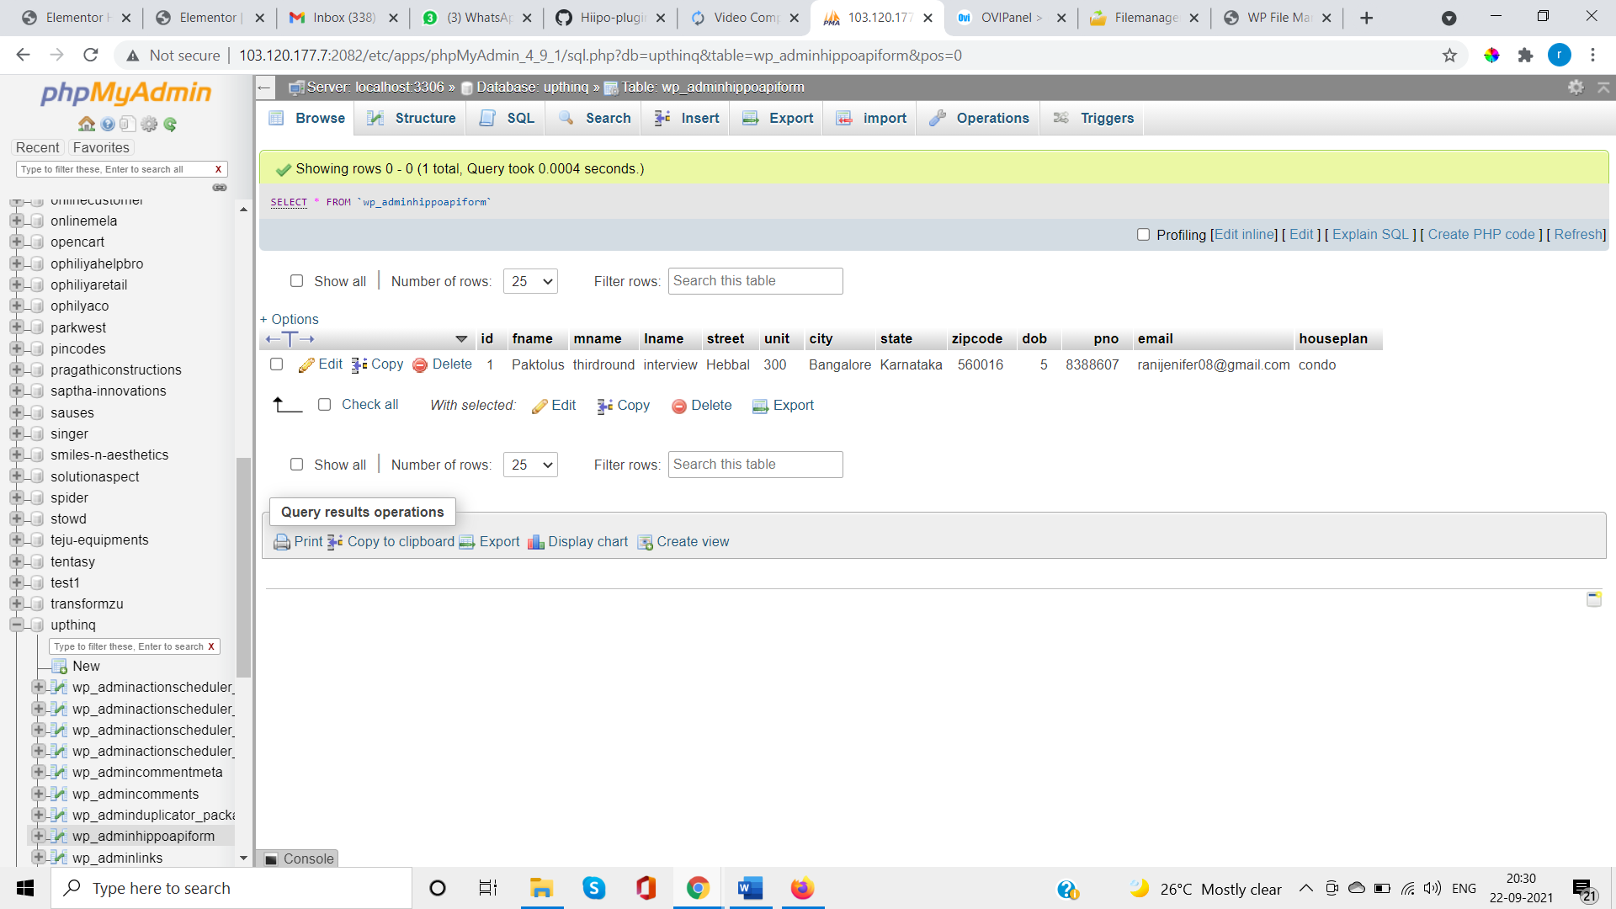

**On submit it opens new page to show the Quote premium value**

