**MSFlowDuplicateLister**

**Prerequisites**

Newtonsoft.Json & Newtonsoft.Json.Linq

To install Json.NET, run the following command in the [Package Manager Console](https://docs.nuget.org/docs/start-here/using-the-package-manager-console)

***Install-Package Newtonsoft.Json***

# Menu and Navigation

Clear folder path

Clear Grid Details

Open JSON Compare form

Fetch all JSON Details from the folder path



Export the grid to Excel

JSON files folder path

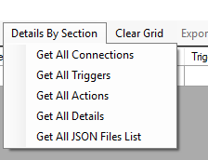

Display only Connections of all JSON Files on grid

Display only Actions of all JSON Files on grid

Display only Triggers of all JSON Files on grid

Display all JSON Details on grid

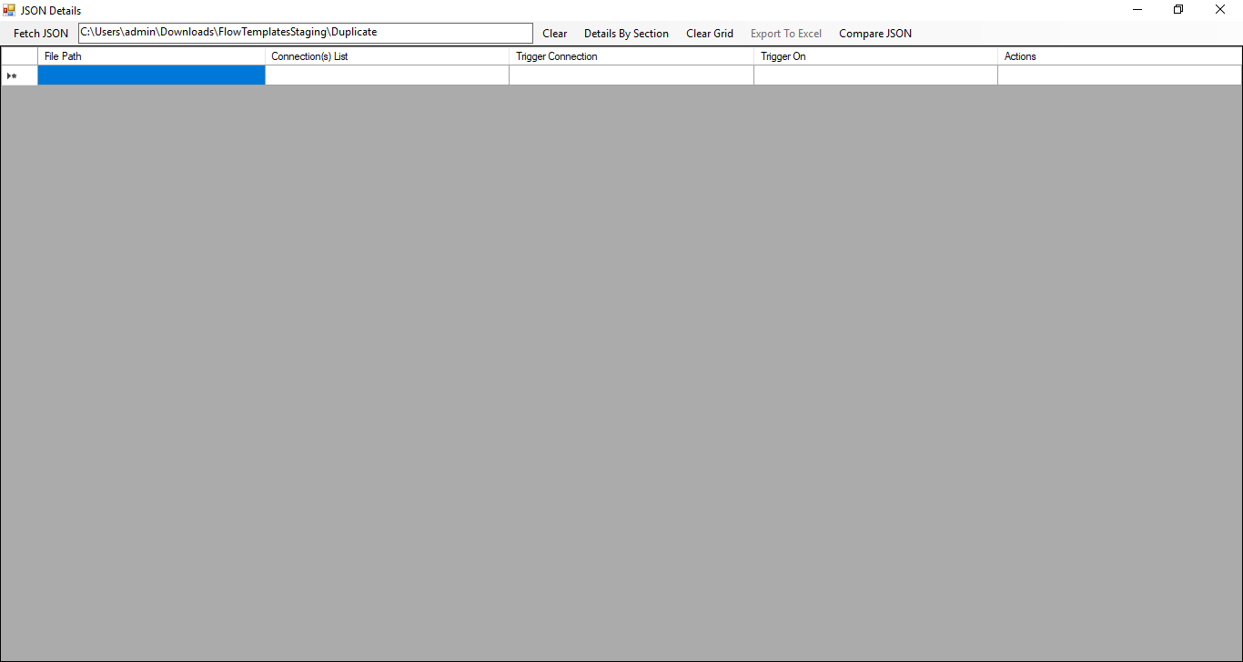

Display only JSON files on grid

# Display only Connections of all JSON Files on grid

When you click on Menu Item “Get All Connections” fetches only the Connections details of all JSON files from the provided folder path. If any template contains more than one connector then each connector was separated with **“– “**.

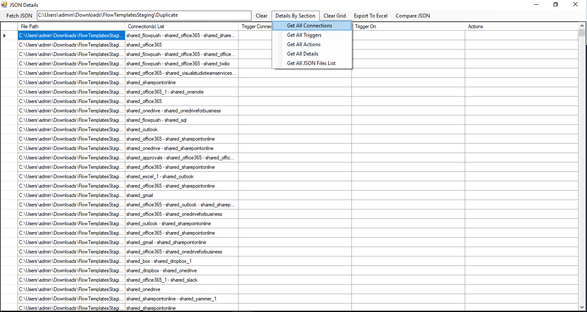

# Display only Triggers of all JSON Files on grid

When you click on Menu Item “Get All Triggers” fetches only the Trigger details of all JSON files from the provided folder path.

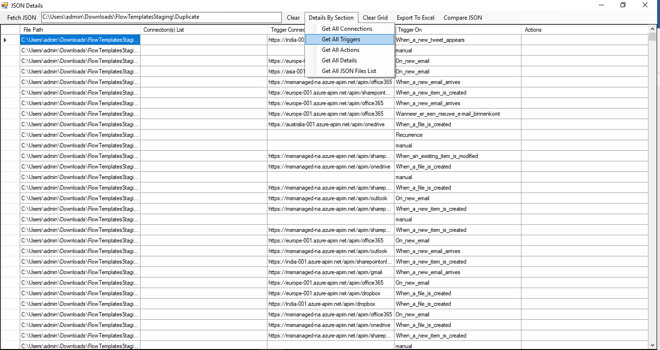

# Display only Actions of all JSON Files on grid

When you click on Menu Item “Get All Actions” fetches only the Actions details of all JSON files from the provided folder path. If any template contains more than one action then each action was separated with “, “. As we are exporting the file in (.CSV) format each action will come with a separate column

**Note**: There is variable name “actionsSeparator” in the code with the value **“, “**change the value to any other new string than **“,”**, you can get all the actions in one column with the newly changed separator between actions**.**

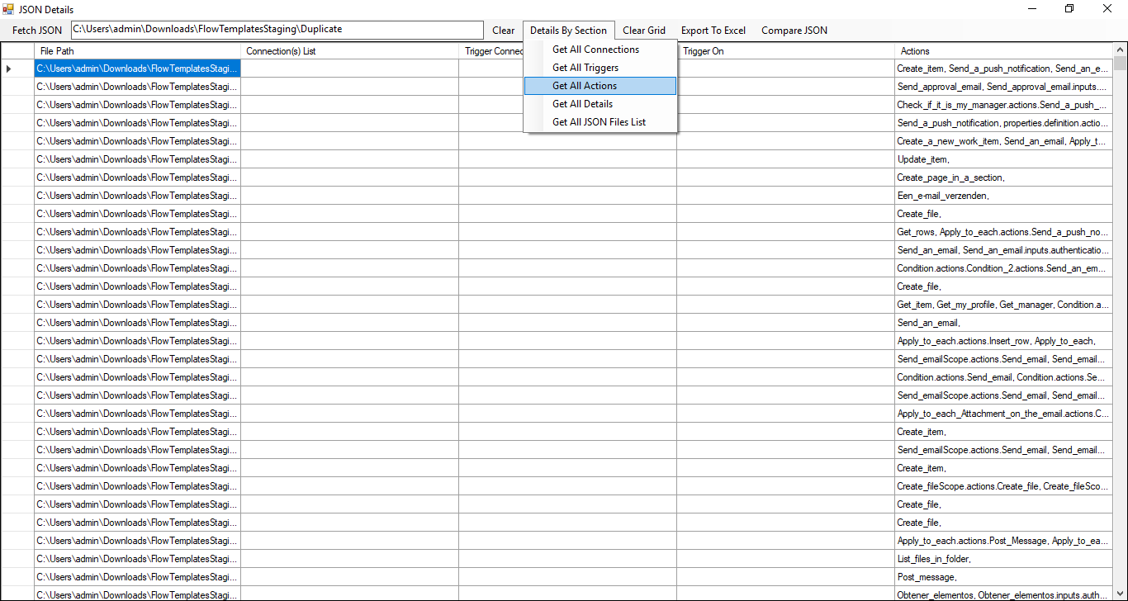

# Display all JSON Details on grid

When you click on Menu Item “Get All Details” fetches all the details of all JSON files from the provided folder path. If any template contains more than one connector then each connector was separated with **“– “**. And if any template contains more than one action then each action was separated with “, “.

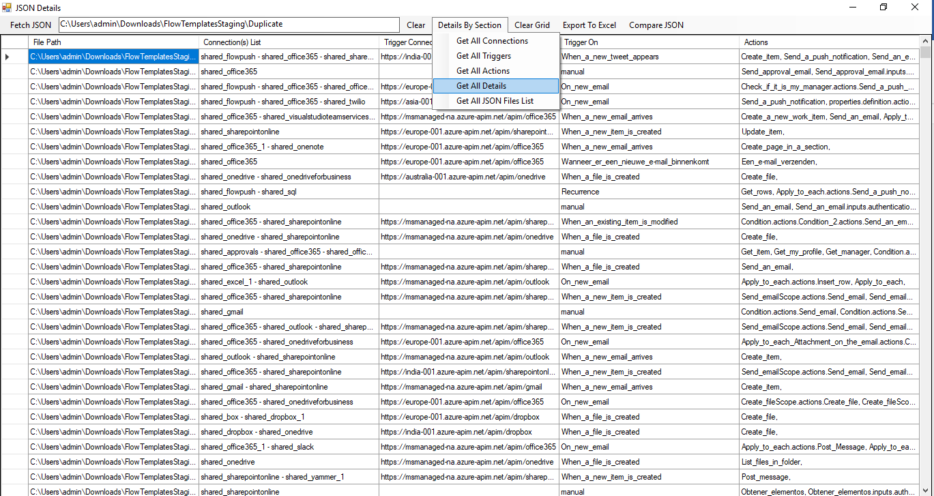

# Display only Connections of all JSON Files on grid

When you click on Menu Item “Get All JSON Files List” fetches all the file names of all JSON files from the provided folder path.

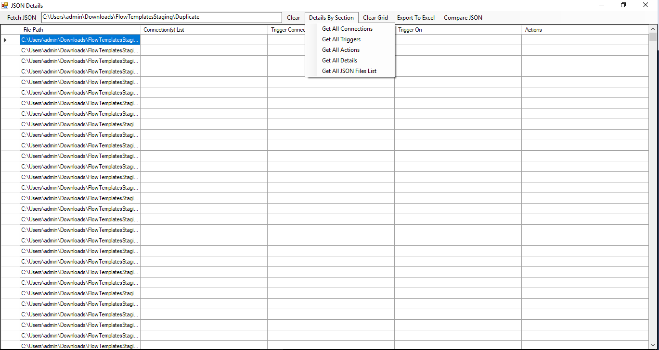

# Fetch and display all JSON Details on grid

When you click on Menu Item “Fetch JSON” fetches all the details of all JSON files from the provided folder path. If any template contains more than one connector then each connector was separated with **“– “**. And if any template contains more than one action then each action was separated with “, “and display on grid.



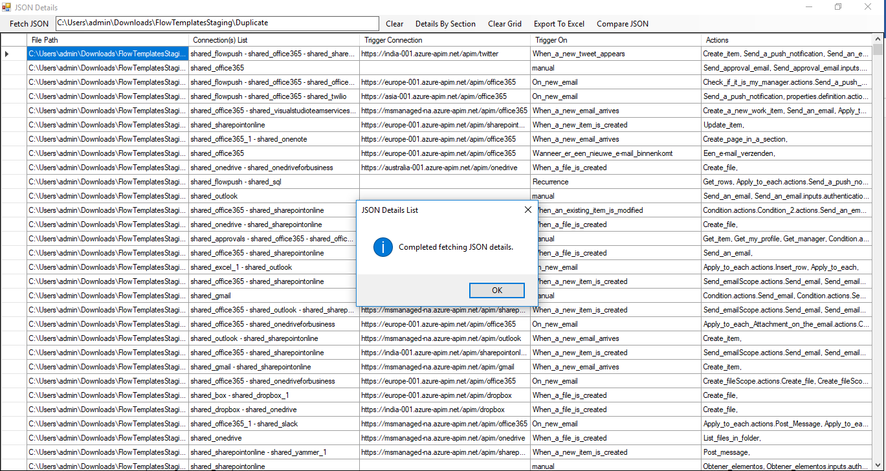

# Clear all the details on the grid

When you click on Menu Item “Clear Grid”, clears all the grid.

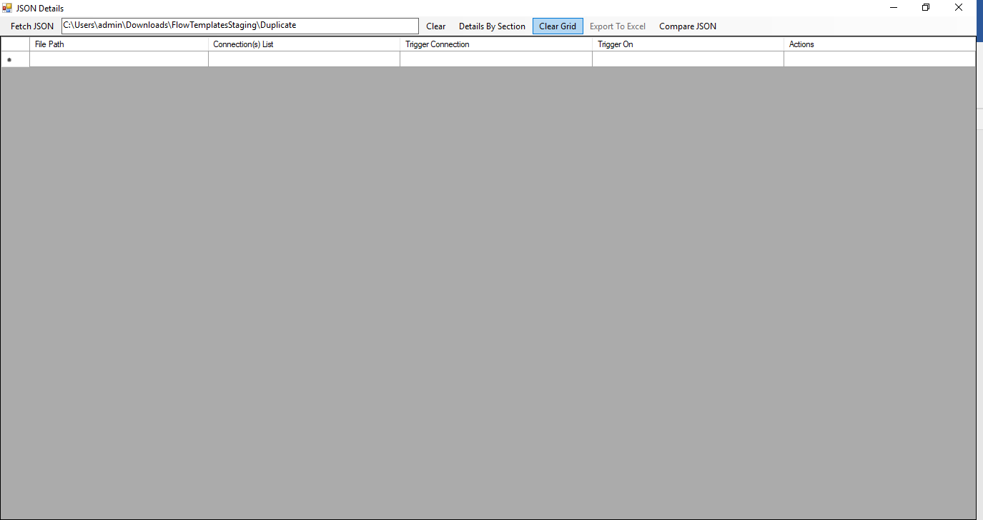

# Export to Excel

Once you get the details on a grid, click on Menu Item “Export To Excel” will prompt for the location where the file want to be save, once the file name given will export the grid to excel in CSV format.

**Note**: The name says “Export To Excel” but the file saving as (.CSV) format because if I save the file as Excel format (.XLS) need some DLL's of Excel which is dependent, so using Comma Separate Value (.CSV) format which can be export without problem and can open in Excel.



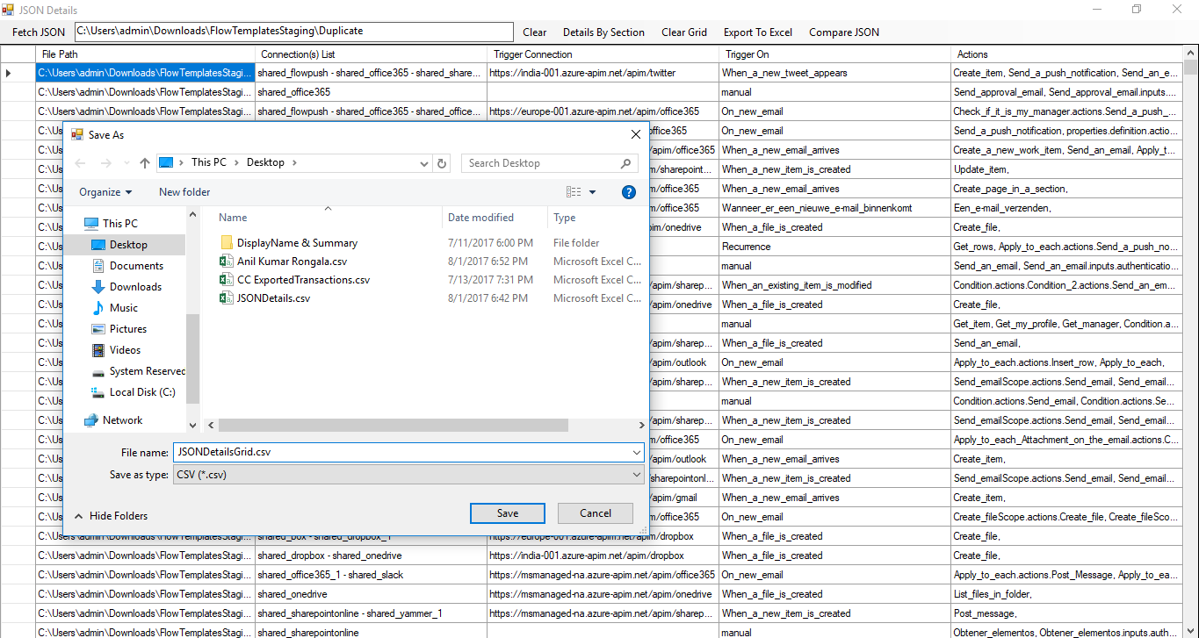

# Compare JSON



When you click on above Menu Item “Compare JSON”, opens below window.

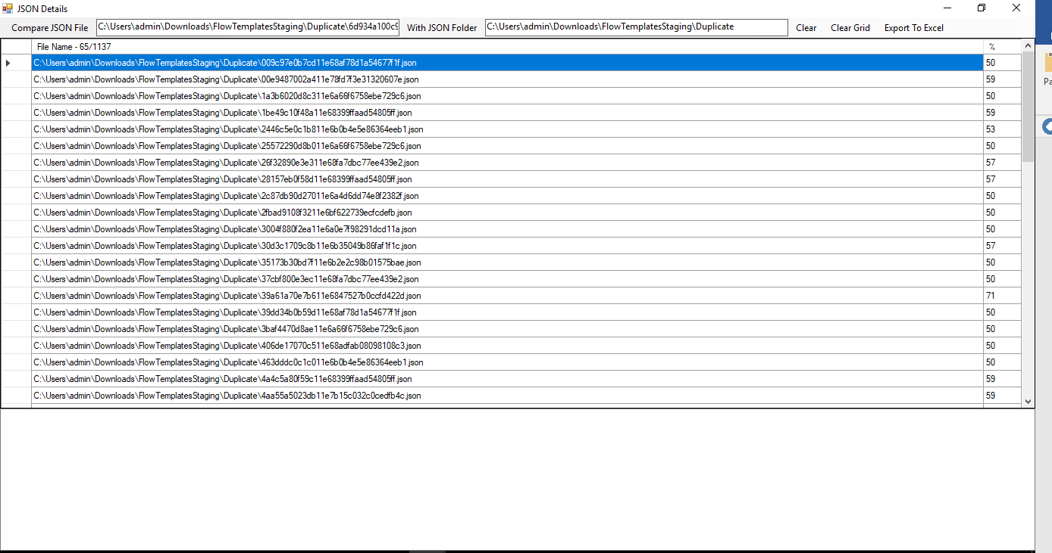

JSON file path



JSON folder path to compare with

Need to provide JSON file path and folder path where the files should compare with and click Menu item “Compare JSON File” which gives below results.

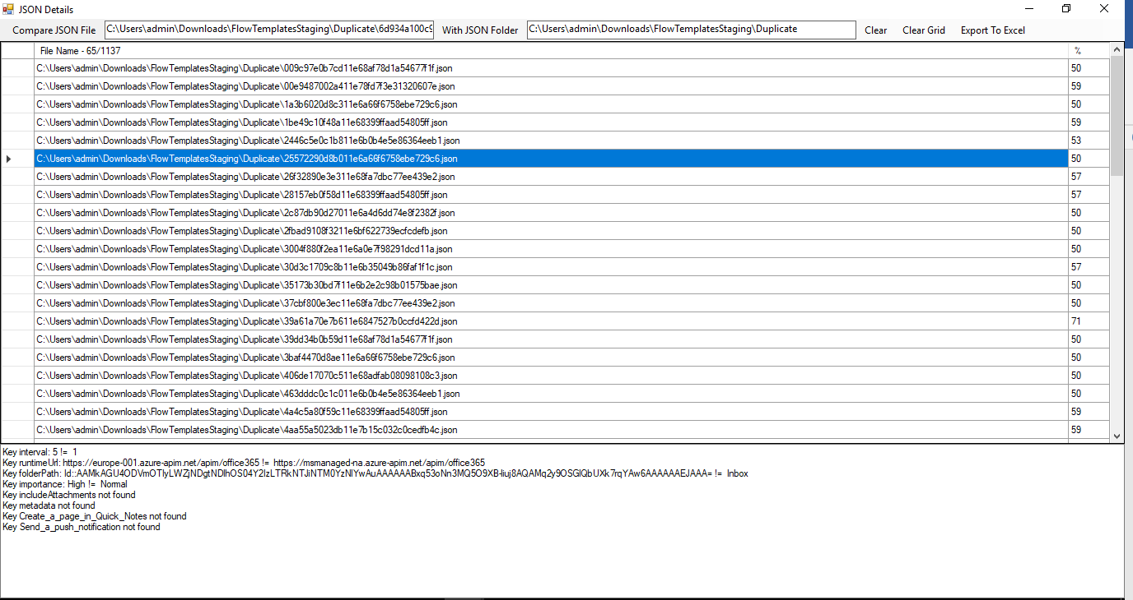

When you select a row from the results on the grid it will give the difference of the files.

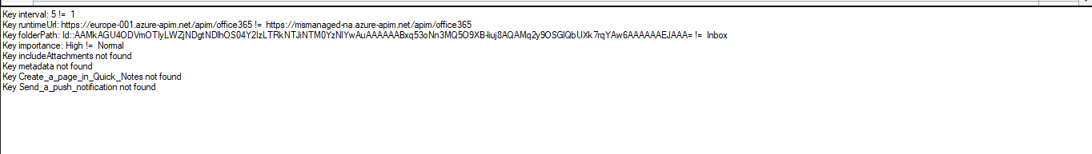

# Export to Excel

You can save this result also by exporting to excel and save as CSV format.

