DATA ANALYSIS
Customer Shopping Behaviour Analysis
SQL Server · Python · Power BI

3,900  Total Transactions | $233,081  Total Revenue | $59.76  Average Purchase Value | 3.75%  Avg Review Rating

Project Type  End-to-end data analysis portfolio project covering data cleaning in Python, SQL querying, Power BI dashboarding, and strategic merchandising insights. | Tools Used  Python (pandas) | Microsoft SQL Server | Power BI Desktop | DAX | Data Modelling

01 INTRODUCTION

This portfolio project analyzes 3,900 retail transactions to understand what drives customer purchasing behavior — from discounting and shipping preferences to product performance and customer loyalty. Raw data was cleaned and transformed in Python, loaded into SQL Server for structured querying, and visualized in an interactive Power BI dashboard.
Project Objectives
- Clean and transform raw transaction data using Python (pandas), including missing-value imputation and feature engineering
- Load the cleaned dataset into SQL Server and write structured queries to answer specific business questions
- Segment customers by purchase history and identify which behaviors correlate with higher spend
- Build an interactive Power BI dashboard summarizing revenue, product, and customer trends
- Deliver merchandising and retention recommendations grounded in the data
Data Preparation (Python)
Before loading into SQL Server, the raw dataset was cleaned and enriched in Python: missing Review Rating values were imputed using the median rating per category, column names were standardized (lowercase, underscores), a redundant Promo Code Used column was dropped after confirming it was identical to Discount Applied, and two engineered features were added — an Age Group bucket (Young Adult / Adult / Middle-Aged / Senior via quartile split) and a Purchase Frequency in Days field mapping each customer's stated frequency to a numeric value.
Dataset Overview
Dimension | Values | Notes
Transactions | 3,900 records | One row per customer transaction
Product Categories | 4 categories | Clothing, Accessories, Footwear, Outerwear
Locations | 50 US states | Full geographic spread
Payment Methods | 6 methods | Credit Card, Debit Card, PayPal, Cash, Venmo, Bank Transfer
Behavioral fields | 6 signals | Discount applied, subscription status, shipping type, review rating, previous purchases, frequency

02 SQL DATA ANALYSIS

Nineteen structured SQL queries were written against a SQL Server database (populated directly from the cleaned Python dataframe via SQLAlchemy) to extract business-relevant metrics across revenue, product, customer, and behavioral dimensions.
1. Revenue by Gender
Compares total revenue generated by male vs. female customers.
-- Total revenue generated by male vs. female customers
SELECT gender, SUM(purchase_amount) AS revenue
FROM customer
GROUP BY gender;

2. Discount Users Spending Above Average
Identifies customers who used a discount but still spent more than the average purchase amount — a signal of price-insensitive, high-value shoppers.
-- Discounted purchases that still exceeded average spend
SELECT customer_id, purchase_amount
FROM customer
WHERE discount_applied = 'Yes'
AND purchase_amount >= (
SELECT AVG(purchase_amount) FROM customer
);

3. Top 5 Products by Review Rating
Ranks products by average customer review rating.
-- Top 5 products with the highest average review rating
SELECT TOP 5 item_purchased, AVG(review_rating) AS avg_review
FROM customer
GROUP BY item_purchased
ORDER BY AVG(review_rating) DESC;

4. Standard vs. Express Shipping Spend
Compares average purchase amount between Standard and Express shipping customers.
-- Average purchase amount: Standard vs Express shipping
WITH cte1 AS (
SELECT AVG(purchase_amount) AS avg_purc, shipping_type
FROM customer
GROUP BY shipping_type
)
SELECT * FROM cte1
WHERE shipping_type IN ('Standard','Express');

5. Subscriber vs. Non-Subscriber Spend
Tests whether subscribed customers spend more, comparing average spend and total revenue.
-- Do subscribers spend more than non-subscribers?
SELECT subscription_status,
COUNT(customer_id) AS total_num,
AVG(purchase_amount) AS avg_spend,
SUM(purchase_amount) AS total_revenue
FROM customer
GROUP BY subscription_status;

6. Products Most & Least Reliant on Discounts
Ranks products by the percentage of purchases made with a discount applied, at both extremes.
-- Products with highest / lowest discount reliance
WITH product_discount_stats AS (
SELECT item_purchased,
COUNT(*) AS total_purchases,
SUM(CASE WHEN discount_applied='Yes'
THEN 1 ELSE 0 END) AS discount_purchases
FROM customer
GROUP BY item_purchased
)
SELECT TOP 5 item_purchased, total_purchases,
discount_purchases,
(discount_purchases * 100.0 / total_purchases)
AS discount_percentage
FROM product_discount_stats
ORDER BY discount_percentage DESC; -- ASC for lowest

7. Customer Segmentation (New / Returning / Loyal)
Segments customers into New, Returning, and Loyal tiers based on previous purchase count.
-- Segment customers by purchase history
WITH customer_type AS (
SELECT customer_id, previous_purchases,
CASE
WHEN previous_purchases = 1 THEN 'New'
WHEN previous_purchases BETWEEN 2 AND 10
THEN 'Returning'
ELSE 'Loyal'
END AS customer_segment
FROM customer
)
SELECT customer_segment, COUNT(*) AS "Number of Customers"
FROM customer_type
GROUP BY customer_segment;

8. Top 3 Products per Category
Uses ROW_NUMBER() to rank the top 3 best-selling items within each product category.
-- Top 3 most purchased products within each category
WITH item_counts AS (
SELECT category, item_purchased,
COUNT(customer_id) AS total_orders,
ROW_NUMBER() OVER (
PARTITION BY category
ORDER BY COUNT(customer_id) DESC) AS item_rank
FROM customer
GROUP BY category, item_purchased
)
SELECT item_rank, category, item_purchased, total_orders
FROM item_counts
WHERE item_rank <= 3;

9. Repeat Buyers & Subscription Likelihood
Tests whether customers with more than 5 previous purchases are more likely to be subscribers.
-- Are repeat buyers more likely to subscribe?
SELECT subscription_status, COUNT(customer_id) AS repeat_buyers
FROM customer
WHERE previous_purchases > 5
GROUP BY subscription_status;

10. Revenue by Age Group
Breaks down total revenue contribution by engineered age-group bucket.
-- Revenue contribution of each age group
SELECT age_group, SUM(purchase_amount) AS total_revenue
FROM customer
GROUP BY age_group
ORDER BY total_revenue DESC;

11. Purchase Frequency Distribution
Counts customers by their stated purchase frequency (weekly, monthly, quarterly, etc.).
-- Distribution of customers by purchase frequency
SELECT COUNT(*) AS customer_count, frequency_of_purchases
FROM customer
GROUP BY frequency_of_purchases;

12. Revenue by Product Category
Ranks the four product categories by total revenue.
-- Revenue by product category
SELECT category, SUM(purchase_amount) AS total_sales
FROM customer
GROUP BY category
ORDER BY total_sales DESC;

13–14. Headline Revenue & Spend Metrics
Foundation KPIs: total revenue across all transactions and the average purchase amount.
-- Total revenue
SELECT SUM(purchase_amount) AS total_revenue FROM customer;

-- Average purchase amount
SELECT AVG(purchase_amount) AS avg_purchase FROM customer;

15. Most & Least Purchased Products by Revenue
Ranks products by total revenue at both the top and bottom of the range.
-- Top 5 products by revenue
SELECT TOP 5 item_purchased, COUNT(*) AS purchase_count,
SUM(purchase_amount) AS revenue
FROM customer
GROUP BY item_purchased
ORDER BY revenue DESC; -- ASC for bottom 5

16. Impact of Discounts on Total Sales
Compares total sales value generated with vs. without a discount applied.
-- Impact of discount on sales
SELECT discount_applied, SUM(purchase_amount) AS total_sales
FROM customer
GROUP BY discount_applied;

17. Seasonal Purchase Trends
Compares total sales across the four seasons to identify seasonal demand patterns.
-- Seasonal purchase trends
SELECT season, SUM(purchase_amount) AS total_sales
FROM customer
GROUP BY season
ORDER BY total_sales DESC;

18. Top Locations by Revenue
Ranks the top 5 US states by total revenue generated.
-- Top 5 locations by revenue
SELECT TOP 5 location, SUM(purchase_amount) AS total_revenue
FROM customer
GROUP BY location
ORDER BY total_revenue DESC;

19. High-Value Customers
Ranks all customers by lifetime spend to identify the highest-value accounts.
-- High value customers ranked by total spend
SELECT customer_id, SUM(purchase_amount) AS total_spent
FROM customer
GROUP BY customer_id
ORDER BY total_spent DESC;

03 POWER BI DASHBOARD

An interactive Power BI dashboard translates the SQL findings into a self-service tool for stakeholders. All visuals are connected to a shared data model with slicer cross-filtering enabled across Category, Gender, Season, and Subscription Status.
Dashboard Contents
Visual 1 | KPI Cards: Total Revenue, Total Transactions, Average Purchase Value, Average Review Rating
Visual 2 | Revenue by Category: Horizontal bar chart ranked by value
Visual 3 | Revenue by Age Group: Clustered bar chart
Visual 4 | Seasonal Trend: Pie chart comparing revenue across Winter, Spring, Summer, Fall
Visual 5 | Top Products Table: By Revenue
Visual 6 | Customer Segment Bar: New / Returning / Loyal split
Visual 7 | Slicers: Category, Gender, Season, Subscription Status

This dashboard is the primary artifact to walk an interviewer through, since it demonstrates the full path from raw, messy transaction data to a decision-ready merchandising tool.
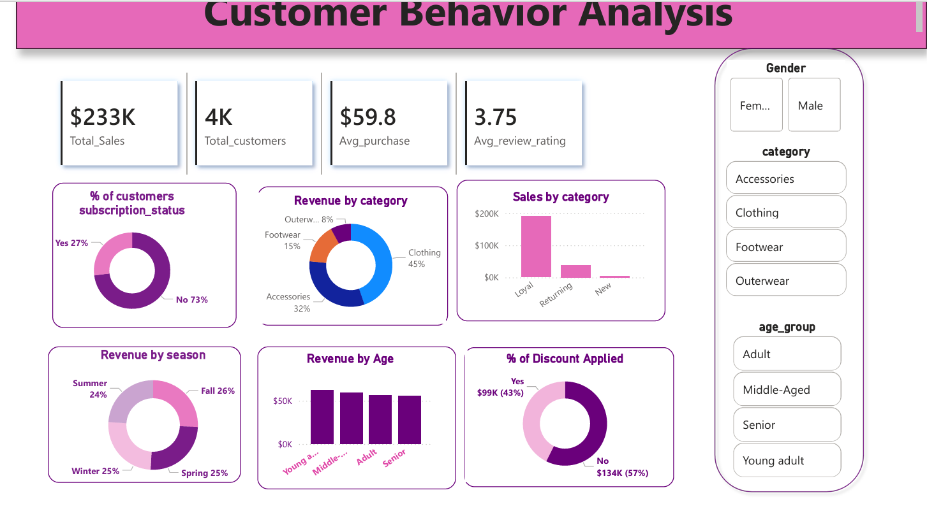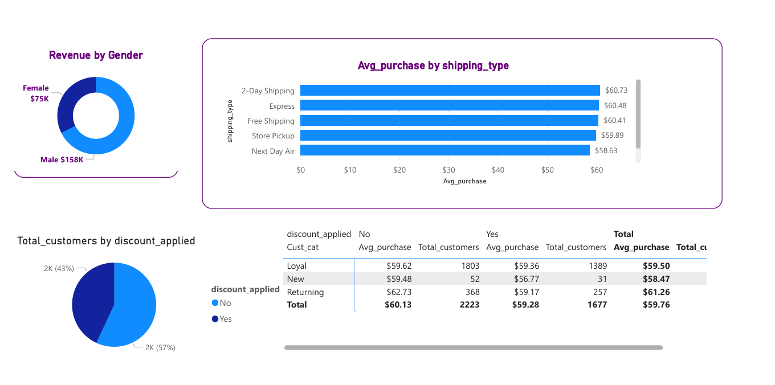04 BUSINESS INSIGHTS & RECOMMENDATIONS

The following insights were derived from the combined Python, SQL, and Power BI analysis. Each is categorised by urgency and strategic impact.
Key Findings
RISK | Subscriptions aren't driving higher spend  Subscribers spend $59.49 on average vs. $59.87 for non-subscribers — statistically flat. The subscription program is not currently a revenue lever, only a retention one.
RISK | "Loyal" segment dominates but may be mislabeled  80% of customers (3,116 of 3,900) fall into the Loyal tier under the current segmentation rule, leaving too little differentiation to target New or Returning customers distinctly.
OPPORTUNITY | Clothing is the clear revenue leader  Clothing generates $104,264 in revenue — 45% of total sales — more than double the next-highest category (Accessories at $74,200).
OPPORTUNITY | Male customers drive the majority of revenue  Male customers generated $157,890 vs. $75,191 from female customers — over 2x
WATCH | Discounted items still cost real revenue  Purchases without a discount generated $133,670 vs. $99,411 with a discount applied — discounting is heavily used (43% of transactions) and materially shifts revenue capture.
WATCH | Express shipping doesn't command a large premium  Express shipping customers spend only marginally more on average ($60.48) than Standard shipping customers ($58.46) — limited evidence of a willingness-to-pay premium for speed.
GROWTH | 863 high-value customers are discount-driven  863 customers used a discount and still spent above the $59.76 average — a strong-fit audience for targeted promotions that convert at higher basket values.

Strategic Action Plan
Immediate (0–3 months)
- Re-evaluate the subscription program's value proposition — since it shows no measurable spend lift, consider redesigning incentives (e.g., early access, free shipping) rather than treating it as a revenue driver.
- Double down on Clothing category merchandising and shelf space, given it drives 45% of total revenue on its own.

Short-term (3–6 months)
- Refine the customer segmentation thresholds so the Loyal tier isn't overloaded
- Launch a targeted promotional campaign toward the 863 discount-responsive, above-average spenders identified in Query 2.

Strategic (6–12 months)
- Investigate the revenue gap between male and female customers.

End of Portfolio Project
Python · SQL · Power BI · DAX · Customer Shopping Behavior Analysis

