DATA ANALYSIS
UAE FMCG Sales 2023–2024
SQL · Power BI · Business Intelligence

AED 4.02M  Total Revenue | AED 1.77M  Total Profit | 44.09%  Gross Margin | +5.69%  YoY Growth

Project Type  End-to-end data analysis portfolio project covering SQL querying, Power BI dashboarding, and strategic business insights. | Tools Used  Microsoft SQL Server | Power BI Desktop | DAX | Data Modelling

01 INTRODUCTION

This portfolio project demonstrates end-to-end data analysis skills across the full analytics stack — from raw SQL queries to interactive Power BI dashboards and actionable business insights. The dataset covers UAE Fast-Moving Consumer Goods (FMCG) sales spanning 2023 and 2024 across six emirates, six distributors, five product categories, and five sales channels.

Project Objectives
- Extract and transform raw sales data using structured SQL queries
- Build an interactive Power BI dashboard with slicers, KPI cards, and visualisations
- Identify revenue trends, category performance, and distributor gaps
- Deliver strategic business recommendations grounded in data

Dataset Overview
Dimension | Values | Notes
Period | 2023–2024 | Two full calendar years
Emirates | 7 (Dubai to UAQ) | All UAE territories
Distributors | 6 national partners | West Zone, Nesto, Al Adil, Lulu, Carrefour, Spinneys
Categories | 5 product lines | Household, Personal Care, Dairy, Snacks, Beverages
Channels | 5 trade channels | Supermarket, Wholesale, Hypermarket, Minimart, Online

02 SQL DATA ANALYSIS

Ten structured SQL queries were written to extract key business metrics from the raw sales database. Each query is designed to answer a specific business question and feed into the Power BI data model.

1. Revenue Overview
Summarises total revenue, profit, and gross margin at the business level — the foundation KPIs for all subsequent analysis.
-- Total revenue, profit, and margin summary
SELECT
year,
quarter,
ROUND(SUM(revenue_aed), 2) AS total_revenue_aed,
ROUND(SUM(cogs_aed), 2) AS total_cogs_aed,
ROUND(SUM(gross_profit_aed), 2) AS total_gross_profit_aed,
ROUND(SUM(gross_profit_aed) * 100.0 / SUM(revenue_aed), 1) AS gross_margin_pct,
COUNT(DISTINCT order_id) AS total_orders
FROM sales
GROUP BY year, quarter
ORDER BY year, quarter;

2. Month-over-Month Revenue Growth
Uses a LAG window function to calculate the revenue delta and growth rate for each calendar month, enabling trend analysis.
-- Tracks revenue trend and growth rate
WITH monthly_revenue AS (
SELECT
year,
month,
ROUND(SUM(revenue_aed), 2) AS revenue
FROM sales
GROUP BY year, month
)
SELECT
year,
month,
revenue,
LAG(revenue) OVER (ORDER BY year, month) AS prev_month_revenue,
ROUND(
(revenue - LAG(revenue) OVER (ORDER BY year, month)) * 100.0
/ LAG(revenue) OVER (ORDER BY year, month), 1
) AS mom_growth_pct
FROM monthly_revenue
ORDER BY year, month;

3. Revenue by Emirate
Breaks down revenue across all seven UAE emirates to identify geographic concentration and expansion opportunities.
-- Performance breakdown across UAE regions
SELECT
emirate,
COUNT(DISTINCT order_id) AS total_orders,
ROUND(SUM(revenue_aed), 2) AS total_revenue_aed,
ROUND(AVG(revenue_aed), 2) AS avg_order_value_aed,
ROUND(SUM(gross_profit_aed), 2) AS total_profit_aed,
ROUND(SUM(gross_profit_aed) * 100.0
/ SUM(revenue_aed), 1) AS gross_margin_pct,
ROUND(SUM(revenue_aed) * 100.0
/ (SELECT SUM(revenue_aed) FROM sales), 1) AS revenue_share_pct
FROM sales
GROUP BY emirate
ORDER BY total_revenue_aed DESC;

4. Top 10 Products by Revenue
Ranks the top-performing SKUs by total revenue and includes gross margin percentage for profitability context.
-- Best performing SKUs with margin analysis
-- ============================================================
SELECT
TOP 10 product,
category,
SUM(quantity) AS total_units_sold,
ROUND(SUM(revenue_aed), 2) AS total_revenue_aed,
ROUND(SUM(gross_profit_aed), 2) AS total_profit_aed,
ROUND(SUM(gross_profit_aed) * 100.0
/ SUM(revenue_aed), 1) AS gross_margin_pct,
ROUND(AVG(unit_price_aed), 2) AS avg_unit_price_aed
FROM sales
GROUP BY product, category
ORDER BY total_revenue_aed DESC;

5. Category Performance
Aggregates revenue and margin at the category level to identify the most profitable product lines.
-- Revenue and margin by product category
SELECT
category,
COUNT(DISTINCT order_id) AS total_orders,
SUM(quantity) AS total_units_sold,
ROUND(SUM(revenue_aed), 2) AS total_revenue_aed,
ROUND(SUM(gross_profit_aed), 2) AS total_profit_aed,
ROUND(SUM(gross_profit_aed) * 100.0
/ SUM(revenue_aed), 1) AS gross_margin_pct,
ROUND(SUM(revenue_aed) * 100.0
/ (SELECT SUM(revenue_aed) FROM sales), 1) AS revenue_share_pct
FROM sales
GROUP BY category
ORDER BY total_revenue_aed DESC;

6. Distributor Performance
Ranks all six distributors by revenue and calculates target achievement rate to flag underperformance.
-- Ranking distributors by revenue and target achievement
-- ============================================================
SELECT
distributor,
COUNT(DISTINCT order_id) AS total_orders,
ROUND(SUM(revenue_aed), 2) AS total_revenue_aed,
ROUND(SUM(sales_target_aed), 2) AS total_target_aed,
ROUND(SUM(revenue_aed) * 100.0
/ SUM(sales_target_aed), 1) AS target_achievement_pct,
ROUND(SUM(gross_profit_aed), 2) AS total_profit_aed,
ROUND(AVG(target_achieved_pct), 1) AS avg_target_achieved_pct,
CASE
WHEN SUM(revenue_aed) * 100.0 / SUM(sales_target_aed) >= 100 THEN 'On Target'
WHEN SUM(revenue_aed) * 100.0 / SUM(sales_target_aed) >= 85 THEN 'Near Target'
ELSE 'Below Target'
END AS performance_status
FROM sales
GROUP BY distributor
ORDER BY total_revenue_aed DESC;

7. Sales Rep Leaderboard
Individual rep performance ranked by revenue using DENSE_RANK to handle tied positions fairly.
-- Individual rep performance with ranking
SELECT
RANK() OVER (ORDER BY SUM(revenue_aed) DESC) AS rank,
sales_rep,
COUNT(DISTINCT order_id) AS total_orders,
ROUND(SUM(revenue_aed), 2) AS total_revenue_aed,
ROUND(SUM(gross_profit_aed), 2) AS total_profit_aed,
ROUND(AVG(target_achieved_pct), 1) AS avg_target_pct,
ROUND(SUM(revenue_aed) / COUNT(DISTINCT order_id), 2) AS revenue_per_order
FROM sales
GROUP BY sales_rep
ORDER BY rank;

8. Channel Analysis
Compares the five sales channels — supermarket, wholesale, hypermarket, minimart, and online — by revenue share.
-- Which sales channel drives the most revenue
SELECT
channel,
COUNT(DISTINCT order_id) AS total_orders,
ROUND(SUM(revenue_aed), 2) AS total_revenue_aed,
ROUND(AVG(revenue_aed), 2) AS avg_order_value_aed,
ROUND(SUM(gross_profit_aed) * 100.0
/ SUM(revenue_aed), 1) AS gross_margin_pct,
ROUND(SUM(revenue_aed) * 100.0
/ (SELECT SUM(revenue_aed) FROM sales), 1) AS revenue_share_pct
FROM sales
GROUP BY channel
ORDER BY total_revenue_aed DESC;

9. Slow-Moving SKUs
Flags products with both low sales volume and below-average margin — priority candidates for range review or discontinuation.
-- Products with low volume AND low margin
-- ============================================================
SELECT
product,
category,
SUM(quantity) AS total_units_sold,
ROUND(SUM(revenue_aed), 2) AS total_revenue_aed,
ROUND(SUM(gross_profit_aed) * 100.0
/ SUM(revenue_aed), 1) AS gross_margin_pct
FROM sales
GROUP BY product, category
ORDER BY total_units_sold ASC;

10. Year-over-Year Comparison
Pivots 2023 and 2024 revenue by category using conditional aggregation to calculate growth percentage side by side.
-- Growth by category across both years
SELECT
category,
ROUND(SUM(CASE WHEN year = 2023 THEN revenue_aed ELSE 0 END), 2) AS revenue_2023,
ROUND(SUM(CASE WHEN year = 2024 THEN revenue_aed ELSE 0 END), 2) AS revenue_2024,
ROUND(
(SUM(CASE WHEN year = 2024 THEN revenue_aed ELSE 0 END)
- SUM(CASE WHEN year = 2023 THEN revenue_aed ELSE 0 END)) * 100.0
/ NULLIF(SUM(CASE WHEN year = 2023 THEN revenue_aed ELSE 0 END), 0), 1
) AS yoy_growth_pct
FROM sales
GROUP BY category
ORDER BY yoy_growth_pct DESC;

03 POWER BI DASHBOARD

Three dashboard pages were built in Power BI Desktop, each targeting a distinct audience and analytical layer. All visuals are connected to a shared data model with slicer cross-filtering enabled across Emirate, Quarter, Year, and Channel.

Page 1 — Executive Overview
Visual 1 | KPI Cards: Total Revenue, Profit, Orders, Gross Margin %
Visual 2 | Revenue by Month: Line chart comparing 2023 vs 2024
Visual 3 | Revenue by Emirate: Horizontal bar chart ranked by value
Visual 4 | Target vs Revenue: Clustered bar by quarter
Visual 5 | Category Split: Pie chart by product category
Visual 6 | Slicers: Emirate, Quarter, Year

Page 2 — Distributor & Channel Performance
Visual 1 | Target vs Revenue by Distributor: Grouped bar chart
Visual 2 | Channel Revenue Share: 100% stacked bar by category
Visual 3 | Distributor Metrics Table: Revenue, Margin %, Target Ach.
Visual 4 | Channel Donut: Overall revenue split by channel

Page 3 — Product & SKU Intelligence
Visual 1 | Top Products Bar: Revenue ranked by SKU
Visual 2 | SKU Scatter Plot: Units Sold (X) vs Margin % (Y), sized by Revenue
Visual 3 | Margin by Category Table: Revenue and Gross Margin %
Visual 4 | YoY Growth Table: 2023 vs 2024 revenue and growth %
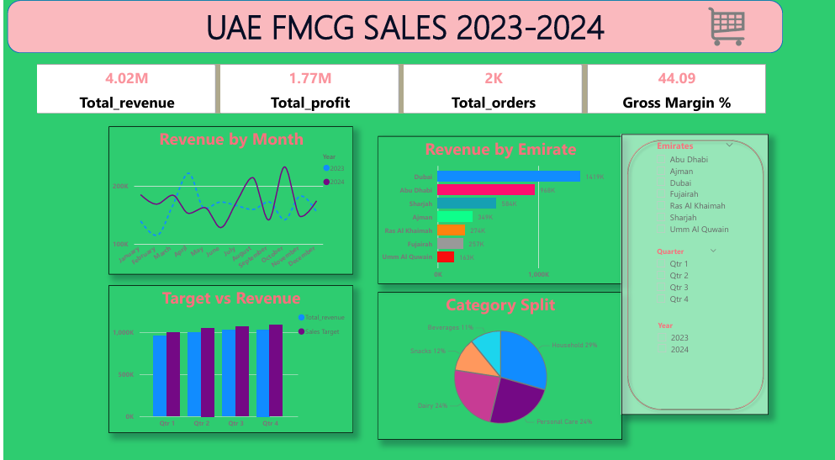
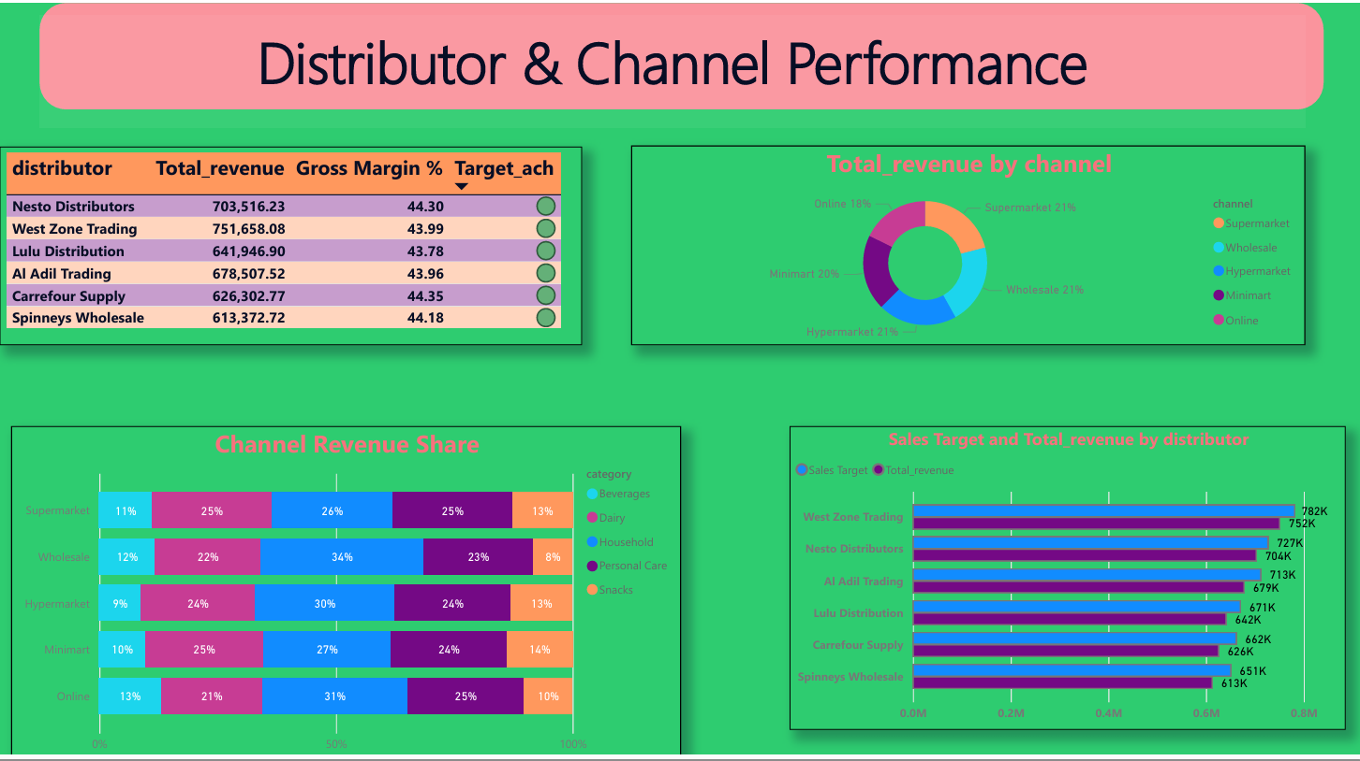
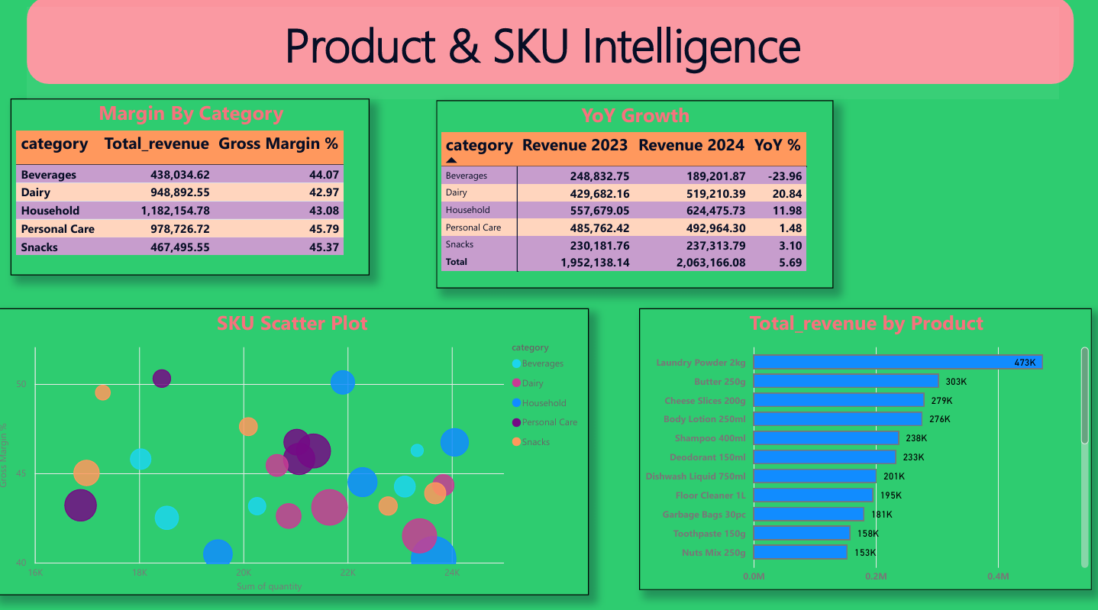
04 BUSINESS INSIGHTS & RECOMMENDATIONS

The following insights were derived from the combined SQL and Power BI analysis. Each is categorised by urgency and strategic impact.

Key Findings
RISK | Beverages in freefall  -23.96% YoY — the largest single-category decline. Investigate pricing, shelf placement, and competitor activity immediately.
RISK | All distributors below target  Systemic miss across all 6 partners signals targets may be misaligned or trade terms need restructuring.
RISK | Revenue concentration — Dubai/Abu Dhabi  59% of revenue from two emirates creates significant geographic dependency and single-market risk.
OPPORTUNITY | Dairy is the fastest growing category  +20.84% YoY with AED 949K revenue. Increase SKU depth and add distributor incentives to accelerate further.
OPPORTUNITY | Personal care margin premium  45.79% gross margin vs 42.97% for Dairy. Premiumisation strategy and SKU expansion would deliver outsized profit growth.
WATCH | Online channel underperforming  Only 18% of revenue vs 21–26% for physical channels — a significant gap in a high-digital-adoption market like the UAE.
GROWTH | Northern emirates untapped  Ajman, RAK, Fujairah, and UAQ collectively generate AED 1.04M with likely low revenue per capita — clear expansion opportunity.

Strategic Action Plan

Immediate (0–3 months)
- Investigate the beverages collapse — a 24% revenue drop across every distributor and emirate point to a pricing or supply issue, not just a single account problem.
- Review distributor contracts — every single partner missed target, which is a structural signal, not individual underperformance. Consider revised tiered incentives or more realistic target-setting for upcoming years.
Short-term (3–6 months)
- Accelerate dairy — at +21% growth and AED 949K revenue, this is your fastest-growing category. Prioritise shelf space negotiations and add distributor incentives for dairy SKUs.
- Build the online channel — UAE has one of the highest e-commerce penetration rates in the MENA region, yet online sits at just 18% of your revenue mix. A marketplace push could close this gap quickly.

Strategic (6–12 months)
- Personal care premiumisation — 45.79% gross margin is your best-performing category. Invest in premium SKU introductions and targeted marketing to grow this mix.
- Northern emirates expansion — Ajman, RAK, Fujairah, and UAQ together generate AED 1.04M but likely represent significantly underpenetrated potential relative to their population and retail infrastructure growth.

End of Portfolio Project
SQL · Power BI · DAX · Business Intelligence · UAE FMCG

