DATA ANALYSIS
Customer Churn Analysis
SQL Server · Python · Power BI

400  Total Customer Accounts | 44%  Overall Churn Rate | AED 1.28M  Monthly Revenue at Risk | AED 1.69M  Retained Revenue

Project Type  End-to-end data analysis portfolio project covering SQL querying, exploratory Python analysis, Power BI dashboarding, and strategic churn-prevention recommendations. | Tools Used  Microsoft SQL Server | Power BI Desktop | DAX | Data Modelling

01 INTRODUCTION

This portfolio project demonstrates end-to-end data analysis skills across the full analytics stack — from raw SQL queries to interactive Power BI dashboards and actionable retention strategy. The dataset covers 400 B2B customer accounts for a company operating across the GCC region, spanning five customer segments, five industries, and five regional markets.
Project Objectives
- Extract and transform raw customer data using structured SQL queries
- Build a weighted churn risk scoring model to flag at-risk accounts before they leave
- Build an interactive Power BI dashboard with slicers, KPI cards, and visualisations
- Identify the segments, industries, and behavioural signals driving churn
- Deliver a prioritized, actionable customer outreach list grounded in data
Dataset Overview
Dimension | Values | Notes
Customers | 400 accounts | Active and churned, single snapshot
Segments | 4 segments | Enterprise, Government, SME, Retail
Industries | 5 industries | Logistics, Construction, Food & Beverage, Healthcare, Retail
Regions | 5 GCC cities | Dubai, Abu Dhabi, Sharjah, Doha, Riyadh
Behavioural fields | 5 signals | Tenure, spend, support tickets, payment delays, order recency

02 SQL DATA ANALYSIS

Ten structured SQL queries were written against a SQL Server database to extract key business metrics. Each query is designed to answer a specific business question and feeds directly into the Power BI data model and the churn risk scoring logic.
1. Churn Summary Overview
Summarises total customers, churn rate, and revenue at risk at the business level — the foundation KPIs for all subsequent analysis.
-- Overall churn rate and revenue exposure
SELECT
COUNT(Customer_ID) AS total_customers,
SUM(Churned) AS churned_customers,
COUNT(Customer_ID) - SUM(Churned) AS retained_customers,
ROUND(SUM(Churned)*100.0/COUNT(*),1) AS churn_rate_pct,
ROUND(SUM(CASE WHEN Churned=0 THEN
Monthly_Spend_AED END),0) AS retained_revenue_aed,
ROUND(SUM(CASE WHEN Churned=1 THEN
Monthly_Spend_AED END),0) AS revenue_at_risk_aed
FROM churn;

2. Churn Rate by Segment
Breaks churn down by customer segment to identify which book of business is least sticky.
-- Which customer segment is churning most?
SELECT
Segment,
COUNT(Customer_ID) AS total_customers,
SUM(Churned) AS churned,
ROUND(SUM(Churned)*100.0/COUNT(*),1) AS churn_rate_pct,
ROUND(SUM(CASE WHEN Churned=1 THEN
Monthly_Spend_AED END),0) AS revenue_at_risk_aed
FROM churn
GROUP BY Segment
ORDER BY churn_rate_pct DESC;

3. Churn Rate by Industry
Ranks industries by churn rate to identify the hardest verticals to retain.
-- Which industries are hardest to retain?
SELECT
Industry,
COUNT(Customer_ID) AS total_customers,
SUM(Churned) AS churned,
ROUND(SUM(Churned)*100.0/COUNT(*),1) AS churn_rate_pct,
ROUND(AVG(Monthly_Spend_AED),0) AS avg_monthly_spend
FROM churn
GROUP BY Industry
ORDER BY churn_rate_pct DESC;

4. Churn Rate by Region
Breaks churn down by GCC city to flag regional service or competitive gaps.
-- Which GCC city has the highest churn?
SELECT
Region,
COUNT(Customer_ID) AS total_customers,
SUM(Churned) AS churned,
ROUND(SUM(Churned)*100.0/COUNT(*),1) AS churn_rate_pct,
ROUND(SUM(CASE WHEN Churned=1 THEN
Monthly_Spend_AED END),0) AS revenue_at_risk_aed
FROM churn
GROUP BY Region
ORDER BY churn_rate_pct DESC;

5. Support Tickets vs Churn
Tests whether rising support ticket volume predicts churn, with a risk flag threshold.
-- Does raising more support tickets predict churn?
SELECT
Support_Tickets,
COUNT(Customer_ID) AS total_customers,
SUM(Churned) AS churned,
ROUND(SUM(Churned)*100.0/COUNT(*),1) AS churn_rate_pct,
CASE
WHEN Support_Tickets >= 5 THEN 'High Risk'
WHEN Support_Tickets >= 3 THEN 'Medium Risk'
ELSE 'Low Risk'
END AS risk_flag
FROM churn
GROUP BY Support_Tickets
ORDER BY Support_Tickets;

6. Inactivity Analysis
Uses a CTE to bucket customers by days since last order and measure churn rate per band.
-- How does days since last order relate to churn?
WITH inactivity AS (
SELECT *,
CASE
WHEN Last_Order_Days_Ago <= 30 THEN '0-30 days'
WHEN Last_Order_Days_Ago <= 60 THEN '31-60 days'
WHEN Last_Order_Days_Ago <= 90 THEN '61-90 days'
WHEN Last_Order_Days_Ago <= 120 THEN '91-120 days'
ELSE '120+ days'
END AS inactivity_band
FROM churn
)
SELECT inactivity_band,
COUNT(Customer_ID) AS total_customers,
SUM(Churned) AS churned,
ROUND(SUM(Churned)*100.0/COUNT(*),1) AS churn_rate_pct
FROM inactivity
GROUP BY inactivity_band
ORDER BY MIN(Last_Order_Days_Ago);

7. Payment Delay vs Churn
Flags accounts with repeated payment delays as an early-intervention trigger.
-- Are customers who delay payments more likely to churn?
SELECT
Payment_Delays,
COUNT(Customer_ID) AS total_customers,
SUM(Churned) AS churned,
ROUND(SUM(Churned)*100.0/COUNT(*),1) AS churn_rate_pct,
CASE
WHEN Payment_Delays >= 4 THEN 'Critical — Intervene Now'
WHEN Payment_Delays >= 2 THEN 'Watch Closely'
ELSE 'Normal'
END AS action_flag
FROM churn
GROUP BY Payment_Delays
ORDER BY Payment_Delays;

8. Tenure vs Churn
Uses a CTE to test whether newer customers churn faster than long-tenured ones.
-- Do newer customers churn faster?
WITH tenure AS (
SELECT *,
CASE
WHEN Tenure_Months <= 6 THEN '0-6 months (New)'
WHEN Tenure_Months <= 12 THEN '7-12 months'
WHEN Tenure_Months <= 24 THEN '13-24 months'
ELSE '24+ months (Loyal)'
END AS tenure_band
FROM churn
)
SELECT tenure_band,
COUNT(Customer_ID) AS total_customers,
SUM(Churned) AS churned,
ROUND(SUM(Churned)*100.0/COUNT(*),1) AS churn_rate_pct,
ROUND(AVG(Monthly_Spend_AED),0) AS avg_spend_aed
FROM tenure
GROUP BY tenure_band
ORDER BY MIN(Tenure_Months);

9. High-Value Customers at Risk
Surfaces active, high-spending accounts already showing early churn warning signs — the most urgent accounts to save.
-- Which high-spending customers are about to churn?
SELECT TOP 10
Customer_ID, Segment, Region, Industry,
ROUND(Monthly_Spend_AED,0) AS monthly_spend_aed,
Tenure_Months, Last_Order_Days_Ago,
Support_Tickets, Payment_Delays, Churned,
CASE
WHEN Last_Order_Days_Ago > 90
AND Support_Tickets >= 5 THEN 'CRITICAL'
WHEN Last_Order_Days_Ago > 60
OR Support_Tickets >= 4 THEN 'HIGH RISK'
ELSE 'MONITOR'
END AS risk_level
FROM churn
WHERE Churned = 0
AND Monthly_Spend_AED > 8000
AND (Last_Order_Days_Ago > 60 OR Support_Tickets >= 3)
ORDER BY Monthly_Spend_AED DESC;

10. Churn Prevention Priority List
Combines all three risk factors into a weighted score, ranking active accounts by urgency for the retention team.
-- Which active customers should we call first?
WITH scored AS (
SELECT Customer_ID, Segment, Region,
ROUND(Monthly_Spend_AED,0) AS monthly_spend_aed,
Last_Order_Days_Ago, Support_Tickets, Payment_Delays,
(CASE WHEN Last_Order_Days_Ago > 90 THEN 3
WHEN Last_Order_Days_Ago > 60 THEN 2
WHEN Last_Order_Days_Ago > 30 THEN 1 ELSE 0 END
+ CASE WHEN Support_Tickets >= 5 THEN 2
WHEN Support_Tickets >= 3 THEN 1 ELSE 0 END
+ CASE WHEN Payment_Delays >= 4 THEN 2
WHEN Payment_Delays >= 2 THEN 1 ELSE 0 END
) AS churn_risk_score
FROM churn WHERE Churned = 0
)
SELECT TOP 10 *,
CASE WHEN churn_risk_score >= 5 THEN 'Call Today'
WHEN churn_risk_score >= 3 THEN 'Follow Up This Week'
ELSE 'Monitor' END AS action
FROM scored
ORDER BY churn_risk_score DESC, monthly_spend_aed DESC;

03 POWER BI DASHBOARD

An interactive Power BI dashboard translates the findings. All visuals are connected to a shared data model with slicer cross-filtering enabled across Segment, Region, and Industry.
Dashboard Contents
Visual 1 | KPI Cards: Total Customers, Churn Rate, Revenue at Risk, Retained Revenue
Visual 2 | Churn Risk Matrix: Segment × Region, conditional-formatted by churn rate
Visual 3 | Clustered column chart: Total Customers vs Days Since Last Order, coloured by churn status
Visual 4 | Line Chart: Churn Rate by Support Tickets(complaints)
Visual 5 | Clustered Column Chart: Support ticket by Payment delays(flagged)
Visual 6 | Slicers: Segment, Region, Industry

Key DAX measures built for the model include Churn Rate %, Revenue at Risk, Retained Revenue, and a dynamic Risk Band calculated column using SWITCH(TRUE()) logic to bucket customers by churn risk score in real time.
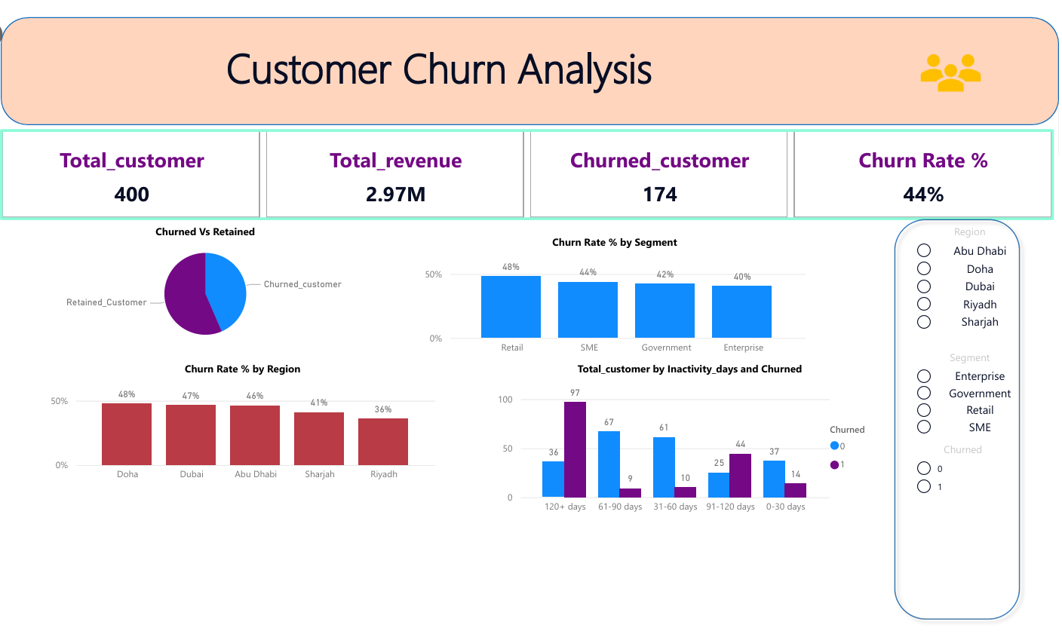

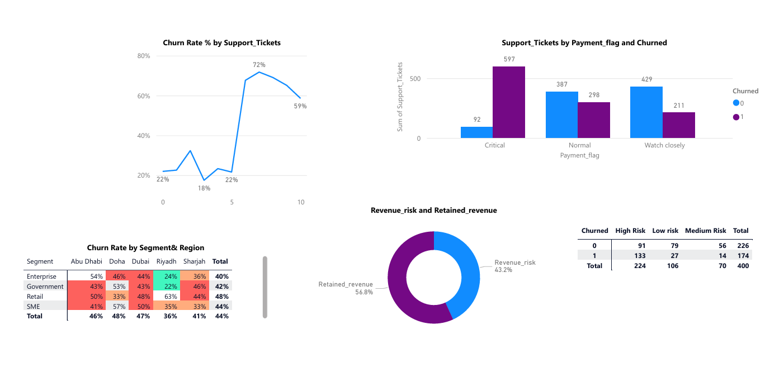

04 BUSINESS INSIGHTS & RECOMMENDATIONS

The following insights were derived from the combined SQL and Power BI analysis. Each is categorised by urgency and strategic impact.
Key Findings
RISK | Inactivity is the sharpest predictor of churn  Churn jumps from 9 customers (61–90 days inactive) to 97 customers (91–120 days) — a 90-day inactivity alert is the highest-leverage intervention trigger available.
RISK | Payment delays signal near-certain churn  Churn more for 4 and more payment delays — nearly as strong a predictor as inactivity.
OPPORTUNITY | Loyal customers are genuinely low-risk  Accounts with 24+ months tenure churn at just 38.7%, over 20 points lower than new accounts — retention investment compounds over time.
OPPORTUNITY | Riyadh outperforms every other region  Riyadh's 35.9% churn rate is nearly 12 points better than Doha (47.6%) — worth studying what's working there and replicating it.
WATCH | New customers are the most fragile  0–6 month accounts churn at 59.3%, the highest of any tenure band — onboarding quality in the first 6 months needs direct attention.
GROWTH | AED 1.28M in monthly revenue is recoverable  174 churned accounts represent AED 1.28M in lost monthly spend — even a modest win-back or prevention rate has an outsized revenue impact.

Strategic Action Plan
Immediate (0–3 months)
- Trigger automated outreach at the 90-day inactivity mark — the sharpest inflection point in the data and the single highest-leverage intervention point.
- Flag any active account with 4+ payment delays for immediate finance/account-management review — the strongest behavioural churn predictor after inactivity.

Short-term (3–6 months)
- Launch a targeted retention review for SME-segment and Doha-region accounts, given they show the highest churn rates by industry and region respectively.
- Build a structured onboarding check-in program for the first 6 months of a new account, where churn risk is nearly 60%.

Strategic (6–12 months)
- Operationalize the churn risk score as a recurring weekly SQL job feeding directly into the retention team's call list, rather than a one-time analysis.
- Study Riyadh's comparatively low churn rate for transferable practices that could be rolled out to Doha, Dubai, and Abu Dhabi.

End of Portfolio Project
SQL · Python · Power BI · DAX · Customer Churn Analysis

