  - IT3081 Statistical Modelling

Product Purchase Prediction Consultancy Report
Draft prepared from the submitted results.zip and Group Assignment(1).pdf | 24 September 2026
Team and organization: [add four names, student numbers, approved topic and dataset publisher].

Executive summary
We studied the next observed purchase order for existing loyalty customers using one year of coffee product transactions. The data cover 64,059 item lines, 40,009 orders, 500 customers and 15 product names in 2025. Historical preferences provide a useful top-three shortlist: customer favourites cover at least one item in 86.28% of held-out orders. The selected logistic model reaches 86.39%, but its recall is marginally lower (75.32% versus 75.34%). A customer-cluster bootstrap 95% interval for the recall difference is -0.202 to +0.167 percentage points. We therefore recommend a customer-favourite pilot as the initial decision rule, with a controlled test before claiming sales or profit impact.
Submission status: the supplied outputs support Tasks 3-5 and a limited PCA discussion. Sections below supply a structured draft for the other tasks; the dataset URL and permission, full-text literature checking, lecturer approval and real expert feedback must be added by the group before submission.

1 Industry problem and scope
The consulting client is a hypothetical coffee retailer with a loyalty program. Staff must decide which three products to show an existing customer before the customer places another order. The aim is to prioritize useful suggestions while avoiding irrelevant messages and unnecessary complexity. Stakeholders include customers, store managers, marketing analysts and staff responsible for privacy and product availability. The analytical question is: given only the customer’s earlier orders, which of the 15 observed products will appear in their next observed basket?
The outcome is product occurrence within an order. We do not predict whether a person visits or makes a purchase, the next order date, basket revenue, or the effect of showing recommendations. This distinction matters: the file contains purchases and no unpurchased visits or randomized exposure records. Obtain lecturer approval for this exact problem statement and replace the hypothetical organization with a real one only if authorized and documented.

2 Research landscape
The literature distinguishes next-basket ranking from purchase-incidence prediction, explains the strength of repeated purchases, and questions whether more complex models improve practical outcomes. Li et al. (2023) argue for separating repeated from newly explored items; van Maasakkers et al. (2023), Zeng et al. (2024), Mao et al. (2024), Huang et al. (2024) and Zhou et al. (2025) explore more complex ways to represent basket history. Such models are relevant comparison points, but a small fixed catalog of 15 items and only 500 customers justify beginning with transparent favourites and pooled logistic regression. The source list at the end includes 15 journal articles, all published within five years as of this draft. The group should read the full papers, verify reference details and expand the critical comparison using their actual methods and limitations before submitting.
A second strand looks at whether recommendations affect behaviour rather than merely match future baskets: Molaie and Lee (2022), Hallikainen et al. (2022) and Yi et al. (2022) consider diversity, promotions or experiments. Forecasting work (Fildes et al., 2022) addresses demand planning, a distinct question. Bayesian forecasting (Wu et al., 2023) illustrates uncertainty-aware decision support. Our gap is an operational one: quantify how much an interpretable model improves on a personal-repeat rule with a date-ordered evaluation, while clearly separating offline match rates from causal business value.

3 Dataset understanding and descriptive analysis
Measure | Observed result
Coverage | January–December 2025; 12 monthly totals
Scale | 64,059 item lines; 40,009 orders; 500 loyalty customers; 15 products
Basket | Mean 1.43 distinct products; median 1; range 1–3
Most frequent products | Iced Mocha 4,346 orders; Mocha 4,326; Americano 4,143
Order-level conflicts | 3,908 order IDs have multiple OrderType values; 5,028 have multiple PaymentMethod values
Missing fields | AddressLine1, Contact No and Registered Outlet entirely missing; SubMenu missing in 48,351 of 64,059 lines
Duplicates and IDs | No exact duplicate rows; no order spans multiple dates or customers

Order-level type and payment fields cannot be treated as reliable for every basket. The paired inference uses only orders with one unambiguous type; payment and future-order context are excluded from predictive inputs. The category mapping is visibly inconsistent: for example, Mocha is tagged Food / RICE and Iced Mocha Merchandizing / FIZZY DRINKS. Avoid category-level recommendations until source labels are corrected. Product names such as “tasty drink” and “Nice Coffee” also require client verification. The source repository URL, public accessibility, license and data-generation process were not supplied; add them and confirm whether records are real, anonymized or synthetic.
The observed basket-size range of one to three is not evidence of a data error, but it is unusually constrained and should be checked against the data collection rules. AdjustedRate, Qty1 and Discount could be examined for extreme values after field definitions and currency are confirmed; the provided results do not contain a numerical price or quantity outlier table. Do not claim those variables were cleared of outliers.
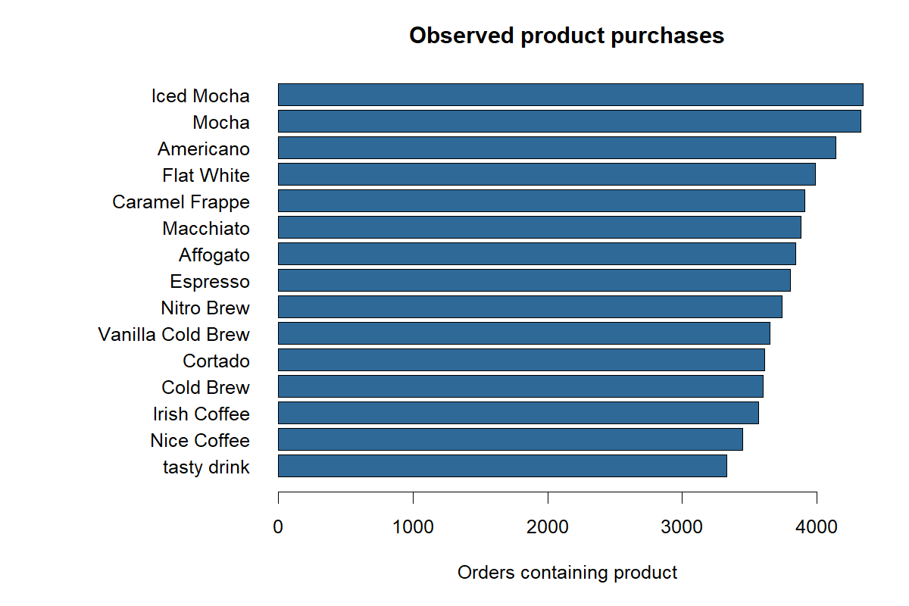
Figure 1 Orders containing each product
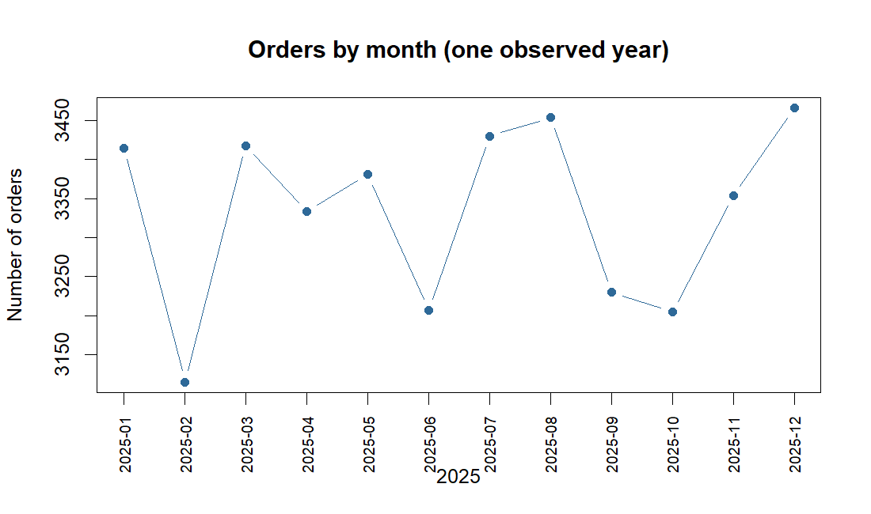
Figure 2 Recorded monthly orders during 2025
Monthly order counts range from 3,115 in February to 3,466 in December. One observed year is too short to establish a repeatable yearly seasonal pattern. Popularity of Iced Mocha and Mocha may inform stock monitoring, but frequencies alone do not show margin, preference changes or the effect of promotions.

4 Statistical inference
Each test uses one summary or indicator per customer where relevant, so repeated orders are not treated as separate people. The exploratory comparisons are observational associations, not causal effects. Use a prespecified 5% significance level and interpret confidence intervals alongside p-values.
Question and hypothesis | Method | Result and interpretation
Dine-In vs Takeaway: mean within-customer basket size difference = 0 | Paired t test; 486 customers with both unambiguous types | Mean Dine-In minus Takeaway = -0.008 products; 95% CI [-0.042, 0.026]; p = 0.635. No evidence of a difference.
Mocha in Q4: under-40 and 40-plus customer purchase proportions equal | Two-sample proportions test with continuity correction | 101/199 (50.75%) vs 142/301 (47.18%); p = 0.489. No evidence of different customer-level rates.
Average basket size equal across age groups 18–29, 30–44, 45–59 and 60+ | One-way ANOVA on customer means | F = 2.469; p = 0.061. Do not reject at 5%; no post-hoc comparison is justified from this test.
Equal dispersion of customer mean baskets across age groups | Brown–Forsythe median-deviation approximation | F = 0.550; p = 0.648. No detected difference in dispersion; this does not prove equal variances.

The paired test assumes customer differences are reasonably suitable for a t approximation; the large sample helps, but a distribution check remains sensible. ANOVA also assumes independent customer summaries and sufficiently well-behaved within-group residuals; the available CSVs do not establish these diagnostics. The age comparisons may be confounded by visit frequency, outlet and other factors. They do not justify age-targeted marketing.

5 Predictive statistical modelling
For each observed order after a customer’s first, the analysis creates 15 candidate rows, one per product. The binary response is whether that product is in the order. Features are calculated from earlier orders: prior order count, product purchase share, and, in the larger model, recent-five frequency, last-order indicator, orders since last purchase, previously seen product variety and mean prior basket size. The simple pooled binomial logistic GLM uses product identity, prior orders and prior product share. The history GLM adds the recent and diversity features. The comparison methods rank customer favourites by their past purchases or rank overall training-period popularity.
The split follows calendar time: 29,484 eligible orders from January–September for training, 3,205 October orders for model selection, and 6,820 November–December orders for a final test. The simple GLM was chosen over the history GLM using validation recall@3 (76.42% vs 76.20%). For each evaluation order, its own products are not used as predictors; as later orders arrive, known earlier orders may update a customer’s history. Consequently, these are repeat-customer, next-observed-order results, not results for brand-new customers.
Method | Top one hit | Top three any hit | Recall at three | Precision at three
Customer favourites | 42.05% | 86.28% | 75.34% | 35.91%
Global popularity | 10.47% | 30.04% | 22.16% | 10.56%
Selected simple logistic GLM | 42.02% | 86.39% | 75.32% | 35.90%

Top-three-any is the fraction of orders containing at least one recommended item. Recall@3 divides all recommended-and-purchased item matches by all purchased items; precision@3 divides matches by three recommendation slots per order. Thus 86.39% coverage does not mean 86.39% of recommendations were correct. The selected GLM minus favourites recall is -0.0205 percentage points; a customer-cluster bootstrap (300 resamples) gives a 95% interval of -0.202 to +0.167 percentage points. This interval includes zero and is too wide to establish a useful advantage. The model improves top-three-any by only 0.117 percentage points, while top-one and recall are slightly lower.
Recommendation: use the customer-favourite rule for a small pilot and retain the logistic GLM as a research comparator. The exported 06_example_next_order_recommendations.csv contains GLM-generated examples after fitting all observed 2025 data; it should not be described as a verified production policy or used to claim lift. Pooled logistic coefficients provide model-based conditional associations, but individual product-candidate rows and customer orders are dependent; the exported naive coefficient p-values are not cluster-robust. Model calibration, probability uncertainty, drift, cold-start behaviour and real-time product availability remain untested.

6 Experimental design for future validation
A completely randomized design would assign consenting existing customers to either the customer-favourite policy or current business-as-usual messaging. Randomize at customer level to prevent one person receiving both policies; prespecify purchase conversion, revenue or contribution margin per eligible customer, and recommendation engagement. A randomized complete block design could block by outlet or historical order-frequency band and randomize customers within each block. Blocking can improve precision if customer mix differs strongly between outlets or frequency bands. It adds operational complexity, may produce small blocks and does not remove cross-customer spillovers or staffing effects. Neither design was carried out with this file. Validate sample size, exposure logging, opt-outs, product availability and consent before launch; analyze customers as the randomized units.

7 Principal component analysis
The script applies PCA to 500 customer profiles of Jan–September product shares after centering and scaling. Component 1 explains 8.69% of variance, the first 10 explain 76.06%, and the first 11 explain 82.41%. The final component has effectively zero variance because shares have a compositional constraint. Reduction from 15 items to 11 components for an 80% threshold saves little and removes direct product interpretability. PCA may help visualize broader tastes when the catalog grows or product histories are strongly correlated; it should be estimated on training data only and checked against a held-out model. No prediction improvement from PCA was measured here.
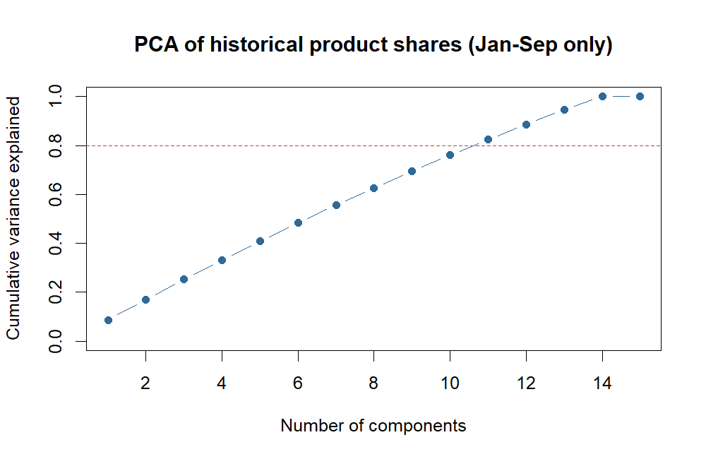
Figure 3 Variance captured by components of historical product shares

8 Bayesian approaches
Naive Bayes could combine earlier product indicators to estimate next-product probabilities, but its conditional-independence assumption is weak when drinks co-occur and purchase habits are correlated. Hierarchical Bayesian logistic regression could partially pool customers with sparse histories and provide posterior intervals, at the cost of prior choice, computation and model checks. Bayesian decisions would rank suggestions by expected benefit, for example purchase probability times contribution margin minus messaging cost, with uncertain inputs represented explicitly. Wu et al. (2023) offer an uncertainty-aware Bayesian sales forecasting example, but forecasting aggregate sales is a different target. None of these Bayesian models was fitted in the supplied results; discuss as options, not measured improvements.

9 Time series and future forecasting
Aggregate order counts or product-level units could support staffing and stock decisions once several years of consistent timestamps, availability and promotion records exist. Inspect trend, day-of-week effects, holidays and repeatable seasonality, then compare simple seasonal baselines with a fitted ARIMA/SARIMA model on later holdout months. Evaluate forecast error and prediction intervals at the useful business horizon. The 12 monthly points in this dataset cover only one year, so a yearly seasonal ARIMA fit would be fragile. This task requires a critical discussion rather than a fitted time-series model; no sales forecast was produced.

10 Proposed customer intelligence workflow
Create an internal dashboard that shows an opted-in returning customer’s three historically preferred available products, the supporting past-order counts, last purchase, and a simple confidence or history-coverage flag. Update recommendations after each confirmed order. Add inventory and margin filters only when trusted data become available. Log which suggestions were displayed, clicked and purchased so a future customer-level experiment can measure incremental value. Resources include a reliable product catalog, transaction pipeline, dashboard owner, access controls and store staff training. The likely operational benefit is quicker relevant suggestions; sales uplift remains unproven.
Input | Decision rule | Action and monitoring
Confirmed historical orders and corrected product catalog | Top three customer favourites; suppress out-of-stock items | Show suggestions to eligible customers; record exposures and purchases
Experiment assignment and cost data once available | Compare policies by randomized customer outcome | Retain only policies showing useful net value

11 Industry expert validation
Required evidence has not been provided. Interview a café manager, retail marketing analyst, loyalty program specialist or similar expert; do not fill this section until an actual conversation or written response occurs. Present the above result table and request feedback on whether the task is relevant, whether favourites are practical, what data quality would obstruct rollout, what stock or margin restrictions apply, and what success measure matters most. Keep a dated interview summary, consented role description, and supporting email, meeting note or completed feedback form. Then add: “The expert recommended [exact feedback]. We changed recommendation [specific change] because [reason].” Do not attribute the statistical findings to an expert or fabricate a quote.

12 Final management recommendations
- Approve a small, opt-in pilot of customer favourites as the initial rule; the held-out match rate is strong and the tested GLM has no clear recall advantage. Literature on repeat purchases supports benchmarking against this rule.
- Correct the product-to-category mapping and clarify generic product names before launching any category report or campaign. Confirm the public dataset URL and permission to use it; avoid storing contact details that are absent or unnecessary.
- Run a customer-randomized comparison against current practice, monitor revenue or margin and customer engagement, and gather documented expert input before changing production policy. Offline recommendation accuracy cannot prove business impact.
- Reassess models when more outlets, several years of data, product availability and promotion exposure become available. Monitor new customers and changing preferences separately from the repeat-customer results in this report.
The recommendations combine observed statistical evidence and related literature; the assignment’s further requirement for actual industry-expert support remains pending until Section 11 is completed.

Presentation plan for four members
Speaker and time | Board-facing slides | Viva preparation
Member 1 | 3 min 30 s | Problem, business decision, dataset provenance, 15-paper comparison | Define next-order target; distinguish prediction from purchase conversion.
Member 2 | 3 min 30 s | Data quality, product/month charts, customer-level inference | Explain sample units, hypotheses, p-values and category errors.
Member 3 | 4 min | Time split, GLMs, baselines, test metrics, bootstrap interval | Explain leakage prevention, metric denominators and why favourites win operationally.
Member 4 | 4 min | CRD/RCBD, PCA, Bayesian, time-series, dashboard, expert feedback and final recommendation | Explain feasibility and how real expert feedback changed the plan.

Total 15 minutes, followed by a 10-minute viva in which all four members contribute. Replace names and timings after rehearsing. Each member should understand the complete analysis, not just their own slides.

Research reading list and traceable sources
These are 15 journal publications located via journal or publisher records. They are a literature-review starting set, not a claim that the group read every full text. Verify bibliographic details and critically compare the actual articles before submission. The links identify publisher pages or DOI records.
1. van Maasakkers et al. (2023). Next-basket prediction in a high-dimensional setting using gated recurrent units. Expert Systems with Applications. https://www.sciencedirect.com/science/article/pii/S0957417422018139
2. Jansen et al. (2024). Online grocery shopping recommender systems: Common approaches and practices. Computers in Human Behavior. https://www.sciencedirect.com/science/article/pii/S0747563224002048
3. Zeng et al. (2024). Hierarchical representation learning for next basket recommendation. Array. https://www.sciencedirect.com/science/article/pii/S2590005624000201
4. Mao et al. (2024). Ranking on user-item heterogeneous graph for Ecommerce next basket recommendations. Knowledge-Based Systems. https://www.sciencedirect.com/science/article/pii/S0950705124004970
5. Huang et al. (2024). Knowledge-reinforced explainable next basket recommendation. Neural Networks. https://www.sciencedirect.com/science/article/pii/S0893608024005999
6. Zhou et al. (2025). Dual-tower model with semantic perception and timespan-coupled hypergraph for next-basket recommendation. Neural Networks. https://www.sciencedirect.com/science/article/pii/S0893608024009304
7. Hruschka (2024). Analyzing market basket data through sparse multivariate logit models. Journal of Marketing Analytics. https://link.springer.com/article/10.1057/s41270-024-00331-0
8. Chen et al. (2024). Customer purchase prediction in B2C e-business: A systematic review and future research agenda. Expert Systems with Applications. https://www.sciencedirect.com/science/article/pii/S0957417424011278
9. Li et al. (2023). A Next Basket Recommendation Reality Check. ACM Transactions on Information Systems. https://dl.acm.org/doi/10.1145/3587153
10. Molaie and Lee (2022). Economic corollaries of personalized recommendations. Journal of Retailing and Consumer Services. https://www.sciencedirect.com/science/article/pii/S0969698922000960
11. Hallikainen et al. (2022). Consequences of personalized product recommendations and price promotions in online grocery shopping. Journal of Retailing and Consumer Services. https://www.sciencedirect.com/science/article/pii/S0969698922001813
12. Yi et al. (2022). Recommendation technologies and consumption diversity: An experimental study on product recommendations, consumer search, and sales diversity. Technological Forecasting and Social Change. https://www.sciencedirect.com/science/article/pii/S004016252200018X
13. Wu et al. (2023). Bayesian non-parametric method for decision support: Forecasting online product sales. Decision Support Systems. https://www.sciencedirect.com/science/article/pii/S0167923623000945
14. Fildes et al. (2022). Retail forecasting: Research and practice. International Journal of Forecasting. https://www.sciencedirect.com/science/article/abs/pii/S016920701930192X
15. Ensafi et al. (2022). Time-series forecasting of seasonal items sales using machine learning - A comparative analysis. International Journal of Information Management Data Insights. https://www.sciencedirect.com/science/article/pii/S2667096822000027

Submission checks
- Replace every bracketed field; add the original public dataset URL, accurate authorship metadata and university-required citation style.
- Read and verify all 15 full papers; develop source-specific strengths, weaknesses and comparisons beyond this preliminary draft.
- Attach an authentic expert-feedback record and state precisely how it affected the final recommendations.
- Acknowledge the dataset, R, research sources and generative AI use as required by the assignment; confirm topic approval with the lecturer.

