Espresso purchase prediction

Statistical consultancy report
Estimating the probability that a coffee shop order contains an Espresso using outlet and order time information

Executive summary
Outlet and order time provide limited information about whether an order contains an Espresso. The analysis covers 20,476 orders across 80 outlets from 1 January to 31 March 2026. Espresso appears in 1,977 orders, or 9.66%. This supports a useful purchase mix benchmark, but the current evidence does not support confident individual targeting or automatic changes to staffing and stock.
Ridge logistic regression was selected using chronological validation within January and February. In the March assessment, its ROC AUC was 0.5295, compared with 0.5000 for a constant probability model. Its Brier score improved by only 0.0000612; the day bootstrap interval for this improvement included zero. The adjusted time band association was also inconclusive, with p = 0.8111. These results suggest weak differentiation within the available outlet and time categories.
All models achieved 90.42% classification accuracy at a probability threshold of 0.50 by predicting no Espresso for every March order. They identified none of the 646 Espresso orders. Management should therefore evaluate probability quality, uncertainty and decision value rather than headline accuracy.
We recommend an Espresso purchase mix monitoring dashboard that displays the observed rate and a transparent baseline, with Ridge retained as a research candidate. Validate on a new, untouched period before operational use. Repair product metadata, establish the dataset's provenance and measure offer effects through a future randomized study before claiming commercial uplift.
This report addresses the twelve assignment tasks. The literature review contains 18 journal publications, including eight from 2022–2024. Real industry expert feedback is still required to complete Task 11 and finalize the recommendations in Task 12. Public dataset attribution, licence, organizational identity and lecturer approval also require documentary confirmation. No expert response, client engagement, source attribution or financial benefit is invented.

Report navigation
Tasks 1–2 establish the problem and research basis. Tasks 3–5 interpret the descriptive, inferential and predictive results. Tasks 6–9 evaluate future methods without claiming that experiments, PCA, Bayesian modelling or time series forecasting were conducted. Tasks 10–12 present the innovation proposal, consultation process and evidence linked recommendations. References and appendices provide the variable dictionary, consultation record and presentation plan.

Task 1 Understanding the industry problem

Industry and organizational context
Coffee shop managers make repeated decisions about product availability, counter service, menu presentation and promotions. Transaction records can describe which products appear together and how purchasing varies across locations and trading periods. Retail research places prediction within a wider set of operational and customer facing uses, rather than treating an algorithm as a business solution by itself (Brackmann et al., 2023).
The case dataset represents a multi-outlet point of sale operation with 80 distinct outlet labels and three months of orders. It includes both transaction and customer related fields, but the organization's legal name, location, operating model and data collection process have not been verified. The organizational discussion therefore concerns the coffee shop operation represented by the records; it does not establish that a named real company commissioned the work.

Business problem and decision scope
The question is whether information available around order initiation can estimate the probability that the resulting order contains at least one item named Espresso. The unit of analysis is an order. An order containing several Espresso items is still one positive outcome. This is neither the probability that a visitor makes any purchase nor a prediction of how many cups will be sold.
The intended inputs are outlet, weekday and time band. Outlet is ordinarily known before product choice, while time can be obtained at order initiation. Historical OrderTime must be checked against the point of sale definition: a payment completion timestamp may not exactly match the intended prediction moment. The current extract cannot verify that assumption.
A dependable probability could help managers understand product mix and identify where further investigation is useful. Combined with a separate order volume forecast, it might later support preparation planning. Purchase propensity alone cannot show whether a discount would cause an additional sale, and a higher Espresso share does not necessarily mean higher profit if other products are displaced.

Stakeholders and objectives
Stakeholder | Decision affected | Information needed
Senior management | Whether to invest in a prediction service | Incremental value, uncertainty and implementation cost
Outlet managers and baristas | Preparation and service planning | Expected mix, order volume and workload constraints
Marketing team | Whether to test menu prompts or offers | Causal sales lift, margin and customer response
Data and point of sale teams | Data repair and system integration | Reliable item codes, timestamps and model monitoring
Customers | Service experience and use of their data | Appropriate privacy, fair treatment and useful offers

The consultancy objectives are to construct a defensible order outcome, assess data quality, describe purchase patterns, test selected associations and compare interpretable probability models against a simple baseline. We then evaluate advanced methods and propose an operationally feasible use of the evidence. Success means a justified decision about model usefulness, including the possibility that the available predictors are insufficient. It does not require a high accuracy claim.
The business objectives remain provisional until an industry expert confirms which decisions matter most, what error costs are acceptable and whether the proposed prediction moment matches the real ordering process.

Task 2 Research landscape

Review scope and evidence base
This is a targeted critical literature review of purchase prediction, retail analytics and the statistical methods relevant to this case. Publisher pages, journal articles and author or institutional copies were checked using searches on purchase prediction, retail forecasting, penalized logistic regression, probability calibration, PCA, Bayesian inference and controlled experiments. The review compares the accessible methods, findings and intended use of the studies. It is not presented as an exhaustive systematic search or meta-analysis.
Eighteen journal publications form the review. Eight were published within the five years preceding September 2026: Eglite and Birzniece (2022), Makridakis et al. (2022), Suzuki (2022), Brackmann et al. (2023), Tay et al. (2023), Chen et al. (2024), Gooljar et al. (2024) and Larsen et al. (2024). Older methodological work is retained because its assumptions and evaluation principles directly inform the analysis. Cross-domain papers support statistical reasoning, not claims that coffee shop performance has already been demonstrated.

Industry practice and transfer from online purchase research
Chen et al. (2024) synthesize 98 studies of B2C purchase prediction published from 1995 to 2023. This broad view helps distinguish modelling approaches and data requirements, but an online purchase setting can contain browsing and behavioural signals absent from a point of sale extract. Gooljar et al. (2024) examine sentiment based online purchase models. Their focus illustrates an additional information source rather than evidence that outlet and clock time are sufficient predictors. Neither review justifies transferring an e-commerce accuracy figure to this dataset.
Brackmann et al. (2023) combine a review of 225 publications with eight expert interviews to organize retail machine learning applications. Their inclusion of practitioner evidence is stronger for identifying operational uses than an algorithm comparison alone. However, a broad retail use case classification cannot establish the accuracy or return on investment of this Espresso model. Taken together, these studies suggest that business relevance depends on the prediction target, available information and workflow. The gap here is a narrowly defined, low information, offline order prediction problem.
Fader et al. (2005) offer a useful counterpoint. Their BG/NBD approach predicts repeat transaction activity in customer bases and simplifies an established purchasing model. It addresses whether and how often customers transact, rather than which product appears in an order. Reliable customer histories would be necessary to apply it meaningfully. With loyalty identifiers missing on 62.72% of item rows and no verified customer observation scheme, adapting it to the present target would confuse customer activity with product choice.

Statistical models and the role of regularization
Friedman et al. (2010) provide efficient estimation for penalized generalized linear models, including binary logistic regression with Ridge, LASSO and Elastic Net penalties. Tay et al. (2023) extend the computational framework to additional model families and utilities. Their strength is a reproducible way to compare shrinkage strategies. Their limitation for this project is that computational capability does not imply that the selected inputs contain useful purchase information.
The relevant comparison is therefore between unpenalized logistic regression, regularized versions and an intercept-only probability. Ridge shrinks coefficients without requiring variable deletion; LASSO can set coefficients to zero; Elastic Net combines the two penalties. For 80 outlet categories, shrinkage can reduce unstable estimates in small outlets. Conversely, penalties can suppress small real differences, and dummy-level LASSO selection need not preserve an entire categorical variable. These tradeoffs must be evaluated on later orders rather than inferred from training fit.
Zeileis et al. (2020) address a different problem: covariance estimation when observations are clustered. Their framework supports more appropriate uncertainty estimates for the unpenalized inference model. It does not eliminate confounding or make a model predict better. This distinction prevents robust standard errors from being mistaken for a remedy for weak information, incomplete provenance or future population change.

Evaluating probabilities under class imbalance
Gneiting et al. (2007) evaluate probabilistic forecasts through calibration, sharpness and suitable scoring rules. Their examples differ from binary retail orders, but the central implication is relevant: probabilities should agree with observed frequencies while providing useful differentiation. Van Calster et al. (2019), writing about clinical prediction, emphasize the importance of calibration and validation. Clinical outcomes and costs do not transfer to retail, whereas the distinction between ranking and trustworthy probability estimates does.
Saito and Rehmsmeier (2015) show why precision–recall assessment is informative when positives are uncommon. This complements, rather than replaces, proper probability scores. A model can have a useful ranking but poorly calibrated probabilities, or acceptable average calibration with little ranking power. Our design consequently reports log loss, Brier score, ROC AUC, average precision and calibration together. March Espresso prevalence of 9.58% makes the always-negative accuracy benchmark particularly important.

Advanced approaches and causal evidence
Jolliffe and Cadima (2016) explain PCA as a method for summarizing variation in predictors. Its strength is compression of correlated measurements; its limitation for supervised prediction is that directions of high predictor variance need not retain the outcome signal. Hand and Yu (2001) examine why Naïve Bayes may classify effectively despite simplifying independence assumptions. That finding makes it a possible comparator, but does not establish calibrated probabilities for dependent outlet and time variables.
Gelman et al. (2008) demonstrate how weakly informative priors can stabilize logistic estimates, including separation problems. Compared with an unconstrained model, prior information can improve stability, but scaling and prior sensitivity matter. Suzuki (2022) explicitly connects binary outcome analysis to decisions using expected loss. Its policy setting differs from retail, yet it exposes a common gap: a probability or significance test does not define the best action without a defensible account of consequences.
Kohavi et al. (2009) discuss controlled web experiments and practical threats to reliable conclusions. Larsen et al. (2024) review more recent statistical challenges in online experimentation. Both support planned randomization, outcome definition and disciplined analysis. Their online settings offer easier exposure tracking than a physical coffee shop. Staff spillover, repeat visitors and outlet constraints must therefore be addressed before translating the ideas into a promotion trial.

Forecasting research and the analytical gap
Eglite and Birzniece (2022) review deep learning methods for retail sales forecasting, including evaluation approaches and limitations. Makridakis et al. (2022) report the M5 retail forecasting competition, involving 42,840 hierarchical sales series. These studies demonstrate the breadth of forecasting comparisons and operational targets. They do not establish that a complex forecasting model is suitable for a 90-day order extract, or that forecasting product quantities is equivalent to estimating basket membership.
The collective gap is the need to establish incremental value for a simple, auditable probability model under limited offline information. The chosen approach uses an order-level binary target, excludes outcome-revealing fields, respects chronology, retains a baseline and interprets uncertainty. Advanced methods remain candidates for specific future data and decisions. The literature provides reasons to test them; the present results determine whether they are useful here.

Task 3 Dataset understanding and descriptive analysis

Dataset suitability and construction
The file V2postransactions.csv contains 29,465 item rows and 28 source variables. Aggregating by OrderNo produces 20,476 distinct orders over 90 calendar days, covering 80 outlets. These records are suitable in structure for the question because they connect named products to order identifiers, outlet and date/time. Their volume supports descriptive analysis and model comparison, although information is unevenly distributed across outlets.
The dataset's public repository URL, creator, release date, licence, original collection process and real or synthetic status remain unverified. Its filename is not a sufficient citation. Public accessibility and appropriate attribution are assignment requirements; the provenance record in Appendix C must be completed before submission. Conclusions describe this extract and should not yet be generalized to an identified business population.
Product names were trimmed, converted to lowercase and normalized for repeated whitespace. An order was labelled positive when at least one normalized ItemName equalled “espresso”. All other orders with fully observed item names were labelled negative. This definition excludes related products such as a latte unless an Espresso item is separately recorded. It depends on complete item capture and a correct product naming convention.
The outcome was constructed from ItemName, not MainCategory or CoffeeOrNonCoffee, because the same product had inconsistent category and coffee flags. Items within an order were kept together throughout aggregation and splitting. There were no unknown outcomes and no conflicting outlet, date, time, order type or loyalty metadata within OrderNo. These checks support this grouping rule within the extract, but do not prove that the source system never reuses order identifiers.

Variables and prediction availability
Variable group | Analytical use | Interpretation or restriction
OrderNo and ItemName | Grouping and binary target | Never included as predictors
Outlet | Categorical predictor | 80 observed labels; new outlets require a fallback
OrderDate and OrderTime | Chronology, weekday and time band | Verify local timezone and timestamp meaning
Qty1, AdjustedRate, Discount and ServiceCharge | Descriptive and quality checks | Excluded from the prediction because they describe the completed basket
Customer and identity fields | Missingness or quality audit | Direct identifiers excluded; no person-level inference
Product categories and supplied calendar labels | Consistency checks | Calendar features recomputed; unreliable product flags excluded

Morning is 07:00–11:59, Afternoon 12:00–16:59, Evening 17:00–20:59 and Night 21:00–06:59. Observed trading hours in the extract span 07:00–23:59. Weekday was derived from the parsed date. Time band simplifies interpretation but may conceal variation within broad periods. The full source variable dictionary appears in Appendix A.

Missing values and data quality
Check | Result | Organizational meaning
Missing target or required outlet/date/time fields | None in the analysed orders | No imputation was needed for the chosen model inputs
Duplicate full item rows | 0 flagged | No blanket duplicate deletion was necessary
Loyalty identifier and customer name | 18,480 missing each, 62.72% of item rows | Customer history based personalization is not supported by this extract alone
SubMenu | 19,632 missing, 66.63% | Menu hierarchy may be incomplete or structurally inapplicable
Age and DOB | 13,921 missing each, 47.25% | Available customer ages are not representative without further investigation
Address, contact number and registered outlet | 100% missing | These fields add no analytical information
Quantity, monetary and calendar validity checks | No flagged invalid values in reported checks | Basic checks passed; business definitions still require verification

Missing percentages above use item rows as their denominator, not unique customers or orders. No missing-at-random assumption is justified by these summaries. Customer fields may be absent because identification is optional, but that explanation requires source or expert confirmation. Removing all rows with any missing field would discard useful transactions and could introduce selection bias; the model therefore uses its complete, relevant inputs.
No nonpositive or fractional quantities, negative rates, negative discounts, negative service charges, or mismatched supplied weekday/time-band labels were found. Product classification inconsistency remains a material issue despite these successful checks. A controlled item code dictionary would be more reliable than free-text product matching in a production workflow.

Descriptive statistics and outlier interpretation
Item-row measure | Mean | Median | Minimum | Maximum | IQR rule flags
Quantity | 1.240 | 1 | 1 | 3 | 5,870
Adjusted rate | 836.51 | 837.52 | 710.35 | 960.45 | 228
Discount | 18.70 | 0 | 0 | 468.38 | 4,068
Service charge | 59.79 | 78.76 | 0 | 288.14 | 656
Age among nonmissing rows | 42.88 | 43 | 18 | 68 | 0

The standard rule flags values below the first quartile minus 1.5 interquartile ranges or above the third quartile plus 1.5 interquartile ranges. Quantity and discount have an interquartile range of zero: ordinary multi-unit purchases and nonzero discounts are therefore flagged. These are review candidates, not evidence of erroneous transactions. Deleting them automatically would distort the business record. Rate flags represent 0.77% of item rows. Currency and rate semantics are unverified, so no revenue total or monetary benefit is inferred.

Purchase patterns and initial business insights
Espresso appears in 1,977 of 20,476 orders, a rate of 9.655%. Non-Espresso orders account for 90.345%. This imbalance makes raw classification accuracy a poor measure of success and establishes a natural baseline near one Espresso-containing order in ten.
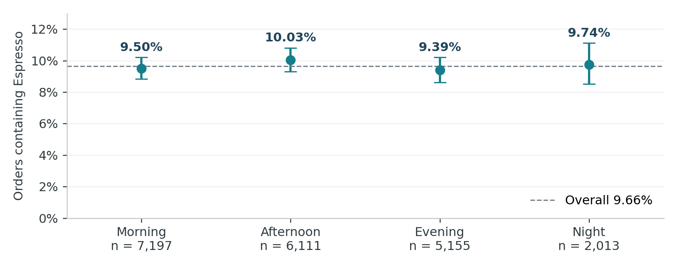
Figure 1 Espresso purchase rates by time band with descriptive 95 percent Wilson intervals. Source: project analysis outputs.
Afternoon has the highest observed time-band rate, 10.03%, and Evening the lowest, 9.39%, a difference of only 0.64 percentage points. Morning has the most orders, 7,197, and 684 Espresso orders. Afternoon has 6,111 orders and 613 positives, Evening 5,155 and 484, and Night 2,013 and 196. The narrower business interpretation is a fairly similar product share across bands; greater Morning Espresso volume mainly accompanies greater overall ordering volume.
Weekday rates range from 8.51% on Thursday to 10.60% on Saturday. Outlet rates range from 2.56% at Location 75, based on only 39 orders, to 16.67% at Location 87, based on 108 orders. These are descriptive extremes selected from many groups. They should not be used as outlet performance rankings or as evidence of a weekend effect without stronger confirmation. Wilson intervals assume independent Bernoulli observations and can understate uncertainty when orders are clustered.
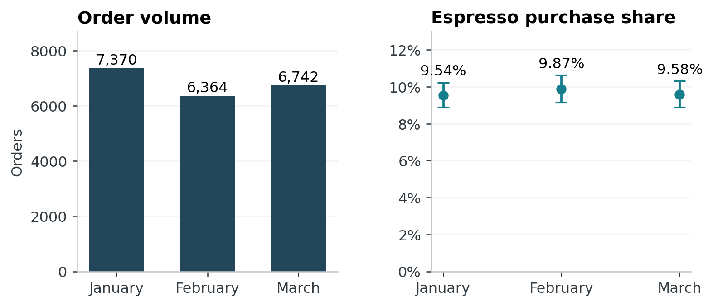
Figure 2 Monthly order counts and Espresso purchase rates. Source: project analysis outputs.
January contains 7,370 orders with an Espresso rate of 9.54%; February contains 6,364 at 9.87%; March contains 6,742 at 9.58%. Monthly rates are close, while order totals differ. Three months do not establish annual seasonality, and monthly totals should not be compared without recognizing different month lengths. The immediate business priority is dependable measurement, not a large change in staffing or promotions based on these small rate differences.

Task 4 Statistical inference

Question and test selection
Inference was performed on the January–February development period: 13,734 orders, including 1,331 Espresso orders. The main question was whether time band is associated with Espresso purchase after controlling for outlet and weekday. A binary outcome naturally supports comparisons of proportions and a binomial logistic model. Separate tests of continuous means, variances and ANOVA were not needed to answer this question. For a binary variable, the mean is the purchase proportion, while the variance is determined by that proportion.
The primary null hypothesis states that all three nonreference time-band coefficients are zero after adjustment. The alternative states that at least one differs. A joint Wald test was used with standard errors clustered by both outlet and date. This allows dependence among orders sharing an outlet and among orders sharing a date, subject to the assumptions of the covariance estimator. The analysis used the HC1 correction and the covariance function's positive semidefinite adjustment (Zeileis et al., 2020).

Primary adjusted result
The joint Wald statistic was 0.9595 on 3 degrees of freedom, with p = 0.8111. At the stated 5% significance level, there is insufficient evidence against the null hypothesis. This is not a demonstration that time bands have identical probabilities, nor that time has no business relevance.
Comparison with Afternoon | Adjusted odds ratio | 95% clustered interval
Evening | 0.944 | 0.775–1.149
Morning | 0.919 | 0.764–1.106
Night | 0.989 | 0.739–1.322

Every interval includes one. For example, the Morning estimate corresponds to slightly lower odds, but its interval is compatible with both lower and higher odds. Odds ratios are not percentage-point changes in purchase probability. The model assumes additive outlet, weekday and time-band effects on the log-odds scale; it does not test every possible outlet-specific time pattern.
For management, these results provide no compelling basis for a time-band-specific Espresso offer solely from the present analysis. Customer mix, stock availability, menu exposure and price may confound observed relationships. An experimental offer effect cannot be inferred from these coefficients.

Supplementary comparisons of proportions
For each comparison, the null hypothesis is equal Espresso purchase proportions across all groups; the alternative is that at least one group differs. Pearson chi-square tests provide an omnibus assessment for categorical groups. The outlet table contained small expected cells, so its p-value used 9,999 Monte Carlo simulations. Holm adjustment was applied to the two supplementary p-values.
Grouping | Chi-square | df | Raw p-value | Holm p-value | Cramer V
Time band | 1.5620 | 3 | 0.6680 | 0.6680 | 0.0107
Outlet | 93.4398 | 79 | 0.1279 | 0.2558 | 0.0825

Neither comparison rejects equal proportions at 5%. The time-band association is very small descriptively. Outlet variation may still matter operationally, but the reported global evidence does not justify selecting particular outlets for action. Degrees of freedom describe the table structure; the outlet p-value comes from simulation, not the asymptotic chi-square reference alone.
These supplementary tests assume independent orders. Monte Carlo calculation addresses sparse expected counts, not repeated customers or clustering. They therefore have a weaker inferential basis than the primary clustered analysis and should not be treated as independent confirmation of a causal result.

Estimation and practical uncertainty
The development-period purchase rate is 9.691%. An outlet-cluster percentile bootstrap with 1,000 resamples gives a 95% interval of 9.159% to 10.258%. This is an estimation exercise, not a hypothesis test against an arbitrary rate. It treats outlets as independent resampling units and does not fully represent common date effects or customers moving across outlets.
The evidence is consistent with a useful approximate ten-in-one-hundred planning reference, conditional on orders being placed. It does not quantify uncertainty in future order arrivals, cup quantities or a promotion's incremental margin. These distinctions limit what management can responsibly decide from the inference.

Task 5 Predictive statistical modelling

Model specification and alternatives
The outcome is Bernoulli: one for an order containing Espresso and zero otherwise. Logistic regression models the log odds using categorical outlet, weekday and time band, then transforms the fitted value to a probability between zero and one. The same predictors were used for ordinary logistic regression, Ridge, LASSO and Elastic Net logistic regression. An intercept-only model assigns the development purchase rate to every order.
This is a family of binomial generalized linear models. Regularization is applied to logistic coefficients, not to a continuous linear approximation of the outcome. Multiple linear regression could produce probabilities outside the valid range and has an unsuitable constant-variance assumption here. Multi-response regression does not match the single target. Stepwise and best subset selection were not added because the project has three prespecified predictor concepts, many outlet indicator levels and a clear shrinkage comparison. More selection procedures would increase search complexity without addressing the information gap.
The design matrix contains 88 predictor columns and an intercept: 79 outlet indicators, six weekday indicators and three time-band indicators. The unpenalized fit converged after 13 iterations, had rank 89 and no aliased coefficients. There were 1,331 development events. Full rank and convergence are reassuring computational checks, but do not establish good prediction or stable estimates for every sparse outlet.

Chronological validation and leakage control
January and February were used for development, and March for retrospective assessment. The three expanding validation windows below were contained entirely within development.
Fold | Training dates | Training orders | Validation dates | Validation orders
1 | 1–20 January | 4,749 | 21 January–3 February | 3,331
2 | 1 January–3 February | 8,080 | 4–17 February | 3,198
3 | 1 January–17 February | 11,278 | 18–28 February | 2,456

Encoding and standardization were learned from each training portion. Thirty penalty values between 1 and 0.0001 were evaluated. Ridge used alpha zero, LASSO alpha one and Elastic Net alpha 0.5; alpha itself was not tuned. Models were selected by validation log loss weighted by the number of validation orders. Near ties within 0.000001 favoured the baseline. Item name, quantities, realized charges, customer identifiers and other completed-basket fields were excluded from predictors. No oversampling or class reweighting altered the event prevalence.
An unseen factor level receives the training prevalence fallback. No unknown groups occurred in March, so the test does not validate performance at genuinely new outlets. The implementation selected the model before its final March evaluation, but March had been examined in earlier project exploration. It is therefore a retrospective temporal holdout, not an untouched prospective validation. A new future period is necessary before deployment.

Selection results
Model | Selected penalty | Validation log loss
Ridge | 0.280722 | 0.317761
Elastic Net | 0.011721 | 0.317843
LASSO | 0.006210 | 0.317860
Constant baseline | Not applicable | 0.318059
Ordinary logistic | Not applicable | 0.326780

Lower log loss is better. Ridge was selected, although the difference from the baseline was only 0.000298. Ordinary logistic regression performed worst in validation, consistent with instability or overfitting from estimating many category effects with weak signal. Shrinkage improved the comparison, but the magnitude does not establish commercial value.

March performance
March contains 6,742 orders and 646 Espresso orders, a prevalence of 9.582%. The following metrics use the same March orders for every model.
Model | Log loss | Brier score | ROC AUC | Average precision
Constant baseline | 0.315801 | 0.086638 | 0.500000 | 0.095817
Ordinary logistic | 0.319005 | 0.086921 | 0.527756 | 0.103579
Ridge | 0.315444 | 0.086576 | 0.529455 | 0.103701
LASSO | 0.315795 | 0.086636 | 0.499829 | 0.096782
Elastic Net | 0.315804 | 0.086638 | 0.501373 | 0.097049

Log loss penalizes confident incorrect probabilities; Brier score measures squared probability error. Both are better when lower. AUC describes ranking, with 0.5 representing chance ordering. Average precision summarizes precision across recall changes and should be compared with the positive prevalence. It is not labelled as a trapezoidal precision–recall area.
Ridge's AUC of 0.5295 is only slightly above chance. Its average precision of 0.1037 is close to the 0.0958 baseline. LASSO and Elastic Net almost reproduce a constant probability. The ordinary logistic model has slightly informative ranking but worse probability scores than the baseline, illustrating why AUC alone is insufficient.
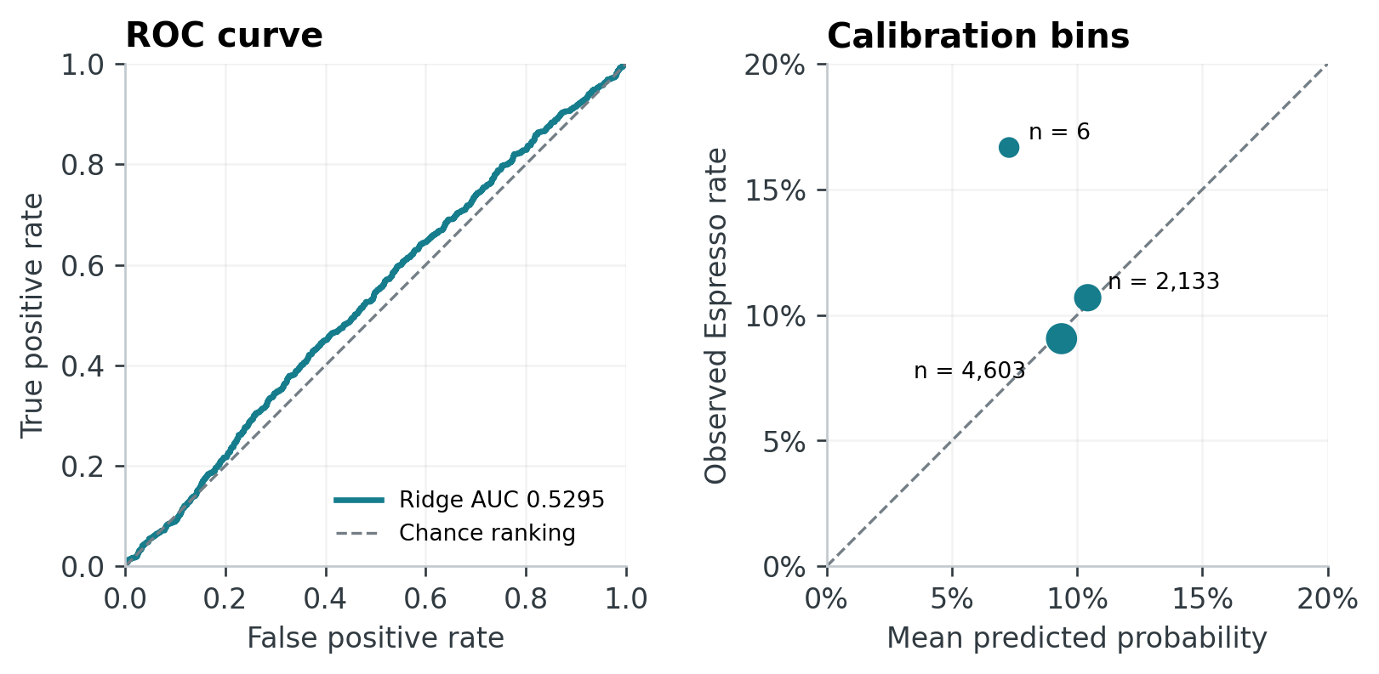
Figure 3 Ridge ranking and calibration on March orders. Source: project analysis outputs.
The three nonempty calibration bins contain 6, 4,603 and 2,133 orders. Their mean predicted and observed rates are respectively 7.28% and 16.67%, 9.38% and 9.06%, and 10.42% and 10.69%. The first bin contains just one Espresso order and is too sparse for a reliable calibration judgment. The larger bins show reasonable agreement within a narrow probability range, but this does not establish fine-grained or subgroup calibration. Tied scores were kept together in fixed-width bins.

Uncertainty and threshold interpretation
Five hundred day-cluster bootstrap resamples give a conditional 95% AUC interval of 0.5063–0.5532 for Ridge. The Brier improvement over baseline is 0.0000612, with interval −0.000033 to 0.000151. The latter includes zero. Resampling preserves dependence within each March day but not every dependence across days or recurring customers. These intervals hold fitted models fixed and exclude uncertainty from model development and selection.
At threshold 0.50, every model predicts no Espresso. The confusion counts are 0 true positives, 0 false positives, 6,096 true negatives and 646 false negatives. Accuracy is 90.42%, recall is zero, specificity is one and balanced accuracy is 0.50. Precision is undefined because there are no positive predictions. A 0.50 threshold is an illustration, not a recommended operating rule. Any later action threshold should be chosen using costs and benefits on development data, then validated separately.

Assumptions and model recommendation
Key assumptions are reliable target recording, comparable future ordering conditions, availability of outlet/time at prediction, an adequate additive log-odds structure and training coverage of relevant categories. No continuous predictor normality assumption is required. Broad time bands, omitted prices and stock availability, limited history and uncertain customer dependence constrain interpretation. The model assesses purchases among placed orders and is not a causal or visitor-conversion model.
Ridge is the preferred model among the fitted multivariable candidates because it won the predefined validation comparison and modestly improved March probability scores. For current organizational monitoring, however, the constant rate is the preferred operational reference because the additional improvement is small and uncertain. Ridge should be evaluated alongside it in a limited prospective pilot before any consequential use.
The saved example for Location 30 on 1 April 2026 at 10:00 gives a probability of 8.61%. This means an expected 8.61 Espresso-containing orders per 100 similar placed orders under the model, not 8.61 cups, an individual customer's certainty of purchase or a promotional increase. It is a model illustration, not an observed April result.

Task 6 Critical evaluation of experimental design

Why an experiment could improve the investigation
The observational model estimates purchase propensity. It cannot establish whether a menu prompt, display or offer increases Espresso purchasing. A future randomized experiment could answer that causal question. No experiment was conducted in this project. The proposals below adapt controlled experimentation principles to a physical retail setting (Kohavi et al., 2009; Larsen et al., 2024).
One feasible intervention is a standardized Espresso menu prompt, compared with the current menu presentation. Its wording, price and staff instructions should be fixed before the study. Randomization should occur before exposure. The primary outcome could be an Espresso purchase per eligible exposed ordering session, counting sessions with no purchase as zero. This differs from the current target conditional on a completed order and requires an exposure denominator. Completion rate, total contribution margin and service delay should be guardrails, because an increased Espresso share can coexist with lower total value.

Comparing CRD and RCBD
Design | Proposed allocation | Advantage | Main limitation
Completely Randomized Design | Randomly allocate eligible outlet-days across the network to prompt or control | Simple allocation and implementation when outlets are sufficiently comparable | Chance imbalance in outlet size, weekday and customer mix may reduce precision
Randomized Complete Block Design | Form pairs of comparable outlet-days within the same outlet and weekday over nearby weeks; randomly allocate one day to each condition within every pair | Both conditions occur in each complete block, reducing variation associated with known context | Matching, scheduling and carryover control are more demanding; calendar trends may remain

CRD is practical for a small operational pilot when management can apply the assigned display consistently. However, the 80-outlet structure and uneven volumes make imbalance plausible. Randomizing individual customers could be statistically efficient, but shared menus and staff behaviour can contaminate conditions, and customer recognition is incomplete.
RCBD is more attractive when outlet and weekday can be used to form sensible complete blocks. Pairing two Mondays at the same outlet, for example, ensures one prompt day and one control day in that block. Random allocation of condition order across blocks helps prevent the prompt always occurring later. Holidays, stockouts and local events should be identified before matching. A block with only one available condition is no longer complete and requires a documented handling rule.

Feasibility and analysis
Outlet-day allocation means the number of independent experimental units is the number of allocated outlet-days, not the number of individual orders. Repeated days within an outlet and repeat visitors create additional dependence. A binomial analysis with treatment and block effects, and uncertainty consistent with the allocation and outlet structure, would be appropriate. Report intention-to-treat effects according to assignment even when implementation is imperfect, together with compliance and exposure audits.
Sample size should be planned from a management-defined minimum worthwhile improvement, approximately 9.7% baseline purchase frequency as an initial reference, cluster sizes and an estimated intracluster correlation. Do not calculate power as though all orders were independent. Predefine the duration, primary outcome, missing-exposure rules and stopping procedure. Log stock availability and avoid overlapping offers. The main practical costs are staff training, reliable exposure logging and keeping treatment consistent across shifts.
RCBD is the provisional preference if suitable pairs can be formed without disrupting operations. An expert must confirm whether display changes persist, whether washout periods are needed and whether the necessary exposure and margin data can be collected. Randomization can support causal interpretation; it cannot repair poor implementation or an outcome denominator that changes unnoticed.

Task 7 Critical evaluation of PCA
PCA is not recommended for the current prediction specification. Although dummy encoding creates 88 predictor columns, these represent only three categorical concepts: outlet, weekday and time band. The development sample is much larger than the number of columns, and the fitted unpenalized design is full rank. There is no demonstrated computational need to compress these variables.
PCA identifies orthogonal directions that retain predictor variance; it does not use the Espresso outcome when choosing those directions (Jolliffe & Cadima, 2016). Applying it to outlet indicators could prioritize common outlets and trading patterns while discarding a small but predictive contrast. Standardizing rare indicators can also give unusual groups disproportionate influence. The resulting components would mix outlet and time information, making managerial interpretation less direct.
Potential advantages would arise if future data contained many correlated numerical measurements, such as weather variables, equipment readings or multiple service-time measures. PCA could then reduce collinearity and storage or modelling burden. Even in that setting, variance explained would not establish predictive value; the number of retained components would need to be selected within chronological training folds and compared using future probability performance.
Ridge already offers a direct response to coefficient instability without replacing the original predictors with difficult-to-explain components. It cannot guarantee interpretability for every coefficient, but retains the variable definitions. PCA should therefore be considered only after data expansion establishes a real redundancy problem. It should not be used merely because it appears in the assignment, and no PCA performance claim is made in this report.

Task 8 Critical evaluation of Bayesian methods

Naive Bayes
Naïve Bayes could estimate class probabilities from categorical outlet, weekday and time band frequencies. It is inexpensive to fit and can be a useful benchmark when data are limited. Smoothing would be needed to avoid zero estimated probabilities in rare category–outcome combinations. Hand and Yu (2001) explain why simple Bayes classification can perform well despite restrictive assumptions; that is a reason to test it, not to assume it will outperform regression here.
The conditional independence assumption is questionable because outlet activity and order time may be related even within an Espresso outcome class. Dependent predictors can result in overconfident probabilities. Validation should therefore compare log loss, Brier score and calibration, not just accuracy. It may be competitive where the conditional distributions are stable and interactions are weak, but the present data provide no empirical Naïve Bayes result.

Bayesian regression
A Bayesian logistic model would retain the binary likelihood and place priors on coefficients. Gelman et al. (2008) show how weakly informative priors can stabilize logistic estimation, especially with separation. A future extension could use hierarchical outlet effects so that small outlets borrow information from the network while larger outlets retain more data-driven estimates. That hierarchical specification is a proposal for this case, not a model fitted in the reported analysis.
This approach is attractive for sparsely observed or newly opened outlets and for communicating posterior uncertainty in predictions. It may outperform an unpenalized model when partial pooling appropriately represents outlet similarity. Its limitations include prior sensitivity, computational and diagnostic work, and the risk that inappropriate pooling hides meaningful outlet differences. Prior predictive checks, alternative prior scales, posterior predictive checks and chronological validation would be required. Priors cannot establish authenticity or restore missing predictors.

Bayesian decision making
Bayesian decision making compares available actions by their expected consequences under posterior uncertainty. Suzuki (2022) demonstrates the importance of making loss assumptions explicit for binary outcomes. In this case, a manager could compare a standardized prompt with business as usual using estimated incremental Espresso margin, substitution losses, offer cost and service effects. Those quantities must be agreed with the organization and measured; they are not available in the current results.
For a promotion, high purchase probability is insufficient: customers likely to buy anyway may receive a discount without increasing purchases. The relevant decision needs the causal difference between purchase under the offer and without it, ideally from the proposed randomized study. A posterior probability of a positive effect also differs from positive expected net value. Decisions should reflect both uncertainty and the costs of each action.
Bayesian methods may be especially useful when sequential information arrives, outlets are sparse or well-supported prior information exists. They are not automatically superior to frequentist methods. The current recommendation is to consider hierarchical Bayesian regression and decision analysis in a future study, while retaining the validated baseline and Ridge comparison for this project.

Task 9 Potential use of time series analysis
The current extract has dates, but only 90 days of history. Its monthly and daily plots are descriptive; no ARIMA or other time series forecasting model was fitted. A separate forecasting study could become useful after collecting a longer, consistently defined history, preferably spanning multiple annual cycles where annual seasonality is a business concern.

Trends and seasonality
Daily order counts, daily Espresso-containing orders, and Espresso units are different time series. The first measures traffic among purchasers, the second combines traffic with product mix, and the third adds quantities within orders. A forecasting project must select its target before modelling. Counts should be linked to opening hours, closures, stockouts, menu changes and promotions. A missing recording day must not silently become a zero-demand day.
Trend analysis could investigate gradual changes in traffic or Espresso share. Day-of-week and within-day seasonality may be relevant to staffing and preparation. Holiday and annual effects require much longer coverage than three months. For purchase share, varying daily order totals matter: a rate based on ten orders is less precise than one based on one thousand. A binomial time model can represent that denominator more naturally than an unweighted model of percentages.

Forecasting and ARIMA
An ARIMA model represents dependence through past observations and forecast errors after any necessary differencing. Seasonal ARIMA can add a weekly pattern to a daily series. With suitable data, an analyst would examine stationarity, autocorrelation, residual dependence and forecast uncertainty, then compare candidate models using rolling forecast origins. A seasonal naïve forecast should be included as a benchmark. Count forecasts also require attention to nonnegative values, zeros and variable exposure.
ARIMA with external predictors could incorporate known opening hours, planned offers or calendar effects. Predictors must be available at the forecast date; future realized weather or sales cannot be used as though already known. Short, noisy outlet series may benefit from pooling or hierarchical forecasts, with forecasts reconciled between outlet and network totals.
Eglite and Birzniece (2022) review deep learning forecasting methods, while Makridakis et al. (2022) provide large-scale comparative evidence from retail series. Their relevance is the need to compare methods and targets carefully. They do not justify starting with a neural network on this small temporal extract or assuming that a competition winner transfers to coffee shop demand.

Organizational use and limits
Validated volume forecasts could inform staffing, ingredient purchasing and equipment preparation. A useful extension would combine a separately evaluated order-volume forecast with purchase-mix estimates. This would still estimate Espresso-containing orders; cup and ingredient requirements additionally depend on quantities and recipes. Benefits should be measured through service and waste outcomes against existing planning, rather than claimed from forecast accuracy alone.
The priorities are longer history, documented closures and stock availability, a stable product dictionary and explicit forecast horizons. Forecast error, interval coverage and business cost should be monitored over time. The present project supports this proposal but supplies no implemented forecasting result.

Task 10 Industry innovation proposal

Espresso purchase mix monitoring dashboard
We propose one decision support dashboard that joins purchase mix measurement, model comparison and manager feedback. The business need is a consistent way to distinguish a changing Espresso share from changes in total orders, while preventing weak model differences from being mistaken for actionable certainty.
The dashboard would display order counts, Espresso-containing orders, observed rates and uncertainty by outlet and time. A baseline probability would be the default reference, with Ridge displayed as a research estimate where data coverage is adequate. The interface would show the last validated period, record counts and new-outlet fallback status. It would avoid presenting a 0.50 binary classification as an operational recommendation.

Conceptual framework
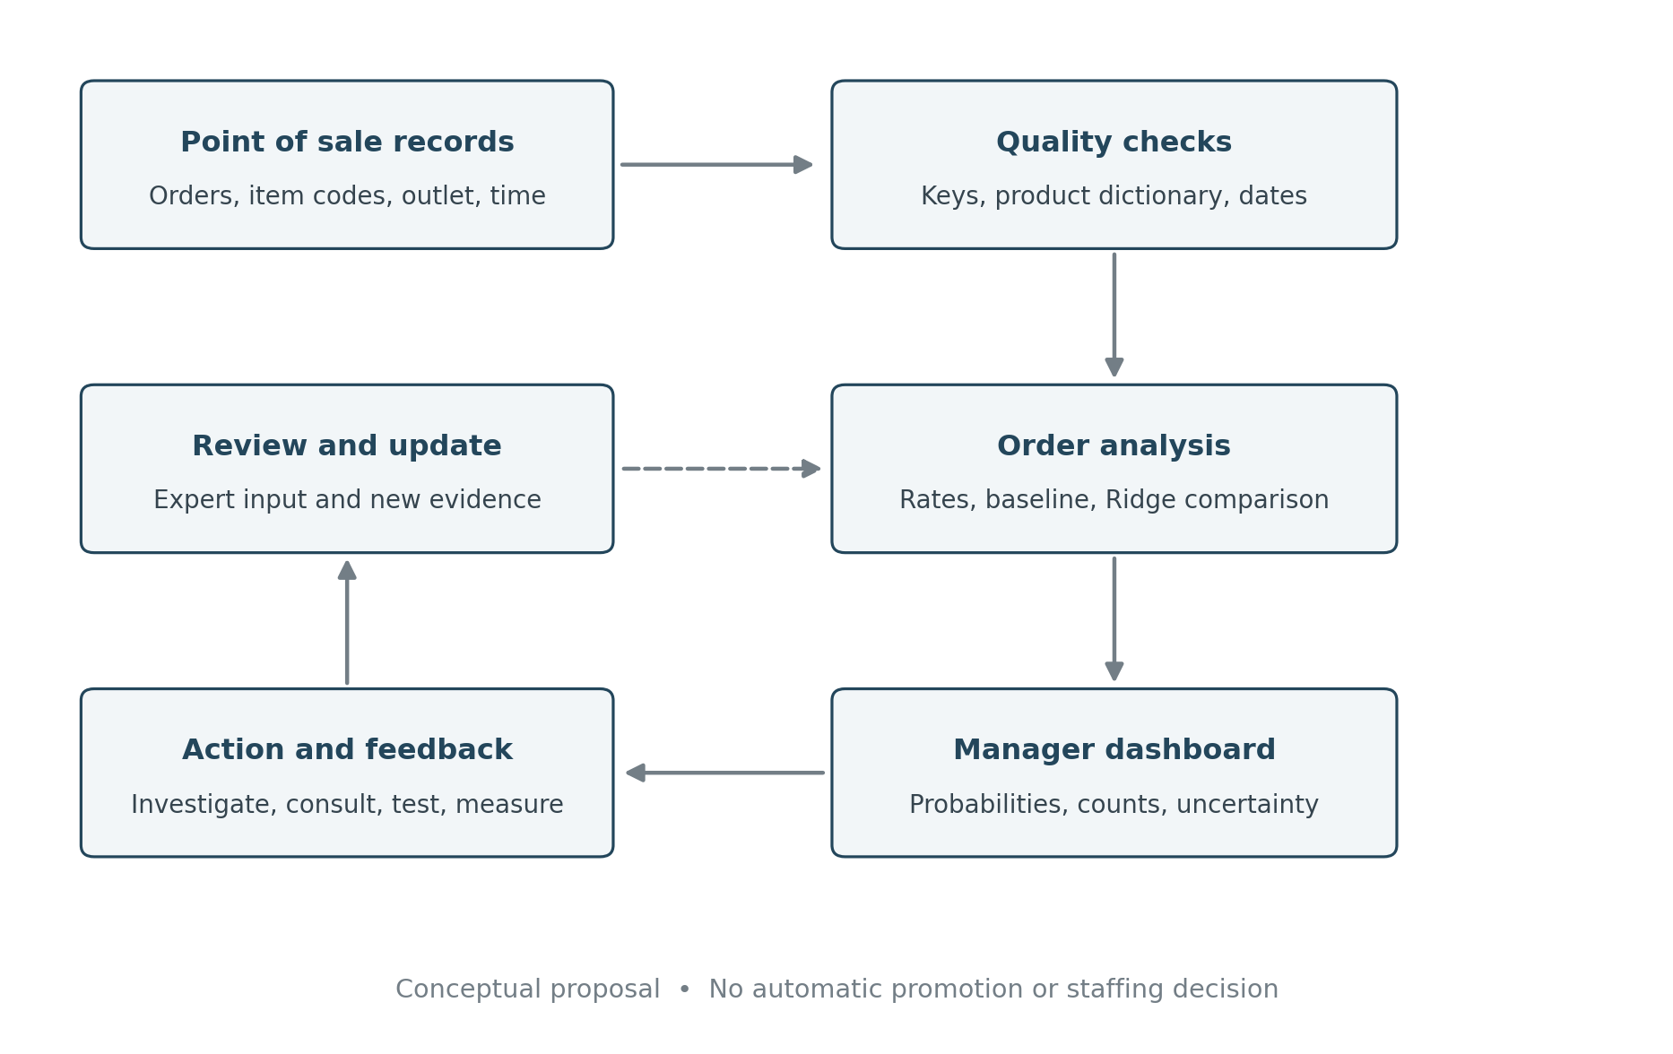
Figure 4 Conceptual framework for the proposed monitoring dashboard. Proposed design.
Point of sale records enter a quality check that validates order keys, dates and item codes. Valid records produce the order outcome and permitted pre-purchase features. The analysis compares observed rates, the baseline and candidate models using chronological evidence. A manager sees probabilities with their scope and uncertainty, records an investigation or decision, and later reviews the measured outcome. Expert feedback and future controlled trials inform revisions. Failed data checks are resolved before the next refresh.

Expected benefits and decision boundaries
The immediate benefit is consistent reporting and traceable decisions, rather than a proven sales increase. Managers could investigate unusual mix changes alongside stock availability and data quality. A prospective pilot could determine whether Ridge adds useful information beyond the baseline. The dashboard should support a human decision and show when evidence is weak; it should not automatically allocate staff, penalize outlets or issue personalized discounts.
The model's expected number of Espresso-containing orders can be obtained by adding probabilities across a defined set of future placed-order scenarios. The dashboard must not label this as an unconditional demand forecast. Order arrivals, multiple cups per order and recipe requirements need separate inputs and validation. Financial savings or revenue uplift would be measured during implementation, not inserted as assumed project outcomes.

Implementation resources and challenges
Required resources are a point of sale data owner, a reproducible analysis process, a secure reporting environment, a manager responsible for interpreting results and an analyst responsible for validation. Existing R outputs can support a prototype. Software development is not required for this assignment, and the conceptual proposal is not represented as a deployed service.
Stage | Deliverable | Gate before proceeding
Establish data trust | Verified source, item dictionary and timestamp definitions | Provenance, access and data quality accepted
Prototype measurement | Dashboard of counts, rates and baseline | Outlet manager confirms definitions and usefulness
Prospective pilot | Baseline and Ridge predictions on a new period | Acceptable probability performance and a practical benefit are demonstrated
Controlled improvement | Preplanned prompt experiment and outcome review | Exposure, margin, service and allocation data are reliable

Integration challenges include inconsistent product coding, timing differences between checkout and order initiation, sparse outlet groups, delayed data and the effort of maintaining the model. Store only necessary fields, restrict access and log model versions. Monitor calibration and input coverage as well as rank performance. If data checks fail or a category is new, flag the limitation and use the documented baseline fallback instead of displaying a misleading personalized estimate.
The expected organizational impact is a shared evidence base for managers, marketing and analysts. Whether it improves decisions depends on expert validation and a measured pilot. Adoption should proceed only when those activities establish value proportionate to maintenance costs.

Task 11 Industry expert validation

Consultation status
No completed interview, meeting record, email response or expert feedback form has been provided for this project. Consequently, Task 11 is not yet complete. There is no basis for naming an expert, attributing an opinion or claiming that feedback changed a recommendation. The protocol below is ready for the group to use in a real consultation; it is not evidence that one occurred.
An appropriate expert is a coffee shop owner, outlet manager, operations manager or retail analyst with direct knowledge of ordering, product availability and store decisions. Record the person's relevant experience, role and the consultation date, with permission to use their feedback for the assignment. Brackmann et al. (2023) demonstrate the value of combining retail literature with expert input, but their interviews cannot substitute for this group's consultation.

Evidence to present and questions to ask
Present a short summary of the 9.66% overall Espresso share, the weak Ridge ranking, the inconclusive adjusted time-band result and the dashboard concept. Explain the distinction between Espresso-containing orders and cups, and between propensity and promotional uplift. Give the expert the results before asking whether the recommendations are useful.
Required feedback area | Consultation question | Record required
Problem relevance | Which actual decisions would an Espresso purchase probability improve, and at what prediction moment? | Specific decision, frequency and responsible role
Practicality | Would a baseline near 9.7% be useful, and what improvement would justify a more complex model? | Minimum useful improvement and examples
Feasibility | Can item codes, exposure logs, stockouts and timestamps be reliably collected? | Operational constraints and required changes
Organizational impact | What effects on margin, service, staff workload and customers must be measured? | Benefits, risks and acceptable guardrails
Recommendation revision | Which recommendation should be accepted, changed or rejected, and why? | Actual feedback linked to a documented revision

Obtain consent for notes or recording, avoid collecting unnecessary personal information, and send the summary to the expert for factual confirmation where feasible. Evidence may be meeting minutes, an interview summary, a completed feedback form or an email exchange. Redact private contact details from submission copies when they are unnecessary.

Incorporating feedback
Appendix B provides a consultation record and revision log. Each final recommendation must link to a real feedback statement, the relevant statistical result and a research source. If the expert disagrees with a statistically supported interpretation, document the reason and distinguish operational judgment from empirical evidence. Expert opinion should refine feasibility and priorities, not replace missing causal evidence or override the reported uncertainty without explanation.
After consultation, revise Task 12 and state exactly what changed. Until then, the recommendations are provisional and cannot satisfy the assignment's requirement for three-way support from statistics, literature and expert feedback.

Task 12 Consultancy recommendations
The recommendations below are grounded in the results and research. They remain provisional until a relevant industry expert has reviewed them and the feedback is incorporated. The evidence register identifies the specific missing third source of support for each recommendation.

Strategic recommendation
Prioritize dependable purchase mix reporting and prospective validation over immediate predictive targeting. Ridge won the validation comparison, but its March AUC of 0.5295 and small Brier improvement do not establish a strong operational advantage. Retain the baseline as the current management reference and compare Ridge during a future pilot. This follows the distinction between probability quality and decision value discussed by Gneiting et al. (2007) and Van Calster et al. (2019). Ask the expert what improvement would justify implementation and ongoing monitoring costs.

Operational recommendation
Create a controlled product dictionary and verify order timestamps before implementing the dashboard. Inconsistent product categories make outcome construction fragile, while the absence of required-input missingness shows that a compact outlet/time reporting workflow is feasible in this extract. Use counts alongside proportions so that Morning's greater Espresso volume is not confused with a clearly greater purchase propensity. Brackmann et al. (2023) support evaluating operational fit alongside analytical capability. The expert must confirm the product definitions, refresh frequency and person responsible for correcting failed checks.

Risk management recommendation
Require an untouched prospective period before allowing the model to influence consequential decisions. Monitor calibration, coverage and baseline-relative performance; document the fallback for new outlets. The Brier improvement interval includes zero, and March was previously explored. Penalization research supports shrinkage as a modelling option, but does not remove the need for validation (Friedman et al., 2010; Tay et al., 2023). Obtain expert agreement on the action limits, review schedule and conditions for reverting to the baseline.

Ethical recommendation
Keep direct identifiers and unnecessary demographic fields outside the model and shared dashboard. Do not treat low outlet probabilities as staff performance scores or as evidence about individual customers. Loyalty identifiers are missing on 62.72% of item rows, and the model estimates an order outcome rather than a person's preference. Fader et al. (2005) illustrate how customer-base questions require a different data structure, while Gooljar et al. (2024) show that richer purchase signals involve additional information. For this project, collect new personal data only for a defined, reviewed purpose. Ask the expert to confirm access responsibilities and acceptable customer uses.

Future research recommendation
Investigate causal offer effects through the proposed blocked trial and collect longer histories with stock availability and actual pre-purchase offer exposure. The adjusted time-band p-value of 0.8111 does not justify a targeted promotion, and 90 days cannot establish annual seasonality. Experimental literature supports planned randomization, while retail forecasting research motivates separate volume forecasts using suitable histories (Larsen et al., 2024; Eglite & Birzniece, 2022; Makridakis et al., 2022). The expert should select the worthwhile intervention, feasible allocation unit and relevant commercial outcomes.

Recommendation evidence register
Recommendation | Statistical support | Literature support | Expert support required
Baseline first and prospective Ridge pilot | AUC 0.5295; Brier gain 0.0000612 | Gneiting et al.; Van Calster et al. | Confirm decision need and minimum worthwhile gain
Product and time data repair | Inconsistent categories; complete chosen inputs | Brackmann et al. | Confirm definitions, data owner and refresh needs
Validation and operating limits | Brier interval crosses zero; retrospective assessment | Friedman et al.; Tay et al. | Agree review and fallback conditions
Minimal personal data and appropriate use | 62.72% item-row loyalty missingness; order target | Fader et al.; Gooljar et al. | Confirm access and permissible customer use
Experiment and longer history | Adjusted p = 0.8111; only 90 observed days | Larsen et al.; Eglite and Birzniece; Makridakis et al. | Confirm treatment, allocation and business outcomes

Management should first establish trustworthy measurement, then assess whether any model-supported action improves an agreed outcome. No quantified return on investment is claimed because intervention effects, costs and expert judgments are not yet available.

References
The following 18 journal publications form the research review. Eight were published in 2022–2024, within the specified five-year window. The software and project material acknowledgements following the list are additional and are not counted toward the literature minimum.
Brackmann, C., Hütsch, M., & Wulfert, T. (2023). Identifying application areas for machine learning in the retail sector. SN Computer Science, 4, Article 426. https://doi.org/10.1007/s42979-023-01888-w
Chen, S., Xu, Z., Xu, D., & Gou, X. (2024). Customer purchase prediction in B2C e-business: A systematic review and future research agenda. Expert Systems with Applications, 252, Article 124261. https://doi.org/10.1016/j.eswa.2024.124261
Eglite, L., & Birzniece, I. (2022). Retail sales forecasting using deep learning: Systematic literature review. Complex Systems Informatics and Modeling Quarterly, 30, 53–62. https://doi.org/10.7250/csimq.2022-30.03
Fader, P. S., Hardie, B. G. S., & Lee, K. L. (2005). “Counting your customers” the easy way: An alternative to the Pareto/NBD model. Marketing Science, 24(2), 275–284. https://doi.org/10.1287/mksc.1040.0098
Friedman, J., Hastie, T., & Tibshirani, R. (2010). Regularization paths for generalized linear models via coordinate descent. Journal of Statistical Software, 33(1), 1–22. https://doi.org/10.18637/jss.v033.i01
Gelman, A., Jakulin, A., Pittau, M. G., & Su, Y.-S. (2008). A weakly informative default prior distribution for logistic and other regression models. The Annals of Applied Statistics, 2(4), 1360–1383. https://doi.org/10.1214/08-AOAS191
Gneiting, T., Balabdaoui, F., & Raftery, A. E. (2007). Probabilistic forecasts, calibration and sharpness. Journal of the Royal Statistical Society Series B, 69(2), 243–268. https://doi.org/10.1111/j.1467-9868.2007.00587.x
Gooljar, V., Issa, T., Hardin-Ramanan, S., & Abu-Salih, B. (2024). Sentiment-based predictive models for online purchases in the era of marketing 5.0: A systematic review. Journal of Big Data, 11, Article 107. https://doi.org/10.1186/s40537-024-00947-0
Hand, D. J., & Yu, K. (2001). Idiot's Bayes—Not so stupid after all? International Statistical Review, 69(3), 385–398. https://doi.org/10.1111/j.1751-5823.2001.tb00465.x
Jolliffe, I. T., & Cadima, J. (2016). Principal component analysis: A review and recent developments. Philosophical Transactions of the Royal Society A, 374(2065), Article 20150202. https://doi.org/10.1098/rsta.2015.0202
Kohavi, R., Longbotham, R., Sommerfield, D., & Henne, R. M. (2009). Controlled experiments on the web: Survey and practical guide. Data Mining and Knowledge Discovery, 18, 140–181. https://doi.org/10.1007/s10618-008-0114-1
Larsen, N., Stallrich, J., Sengupta, S., Deng, A., Kohavi, R., & Stevens, N. T. (2024). Statistical challenges in online controlled experiments: A review of A/B testing methodology. The American Statistician, 78(2), 135–149. https://doi.org/10.1080/00031305.2023.2257237
Makridakis, S., Spiliotis, E., & Assimakopoulos, V. (2022). M5 accuracy competition: Results, findings, and conclusions. International Journal of Forecasting, 38(4), 1346–1364. https://doi.org/10.1016/j.ijforecast.2021.11.013
Saito, T., & Rehmsmeier, M. (2015). The precision-recall plot is more informative than the ROC plot when evaluating binary classifiers on imbalanced datasets. PLOS ONE, 10(3), Article e0118432. https://doi.org/10.1371/journal.pone.0118432
Suzuki, A. (2022). Policy implications of statistical estimates: A general Bayesian decision-theoretic model for binary outcomes. Statistics and Public Policy, 9(1), 85–96. https://doi.org/10.1080/2330443X.2022.2050328
Tay, J. K., Narasimhan, B., & Hastie, T. (2023). Elastic net regularization paths for all generalized linear models. Journal of Statistical Software, 106(1), 1–31. https://doi.org/10.18637/jss.v106.i01
Van Calster, B., McLernon, D. J., van Smeden, M., Wynants, L., & Steyerberg, E. W., on behalf of the STRATOS initiative. (2019). Calibration: The Achilles heel of predictive analytics. BMC Medicine, 17, Article 230. https://doi.org/10.1186/s12916-019-1466-7
Zeileis, A., Köll, S., & Graham, N. (2020). Various versatile variances: An object-oriented implementation of clustered covariances in R. Journal of Statistical Software, 95(1), 1–36. https://doi.org/10.18637/jss.v095.i01

