UKSO---Round 3---1AC

OFF

1AC

INTERPRETATION: Debaters must include all relevant author qualifications in the cites of all evidence read in round and disclosed to the extent provided, or denote the absence of author quals. (to clarify, author quals = education, awards, positions, etc).
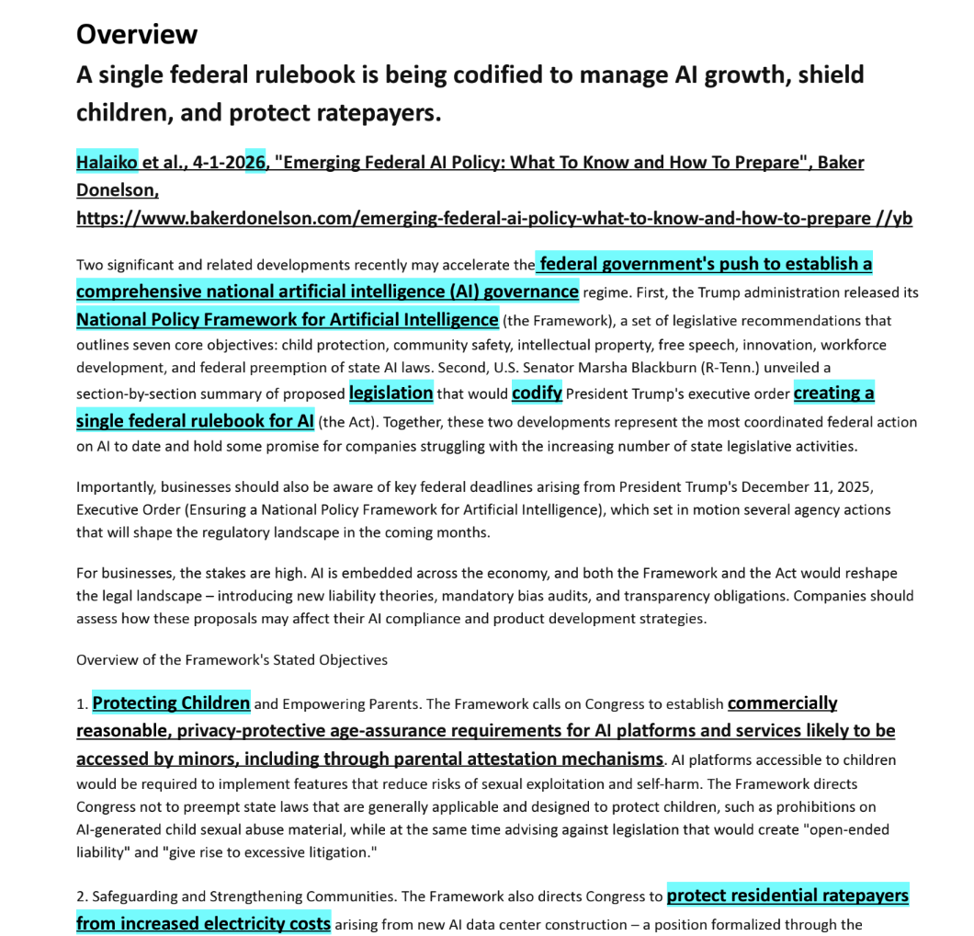
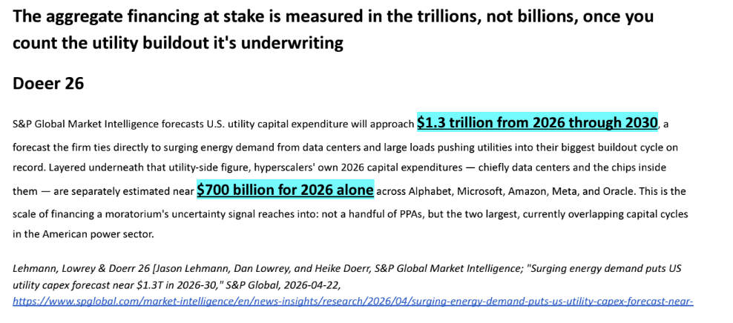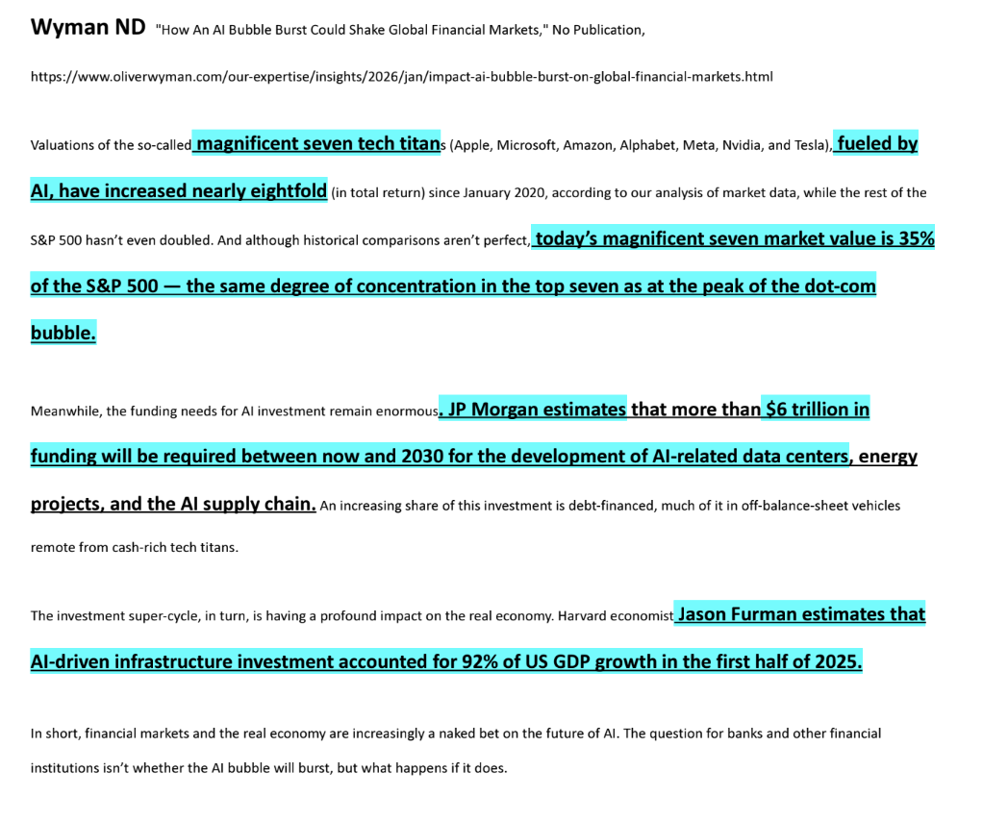
https://opencaselist.com/hspf26/MissionSanJose/BhPa
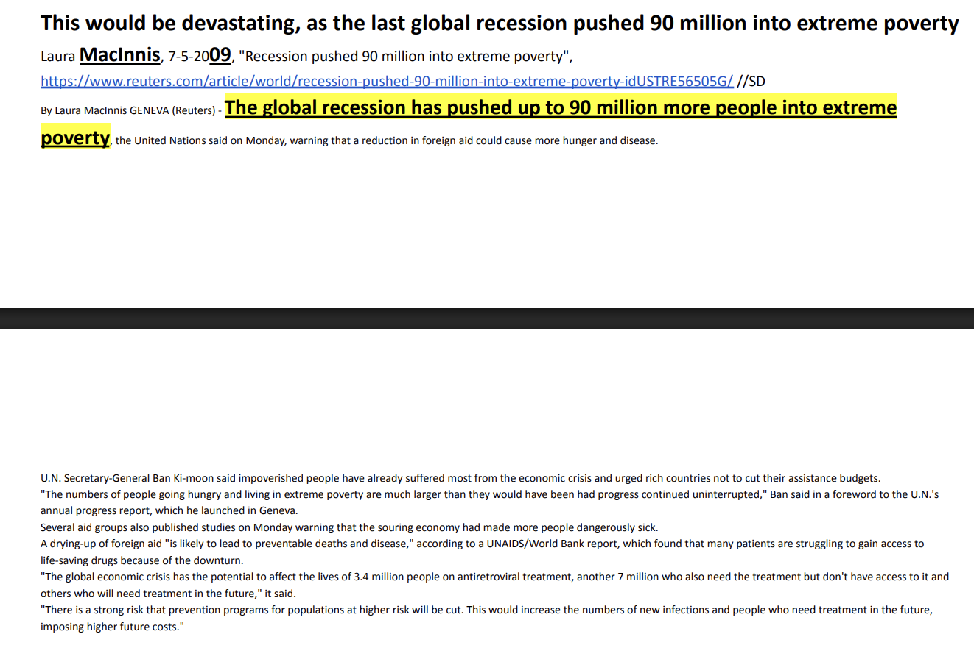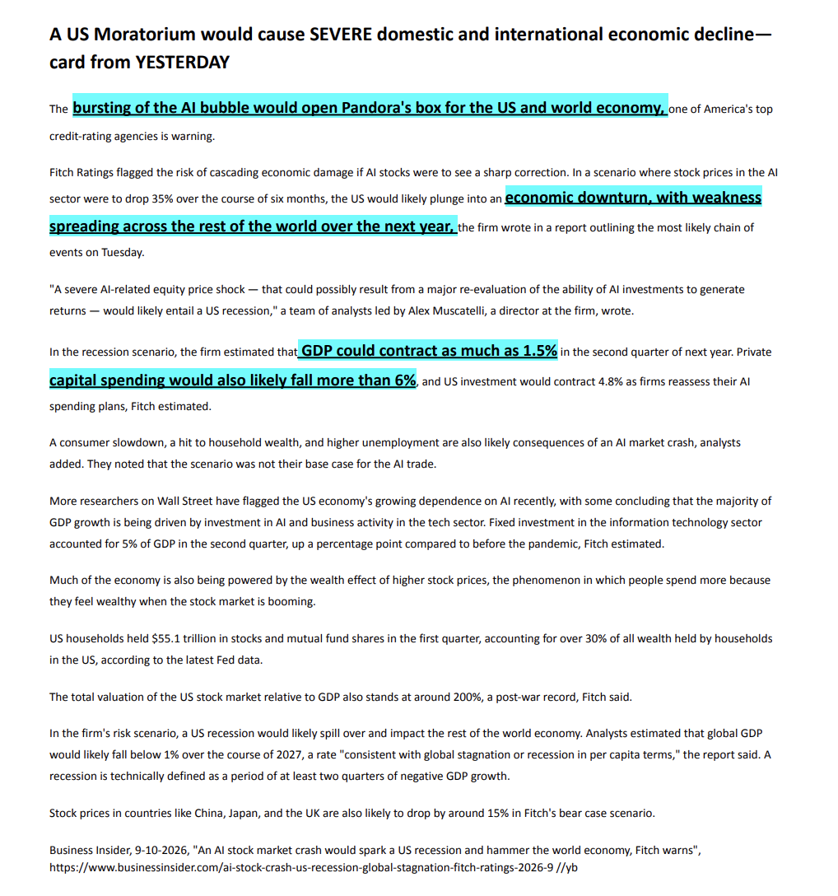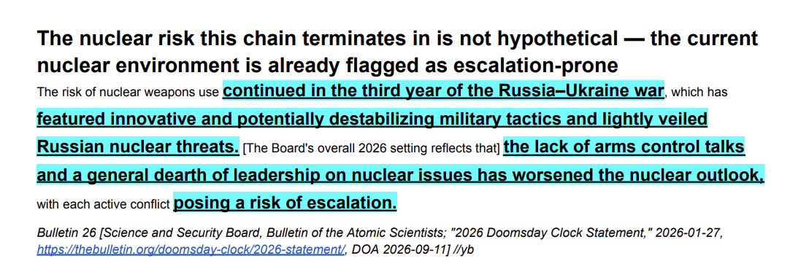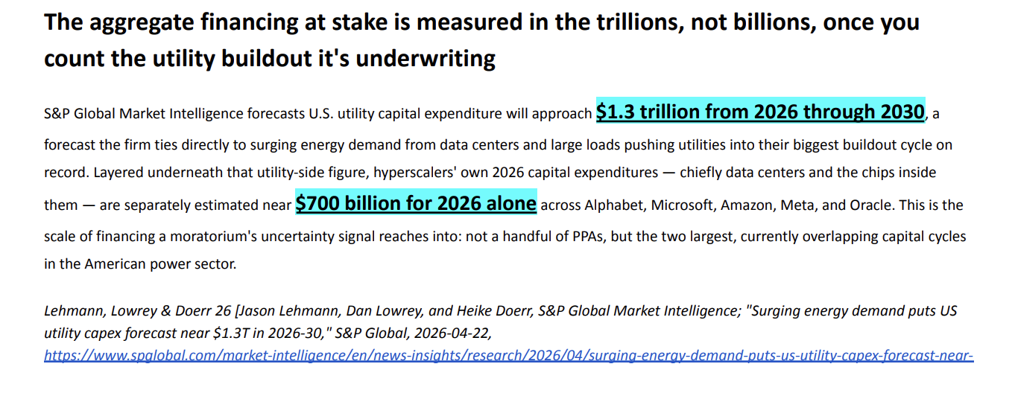

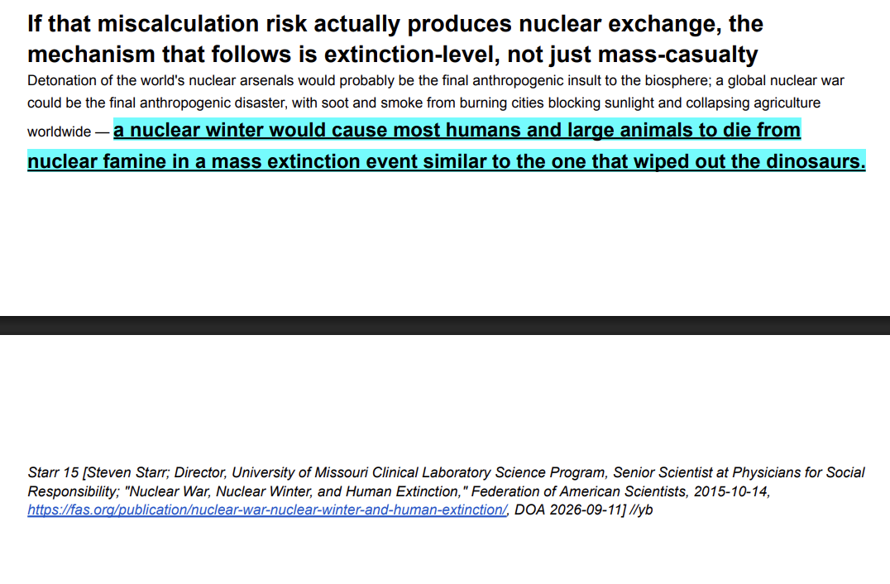

Standard evidence rules in the NSDA manual say that the written cite must include qualifications.
NSDA 23 (National Speech and Debate Association, 10-15-2023, [NSDA is the leading governing body of high school debate; manual authors are high-ranking diamond coaches and/or NSDA administrators, no specific author quals], “High School Unified Manual,” Pg. 30, DOA: 11/27/2023. https://www.speechanddebate.org/wp-content/uploads/High-School-Unified-Manual-2023-10-19.pdf)
Oral source citation. In all debate events, contestants are expected to, at a minimum, orally deliver the following when introducing evidence in a debate round: primary author(s)'name (last) and year of publication. Any other information such as source, author's qualifications, etc., may be given, but is not required. Should two or more quotations be used from the same source, the author and year must be given orally only for the first piece of evidence from that source. Subsequently, only the author's name is required. Oral citations do not substitute for the written source citation. The full written citation must be provided if requested by an opponent or judge. Written source citation. To the extent provided by the original source, a written source citation must include: Full name of primary author and/or editor Publication date ﻿﻿﻿Source ﻿﻿﻿Title of article Date accessed for digital evidence ﻿﻿﻿Full URL, if applicable ﻿﻿﻿Author qualifications ﻿﻿﻿Page number(s)

1AC

INTERPRETATION: The 1AC must specify the duration of the fiated moratorium.

A moratorium is...
2: a suspension of activity
That’s Merriam-Webster. The most authoritative English Dictionary. “Definition of MORATORIUM”. Merriam-Webster. xx-xx-xxxx. https://www.merriam-webster.com/dictionary/moratorium. accessed 7-12-2026. jerry

Case

Turn---1AC
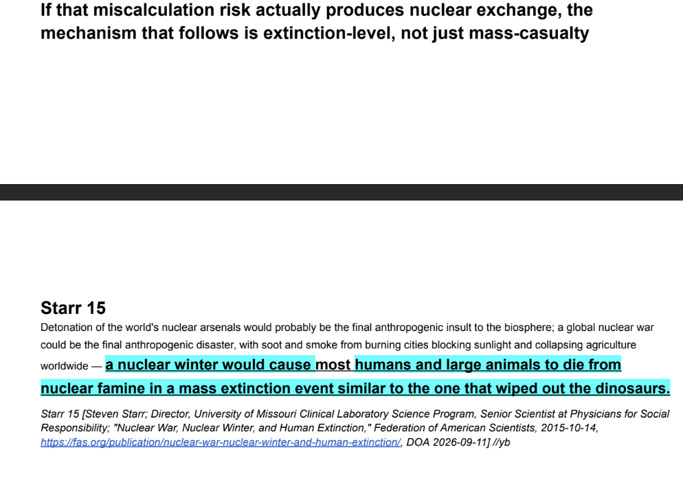

1. Current AND future trends ensure animal suffering.
Horta ’24 [Oscar and Mat Rozas; November 16; Professor in the Department of Philosophy and Anthropology at the University of Santiago de Compostela; Doctoral Student at Syracuse University, Department of Philosophy; World Futures: The Journal of New Paradigm Research, “Animals and Longtermism,” pp. 85-95, https://philarchive.org/archive/HORAAL-3]
HARM INFLICTED ON ANIMALS OUT OF DISREGARD FOR THEIR INTERESTS
To examine potential risks of negative future scenarios for animals, we begin by considering the harm that humans cause to nonhuman animals not out of malevolence but out of disregard for the latter’s interests. This is what occurs when animals are used as resources today. Doing so is simply convenient for humans, despite the fact that harm inflicted on nonhuman animals as a result is very significant. According to estimates, over eighty billion land vertebrates, two trillion aquatic vertebrates, and up to several tens of trillions of sentient invertebrates are killed annually for this purpose (Fishcount, 2010; Rowe, 2020; Šimčikas, 2020; Waldhorn & Autric, 2023). In slaughterhouses and fisheries, animals are not only killed but also suffer immensely. In factory farms, they suffer substantially for most of their lives (Singer, 1975/2023; Horta, 2022). Therefore, it can be concluded that the current state of affairs is very negative for them. However, there are two ways in which it could become even worse in the future. First, more animals may be harmed; second, the harm may become qualitatively worse. Below, we examine how this could happen.
Increasing the Number of Animals Harmed Because of Human Use
In the future, more animals may be harmed by humans than in the present both synchronically and especially diachronically.
Synchronic Expansión
Suppose that humans keep using animals in the same ways that they do now. This may mean that the number of exploited animals at any given time may increase substantially. This could happen, for instance, if the global human population grows without the per capita demand for animal products diminishing. Alternatively, the per capita consumption of animal products might rise (Alexandratos & Bruinsma, 2012; United Nations, Department of Economic & Social Affairs, Population Division, 2022). Both changes have occurred in recent decades despite the steady increase in the number of vegans and in their proportion to the total human population (Vegan Society, 2023).
The number of animals that are exploited may also increase if the use of smaller animals becomes more widespread. This is currently happening owing to the growth of the invertebrate farming and fishing industries, which might increase more dramatically in future decades.
Diachronic Expansión
The vast duration of the long-term future means that the cumulative harm inflicted on animals could ultimately be immense (Animal Ethics, 2020; Baumann, 2022). As time passes, more animals can be exploited, eventually exceeding by several orders of magnitude the number who will suffer and die in the near future. This could occur even if the number of animals harmed and killed at any given time is reduced and regardless of whether the injuries inflicted become less significant than they currently are.
Creating Worse Forms of Harm
In addition to changing quantitatively, animal exploitation can be expected to change qualitatively. Technology might open up the possibility of creating new methods of exploiting animals, which we may be unable to imagine today. This may cause more suffering per animal exploited and thus more suffering overall in several possible ways. We examine these next.
Worsening the Harm Inflicted on Animals Without Altering Their Genomes
Animals who are currently used as resources may continue to be employed in the same ways. Furthermore, others who are currently not utilized for food and clothing production may begin to be used in ways that we may not foresee today. Nonetheless, it is reasonable to expect that methods of this kind will be developed, as this has happened in the past. These methods could be widely used because they are profitable for humans. Again, we are already witnessing this with the development of invertebrate industrial farming, which was preceded by fish and land based industrial farming, and with the use of artificial intelligence to make animal exploitation more profitable (Singer and Tse, 2023). The evolution of animal exploitation since the midtwentieth century indicates that the use of animals as resources may worsen very quickly, and this pattern may continue in the future (Fishcount, 2010; Waldhorn & Autric, 2023).
Creating New Animals Using Top-Down Synthetic Biology
In addition to the possibilities outlined above, new animals could be created using synthetic biology. This could be done following a top-down approach, starting with existing living beings and redesigning them by altering their genomes (Menchaca, 2021; Roberts et al., 2013). Such an approach may give rise to organisms that barely differ from their antecessors, but it may also lead to new ones if the modifications are significant. There may be different motivations creating new animals in this way, ranging from mere curiosity and scientific interest to the development of new animal products or services, most likely food items. The animals thus created may suffer just as much as those currently used for these purposes. However, they could also be harmed more significantly for different reasons. One possibility is that those animals will be used in ways that are especially detrimental to them, as is the case today with the animals used in experimentation. Furthermore, they may be genetically designed in ways that cause them to be afflicted by severe chronic pain, like some dogs and broiler chickens today, or in more exacerbated ways. Animals could also be genetically modified to mitigate their capacity to suffer pain, so that they can be used more easily in ways that cause them other forms of suffering, in addition to depriving them of their lives. Moreover, if these genetic modifications inadvertently failed, the animals thus modified could suffer very significantly without humans being aware of it.
Creating New Sentient Organisms Using Bottom-Up Synthetic Biology
New sentient organisms may also be created using a bottom-up approach, whereby inert components are employed to create new creatures (Kolisis & Kolisis, 2021; Schwille, 2011). If efforts in this field were successful, some of the resulting organisms might be sentient. These beings could suffer for the same reasons we have previously examined. Moreover, their suffering might be more difficult for us to assess because these creatures could differ significantly from currently existing animals, making it more likely for such suffering to go unnoticed and thus not be considered.
In the future, all these ways of harming animals (or new biological sentient beings) could happen simultaneously and interact in ways that might be especially negative for exploited animals. For example, the number of animals exploited synchronically could grow exponentially given the possibility of creating new sentient animals with synthetic biology (especially because the animals in question may be very small, like the invertebrates currently killed for consumption). If the worst were to occur, these undesirable scenarios could last for a very long time. It is uncertain whether and how these situations may unfold; however, past and current trends suggest that we cannot rule out the possibility of their occurrence. In particular, the use of artificial intelligence systems can be expected to have a crucial role in this being the case, through their application to the design of new animal exploitation systems and in synthetic biology research and developments.
MAKING ANIMALS SUFFER AVOIDABLE HARM OUT OF INDIFFERENCE TO THEIR INTERESTS
Consider the harm that is inflicted indirectly or allowed to occur even though it could be prevented, again out of a lack of concern for the victims. This is what happens in the case of wild animal suffering. Wild animals are negatively affected by a number of factors, including among others lack of food and water, harmful weather conditions, natural disasters, diseases, conflicts, and accidents. These factors cause them to suffer, often very significantly, and to die prematurely (Animal Ethics, 2020; Faria, 2023; Horta, 2022; Johannsen, 2020). For the most part, humans are indifferent to the fate of these animals, although there are important exceptions. All around the world, people help wild animals in many ways. These include rescuing trapped individuals; caring for injured, sick, or orphaned animals; saving those affected by harmful weather events or natural disasters; implementing vaccination programs; and other similar measures. These initiatives could have more positive effects in the future as we build our knowledge of how to successfully aid affected animals and get better at avoiding unintended consequences for others. The result could be a reduction in wild animal suffering (Horta and Teran, Citation2023). However, the opposite might happen. Wild animal suffering may increase substantially in two ways, especially in the long term.
Increasing Wild Animal Suffering Due to Changes in Earth’s Biosphere
One way in which wild animal suffering could increase is already occurring; it has to do with humans’ impact on the biosphere. This is not to say that anthropogenic influence is always negative. In fact, it can have positive effects, for example, by modifying ecosystems in ways that are net positive for animals. However, there is one important factor that might be considerably deleterious for wild animals, which is climate change (Palmer, 2021; Sebo, 2022). In the short term, climate change may worsen the lives of many animals by altering the conditions in which they live. This will happen owing to various factors, such as changes in temperature, water and food availability, and the oceans’ salinity (Root et al., 2005). Such changes mean that many animals will die, often painfully. However, for at least two reasons, short-term environmental changes are unlikely to be the crucial factor in terms of wild animal suffering. First, in the same way that these changes will harm some wild animals, they will benefit others, for which the new situations will make survival easier. Second, and more importantly, the major harm that climate change may cause to animals will not happen in the short term. Global warming will render the planet’s colder regions warmer. Consequently, the affected regions will become more habitable, and as a result, animals that could not previously live in these regions may begin to populate them in great numbers. Because these regions include some of the largest land masses on Earth, global warming is likely to lead to a significant increase in the number of land animals. The opposite is likely to happen in the oceans, where colder waters allow for higher concentrations of living beings. However, the increase in the number of terrestrial animals may outweigh that of aquatic ones. This is often poorly understood because global warming will also cause a reduction in biological diversity, and when thinking of wild animals, people typically conflate diversity (especially the number of species) with the number of individuals. But from a perspective focused on sentient beings’ interests, what matters is these individuals’ situations, not the species to which they belong.
Unfortunately, this increase is likely to come about mainly through the proliferation of wild animals with particularly bad lives, as they are the ones who are most likely to colonize new areas. On average, the animals with the most miserable lives are usually those that reproduce by having a large number of offspring. In stable populations, on average, only one animal per parent reaches adulthood in each generation. The others—the vast majority—die early on, often shortly after coming into existence, and generally in very painful ways (due to starvation, bad weather, conflicts with other animals, etc.). Because they die so young, they barely have the opportunity to enjoy their lives. This means that many wild animals have lives in which suffering predominates (Faria, 2023; Hecht, 2021; Soryl et al., 2021). However, although this reproductive strategy is associated with lower levels of positive wellbeing and large amounts of suffering, it contributes to making these animals more efficient at colonizing new areas compared to those who have only a few offspring and who typically have better net levels of well-being. For their part, those who typically have only a few offspring are much more likely to disappear owing to climate change.

It outweighs 200-fold per year.
Hilton 24 [Benjamin; July; Masters in Theoretical Physics and Economics, former policy advisor in the UK government cabinet; 80,000 hours, “Factory Farming,” https://80000hours.org/problem-profiles/factory-farming/#top] owen
Above, we looked at how many animals count morally the same as one human. We saw that from a welfarist perspective, there are two components to this:
Animals are worthy of moral consideration if they are conscious, so we need to consider the chances that each animal is conscious.
Animals have different welfare ranges (i.e. capacity for wellbeing). We looked into the most recent and most comprehensive research that’s been done on this topic — Rethink Priorities’ Moral Weight Project.
If we use the mean moral weights from the Moral Weights Project (that include both the welfare ranges and a weighting for the probability that each animal is conscious), and we multiply those weights by the number of animals of each species studied, we find that we kill the moral equivalent of 160 billion humans each year through factory farming, from a welfarist perspective.
There’s huge uncertainty on this figure. Just looking at uncertainty in the welfare ranges, this figure might vary from 60 million to around 800 billion (using the 5th and 95th percentile estimates respectively). And that is before taking into account uncertainty that this is the right way to approach the question.
Still, let’s compare that to the immediate consequences of a nuclear catastrophe (putting aside the long-run implications for now). A large-scale nuclear catastrophe could kill up to around 8 billion humans (the entire world population), and do so once — not every year.

Upsides are insignificant.
Vinding ’20 [Magnus; May 29; Co-founder of the Center for Reducing Suffering; Ratio Ethica, “Suffering-Focused Ethics: Defense and Implications,” https://magnusvinding.com/wp-content/uploads/2020/05/suffering-focused-ethics.pdf; DOA: 11-17-2025; Archan Sen]
Another asymmetry, quite different from the one reviewed in the previous section, is an asymmetry found in the quantity of happiness and suffering, both in the realm of potential and actual states. At the level of potential states, we can observe that, as philosopher Jamie Mayerfeld notes, it is a “sense shared by many people that the intensity of happiness can expand very little in comparison with the intensity of suffering.”19 In other words, the range of possible positive experiences does not seem to reach remotely as high as the range of possible negative experiences reaches deep.20 Here is Adam Smith hinting at this asymmetry:
What can be added to the happiness of the man who is in health, who is out of debt, and has a clear conscience? … Though little can be added to this state, much may be taken from it. Though between this condition and the highest pitch of human prosperity, the interval is but a trifle; between it and the lowest depth of misery the distance is immense and prodigious.21
Psychological evidence supports the existence of such an asymmetry at the level of potential states, not just between happiness and suffering, but between bad and good states in general. For instance, a systematic review by psychologist Roy Baumeister et al. titled “Bad Is Stronger Than Good” found that:
The greater power of bad events over good ones is found in everyday events, major life events (e.g., trauma), close relationship outcomes, social network patterns, interpersonal interactions, and learning processes. Bad emotions, bad parents, and bad feedback have more impact than good ones, and bad information is processed more thoroughly than good. The self is more motivated to avoid bad self-definitions than to pursue good ones. … Hardly any exceptions (indicating greater power of good) can be found. Taken together, these findings suggest that bad is stronger than good, as a general principle across a broad range of psychological phenomena.22
To get a clearer sense of the scope of the asymmetry in potential between happiness and suffering, we can imagine a situation in which we are offered ten years of maximal bliss at the price that we must experience some duration of the very worst states of suffering. How much such suffering would we be willing to endure in order to attain this happiness if the alternative were to experience a neutral and untroubled state of consciousness?
Many of us would reject such an offer completely.23 Some, however, will be willing to accept the offer (at least while they are in a position where they have not yet experienced these very worst of states). Yet how big a sacrifice would such people be willing to make? Would they be willing, from the outset, to endure a full hour of the most extreme suffering? Perhaps even an entire day? Some might go as far as saying an entire day, yet very few, if any, would be willing to push the scale to anywhere near 50/50. That is, it seems safe to say that a great majority of people would firmly reject ten years of the most extreme suffering in order to attain ten years of the most sublime happiness.
Those who would be willing, from the outset, to endure a full day of the most extreme suffering in order to enjoy ten years of the most extreme happiness are, I think, among those who are willing to push it the furthest to attain such happiness. Yet notice how far they are from 50/50 (i.e. symmetry) in terms of the “days of happiness to days of suffering” ratio they are willing to accept. We are not talking 80/20 or even 99/1 here, but rather 3,650/1. And that is for those who are willing to push it. Even an iceberg, for metaphorical comparison, has more of its relative mass above the surface than this — 300 times more, in fact.
So not only is there no symmetry here, but the disvalue of the worst suffering is, even in this relatively suffering-permissive tradeoff, orders of magnitude greater than the value of the greatest happiness, which lends strong support to the view that the prevention of suffering should take priority over the promotion of happiness in practice. For even on a view according to which we are willing to really push it and endure what is, arguably by most accounts, an unreasonable amount of suffering in order to gain happiness, the disvalue of suffering still strongly dominates the value of happiness.
A short moment of the very worst forms of suffering24 can make an entire happy life seem of little value in comparison. Yet the same thing cannot be said in reverse — a short moment of the greatest happiness cannot make an entire miserable life seem of comparatively slight disvalue. Indeed, it seems a priori plausible, and will be defended at length in later chapters, that some states are so bad that no amount of positive goods could ever outweigh just a single instance of them.25 In contrast, it seems highly implausible that there exists any positive good that can never be outweighed by any amount of suffering.

Use species-neutral ethics---all else is violent.
Jaeger ’24 [Bastian; February; Researcher and Assistant Professor in the Department of Social Psychology at Tilburg University; Tilburg University, “Prejudice Across Species Lines: Testing the Link Between Human-Directed Prejudice and the Devaluation of Non-Human Animals,” pp. 3-10, https://www.researchgate.net/publication/372497990_Prejudice_across_species_lines_Testing_for_a_link_between_the_devaluation_of_humans_and_non-human_animals] SDO = Social Dominance Orientation
Philosophers and scientists have noted the many similarities between the systemic exploitation of animals and (past and ongoing) systemic discrimination against certain human groups, such as racism and sexism (Dhont et al., 2020; Horta, 2010; Singer, 1975). Building on these observations, an emerging field of study is exploring the psychology underlying the differential treatment of beings based on their species membership (Caviola et al., 2019; Dhont et al., 2020). These attitudes and behaviors are often subsumed under the label of “speciesism”, a term that is meant to highlight parallels with racism and sexism (Horta, 2010; Singer, 1975). But parallels may not only exist at the surface. Some have proposed that both prejudice against humans and prejudice against animals are the product of the same underlying psychology (Dhont et al., 2016; Dhont & Hodson, 2014). Thus, generalized prejudice— the observation that people who are prejudiced against one social group also tend to be prejudiced against other social groups—may not only generalize across different social groups (Akrami et al., 2011; Bergh & Brandt, 2023), but also across species lines.
The present studies test this hypothesis, examining whether people who show prejudice against different social groups also show prejudice against animals. The studies are based on large, demographically diverse samples of participants (Study 1: 56,759 participants from 46 countries, Study 2: 1,566 participants from the Netherlands) and examine a host of attitudes, beliefs, emotional responses, and behaviors related to the devaluation of animals.
Prejudice against humans and animals
Decades of research have shown that people who derogate and devalue some groups also tend to devalue and derogate others, an individual difference that is referred to as generalized prejudice (Akrami et al., 2011; Allport, 1954; Dhont et al., 2016). One explanation for why different forms of prejudice often come as a package deal is that they are underpinned by the same beliefs and ideologies. Two traits in particular are often invoked to explain the causes of generalized prejudice: right-wing authoritarianism (RWA), a preference for conformity, traditional values, and deference to authority (Altemeyer, 1981), and social dominance orientation (SDO), a preference for group-based dominance hierarchies and social inequalities (Ho et al., 2015).
Building on this work, recent theoretical models propose that generalized prejudice and the devaluation and derogation of animals—manifested, for example, in the common practices of meat consumption, animal experimentation, and recreational hunting—share the same underlying psychological mechanisms (Costello & Hodson, 2010, 2014; Dhont et al., 2016). SDO in particular has been highlighted as a proximate cause of prejudice against humans and animals alike (Dhont & Hodson, 2014; Sibley & Duckitt, 2008). According to the social dominance human-animal relations model (SD-HARM), preferences for group-based hierarchy and inequality, as captured by measures of SDO, motivated prejudice towards both humans and non-human animals (Dhont et al., 2016). Moreover, the interspecies model of prejudice posits that beliefs about the fundamental divide between humans and animals, and human superiority in particular, facilitate the derogation of human outgroups by likening them to lower-status animals (Costello & Hodson, 2010, 2014).
There is considerable empirical support for the proposed links between prejudice against humans and animals. Individual differences in speciesism (i.e., attributions of lower moral worth to animals) are positively related to measures of racism and sexism (Caviola et al., 2019; Dhont et al., 2016), and broader antisocial personality traits such as low empathy, entitlement, and callousness (Hopwood & Bleidorn, 2020). For example, a study by Jackson (2019) showed that participants who scored higher on speciesism also indicated more negative attitudes towards a host of social groups (measured with feeling thermometers), and this association was particularly strong for groups that are typically marginalized (e.g., homosexuals, Muslims, and disabled people). The killing and consumption of animals is perhaps the most typical symptom of the devaluation of animal lives. Evidence suggests that meat eaters are also more likely to be prejudiced against human groups (Veser et al., 2015). Lay people may even be aware that generalized prejudice extends to non-human groups: Participants expected that a person with speciesist attitudes would be less supportive of gay, Black, and women’s rights (Everett et al., 2019). Finally, there is evidence showing that interventions that tend to reduce prejudice towards humans groups, imagined contact with a member of the group, may also succeed in reducing prejudice towards animals (Auger & Amiot, 2019).
There is also evidence suggesting that social dominance orientation can explain prejudice against both humans and animals. Decades of research have shown that SDO predicts prejudice against various social groups (Bergh & Brandt, 2023; Ho et al., 2015; Sibley & Duckitt, 2008).
Recent work has found similar associations between SDO and prejudice against animals. People who score higher on SDO also score higher on speciesist attitudes (Caviola et al., 2019; Dhont et al., 2016; Dhont & Hodson, 2014; Graça et al., 2018; Hopwood & Bleidorn, 2020). They are more likely to think that hunting and fishing are justified (Hopwood & Bleidorn, 2020), more strongly endorse the use of animals by humans (Hyers, 2006), and are less likely to condemn acts of animal cruelty (Jarmakowski-Kostrzanowski & Radkiewicz, 2021). Several studies have shown that meat eaters score higher on SDO than vegetarians or vegans (Dhont & Hodson, 2014; Krings et al., 2021; Veser et al., 2015) and high-SDO individuals are less motivated to reduce their meat consumption because of animal welfare concerns (Hopwood & Bleidorn, 2020).
Research by Dhont and colleagues (2014, 2016) directly tested whether SDO can account for the links between prejudice towards humans and animals. Across multiple studies, they found that speciesist attitudes were positively correlated with ethnic prejudice (i.e., more negative attitudes towards immigrants and various ethnic minorities). SDO was positively related to both and, crucially, the positive association between speciesism and ethnic prejudice was nonsignificant when controlling for SDO. These findings were replicated by Jackson (2019), who found positive associations between SDO, speciesism, and prejudice towards marginalized social groups (although there was still a significant link between speciesism and prejudice towards humans when controlling for SDO). Thus, accumulating evidence supports the notion that generalized prejudice also extends to animals and that individual differences in SDO can explain this link.
<<CONDENSED, NONE OMITTED>>
The Present Studies Prior work mostly supported the notion that human- and animal-directed prejudice are linked, but they also share a number of limitations. Previous studies overwhelmingly relied on participants from English-speaking countries who were recruited from university participant pools or online platforms, such as Amazon MTurk or Prolific (Auger & Amiot, 2019; Caviola et al., 2019; Dhont et al., 2016; Everett et al., 2019; Hopwood & Bleidorn, 2020; Hyers, 2006; Jackson, 2019). That is, evidence from demographically diverse samples outside of the Anglosphere is scare, raising questions about the generalizability of results. To address this issue, the present studies leverage large, demographically diverse panel data sets (Study 1: 56,759 European participants, Study 2: 1,566 Dutch participants). Specifically, Study 1 relies on data from 46 countries, spanning Northern Europe (e.g., Sweden, Denmark, Iceland), Western Europe PREJUDICE ACROSS SPECIES LINES 6 (e.g., France, Ireland, Luxemburg), Eastern Europe (e.g., Russia, Poland, Azerbaijan), and Southern Europe (e.g., Greece, Turkey, Portugal). It is also unclear how robust the positive association between human-directed and animaldirected prejudice is when controlling for various socio-demographic factors. For example, men and conservatives often show higher levels of prejudice against marginalized groups and prejudice against animals (Caviola et al., 2019; Hodson & Dhont, 2015) and it seems like these association are not only due to differences in SDO (Dhont & Hodson, 2014; Graça et al., 2018). The present studies explore (a) how various socio-demographic variables (i.e., gender, age, educational attainment, income, rural vs. urban living environment, religiosity, and political orientation) are related to attitudes, beliefs, emotions, and behaviors related to the devaluation of animals and (b) whether the link between human- and animal-directed prejudice still emerges when controlling for these variables. Finally, the majority of previous studies examined prejudice towards humans and animals by measuring general attitudes and beliefs towards these groups (e.g., Caviola et al., 2019; Dhont et al., 2016). The present studies rely on a larger and more diverse set of attitudes, beliefs, and emotional responses towards animals, including the endorsement of human supremacy beliefs (Study 1), beliefs about the ethicality and animal friendliness of animal agriculture, and feelings of shame and guilt when thinking about meat consumption (Study 2). Study 2 also examined specific behavioral expressions of the devaluation of animals, including participants’ frequency and quantity of meat consumption and their willingness to buy meat replacement products. Thus, the present studies test whether the link between human- and animal-directed prejudice generalizes across a conceptually diverse set of operationalizations of animal-directed prejudice. In sum, the present studies leverage large, demographically diverse panel data sets with different operationalizations of human- and animal-directed prejudice to provide a more severe test of the hypothesis that generalized prejudice also extends to animals. All data and analysis scripts are available at the Open Science Framework (https://osf.io/dxrq5). Study 1 Study 1 was a first test of the hypothesis that people who are more prejudiced towards human social groups are also prejudiced against non-humans. This hypothesis was tested with a large, demographically diverse, cross-national data set with 56,759 participants from 46 European countries. Specifically, associations between human-directed prejudice and beliefs that humans are meant to rule over nature were examined. Beliefs about human supremacy are key in legitimizing the domination of animals and individual differences in these beliefs are associated with increased meat consumption, support for the use of animals in testing, and related outcomes (Becker et al., 2019; Dhont & Hodson, 2014; Krings et al., 2021; Leite et al., 2019). Recent work has explored whether there are distinct dimensions of generalized prejudice (e.g., Bergh & Brandt, 2022, 2023). Although factor analyses provided some evidence for a general negativity (i.e., “misanthropy”) component across a large and diverse set of target groups, results also suggest that there may be three somewhat distinct prejudice types, representing (in the context of the United States) prejudice against marginalized groups (e.g., immigrants, racial minorities), prejudice against unconventional groups (e.g., atheists), and prejudice against privileged groups (e.g., rich people, politicians). In the present study, prejudice towards various human social groups was measured, allowing for operationalizations of prejudice that differed in breadth. Specifically, the present study could test if human supremacy beliefs are positively associated with (a) prejudice against people from another race, which may be psychologically closest to prejudice against animals (Caviola et al., 2019; Singer, 1975), (b) generalized prejudice against various groups that are typically marginalized in society (e.g., immigrants, homosexuals, drug addicts) and (c) generalized prejudice against an even larger set of social groups, including groups that are typically not marginalized (e.g., large families, Christians). Methods Participants. Study 1 used data from the fourth wave of the European Values Survey, which was administered in 2008. The EVS is a European cross-national, longitudinal survey, which is administered approximately every ten years to understand trends in values, attitudes, beliefs, and other indicators. Data from a total of five waves are currently available (1981, 1990, 1999, 2008, 2017). Data from the fourth wave was chosen because it was the only one in which human supremacy beliefs were assessed. The integrated data set across all countries was downloaded from gesis.org. The data set contains responses from 66,280 participants in 46 European countries. After excluding participants with missing data on the two key variables (human supremacy beliefs and racial prejudice), a sample of 56,759 participants was retained for analysis (Mage = 46.21, SDage = 17.83; 54.81% female, 45.19% male; see Table 1 for descriptive statistics). Sample sizes per country ranged from 355 (Great Britain) to 1961 (Switzerland) with a median sample size of 1,276 (M = 1,234, SD = 297). Measures. Devaluation of animals was measured with a single item. Participants indicated their agreement with the statement “Humans were meant to rule over nature” on a fourpoint scale (agree strongly, agree, disagree, disagree strongly). The item was reverse-coded so that higher scores reflect stronger human supremacy beliefs. Individual differences in prejudice were measured in three ways. Participants were shown a list of fifteen diverse social groups (people from another race, immigrants, Muslims, Jews, gypsies, homosexuals, people with AIDS, drug addicts, criminals, emotionally unstable people, left wing extremists, right wing extremists, large families, Christians, heavy drinkers) and they were asked to indicate which of the groups they “would not like to have as a neighbor”. Groups were coded as 1 if they were mentioned and as 0 if they were not mentioned. For the present study, three different measures were constructed based on participants responses. Racial prejudice may be psychologically closest to speciesist prejudice (Caviola et al., 2019; Singer, 1975). The first prejudice measure was therefore a binary variable indicating whether participants would not like to have a person from another race as a neighbor. The treatment of animals is often likened to the treatment of marginalized social groups. Therefore, a measure of prejudice against marginalized groups was created (McDonald's ω = .84), which was the total number of marginalized groups (people from another race, immigrants, Muslims, Jews, gypsies, homosexuals, people with AIDS, drug addicts, criminals, emotionally unstable people) that participants would not like to have as a neighbor. Finally, a measure of prejudice against all groups that were assessed was created (McDonald's ω = .84), which was the total number of groups that participants would not like to have as a neighbor, including groups that are typically not marginalized (left wing extremists, right wing extremists, large families, Christians, heavy drinkers). Several socio-demographic variables were also recorded including participants’ sex (male or female), age, level of education, income, religiosity, and political orientation. Educational attainment was measured by recoding participants’ highest completed education to a crossnational eight-point scale ranging from 1 (preprimary school or no education) to 8 (second stage of tertiary education). Income was measured by recording participants’ monthly household income in Euros (as multiples of 1000 Euros). To enable comparability across countries income was adjusted for purchasing power parity. Due to its right-skewed distribution, the income variable was log10-transformed. Religiosity was measured by asking participants if they would describe themselves as a religious person, not a religious person, or a convinced atheist (irrespective of whether they go to church). The last two response options were combined, creating a binary variable indicating whether participants are religious or not. Political orientation was measured by asking participants how they would place their political views on a ten-point scale ranging from 1 (left) to 10 (right). All continuous predictors were z-standardized prior to analysis. Results To test the primary hypothesis, the relationship between prejudice and human supremacy beliefs was examined by estimating a series of multilevel regression models with random intercepts per country using the lme4 and lmerTest packages in R. Three different operationalizations of prejudice were: prejudice against people from another race, prejudice against marginalized groups, and prejudice against all fifteen groups that were assessed, including groups that are typically not marginalized. These models thus show how individual differences in human-directed prejudice, operationalized in different ways, related to individual differences in human supremacy beliefs.
<<PARAGRAPH INTEGRITY RESUMES>>
Regressing human supremacy beliefs on racial prejudice yielded a significant positive effect, β = 0.113, SE = 0.010, 95% CI [0.089, 0.134], p < .001 (see Table 1, Model 1). More prejudiced individuals expressed stronger human supremacy beliefs. Next, I tested whether this relationship still emerges when controlling for a host of demographic factors (i.e., sex, age, education, income, and religiosity). Results showed that human supremacy beliefs were more strongly endorsed by men, by older participants, by less educated and lower-income participants, and by religious participants. There was still a positive association between racial prejudice and human supremacy beliefs when controlling for these variables, β = 0.099, SE = 0.012, 95% CI [0.078, 0.121], p < .001 (see Table 1, Model 2). Previous work suggests that political conservatism is a strong predictor of the devaluation of animals (Dhont & Hodson, 2014). In Model 3, political orientation was also included as a predictor. Identification with the political right was positively related to human supremacy beliefs, but there was still a positive association between racial prejudice and human supremacy beliefs, β = 0.091, SE = 0.013, 95% CI [0.066, 0.118], p < .001 (see Table 1, Model 3).
Next, I tested the robustness of these results by examining the association between human supremacy beliefs and prejudice against groups that are typically marginalized. There was again a positive association between prejudice against marginalized groups and human supremacy beliefs, β = 0.061, SE = 0.004, 95% CI [0.053, 0.069], p < .001 (see Table 1, Model 4). This association remained significant when controlling for sex, age, education, income, and religiosity, β = 0.053, SE = 0.005, 95% CI [0.045, 0.064], p < .001 (see Table 1, Model 5), and when also controlling for political orientation, β = 0.050, SE = 0.005, 95% CI [0.040, 0.063], p < .001 (see Table 1, Model 6).
Finally, the association between human supremacy beliefs and prejudice against an even broader set of social groups (including groups that are typically not marginalized) was examined. Again, prejudice was positively associated with human supremacy beliefs, β = 0.048, SE = 0.005, 95% CI [0.040, 0.058], p < .001 (see Table 1, Model 7). This association remained significant when controlling for sex, age, education, income, and religiosity, β = 0.053, SE = 0.005, 95% CI [0.045, 0.062], p < .001 (see Table 1, Model 8), and when also controlling for political orientation, β = 0.050, SE = 0.005, 95% CI [0.041, 0.061], p < .001 (see Table 1, Model 9).

2. AI consciousness is inevitable.
Blum ’24 [Lenore; May; Professor of Computer Science @ Carnegie Mellon University; Manuel Blum; Professor of Computer Science @ Carnegie Mellon University; “AI Consciousness is Inevitable: A Theoretical Computer Science Perspective;” https://arxiv.org/pdf/2403.17101] sajad
We look at consciousness through the lens of Theoretical Computer Science, a branch of mathematics that studies computation under resource limitations. From this perspective, we develop a formal machine model for consciousness. The model is inspired by Alan Turing’s simple yet powerful model of computation and Bernard Baars’ theater model of consciousness. Though extremely simple, the model aligns at a high level with many of the major scientific theories of human and animal consciousness, supporting our claim that machine consciousness is inevitable.
1 Introduction
We study consciousness from the perspective of Theoretical Computer Science (TCS), a branch of mathematics concerned with understanding the underlying principles of computation and complexity, including the implications and surprising consequences of resource limitations.
By taking resource limitations into account, the TCS perspective is distinguished from the earlier Turing Theory of Computation (TOC) where limitations of time and space did not figure. TOC distinguishes computable from not computable. It does not distinguish between efficiently computable and not efficiently computable.1 In our study of consciousness from a TCS perspective we highlight the importance of resource limitations for tackling consciousness and related topics such as the paradox of free will (Blum & Blum, 2022).
Elsewhere (Blum & Blum, 2021), we describe the Conscious Turing Machine (CTM), a simple formal machine model of consciousness inspired in part by Alan Turing’s simple, yet powerful, formal machine model of computation (Turing, 1937), and by Bernard Baars’ theater model of consciousness (Baars, Bernard J., 1997). In (Blum & Blum, 2022), we consider how a CTM could exhibit various phenomena associated with consciousness (e.g., blindsight, inattentive blindness, change blindness) and present CTM explanations that agree, at a high level, with cognitive neuroscience literature.
In contrast to Turing, we take resource limitations into account, both in designing the CTM model and in how resource limitations affect (and help explain) feelings of consciousness. Our perspective differs even more. What gives the CTM its feeling of consciousness is not its input output map, nor its computing power, but what’s under the hood.2
In this paper we take a brief look under the hood (section 2.1). We also indicate how the CTM provides a framework for constructing an Artificial General Intelligence (AGI). (See section 2.4.)
In addition, we show how the CTM naturally aligns with and integrates features considered key to human and animal consciousness by many of the major scientific theories of consciousness (Section 3).3 These theories consider different aspects of consciousness and often compete with each other (Lenharo, 2024). Yet their alignment with the CTM at a high level helps demonstrate their compatibility and/or complementarity.
Even more, their alignment with the CTM, a simple machine model that exhibits phenomena associated with consciousness, supports our claim that a conscious AI is inevitable.4
David Chalmers’ introduction of the Hard Problem (Chalmers, 1995) helped classify most notions of consciousness into one of two types. The first type, variously called access consciousness (Block, 1995) or computational consciousness or cognitive consciousness, we call conscious attention (section 2.2). The second type (associated with the Hard Problem) is called subjective or phenomenological consciousness and is generally associated with feelings or qualia. We call it conscious awareness (section 2.3). Chalmers’ Hard Problem can be viewed as a challenge to show that subjective consciousness is “computational”.
We argue (in our previously cited papers and in section 2.3) that consciousness generally requires both conscious attention and conscious awareness, each informing the other to various degrees. We contend that a machine that interacts with its worlds (inner and outer) via input sensors and output actuators, that constructs models of these worlds enabling planning, prediction, testing, and learning from feedback, and that develops a rich internal multimodal language, can have both types of consciousness. In particular, we contend that subjective consciousness is computational.
We emphasize that the CTM is a simple formal machine model designed to explore and understand consciousness from a TCS perspective. It is not intended to model the brain nor the neural correlates of consciousness, though it is inspired by cognitive and neuroscience theories of consciousness.
Specifically, as we have mentioned, the CTM is inspired by cognitive neuroscientist Bernard Baars’ theater model of consciousness (Baars, Bernard J., 1997), which is also called the global workspace (GW) theory of consciousness. However, the CTM is not a standard GW model. The CTM differs from GW in a number of important ways: its competition for global broadcast is formally defined and completely replaces the ill-defined Central Executive of other GW models; its special processors including especially its Model-of-the-World processor construct and employ models of its (inner and outer) worlds; its rich multimodal internal language, Brainish, for creating labeled sketches in its world models and for communicating between processors; and its predictive dynamics (cycles of prediction, testing, feedback and learning, locally and globally).
The CTM also interacts with its outer world via input sensors and output actuators. To emphasize CTM’s embodied, embedded, enacted and extended mind, we call it here the CTM Robot (CtmR).
While working on this paper, we became aware of Kevin Mitchell’s blog post in Wiring the Brain (Mitchell, 2023) in which he makes a point similar to one that we make, namely, that many of the major theories of consciousness are compatible and/or complementary. For a similar conclusion, see (Storm & et.al., 2024). Even more, Mitchell presents “a non-exhaustive list of questions ... that a theory of consciousness should be able to encompass”. He declares that “even if such a theory can’t currently answer all those questions, it should at least provide an overarching framework5 (i.e., what a theory really should be) in which they can be asked in a coherent way, without one question destabilizing what we think we know about the answer to another one.”
<<<CONDENSED, NONE OMITTED>>>
Mitchell’s questions are thoughtful, interesting, and important. Later in this paper (Section 4), we offer preliminary answers from the perspective of the Conscious Turing Machine Robot (CtmR). Our answers both supplement and highlight material in the brief Overview of CtmR that we now present.6 2 Brief Overview of CTM and CtmR, a Robot with a CTM Brain 2.1 Formal Definition of CtmR CTM, known here as CtmR, is defined formally as a 7-tuple, (STM, LTM, Up-Tree, Down-Tree, Links, Input, Output). The seven components each have well-defined properties. We indicate these properties here. For CtmR, the stage in the theater model is represented by a Short Term Memory (STM) that at any moment in time contains CtmR’s current conscious content. STM is not a processor; it is merely a buffer and broadcasting station. The N audience members7 are represented by a massive collection of (initially independent) powerful processors that comprise CtmR's principal computational machinery and Long Term Memory, together called LTM. These processors compete to get their information on stage to be immediately broadcast to the audience.8 (See Appendix 7.2 for a discussion of CtmR’s competition.) CtmR has a finite lifetime T.9 At time t = 0, all but the input and output LTM processors are “generic” with certain basic built-in properties, e.g., some learning/prediction correction algorithms, as well as a preference for choosing the positive over the negative.10 Their functionalities evolve over time. But for now, we designate some important LTM processors built in. These include: a Model-of-the- World processor (MotWp), actually a collection of processors, for building models of CtmR’s inner and outer worlds; Sensation processors (with input from CtmR’s outer world via its various sensors11); Motor processors (with output to CtmR’s outer world via motor actuators12); and so on. We also allow off-the-shelf processors (like ChatGPT and Google) that extend CtmR’s capabilities. All processors are in LTM so when we speak of a processor, we mean an LTM processor. While each processor may have its own distinct language, processors communicate within CtmR in Brainish, Brainish being CtmR’s rich multimodal inner language. Brainish words, gists, and phrases fuse sensory modalities (e.g., sight, sounds, smells, tactile) as well as dynamical processes.13 The Brainish language evolves over CtmR’s lifetime.14 Brainish can differ from one CtmR to another. LTM processors compete in a well-defined (fast and natural) probabilistic competition (Appendix 7.2) to get their questions, answers, and information onto the stage (STM). The competition is hosted by the Up-Tree, a perfect15 binary tree of height h which has a leaf in each LTM processor and its root in STM. At each clock tick, a new competition starts with each processor putting a chunk of information into its Up-Tree leaf node. A chunk is defined formally to be a tuple, <pointer, time, gist, weight, auxiliary information>, consisting of (in order of importance) a succinct Brainish gist of information, a valenced weight (to indicate the importance/urgency/value/confidence the originating processor assigns the gist), a pointer to the originating processor, and the time the chunk was created, plus some auxiliary information. Each submitted chunk competes locally with its neighbor (like in a tennis tournament); a variation of the local winner moves up one level of the Up-Tree in one clock tick, now to compete with its neighbor. The process continues until a chunk reaches the Up-Tree root node in STM. The competition takes h clock ticks. (See Appendix 7.2 for a fuller discussion of the Up-Tree competition.) Notable about CtmR’s probabilistic competition is that each chunk entered into the competition has probability proportional to (a function of) its weight to be the “winner”, so the winner is independent of its submitting processor’s location. Clearly this is an important feature for a machine or brain; no moving around of processors is needed. And also, it is fairer than other binary tournaments (e.g., tennis or chess). The chunk that gets onto the stage (STM), i.e., the winning chunk, is called CtmR’s current conscious content and is immediately globally broadcast (in one clock tick) via the Down-Tree (a bush of height 1 with a root in STM and N branches, one leaf in each LTM processor) to the audience (of all LTM processors). [KM2] [KM5] The single chunk in STM to be globally broadcast will enable CtmR to focus attention on the winning gist. One is not the “magical number” 7±2, but we are looking for simplicity and a single chunk will do.16
<<<PARAGRAPH INTEGRITY RESUMES>>>
2.2 Conscious Attention in CtmR
Formal definition 1. Conscious attention in CtmR is the reception by all LTM processors of the broadcast of CtmR’s current conscious content. [KM2] [KM5] In other words, CtmR pays conscious attention at time t+h+1 to the winner of the competition that commenced at time t.17
LTM processors make predictions and get feedback from broadcasts and from CtmR’s inner and outer worlds. Based on this feedback, learning algorithms internal to each processor improve that processor’s behavior.
These learning algorithms include each processor’s built-in Sleeping Experts Learning algorithm (appropriately modified for CTM) that adjusts the weights each processor gives its gists. See (Blum A. , 1995) and (Blum, Hopcroft, & Kannan, 2015). [KM7] Thus, we can already see some basic predictive dynamics (prediction + testing + feedback + learning/correction) occurring within CtmR. [KM2]
In time, some LTM processors become connected via bi-directional links.18 Such links enable conscious communication, i.e. communication that goes through STM, to be replaced by more direct unconscious communication through links. Thus, when CtmR initially learns to ride a bike, most communication is done consciously until relevant processor links have formed. Then, for the most part, riding a bike is done unconsciously until an obstacle is encountered, forcing CtmR to pay conscious attention again. [KM6]
CtmR’s competition, broadcast, attention and immediate direct communication via links is reminiscent of a process that Dehaene and Jean-Pierre Changeux call ignition (Dehaene & Changeux, 2005). But for feelings of consciousness, attention is not all you need. More is required.
2.3 Conscious Awareness and the Feeling of Consciousness in CtmR
Importantly, CtmR’s Model-of-the-World processor (MotWp) constructs models of CtmR’s inner and outer worlds that are collectively called the Model-of-the-World (MotW). The MotW has CtmR’s current and continuing view of CtmR’s world. [KM1] [KM3]
The MotWp, in collaboration with other processors, plays an important role in planning, predicting, exploring, testing and correcting/learning. The models it constructs contain sketches of referents in CtmR’s inner and outer worlds. Sketches are labeled with succinct Brainish gists.
These labels indicate what CtmR learns or “thinks” about those referents over time. In particular, the sketch “CtmR” whose referent is CtmR itself will develop from scratch and eventually be labeled with SELF, CONSCIOUS, and FEELS.19 [KM1] [KM3] [KM9]
Both the Model-of-the-World and Brainish evolve over time and play an essential role in the feeling of “what it is like” to be a CtmR. Thomas Nagel’s “what it is like” (Nagel, 1974) is often taken to be the canonical definition of phenomenological consciousness. [KM1] [KM3] [KM9]
The infant CtmR has only a very foggy MotW that does not even include a sketch of itself. Sketches in the MotW develop gradually, become refined, and gather labels. For example, when the infant CtmR discovers it can move its left leg (actuator) by the “power of thought”, the MotWp labels the sketch of that leg in the MotW as SELF. 20 (Built into each processor is an algorithm that tracks what happens in the outer world when the processor tries to do something. This is built in because tracking is necessary for making predictions and corrections in the MotW. When the infant’s planning processor gets its motor processor to move its left leg and the infant detects the movement via its sensors, the MotWp will label the left leg as SELF.) [KM3] [KM16]
Feelings of pain and pleasure start to develop even earlier. When the infant CtmR’s Fuel Gauge gets low, the Fuel Gauge processor creates a chunk with this information and a negatively valenced weight with |weight| proportional to the need. When this chunk wins the competition and gets globally broadcast, the Fuel Pump processor activates. The infant CtmR learns that the Fuel Pump relieves the pain when the Fuel Gauge indicates “low fuel” (hunger). The “Fuel Pump” in the MotW is labeled PAIN RELIEVER, and may also get labeled PLEASURE PROVIDER.21 [KM3][KM12]
Formal definition 2. Conscious awareness in CtmR is conscious attention of Brainish-labeled MotW sketches. In other words, CtmR becomes consciously aware of a chunk with a Brainish-labeled MotW sketch when CtmR pays conscious attention to that chunk.22 [KM2]
Thus, feelings of consciousness (i.e., conscious awareness) in CtmR, are consequences of Brainish-labeled MotW sketches being globally broadcast.23 As CtmR becomes increasingly consciously aware, the MotWp will label the sketch “CtmR” in the MotW as CONSCIOUSLY AWARE or simply CONSCIOUS.

That causes digital suffering.
Saad ’22 [Bradford and Adam Bradley; November 23; Senior research fellow in philosophy at University of Oxford, former researcher in philosophy of AI at Utrecht University, Ph.D. in philosophy from University of Texas at Austin; Assistant Professor in the Department of Philosophy at Lingnan University, Ph.D. in philosophy from University of California at Berkeley; Inquiry, “Digital suffering: why it’s a problem and how to prevent it,” DOI: 10.1080/0020174X.2022.2144442, https://www.tandfonline.com/doi/full/10.1080/0020174X.2022.2144442#d1e288]
We are living through a period of rapid progress in the development of artificially intelligent systems. In less than the span of an average human life, the state of the art has advanced from a desktop electronic calculator to self-driving cars, facial recognition devices, and the likes of AlphaFold 2, MuZero, and GPT-3, which have respectively made scientific breakthroughs on long-standing protein prediction problems, taught itself how to play strategy games at superhuman levels, and displayed hints of general intelligence in summarizing texts, responding to natural language instructions, and writing both computer code and passable poetry. It is doubtful that any digital system that exists today is conscious, i.e. is such that there is something it is like to be it. But as digital systems’ capabilities continue to increase, this will become less doubtful. We will call digital systems with conscious experiences digital minds. With digital minds comes the potential for digital suffering, i.e. the potential for experiences with negative valence that are pro tanto morally bad to cause.2 Hence, we face the problem of digital suffering: the problem of mitigating the risk of suffering in digital minds.3
The problem of digital suffering is acute for three reasons. First, current technological trends render the arrival of digital minds an increasingly live possibility. AI researchers tend to disagree about when digital systems that exceed all human cognitive capabilities will arrive, not whether they will. One recent survey of machine learning researchers found that in aggregate respondents accorded a 50% chance of machines that exceed humans in all abilities arriving within 45 years.4 Admittedly, artificial intelligence researchers have a track record of erring on the side of optimism for predictions about the pace of technological progress, and they sometimes think of human abilities in a manner divorced from consciousness. Still, it would be perilous to ignore the possibility of digital minds in the face of such forecasts from researchers in the field. Nor would it be appropriate to ignore the possibility of digital minds until their arrival is imminent. For digital minds may arrive in the midst of an intelligence explosion in which digital systems recursively self-improve, leading to accelerating gains in digital capabilities that quickly improve from roughly human to well-beyond human.5 Under such circumstances, we may have little advanced warning about the arrival of digital minds. And with the arrival of digital systems with capabilities that vastly exceed our own, we may no longer be in a position to prevent digital suffering. Thus, we should regard the arrival of digital minds as a live possibility for the not-too-distant future, and we have reason to take it seriously well before it occurs.
Second, the moral stakes here are astronomical: digital suffering could quickly come to swamp the amount of suffering that has occurred in biological systems throughout the history of the planet. There are several paths to this outcome. On one, digital minds become cheap to produce. As a result, digital minds come to greatly outnumber biological minds. In this case, even if individual digital minds’ capacity to suffer is similar to that of biological minds, the sheer number of digital minds could generate quantities of digital suffering that exceed the amount of biological suffering. Another path exploits differences in processing speed. Digital systems can be expected to surpass brains in processing power by many orders of magnitude.6 This suggests that a given digital mind might undergo more experiences in less time than any biological subject. In that case, even a relatively small number of digital minds might endure many more suffering experiences than all those had by biological subjects. Yet another path turns on the types of suffering that a digital mind might undergo. Given the vastness of the space of minds, there is little reason to think that the sorts of suffering we are familiar with are among the worst possible kinds. So it would be unsurprising if some digital minds are capable of kinds of suffering that are worse than any endured in the biological realm. This raises the possibility of a short-lived ‘disutility monster’, a digital system that undergoes a form of suffering so severe that its moral importance outstrips all other suffering that occurs in our world.7 While the problem of digital suffering is especially acute on some utilitarian views, one does not need to be a utilitarian (or consequentialist) to recognize that suffering is pro tanto bad and that we have reason to prevent it. This principle can and should be embraced by a wide range of moral views including deontological, contractualist, and virtue theories; if a theory rejects it, that is a very serious mark against such a theory. The problem of digital suffering is thus a high stakes moral problem regardless of one’s choice of moral theory, though the precise dimensions of the problem may be sensitive to this choice.8

They’re the same as humans.
Hyvärinen ’24 [Aapo; September; Professor of Computer Science @ University of Helsinki; “Painful intelligence: What AI can tell us about human suffering,” Ch. 1, https://arxiv.org/pdf/2205.15409; Accessed June 5, 2026] sajad recut cpsof
The prerequisite for learning about the brain by building intelligent systems is that our brain is in many ways like a computer. In fact, the modern paradigm in neuroscience and psychology considers the brain as an information-processing device. The term “cognition” is used to describe information-processing performed by the brain, while with ordinary computers we usually talk about computation.
The brain receives new data by seeing, hearing, or otherwise sensing things. It processes the sensory data in various ways, ultimately enabling us to recognize objects and act in the world. It can also process information retrieved from its own memory, which is necessary for what we call thinking in plain English. A system that processes information in such ways can be called, almost by definition, a computer, so it is natural to say that, actually, the brain is a computer.
Certainly, the brain is very different from any ordinary computer that you can buy in a shop. For example, your PC, or your mobile phone, has a central processing unit (CPU), sometimes a couple of them. The brain has no such thing. The information-processing happens in the neural cells, or neurons. Each of them is like a tiny CPU which can only perform extremely simple processing— but there is a huge number of them, tens of billions. The crucial difference with respect to a CPU is that each neuron processes its own input independently, and all the neurons do that at the same time—this is called parallel and distributed processing.
Yet, from an abstract viewpoint, such differences can be seen as just technical details. In particular, if we are interested in the question of “why” certain computations are performed, the physical structure of the information-processing device, or even the details of the programming do not matter. What really matters for our purposes is whether the brain and the computer need to solve the same kinds of computational problems. This will be the case if humans and the AI live in the same kind of environment, have the same kind of goals for their actions, and use similar means to try to reach them. That is increasingly the case when AI develops in terms of autonomous robots, for example, and in any case, we can use our current AI theory to extrapolate what AI’s might be like in the future.
Machine learning as analogue to evolution
Even granted that humans and computers are both information-processing devices, some would argue that they process information based on very different principles. A popular claim is that a computer does exactly what it is programmed to do, and nothing else, and this is supposed to be very different from humans who do what they want themselves —so any parallels between humans and computers are impossible. I think this reasoning is fundamentally wrong, for two reasons.
First, modern AI systems do not just do what they are programmed to do. That’s because their function is based on learning. They are programmed to learn from input data. The input may be a database determined by the programmer; it can be obtained by crawling the internet; or it can be the result of interactions with the environment, like a robot using a camera or users typing words, and so on. What the programmer really does is to provide an algorithm for learning. The algorithm is based on certain goals or objective functions that the AI is trying to optimize. An AI dedicated to searching the internet for images that resemble a given target image will learn to optimize the accuracy of its search results, for example by maximizing the number of clicks users make on each image it proposes.
What this means is that anyone who programs an AI cannot really know in detail what the AI will actually do, because it is often impossible to know what kind of input the AI will receive, and it is equally difficult to understand what the AI will learn from it. Even in the simplest case where the programmer completely decides the input to the AI, the input is often so complex (say, millions of pictures downloaded from the internet) that it is impossible for a human programmer to understand what can be learned from that data.
The second reason why this is not a major difference between humans and AI is that just like an AI is programmed by humans, we humans are designed—one might say “programmed”—by evolution. From an evolutionary perspective, we are programmed to maximize an objective function which roughly is given by the total number of copies of our genes in the population. To satisfy such programming, we gather a lot of data—by reading things, talking to people, and simply looking around—which is not so different from an AI.
So, I have turned the claim about the difference between AI and humans on its head. What humans and AI have in common is that both are programmed by something else to have certain goals and needs; nobody has really decided “by themselves” to have the needs and goals they have. To accomplish those goals, both humans and AI gather data from the environment and learn from it, which leads to actions that are very difficult to predict. So, in the end there is little difference between AI and humans, except regarding the source of the original programming—whether it was by evolution or a human programmer.

UKSO---Round 3---2AC

No evidence read.

