Git bash

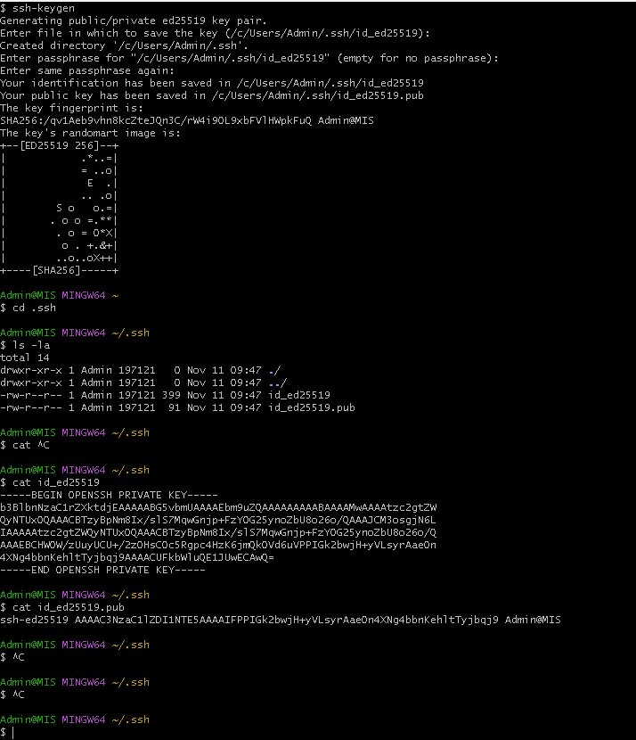

Login to github via gmail- add the above SSH key / copy the repo(QA_DE) SSH KEY
Go back virtual pc VS code and // cd to desktop / clone the SSH KEY of the repo

git config --global user.email "you@example.com"
git config --global user.name "Your Name"
Git status
Git add .
Git commit – m “add msg”
Git push

