STRATEGIC PLANNING REPORT
Data-Driven Distribution Planning for EastLink Distribution
Inventory forecasting, delay prediction and route optimisation for an Eastern India FMCG network using Python
Week 1 Deliverable: Strategic Planning and Data Exploration in Logistics
Scope: project definition, KPIs, background research, methodology, roadmap and a working Python prototype
Prepared by: Shruti Rani
Date: 17 October 2026
Code repository: logistics-strategic-planning/ (README, src/, data/, outputs/)

Contents
1. Executive Summary
2. Project Definition
3. Key Performance Indicators
4. Background Research
5. Strategic Roadmap
6. Python Code Illustration
7. Prototype Results and Insights
8. Feasibility, Risks and Assumptions
9. Expected Outcomes and Decision Impact
10. References

1. Executive Summary
EastLink Distribution is a hypothetical regional distributor of FMCG and pharmacy products that supplies 40 towns in West Bengal, Odisha, Jharkhand and North Bengal from three warehouses (Dankuni/Kolkata, Haldia and Durgapur). Management faces three connected problems: late deliveries (especially in the monsoon), inventory that is either too high or too low during festival peaks, and delivery routes planned by hand.
This report defines the scenario, selects five KPIs, summarises public research that frames the problem, and sets out an end-to-end Python roadmap covering data collection, cleaning, exploratory analysis, predictive modelling and optimisation. To prove feasibility, a working prototype was built on a reproducible synthetic dataset (22,060 shipment records and 29,240 daily demand records). Results are illustrative and must be re-validated on real company data.
Prototype headline results (synthetic data):
- Baseline on-time delivery is 82.8%; it falls to 51.6% on rainy days versus 92.2% on dry days, so weather is the dominant delay driver.
- A gradient-boosting model predicts delay with MAE 0.318 h (R² 0.545) and flags late shipments with ROC-AUC 0.81.
- Demand forecasting reduces network WAPE from 6.75% (seasonal naive) to 4.98%; in a stock simulation this allows about 11.6% lower average inventory at the same 100% fill rate.
- Capacitated allocation cuts average distance per unit by 9%, and savings-based routing cuts route kilometres by 32.7% against a nearest-neighbour dispatcher baseline.

2. Project Definition

2.1 Logistics scenario
Company profile. EastLink Distribution moves roughly 1,900 units of product per day (2024 average) from three warehouses to 40 delivery towns. Customers fall into four segments: grocery, pharmacy, modern trade and e-commerce. Three vehicle classes are used: Tata Ace (up to 750 kg), Eicher Pro (up to 3 tonnes) and 10-tonne trucks. Road transport carries all volume.
Warehouse | Location | Daily capacity (units)
WH_KOL | Dankuni, Kolkata | 900
WH_HAL | Haldia | 550
WH_DGP | Durgapur | 700

2.2 Business problems
- Service reliability: deliveries are frequently late, with strong monsoon and congestion effects, and dispatchers have no early-warning signal.
- Inventory imbalance: static par levels ignore weekly seasonality, the Durga Puja and Diwali demand peak (about +35%) and the underlying growth trend.
- Allocation and routing inefficiency: about 20% of shipments leave a non-nearest warehouse, and multi-drop routes are built by experience rather than by optimisation.

2.3 Project objectives
- Quantify current performance with a baseline KPI dashboard built from cleaned shipment and demand data.
- Predict shipment delay and late-delivery risk before dispatch so planners can act.
- Forecast warehouse-level demand 7 days ahead and convert forecasts into safety-stock and order-up-to levels.
- Optimise warehouse-to-customer allocation and multi-drop vehicle routes to cut distance and cost.
- Translate model outputs into decision rules and a monitoring plan for operations managers.

3. Key Performance Indicators
Five KPIs were chosen so that each project objective can be measured. Baselines come from the prototype dataset; targets are proposed planning values that will be agreed with stakeholders after real baselines are computed.
KPI | Definition / formula | Baseline (prototype) | Proposed target
On-time delivery (OTD) | Deliveries with actual time ≤ planned + 30 min ÷ total deliveries | 82.8% (rain: 51.6%) | ≥ 90% overall
Transport cost per tonne-km | Σ trip cost (INR) ÷ Σ (tonnes × km) | INR 21 | −8% to −10%
Fill rate and average stock | Units served ÷ units demanded; mean on-hand stock (units) | 100% fill rate; 2180 units on hand | Hold ≥ 98% fill; stock −11.6%
Forecast accuracy (WAPE) | Σ|actual − forecast| ÷ Σ actual on 60-day hold-out | 6.75% (seasonal naive) | ≤ 4.98% (achieved in prototype)
Average km per unit delivered | Demand-weighted road distance from serving warehouse | 155.5 km | ≤ 141.5 km

4. Background Research

4.1 Industry context
Logistics cost is a policy priority in India. The NCAER study for DPIIT, released in 2025, estimated India's logistics cost at 7.97% of GDP for 2023–24. This replaced the widely quoted 13–14% figure, which came from external or partial data. Road transport carries the largest share of freight in India, and the National Logistics Policy (2022) aims to bring cost down to global benchmarks through multimodal shifts, digitisation and initiatives such as PM Gati Shakti and the Unified Logistics Interface Platform.
For a distributor like EastLink the lesson is that cost per tonne-km, delivery reliability and inventory carrying cost are the controllable levers. These are data problems: demand uncertainty, travel-time variability and network design can all be modelled.

4.2 Public data and resources
Source | Use in this project
NCAER / DPIIT logistics cost reports (ncaer.org, pib.gov.in) | Benchmarks for cost structure, freight cost per tonne-km and target setting
World Bank Logistics Performance Index | Country-level benchmarking of timeliness, tracking and infrastructure
DataCo Smart Supply Chain dataset (public on Kaggle/Mendeley Data) | Real-world order, shipping and late-delivery fields to validate the delay-classification pipeline
CVRPLIB benchmark instances | Verify the routing heuristic against published best-known solutions
OpenStreetMap / OSRM road network | Replace the 1.3 × straight-line distance with actual road distance and drive time
IMD rainfall records | Replace the simulated rain flag with observed weather by district and date
Note: the datasets above are candidates; availability, licences and schema will be confirmed in Week 2. The prototype uses synthetic data generated by src/generate_data.py, calibrated to patterns reported in the literature (monsoon slowdowns, festival peaks, weekly cycles).

4.3 Data science concepts and how they apply
Technique | Logistics question | Python implementation
Regression (linear, gradient boosting) | How many hours late will this shipment be? Which factors drive delay? | scikit-learn LinearRegression, HistGradientBoostingRegressor, permutation importance
Classification | Is this shipment at high risk of being late? | HistGradientBoostingClassifier, ROC-AUC
Clustering (K-Means) | Which customers share demand and service profiles and need different policies? | KMeans, silhouette score, PCA for visualisation
Time-series forecasting | How much will each warehouse need in the next 7 days? | Lag/rolling features + gradient boosting; seasonal-naive benchmark
Linear programming | Which warehouse should serve each customer within capacity? | scipy.optimize.linprog (HiGHS)
Heuristic optimisation (VRP) | In what order should a truck visit its customers? | Clarke–Wright savings + 2-opt in NumPy
Simulation | What fill rate and stock result from a given inventory policy? | Order-up-to policy simulation in src/inventory.py

5. Strategic Roadmap
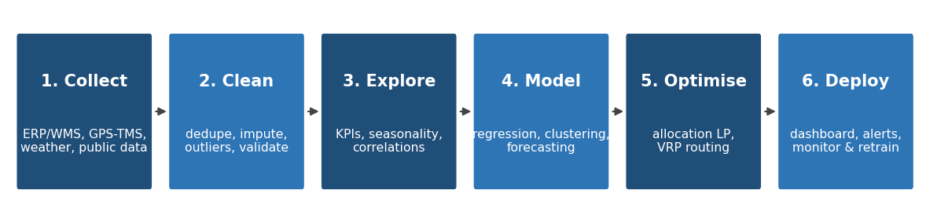
Figure 1: End-to-end analysis process flow
Phase | Activities | Python tools | Output
1. Data collection | Extract shipments from TMS/ERP, daily demand from WMS, customer and warehouse masters; add weather and road-distance data | pandas, requests, SQLAlchemy | Raw CSV / database tables with data dictionary
2. Cleaning | Remove duplicates, standardise labels, impute missing values, flag impossible durations, engineer delay and cost features | pandas, numpy | shipments_clean.csv plus audit log
3. Exploration | Compute KPIs, monthly trends, rain/traffic effects, demand seasonality, customer profiles | pandas, matplotlib, seaborn | Baseline KPI report and charts
4. Modelling | Delay regression and late-risk classifier, K-Means segmentation, demand forecasting, inventory simulation | scikit-learn | Validated models and metrics.json
5. Optimisation | Capacitated allocation LP, savings-based vehicle routing | scipy, numpy | Allocation matrix and route plans
6. Deployment | Weekly refresh, dashboard, alerting, drift monitoring and retraining | Streamlit or Power BI, cron/Airflow | Planner-facing dashboard and monitoring report

5.1 Timeline
- Week 1: scenario, KPIs, research, roadmap and prototype (this report).
- Week 2: acquire and profile real or public datasets; finalise schema and data-quality rules.
- Weeks 3–4: cleaning pipeline, EDA and baseline KPI dashboard.
- Weeks 5–6: predictive models with time-based validation.
- Weeks 7–8: optimisation, what-if scenarios and stakeholder review.

5.2 Validation strategy
Forecasts are validated on the last 60 days using a time split rather than a random split, and are always compared with a seasonal-naive benchmark. Delay models use a held-out test set and are compared with a predict-the-mean baseline. Optimisation results are benchmarked against what dispatchers do today, not against a theoretical worst case.

6. Python Code Illustration
The snippets below are taken from the working prototype in the src/ folder. Run python -m src.generate_data followed by python -m src.run_pipeline to reproduce every number and figure in this report.

6.1 Cleaning and feature engineering
def clean_shipments(ship):
df = ship.drop_duplicates(subset="shipment_id").copy()
vmap = {"tata_ace": "Tata_Ace", "eicher_pro": "Eicher_Pro", "truck_10t": "Truck_10T"}
v = df["vehicle_type"].str.strip().str.lower().str.replace(" ", "_")
df["vehicle_type"] = v.map(vmap)
# impute with group medians
g = df.groupby("vehicle_type")["weight_kg"].transform("median")
df["weight_kg"] = df["weight_kg"].fillna(g)
g = df.groupby("warehouse_id")["traffic_index"].transform("median")
df["traffic_index"] = df["traffic_index"].fillna(g)
# actual duration > 4x plan is treated as a recording error
df = df[(df["actual_hours"] / df["planned_hours"]) <= 4]
df["delay_hours"] = df["actual_hours"] - df["planned_hours"]
df["late"] = (df["delay_hours"] > 0.5).astype(int)
return df

6.2 Delay prediction (regression and classification)
pre = ColumnTransformer([("num", StandardScaler(), NUM),
("cat", OneHotEncoder(handle_unknown="ignore"), CAT)])
reg = HistGradientBoostingRegressor(max_iter=250, learning_rate=0.06)
gbr = Pipeline([("pre", pre), ("m", reg)])
gbr.fit(X_train, y_delay_train)
print("MAE (h):", mean_absolute_error(y_test, gbr.predict(X_test)))
clf = Pipeline([("pre", pre), ("m", HistGradientBoostingClassifier(max_iter=250))])
clf.fit(X_train, late_train)
print("AUC:", roc_auc_score(late_test, clf.predict_proba(X_test)[:, 1]))

6.3 Customer clustering
Z = StandardScaler().fit_transform(features) # demand, variability, distance, late rate
scores = {k: silhouette_score(Z, KMeans(k, n_init=10).fit_predict(Z))
for k in range(2, 8)}
best_k = max(scores, key=scores.get)
features["cluster"] = KMeans(best_k, n_init=10, random_state=42).fit_predict(Z)

6.4 Demand forecast with a naive benchmark
f["lag_7"], f["lag_14"] = s.shift(7), s.shift(14) # lags >= 7 d: valid for 7-day horizon
f["roll28"] = s.shift(7).rolling(28).mean()
f["dow"], f["month"] = s.index.dayofweek, s.index.month
model = HistGradientBoostingRegressor(max_iter=300).fit(train[cols], train["y"])
wape = lambda a, p: np.abs(a - p).sum() / a.sum()
print(wape(test["y"], model.predict(test[cols])))
print(wape(test["y"], test["lag_7"])) # seasonal-naive benchmark

6.5 Warehouse allocation (linear programming)
# minimise sum(distance[i, j] * x[i, j])
# s.t. sum_j x[i, j] = demand[i] (every customer fully served)
# sum_i x[i, j] <= capacity[j] (warehouse capacity)
res = linprog(c=D.flatten(), A_ub=A_ub, b_ub=capacity, A_eq=A_eq, b_eq=demand,
bounds=(0, None), method="highs")
x = res.x.reshape(n_customers, n_warehouses)

6.6 Vehicle routing (savings heuristic)
savings = sorted(((d[0, i] + d[0, j] - d[i, j], i, j)
for i in customers for j in customers if i < j), reverse=True)
for s, i, j in savings: # merge routes while capacity and max-km allow
if route_of[i] != route_of[j] and fits_capacity(i, j) and are_endpoints(i, j):
merge_routes(i, j)
routes = [two_opt(r, d) for r in routes] # local improvement per route

7. Prototype Results and Insights
All results below come from synthetic data and demonstrate that the approach is technically feasible; they are not claims about a real company.

7.1 Data quality
The raw shipment table held 22,060 rows. Cleaning removed 60 duplicate records and 40 impossible durations, and imputed 440 missing traffic values and 220 missing weights, leaving 21,960 rows with no missing values.

7.2 Delivery performance
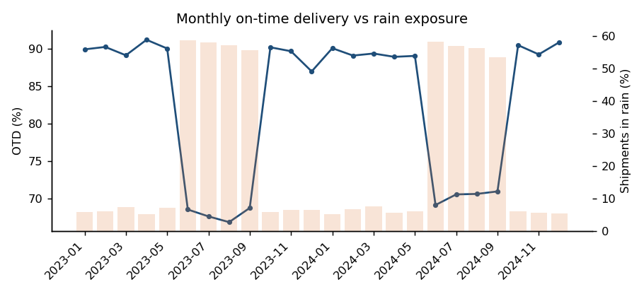
Figure 2: Monthly on-time delivery follows rain exposure
OTD is 92.2% on dry days and 51.6% in rain. Permutation importance confirms rain as the strongest delay driver, followed by planned duration, distance, driver experience and traffic.
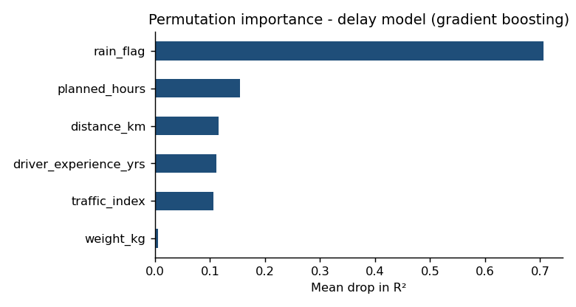
Figure 3: Drivers of delivery delay
Model | MAE (hours) | R²
Predict the mean (baseline) | 0.441 | 0.00
Linear regression | 0.366 | 0.371
Gradient boosting | 0.318 | 0.545

The late-risk classifier reaches ROC-AUC 0.81. Operationally, shipments with high predicted risk can be re-planned, given a more experienced driver, or communicated early to the customer.

7.3 Customer segments
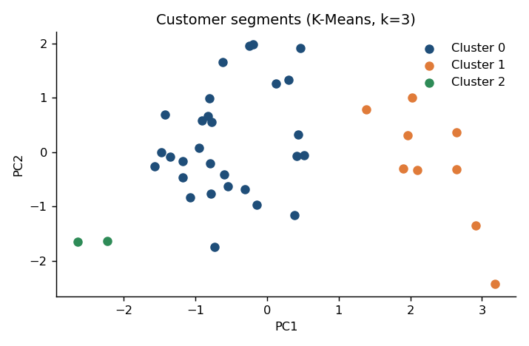
Figure 4: K-Means segments (k chosen by silhouette score)
Cluster | Customers | Avg daily demand | Avg distance (km) | Late rate
0 | 29 | 46.85 | 100.88 | 16%
1 | 9 | 39.93 | 387.24 | 22%
2 | 2 | 46.63 | 28.78 | 16%

Cluster 1 holds the distant North Bengal, Jharkhand and Odisha towns, which have the highest late rate and should receive buffer time, consolidated schedules or a regional cross-dock. Cluster 2 contains the two towns that sit next to a warehouse (Durgapur and Haldia): trips are very short, so cost per km is high, and small vehicles or combined milk-run deliveries are a better fit.

7.4 Demand forecasting and inventory
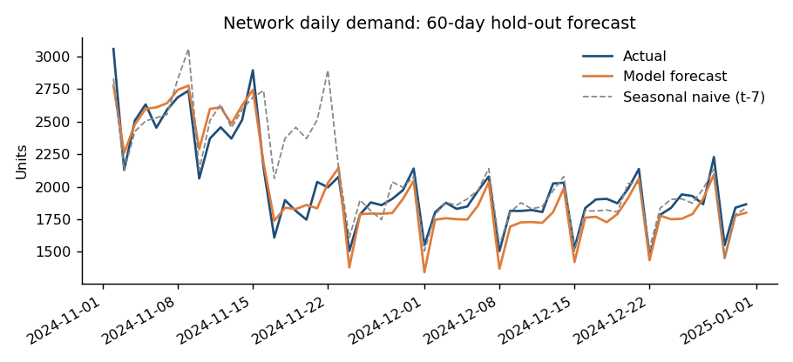
Figure 5: 60-day hold-out forecast (network level)
Warehouse | WAPE model | WAPE naive | Avg stock baseline | Avg stock forecast-driven
WH_DGP | 5.95% | 8.96% | 920 | 810
WH_HAL | 5.46% | 8.29% | 636 | 605
WH_KOL | 7.32% | 8.28% | 625 | 511

Both policies achieved a 100% fill rate in the simulation, so the benefit appears as lower stock: 2180 to 1926 units on hand in total (11.6% less). The baseline is a rule-of-thumb order-up-to level; the proposed policy uses forecast demand plus safety stock at z = 1.65.

7.5 Allocation and routing
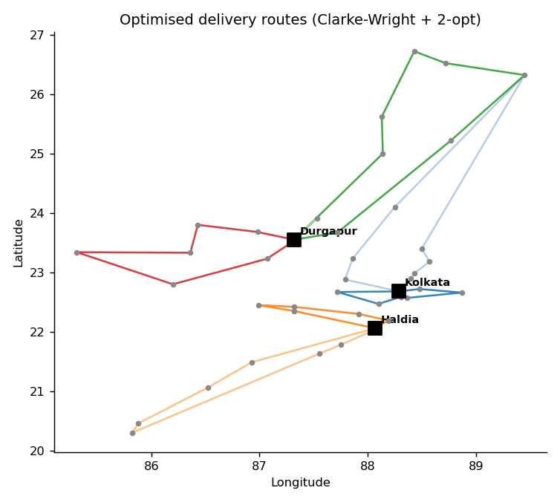
Figure 6: Optimised multi-drop routes from the three warehouses
Measure | Current / baseline | Optimised | Change
Average km per unit (allocation) | 155.5 | 141.5 | −9%
Daily route km vs nearest-neighbour dispatch | 6,770 | 4,557 | −32.7%
Daily route km vs one-truck-per-customer | 12,943 | 4,557 | −64.8%

The nearest-neighbour comparison is the realistic one: it represents a dispatcher choosing the closest next stop. The one-truck-per-customer figure is an upper bound. At an assumed INR 28 per km for a 5-tonne truck, the difference against nearest-neighbour is about INR 61,964 per day. Durgapur is fully loaded at its 700-unit capacity, so the LP also signals where extra capacity would be most valuable.

8. Feasibility, Risks and Assumptions
Risk / assumption | Impact | Mitigation
Real data is incomplete or inconsistent | Weaker models, delayed schedule | Data-quality audit in Week 2; documented imputation rules; start with core fields
Synthetic results overstate real gains | Unrealistic expectations | Report all prototype numbers as illustrative; re-baseline on real data before committing targets
Straight-line distance × 1.3 is an approximation | Route and cost errors | Use OSRM or Google road distances and drive times
Weather and demand shocks (floods, strikes, festival shifts) | Forecast and delay error | Event features, prediction intervals, safety stock, weekly retraining
Planner adoption | Models unused | Explainable outputs, dashboard in planners' workflow, pilot on one warehouse first

All libraries used (pandas, NumPy, SciPy, scikit-learn, matplotlib) are open source, and the prototype runs in under a minute on a laptop, so the approach needs no specialised infrastructure. Larger route problems can move to OR-Tools or a commercial solver without changing the surrounding pipeline.

9. Expected Outcomes and Decision Impact
If the prototype gains carry over to real data even partially, EastLink can expect:
- Higher service reliability: earlier warnings for rain and long-haul shipments so that dispatchers can add buffer, re-plan or notify customers.
- Lower inventory with stable service: forecast-based order-up-to levels replace static par stocks, releasing working capital, particularly ahead of festival peaks.
- Lower transport cost: better warehouse allocation and consolidated routes reduce kilometres driven and cost per tonne-km.
- Better strategic decisions: segmentation and capacity-shadow-prices show where to add a cross-dock, upgrade vehicles or renegotiate customer delivery windows.
The decision flow is: forecast → set stock levels → allocate orders to warehouses → plan routes → monitor OTD and cost KPIs → retrain. Each step produces numbers that a planner can act on, and each is measured by one of the five KPIs defined in Section 3.
Next step: begin Week 2 by confirming real data access (or adopting a public dataset such as DataCo), freezing the data dictionary, and re-computing the baseline KPIs before any target is committed.

10. References
- NCAER (2025). Assessment of Logistics Cost in India. Study for DPIIT, Ministry of Commerce and Industry. https://ncaer.org/wp-content/uploads/2025/09/NCAER_Logistic_Study_Report_Sept2025.pdf
- Press Information Bureau (2025). Supercharging India's Logistics (7.97% of GDP, 2023–24). https://static.pib.gov.in/WriteReadData/specificdocs/documents/2025/nov/doc20251127708301.pdf
- NCAER. Logistics Cost in India: Assessment and Long-term Framework. NCAER. https://www.ncaer.org/?p=21265
- Business Standard (2025). Confidence in India's logistics cost: the story of economic transition. https://www.business-standard.com/amp/opinion/columns/confidence-in-india-s-logistics-cost-the-story-of-economic-transition-125112001452_1.html
- Government of India (2022). National Logistics Policy; PM Gati Shakti National Master Plan.
- Clarke, G. and Wright, J. W. (1964). Scheduling of vehicles from a central depot to a number of delivery points. Operations Research, 12(4).
- Dantzig, G. B. and Ramser, J. H. (1959). The truck dispatching problem. Management Science, 6(1).
- Hyndman, R. J. and Athanasopoulos, G. Forecasting: Principles and Practice (online textbook).
- Chopra, S. and Meindl, P. Supply Chain Management: Strategy, Planning, and Operation. Pearson.
- Pedregosa, F. et al. (2011). Scikit-learn: Machine learning in Python. Journal of Machine Learning Research, 12.

