LOGISTICS DATA ANALYSIS PROJECT
Research Report: Improving Delivery Performance and Inventory Decisions with Data Science
Week 1: Strategic Planning and Data Exploration
Prepared by: [Shruti Rani] Date: October 2026

1. Introduction and Problem Background
Logistics connects every sale to a customer’s doorstep, and small inefficiencies add up quickly. Three problems appear again and again in e-commerce and retail supply chains: late deliveries, stockouts or overstock, and high transport cost. Each one hurts both customer experience and profit.
The last mile is the clearest example. Estimates attributed to the Capgemini Research Institute put last-mile delivery at roughly 41% of total retail parcel supply chain cost, and up to about 53% of total shipping cost, depending on how the figure is measured [6]. It is expensive because each stop serves one customer, so there are no economies of scale on the final leg. Data can help on the planning side too: McKinsey reports that early adopters of AI-enabled supply chain management improved logistics costs by 15%, inventory levels by 35% and service levels by 65% compared with slower-moving competitors [5].

Table 1: Common logistics problems, causes and business impact
Problem | Typical causes | Business impact | Linked KPI
Late delivery | Carrier delays, poor route planning, warehouse backlog, weather | Lower customer satisfaction, refunds, lost repeat purchases | On-Time Delivery %
Stockout | Inaccurate demand forecast, long supplier lead time | Lost sales, expensive emergency shipping | Stockout Rate
Overstock | Over-ordering, ignoring seasonality | Capital locked in inventory, storage cost, markdowns | Inventory Turnover
High transport cost | Low vehicle utilisation, long routes, failed attempts | Shrinking margin per order | Cost per Order
Failed delivery / returns | Wrong address, customer unavailable, damage | Re-delivery and reverse-logistics cost | Perfect Order Rate
Source: compiled from [5], [6] and [7].
Project objectives. (1) Measure current delivery and inventory performance using standard KPIs; (2) identify where and why delays occur; (3) test forecasting, clustering, delay-prediction and routing methods on public data; and (4) recommend actions that improve on-time delivery and reduce cost per order.

2. Key Performance Indicators (KPIs)
KPIs turn raw order data into numbers that managers can act on. The set below follows common logistics practice and the SCOR model, a widely used supply chain framework from ASCM that organises performance into reliability, responsiveness, agility, costs and asset management [7]. Baselines are illustrative and are shaped by the delivery patterns typically seen in the DataCo dataset.
Table 2: KPI definitions, formulas and illustrative targets
KPI | Definition | Formula | Baseline* | Target
On-Time Delivery (OTD) | Share of orders delivered by the promised date | (Orders delivered on or before promise ÷ Total orders) × 100 | 45% | ≥ 80%
Order Cycle Time | Average time from order placement to delivery | Σ (Delivery date − Order date) ÷ Number of orders | 4.1 days | ≤ 3.5 days
Inventory Turnover | How many times stock is sold and replaced in a period | Cost of goods sold ÷ Average inventory value | 5.8× | ≥ 7.5×
Stockout Rate | Share of time products are unavailable | (SKU-days out of stock ÷ Total SKU-days) × 100 | 7.4% | ≤ 3%
Perfect Order Rate | Orders that are on time, in full, undamaged and correctly documented | OTD% × In-full% × Damage-free% × Documentation-accurate% | 38% | ≥ 65%
Transport Cost per Order | Average transport spend for each order shipped | Total transport cost ÷ Orders shipped | $8.40 | ≤ $7.20
Forecast Error (MAPE) | Average percentage gap between forecast and actual demand | (1/n) Σ |Actual − Forecast| ÷ |Actual| × 100 | 20% | ≤ 12%
*Illustrative planning values, not measured results. They will be replaced with actual figures after exploratory data analysis (EDA).

3. Data Science Techniques in Logistics
Four techniques are selected, each linked to a specific problem and KPI. Table 3 gives the overview and the subsections explain what each technique does, where it has been used, and what result it produces.

Table 3: Technique-to-problem mapping
Technique | Problem addressed | Method / tool | Key source | Output / metric
Demand forecasting | Stockouts, overstock | Exponential smoothing, ARIMA, gradient boosting | Hyndman & Athanasopoulos [3]; M5 results [9] | Forecast, MAPE
Route optimization | High transport cost, late delivery | Vehicle Routing Problem (VRP), OR-Tools | Dantzig & Ramser [1]; OR-Tools docs [2] | Total distance, cost per order
Clustering | Uneven service across regions | k-means on location and delay data | scikit-learn [4] | Delivery zones, silhouette score
Delay prediction | Late delivery | Classification: logistic regression, random forest | scikit-learn [4]; DataCo [8] | Precision, recall, F1-score

3.1 Demand forecasting
Forecasting predicts future sales from past patterns such as trend, seasonality and promotions. Hyndman and Athanasopoulos describe the standard toolkit, including exponential smoothing and ARIMA models, with worked examples [3]. In the M5 competition, which used Walmart sales data, top-performing entries relied heavily on gradient-boosted tree models rather than purely classical methods [9]. In this project, a seasonal-naive forecast will serve as the baseline, and the improvement will be measured by MAPE.
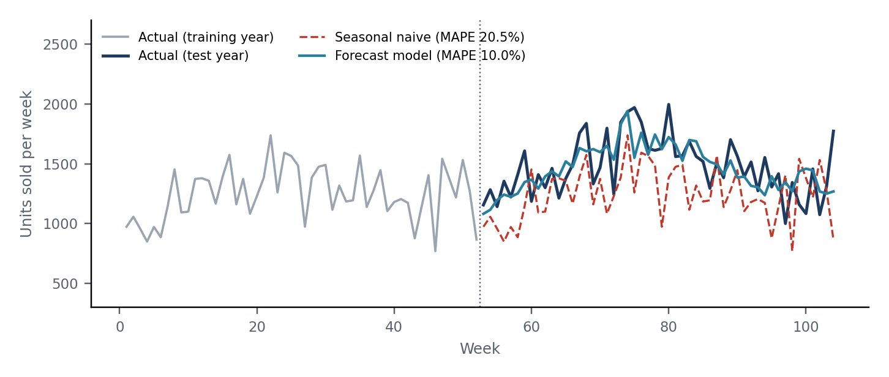
Figure 2: Illustrative weekly demand for one product. A seasonal-naive forecast (repeat last year) gives MAPE 20.5%, while a model that learns trend, seasonality and promotions gives 10% (simulated series)

3.2 Route optimization
The Vehicle Routing Problem asks for the cheapest set of routes that serve all customers from a depot. It was first formulated by Dantzig and Ramser in 1959 as “The Truck Dispatching Problem”, which was motivated by fuel delivery to service stations [1]. Google OR-Tools provides a routing solver that applies heuristics and local search to such problems [2]. The expected result is a lower total distance, and therefore a lower cost per order, for a sample of delivery points.

3.3 Clustering
k-means groups locations into k clusters by minimising within-cluster distance. Applied to customer coordinates or regional delay patterns, it can define delivery zones that make routes more compact. The scikit-learn documentation covers the algorithm and its evaluation through the elbow method and silhouette score [4].

3.4 Delay prediction
Delay prediction is a classification task: given order features such as shipping mode, region, order value and scheduled days, predict whether the order will arrive late. The DataCo dataset includes a late-delivery label that makes this possible [8]. Models will be compared using precision, recall and F1-score, because accuracy alone is misleading when late deliveries are a large share of orders.

4. Public Datasets
Three public datasets are shortlisted. They come from different companies and countries, so they will be analysed separately rather than merged. Each supports a different part of the project.
Table 4: Shortlisted datasets
Dataset | Source | Approx. size | Important columns | Used for
DataCo Smart Supply Chain | Mendeley Data / Kaggle [8] | ≈ 180,500 rows × 53 columns | Order date, shipping mode, scheduled vs real shipping days, delivery status, order region, sales | OTD, cycle time, delay prediction
M5 Forecasting (Walmart) | Kaggle [9] | 30,490 item-level series (42,840 incl. aggregates), 1,941 days | Date, item, store, units sold, sell price, calendar events | Demand forecasting, MAPE
Olist Brazilian E-commerce | Kaggle [10] | ≈ 99,400 orders across 9 linked tables | Purchase timestamp, estimated and actual delivery date, customer state, freight value | Delay analysis, freight cost, geographic clustering
Sizes are approximate and should be confirmed on each dataset page (Kaggle “Data Explorer”) before use.
Table 5 shows the kind of records the analysis will work with. The rows are a hand-made illustration that mirrors the DataCo column structure.
Table 5: Illustrative sample of order records
Order ID | Order date | Ship mode | Scheduled (days) | Actual (days) | Status | Region
70231 | 2017-03-14 | Standard Class | 4 | 4 | On time | Western Europe
70232 | 2017-03-14 | Second Class | 2 | 4 | Late | South Asia
70233 | 2017-03-15 | First Class | 1 | 2 | Late | Central America
70234 | 2017-03-15 | Same Day | 0 | 0 | On time | Western Europe
70235 | 2017-03-16 | Standard Class | 4 | 5 | Late | South America
70236 | 2017-03-16 | Standard Class | 4 | 3 | Early | Oceania
A first view of the data will compare late-delivery rates by shipping mode. Figure 1 shows the illustrative pattern expected: premium modes with tight promises are missed more often than standard shipping, a pattern that DataCo-style data is known to show.
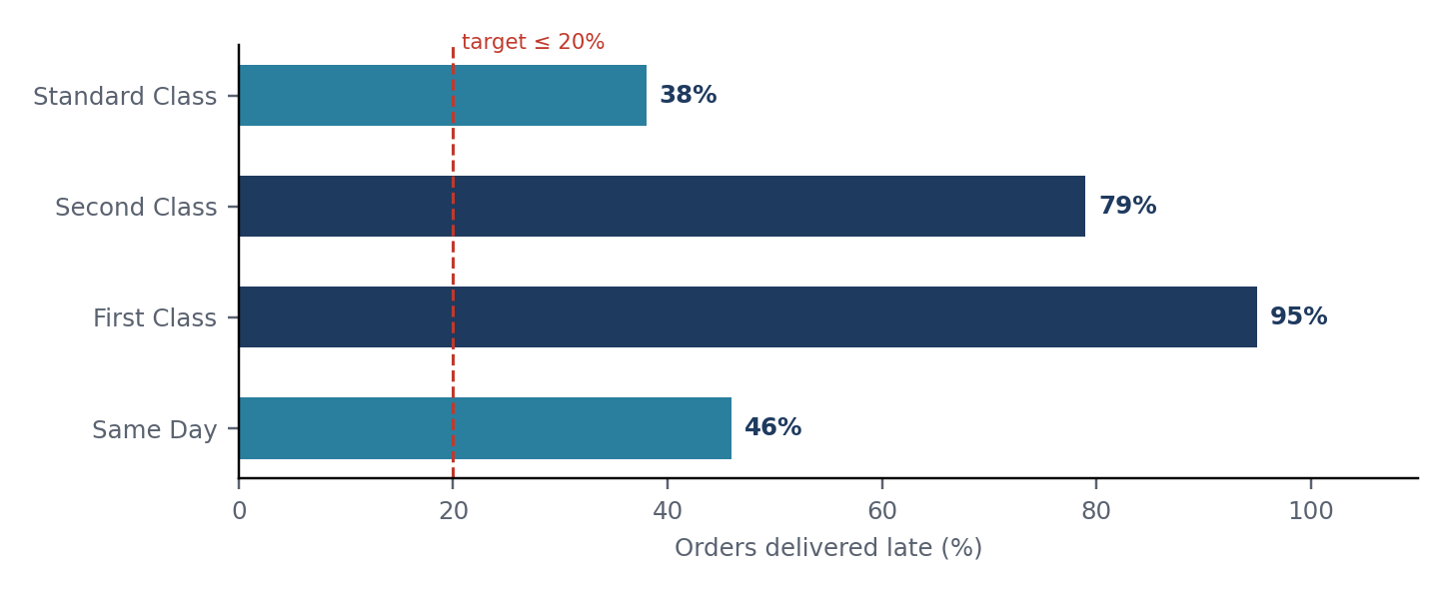
Figure 1: Illustrative late-delivery rate by shipping mode (assumed order mix: 60% Standard, 20% Second, 15% First, 5% Same Day, giving about 45% OTD overall)

5. Python Tools
Table 6: Libraries and their role
Library | Role in the project | Example task
pandas | Data cleaning and manipulation | Parse dates, drop duplicates, compute KPIs
matplotlib / seaborn | Charts and visualization | Late rate by mode, regional heatmaps
scikit-learn | Machine learning and clustering | k-means zones, random forest delay model
statsmodels | Time series forecasting | Exponential smoothing, ARIMA on weekly sales
OR-Tools | Route optimization | Solve a small VRP for sample delivery points
Source: official documentation for each library [2], [4], [11].
As a first test of the toolset, the on-time delivery rate can be computed from DataCo in a few lines:
import pandas as pd
df = pd.read_csv("DataCoSupplyChainDataset.csv", encoding="latin-1")
df = df[df["Delivery Status"] != "Shipping canceled"]
on_time = df["Delivery Status"].isin(["Shipping on time", "Advance shipping"])
print(f"OTD: {on_time.mean() * 100:.1f}%")

6. Proposed Methodology
The project follows the eight-step workflow in Figure 3. Steps 1 to 4 prepare the problem and data; steps 5 to 8 measure, model and report. If evaluation shows weak results, the workflow returns to modelling for feature changes or parameter tuning.
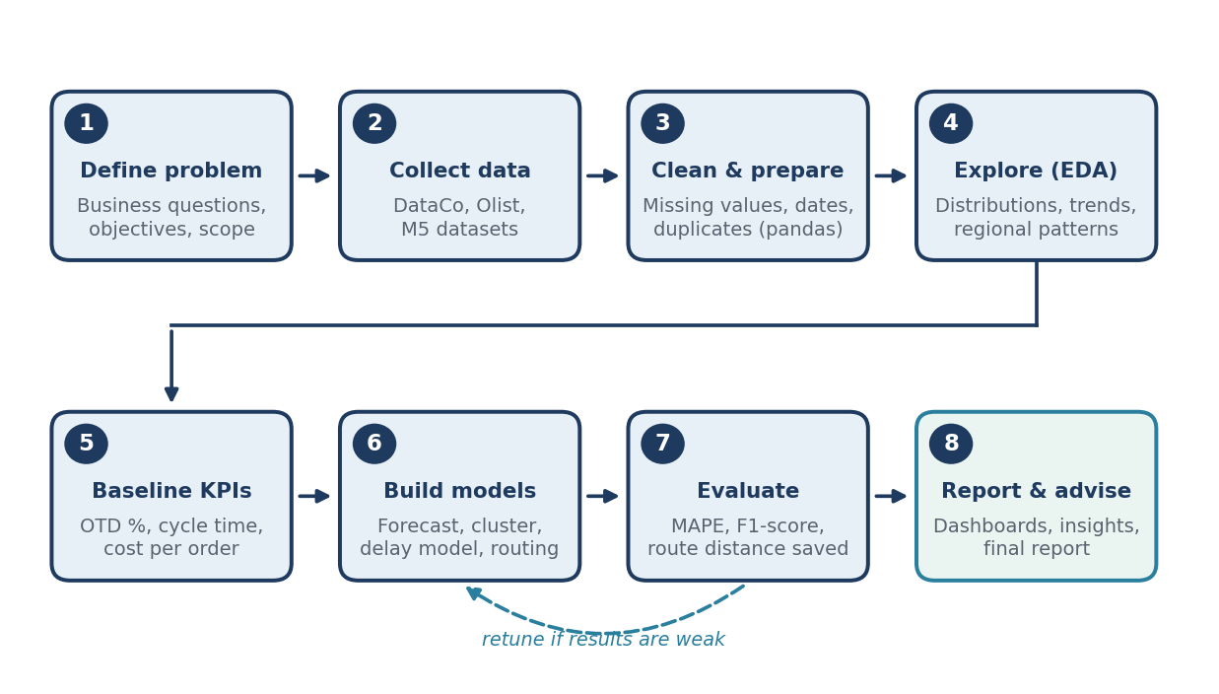
Figure 3: Project workflow from problem definition to recommendations
- Define and collect (steps 1–2): confirm business questions and download the three datasets.
- Clean and explore (steps 3–4): fix date formats and missing values, remove duplicates and cancelled orders, then study trends and regional patterns.
- Baseline and model (steps 5–6): calculate current KPIs first, so that every model is judged against a clear starting point.
- Evaluate and report (steps 7–8): test models on unseen data, then present findings as charts and practical recommendations.
Table 7 lists the planned analyses so that every business question is tied to a dataset, a method and a KPI.
Table 7: Planned analyses
Business question | Dataset | Method | KPI affected
Which shipping modes and regions miss delivery promises most often? | DataCo | Group-by analysis, bar charts | On-Time Delivery
Can a late delivery be predicted before dispatch? | DataCo | Logistic regression, random forest | On-Time Delivery
How much does weekly demand vary by store and season? | M5 | Seasonal-naive baseline, exponential smoothing | Forecast Error, Stockout Rate
Which customer states have the longest delivery time and highest freight cost? | Olist | Aggregation, k-means zones | Cycle Time, Cost per Order
How much distance can better routing save on a sample of stops? | Olist (coordinates) / simulated depot | VRP with OR-Tools | Cost per Order

7. Week 1 Plan, Deliverables and Risks
Table 8: Week 1 work plan
Day | Task | Output
Day 1 | Research Topics 1 and 2: problem background and KPIs | Source log, KPI table
Day 2 | Research Topic 3: one source per technique | Notes on method, use case, result
Day 3 | Review the three datasets on Kaggle and Mendeley | Dataset shortlist with columns
Day 4 | Install Python tools and run a sample KPI script | Working notebook
Day 5 | Write the draft report and format references | This report
Later weeks. Week 2: data cleaning and EDA with baseline KPIs. Week 3: forecasting, clustering, delay prediction and routing. Week 4: evaluation, visualization and the final report.
Main risks. Real-world data can contain missing values, inconsistent dates and file-encoding problems (the DataCo CSV, for example, needs latin-1 encoding). Because the three datasets come from different businesses, findings should not be combined into a single claim about one company. Finally, any conclusion must stay within what the data shows, and every external statistic must carry a source.

8. Conclusion
The research supports a clear project direction: logistics performance can be measured with a small set of well-defined KPIs, and each major problem has a matching data science technique and a suitable public dataset. With the tools and workflow now defined, the next step is to clean the data, establish real baseline values and begin modelling.

