WEEK 2 PROJECT REPORT
Data Collection, Cleaning and Preprocessing for Logistics Analysis
A Python-based preprocessing pipeline for shipment, cost and delivery-time data
Name: Shruti Rani
Programme: Data Science Internship – Week 2 Project
Date: October 2026
Code repository: logistics_preprocessing.py, logistics_raw.csv, logistics_cleaned.csv (see Appendix A)

1. Introduction and Objectives
Logistics decisions such as choosing a carrier, planning a route, setting delivery promises or forecasting freight spend are only as good as the data behind them. Operational logistics data is generated by many systems (order management, warehouse, transport management, driver apps) and entered by many people, so it is rarely analysis-ready. This report documents a complete preprocessing pipeline that converts a messy shipment export into a dataset that can be trusted for analysis.
The objectives of this project are to:
- simulate the collection of a realistic logistics dataset and describe its characteristics;
- identify the typical data-quality problems (duplicates, missing values, inconsistent labels, impossible values and outliers) and show how each is detected;
- resolve each problem with a technique that is justified by logistics domain knowledge, not applied mechanically;
- document the process with working pandas code, and reflect on how data quality affects analytics and decisions.

2. Data Collection (Simulation)

2.1 Reference datasets
Genuine operational logistics data is commercially sensitive, so public datasets are the normal starting point. The structure of this project follows the DataCo Smart Supply Chain dataset (Kaggle), which holds order, shipping-mode, shipping-days and delivery-status fields, and typical Indian freight records (origin and destination city, vehicle type, weight, freight charge). Other public sources with similar content include the US Bureau of Transportation Statistics Freight Analysis Framework and the World Bank Logistics Performance Index.
Transparency note. The file used here, logistics_raw.csv, is simulated rather than downloaded. Public datasets are usually already partly cleaned, so a simulation lets us inject known problems and then check that the pipeline repairs them. The generator (generate_raw_data.py, seed 42) is included so the experiment can be reproduced exactly.

2.2 Dataset characteristics
The dataset contains 2,045 records (2,000 unique shipments plus 45 duplicates) and 13 fields. Shipments were ordered between 1 January and 31 December 2024 and exported on 2 January 2025. Seven warehouse hubs ship to eleven destination cities, using four vehicle types and five (fictional) carriers. Order volume peaks in October to December (festive season) and delays are more frequent in the monsoon months (July to September), as in real Indian logistics.
Field | Type | Description | Example
shipment_id | text | Unique shipment key | SHP-000306
order_date | date | Date the customer order was placed | 2024-06-23
dispatch_date | date | Date the shipment left the hub | 2024-06-25
delivery_date | date | Date delivered (empty while in transit) | 2024-06-27
origin_city | category | Dispatch hub | Bengaluru
destination_city | category | Delivery city | Ahmedabad
distance_km | numeric | Road distance of the route | 1640.7
carrier | category | Transport company | BharatCargo
vehicle_type | category | Mini Truck, Truck, Container, Air Cargo | Truck
priority | category | Standard or Express service | Express
weight_kg | numeric | Shipment weight | 4831.5
freight_cost_inr | numeric | Freight charge in rupees | 62590
delivery_status | category | Delivered, In Transit, Returned | Delivered

3. Data Quality Assessment
Before changing anything, the raw file was audited. All columns were loaded as text (dtype=str) so that pandas could not silently convert or drop values, and common placeholders (NA, N/A, null, a dash, an empty cell) were mapped to missing. The audit found the problems below.
Issue | Evidence in raw data | How it is detected
Duplicate records | 45 repeated shipment_ids (2.2% of rows); some copies differ only in text case | df.shipment_id.duplicated().sum()
Missing values | weight_kg 121, freight_cost_inr 101, delivery_date 102, distance_km 83, carrier 61, vehicle_type 41 | df.isna().sum(); placeholder tokens via na_values
Inconsistent labels | Destination city has 34 spellings for 11 cities (Bombay, mumbai, "Mumbai "); carrier has 26 spellings for 5; status has 9 for 3 | nunique(), value_counts()
Mixed formats | Three date formats (2024-06-23, 23-06-2024, 23/06/2024); cost as 62590, ₹62,590 or INR 62,590; weight as 950 or 950 kg | Regex pattern checks, failed to_numeric / to_datetime
Impossible values | 12 impossible distances (negative, zero or > 4,000 km); 11 weights above the vehicle's capacity; 3 zero costs; 14 delivery dates before dispatch or more than 30 days after | Business rules (domain limits)
Statistical outliers | Weights up to 2.2 million kg and freight costs up to ₹14.7 lakh, many times the typical range | Box plots, IQR, regression residuals
Legitimate emptiness | 21 shipments are still In Transit, so an empty delivery_date is correct | Cross-check with delivery_status

Key insight. Not every empty cell is a defect. A shipment that has not arrived yet has no delivery date. Treating it as missing and filling it would invent a delivery that never happened, so the pipeline separates errors from legitimate absence before imputing.

4. Methodology
The pipeline follows a deliberate order. Standardisation comes first because later steps (duplicates, medians, group statistics) only work if equal things look equal. Validation comes before imputation so that impossible values are replaced instead of being used to compute the replacements. Outliers are handled after imputation, and scaling is always the last step because every earlier step changes the distributions that the scalers learn from.
Step | Operation | Main pandas / scikit-learn tools
1 | Load and audit | read_csv(dtype=str, na_values=...), isna()
2 | Standardise text, numbers, dates | str.strip/lower, map, str.replace (regex), to_numeric, to_datetime(format=)
3 | Remove duplicates | sort_values, drop_duplicates
4 | Validate with business rules | boolean masks, .loc
5 | Impute missing values | groupby().transform('median'), fillna, pd.cut
6 | Detect and treat outliers | quantile (IQR), clip, numpy lstsq, MAD
7 | Engineer features | dt accessor, arithmetic on dates
8 | Normalise | MinMaxScaler, StandardScaler, np.log1p

4.1 Standardising text, numbers and dates
Problem. The same city appears under 34 different labels. A group-by on destination would split Mumbai's shipments across "Mumbai", "mumbai" and "Bombay", producing several small, misleading groups. Cost values containing ₹, commas or INR cannot be averaged at all.
Technique. Labels are trimmed, lower-cased and mapped through an alias dictionary for cities and statuses. For carriers, each lower-case key is mapped to its most frequent spelling. Numeric fields are stripped of every character except digits, the decimal point and a minus sign. Dates are parsed with each known format listed explicitly.
Why this choice. An explicit alias table is transparent and auditable, and unknown names are kept (title-cased) instead of being discarded. Listing date formats avoids pandas guessing: 03-04-2024 can mean 3 April or 4 March, and a wrong guess would silently shift delivery times.
Impact. Distinct destination labels fall from 34 to 11, carriers from 26 to 5 and statuses from 9 to 3. Every later group-by, join and KPI is now computed on correct groups.
def harmonise_case(s: pd.Series) -> pd.Series:
"""'safehaul', 'SAFEHAUL', ' SafeHaul ' -> the most frequent spelling ('SafeHaul')."""
s = s.str.strip().str.replace(r"\s+", " ", regex=True)
known = s.dropna()
canonical = known.groupby(known.str.lower()).agg(lambda x: x.value_counts().idxmax())
return s.str.lower().map(canonical)

def to_number(s: pd.Series) -> pd.Series:
"""'₹12,450' / 'INR 12,450' / '1250.5 kg' -> float (keeps minus sign)."""
return pd.to_numeric(s.str.replace(r"[^0-9.\-]", "", regex=True), errors="coerce")

def parse_dates(s: pd.Series) -> pd.Series:
"""Try each known format explicitly - never let pandas guess day/month order."""
out = pd.Series(pd.NaT, index=s.index, dtype="datetime64[ns]")
for fmt in DATE_FORMATS:
out = out.fillna(pd.to_datetime(s, format=fmt, errors="coerce"))
return out

4.2 Removing duplicate records
Problem. 45 shipments appear twice, typically after a system re-sync. Duplicates double-count volume, revenue and costs and bias averages towards the repeated shipments.
Technique. Duplicates are identified by the business key (shipment_id) after standardisation, so that copies differing only in capitalisation are caught. Among the copies, the record with the fewest missing fields is kept.
Why this choice. Plain drop_duplicates() on all columns would miss near-duplicates. Keeping the most complete copy preserves information that a keep-first rule might throw away.
Impact. The dataset shrinks from 2,045 to 2,000 rows and shipment counts, total freight spend and carrier volumes become correct.
def drop_duplicates(df: pd.DataFrame) -> pd.DataFrame:
"""Keep, for every shipment_id, the record with the fewest missing fields."""
return (df.assign(_n_missing=df.isna().sum(axis=1))
.sort_values(["shipment_id", "_n_missing"])
.drop_duplicates("shipment_id", keep="first")
.drop(columns="_n_missing")
.sort_values("shipment_id").reset_index(drop=True))

4.3 Validating values against business rules
Problem. Some values are not merely unusual; they are impossible. A negative distance, a Mini Truck carrying 25 tonnes or a parcel delivered before it was dispatched is a data-entry or integration error, not information.
Technique. Domain limits are encoded as rules: distance must be between 0 and 4,000 km, weight must not exceed the vehicle's capacity, cost must be positive, and transit time must lie between 0 and 30 days. Violations are converted to missing, so that the imputation step can replace them.
Why this choice. Rules are applied before statistics because a statistical method cannot tell a typing error from a genuine extreme, whereas domain knowledge can. Setting the value to missing, rather than deleting the row, keeps the rest of the shipment's information.
Impact. 40 impossible values were removed from the data. None of them can now distort a mean, a cost model or a transit-time estimate.
def apply_business_rules(df: pd.DataFrame) -> tuple[pd.DataFrame, dict]:
df = df.copy()
found = {}

bad = (df["distance_km"] <= 0) | (df["distance_km"] > MAX_ROAD_DISTANCE_KM)
found["invalid_distance"] = int(bad.sum()); df.loc[bad, "distance_km"] = np.nan

capacity = df["vehicle_type"].map(VEHICLE_CAPACITY_KG).fillna(DEFAULT_CAPACITY_KG)
bad = (df["weight_kg"] <= 0) | (df["weight_kg"] > capacity)
found["weight_exceeds_vehicle_capacity"] = int(bad.sum()); df.loc[bad, "weight_kg"] = np.nan

bad = df["freight_cost_inr"] <= 0
found["non_positive_cost"] = int(bad.sum()); df.loc[bad, "freight_cost_inr"] = np.nan

transit = (df["delivery_date"] - df["dispatch_date"]).dt.days
bad = (transit < 0) | (transit > MAX_TRANSIT_DAYS)
found["impossible_delivery_date"] = int(bad.sum()); df.loc[bad, "delivery_date"] = pd.NaT

found["dispatch_before_order"] = int((df["dispatch_date"] < df["order_date"]).sum())
return df, found

4.4 Handling missing values
Problem. After validation, 131 weights, 103 costs, 92 distances, 60 carriers and 40 vehicle types were missing, plus delivery dates for delivered shipments. Dropping every incomplete row (listwise deletion) would have removed 473 shipments, which is 23.6% of the data, and probably not at random.
Technique. Each field is imputed using the variable that best explains it in logistics terms:
Field | Strategy | Reasoning
distance_km | Median of the same origin → destination route | A route has an almost fixed distance, so this is close to the true value
weight_kg | Median of the same vehicle type | Vehicle type constrains weight: a Mini Truck never carries 15 t, so a global median would be wrong
freight_cost_inr | Median cost per km for the vehicle type and distance band × distance | Cost scales with distance and vehicle; a plain median would ignore both
delivery_date | Dispatch date + expected transit days (distance ÷ vehicle speed), only for Delivered / Returned | Reflects how long that route should take; In Transit rows stay empty on purpose
carrier, vehicle_type | Category 'Unknown' | Guessing a carrier would invent facts; 'Unknown' keeps the gap visible

Why this choice. A global mean would be simple but would hide the structure of logistics data and would be pulled upward by extreme values. Group medians are robust to outliers and respect the relationships in the data. Each imputed value is flagged (distance_imputed, weight_imputed, cost_imputed, delivery_imputed) so analysts can test whether results change when imputed rows are excluded.
Impact. Between 4.6% and 6.6% of values per field were imputed (92 distances, 131 weights, 103 costs and 94 delivery dates), so all 2,000 shipments remain usable. The trade-off is slightly reduced variance, which is why the flags are retained.
def impute(df: pd.DataFrame) -> tuple[pd.DataFrame, dict]:
df = df.copy()
before = {c: int(df[c].isna().sum()) for c in
["carrier", "vehicle_type", "distance_km", "weight_kg", "freight_cost_inr", "delivery_date"]}

# categorical: explicit 'Unknown' keeps the information that the value was absent
df["carrier"] = df["carrier"].fillna("Unknown")
df["vehicle_type"] = df["vehicle_type"].fillna("Unknown")

# distance: median of the same origin->destination route
df["distance_imputed"] = df["distance_km"].isna()
route_median = df.groupby(["origin_city", "destination_city"])["distance_km"].transform("median")
df["distance_km"] = df["distance_km"].fillna(route_median).fillna(df["distance_km"].median())

# weight: median of the same vehicle type (a Mini Truck never carries 15 t)
df["weight_imputed"] = df["weight_kg"].isna()
df["weight_kg"] = df["weight_kg"].fillna(df.groupby("vehicle_type")["weight_kg"].transform("median"))

# freight cost: median cost-per-km of the same vehicle type and distance band x distance
df["cost_imputed"] = df["freight_cost_inr"].isna()
band = pd.cut(df["distance_km"], [0, 500, 1_000, 1_500, 2_500, np.inf]).astype(str)
cpk = df["freight_cost_inr"] / df["distance_km"]
cpk_med = cpk.groupby([df["vehicle_type"], band]).transform("median")
cpk_med = cpk_med.fillna(cpk.groupby(df["vehicle_type"]).transform("median")).fillna(cpk.median())
df["freight_cost_inr"] = df["freight_cost_inr"].fillna((cpk_med * df["distance_km"]).round(0))

# delivery date: only for shipments that SHOULD have one. 'In Transit' stays empty on purpose.
expected = expected_transit(df)
observed = (df["delivery_date"] - df["dispatch_date"]).dt.days
typical_delay = float((observed - expected).median())
need = df["delivery_date"].isna() & df["delivery_status"].isin(["Delivered", "Returned"])
df["delivery_imputed"] = need
fill = df.loc[need, "dispatch_date"] + pd.to_timedelta(expected[need] + round(typical_delay), unit="D")
df.loc[need, "delivery_date"] = fill

return df, {"missing_before_imputation": before, "typical_delay_days": typical_delay}

def expected_transit(df: pd.DataFrame) -> pd.Series:
speed = df["vehicle_type"].map(SPEED_KM_PER_DAY).fillna(DEFAULT_SPEED)
return np.ceil(df["distance_km"] / speed).clip(lower=1)

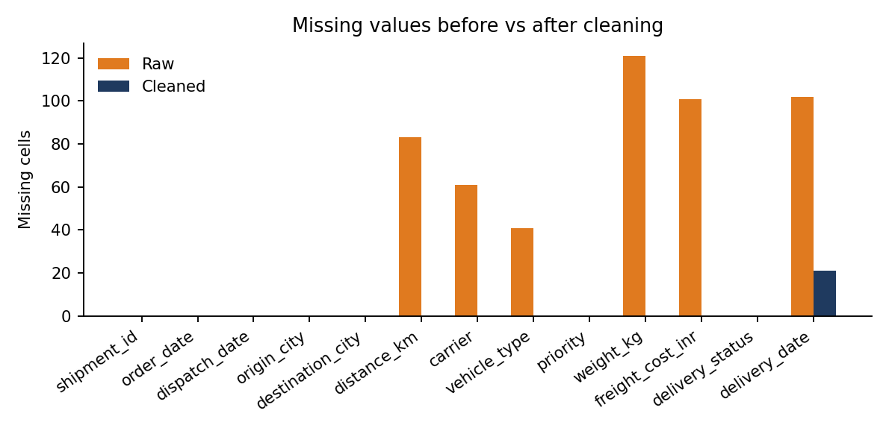
Figure 1. Missing cells per column before and after cleaning (the 21 remaining delivery dates are In Transit shipments).

4.5 Detecting and treating outliers
Problem. After the impossible values were removed, extreme values remained, and the raw data show how damaging they are: the largest raw weight is 2,198,860 kg and the largest freight cost is ₹1,468,782. A single such value moves an average and dominates any distance-based or squared-error method.
Technique. Three different treatments are used, because the three variables behave differently.
- Weight (cap). The IQR rule (values outside Q1 − 1.5·IQR and Q3 + 1.5·IQR) is applied on the logarithmic scale and separately per vehicle type, because weights are right-skewed and differ greatly between vehicles. Values beyond the fences are winsorised (capped) and flagged.
- Freight cost (correct). Cost depends on distance, weight and vehicle, so a simple IQR on cost would flag every long-haul trip. Instead a regression of log(cost) on log(distance), log(weight) and vehicle type is fitted, and shipments whose residual has a modified z-score above 3.5 (based on the median absolute deviation, Iglewicz and Hoaglin, 1993) are replaced by the model's prediction.
- Delays (flag only). Late deliveries are the very phenomenon logistics teams want to study, so severe delays are flagged (severe_delay_flag) but never altered or removed.
Why this choice. Deleting all outliers would also delete real heavy shipments and real disruptions, producing an unrealistically smooth picture. Capping keeps the record but limits its influence; flagging preserves the signal. The method follows the nature of each variable instead of one rule for everything.
Impact. 20 weights were capped and 22 costs corrected; 73 severe delays were flagged and kept. The mean weight moved from 8,870 kg to 6,803 kg and the mean freight cost from ₹44,619 to ₹41,315, so the raw averages were overstated by roughly 30% and 8% respectively.
def iqr_bounds(x: pd.Series, k: float = 1.5) -> tuple[float, float]:
q1, q3 = x.quantile([0.25, 0.75])
iqr = q3 - q1
return q1 - k * iqr, q3 + k * iqr

def cap_outliers(df: pd.DataFrame, col: str, group: str, k: float = 1.5) -> pd.DataFrame:
"""Winsorise on the log scale per group; adds <col>_outlier flag."""
df = df.copy()
logged = np.log(df[col])
flag = pd.Series(False, index=df.index)
for _, idx in df.groupby(group).groups.items():
lo, hi = iqr_bounds(logged.loc[idx], k)
flag.loc[idx] = (logged.loc[idx] < lo) | (logged.loc[idx] > hi)
logged.loc[idx] = logged.loc[idx].clip(lo, hi)
df[f"{col}_outlier"] = flag
df[col] = np.exp(logged).round(1)
return df

def correct_cost_outliers(df: pd.DataFrame, z_thresh: float = 3.5) -> pd.DataFrame:
"""
Freight cost depends on distance, weight and vehicle, so a plain IQR on cost
would flag every long-haul shipment. Instead: fit log(cost) ~ log(distance)
+ log(weight) + vehicle, and flag shipments whose residual is extreme
(modified z-score based on MAD > 3.5). Flagged costs are replaced by the
model's prediction (fit again without the flagged rows).
"""
df = df.copy()
X = pd.get_dummies(df["vehicle_type"], dtype=float)
X["log_dist"], X["log_wt"] = np.log(df["distance_km"]), np.log(df["weight_kg"])
y = np.log(df["freight_cost_inr"])

def fit(mask):
beta, *_ = np.linalg.lstsq(X[mask].to_numpy(), y[mask].to_numpy(), rcond=None)
return X.to_numpy() @ beta

keep = pd.Series(True, index=df.index)
for _ in range(2): # 2 passes: robust to the outliers themselves
resid = y - fit(keep)
mad = (resid[keep] - resid[keep].median()).abs().median()
z = 0.6745 * (resid - resid[keep].median()) / mad
keep = (z.abs() <= z_thresh) | (df["vehicle_type"] == "Unknown") # model is meaningless for mixed 'Unknown'
df["cost_outlier"] = ~keep
df.loc[~keep, "freight_cost_inr"] = np.exp(fit(keep))[~keep].round(0)
return df

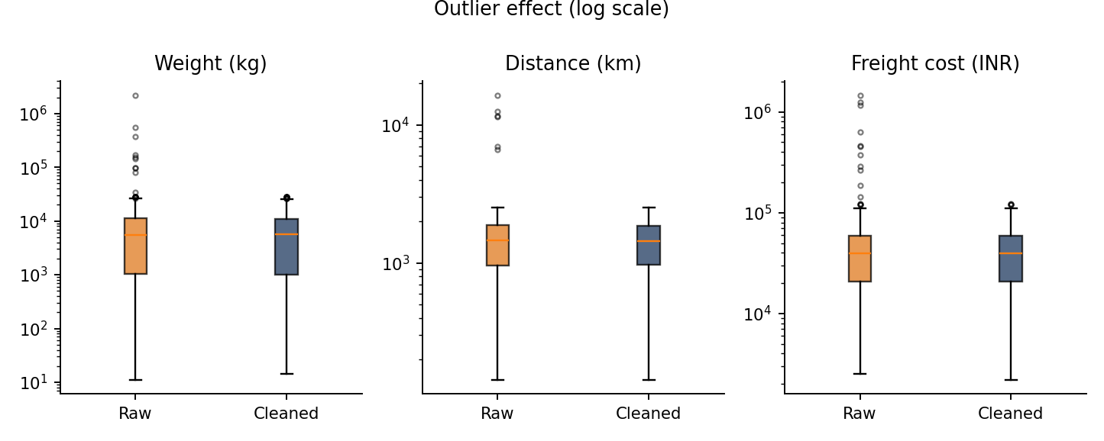
Figure 2. Box plots (log scale) of weight, distance and cost before and after treatment.

4.6 Feature engineering
Raw dates and amounts are converted into the quantities logistics teams actually monitor: transit_days (delivery minus dispatch), expected_transit_days (distance divided by the vehicle's typical daily distance), delay_days (actual minus expected), is_late, cost_per_km, dispatch_lag_days and order_month. These turn a table of records into measurable service and cost KPIs, and they are the basis of any later delay-prediction or cost model.
def add_features(df: pd.DataFrame) -> pd.DataFrame:
df = df.copy()
df["dispatch_lag_days"] = (df["dispatch_date"] - df["order_date"]).dt.days
df["transit_days"] = (df["delivery_date"] - df["dispatch_date"]).dt.days
df["expected_transit_days"] = expected_transit(df)
df["delay_days"] = df["transit_days"] - df["expected_transit_days"]
df["is_late"] = np.where(df["delay_days"].isna(), np.nan, (df["delay_days"] > 0).astype(float))
df["cost_per_km"] = (df["freight_cost_inr"] / df["distance_km"]).round(2)
df["order_month"] = df["order_date"].dt.month

late = df.loc[df["delay_days"] > 0, "delay_days"] # IQR among LATE shipments only
_, hi = iqr_bounds(late, k=1.5) # (most shipments have 0 delay -> IQR = 0)
df["severe_delay_flag"] = df["delay_days"] > hi # FLAG only - genuine delays are signal
return df

4.7 Normalisation
Problem. Weight is measured in thousands, distance in hundreds and delay in single digits. Algorithms that rely on distances or gradients (k-means, k-NN, SVM, regression with regularisation, neural networks) would be dominated by the largest-scale variable. Weight and cost are also strongly right-skewed.
Technique. Skewed variables (weight, distance, cost) are log-transformed with log1p and then Min-Max scaled to the range 0 to 1. Transit and delay days, which are roughly symmetric, are standardised with the Z-score (mean 0, standard deviation 1). Missing values (In Transit) pass through the scalers unchanged.
Why this choice. Min-Max after a log transform compresses the long tail so that a few very heavy shipments do not squeeze all other values into a narrow band near zero. Z-scores suit variables that will feed methods assuming centred data. The original columns are kept next to the scaled ones (_norm and _z suffixes) so reports remain in real units.
Impact. All scaled variables now carry comparable weight in a model. Scaling is not needed for tree-based models, so the original columns remain available. When this is used for machine learning, scalers must be fitted on the training split only to avoid data leakage.
def normalise(df: pd.DataFrame) -> pd.DataFrame:
df = df.copy()
for col in ["weight_kg", "distance_km", "freight_cost_inr"]: # right-skewed -> log then Min-Max
df[f"{col}_norm"] = MinMaxScaler().fit_transform(np.log1p(df[[col]]))[:, 0]
for col in ["transit_days", "delay_days"]: # roughly symmetric -> Z-score
df[f"{col}_z"] = StandardScaler().fit_transform(df[[col]])[:, 0] # NaN (in transit) is preserved
return df

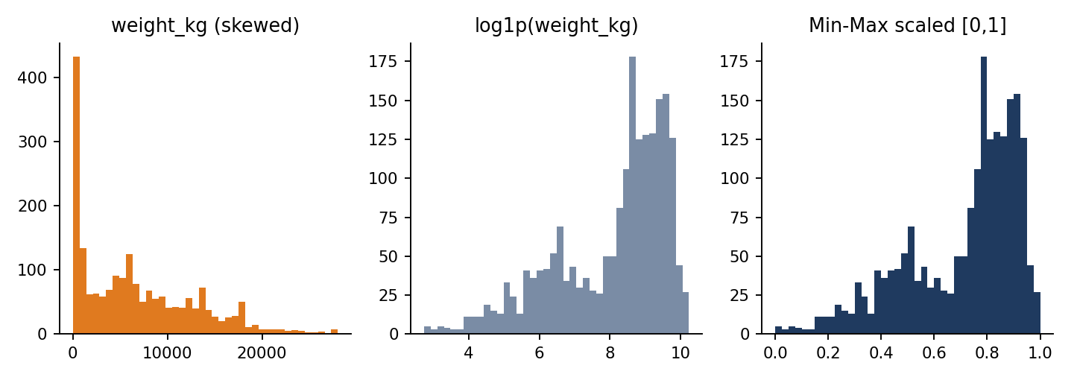
Figure 3. Weight before scaling (skewed), after log transform, and after Min-Max scaling.

5. The Complete Pipeline
The individual functions are chained in a single run() function. Every stage records what it changed in a JSON data-quality report, which makes the cleaning auditable and repeatable. The full script is provided in logistics_preprocessing.py.
def run(input_path, output_path):
raw = load_raw(input_path) # 1. load as text
report = {"raw": audit(raw)} # 2. audit before touching anything
df = standardise(raw) # 3. labels, numbers, dates
df = drop_duplicates(df) # 4. one row per shipment
df, report["rule_violations"] = apply_business_rules(df) # 5. impossible -> NaN
df, report["imputation"] = impute(df) # 6. domain-aware imputation
df = cap_outliers(df, "weight_kg", "vehicle_type") # 7a. weight: cap
df = correct_cost_outliers(df) # 7b. cost: model residual
df = add_features(df) # 8. KPIs and flags
df = normalise(df) # 9. scaling
df.to_csv(output_path, index=False) # 10. export + report + figures
return df

Run from the command line with: python logistics_preprocessing.py --input logistics_raw.csv --output logistics_cleaned.csv

6. Results: Before and After
Measure | Raw data | Cleaned data
Records | 2,045 | 2,000
Duplicate shipment IDs | 45 | 0
Spellings: destination city / carrier / status | 34 / 26 / 9 | 11 / 5 (+Unknown) / 3
Impossible values | 40 | 0
Missing values in key fields | Present in 6 fields | 0 (21 In Transit dates correctly empty)
Maximum weight (kg) | 2,198,860 | 28,000
Maximum distance (km) | 16,485 | 2,520
Maximum freight cost (INR) | 1,468,782 | 122,972
Mean freight cost (INR) | 44,619 | 41,315
Columns | 13 | 32 (flags, features, scaled values)

The cleaned dataset (logistics_cleaned.csv) is complete, consistently labelled, free of impossible values and contains engineered KPIs and scaled variables. All imputed or corrected values remain identifiable through flag columns.

7. Reflection: Why Data Quality Matters in Logistics

7.1 What clean data makes possible
On the cleaned data a basic service analysis is immediately meaningful. 22% of delivered shipments arrived later than expected, but the rate was 39.9% for orders placed in the monsoon months (July to September) against 16.2% in other months, and 16% for Express against 24% for Standard service. (These patterns were built into the simulation; the point is that they can only be seen, and acted on, when dates, labels and delays are correct.)
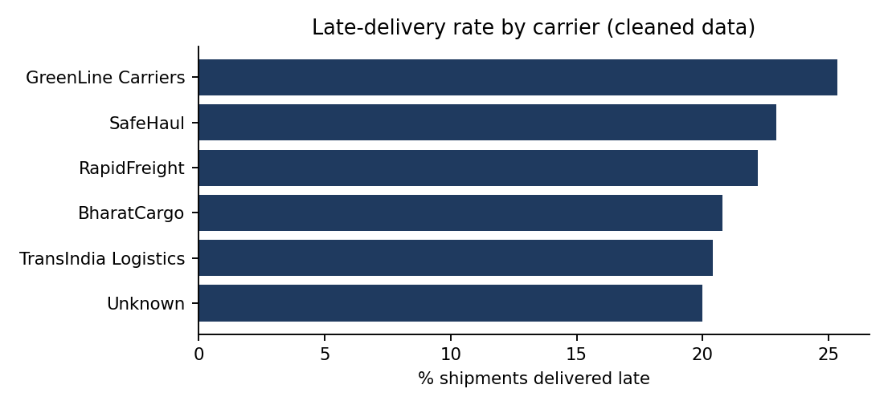
Figure 4. Share of late deliveries by carrier in the cleaned data.

7.2 What dirty data would have caused
- Wrong cost decisions. The raw average freight cost was about 8% too high because of a few mistyped values. A budget or rate negotiation built on it would be off by the same amount.
- Distorted carrier comparisons. With 26 spellings of five carriers, volume and on-time performance are scattered over many small groups, and the best or worst carrier cannot be identified.
- Inflated demand and capacity. Duplicate shipments overstate volume and could trigger unnecessary fleet or warehouse capacity.
- Broken forecasts and ETAs. Delivery dates before dispatch or 28 years in the future would corrupt average transit time, and any ETA model trained on them.
- Lost data or hidden bias. Deleting incomplete rows would remove 23.6% of shipments, and probably the harder cases, which makes performance look better than it is.

7.3 Principles learned
- Understand before you clean. Domain knowledge decides whether a value is an error (25,000 kg on a Mini Truck), a legitimate extreme (28 t container) or a legitimate gap (In Transit).
- Order matters. Standardise, de-duplicate, validate, impute, treat outliers, then scale.
- Prefer transparency to silent fixes. Flag every changed value and write a quality report, so results can be audited and the cleaning can be challenged.
- Match the method to the variable. Skewed amounts, dependent costs and meaningful delays each needed a different outlier approach.

7.4 Limitations and next steps
The data is simulated, so real data will contain errors that are less regular than those injected here. Median-based imputation slightly shrinks variance; multiple imputation or model-based imputation (for example scikit-learn's IterativeImputer or k-NN imputation) would be a natural improvement. Alias dictionaries need maintenance as new spellings appear, and in production the same checks should run automatically on every new data load (for example with Great Expectations or pandera) so that quality problems are caught at the source. Finally, scalers should be fitted only on training data when the dataset is used for machine learning.

8. Conclusion
This project built a documented, reproducible pipeline that turned a messy 2,045-row logistics export into 2,000 clean, consistent and analysis-ready shipment records. Each technique was chosen for a reason grounded in the logistics context: explicit alias and date handling for consistency, business rules for impossible values, route- and vehicle-aware imputation for missing data, variable-specific outlier treatment, and log plus Min-Max or Z-score scaling for modelling. The results show that data preparation is not a preliminary chore but a decisive part of analytics: the quality of every KPI, forecast and cost decision in a logistics network is bounded by the quality of the data it is built on.

References
- Constante, F., Silva, F., Pereira, A. (2019). DataCo Smart Supply Chain for Big Data Analysis. Mendeley Data / Kaggle.
- Iglewicz, B. and Hoaglin, D. (1993). How to Detect and Handle Outliers. ASQC Quality Press.
- Little, R. and Rubin, D. (2019). Statistical Analysis with Missing Data, 3rd ed. Wiley.
- Tukey, J. W. (1977). Exploratory Data Analysis. Addison-Wesley.
- The pandas development team. pandas documentation: Working with missing data. https://pandas.pydata.org/docs/
- scikit-learn developers. Preprocessing data (MinMaxScaler, StandardScaler). https://scikit-learn.org/stable/modules/preprocessing.html

Appendix A: Project Files
File | Purpose
README.md | Project overview shown on the GitHub page
logistics_preprocessing.py | Complete pipeline code
generate_raw_data.py | Creates the simulated raw dataset (seed 42)
logistics_raw.csv | Raw input data with injected quality problems
logistics_cleaned.csv | Output of the pipeline (2,000 rows × 32 columns)
reports/data_quality_report.json | Machine-readable summary of every cleaning step
figures/ | Charts used in this report
requirements.txt | Python libraries needed (pandas, numpy, scikit-learn, matplotlib)
Week2_Logistics_Project.docx | This report

