BUSINESS STRATEGY & INVESTMENT REPORT
AI-Assisted Design-to-Code Service
Market: India | Stage: Pre-Revenue MVP
Prepared by: AI Co-Founder & Growth Strategy Advisor
Source: Customer & MVP Blueprint (Day 23)
Date: July 29, 2026
🟡 VERDICT: VALIDATE
Composite Score: 40 / 100

Table of Contents

1. Startup Summary
- Service converts client design mockups (Figma/XD) into production-ready front-end code using AI-assisted workflows (Cursor, v0, Bolt) — not a proprietary AI model.
- Positioned as faster and cheaper than hiring a developer, using freelancers, or hiring an agency.
- Target market: India — bootstrapped/seed-stage startups, small digital agencies, and solo designers without in-house dev support.
- Zero paying clients to date; validation so far is informal conversations only.
- MVP is explicitly service-first: a portfolio site, one fixed-price package, and an intake form — no SaaS platform, no billing system, no custom AI model.
- Pricing hypothesis: ₹15,000–₹50,000 per project; ₹25,000–₹75,000/month retainer as a later upsell.
- 30-day goal: convert existing warm leads into 5 paid pilot projects, 4.5+/5 rating, sub-5-day turnaround.
- Primary distribution channel is the founder's personal network and warm outreach, supplemented by LinkedIn/X content.
- Founder's own internal scoring rates Customer Clarity 55, Problem Severity 70, PMF Potential 45, MVP Readiness 60.
- Founder's own verdict: "Promising but Unvalidated" — matches our independent assessment below.

2. Extracted Assumptions

Customer
Early-stage founders, small agencies, and freelance designers in India, 1-20 people, ₹15,000-₹1,50,000 budget per project, high pain (blocked on launch), low-to-medium tech maturity.

MVP
A portfolio/landing page with 2-3 before/after conversions, one fixed-scope fixed-price package (5-page site, 5-day delivery), and a lightweight intake form. Explicitly excludes a self-serve SaaS platform, custom AI tooling, and subscription billing.

Value Proposition
Faster and more affordable delivery than agencies or freelancers, with more reliability and communication clarity than typical freelancers, using AI tools to compress delivery time.

Pricing
Flat per-project pricing anchored 2-3x below agency rates; a monthly retainer is a stated future option, not part of the initial offer.

Revenue
Revenue model is entirely project-based services income at this stage. No recurring revenue exists yet; retainers are aspirational. There is no unit economics data (cost to deliver a project, hours spent, AI tooling cost, cleanup time) provided in the source document — this is a significant gap.

Go-To-Market
GTM is founder-led manual outreach to 20-30 warm leads in the first month, supplemented by content on LinkedIn/X and founder communities (Reddit, IndieHackers). There is no paid acquisition, SEO, or partnership channel defined.

3. Business Reality Check

Who pays?
The buyer is the founder, product manager, or creative director at a small, resource-constrained company who needs a design turned into working code and has no in-house developer. This is a believable, well-defined buyer — but none has paid yet.

Why do they pay?
They pay to avoid the time cost and risk of hiring, managing, or vetting a freelancer or agency, and to hit a launch deadline. The trigger is urgency (a deadline or a bad prior experience), not a considered vendor evaluation — which favors fast, low-friction closing but also means the relationship is transactional and price-sensitive by default.

How will they discover the product?
Almost entirely through the founder's own network and manual outreach in month one. Content on LinkedIn/X and founder communities is a secondary, unproven channel with no stated content plan, cadence, or distribution edge. There is no channel here that doesn't depend on the founder's personal time and social capital.

Biggest growth risks
- The GTM plan has exactly one real channel (warm network) that does not scale past roughly 20-30 people and cannot be repeated indefinitely.
- No content, SEO, or partnership engine exists to replace warm outreach once the network is exhausted.
- The service is easy to describe but easy to copy — any freelancer with the same AI tools can make the same pitch.

Biggest monetization risks
- No unit economics: the blueprint gives a price range but no data on actual delivery cost (hours + AI tool cost + manual cleanup time), so margin is unknown.
- Fixed-price plus undefined scope is a classic services trap — scope creep on "unlimited revisions" can erase margin project by project.
- Retainer revenue, the only path to recurring income, is entirely aspirational with no evidence any client will convert to it.

Weakest assumptions to validate first
- That informal interest converts into actual payment at the stated price point — untested.
- That AI-generated code needs little enough manual cleanup to preserve margin — untested, and flagged as a top-5 risk by the founder.
- That warm-network leads convert at a rate that makes the 30-day plan realistic (5 paid pilots from 20-30 leads is a ~17-25% close rate, which is optimistic for a new, unproven vendor).

4. Business Strategy Report

4.1 Executive Summary
This is a founder-led services business, not yet a scalable startup. The problem — Indian founders and agencies needing fast, affordable front-end execution — is real and well-understood, and the MVP plan is appropriately lean (no premature platform-building). However, the business currently has zero paying customers, no unit economics, and a go-to-market plan that depends entirely on one non-repeatable channel: the founder's personal network. The correct near-term move is not to raise money or scale, but to close 3-5 paid pilots in the next 30 days, measure actual delivery cost and client conversion rate, and only then decide whether this becomes a productized service, a small agency, or a true venture-scale business.

4.2 Business Model Canvas
Block | Details
Key Partners | AI coding tools (Cursor, v0, Bolt); Razorpay/UPI for payments; freelance QA help if scaling
Key Activities | Design-to-code conversion, client scoping, QA/cleanup of AI output, outreach
Key Resources | Founder's own dev/design skill, AI tool subscriptions, portfolio site, personal network
Value Propositions | Faster and cheaper than agencies/freelancers; more reliable communication and delivery
Customer Relationships | Direct, high-touch per project (WhatsApp/Slack); referral-based repeat relationships
Channels | Warm network outreach, LinkedIn/X content, founder communities (Reddit, IndieHackers)
Customer Segments | Bootstrapped/seed-funded India startups, small digital agencies, solo designers
Cost Structure | AI tool subscriptions, founder's time, payment gateway fees; no major fixed cost
Revenue Streams | Fixed-price projects (₹15k-50k); future monthly retainers (₹25k-75k)

4.3 Revenue & Pricing Strategy
The stated pricing (₹15,000-₹50,000 per project, anchored 2-3x below agency rates) is a reasonable starting hypothesis for the Indian market, but it is untested and unsupported by cost data. Before scaling outreach, the founder should price the first 2-3 pilot projects deliberately close to the top of the range to test willingness to pay, track actual hours and AI-tool cost per project to compute true margin, and only then decide whether ₹15,000 entry-tier projects are worth taking at all. Retainer pricing should not be offered until at least one client has completed a project and explicitly asked for ongoing work — leading with a retainer pitch before trust is built is a common and avoidable mistake.

4.4 Go-To-Market Strategy
Phase | Action | Goal
Week 1 | Finalize 1 fixed-price package, build 1-page portfolio, set up Razorpay/UPI | Ready to sell
Week 2 | Direct outreach to 20-30 warm leads; start LinkedIn/X posting | Generate pilot leads
Week 3 | Deliver 2-3 pilot projects, track hours/cost, collect testimonials | Prove delivery + margin
Week 4 | Ask for referrals; refine offer; decide productize vs. scale-service | Decide next 30 days

4.5 Customer Acquisition Strategy
- Primary: direct, personal outreach to the founder's existing network — highest conversion, but not repeatable at scale.
- Secondary: LinkedIn/X before-after content to build a small inbound trickle and social proof for later cycles.
- Tertiary: founder communities (Reddit, IndieHackers) — good for credibility-building, weak for direct lead volume.
- Recommended addition: ask every pilot client for one specific warm introduction, not just "a referral" — specificity roughly doubles referral conversion in services businesses.

4.6 First 100 Users Plan
For a services business at this price point, "100 users" is the wrong frame — the real target is the first 10 paying clients, since each one requires founder-hours to deliver. The realistic sequence: (1) convert 5 existing warm conversations into paid pilots in 30 days, (2) use those 5 case studies and testimonials to close 5 more from second-degree referrals over the following 30-60 days, (3) at 10 completed projects, decide whether to raise prices, hire help, or begin productizing a repeatable component library. Chasing broad top-of-funnel volume before this point would waste effort the founder doesn't have to spare.

4.7 Competitive Position & Moat
There is effectively no moat today. Any freelancer or small agency with access to Cursor, v0, or Bolt can make the identical pitch of faster, AI-assisted, cheaper delivery. The founder's only current edge is personal execution speed, communication reliability, and existing relationships — all real but not defensible or scalable. A genuine moat would require one of: a proprietary QA/cleanup layer that reliably fixes AI-code gaps, a reusable component library specialized to one vertical (e.g., D2C landing pages, SaaS marketing sites), or accumulated case-study and referral trust concentrated in a specific niche rather than "design-to-code in general."

4.8 Reverse SWOT Analysis
A reverse SWOT stress-tests the business by asking what would have to be true for each quadrant to flip.
Quadrant | What Would Have To Be True
Strength → Weakness | "AI-assisted speed" becomes a weakness the moment a client's competitor uses the same tools for free or cheaper — speed alone stops differentiating within 6-12 months as AI coding tools commoditize.
Weakness → Strength | Zero paying clients could become a strength if the founder uses this pre-revenue period to test 3-4 pricing/positioning variants cheaply, arriving at a validated offer competitors haven't found.
Opportunity → Threat | The large India SMB/startup market is also what invites 100 other freelancers to copy this exact pitch — the same market size that creates opportunity also guarantees fast commoditization.
Threat → Opportunity | AI code quality gaps (a stated risk) could become the moat if the founder builds a genuine, documented QA process around it — turning the industry's biggest weakness into this business's specific strength.

4.9 Investor One-Liner
"We help India's resource-constrained founders and agencies turn a design file into shipped, production-ready code in under five days, at a fraction of agency cost."

4.10 30-Second Founder Pitch
"Every founder I know has a Figma file and no developer. Freelancers ghost them, agencies overcharge them, and they lose weeks they don't have before launch. I use AI coding tools to turn a design into working front-end code in under five days, at a third of agency pricing, with a clear fixed scope so there are no surprises. I'm currently converting my first pilot clients from warm conversations into paid projects to prove this works before I think about scaling it."

5. Founder Action Sheet — Top 10 Actions
# | Action | Why It Matters
1 | Finalize one clear service package (scope, price, timeline) and stop iterating on it | Removes decision fatigue and lets outreach start immediately
2 | Ship a 1-page portfolio site with 2-3 before/after conversions | Gives leads something concrete to evaluate instantly
3 | List and directly message 20 warm leads this week | Only proven channel — must be exhausted, not delayed
4 | Set up Razorpay/UPI so payment is frictionless the moment someone says yes | Removes a common last-mile drop-off point
5 | Build a simple intake form (Google Form/Typeform) | Standardizes scoping and reduces founder time per lead
6 | Convert the 5 people who expressed informal interest into signed pilots this month | This is the single highest-leverage action available right now
7 | Track actual hours + AI tool cost per project from pilot #1 onward | The business has no real margin data — this must start immediately
8 | Deliver the first project fast and turn it into a documented case study | Case studies are the only credible proof point a new brand has
9 | Ask every client for one specific referral, not a general one | Specific asks convert meaningfully better than open-ended ones
10 | After 5 completed projects, explicitly decide: productize, hire, or stay solo | Prevents drifting indefinitely as an undifferentiated freelancer

6. Investment Scorecard
Dimension | Score | Reasoning
Business Viability | 48 / 100 | Real problem and defined buyer, but zero revenue proof and no cost/margin data.
Revenue Potential | 42 / 100 | Pricing hypothesis is reasonable but unvalidated; retainer upside is speculative.
GTM Strength | 58 / 100 | The 30-day plan is concrete and executable, but relies on a single, non-repeatable channel.
Competitive Strength | 30 / 100 | No moat; the core service is easily replicated by any freelancer using the same AI tools.
Investor Readiness | 22 / 100 | Pre-revenue services business with no traction data — not fundable in its current form; not seeking VC-style scale yet either.
Composite Average: 40 / 100 → 🟡 Validate

7. Visual Dashboard
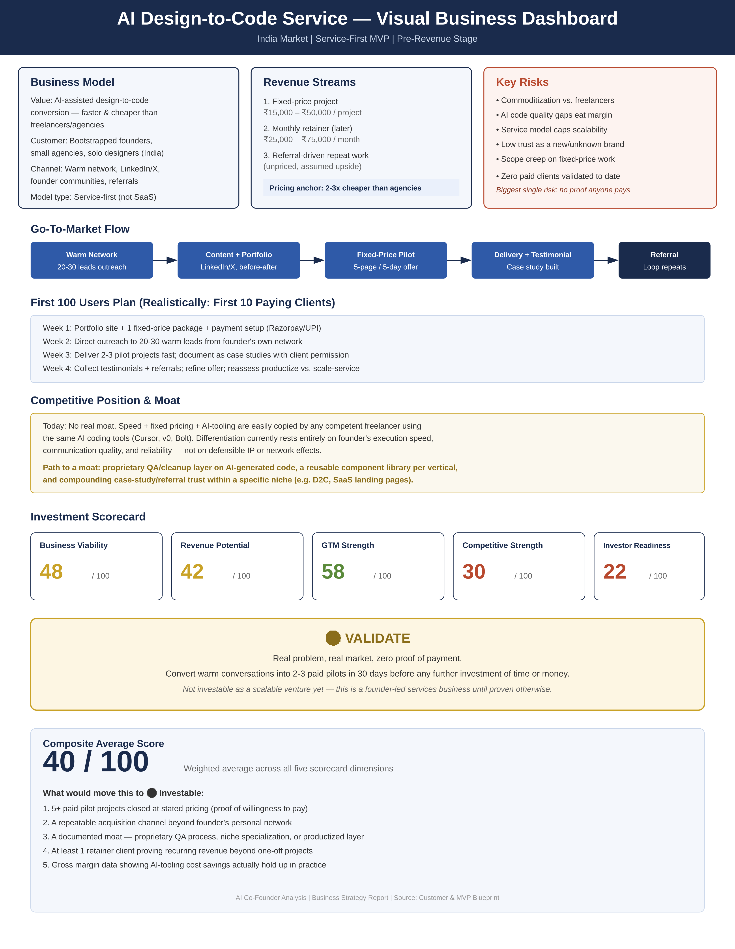

8. Sustainability Verdict
This can become a sustainable, profitable founder-led business, but it is not yet a proven one and is not, in its current form, a venture-scale opportunity. The problem is real, the MVP is appropriately minimal, and the 30-day pilot plan is the right next step — but until 3-5 paid projects close, actual delivery margin is measured, and a second acquisition channel exists beyond the founder's personal network, this remains a validate-stage bet, not an investable one.

