ALIBABA STOCK PRICE PREDICTION

Project Description:
Stock price prediction is one of the most complex and highly sought-after problems in financial analysis. With the rapid development of machine learning and data analytics techniques, predicting stock prices has become more feasible. This project focuses on predicting the future stock prices of Alibaba Group (BABA) by applying machine learning and time-series analysis techniques to historical stock data and external factors that influence market dynamics. Accurate stock price prediction can be of immense value to investors, helping them make more informed trading decisions.
Approach:
In this project, we seek to predict the stock prices of Alibaba Group (BABA) using a combination of time-series forecasting methods and machine learning models. The approach is grounded in the theory of stock price movements, machine learning algorithms, and financial analysis. The core idea is to leverage both historical stock data and external market factors, such as economic indicators and sentiment analysis, to make accurate predictions about future stock prices.

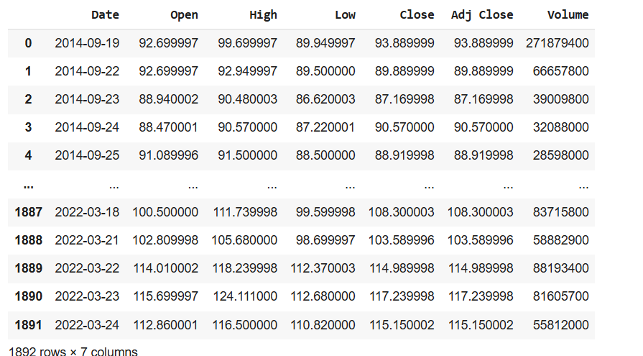

Technical Architecture:

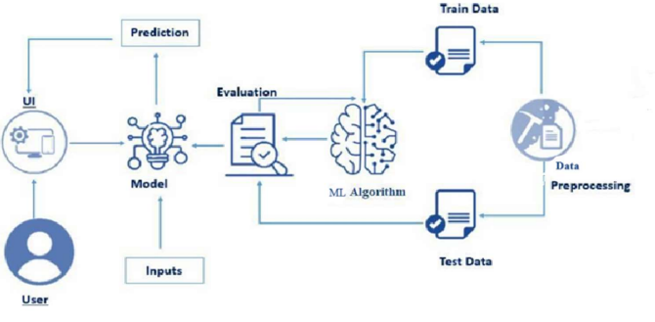
Prerequisites:
To successfully complete the Tesla Stock Prediction project, you will need the following software, concepts, and packages:
- Software and Tools:
  - Python programming environment (e.g., Jupyter Notebook, Google collab PyCharm, or VS Code)
  - Data visualization tools (e.g., Matplotlib, Seaborn, or Plotly)
  - Machine learning libraries (e.g., TensorFlow, Scikit-learn)
- Concepts:
  - Fundamentals of stock market data (e.g., opening/closing prices, trading volume)
  - Time-series analysis and forecasting principles
  - Machine learning concepts.
  - Model evaluation metrics (e.g., RMSE, MAE, and R-squared)
- Packages:
  - Data manipulation: Pandas, NumPy
  - Visualization: Matplotlib, Seaborn, Plotly
  - Machine Learning: Scikit-learn.
Familiarity with these tools and concepts will ensure efficient implementation and successful project execution.

Project Objectives:
By the end of this project, you will have the skills to collect and preprocess historical stock data, including handling missing values and feature engineering. You will learn how to apply machine learning techniques. You will evaluate model performance using key metrics like RMSE, MAE, and R-squared, ensuring the models are accurate and reliable. Additionally, you will gain experience in the prediction process. You will create visualizations to interpret stock trends and prediction results effectively. This project will provide you with hands-on experience in financial machine learning and data-driven decision-making.
Project Flow:
- Data Collection:
  - Gather historical stock price data for Alibaba (BABA) from financial APIs.
  - Collect external factors like market indices, interest rates, and news sentiment data that could impact stock prices.
- Data Preprocessing:
  - Clean the data by handling missing values, removing outliers, and normalizing features.
  - Perform feature engineering, creating relevant technical indicators (e.g., moving averages, RSI) to enhance model performance.
- Model Selection:
  - Choose appropriate models for prediction.
- Model Training & Evaluation:
  - Train the selected models on the preprocessed data.
  - Evaluate model performance using metrics such as RMSE, MAE, and R-squared.
- Model Optimization:
  - Fine-tune hyperparameters and test different configurations to improve model accuracy.
- Prediction & Visualization:
  - Use the trained models to make stock price predictions and visualize the results using Matplotlib, Seaborn, or Plotly.
- Testing & Deployment:
  - Test the complete solution to ensure all components work seamlessly.
  - Deploy the dashboard for real-time stock price prediction.
- Final Presentation:
- Summarize the findings, model performance, and potential applications of the project, presenting the results to stakeholders or users.
Project Structure:
Milestone 1: Data Collection
- Gather historical stock data for Alibaba from the Kaggle dataset, including attributes such as date, open price, close price, high, low, volume, and other relevant financial indicators.

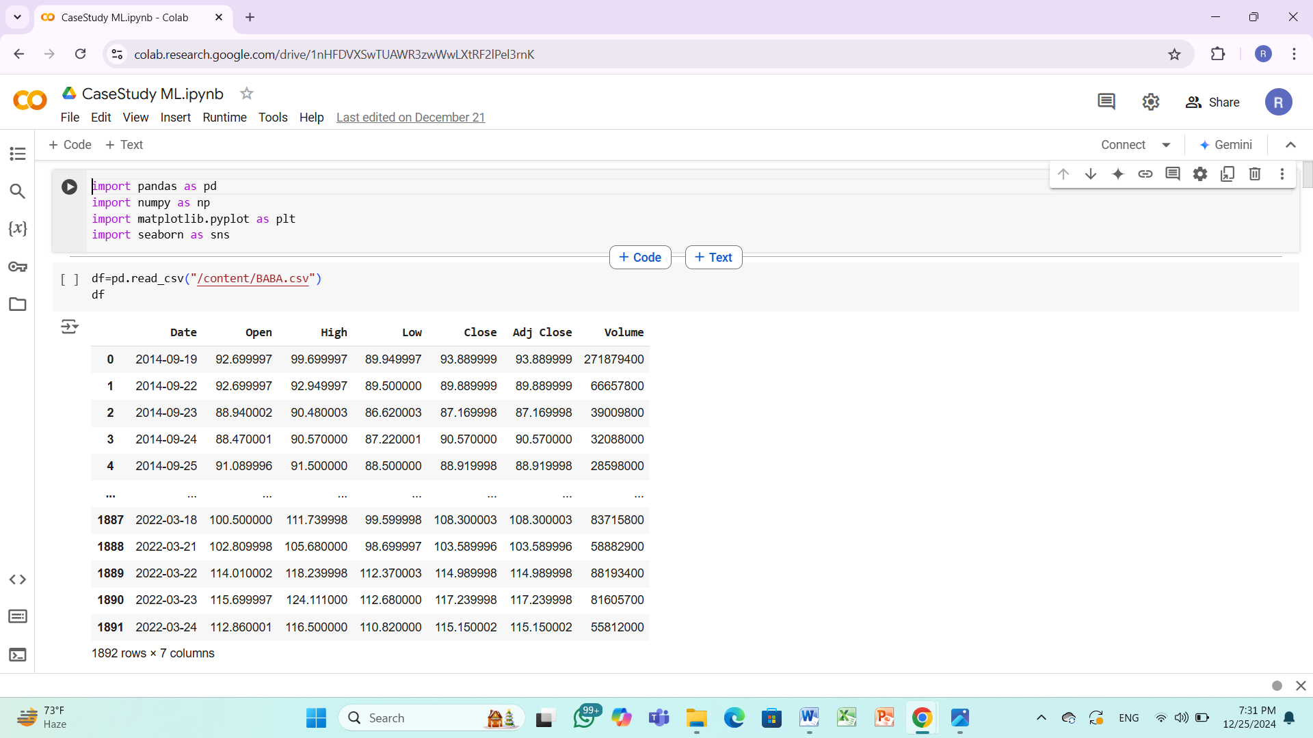

Milestone 2: Data Preprocessing
• Identify and handle missing values.
• Analyze correlations and feature distributions.
• Normalize, encode, and scale features as needed.

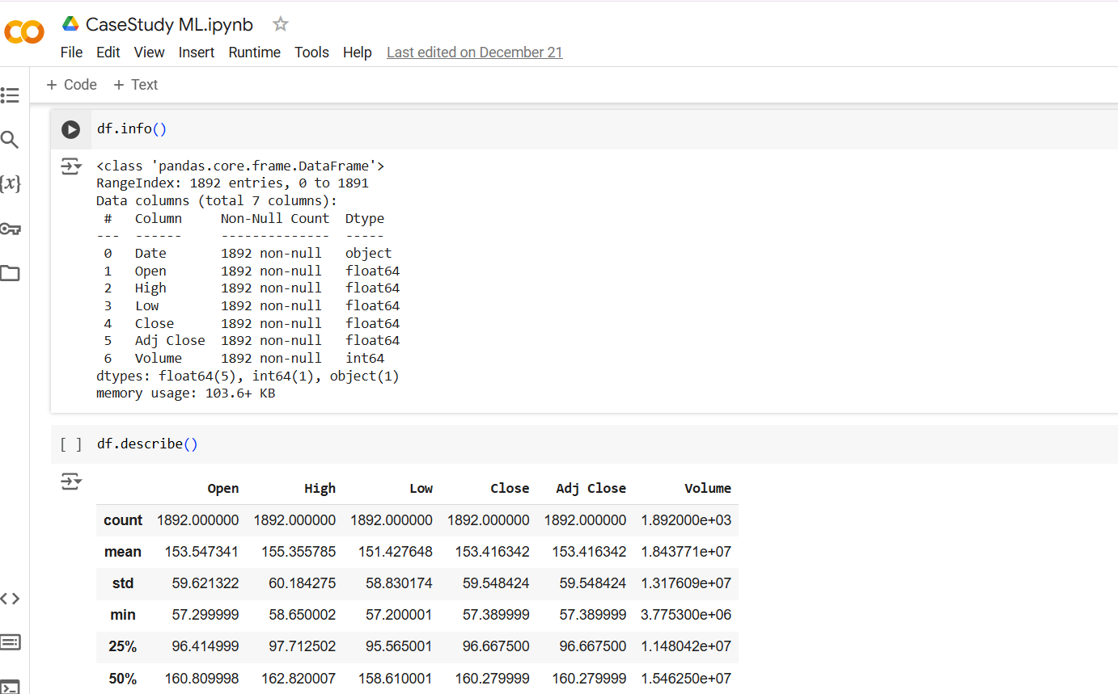

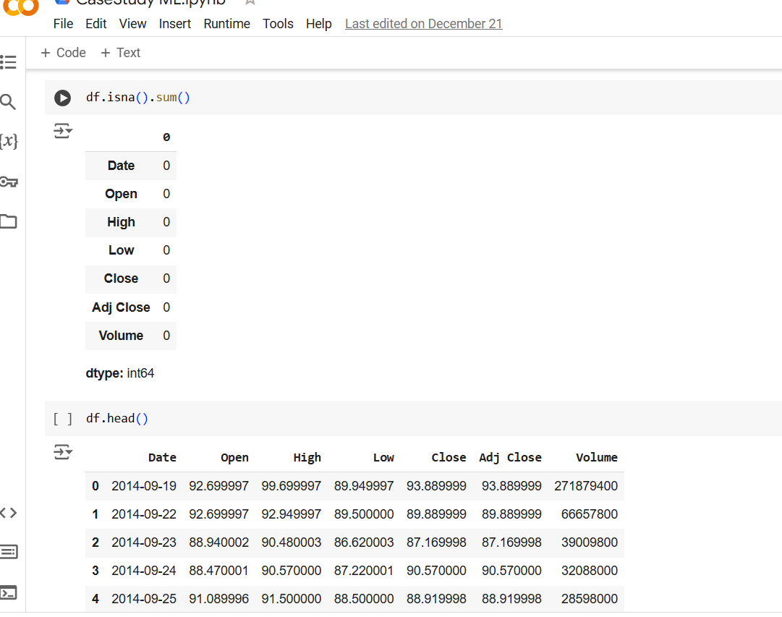
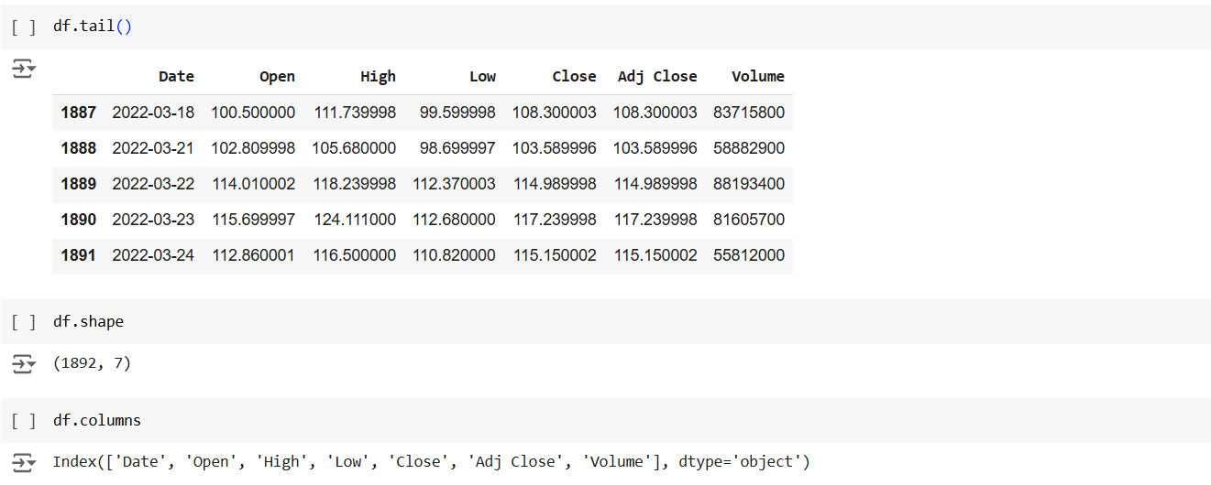
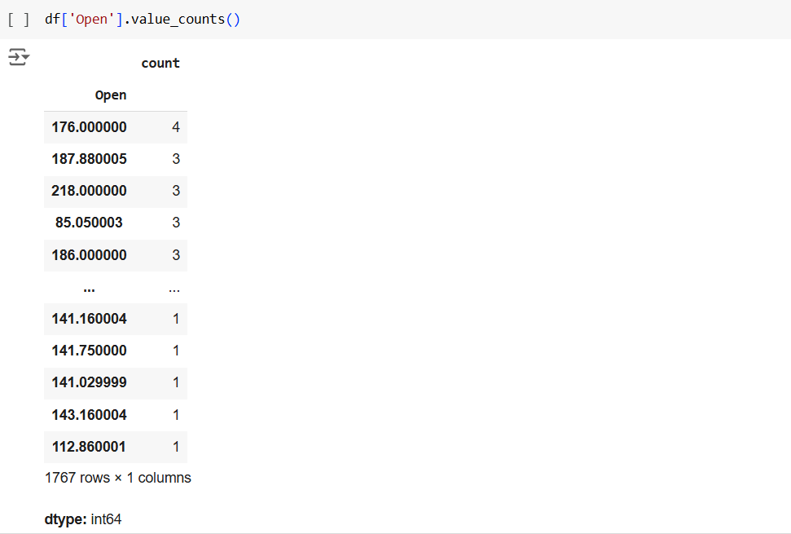

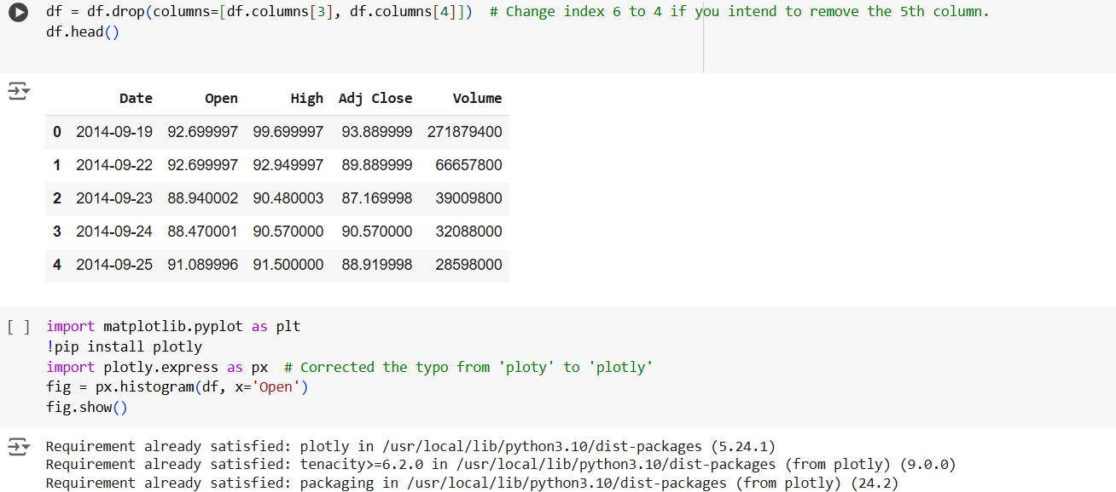

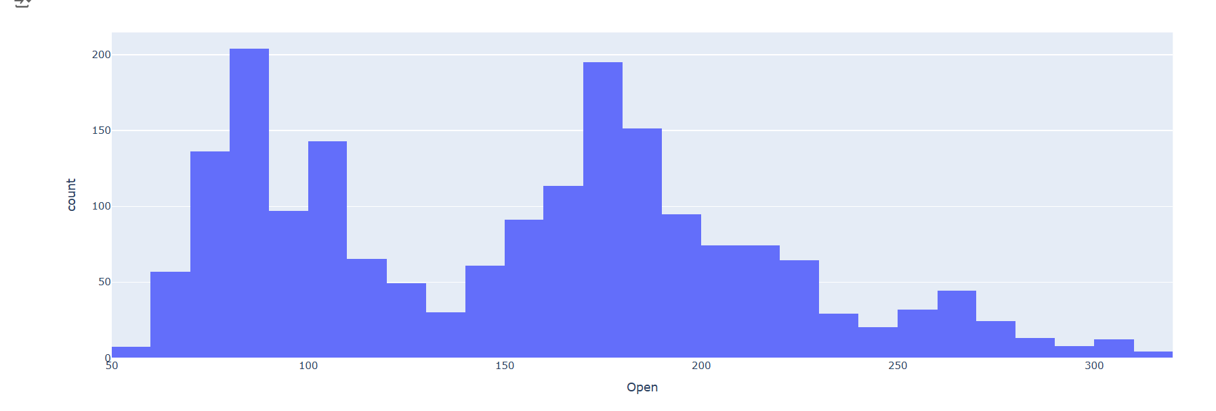

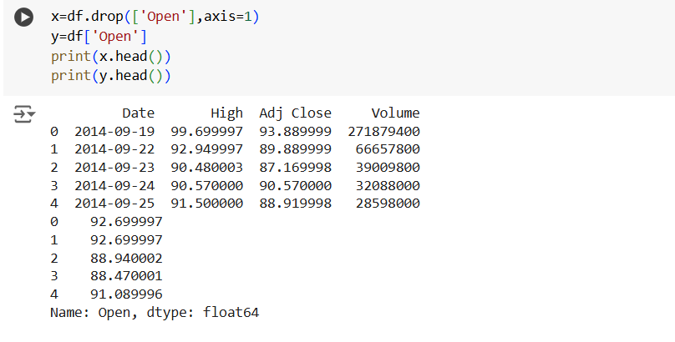

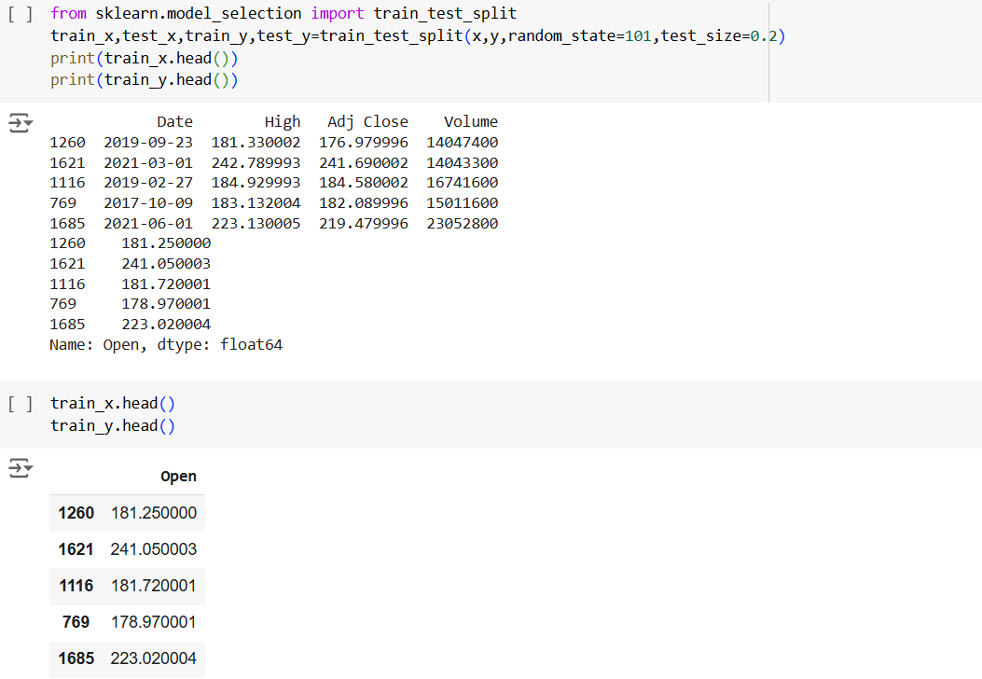
Milestone 3: Model Building
- Linear Regression: Predict future stock prices based on historical data.
- Decision Tree: Capture non-linear patterns in stock price movements.
- K-Means: Cluster trading days with similar patterns in prices and volumes.
- KNN: Predict stock price trends by analyzing similar historical patterns.
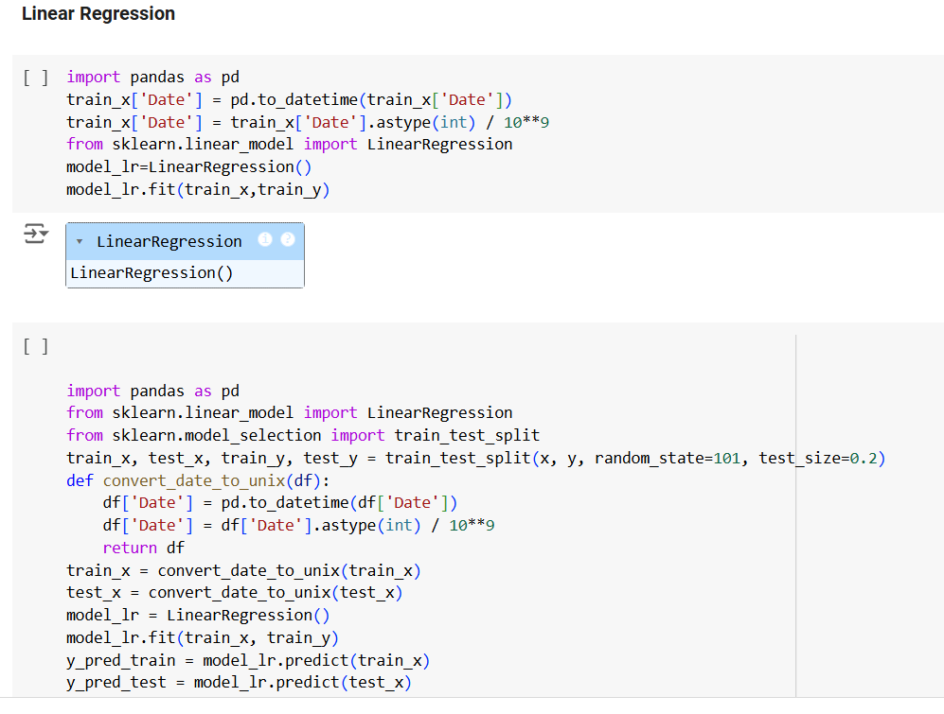

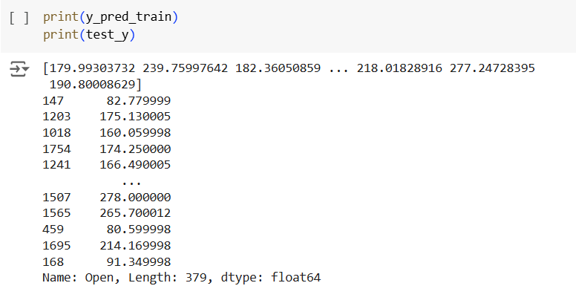
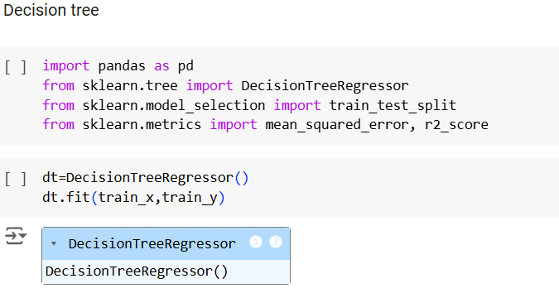

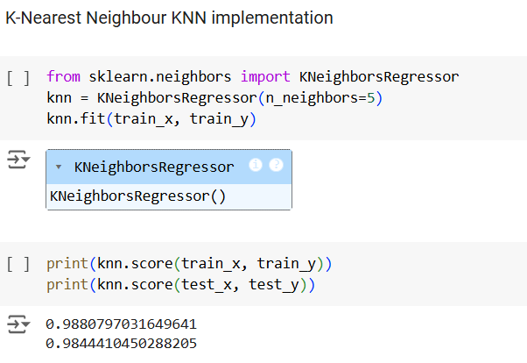

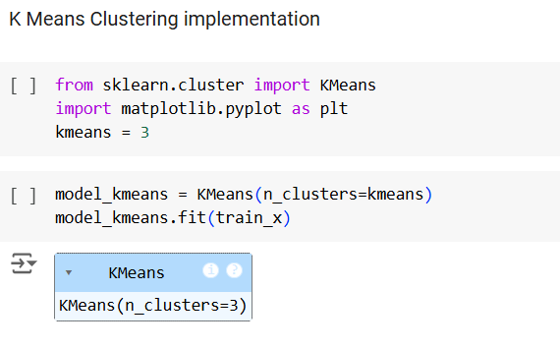

Milestone 4: Model Evaluation
- Model Evaluation for this project focuses on assessing how well the trained model predicts severity levels using metrics like accuracy, F1-score, and recall.
- A confusion matrix will help analyze the distribution of correct and incorrect predictions across the severity classes.

LINEARREGRESSION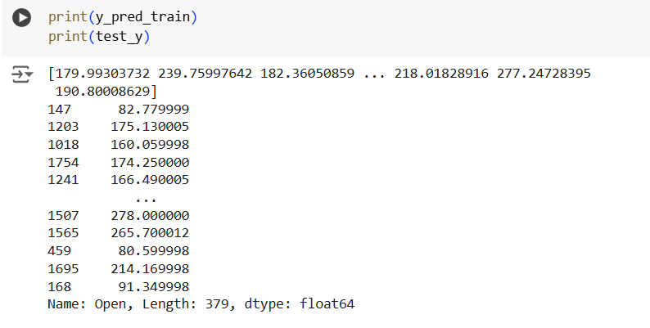
DECISION TREE
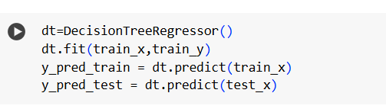
KNN
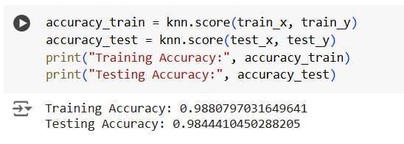
K-MEANS CLUSTERING

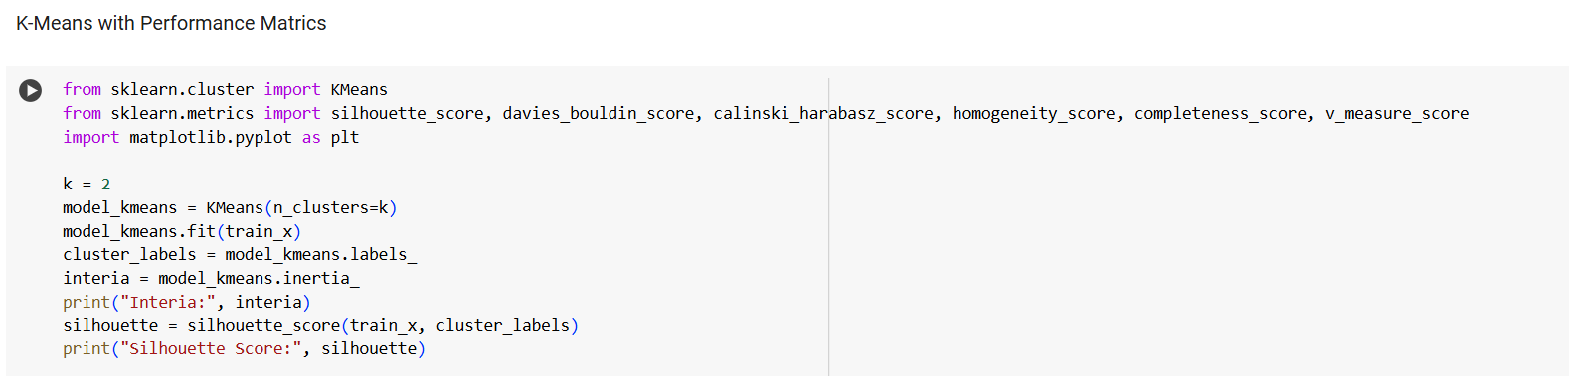
Milestone 5: Model Prediction
- Use the trained models to:
  - Predict Alibaba stock prices for upcoming days.
  - Identify clusters of similar market conditions.
Compare predictions with actual prices to analyze model performance.
LINEAR REGRESSION


DECISION TREE

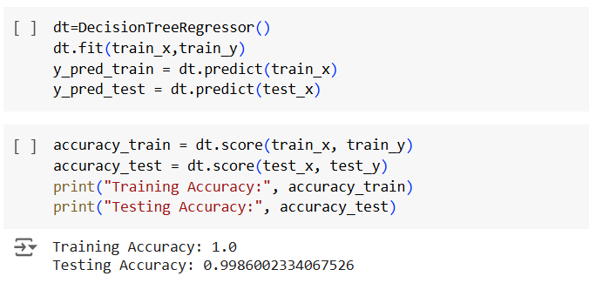

KNN
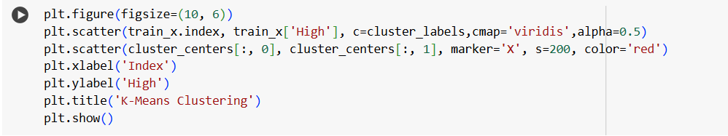
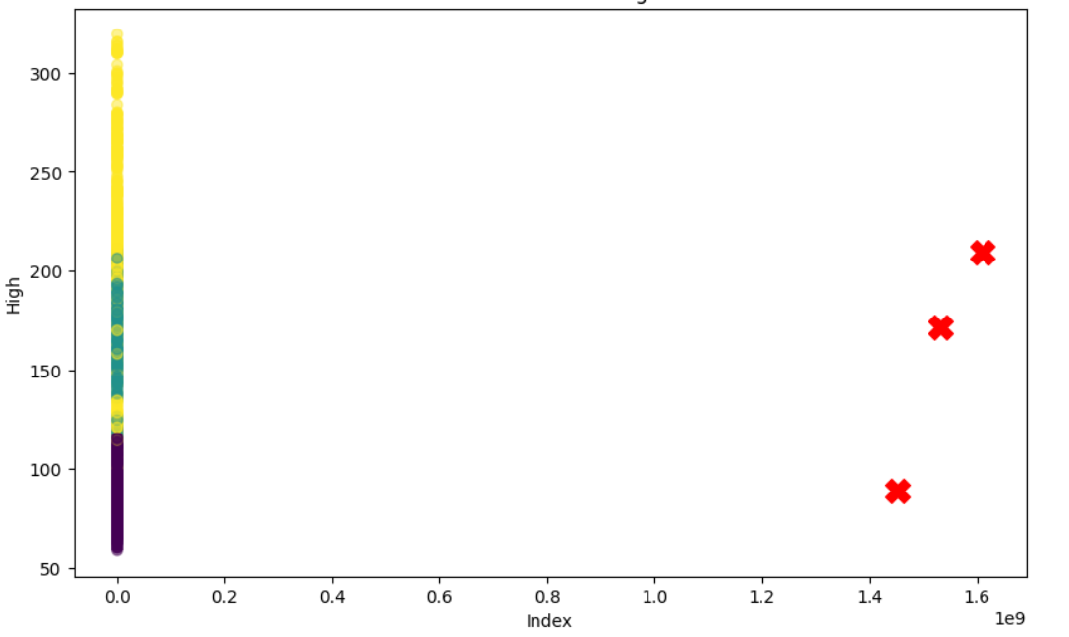
K-MEANS CLUSTERING
