VML25CSD009. ASSIGNMENT 2

Question :5
. A company has the following organisational hierarchy:
- CEO → HR, Finance, IT
- IT → Development, Testing
- Development → Frontend, Backend
5. a)Represent the given organisational hierarchy using a suitable tree data structure and implement its construction. Execute the program and display the hierarchy using level-order traversal.
b)Store the department names using a suitable searchable representation and compare Linear Search and Binary Search for locating a department. Record the number of comparisons for at least three searches.
c) Analyse:
- Tree height
- Traversal behaviour
- Search comparisons
- Time complexity of the selected operations
- Determine whether the chosen representation is suitable for organisational reporting and department searching.
Answers
5.a)
#include <stdio.h>
#include <stdlib.h>
#include <string.h>
Struct Node {
Char name[30];
Struct Node *children[10];
Int childCount;
};
Struct Node* createNode(char *name) {
Struct Node *n = (struct Node*) malloc(sizeof(struct Node));
Strcpy(n->name, name);
n->childCount = 0;
return n;
}
Void addChild(struct Node *parent, struct Node *child) {
Parent->children[parent->childCount] = child;
Parent->childCount++;
}Void levelOrder(struct Node *root) {
Struct Node *queue[50];
Int front = 0, rear = 0;
Queue[rear++] = root;
While (front < rear) {
Struct Node *current = queue[front++];
Printf(“%s”, current->name);
If (front < rear)
Printf(“ -> “);
For (int I = 0; I < current->childCount; i++) {
Queue[rear++] = current->children[i];
}
}
Printf(“\n”);
}
Int main() {
Struct Node *ceo = createNode(“CEO”);
Struct Node *hr = createNode(“HR”);
Struct Node *finance = createNode(“Finance”);
Struct Node *it = createNode(“IT”);
Struct Node *dev = createNode(“Development”);
Struct Node *testing = createNode(“Testing”);
Struct Node *frontend = createNode(“Frontend”);
Struct Node *backend = createNode(“Backend”);
addChild(ceo, hr);
addChild(ceo, finance);
addChild(ceo, it);
addChild(it, dev);
addChild(it, testing);
addChild(dev, frontend);
addChild(dev, backend);
printf(“Level-order: “);
levelOrder(ceo);
return 0;
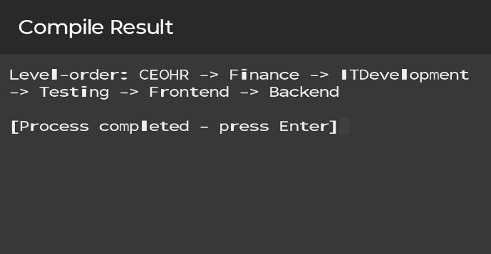
}

5.b)
#include <stdio.h>
#include <string.h>

Int linearSearch(char arr[][20], int n, char *key) {
Int count = 0;
For (int I = 0; I < n; i++) {
Count++;
If (strcmp(arr[i], key) == 0) {
Printf(“Linear: found at index %d, comparisons = %d\n”, I, count);
Return count;
}
}
Printf(“Linear: not found, comparisons = %d\n”, count);
Return count;
}

Int binarySearch(char arr[][20], int n, char *key) {
Int low = 0, high = n – 1, count = 0;

While (low <= high) {
Count++;
Int mid = (low + high) / 2;
Int cmp = strcmp(arr[mid], key);

If (cmp == 0) {
Printf(“Binary: found at index %d, comparisons = %d\n”, mid, count);
Return count;
} else if (cmp < 0) {
Low = mid + 1;
} else {
High = mid – 1;
}
}
Printf(“Binary: not found, comparisons = %d\n”, count);
Return count;
}
Int main() {
Char departments[8][20] = {
“Backend”, “CEO”, “Development”, “Finance”,
“Frontend”, “HR”, “IT”, “Testing”
};
Int n = 8;
Printf(“Departments (sorted): “);
For (int I = 0; I < n; i++)
Printf(“%s “, departments[i]);
Printf(“\n\n”);
char searchList[4][20] = {“Backend”, “IT”, “HR”, “Finance”};
for (int I = 0; I < 4; i++) {
Printf(“Key: %s\n”, searchList[i]);
linearSearch(departments, n, searchList[i]);
binarySearch(departments, n, searchList[i]);
printf(“\n”);
}
return 0;
}
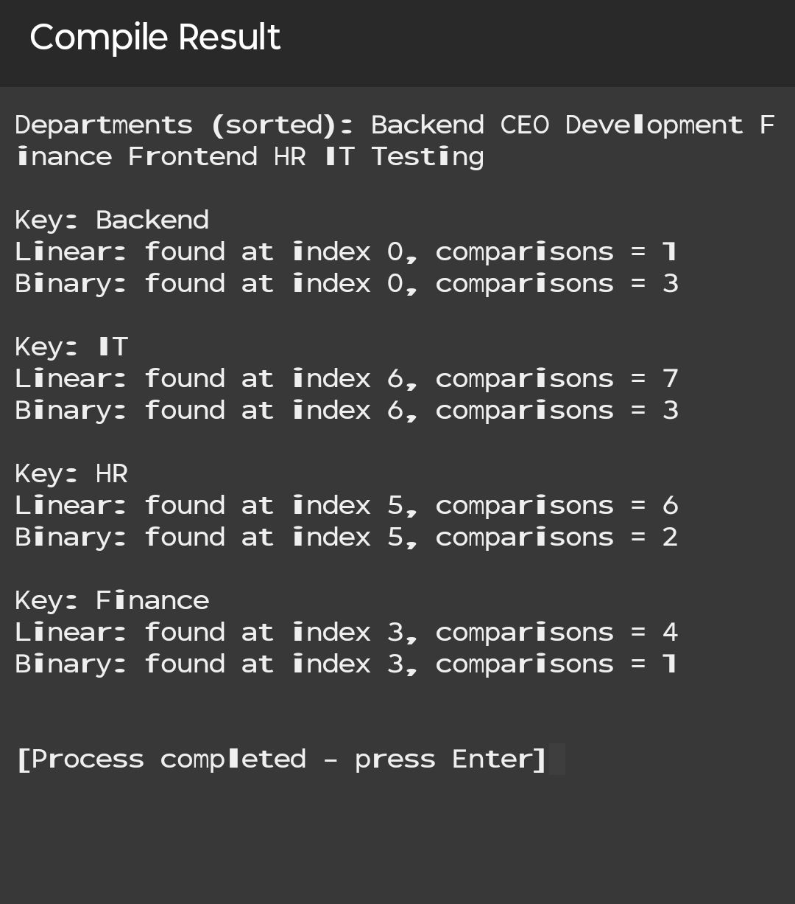

Comparison Table
Search Key | Linear Search Comparisons | Binary Search Comparisons
Backend | 1 | 3
IT | 7 | 2
HR | 6 | 2
FINANCE | 4 | 1

5.c)
The organisational tree has 4 levels. The longest path is CEO → IT → Development → Frontend.
Level-order traversal visits the nodes level by level: CEO → HR → Finance → IT → Development → Testing → Frontend → Backend. It is suitable for displaying the organisational hierarchy from top to bottom.
Linear Search comparisons depend on the position of the department in the list. Binary Search requires fewer comparisons when the list is sorted. In the given searches, Binary Search required at most 3 comparisons, while Linear Search required up to 7 comparisons.
The time complexity of building the tree is O(n). Level-order traversal is O(n). Sorting the department names is O(n log n). Linear Search is O(n), while Binary Search is O(log n).
The tree structure is suitable for representing organisational reporting because it clearly shows the parent-child relationship between departments. A sorted list is suitable for department searching using Binary Search. Therefore, using a tree for organisational reporting and a sorted list for searching provides an effective representation for the system.

