Insert your name, centre number and candidate number into the header above.
Save this evidence document as evidence_ followed by your centre number_ candidate number. For example: evidence_ zz999_9999
Screenshots or program listings must be copied into appropriate cells in the following tables.
Examiners must be able to read the contents including any screenshots without the use of a magnifying glass. Answers that are not readable or missing will not be awarded any marks.
Save this evidence document at regular intervals, for example, every 10 minutes.
Question 1
Part 1(a)
Structure node
Dim data As Integer
Dim nextNode As Integer
End Structure

Part 1(b)
Sub Main()
Dim linkedList(0 To 9) As node
Dim startPointer As Integer
Dim emptyList As Integer

linkedList(0).data = 1
linkedList(0).nextNode = 1
linkedList(1).data = 5
linkedList(1).nextNode = 4
linkedList(2).data = 6
linkedList(2).nextNode = 7
linkedList(3).data = 7
linkedList(3).nextNode = -1
linkedList(4).data = 2
linkedList(4).nextNode = 2
linkedList(5).data = 0
linkedList(5).nextNode = 6
linkedList(6).data = 0
linkedList(6).nextNode = 8
linkedList(7).data = 56
linkedList(7).nextNode = 3
linkedList(8).data = 0
linkedList(8).nextNode = 9
linkedList(9).data = 0
linkedList(9).nextNode = -1

startPointer = 0
emptyList = 5

End Sub

Part 1(c)(i)
Sub outputNodes(ByRef linkedList As node, ByVal current As Integer)
While current <> -1
Console.WriteLine(linkedList(current).data)
current = linkedList(current).nextNode
End While
End Sub

Part 1(c)(ii)
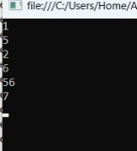

Part 1(d)(i)
Function addNode(ByRef linkedList() As node, ByVal current As Integer, ByRef emptyList As Integer) As Boolean

Dim value As Integer
Dim newvalue As node
Dim lastindex As Integer
Dim valueToWrite As Integer

Console.WriteLine("Enter the data you want to add to the list:")
value = Console.ReadLine

If emptyList < 0 Or emptyList > 9 Then
Return False
Else
newvalue.data = value
newvalue.nextNode = -1
linkedList(emptyList) = newvalue

lastindex = 0
While current <> -1
lastindex = current
current = linkedList(current).nextNode
End While

valueToWrite = emptyList
linkedList(lastindex).nextNode = valueToWrite
emptyList = linkedList(emptyList).nextNode
Return True
End If

End Function

Part 1(d)(ii)
Call outputNodes(linkedList, current)

If addNode(linkedList, current, emptyList) = True Then
Console.WriteLine("The value was added.")
Else
Console.WriteLine("The value was not added.")
End If

Call outputNodes(linkedList, current)

Part 1(d)(iii)
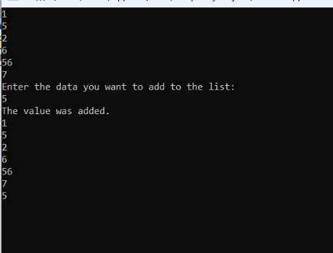

Question 2
Part 2(a)
Dim arrayData(0 to 9) As Integer
Sub Main()
arrayData = {10, 5, 6, 7, 1, 12, 13, 15, 21, 8}
End Sub

Part 2(b)(i)
Function linearSearch(ByVal find As Integer) As Boolean
Dim x As Integer
x = 0
Dim found As Boolean
found = False
While x <= 9 And found = False
If find = arrayData(x) Then
found = True
Return found
End If
x = x + 1
End While
Return found
End Function

Part 2(b)(ii)
Sub Main()
arrayData = {10, 5, 6, 7, 1, 12, 13, 15, 21, 8}
Dim find As Integer
Console.WriteLine("Enter the value you need to find.")
find = Console.ReadLine
If linearSearch(find) = True Then
Console.WriteLine("The value was found in the array.")
Else
Console.WriteLine("The value was not found in the array.")
End If
Console.ReadKey()
End Sub

Part 2(b)(iii)
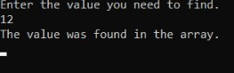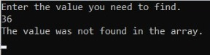

Part 2(c)
Sub bubbleSort()
Dim temp As Integer
For x = 0 To 9
For y = 0 To 8
If arrayData(y) < arrayData(y + 1) Then
temp = arrayData(y)
arrayData(y) = arrayData(y + 1)
arrayData(y + 1) = temp
End If
Next y
Next x
End Sub

Question 3
Part 3(a)
Class TreasureChest
Private question As String
Private answer As Integer
Private points As Integer

Sub New(ByVal questionNew, ByVal answerNew, ByVal pointsNew)
question = questionNew
answer = answerNew
points = pointsNew
End Sub
End Class

Part 3(b)
Sub readData()
Dim arrayTreasure(4) As treasureChest
Dim filename As String = "treasureChestData.txt"
Try
Dim fileReader As New System.IO.StreamReader(filename)
Dim question As String
Dim answer As Integer
Dim points As Integer
Dim numberQuestions As Integer = 0
While fileReader.Peek <> -1
question = fileReader.ReadLine()
answer = fileReader.ReadLine()
points = fileReader.ReadLine()
arrayTreasure(numberQuestions) = New TreasureChest(question, answer, points)
numberQuestions = numberQuestions + 1
End While
fileReader.Close()
Catch ex As Exception
Console.WriteLine("The file was not found.")
End Try
End Sub

Part 3(c)(i)
Function getQuestion()
Return question
End Function

Part 3(c)(ii)
Function checkAnswer(ByVal answerNew) As Boolean
If answer = answerNew Then
Return (True)
Else
Return False
End If
End Function

Part 3(c)(iii)
Function getPoints(ByVal attempts) As Integer
Select Case attempts
Case 1 : Return points
Case 2 : Return points / 2
Case 3 : Return points / 4
Case 4 : Return points / 4
Case Else
Return 0
End Select
End Function

Part 3(c)(iv)
Sub Main()
Dim choice As Integer
Dim result As Boolean
Dim ans As Integer
Dim attempts As Integer

Call readData()
Console.WriteLine("Enter a number to open a box:")
choice = Console.ReadLine
If choice > 0 And choice < 6 Then
result = False
attempts = 0

While result = False
Console.WriteLine(arrayTreasure(choice - 1).getQuestion())
ans = Console.ReadLine
result = arraytreasure(choice - 1).checkAnswer(ans)
attempts = attempts + 1
End While

Console.WriteLine(arrayTreasure(choice - 1).getPoints(attempts))
End If
End Sub

Part 3(c)(v)
{Copy and paste screenshots of the two tests for question 3(c)(v) here}

