WILP-AIML - Machine Learning

Assignment 2

Name: Ranjan Das
BITS ID: 2025AC05093

- GitHub Repository Link – https://github.com/ranjan-corp-ghub-1526/ML
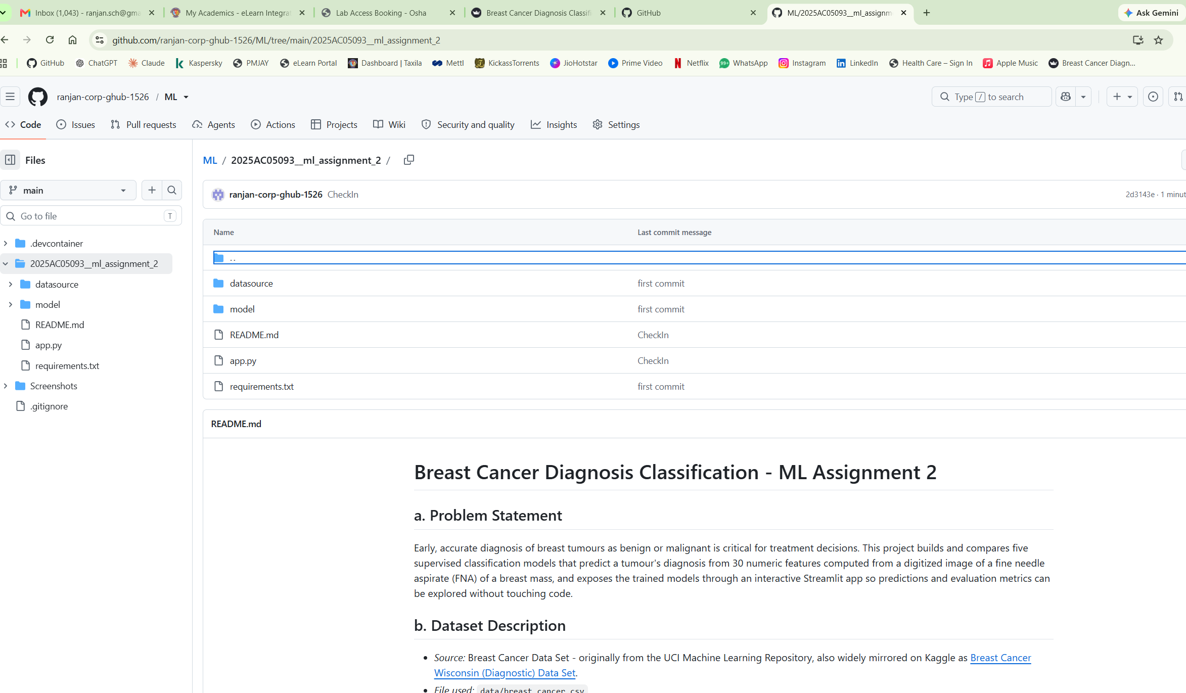
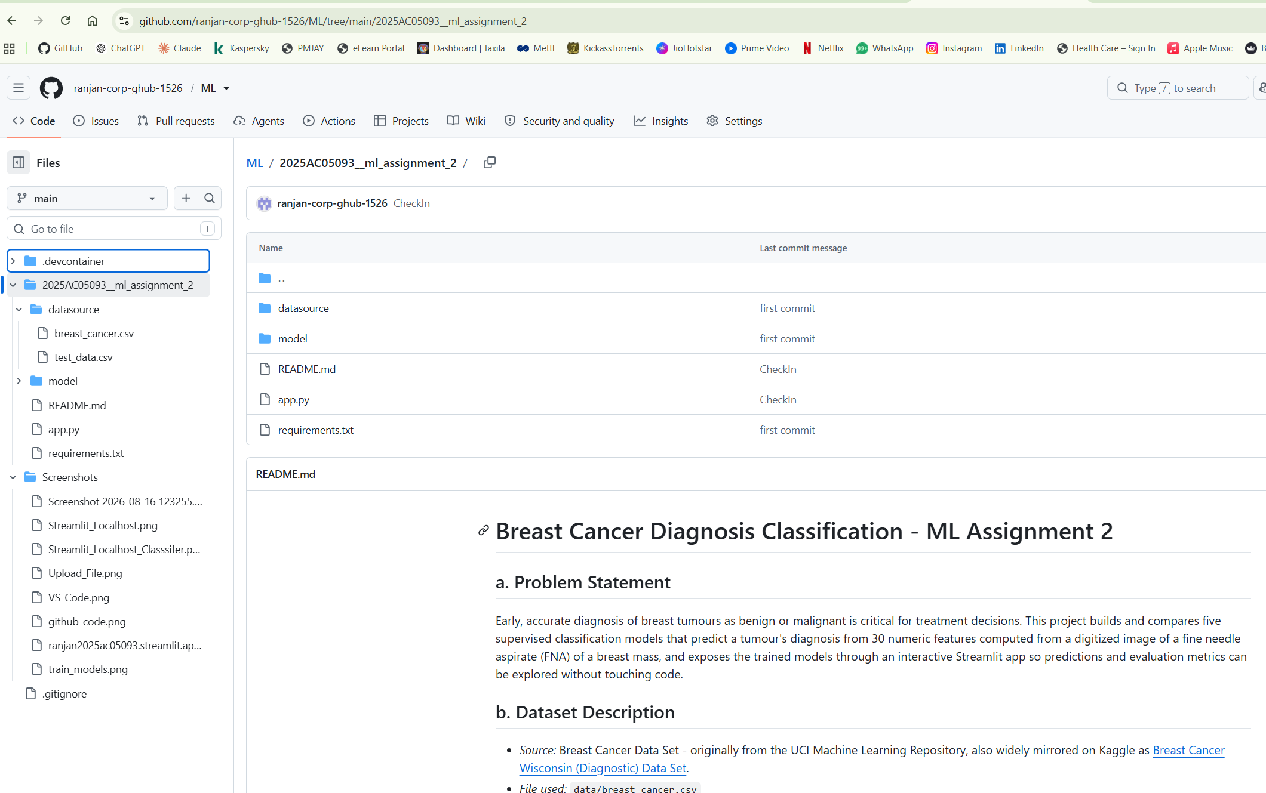

- Live Streamlit App Link - https://ranjan2025ac05093.streamlit.app/
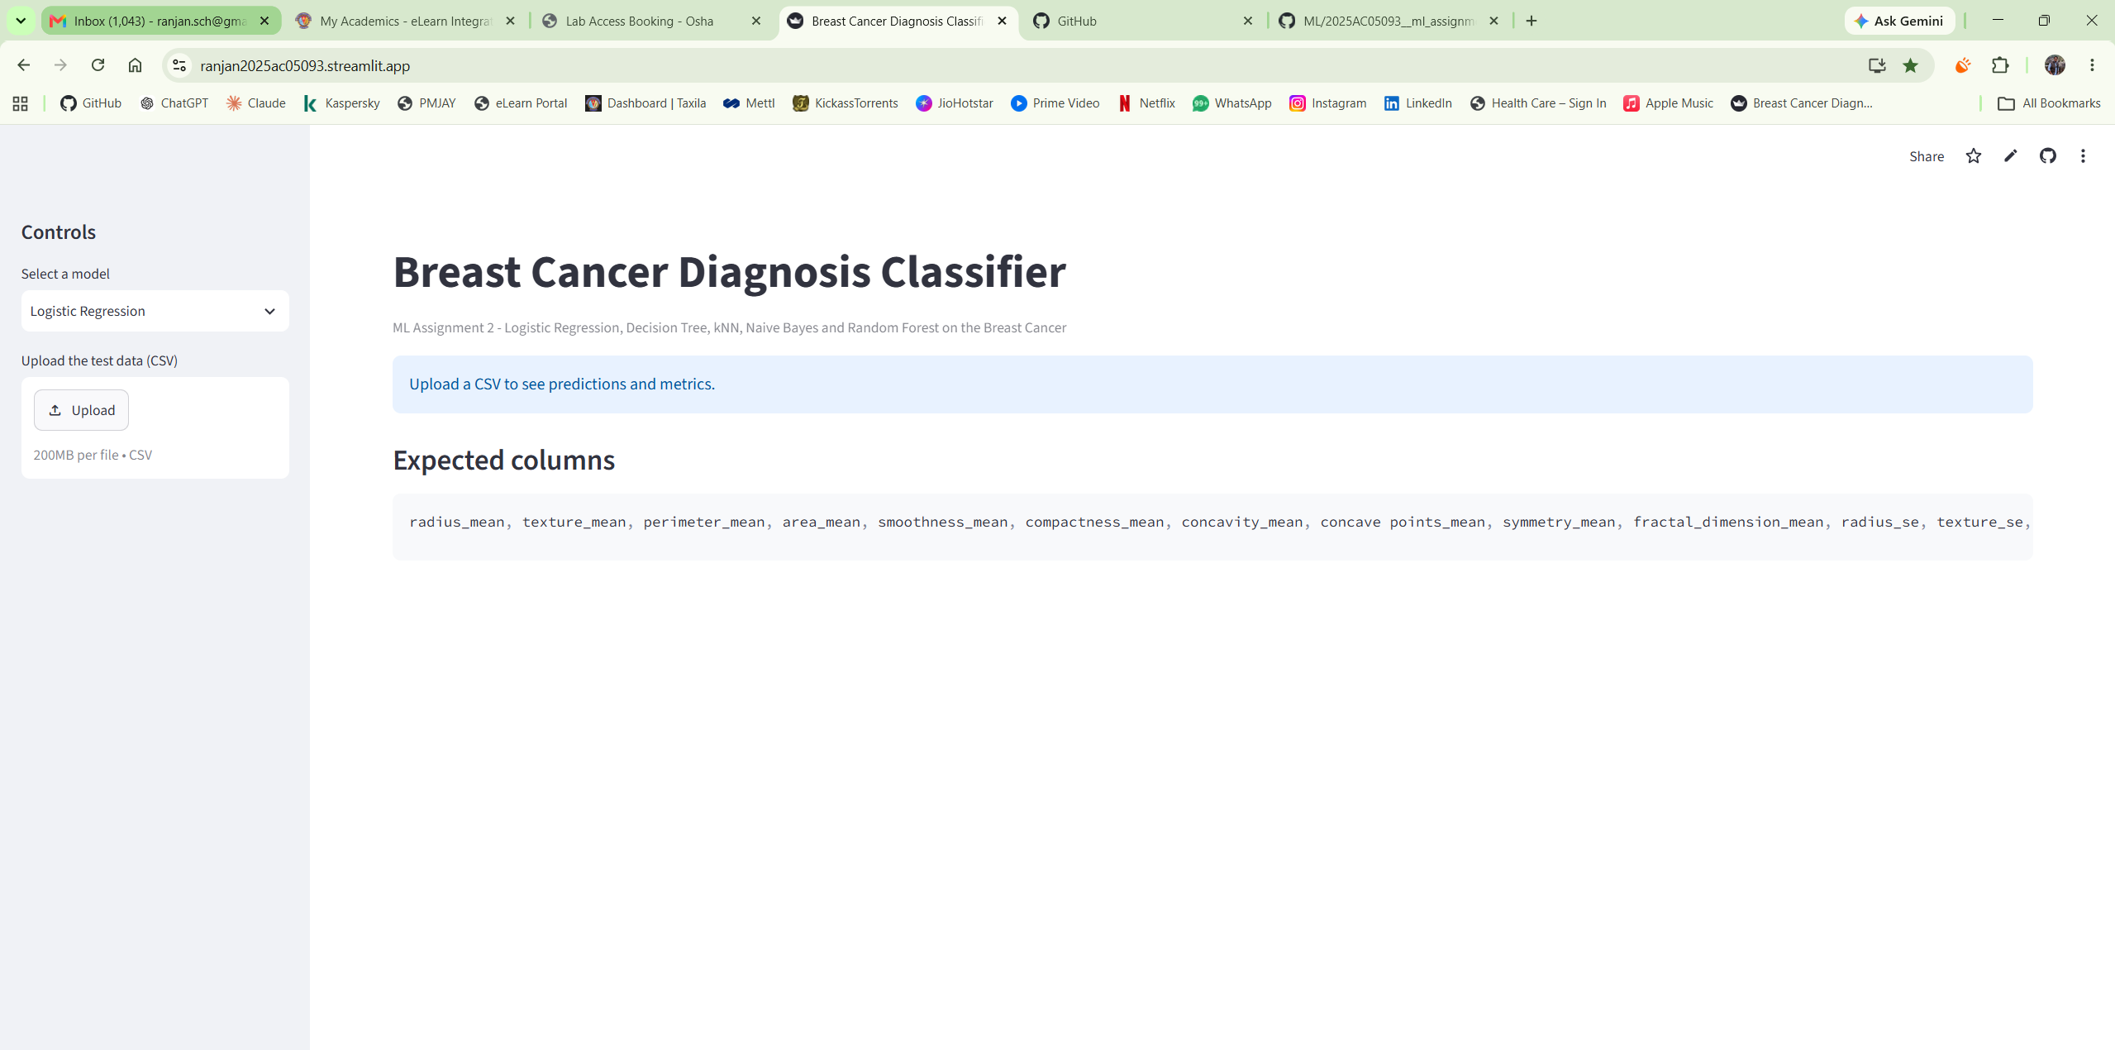
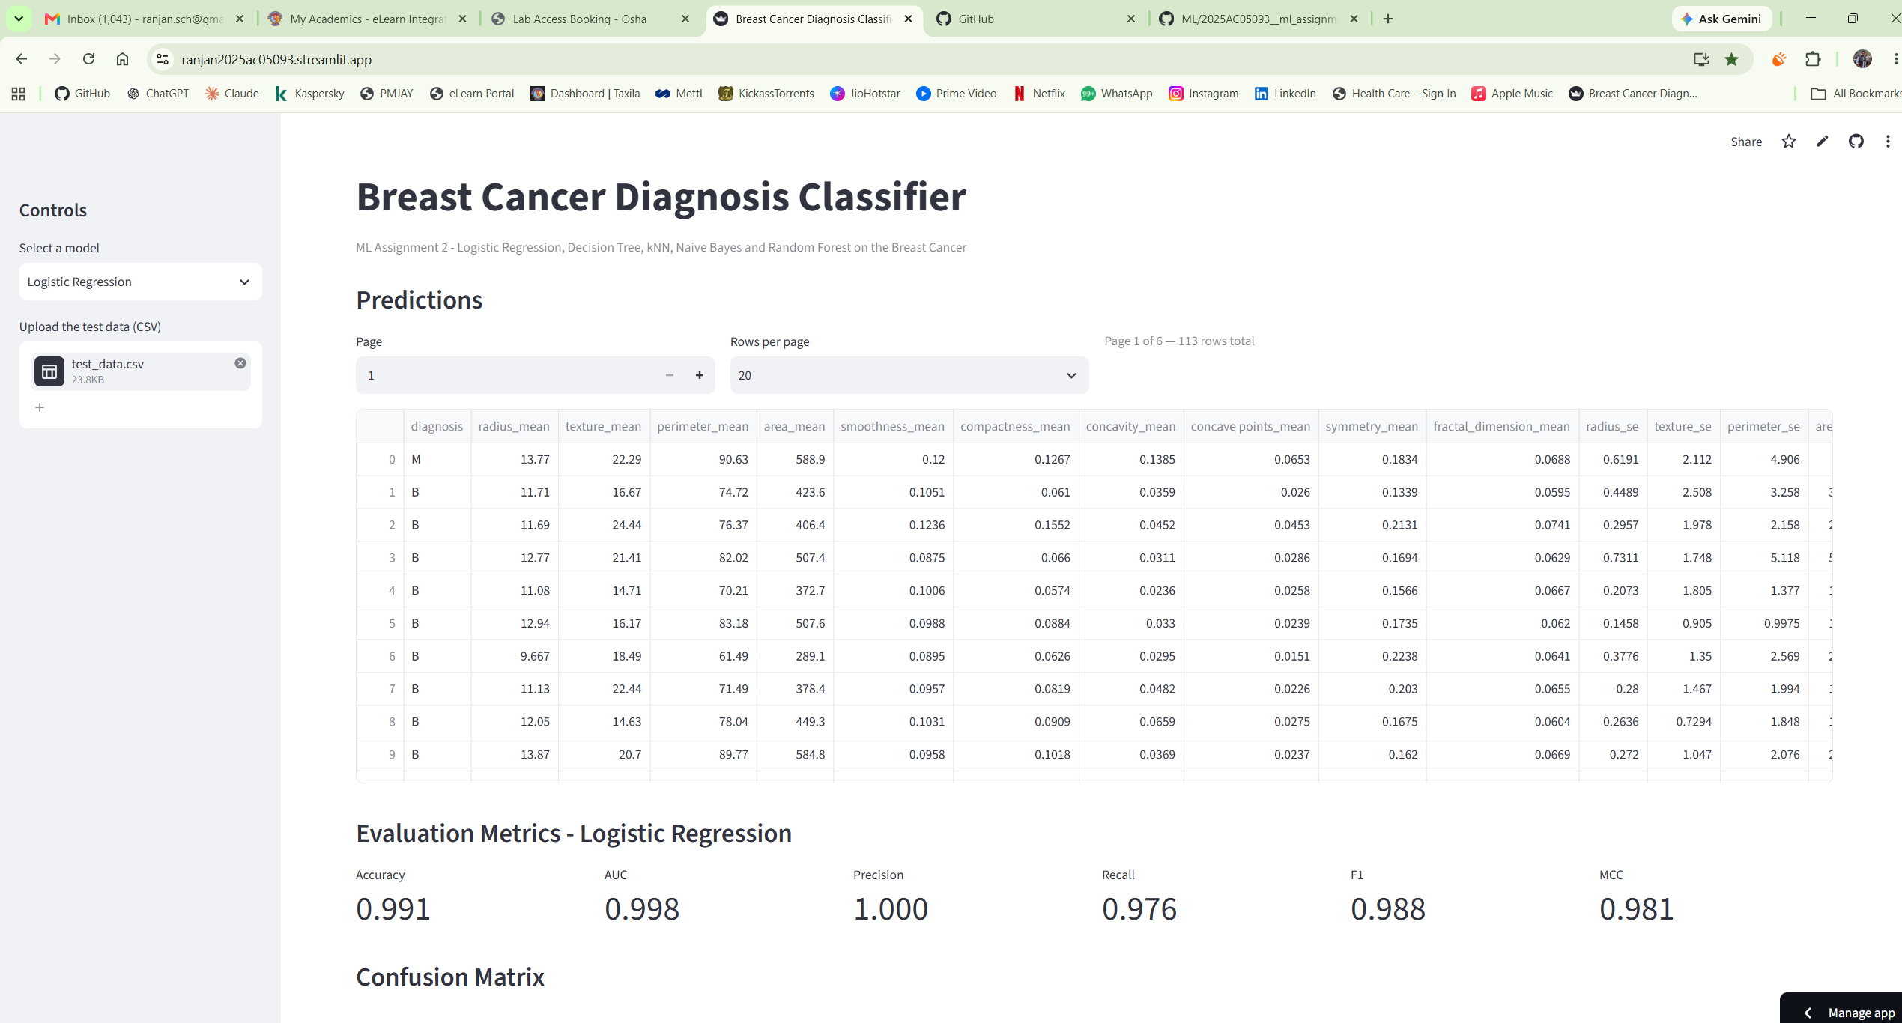
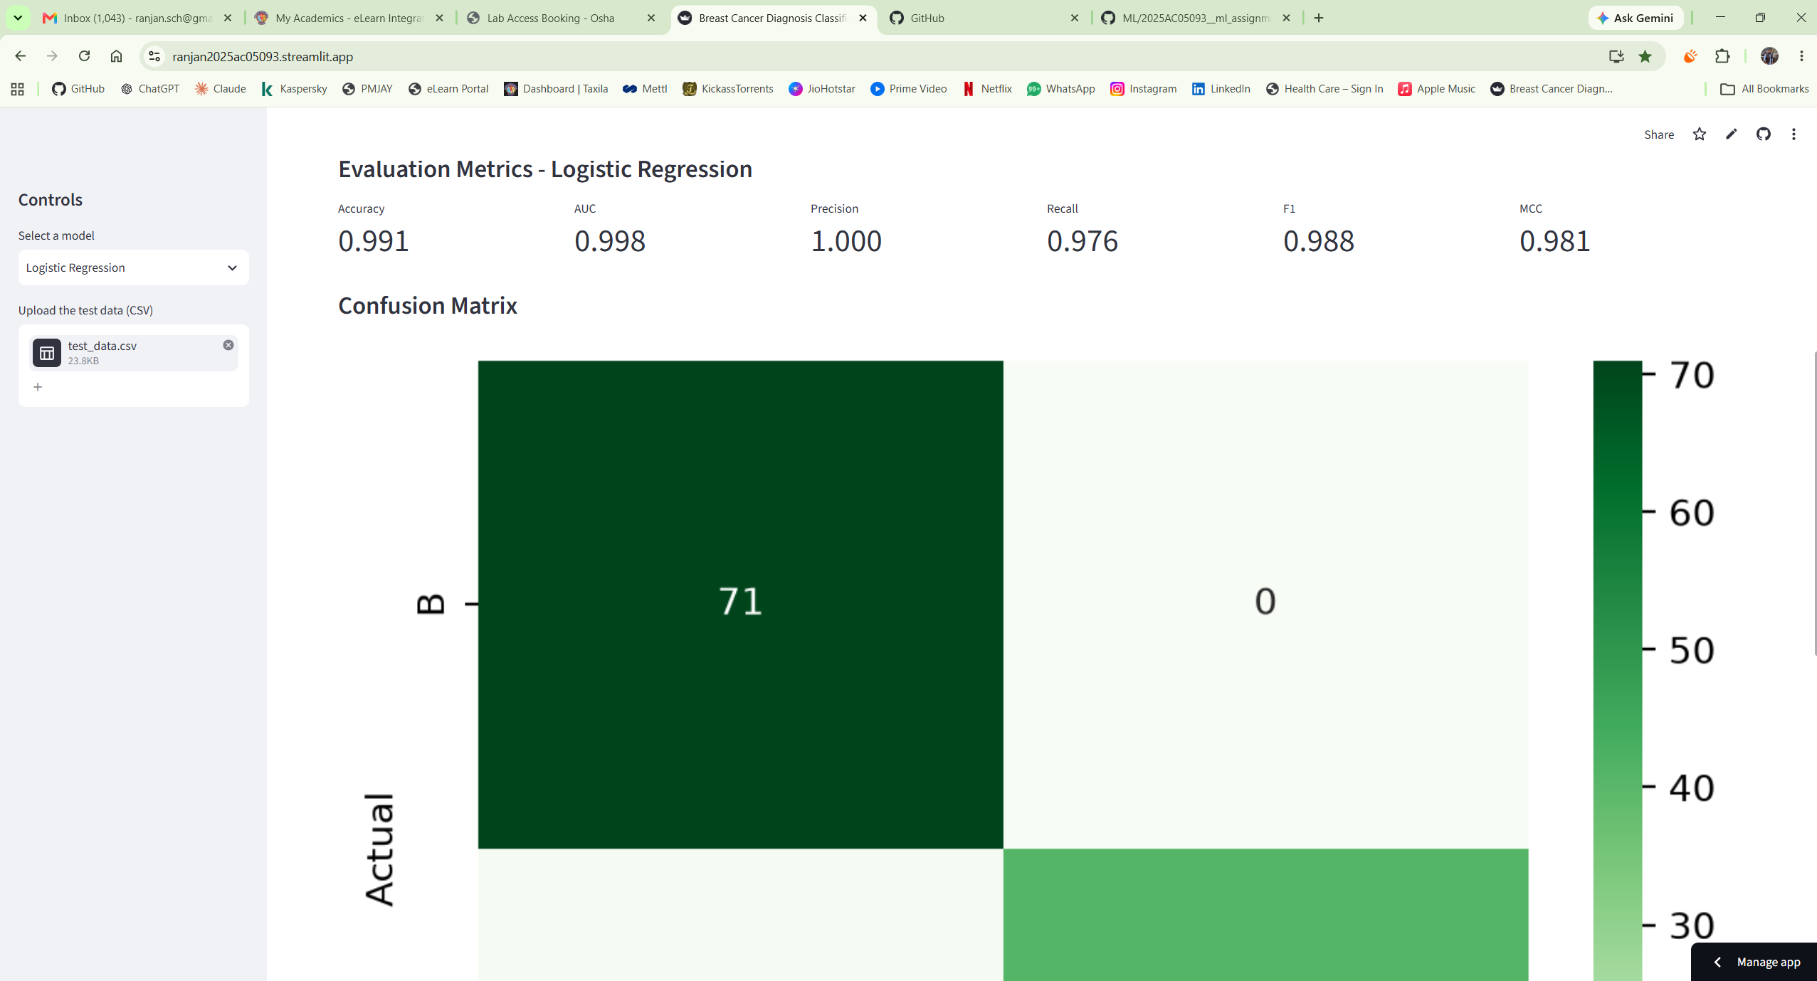
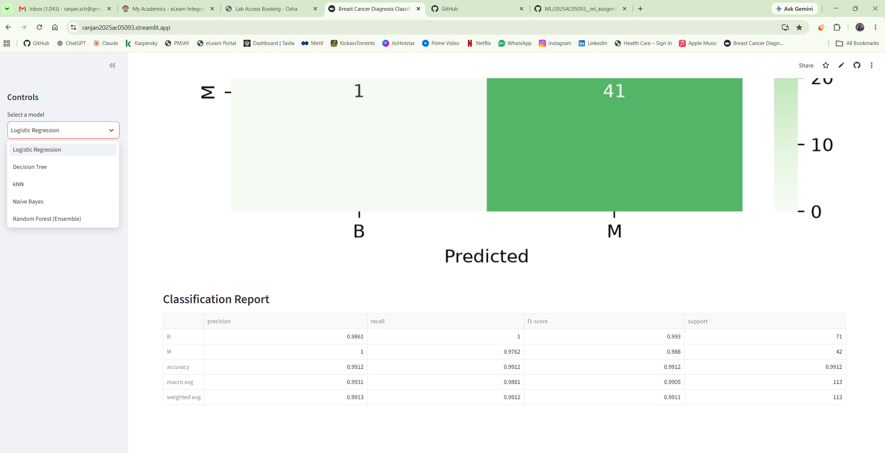

- Screenshot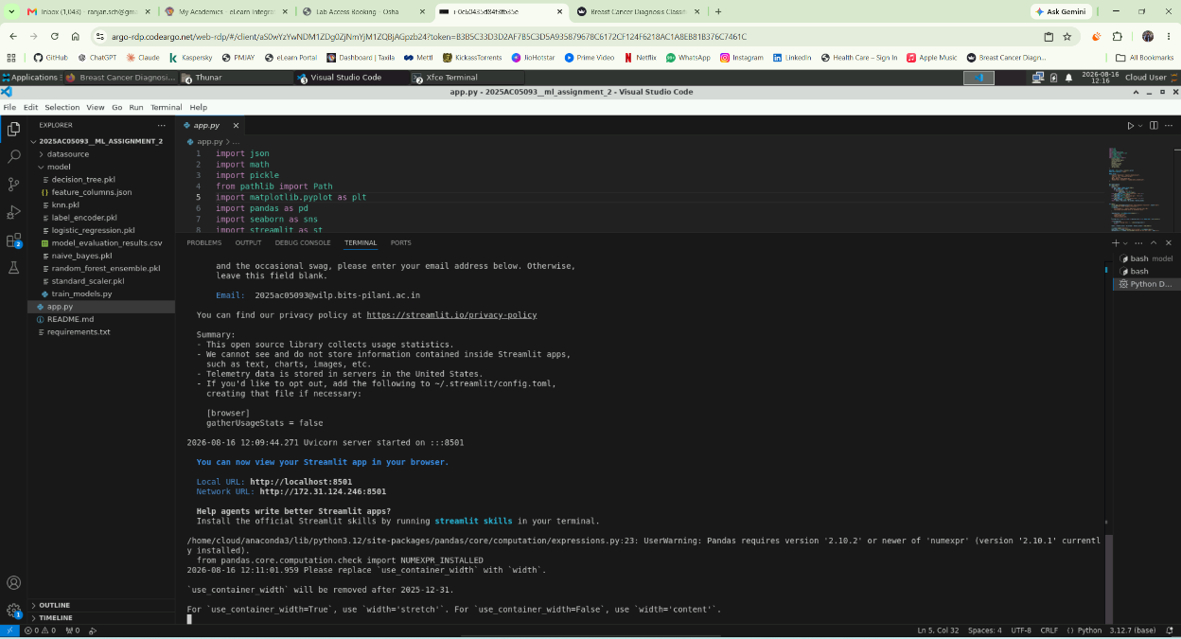
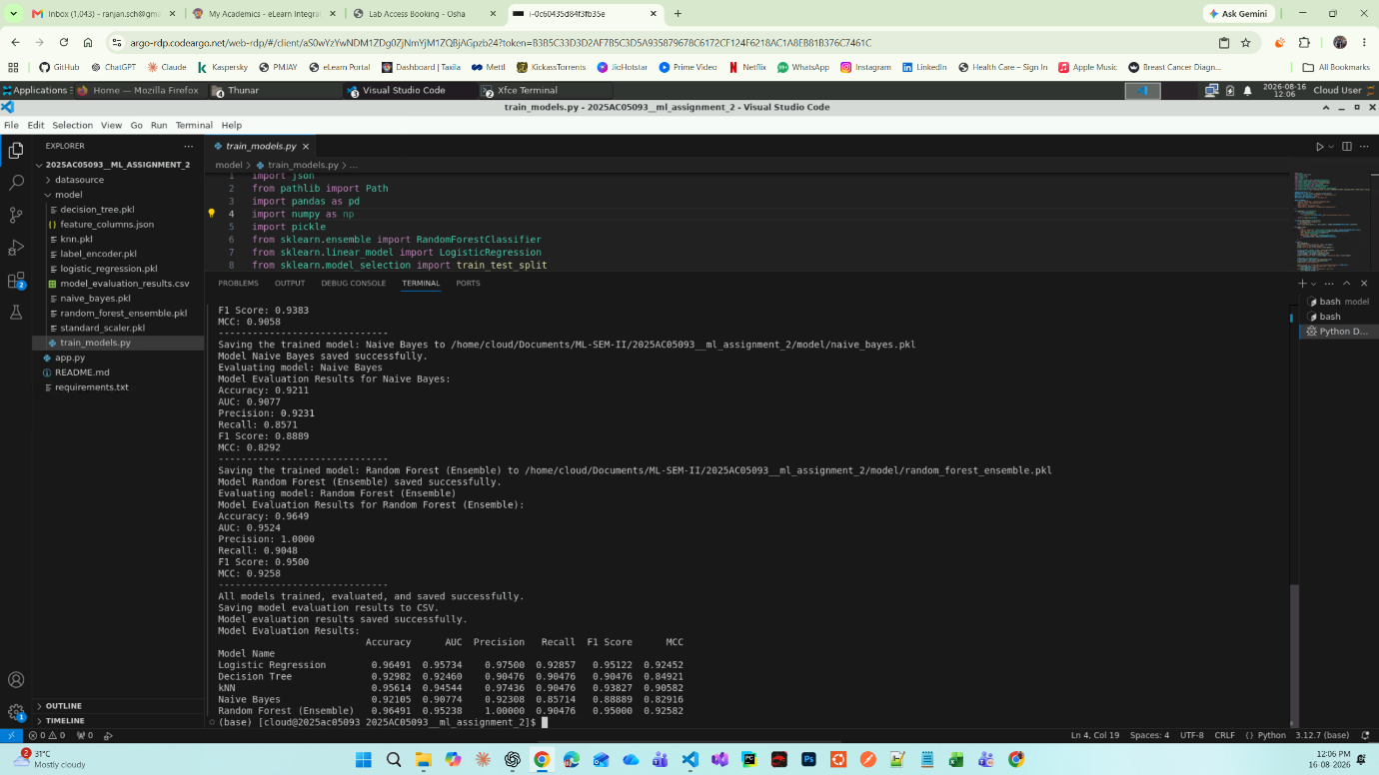

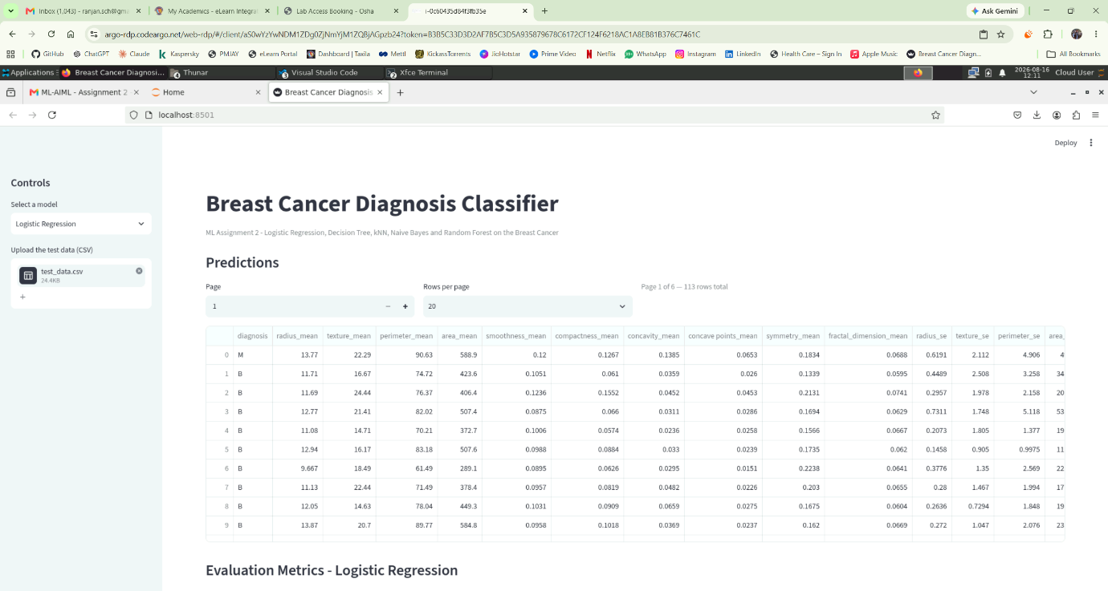
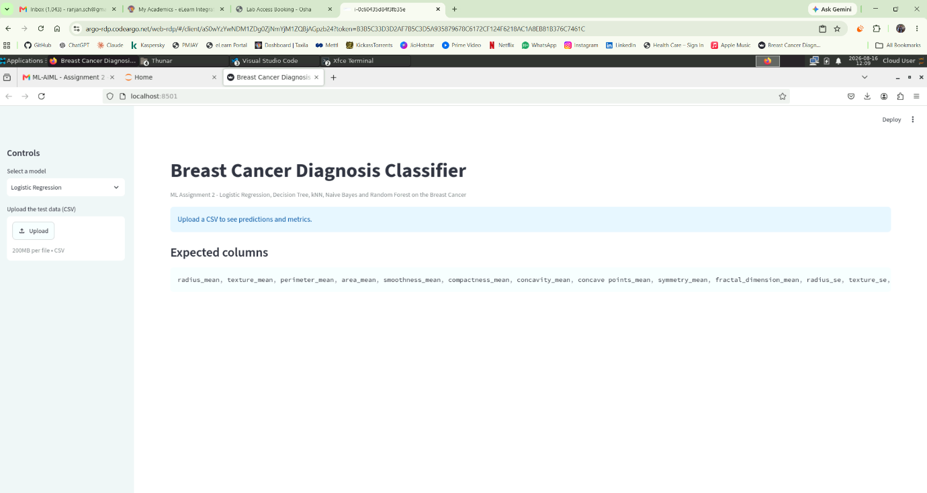
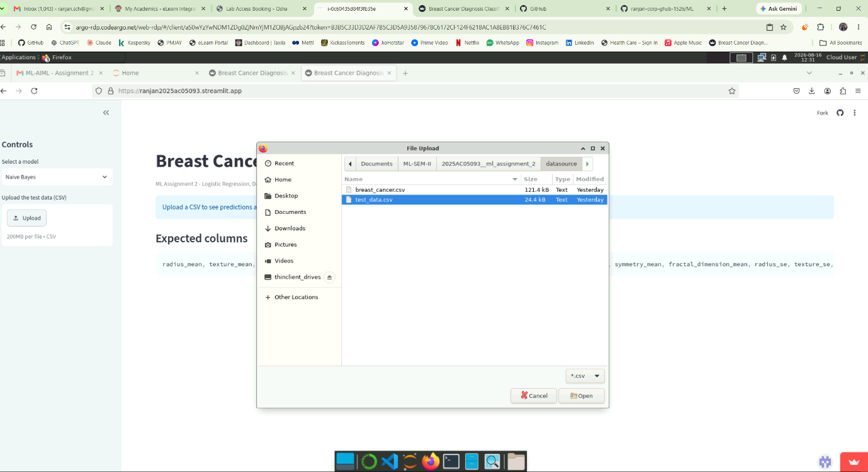
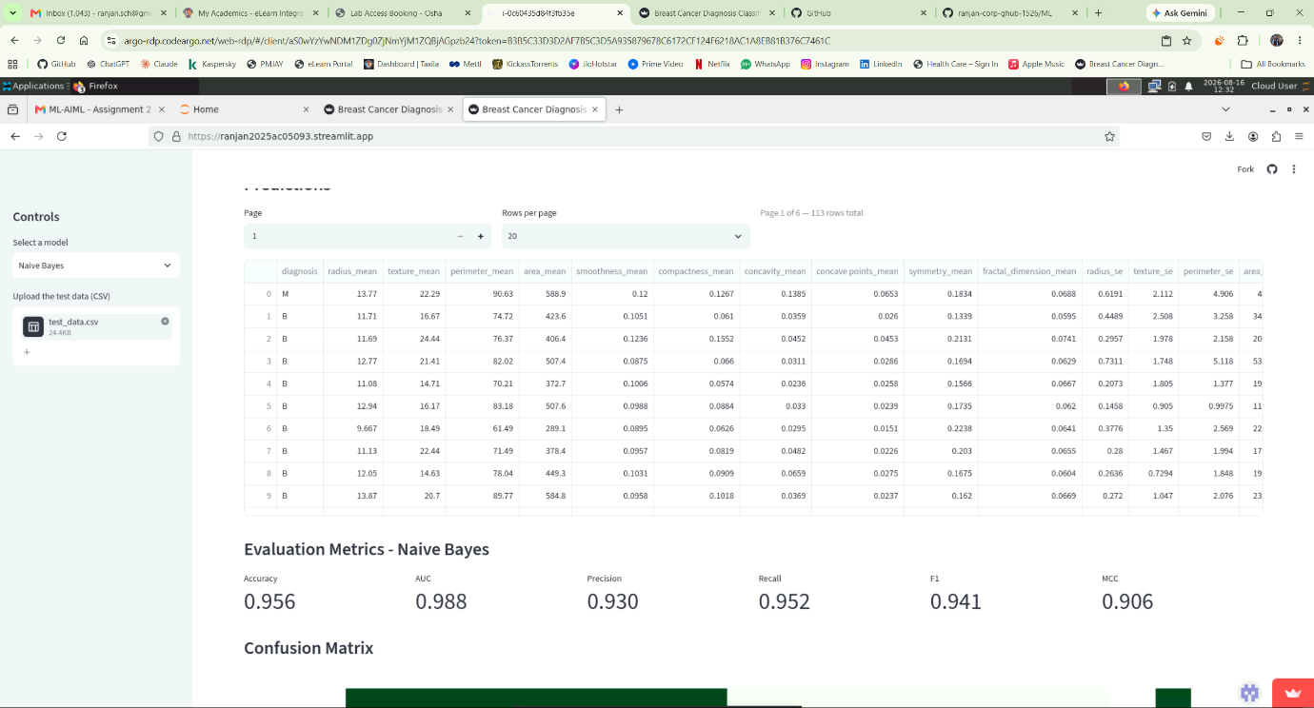

GITHUb ReadMe CONTENT -
Breast Cancer Diagnosis Classification - ML Assignment 2

a. Problem Statement
Early, accurate diagnosis of breast tumours as benign or malignant is critical for treatment decisions. This project builds and compares five supervised classification models that predict a tumour's diagnosis from 30 numeric features computed from a digitized image of a fine needle aspirate (FNA) of a breast mass, and exposes the trained models through an interactive Streamlit app so predictions and evaluation metrics can be explored without touching code.

b. Dataset Description
- Source: Breast Cancer Data Set - originally from the UCI Machine Learning Repository, also widely mirrored on Kaggle as Breast Cancer Wisconsin (Diagnostic) Data Set.
- File used: data/breast_cancer.csv
- Instances: 569 (exceeds the 500-instance minimum)
- Features: The dataset has 30 numerical features, so it satisfies the minimum requirement of 12 features. These features are based on 10 measurements: radius, texture, perimeter, area, smoothness, compactness, concavity, concave points, symmetry, and fractal dimension. For each measurement, three values are given: mean, standard error (SE), and worst value.
- Target: The target column is diagnosis. It contains two classes, M (malignant) and B (benign). So, the problem is a binary classification problem where the model has to predict whether a case is malignant or benign.
- Class balance: 357 benign (62.7%) vs. 212 malignant (37.3%) - Did not consider accuracy alone for comparing the models. I also looked at recall for the malignant class and MCC, since predicting a malignant case as benign is more serious.
- Preprocessing: all 30 features are continuous and on very different scales (e.g. area_mean is in the hundreds, smoothness_mean is around 0.1), so they are standardized (sklearn.preprocessing.StandardScaler, fit on the training set only) before being fed to every model. The target is label-encoded (B→0, M→1).
- Train/test split: stratified 80/20 split, random_state=42. The held out 20% (110+ rows) is exported as test_data.csv.

c. GitHub Repository Link
https://github.com/ranjan-corp-ghub-1526/ML
- Screenshots uploaded in the Repository

d. Streamlit Link
https://ranjan2025ac05093.streamlit.app/

e. Models Used
Five classifiers are trained on the identical train/test split in model/train_models.py:
- Logistic Regression
- Decision Tree Classifier
- K-Nearest Neighbor Classifier
- Naive Bayes Classifier (Gaussian - fits standardized continuous features naturally)
- Random Forest Classifier (Ensemble, 200 trees)

Comparison Table
ML Model Name | Accuracy | AUC | Precision | Recall | F1 | MCC
Logistic Regression | 0.9649 | 0.9573 | 0.9750 | 0.9286 | 0.9512 | 0.9245
Decision Tree | 0.9298 | 0.9246 | 0.9048 | 0.9048 | 0.9048 | 0.8492
kNN | 0.9561 | 0.9454 | 0.9744 | 0.9048 | 0.9383 | 0.9058
Naive Bayes | 0.9211 | 0.9077 | 0.9231 | 0.8571 | 0.8889 | 0.8292
Random Forest (Ensemble) | 0.9649 | 0.9524 | 1.0000 | 0.9048 | 0.9500 | 0.9258

Observations
ML Model Name | Observation about model performance
Logistic Regression | Best all-round performer despite being the simplest model — highest recall (92.86%) and F1 (0.951) of all five, tied for highest accuracy (96.49%), and the highest AUC (0.957). Suggests the two classes are close to linearly separable once features are standardized.
Decision Tree | Weakest of the five on almost every metric (accuracy 92.98%, AUC 0.925, MCC 0.849) — a single tree overfits to specific splits and doesn't generalize as well as an ensemble of many trees.
kNN | Strong precision (97.44%, close behind Random Forest) but recall (90.48%) trails Logistic Regression, meaning it misses slightly more malignant cases. Performs well because distance-based methods benefit a lot from the standardized features.
Naive Bayes | Lowest score on every single metric (AUC 0.908, F1 0.889, MCC 0.829, recall 85.71%). Its core assumption — that features are independent given the class — doesn't hold well here, since many tumour measurements (radius, perimeter, area) are naturally correlated with each other.
Random Forest (Ensemble) | Highest precision of all models — a perfect 1.0, meaning zero benign cases were misclassified as malignant on this test set — and the highest MCC (0.926), reflecting the benefit of averaging 200 trees over one. Recall (90.48%) is a touch below Logistic Regression, so it's marginally more likely to miss a malignant case in exchange for never raising a false alarm.
Overall Winner for your dataset? | Logistic Regression, by a narrow margin over Random Forest. LR leads on recall, F1, and AUC; Random Forest leads on precision and MCC — genuinely close. In a cancer-diagnosis context, missing a malignant tumor (false negative) is usually costlier than a false alarm, so LR's higher recall tips it as the winner here, though Random Forest is a very reasonable alternative pick if precision/MCC matter more for your framing.

