# High Level Design for Match-Filter app

## Problem Statement:

To design an application which allows users to filter on a prebuilt set of filters (using server side filtering).

More details on the GitHub page -<https://github.com/sparknetworks/coding_exercises_options/tree/master/filtering_matches>

## Design Assumptions:

1. User Login functionality and associated security is not in scope of this application
2. Persistence of data in a data store outside the application scope is not a requirement
3. Two separate modules – in the lines of Microservices concepts are being designed for Back-end and Front-end features

## Design Propositions/Justifications:

1. For back-end server,
   1. a spring-boot-JAVA application with
      * + spring-boot provides good integration with embedded application servers and databases, alongside injectable rest-full services and dependency management and an extensive test-bed, alongside all the goodness of Spring.
   2. Embedded Tomcat
      * + Out of box web application server container
   3. Embedded -MondoDB
      * + Easily configurable data-store available in application lifecycle
        + Mongo was chosen for its inherent support of Geo-spatial queries
2. For front-end,
   1. A single-page-Angular application running on Node Server has been designed.
      * + The choice of Angular has been due to some pre-existing exposure of this developer
        + Angular supports a large component library community, of which PrimeNG Component Library has been leveraged.
        + Front-end MV testability is key driving reason.

# Detail Level Design for Match-Filter app

## Back-end Server app:

The core logic is built around the concepts of extendibility guided by:

* + - * SOLID principles of software design
      * Strategy design pattern
      * Modularity and reduced coupling between layers (UI, Service, DataStore)

The principle Classes performing the core task has been represented in a class diagram below.

The members of the diagram are –

* Filters ( Classes defining the contract between UI and Server )
* Strategies ( Classes defining different strategies for filtering, e.g. – *NumberIsGreaterThanStartegy*, *IsTrueOrFalseStrategy, etc.*)
* Specifications ( Classes churning out Criteria to be applied while querying DB. They have a *Strategy* to work with )

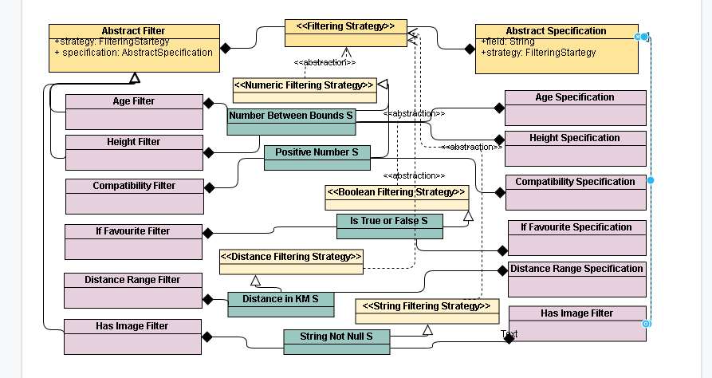

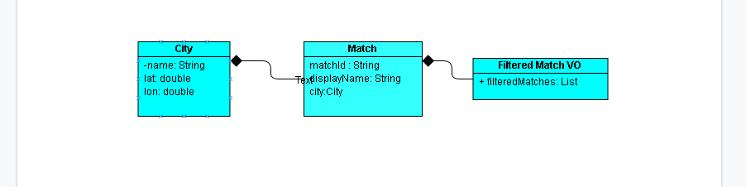

## Initial Design Scribbles:

