IOT Based Industrial Automation

Ashwin Anjan, Vishal Kumar, Ranjan Yadav, Shivam Mishra, DVS Srikar

*Department of Electronics and Communication*

Indian Institute of Information Technology, Design and Manufacturing

Kancheepuram, Tamil Nadu, 600-127

esd17i012@iiitdm.ac.in, esd17i009@iiitdm.ac.in,evd17i009@iiitdm.ac.in

evd17i020@iiitdm.ac.in, evd17i014@iiitdm.ac.in

*Abstract--* **In an ever-growing world of doorstep services, the quality of the delivered product has risen in importance. This is especially true for the packaging and delivery industry. In this report we theorize a novel method for the verification of the packaging of a product and also a method to verify the quantity of the product present inside.**

**Theoretically, a machine packaged product will always be perfectly packed, however it is not possible to completely run a factory on machines. Humans need to be there to control, direct and quantify the machines. This introduces a scope of human error that might cause some unforeseen machine error to creep in.**

**We, through our product hope to minimize this error by placing a number of quality and quantity checks that ensure no bad product will leave the factory.**

**The main idea can be broken down into:**

1. **Getting an input of how many and what products to quality check.**
2. **Verifying the outer packaging**
3. **Verifying the quantity.**
4. **Separating the bad and good products.**

**Whenever a product is flagged as bad, the controller will know what product it is, and will send a signal back to the main product line and inform them to repackage that particular product. The verification line keeps checking until it has got the exact number of products required, it verifies the number and type by cross checking with the input given.**

**There are 4 major technologies being used in this product line:**

1. **IR sensors: To detect and products and time the delays in the conveyer belt functioning.**
2. **Weight/Load Sensor: This is used for the quantitative analysis (amount of milk in a tetra pack etc.)**
3. **SONAR sensor: Used to ensure that the dimensions of the product are in order.**
4. **IOT: This is used to compare the input given via cloud, and repeats the loop until we get the output required.**

**Keywords— IOT, Efficient Packing, Quantitative Analysis, Automation**

I. INTRODUCTION

The internet of things (IOT) is a sophisticated technology which has recently come into the commercial space due to increase in performance of network speed and bandwidth.

In the industrial world the concept of IOT has begun to change the spectrum of automation. Earlier automation was just about removing the labour from human hands and putting it in machine hands to improve speed and accuracy. This also reduced the burden on humans.

However, with the introduction of IOT, automation has the capability to reach new levels.

Factories can be controlled from an app on your phone without any effort. All kinds of diagnostic data will be present at your fingertips and if machine learning is implemented the system will strive for optimization by itself.

This all seems futuristic, but we are very close to this in reality as well.

The name given to this new technology driven automation is “Industry 4.0”, and it is what many companies have been striving to achieve for the past decade or so.

Our project aims to develop a method of packaging and error detection that will allow for automation in mass manufacturing and delivery systems. We also aim to create a network wherein all participating parties get required information to fulfil their roles at appropriate times.

The result we hope to achieve is a fully automated error-based sort system that ensures that every package sent out from the factory is in proper condition.

II. MOTIVATION

* The [Internet of Things (IOT)](https://mapr.com/solutions/enterprise/internet-of-things) will be huge in several ways. The forces that are driving it and the benefits that are motivating it are increasingly numerous, as more and more organizations, industries, and technologists catch the IOT bug.
* The number of connected devices on the IOT network will be huge. One estimate says that the number will be nearly 21 billion by the year 2025, which is approximately 30 devices for each and every [active social network users](http://expandedramblings.com/index.php/by-the-numbers-17-amazing-facebook-stats/) in the world.
* The quantity of data being collected and analysed in and through the IOT will be huge. We are talking nearly petabytes of data, the big tech companies (Google, Microsoft, Amazon, Facebook) together have about 1.2 million terabytes of data ~ 1200 petabytes

*A. Motivating Factors for IOT in Industries*

Internet of Things (IOT) will provide a promising opportunity to build powerful industrial systems and applications by leveraging the growing ubiquity of radio-frequency identification (RFID), and wireless, mobile, and sensor devices.

1. Ubiquitous networks
2. Connected computing
3. Ubiquitous sensors
4. Analytics-as-a-Service
5. Marketing automation
6. Supply Chain Analytics

*B. Benefits*

* Tracking behaviour for real-time marketing;
* Enhanced situational awareness;
* Sensor-driven decision analytics;
* Process optimization;
* Optimized resource consumption; and
* Instantaneous control and response in complex autonomous systems.

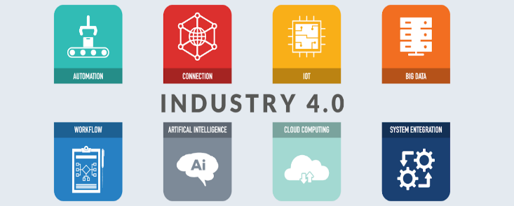

Fig. 1 [Industry 4.0](https://en.wikipedia.org/wiki/Industry_4.0) refers to the use of automation and data exchange in manufacturing.

III LITERATURE

Mr. Vidhyadhar P. Kshirsaga says about “Modeling and Analysis of Belt Conveyer System used in various industries”. Belt conveyor is the transportation of material from one location to another. Belt conveyor is a commonly used equipment of continuous transport; it has a high efficiency and large conveying capacity, high load carrying capacity, large length of conveying path, simple design, easy maintenance and high reliability of operation. That can be achieved at different distances, different materials transportation and also widely used in coal handling system in thermal power plant and other projects[5].

Mr. Ravindra Gandhe say that study and analysis of roller conveyor in material handling. A wide variety of related conveying machines are available, different as regards principle of operation, means and direction of conveyance, including screw conveyors, vibrating conveyors, pneumatic conveyors, the moving floor system, which uses reciprocating slats to move cargo, and roller conveyor system, which uses. A series of powered rollers to convey boxes or pallets on his work, an attempt is made to test the feasibility of a fiber composite material with optimum properties with an idea towards replacing the existing stainless steel material in industrial conveyor application [4].

Mr. Santanu Chakarborthy says about study and create an adaptive design of semi-flexible screw conveyor using conventional specifications and standards. In this paper as stated above Screw Conveyors are used in a variety of situations. Some of these situations require material to be transported over a large distance or at considerable heights. Till date various concepts have been developed to satisfy the need of a flexible screw conveyor. Like, in April 1958, Inventors Marion H Fennimore and Ivan J Stephenson invented a Flexible Screw Auger for Conveying grain. One of the most difficult problems encountered with conveyors having flexible sections therein is that of bunching or folding of the flexible tubing at the inside of a bend. Such folding4 tends to restrict the flow of material within the tube. He has chosen to develop a Screw Conveyor model with three stages connected by universal joints. The universal joint allows power transmission at deflected angle in turn allowing each stage of the conveyor a certain degree of flexibility [3].

# IV THE HISTORY OF CONVEYOR BELTS: FROM 1892 TO TODAY [2]

Conveyor belts have been an industrial staple since being introduced in the late 19th century. While we generally credit Henry Ford for his use of the conveyor belt in the Ford Motor Company assembly line, the precursor to the conveyor belt was actually first used in 1892 and developed by Thomas Robbins. A series of inventions eventually lead to the conveyor belt, which was used to carry coal, ores, and other mining materials, revolutionizing the industry completely.

It wasn’t until 1913 that Henry Ford introduced the conveyor belt assembly line to his Michigan factory, and through the remainder of the 20th century, the conveyor belt was continuously improved through the implementation of new construction materials and configurations. In the 1950s, the half-twist was introduced in order to allow an even wear of the belt itself, preventing excessive wear of one area of the belt and extending its lifetime. By 1970, the first plastic, modular conveyor belt was developed, which was more resistant to weak overall.

Just recently, conveyor belt manufacturers made yet another breakthrough by developing a solar powered conveyor belt. The company, Wire Belt Company of America, is based in Londonderry, NH, and is credited with supplying belts to high-profile customers like McDonald’s, Dunkin’ Donuts, Quizno’s, Papa Gino’s, and Domino’s.

Solar power is not an integral part of the company’s manufacturing. Previously, its photovoltaic rooftop array was just 100 kW, but has since expanded to 150 kW.



Fig. 2 Conveyor Belt of inside of coal mine

These belts are now used across a variety of industries for numerous purposes. But one thing that they all have in common is that they need to be cleaned. [Conveyor belt cleaners](http://www.efalcon-inc.com/conveyor-belt-cleaning-system/) are necessary in every industry that uses a belt.

Falcon Pro Solutions Inc. has developed chemical-free steam cleaning systems in order to automate this otherwise tedious task and improve productivity by decreasing down time. Our industrial conveyor belt cleaners are custom-built in order to meet the needs of all of our customers while killing 99% of common germs like E. coli, staph, and salmonella, which are common in the food packaging industry, as well as insects like dust mites and bed bugs.

Improve your assembly line or product handling system by contacting Falcon Pro Solutions today.

HISTORY OF PACKING [1]

The story began 3,500 years ago in Egypt with glass and continued with mulberry bark containers in China and Napoleon’s push for canned food. Design and branding entered the story in the 1890s when NABISCO created the first branded consumer package. In our time, plastic is packaging’s workhorse, and recycling, increased branding capabilities and serialized packaging are making headlines.

V. SENSORS, MICROCONTROLLER AND THEIR SPECIFICATIONS

*A. Passive IR Sensor*

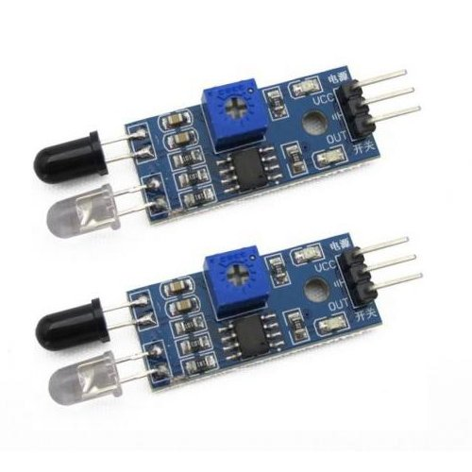

Fig. 3 IR Sensor

A passive infrared sensor (PIR sensor) is an electronic sensor that measures infrared (IR) light radiating from objects in its field of view. They are most often used in PIR-based motion detectors. PIR sensors are commonly used in security alarms and automatic lighting applications.

*1) Operation:*

A PIR sensor can detect changes in the amount of infrared radiation impinging upon it, which varies depending on the temperature and surface characteristics of the objects in front of the sensor. When an object, such as a person, passes in front of the background, such as a wall, the temperature at that point in the sensor's field of view will rise from room temperature to body temperature, and then back again. The sensor converts the resulting change in the incoming infrared radiation into a change in the output voltage, and this triggers the detection. Objects of similar temperature but different surface characteristics may also have a different infrared emission pattern, and thus moving them with respect to the background may trigger the detector as well.

*2) Features of IR Sensor Module:*

* When the module detects obstacles in front of the signal, the circuit board green indicator light level, while the OUT port continuous output low-level signals, the module detects a distance of 2 ~ 10cm, detection angle 35 °, the detection distance can be potential adjustment with adjustment potentiometer clockwise, the increase in detection distance; counter clockwise adjustment potentiometer, the detection distance decreased.
* The sensor active infrared reflection detection, target reflectivity and shape of the detection distance of the key. The black minimum detection range, white maximum; small area object distance is small, a large area from the large.
* The sensor module output port OUT can be directly connected with the microcontroller IO port can also be driven directly to a 5V relay; Connection: VCC-VCC; GND-GND; OUT-IO.
* The comparator using LM393, stable.
* 3-5V DC power supply module can be used. When the power is turned on, the red power LED is lit.
* With the screw holes of 3mm, easy to install.
* Board size: 3.1CM * 1.5CM.
* Each module in the delivery has threshold comparator voltage adjustable via potentiometer, special circumstances, please do not adjust the potentiometer.

*3) Interface (3-wire):*

* VCC external 3.3V-5V voltage (can be directly connected with the 5v microcontroller and 3.3v microcontroller).
* GND external GND.
* OUT board digital output interface (0 and 1).

*B .Load Sensor:*

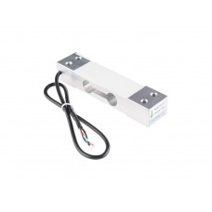

Fig. 4 Load cell (weight Sensor)

A load cell is a transducer that is used to create an electrical signal whose magnitude is directly proportional to the force being measured. The various types of load cells include hydraulic load cells, pneumatic load cells and strain gauge load cells.

This is a standard load cell for measuring weight up to 5 Kg. The output of the load cell is in milli-volts and cannot be directly measured by a micro-controller. So, an ADC with high resolution or an instrumentation amplifier is required to make the output of the load cell readable to a micro-controller.  
*1) Specifications:*

* Capacity: 5KG
* Rated output (MV/V): 2.0±0.15
* Accuracy class: C2
* Maximum number of load cell verification intervals (N max): 2000

Minimum number of load cell verification intervals (Vmin): EMax/5000

* Combined error(%RO): <±0.030
* Creep(%RO/30min): 0.03
* Temperature effect on sensitivity(%RO/°C): 0.0016
* Temperature effect on zero(%RO/°C): 0.003
* Zero balance(%RO): 1.0
* Input resistance(O): 402±6
* Output resistance(O): 350±3
* Insulation resistance (MO<50V>): 5000
* Recommended excitation voltage(V): 10~15
* Safe overload(%RO): 150
* Load cell material: Aluminium
* Connecting cable: ø4.2x350mm
* Method of connecting wire: Red (+), Black (-), Green (+), White (-)

*2) Applications:*

* Electronic platform scale
* Digital scale
* Parcel post scale
* Electronic balance

*2) Working Principle:*  
 A load cell is made by using an elastic member (with very highly repeatable deflection pattern) to which a number of strain gauges are attached.

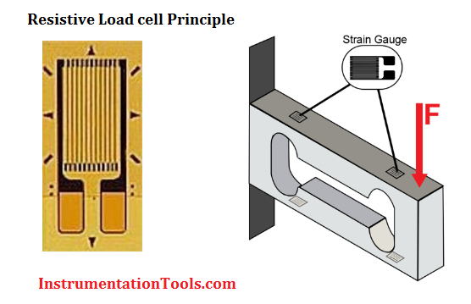

Fig. 5 Figure shows the strain Gauge

In this particular load cell shown in above figure, there are a total of four strain gauges that are bonded to the upper and lower surfaces of the load cell.

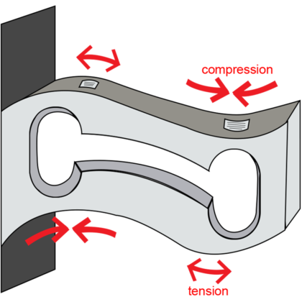Fig. 6 Figure shows how the Strain Gauge will get affected when load Cell is subjected to tension & compression

When the load is applied to the body of a resistive load cell as shown above, the elastic member, deflects as shown and creates a strain at those locations due to the stress applied. As a result, two of the strain gauges are in compression, whereas the other two are in tension as shown in below animation.



Fig. 7 Strain Gauges undergoes compression is shown by blue color while tension by red color

During a measurement, weight acts on the load cell’s **metal spring element** and causes **elastic deformation**.

This strain (positive or negative) is converted into an electrical signal by a **strain gauge (SG)** installed on the spring element. The simplest type of load cell is a bending beam with a strain gauge.

We use Wheatstone bridge circuit to convert this change in strain/resistance into voltage which is proportional to the load.

*3) Wheatstone Bridge Circuit:*

The four strain gauges are configured in a Wheatstone Bridge configuration with four separate resistors connected as shown in what is called a Wheatstone Bridge Network.

An excitation voltage – usually 10V is applied to one set of corners and the voltage difference is measured between the other two corners. At equilibrium with no applied load, the voltage output is zero or very close to zero when the four resistors are closely matched in value. That is why it is referred to as a balanced bridge circuit.

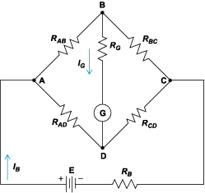

Fig. 8 Circuit Diagram of Load Cell

When the metallic member to which the strain gauges are attached, is stressed by the application of a force, the resulting strain – leads to a change in resistance in one (or more) of the resistors. This change in resistance results in a change in output voltage. This small change in output voltage (usually about 20 mVolt of total change in response to full load) can be measured and digitized after careful amplification of the small milli-volt level signals to a higher amplitude 0-5V or 0-10V signal.

There are **various load cell designs** in addition to bending beams. This includes for example:

* Load cells with column-shaped spring elements for high loads
* Hollow cylindrical load cells for very high loads
* Load cells with spring elements directly from the measuring bracket
* Ring torsion load cells
* Shear beam load cells

*C .SONAR Sensor*

Ultrasonic Distance Sensor provides very short (2CM) to long-range (4M) detection and ranging. The sensor provides precise and stable non-contact distance measurements from about 2cm to 4 meters with very high accuracy. It can be easily interfaced to any microcontroller.

*1) Description:*

This ultrasonic sensor module can be used for measuring distance, object sensor, motion sensors etc. Highly sensitive modules can be used with microcontroller to integrate with motion circuits to make robotic projects and other distance, position & motion sensitive products.

The module sends eight 40Khz square wave pulses and automatically detects whether it receives the returning signal. If there is a signal returning, a high-level pulse is sent on the echo pin. The length of this pulse is the time it took the signal from first triggering to the return echo.

*2) Features:*

* Sensor Type: Ultrasonic
* Output: Digital Sensor
* Voltage: 5VDC
* Detection distance: 2cm-400cm (0.02M - 4.0M)
* Static current: < 2mA
* Level output: high-5V
* High precision: up to 0.3cm

*3) Ultrasonic principle:*

Ultrasonic sensors emit short, high-frequency sound pulses at regular intervals. These propagate in the air at the velocity of sound. If they strike an object, then they are reflected back as echo signals to the sensor, which itself computes the distance to the target based on the time-span between emitting the signal and receiving the echo.

As the distance to an object is determined by measuring the time of flight and not by the intensity of the sound, ultrasonic sensors are excellent at suppressing background interference. Virtually all materials which reflect sound can be detected, regardless of their colour. Even transparent materials or thin foils represent no problem for an ultrasonic sensor.

Micro sonic ultrasonic sensors are suitable for target distances from 20 mm to 10 m and as they measure the time-of-flight, they can ascertain a measurement with pinpoint accuracy. Some of our sensors can even resolve the signal to an accuracy of 0.025 mm. Ultrasonic sensors can see through dust-laden air and ink mists. Even thin deposits on the sensor membrane do not impair its function.

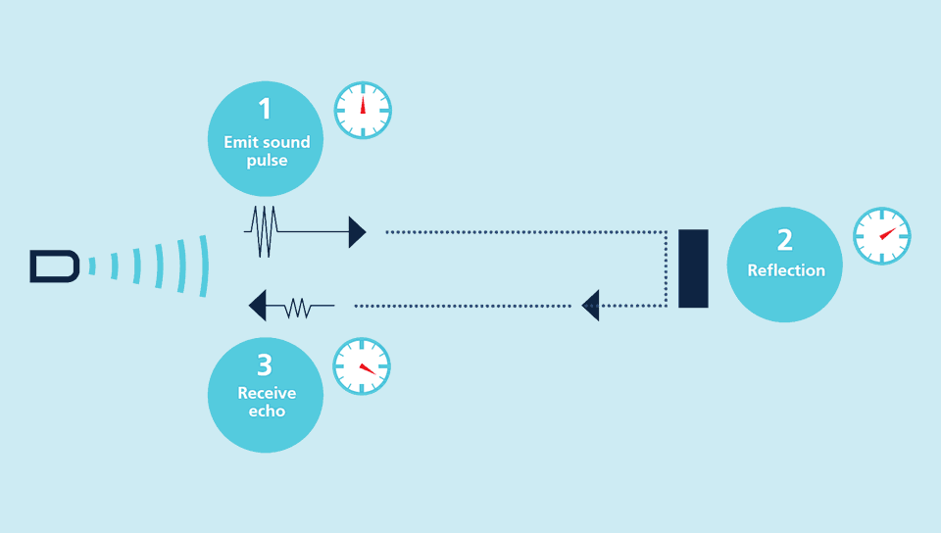

Fig. 9 Figure shows how the Ultra Sound is produced and get Reflected and again get received

Sensors with a blind zone of only 20 mm and an extremely thin beam spread are making entirely new applications possible today: Fill level measurement in wells of microtiter plates and test tubes, as well as the detection of small bottles in the packaging industry, can be implemented with ease. Even thin wires are reliably detected.

*D. Arduino Mega*

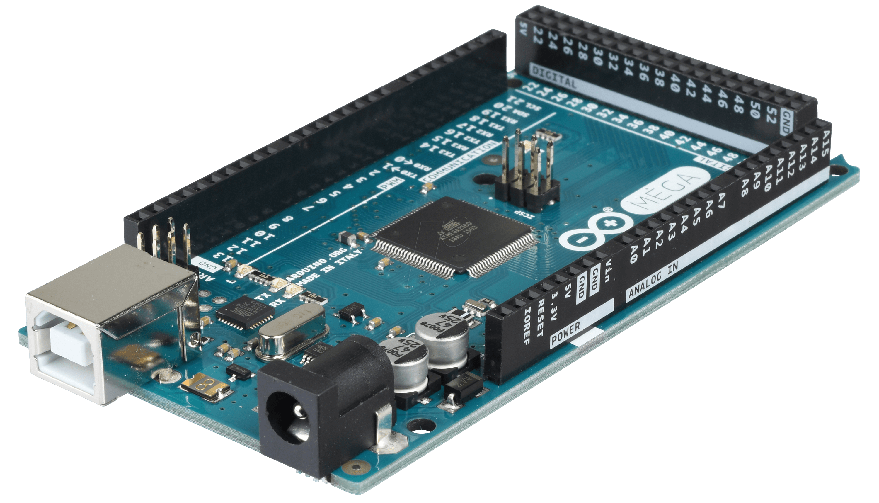

Fig. 10 Arduino Mega

The Arduino Mega 2560 R3 is an open source precise microcontroller board Successor to the Arduino Mega based on the ATmega2560 SMD chip. The Mega 2560 R3 also adds SDA and SCL pins next to the AREF. In addition, there are two new pins placed near the RESET pin. One is the IOREF that allow the shields to adapt to the voltage provided from the board. The other is a not connected and is reserved for future purposes. The Mega 2560 R3 works with all existing shields but can adapt to new shields which use these additional pins.

This Board has 54 digital input/output pins (of which 15 can be used as PWM outputs), 16 analog inputs, 4 UARTs (hardware serial ports), a 16 MHz crystal oscillator, a USB connection, a power jack, an ICSP header, and a reset button. It contains everything needed to support the microcontroller. Using the board is also very easy, simply connect it to a computer with a USB cable or power it with DC adapter or battery to get started.

*1) Specifications:*

* Microcontroller: ATmega2560
* Operating Voltage: 5V
* Input Voltage (recommended): 7-12V
* Input Voltage (limits): 6-20V
* Digital I/O Pins: 54 (of which 15 provide PWM output)
* Analog Input Pins: 16
* DC Current per I/O Pin: 40 mA
* DC Current for 3.3V Pin: 50 m
* Flash Memory: 256 KB of which 8 KB used by bootloader
* SRAM: 8 KB
* EEPROM: 4 KB
* Clock Speed: 16 MHz
* USB Host Chip: MAX3421E

*E. ESP 8266 WIFI Module*

ESP8266 is Wi-Fi enabled system on chip (SOC) module developed by Espressif system. It is mostly used for development of IOT (Internet of Things) embedded applications.

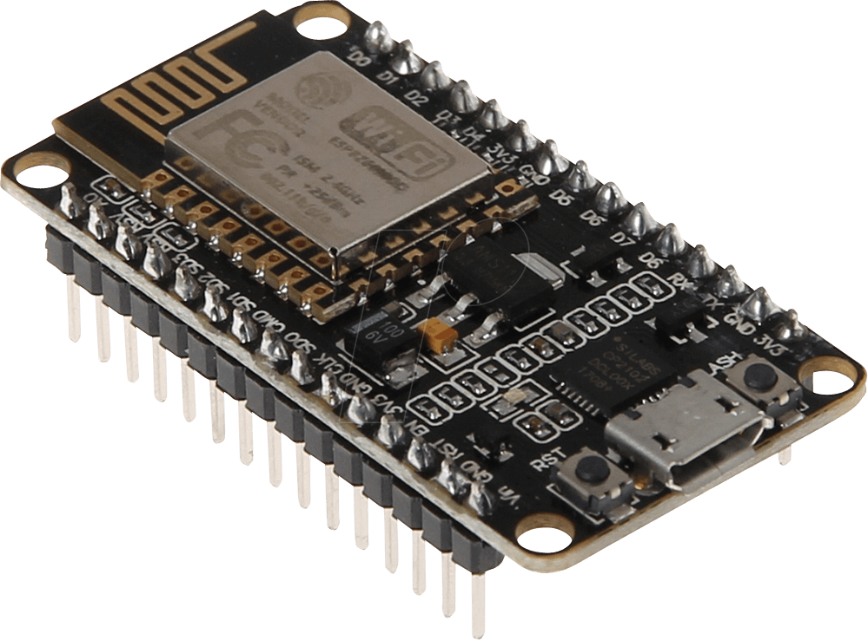

Fig. 11 ESP8266 NODEMCU (WIFI MODULE)

*1) ESP8266-01 WIFI Module specifications:*

ESP8266 comes with capabilities of

* 2.4 GHz Wi-Fi (802.11 b/g/n, supporting WPA/WPA2),
* general-purpose input/output (16 GPIO),
* analog-to-digital conversion (10-bit ADC)
* Serial Peripheral Interface (SPI) serial communication protocol,
* I²S (Inter-IC Sound) interfaces with DMA (Direct Memory Access) (sharing pins with GPIO),
* UART (on dedicated pins, plus a transmit-only UART can be enabled on GPIO2), and

It employs a 32-bit RISC CPU based on the Tensilica Xtensa L106 running at 80 MHz (or overclocked to 160 MHz). It has a 64 KB boot ROM, 64 KB instruction RAM and 96 KB data RAM. External flash memory can be accessed through SPI.

ESP8266 module is low cost standalone wireless transceiver that can be used for end-point IoT developments.

VI OTHER COMPONENT

*A. DC Motor*

DC Motors are electromechanical devices which use the interaction of magnetic fields and conductors to convert the electrical energy into rotary mechanical energy

**Electrical DC Motors** are continuous actuators that convert electrical energy into mechanical energy. The DC motor achieves this by producing a continuous angular rotation that can be used to rotate pumps, fans, compressors, wheels, etc.

As well as conventional rotary DC motors, linear motors are also available which are capable of producing a continuous liner movement.

Normal DC motors have almost linear characteristics with their speed of rotation being determined by the applied DC voltage and their output torque being determined by the current flowing through the motor windings. The speed of rotation of any DC motor can be varied from a few revolutions per minute (rpm) to many thousands of revolutions per minute making them suitable for electronic, automotive or robotic applications. By connecting them to gearboxes or gear-trains their output speed can be decreased while at the same time increasing the torque output of the motor at a high speed.

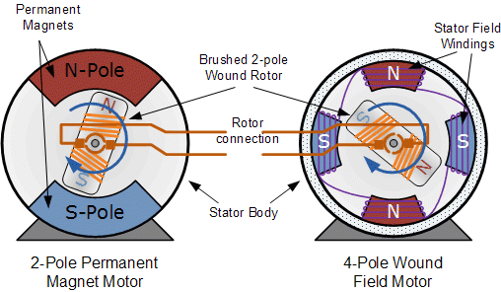

Fig. 12 Transactional View of DC Motor

*B. Servo Motor*

**DC Servo motors** are used in closed loop type applications were the position of the output motor shaft is fed back to the motor control circuit. Typical positional “Feedback” devices include Resolvers, Encoders and Potentiometers as used in radio control models such as aeroplanes and boats etc.

A servo motor generally includes a built-in gearbox for speed reduction and is capable of delivering high torques directly. The output shaft of a servo motor does not rotate freely as do the shafts of DC motors because of the gearbox and feedback devices attached.

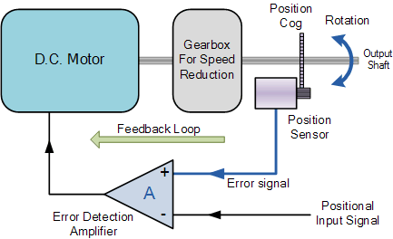

Fig. 13 DC Servo Motor Block Diagram

  A servo motor consists of a DC motor, reduction gearbox, positional feedback device and some form of error correction. The speed or position is controlled in relation to a positional input signal or reference signal applied to the device.

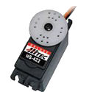 Fig. 14 DC Servo Moto

VII WORKING PRINCIPLE

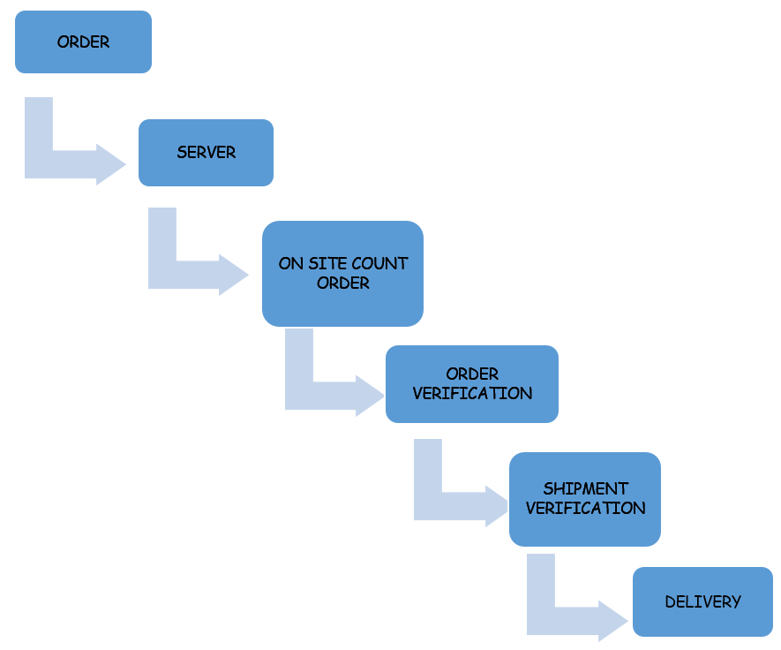

Fig. 15 Block Diagram of the Overall Process

The working of this product can be segmented into 2 major phases:-

*A. Receiving the order*

We use an IOT control app called the Blynk app to control the quantity of each good being produced. We input what type of product we want and the quantity required. We can also control the entire factory’s power through this app.

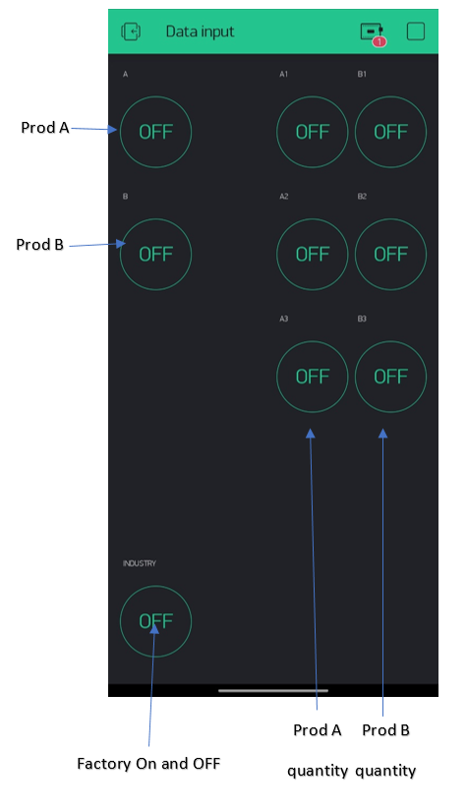

Fig 16 Front End of the blynk App

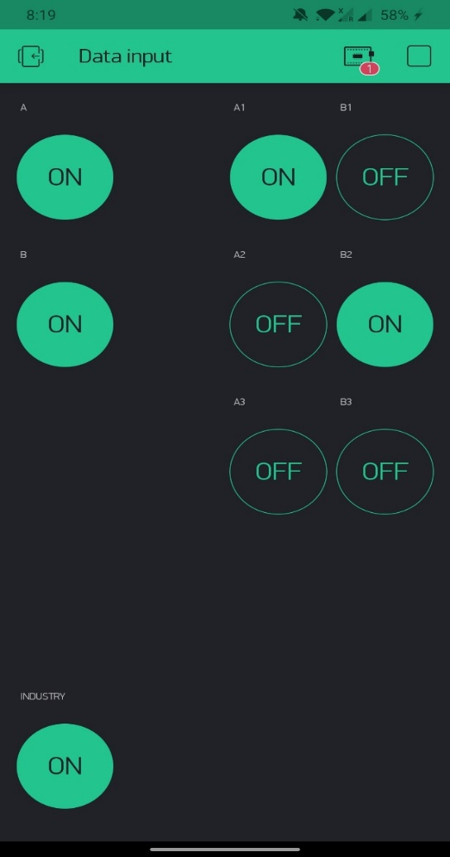

Fig 17 Entered Data to the App

*B. Quality checking and ensuring the correct number of packages is delivered*

This is the main stage of the verifying process. This is where the qualitative and quantitative analysis takes place.

Once the controller knows how many of each product needs to be taken, it asks you to place the first product onto the conveyer belt.

An IR sensor will detect when you have placed it and will automatically start the belt.

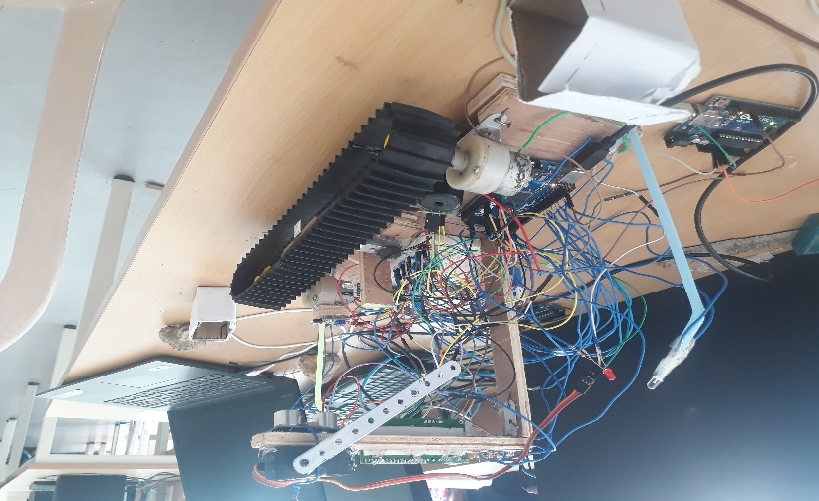

A second IR sensor will stop the product as soon as it reaches the weight and SONAR sensors.

The weight and SONAR sensors will be given 2 secs to process and decide whether the product is in good packaging and whether the quantity inside is correct. If it is correct the conveyor belt starts again and takes the product ahead, if the product is bad then we use a mechanical arm attached to a servo motor to push the product out of the conveyor belt.

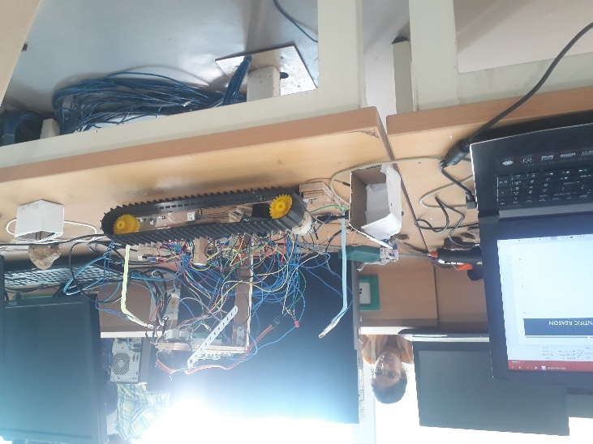

Once this is done it again asks you to place the same product until we receive the required number of good products.

Once we get the proper number of good products of the first kind, we repeat this entire process for the second product too.

VIII. FUTURE SCOPE

As IOT gets better there will be many more improvements which will further enhance the efficiency of this verification system. In the long term we can expect that image processing and gyro sensors can be implemented in order to properly verify products.

Improvements in technology also means the earlier technology will become a cheaper less sophisticated alternative, this is beneficial as then even the smallest manufacturers will verify their products.

IX RESULT/CONCLUSSION

We have successfully completed the project and achieve the desired goals. After doing the project we came to the conclusion that with the help of Image Processing we can even detect the very minute defects in the packaging and with the help Capacitive Sensor and Accelerometer we can find the internal damage to the product without opening the box.

ACKNOWLEDGMENT

We would like to express our heartfelt gratitude to our supervisor, Dr.Selvajyothi K, Assistant Professor of department of electronics and communication engineering, IIITDM-Chennai, for laying the foundation for our thesis concept and providing his valuable insight and guidance at each and every step of the development process.

Furthermore, we would like to thank our family and friends for their continued support and encouragement throughout. Without them, this would not have been made possible, as they have helped push us further and further to reach our desired destination.

Last, but not least, we would like to thank our peers who have lent their support, advice and much appreciated words of encouragement. Their valuable input and suggestions with respect to our thesis is thoroughly appreciated.

REFERENCES

[1]<https://www.digimarc.com/resources/history-of-packaging>

[2]<https://www.efalcon-inc.com/history-conveyor-belts-1892-today/>

[3] Santanu Chakarborthy, “Semi flexible screw conveyor”, IOSR journal of mechanical and civil engineering (iosr-jmce) eissn:2278-1684,p-issn: 2320-334x, volume 11, issue5 ver. iv (sep- oct. 2014), pp 01-13.

[4] Prof. Ravindra Gandhe, “study and analysis of roller conveyor in material handling” international journal of engineering sciences & research -technology, ISSN: 2277-9655 (I2OR), Publication Impact Factor: 3.785

[5] Rohini N. Sangolkar, Vidhyadhar P. Kshirsagar, “modeling and analysis of industrial belt conveyor system using creo parametric and ansys software”, International Journal of Technical Research and Applications e-ISSN: 2320-8163, www.ijtra.com Volume 3, Issue 4 (July-August 2015), PP. 178-181