Given a picture with a object, we are supposed to box the object.

Box data make up of 4 data: the top left corner coordinate of box, width+x1 of box and height+y1 of box.

Neural Network

For traditional CNN and FC, it will meet degeneration problems when layers go deep.

In paper Deep Residual Learning for Image Recognition, they try to solve this problem by using a Residual Block:

I use ResNet-18 in this project by adding a 4-dimension layer after ResNet-18 to predict box's x, y ,x+w and h+y

Loss: smooth l1 loss

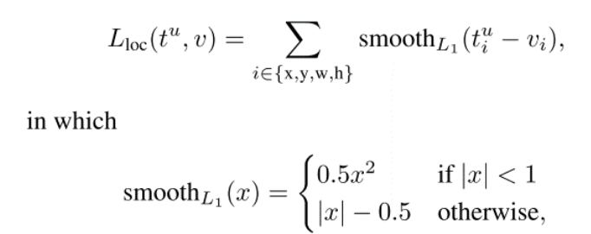

Metric: IoU of groound truth and prediction, threshold=0.75

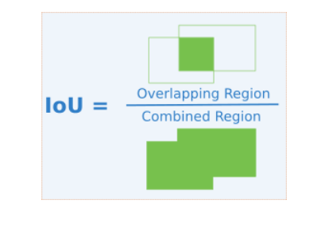

Train
Resize all images to 224*224*3
Then normalize and standardize all pixel channel.
Split all data into 13000 training data and 12816 tesing data. Train network on training data using batch size=128, epoch=100 and validation split ratio=0.1

To run the code

To get data from file

Run first getdata.py
Then train.py
Then getestdata.py
Then test.py

