<https://www.youtube.com/watch?v=4MtsFAArXVU&list=PLBGx66SQNZ8aPsFDwb79JrS2KQBTIZo10&index=15>

Branch:

-----------

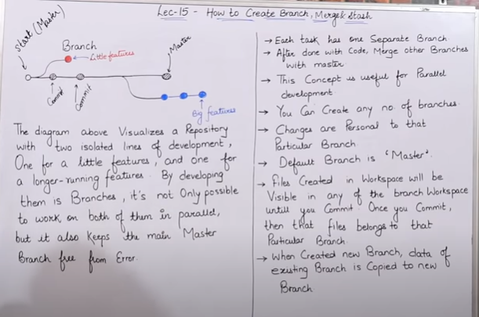

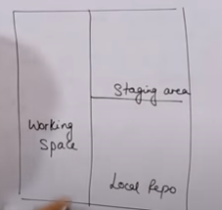

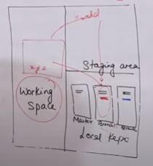

$ git init

$ git log - -oneline

$ git branch

$ git branch <branch-name>

$ git checkout <which branch you want to go like new brach>

$ git branch -d <branch-name> //d -- delete the branch

$ git branch -D <branch-name> //D-- forcefully delete the branch

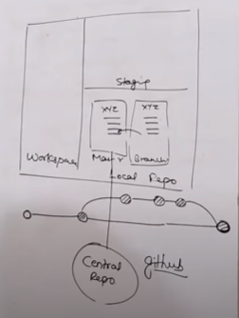

GitHub ----- Microsoft

GitLab ----- Opensource

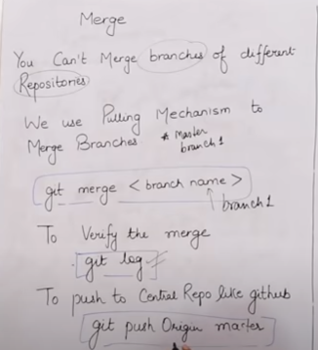

Merging only in the repository not in different server.

Ranjan@DESKTOP-K87NR6R MINGW64 ~/git-test (master)

$ ll

total 0

-rw-r--r-- 1 Ranjan 197121 0 Nov 5 01:19 abc1

Ranjan@DESKTOP-K87NR6R MINGW64 ~/git-test (master)

$ git log --oneline

8366252 1st commit

Ranjan@DESKTOP-K87NR6R MINGW64 ~/git-test (master)

$ git checkout branch1

Switched to branch 'branch1'

Ranjan@DESKTOP-K87NR6R MINGW64 ~/git-test (branch1)

$ ll

total 1

-rw-r--r-- 1 Ranjan 197121 0 Nov 5 01:19 abc1

-rw-r--r-- 1 Ranjan 197121 11 Nov 5 01:58 ght

Ranjan@DESKTOP-K87NR6R MINGW64 ~/git-test (branch1)

$ git checkout master

Switched to branch 'master'

Ranjan@DESKTOP-K87NR6R MINGW64 ~/git-test (master)

$ git branch

branch1

\* master

Ranjan@DESKTOP-K87NR6R MINGW64 ~/git-test (master)

$ git merge branch1

Updating 8366252..6850c8c

Fast-forward

ght | 2 ++

1 file changed, 2 insertions(+)

create mode 100644 ght

Ranjan@DESKTOP-K87NR6R MINGW64 ~/git-test (master)

$ ll

total 1

-rw-r--r-- 1 Ranjan 197121 0 Nov 5 01:19 abc1

-rw-r--r-- 1 Ranjan 197121 11 Nov 5 01:59 ght

Ranjan@DESKTOP-K87NR6R MINGW64 ~/git-test (master)

$

$ git push origin master

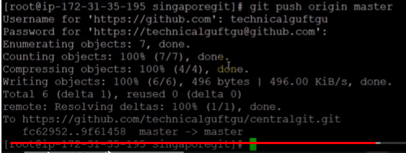

Merge Conflict:

---------------------

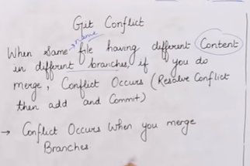

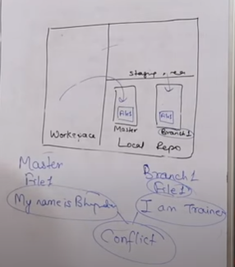

Ranjan@DESKTOP-K87NR6R MINGW64 ~/git-test (master)

$ ll

total 1

-rw-r--r-- 1 Ranjan 197121 0 Nov 5 01:19 abc1

-rw-r--r-- 1 Ranjan 197121 11 Nov 5 01:59 ght

Ranjan@DESKTOP-K87NR6R MINGW64 ~/git-test (master)

$ cat >election

hello us ellection

Ranjan@DESKTOP-K87NR6R MINGW64 ~/git-test (master)

$ git add .

warning: LF will be replaced by CRLF in election.

The file will have its original line endings in your working directory.

Ranjan@DESKTOP-K87NR6R MINGW64 ~/git-test (master)

$ ll

total 2

-rw-r--r-- 1 Ranjan 197121 0 Nov 5 01:19 abc1

-rw-r--r-- 1 Ranjan 197121 19 Nov 5 02:15 election

-rw-r--r-- 1 Ranjan 197121 11 Nov 5 01:59 ght

Ranjan@DESKTOP-K87NR6R MINGW64 ~/git-test (master)

$ git status

On branch master

Changes to be committed:

(use "git reset HEAD <file>..." to unstage)

new file: election

Ranjan@DESKTOP-K87NR6R MINGW64 ~/git-test (master)

$ git commit -m "third commit with merge conflict"

[master 177ca7d] third commit with merge conflict

1 file changed, 1 insertion(+)

create mode 100644 election

Ranjan@DESKTOP-K87NR6R MINGW64 ~/git-test (master)

$ git log --oneline

177ca7d third commit with merge conflict

6850c8c 2nd commit

8366252 1st commit

Ranjan@DESKTOP-K87NR6R MINGW64 ~/git-test (master)

$ git checkout branch1

Switched to branch 'branch1'

Ranjan@DESKTOP-K87NR6R MINGW64 ~/git-test (branch1)

$ ll

total 1

-rw-r--r-- 1 Ranjan 197121 0 Nov 5 01:19 abc1

-rw-r--r-- 1 Ranjan 197121 11 Nov 5 01:59 ght

Ranjan@DESKTOP-K87NR6R MINGW64 ~/git-test (branch1)

$ cat >election

Hi us election

Ranjan@DESKTOP-K87NR6R MINGW64 ~/git-test (branch1)

$ git add .

warning: LF will be replaced by CRLF in election.

The file will have its original line endings in your working directory.

Ranjan@DESKTOP-K87NR6R MINGW64 ~/git-test (branch1)

$ git commit -m "trd commit with new conflict msg"

[branch1 3fb03b4] trd commit with new conflict msg

1 file changed, 1 insertion(+)

create mode 100644 election

Ranjan@DESKTOP-K87NR6R MINGW64 ~/git-test (branch1)

$ git branch

\* branch1

master

Ranjan@DESKTOP-K87NR6R MINGW64 ~/git-test (branch1)

$ git checkout master

Switched to branch 'master'

Ranjan@DESKTOP-K87NR6R MINGW64 ~/git-test (master)

$ git merge branch1

Auto-merging election

CONFLICT (add/add): Merge conflict in election

Automatic merge failed; fix conflicts and then commit the result.

Ranjan@DESKTOP-K87NR6R MINGW64 ~/git-test (master|MERGING)

$ vi election

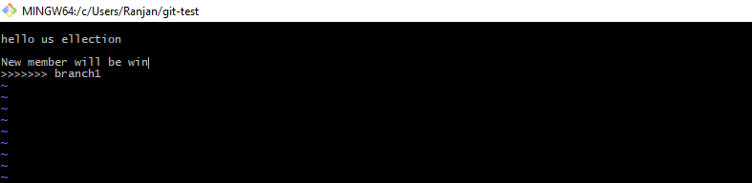



Ranjan@DESKTOP-K87NR6R MINGW64 ~/git-test (master|MERGING)

$ git status

On branch master

You have unmerged paths.

(fix conflicts and run "git commit")

(use "git merge --abort" to abort the merge)

Unmerged paths:

(use "git add <file>..." to mark resolution)

both added: election

no changes added to commit (use "git add" and/or "git commit -a")

Ranjan@DESKTOP-K87NR6R MINGW64 ~/git-test (master|MERGING)

$ git add .

Ranjan@DESKTOP-K87NR6R MINGW64 ~/git-test (master|MERGING)

$ git commit -m "resolve conflict"

[master 3a8b9a3] resolve conflict

Ranjan@DESKTOP-K87NR6R MINGW64 ~/git-test (master)

$ git log --oneline

3a8b9a3 resolve conflict

3fb03b4 trd commit with new conflict msg

177ca7d third commit with merge conflict

6850c8c 2nd commit

8366252 1st commit

Ranjan@DESKTOP-K87NR6R MINGW64 ~/git-test (master)