**NAME :** DUDHE ANIL AJINATH

**ROLL NO :** TEAD21269

**SUBJECT :** DBMS

**CLASS :** TE

**BRANCH :** AI&DS

**EXPERIMENT NO :3**

**TITLE :**

**MongoDB Queries:**

**Design and Develop MongoDB Queries using CRUD operations. (Use CRUD**

# operations, SAVE method, logical operator.

**CODE:**

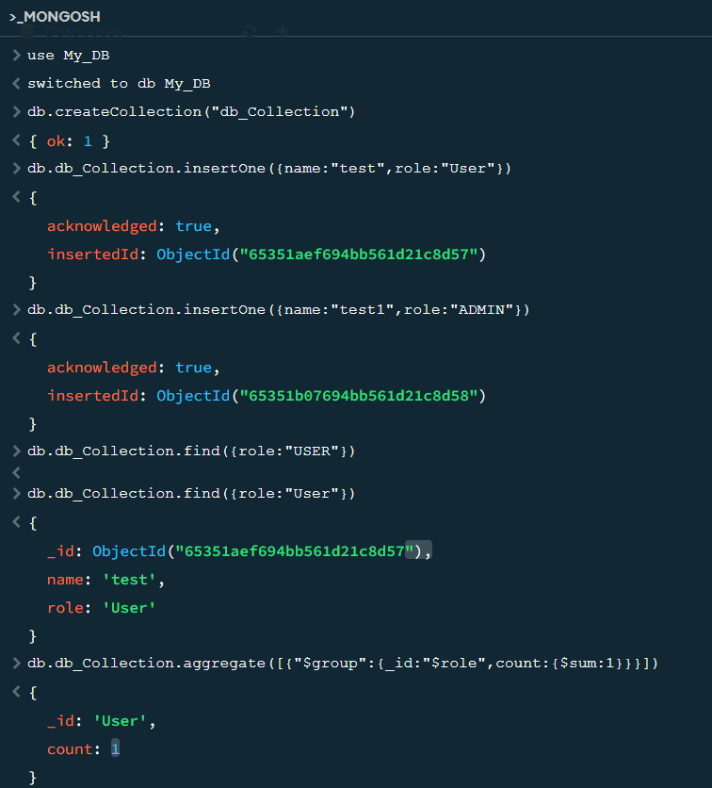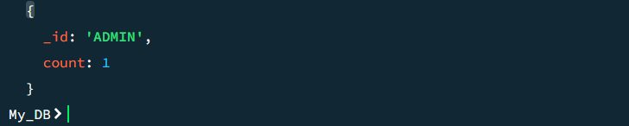

**OUTPUT:**

