**ASSIGNMENT -11**

**Consider the following schema of SUPPLIER database**

**SUPPLIER (supp_id, supp_name, supp_cit, supp_status)**

**PARTS (part_no, part_name, part colour, part_weight, part_city)**

**SUPP_PARTS (supp_id, part_no, quantity)**

**PROGRAM:**

create table SUPPLIER(supp_id varchar2(30) primary key,supp_name varchar2(30),supp_cit varchar2(30),supp_status varchar2(30));

**OUTPUT:** Table created.

**PROGRAM:** Describe Supplier;

**OUTPUT:**

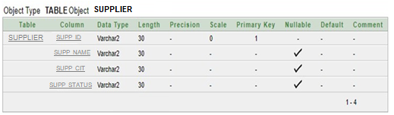

**PROGRAM:**

insert into supplier values('s1','sarla', ,'mumbai',20);

insert into supplier values('s2','uma','chennai',10);

insert into supplier values('s3','nehru','mumbai',30);

insert into supplier values('s4','priya','mumbai',20);

insert into supplier values('s5','anand','delhi',30);

**PROGRAM:** select * from supplier;

**OUTPUT:**

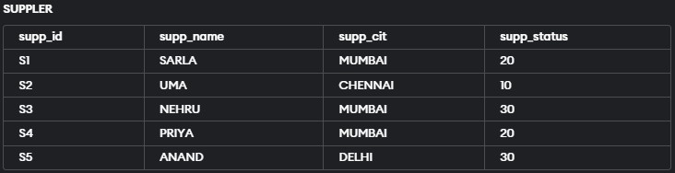

**PROGRAM:**

create table PARTS(part_no varchar2(30) primary key,part_name varchar2(30),part_colour varchar2(30),part_weight varchar2(30),part_city varchar2(30));

**OUTPUT:** Table created.

**PROGRAM:** Describe Parts;

**OUTPUT:**

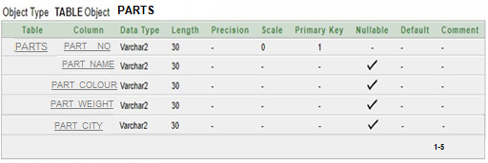

**PROPGRAM:**

insert into parts values('P1' ,'NUT','RED',12,'MUMBAI');

insert into parts values('P2','BOLT','GREEN',17,'CHENNAI');

insert into parts values('P3','SCREW','BLUE',17,'BENGALURU');

insert into parts values('P4','SCREW','RED',14,'MUMBAI');

insert into parts values('P5','CAM','BLUE',12,'CHENNAI');

insert into parts values('P6','COG','RED',19,'MUMBAI');

**PROPGRAM:**

select * from parts;

**OUTPUT:**

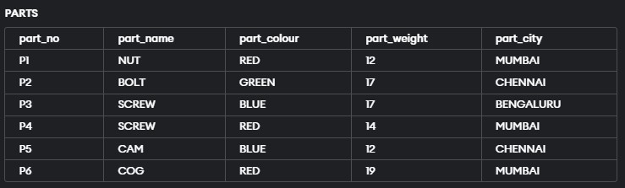

**PROGRAM:**

create table SUPP_PARTS(supp_id varchar2(30) ,part_no varchar2(30),quantity varchar2(30), foreign key(supp_id) references supplier(supp_id),foreign key(part_no) references parts(part_no));

**OUTPUT:** Table created.

**PROGRAM:** Describe Supp_Parts;

**OUTPUT:**

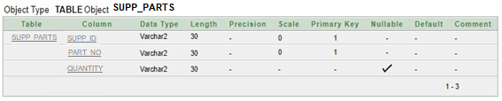

**PROGRAM:**

insert into supp_parts values('s1','p1',300);

insert into supp_parts values('s1','p2',200);

insert into supp_parts values('s1','p3',400);

insert into supp_parts values('s1','p4',200);

insert into supp_parts values('s1','p5',100);

insert into supp_parts values('s1','p6',100);

insert into supp_parts values('s2','p1',300);

insert into supp_parts values('s2','p2',400);

insert into supp_parts values('s3','p2',400);

insert into supp_parts values('s4','p2',200);

insert into supp_parts values('s4','p4',300);

insert into supp_parts values('s4','p5',400);

**PROGRAM:**

Select * From Supp_Parts;

**OUTPUT:**

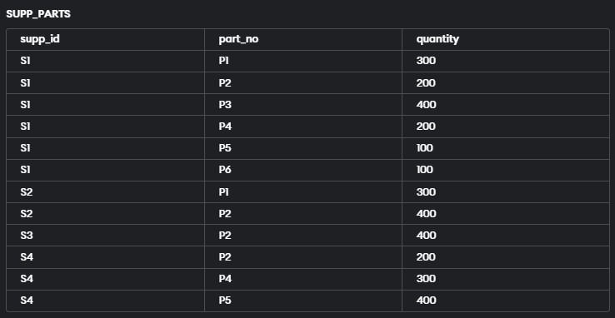

**1. For all parts, get the part no and weight of that part.**

**PROGRAM:**

select part_no,part_weight from parts;

**OUTPUT:**

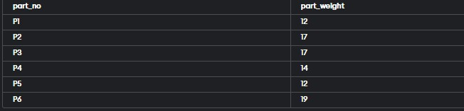

**2. Get all combinations of supplier and part such that both are co-located.**

**PROGRAM:**

select * from supplier,parts where supp_cit = part_city;

**OUTPUT:**

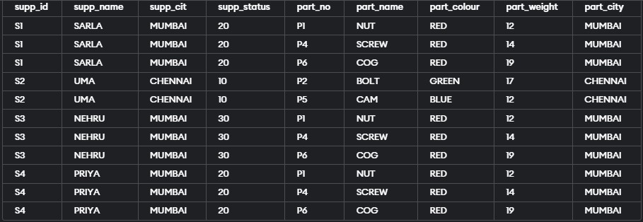

**3. Get all pairs of city names such that a supplier located in first city supplies a part stored in another city.**

**PROGRAM:**

select supp_cit,part_city from supplier,parts where supp_cit != part_city;

**OUTPUT:**

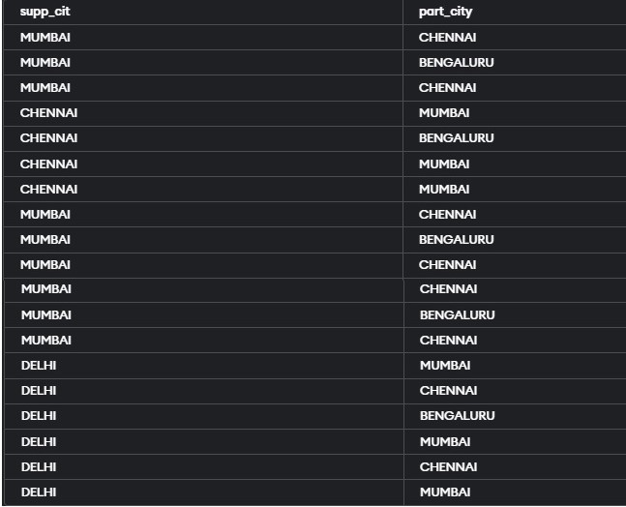

**4. Get all pairs of supplier ids such that the two are co-located.**

**PROGRAM:** select a.supp_id as A ,b.supp_id as B from supplier A JOIN supplier B ON a.supp_cit = b.supp_cit;

**OUTPUT:**

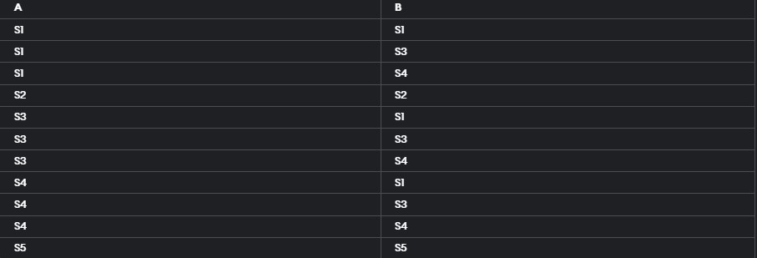

**5. Obtain the total no of suppliers.**

**PROGRAM:** select count(supp_id) from supplier ;

**OUTPUT:**



**6. Find the part ids for which there is only one supplier.**

**PROGRAM:**

select part_no from supp_parts group by part_no having count(supp_id)=1;

**OUTPUT:**

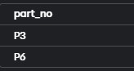

**7. Find the part ids for which there is more than one supplier.**

**PROGRAM:**

select part_no from supp_parts group by part_no having count(supp_id)!=1;

**OUTPUT:**

