Abhay Ranjan

Reporting and Visualization:

Incident Flow:

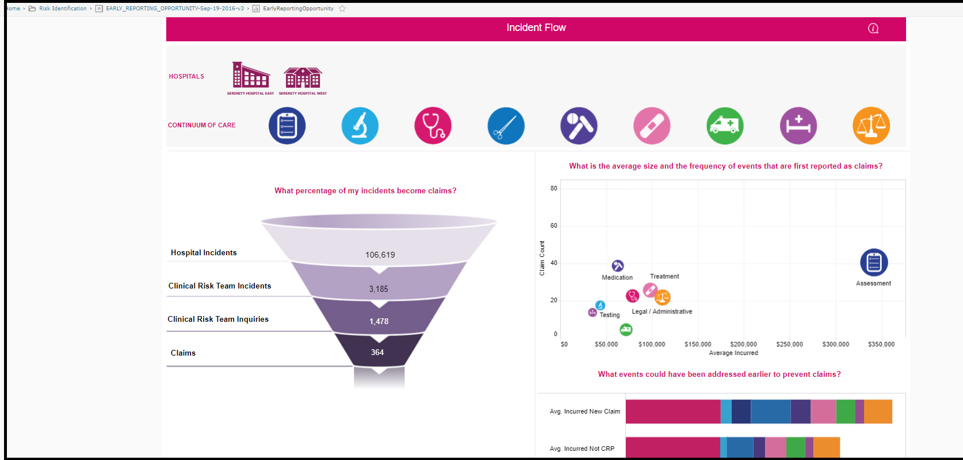

Hospital vs. Hospital Comparison

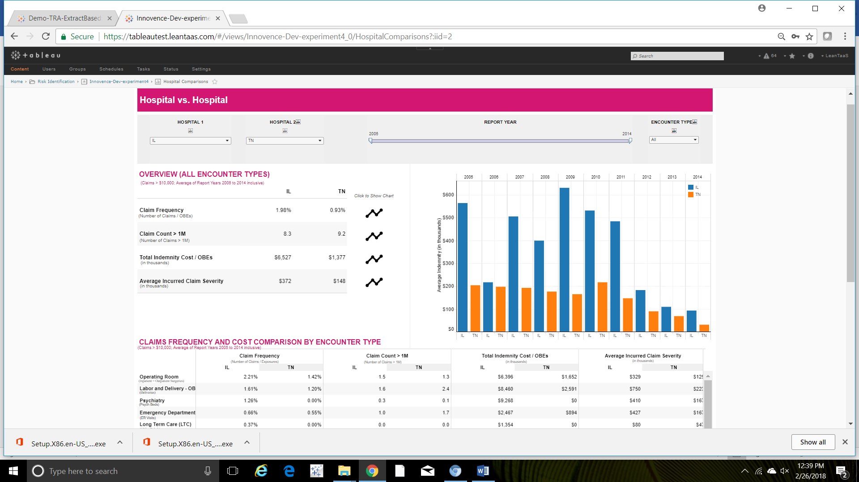

Incident Analysis: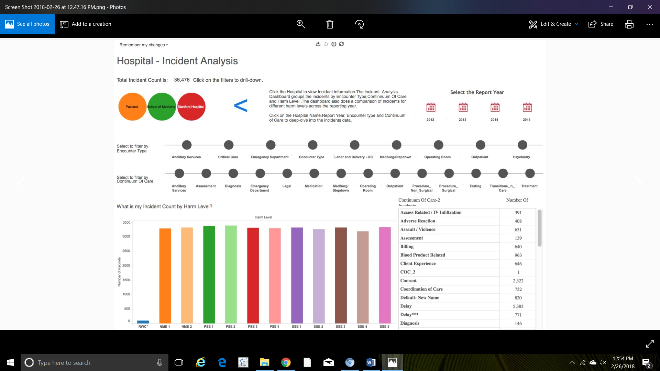

Claims - Frequency Severity Report:

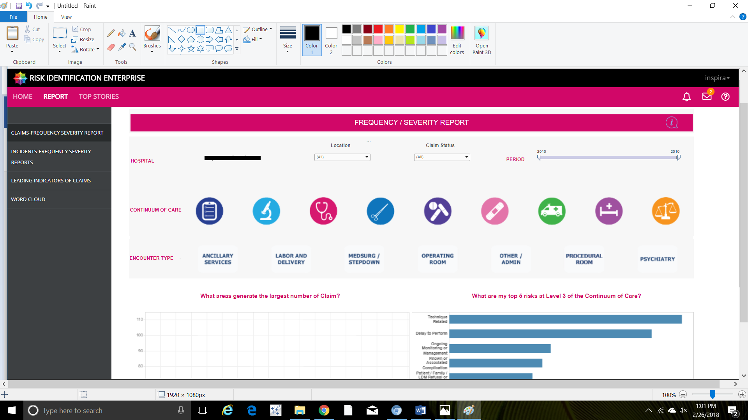

Incidents- Frequency Severity Report

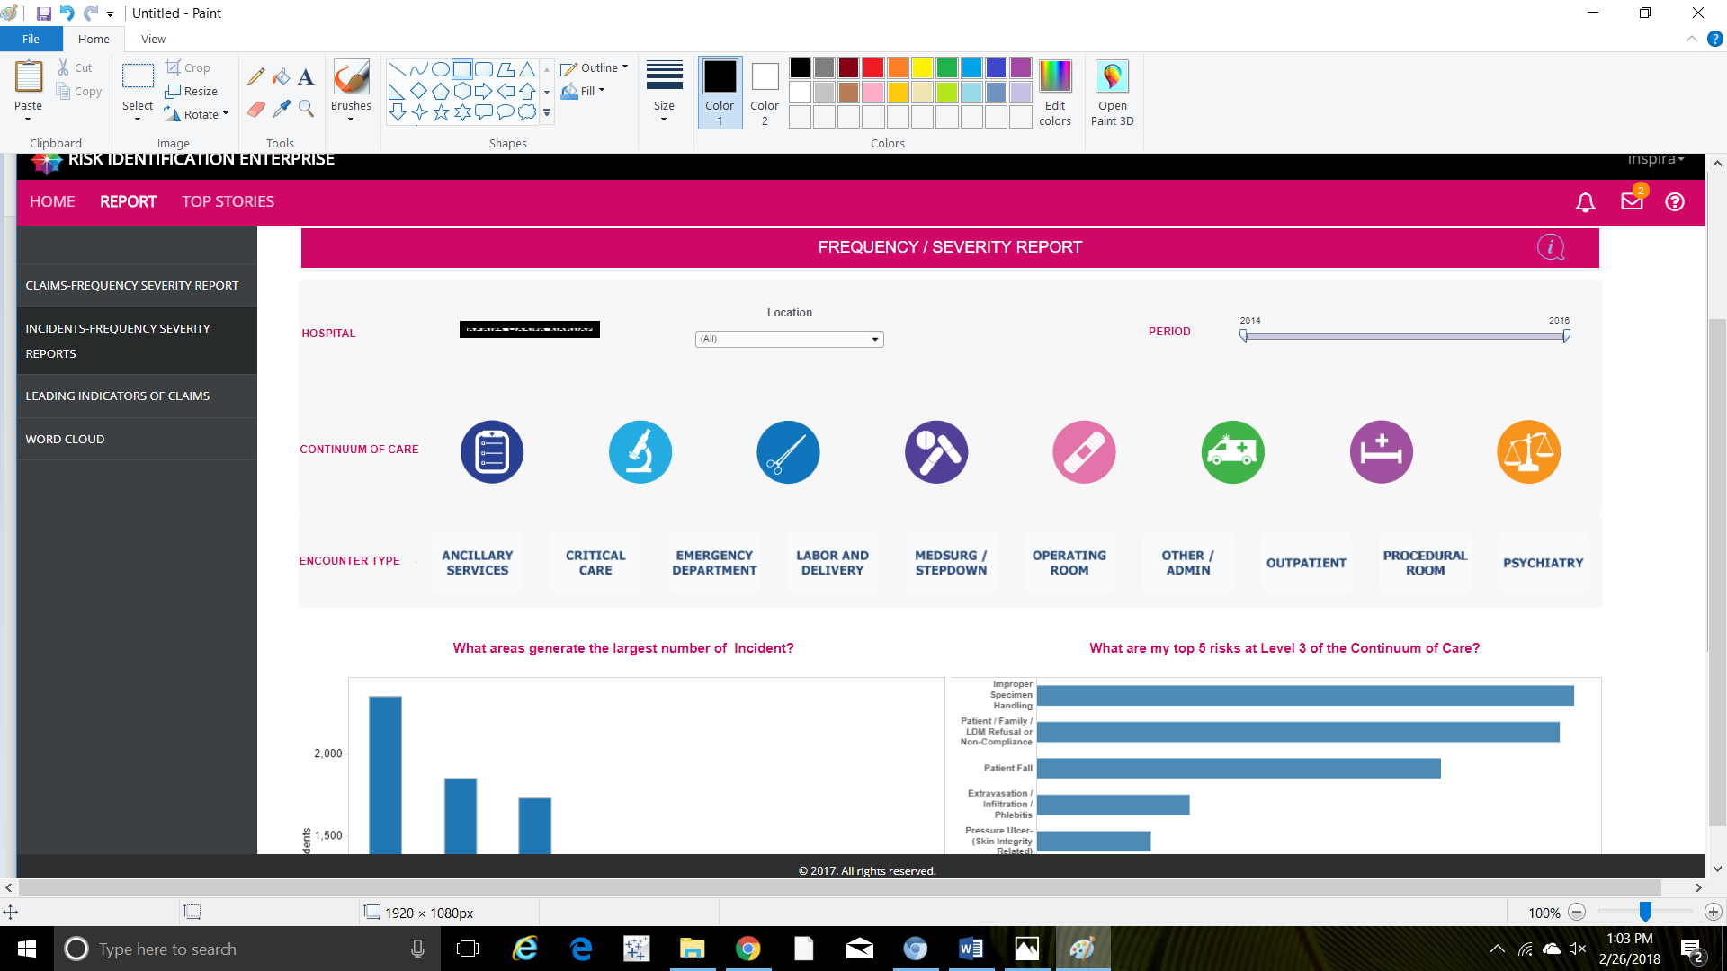

Leading Indicators of Claims:

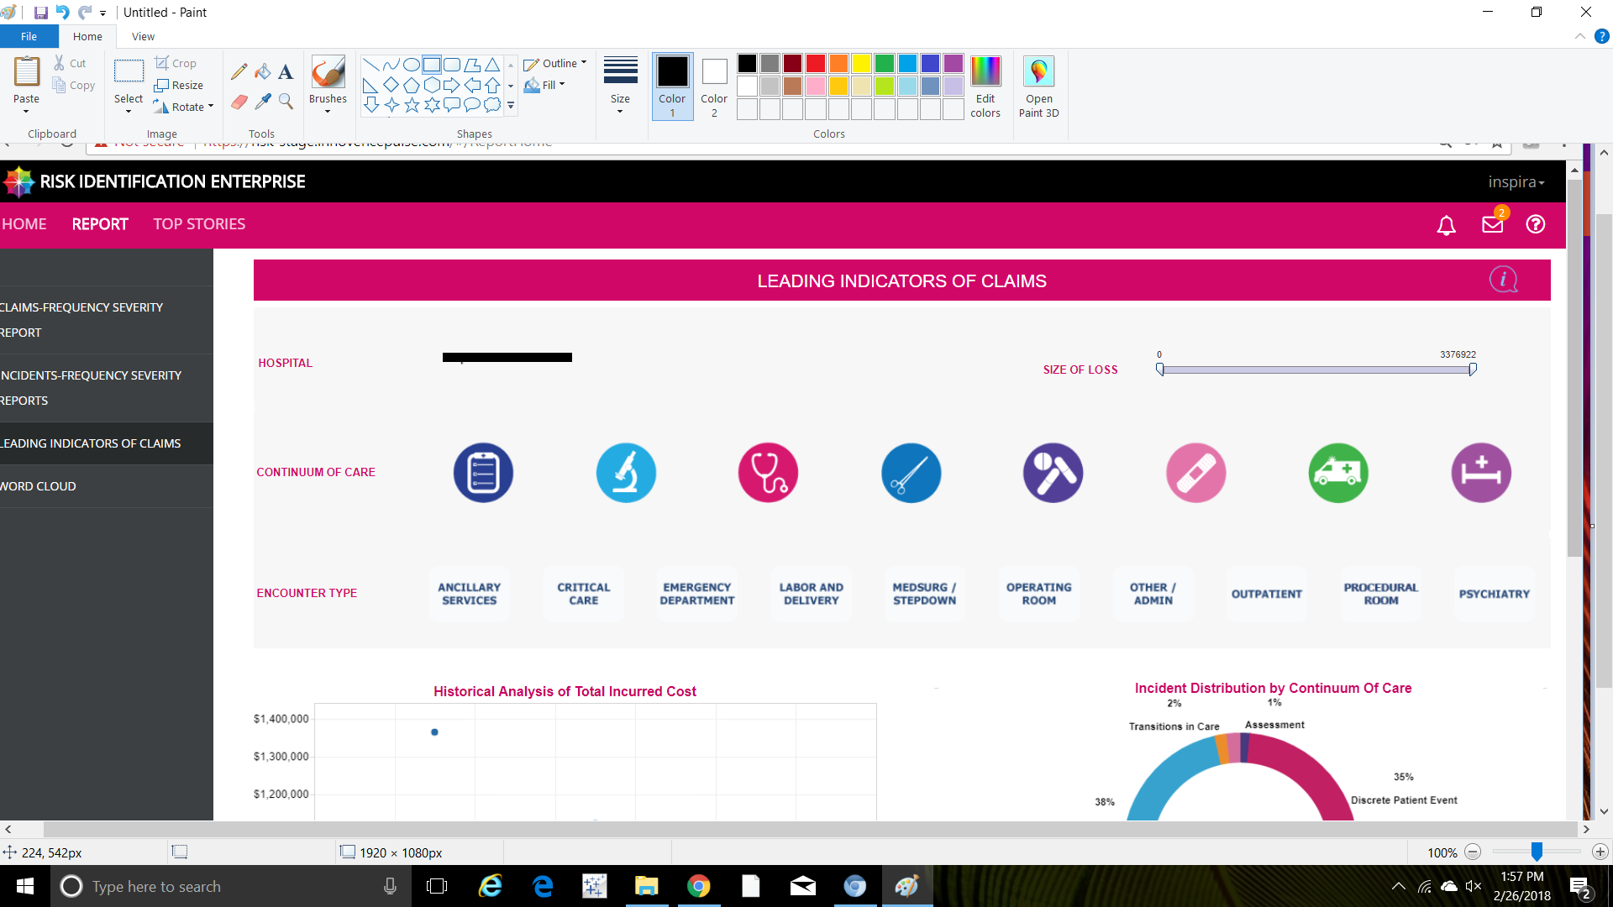

Kaggle: <https://www.kaggle.com/ranjanabhay>

LinkedIn: <https://www.linkedin.com/in/abhayranjan/>