Capstone Project: Predicting Chronic Disease Risk Using Lifestyle and Health Indicators
Module C - Data Science Capstone (DX799S)
Dr. Joshua Von Korff
Ranjana Kumari
Spring 2026

- Problem Statement and Description
This capstone project operates in the healthcare and public health industry, investigating whether machine learning models can predict chronic disease risk using lifestyle, demographic, and health indicators. The research question is: Can machine learning models identify individuals at risk for Type 2 diabetes, obesity, and heart disease, and which factors most consistently predict disease risk across these conditions? Three datasets were analyzed: the CDC Diabetes Health Indicators dataset (~230,000 observations, 2015 BRFSS survey; three outcome classes: no diabetes, prediabetes, diabetes), the UCI Obesity Level Estimation dataset (2,087 observations; seven obesity classes), and the Cleveland Heart Disease dataset (303 observations; binary outcome). Using multiple datasets tests model generalizability across diseases with different class structures, population sizes, and clinical complexity. Approximately 38 million Americans have diabetes, and 98 million have prediabetes, many undiagnosed, with an estimated annual economic burden of $327 billion. By evaluating six machine learning approaches across three chronic diseases, this project assesses both the potential and limitations of AI-driven risk prediction, with implications for earlier identification of high-risk individuals, targeted prevention, and health equity.
- Modeling Techniques Breadth (Weeks 1, 2, 3, and 5) Depth (Weeks 4 and 6)
Week 1 - Polynomial and Interaction Terms (Breadth) – Polynomial and interaction terms were applied to all three datasets using 5-fold cross-validation. CDC Diabetes showed only marginal improvement over baseline (Test R² = 0.1524 → 0.1624), confirming that the outcome is not well captured by polynomial transformations of these features. Obesity benefited substantially (baseline 0.2561 → polynomial 0.4532), while heart disease showed no benefit and a slight decline (0.3986 → 0.3847), consistent with. cardiovascular predictors being threshold-based rather than smoothly nonlinear. VIF > 5 for BMI² and Age² confirmed multicollinearity from feature engineering, directly motivating regularization in Week 2.
Week 2 - Lasso, Ridge, and Elastic Net Regularization (Breadth) -Ridge, Lasso, and Elastic Net were applied to all three datasets, with regularization parameters selected using cross-validation on the training data. Model performance was evaluated using Test R². The CDC Diabetes dataset showed minimal improvement (Test R² ≈ 0.167), indicating that its large sample size already produced stable estimates without substantial benefit from regularization. The Obesity dataset also showed little change. In contrast, heart disease benefited the most: Ridge increased Test R² from 0.4544 to 0.4879, Lasso reduced the number of predictors from 13 to 9, and Elastic Net achieved Test R² = 0.47. These results indicate that regularization improved model stability and feature selection for the smaller heart disease dataset, while providing limited benefit for the larger datasets.
Week 3 - Forward/Backward Selection, PCR, and PLSR (Breadth)- Forward and backward selection, PCR, and PLSR were applied to all three datasets and evaluated using Test R². These methods identified the same eight predictors for CDC Diabetes, maintaining Test R² = 0.1552. For Heart Disease, PLSR achieved the highest Test R² (0.5509), outperforming PCR (0.5340). CDC Diabetes and Obesity required all available components in both PCR and PLSR, indicating that predictive information was distributed across multiple variables. A limitation of Week 3 methods is that they are regression -based, limiting their use for classification models in Week 4.
Week 4 - Logistic Regression and Feature Scaling (Depth) - This section addresses the shift from regression to classification, as disease prediction is inherently a classification task and earlier R² values reflected model mismatch rather than performance failure. Features were standardized using training-set scaling to prevent data leakage. Logistic regression was evaluated using cross-validated macro F1 tuned across regularization strengths. A key finding is the optimal regularization across datasets: CDC Diabetes (C = 0.1), Obesity (C = 100), and heart disease (C = 10.0), reflecting differences in dataset structure rather than model instability. Strong regularization in CDC Diabetes is required due to class imbalance and overlapping feature distributions, particularly between non-diabetic and prediabetic cases. The obesity dataset is highly separable based on body composition variables, requiring minimal regularization. Heart disease lies between these extremes, reflecting moderate complexity and limited sample size. Table 1. Logistic Regression Performance Metrics
Dataset | F1 Score | Recall | Precision | AUC-ROC | CV F1(5-fold)
CDC Diabetes | 0.3822 | 0.3773 | 0.4610 | 0.7652 | 0.3805 ±0.001
Obesity | 0.9649 | 0.9650 | 0.9652 | 0.9977 | 0.9677 ±0.011
Heart Disease | 0.8333 | 0.9091 | 0.7692 | 0.8734 | 0.8506 ±0.058

Figure 1: ROC curves (logistic regression) across all three datasets: Obesity shows near-perfect class separation (AUC = 0.9977), while heart disease shows strong discrimination (AUC = 0.8734). CDC Diabetes shows weaker separability (AUC = 0.7652), with reduced performance for the prediabetes class (AUC ≈ 0.685) compared to the other classes (AUC ≈ 0.80–0.81).
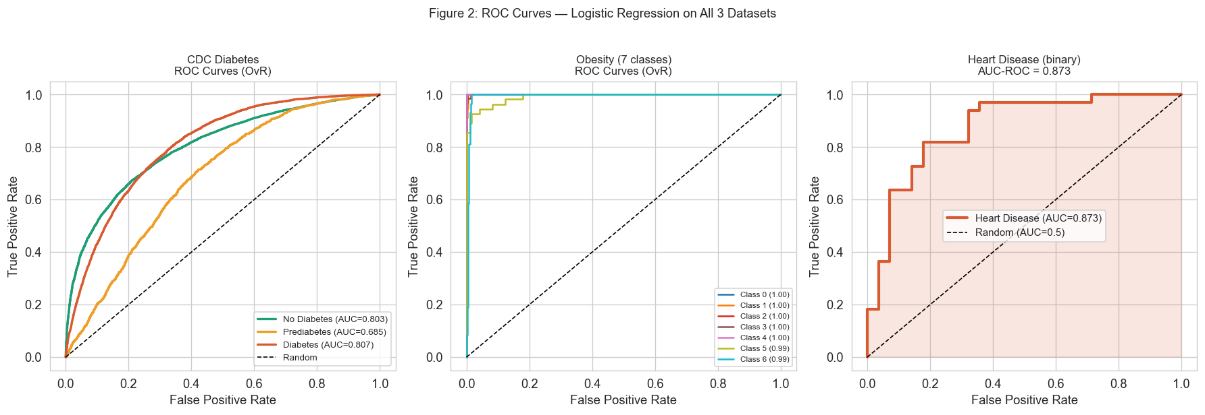
AUC–F1 Discrepancy and Clinical Implications - CDC Diabetes AUC-ROC of 0.7652, but low macro F1 of 0.3822. The confusion matrix resolves this: 37,146 non-diabetic individuals were correctly classified, while 0 of 926 prediabetes cases were predicted correctly, all assigned to the no-diabetes majority. AUC measures ranking ability, whereas F1 measures class assignment at a fixed threshold. The 1.9% prediabetes class receives almost no correct predictions despite an acceptable AUC. Prediabetics are precisely those for whom early intervention prevents progression to Type 2 diabetes, yet this model cannot identify them.
Figure 2. The CDC Diabetes confusion matrix shows no correct prediabetes predictions, explaining the gap between AUC (0.7652) and macro F1 (0.3822).
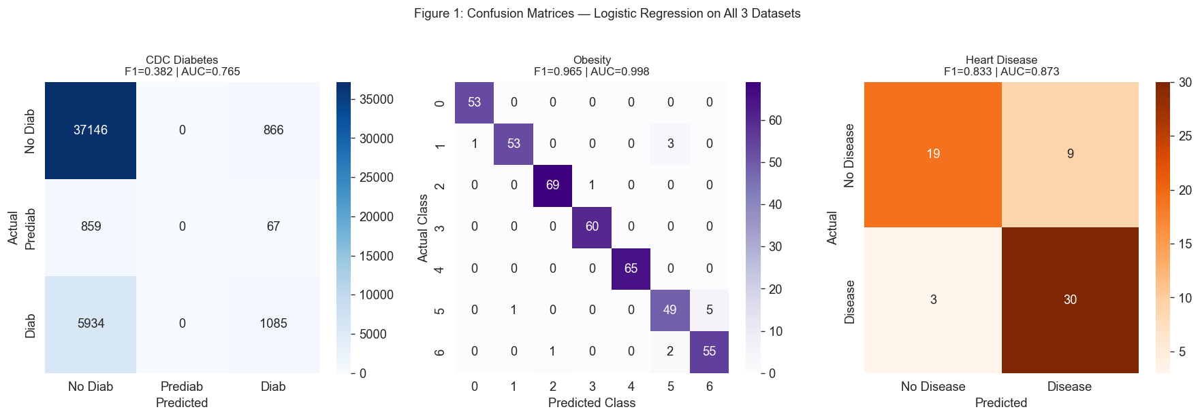
Why Logistic Regression Reaches Its Ceiling - The HighBP coefficient exceeded the GenHlth coefficient despite GenHlth having the highest Pearson correlation (r ≈ 0.28 in Week1), highlighting the difference between univariate correlation and partial regression coefficients: once other predictors are controlled, HighBP contributes more independently to diabetes risk. Even with the correct classification framework, performance barely moved. CDC Diabetes scores (logistic regression F1= 0.3822, SVM = 0.4010, RF = 0.3935), indicating a dataset-driven ceiling rather than a model limitation. This suggests prediabetes is not well separated from non-diabetes using lifestyle survey variables alone, and that clinical biomarkers such as HbA1c or fasting glucose may be required for better separability.
Week 5 -Support Vector Machines and the Kernel Trick (Breadth)- SVM with RBF kernel achieved macro F1=0.4010 for CDC Diabetes (stratified 10,000-row subsample due to O(n²–n³) complexity), modestly improving logistic regression (0.3822). Heart Disease achieved F1 = 0.8533, improving on Week 4 (0.8333). Obesity required only a linear kernel despite seven classes (F1 = 0.9673), confirming that body-composition features are nearly linearly separable in the original feature space. For Heart Disease, large C values produced a widening train-test gap, confirming that C regularization was essential for generalization on the 303-row dataset. The best C = 1.0 was selected via GridSearchCV with 5-fold stratified CV. Across all models, CDC diabetes remains bounded by a consistent performance ceiling, suggesting feature overlap rather than model choice is the limiting factor.
Week 6 - Decision Trees and Random Forests (Depth) - Decision tree performance shows a clear bias–variance tradeoff as model complexity increases. Shallow trees underfit the CDC Diabetes dataset, while performance stabilizes only slightly at intermediate depths. Beyond depth 10, test performance declines as the model begins capturing noise instead of signal. At full depth, the model exhibits severe overfitting, with Train F1 = 0.9144 and Test F1 = 0.3910, producing a generalization gap of 0.5234. This confirms that high-capacity trees require constraints, motivating the shift to random forests.
Table 2. Decision tree performance by maximum depth on the CDC Diabetes dataset
Max Depth | Train F1 | Test F1 | Gap | Interpretation
2 | 0.3018 | 0.3018 | 0.0000 | No overfitting model too simple
4 | 0.3946 | 0.3982 | -0.0036 | Slight underfitting
6 | 0.3567 | 0.3584 | -0.0017 | Stable but limited
8 | 0.3857 | 0.3868 | -0.0011 | Near stable
10 | 0.4051 | 0.3936 | 0.0115 | Small overfitting gap begins
15 | 0.5763 | 0.4005 | 0.1758 | Overfitting emerging
None (Full) | 0.9144 | 0.3910 | 0.5234 | Severe overfitting memorization

Figure 3- Train vs Test F1 as max depth increases for CDC Datasets. The shades gap is widening. Right: depth-3 tree with GenHlth at the root node, consistent EDA (r ≈ 0.28).
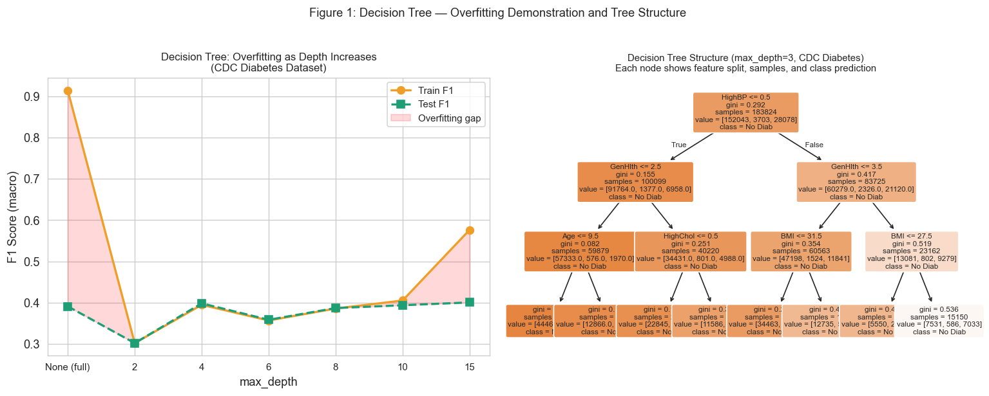
Random Forest: Hyperparameter Tuning and Results
Random Forest resolves the overfitting behavior observed in single decision trees by aggregating multiple constrained models. Hyperparameter tuning via GridSearchCV showed that CDC Diabetes and Obesity favored unrestricted tree depth, while heart disease selected max_depth = 5, reflecting the need for stronger structural constraints on the smaller dataset. This indicates that model complexity must be adapted to sample size, with smaller datasets requiring tighter regularization to avoid instability.
Table 3. Random Forest performance across all three Datasets- Heart Disease achieves high sensitivity (recall = 0.9697), indicating reliable detection of positive cases, whereas CDC Diabetes and Obesity exhibit broader differences in class structure and separability.
Dataset | F1(macro) | Recall | AUC-ROC | CV F1 | Best Params
CDC Diabetes | 0.3935 | 0.3874 | 0.6922 | 0.3966±0.003 | None, 100 trees
Obesity | 0.9901 | 0.9906 | 0.9999 | 0.9877±0.005 | None, 100 trees
Heart Disease | 0.8533 | 0.9697 | 0.9037 | 0.8297±0.068 | depth=5, 200

Feature Importance: Cross-method Validation
Table 4. Random Forest feature importance scores. BMI and Age appear as top predictors in both CDC Diabetes and Heart Disease, consistent with Week 3 forward selection results providing cross-method validation across six independent analyses. Income ranking third for CDC Diabetes (0.138) was absent from linear model results, revealing a nonlinear socioeconomic interaction that regularized regression could not detect.
Rank | CDC Diabetes | Obesity | Heart Disease | Cross-disease
1 | BMI (0.248) | BMI_calc(0.428) | Chest pain (0.190) | All 3
2 | Age (0.160) | Weight (0.248) | thal (0.174) | 2 of 3
3 | Income (0.138) | Height (0.150) | Oldpeak (0.132) | -
4 | PhysHlth (0.125) | Age (0.062) | thalach(0.105) | 2 of 3
5 | Education (0.096) | FAF (0.043) | Ca (0.096)
Figure 4. Random Forest feature importance: top features ranked by mean decrease in impurity for each dataset. BMI and Age appear across the CDC Diabetes and Heart Disease. BMI_calc dominates Obesity. Income ranks unexpectedly high for CDC Diabetes.
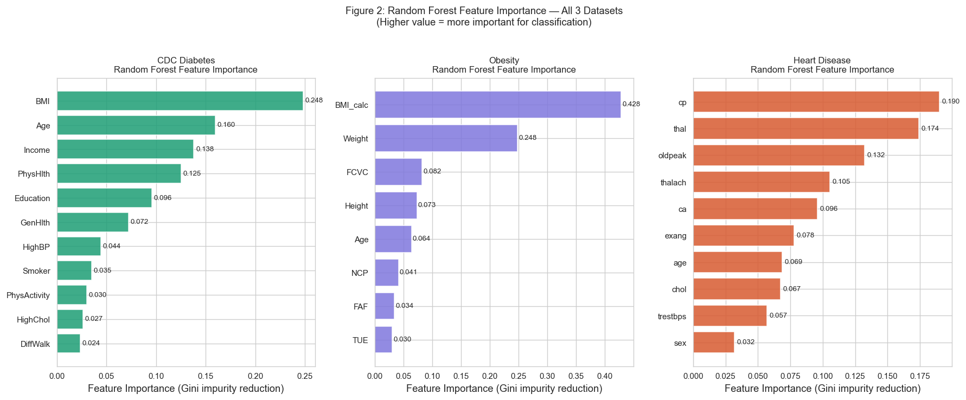
Logistic Regression vs. Random Forest: Final comparison
Dataset | LR F1 | LR AUC | RF F1 | RF AUC | Key Difference
CDC Diabetes | 0.3822 | 0.7652 | 0.3935 | 0.6922 | +0.011 F1; RF found non-linear effect
Obesity | 0.9649 | 0.9977 | 0.9901 | 0.9999 | +0.025F1; near perfect prediction maintained
Heart Disease | 0.8333 | 0.8734 | 0.8533 | 0.9037 | Same F1; Rf improves AUC by +0.030
Table 5. LR vs RF across all three datasets. RF improvement is modest for CDC Diabetes (+0.011 F1) but meaningful for Heart Disease AUC (+0.030). RF uniquely identified Income as the third most important diabetes predictor, a finding with direct health equity implications.
Figure 5-Model comparison across week 4-6. Test F1 for LR, SVM, RF by dataset. Obesity and Heart Disease show consistent improvement across methods. CDC Diabetes performance converges near F1=0.40 across all three approaches, suggesting a data ceiling rather than a model limitation.
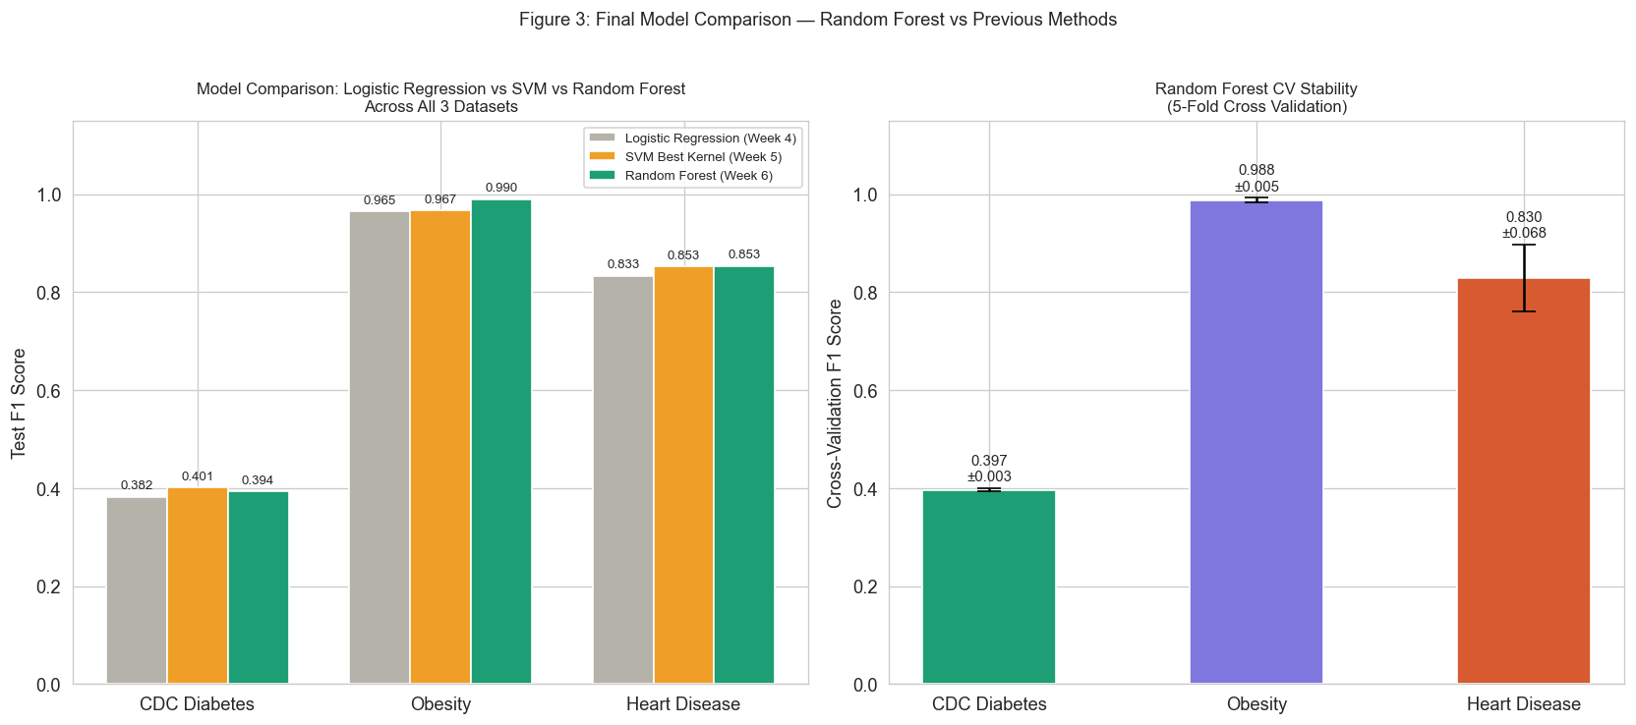
Part 3: Overfitting Prevention - Overfitting was handled differently depending on the model and dataset. Stratified splits were used everywhere because, without them, the 1.9% prediabetes class in CDC Diabetes could almost disappear from some folds entirely. Performance estimates become unstable when very few observations are available in the test set. A 5-fold stratified CV was used instead of a single holdout for heart disease, specifically because 303 rows is too small for a holdout to be stable, and 60 rows end up in the test set matter too much. Regularization in Weeks 2, 4, and 5 was needed because polynomial features introduced multicollinearity, and class imbalance inflates coefficients; shrinkage keeps the weights from blowing up. For SVM, large C values on the 303-row heart disease dataset produced a widening train-test gap, so C was tuned via GridSearchCV to find the point where regularization prevented memorization without underfitting. For trees, the problem is that a fully grown tree just memorizes training data (Train F1=0.9144, Test F1=0.3910 for CDC). Random forests fix this by averaging across many trees that were each trained on different data subsets and different feature splits; individual tree errors cancel out instead of stacking.
Part 4: Metrics and Hyperparameter Tuning
Macro F1 was used instead of accuracy because a model predicting no-diabetes for every CDC observation would hit 84% accuracy, while catching zero cases; macro F1 weights all classes equally so minority classes matter. Recall received additional weight for heart disease because false negatives in cardiac screening carry greater clinical cost than false positives. AUC-ROC was reported alongside F1 to capture ranking ability independent of threshold. For logistic regression, C values directly reflect dataset structure: CDC needed C=0.1 (heavy class overlap), Obesity needed C=100 (near-perfect separability), and heart disease landed at C=10.0. For random forests, max_depth=None worked for CDC and Obesity because the signal is broadly distributed and shallow trees underfit, while heart disease needed max_depth=5 because 303 rows cannot support deep splits without memorizing the training set. Weeks 1–3 were left at defaults deliberately; the goal was a regression baseline before switching to classification.
Part 5: Exploratory Data Analysis- EDA directly shaped three modeling decisions. BMI distributions were noticeably different across diabetes classes (No Diabetes ≈ 27.4, Prediabetes ≈ 29.6, Diabetes ≈ 31.8), and Age showed a nonlinear increase across 13 categories, which is what motivated adding degree-2 polynomial terms for both in Week 1. The class imbalance in CDC Diabetes was severe enough (1.9% prediabetes, 84.2% no-diabetes) that accuracy as a metric was never an option, which is why macro F1 and StratifiedKFold were used throughout all classification weeks. After polynomial expansion, VIF exceeded 5 for BMI² and Age², which confirmed the multicollinearity problem and made regularization in Week 2 a necessity rather than a choice.
Part 6: Expected vs. Unexpected Results- Several results matched expectations. The Obesity dataset achieved the highest performance because its classes are largely determined by weight- and height-related variables. The Heart Disease dataset also performed consistently, reflecting the strong predictive value of cardiovascular risk factors. Decision tree overfitting was clearly observed, as training performance increased with tree depth while test performance remained relatively stable. Three findings were unexpected. Forward selection, backward selection, and Lasso all identified the same eight predictors for the CDC Diabetes dataset, indicating these variables are robust predictors. Income ranked third in Random Forest feature importance (0.138) despite having little influence in the linear models, suggesting a nonlinear relationship with diabetes risk. Finally, BMI became the most important Random Forest feature even though GenHlth showed the strongest correlation during exploratory data analysis, demonstrating that the strongest individual predictor is not always the most influential across the full ensemble. Key external sources included James et al. (2021), Breiman (2001), Hastie et al. (2009), Hosmer and Lemeshow (2000), Cortes and Vapnik (1995), Wold et al. (2001), and the Scikit-learn documentation.

References
Breiman, L. (2001). Random forests. Machine Learning, 45(1), 5–32.
CDC Diabetes Health Indicators Dataset. (2015). UCI Machine Learning Repository. https://archive.ics.uci.edu/dataset/891/cdc+diabetes+health+indicators
Centers for Disease Control and Prevention. (2022). National diabetes statistics report. https://www.cdc.gov/diabetes/data/statistics-report/index.html
desalegngeb. (2023, April 30). Heart disease predictions. Kaggle. https://www.kaggle.com/code/desalegngeb/heart-disease-predictions/output
Cortes, C., & Vapnik, V. (1995). Support-vector networks. Machine Learning, 20(3), 273–297.
Hastie, T., Tibshirani, R., & Friedman, J. (2009). The elements of statistical learning (2nd ed.). Springer.
Hosmer, D. W., & Lemeshow, S. (2000). Applied logistic regression (2nd ed.). Wiley.
James, G., Witten, D., Hastie, T., & Tibshirani, R. (2021). An introduction to statistical learning (2nd ed.). Springer.
Obesity Level Estimation Dataset. (2019). UCI Machine Learning Repository. https://doi.org/10.24432/C5H31Z
Scikit-learn. (2024). RandomForestClassifier. https://scikit-learn.org/stable/modules/generated/sklearn.ensemble.RandomForestClassifier.html
Wold, S., Sjöström, M., & Eriksson, L. (2001). PLS-regression: A basic tool of chemometrics. Chemometrics and Intelligent Laboratory Systems, 58(2), 109–130.

