Capstone Project: Predicting Chronic Disease Risk Using Lifestyle and Health Indicators

Module C - Data Science Capstone (DX799S)
Dr. Joshua Von Korff
Ranjana Kumari
Summer 2026

1.Problem Statement and Description - This capstone project operates in the healthcare and public health industry, investigating whether machine learning models can predict chronic disease risk using lifestyle, demographic, and health indicators. The research question is: Can machine learning models identify individuals at risk for Type 2 diabetes, obesity, and heart disease, and which factors most consistently predict disease risk across these conditions? Three datasets were analyzed: the CDC Diabetes Health Indicators dataset (~230,000 observations, 2015 BRFSS survey; three outcome classes: no diabetes, prediabetes, diabetes), the UCI Obesity Level Estimation dataset (2,087 observations; seven obesity classes), and the Cleveland Heart Disease dataset (303 observations; binary outcome). Using multiple datasets tests model generalizability across diseases with different class structures, population sizes, and clinical complexity. Approximately 38 million Americans have diabetes, and 98 million have prediabetes, many undiagnosed, with an estimated annual economic burden of $327 billion. By evaluating six machine learning approaches across three chronic diseases, this project assesses both the potential and limitations of AI-driven risk prediction, with implications for earlier identification of high-risk individuals, targeted prevention, and health equity.
2. Modeling Techniques (Breadth: Weeks 8-11; Depth: Weeks 9–10)
2.1 Week 8 - K-Nearest Neighbors (Breadth) – K-Nearest Neighbors (KNN) was applied to the CDC Diabetes, Obesity, and heart disease datasets after standardizing the predictor variables using StandardScaler. Euclidean, Manhattan, and Minkowski distance metrics were evaluated, with the optimal hyperparameters selected using five-fold cross-validation. Macro F1 was used as the primary evaluation metric because it gives equal weight to each class and is more appropriate than accuracy for the imbalanced CDC Diabetes dataset. The Manhattan distance metric produced the best performance for the CDC Diabetes dataset (macro F1 = 0.3947) and the Obesity dataset (macro F1 = 0.9367). In contrast, the heart disease dataset performed best using the Minkowski distance metric (macro F1 = 0.8649). Overall, KNN performed well on the Obesity and Heart Disease datasets, where the outcome classes were more clearly separated, but achieved only moderate performance on the CDC Diabetes dataset. As with the supervised learning methods evaluated in previous weeks, the CDC Diabetes dataset continued to plateau at a macro F1 score of 0.39–0.40, indicating that the available health indicators provide limited separation between diabetes classes rather than the choice of classification algorithm being the primary limitation. A limitation of KNN is that prediction becomes computationally expensive for large datasets because each new observation must be compared with all training instances.
2.2 Week 9 – Gradient Boosting (Depth Analysis) - Week 9 is my first depth topic for Milestone Two. Gradient Boosting was selected because it builds decision trees sequentially, allowing each new tree to correct the errors made by the previous ones. Unlike Random Forest, which builds many independent trees in parallel, Gradient Boosting improves the model step by step by learning from previous mistakes. The goal was to determine whether this sequential learning approach could improve prediction performance across the three healthcare datasets while providing additional insight into how the model learned from the data.
Table 1. Gradient Boosting performance across all three datasets
Dataset | Test F1 | Recall | Precision | AUC-ROC | CV F1 | Best Parameters
CDC Diabetes | 0.3948 | 0.3863 | 0.4712 | 0.7712 | 0.3912 ± 0.0022 | lr = 0.2, 100 trees, depth = 2
Obesity | 0.9856 | 0.9851 | 0.9865 | 0.9995 | 0.9771 ± 0.0115 | lr = 0.1, 200 trees, depth = 2
Heart Disease | 0.8378 | 0.9394 | 0.7561 | 0.8864 | 0.8231 ± 0.0659 | lr=0.05, 100 trees, depth=2
As shown in Table 1, the Obesity dataset achieved the strongest performance, followed by the heart disease dataset, while the CDC Diabetes dataset remained the most challenging to classify. These results suggest that Gradient Boosting performs best when the outcome classes are well separated.
Figure 1. Training and testing F1 scores across boosting rounds for the CDC Diabetes, Obesity, and Heart Disease Gradient Boosting models.
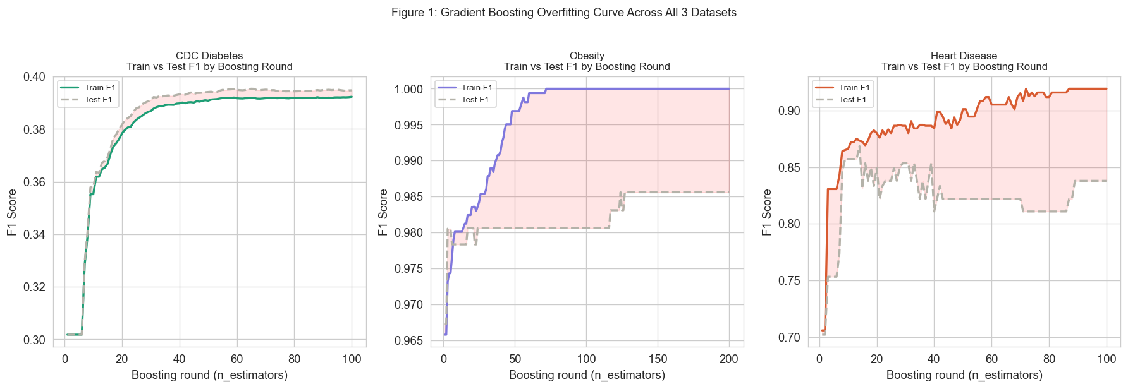
For the CDC Diabetes dataset, both the training and testing F1 scores increased rapidly before plateauing near 0.39. The small gap between the curves indicates good generalization, but the early plateau suggests that the available survey-based health indicators provided limited separation between diabetes classes. The Obesity dataset maintained consistently high training and testing performance, indicating that the predictor variables clearly separated its classes. The Heart Disease dataset exhibited greater variability in test performance due to its small sample size (303 observations), but the overall gap between the curves remained small, indicating reasonable generalization.
Figure 2. Gradient Boosting feature importance for the CDC Diabetes dataset
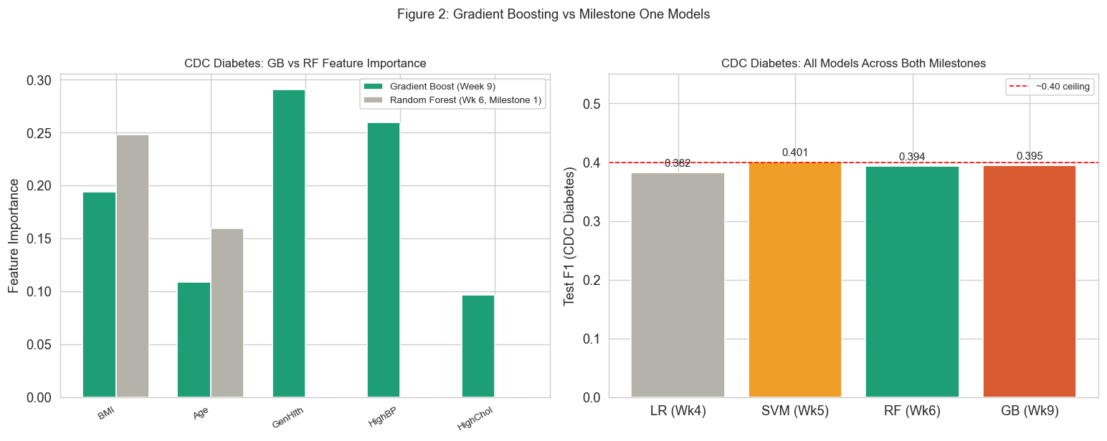
Figure 2 shows that General Health (0.291) and High Blood Pressure (0.260) contributed the largest proportion of predictive power, followed by BMI (0.194), Age (0.109), and High Cholesterol (0.097). Together, these variables accounted for most of the model's predictive signal for the CDC Diabetes dataset and are consistent with established clinical knowledge. I expected Gradient Boosting to improve performance on the CDC Diabetes dataset because it learns from the errors of previous trees. However, despite sequential boosting and extensive hyperparameter tuning, the model still plateaued at a macro F1 score of approximately 0.39-0.40, like the earlier supervised models. This suggests that the primary limitation lies in the survey-based health indicators rather than the Gradient Boosting algorithm itself. Overall, Gradient Boosting performed best on the Obesity and Heart Disease datasets, while future improvements for the CDC Diabetes dataset will likely require additional clinical information, such as HbA1c or fasting glucose.
2.3 Week 10 – K-Means Clustering (Depth Analysis)- Week 10 is my second depth topic for this project. Unlike the supervised learning algorithms used in previous weeks, K-Means is an unsupervised learning algorithm that groups observations based on similarities in their predictor variables without using the outcome labels. The objective was to determine whether natural patient groups existed within the CDC Diabetes, Obesity, and heart disease datasets and whether those groups corresponded to meaningful disease patterns.
Table 2. K-Means clustering performance across the three healthcare datasets
Dataset | Optimal K | Best Silhouette Score
CDC Diabetes | 2 | 0.2293
Obesity | 4 | 0.2216
Heart Disease | 2 | 0.1936
As shown in Table 2, the CDC Diabetes and Heart Disease datasets were best represented by two clusters, whereas the Obesity dataset achieved its highest silhouette score with four clusters. Although all silhouette scores were relatively low (0.19-0.23), this is expected in healthcare data, where patients often share overlapping risk factors that reduce cluster separation.
Figure 3. Elbow method and silhouette score across K for all three datasets
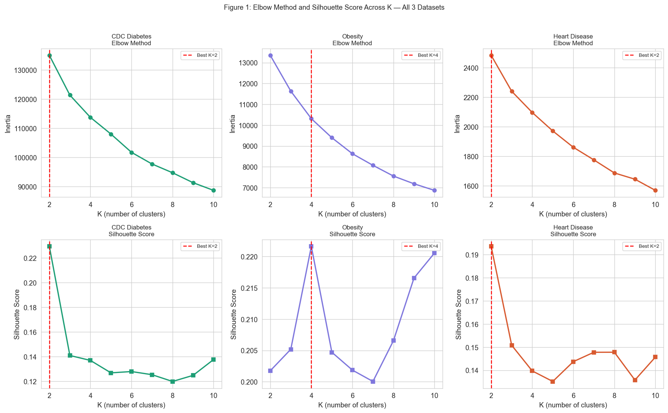
Figure 3 shows that inertia decreased steadily as the number of clusters increased for all three datasets, while the silhouette score identified the most appropriate value of K. The CDC Diabetes and Heart Disease datasets achieved their highest silhouette scores at K = 2, whereas the Obesity dataset peaked at K = 4. These results suggest that obesity characteristics formed more distinct patient groups, whereas the CDC Diabetes and Heart Disease datasets contained broader, less clearly separated patient populations. Increasing the number of clusters did not improve separation for these datasets because of overlapping patient characteristics rather than limitations of the clustering algorithm.
Figure 4. Cluster composition compared with the true disease labels.
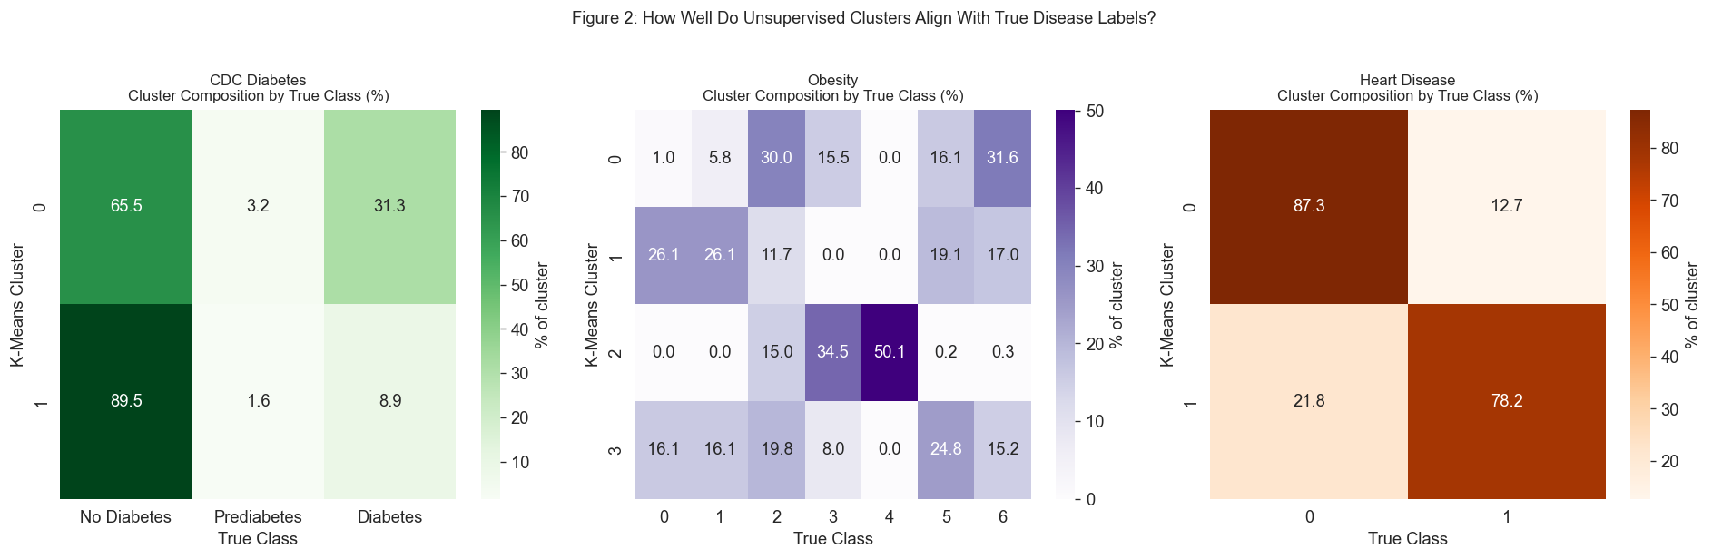
To determine whether the clusters represented clinically meaningful groups, I compared each cluster with the true disease labels after clustering. Although K-Means never used these labels during training, the resulting clusters provided valuable insight into the underlying structure of each dataset. For the CDC Diabetes dataset, the clusters broadly separated higher-risk and lower-risk individuals. Cluster 0 contained 31.3% diabetes cases compared with 8.9% in Cluster 1, while 89.5% of Cluster 1 had no diabetes compared with 65.5% in Cluster 0. Prediabetes accounted for only 3.2% of Cluster 0 and 1.6% of Cluster 1, both close to its overall prevalence of approximately 2%. Rather than forming a distinct cluster, prediabetes cases were distributed across both groups in nearly the same proportion as the original dataset. This suggests that prediabetes does not form a distinct group within the available feature space, reinforcing that the primary limitation lies in the data rather than the algorithm.
The Obesity dataset produced four clusters with distinct class distributions. Cluster 2 consisted primarily of Class 4 (50.1%) and Class 3 (34.5%) individuals, while Cluster 0 contained larger proportions of Classes 2, 5, and 6. Although the clusters did not perfectly match the seven obesity classes, they captured meaningful differences in obesity severity, explaining why K = 4 performed better than K = 7. For the heart disease dataset, Cluster 0 consisted of 87.3% patients without heart disease, whereas Cluster 1 contained 78.2% patients diagnosed with heart disease. Despite the small sample size, K-Means successfully separated patients into groups with markedly different disease prevalence. Overall, K-Means identified meaningful patient groups for the Obesity and Heart Disease datasets but no distinct prediabetes cluster for the CDC Diabetes dataset, reinforcing that the main limitation lies in the data rather than the clustering algorithm. Future improvements will likely require additional clinical biomarkers such as HbA1c or fasting glucose.
2.4 Week 11- DBSCAN and Hierarchical Clustering- DBSCAN and Hierarchical Agglomerative Clustering were applied to the CDC Diabetes, Obesity, and heart disease datasets to compare density-based and hierarchical clustering with the K-Means results from Week 10. DBSCAN hyperparameters were selected using k-distance plots, while Ward linkage was used for hierarchical clustering. Silhouette score was used to evaluate clustering quality and compare the methods across datasets. For the CDC Diabetes dataset, DBSCAN identified four clusters with 6.1% of observations classified as noise and achieved a silhouette score of 0.1517, indicating substantial overlap among patients. In contrast, DBSCAN identified a single cluster for both the Obesity and Heart Disease datasets, with 7.9% and 26.4% of observations labeled as noise, respectively. Hierarchical clustering produced two clusters for the CDC Diabetes and Heart Disease datasets and four clusters for the Obesity dataset. The CDC Diabetes dataset achieved the highest hierarchical silhouette score (0.2381), slightly exceeding the K-Means result (0.2293), while the Obesity (0.1698) and heart disease (0.1790) datasets produced lower silhouette scores than the K-Means analysis. Overall, both clustering methods produced findings consistent with the Week 10 K-Means analysis. The CDC Diabetes dataset remained difficult to separate because of overlapping patient characteristics, while the Obesity and Heart Disease datasets continued to demonstrate meaningful underlying structure across multiple clustering approaches.

3. Overfitting Prevention - Overfitting was controlled using strategies appropriate for each modeling approach. For all supervised models, stratified 80/20 train-test splits and five-fold stratified cross-validation were used. Stratification was particularly important for the CDC Diabetes dataset because the prediabetes class represents only about 2% of the observations, and unstratified sampling could produce unstable performance estimates. Hyperparameters were selected using GridSearchCV on the training data, while the test set was reserved for final evaluation. For KNN, StandardScaler was fitted only on the training data to prevent data leakage. For Gradient Boosting, a tuned learning rate and max_depth = 2 limited model complexity across all three datasets. As shown in Figure 1, the CDC Diabetes test F1 plateaued after approximately 20 boosting rounds while the training score continued to improve, indicating that additional trees were fitting noise rather than improving generalization. For the unsupervised methods, K-Means used n_init = 10 to reduce sensitivity to centroid initialization, DBSCAN parameters were selected using the k-distance plot, and Ward linkage was used for hierarchical clustering to produce stable clusters for comparison with K-Means. Across all clustering methods, the CDC Diabetes dataset continued to show overlapping groups, suggesting that the primary limitation was the underlying structure of the data rather than overfitting.

4. Evaluation Metrics and Hyperparameter Tuning- Because the three datasets differed in size and class balance, multiple evaluation metrics were used to assess model performance. Macro F1 was the primary metric because it gives equal weight to each class, making it more appropriate than accuracy for the imbalanced CDC Diabetes dataset. Precision, recall, ROC-AUC, and five-fold cross-validation scores were also reported to evaluate predictive performance and model stability. Hyperparameters were optimized using GridSearchCV. For KNN, the number of neighbors and distance metric were tuned, with Manhattan performing best for the CDC Diabetes and Obesity datasets and Minkowski for the heart disease dataset. For Gradient Boosting, all three datasets selected max_depth = 2, showing that shallow trees generalized better than deeper trees. Learning rate and the number of estimators were tuned together to maximize performance while limiting overfitting. For the clustering methods, silhouette scores, elbow plots, and k-distance plots were used to select the optimal clustering parameters.

5. Exploratory Data Analysis- The exploratory data analysis (EDA) completed in Milestone One provided important context for interpreting the modeling results in Milestone Two. The EDA showed that the CDC Diabetes dataset contained substantial overlap among the diabetes classes and a highly imbalanced class distribution, suggesting that classification would be challenging regardless of the algorithm used. This expectation was confirmed by the consistent performance limitations observed across KNN, Gradient Boosting, and K-Means. In contrast, the Obesity dataset exhibited more distinct feature distributions, corresponding to consistently stronger supervised and unsupervised model performance. The EDA also identified BMI, Age, General Health, High Blood Pressure, and High Cholesterol as influential variables, which later emerged among the most important predictors in the Gradient Boosting model. Although the EDA successfully explained differences in feature distributions and class separability, it did not examine neighborhood density or cluster structure, so it could not fully anticipate the different behaviors observed across the clustering algorithms in Week 11. Overall, the EDA explained why some datasets were easier to model than others.
6. Expected and Unexpected Findings- Several findings matched expectations. The CDC Diabetes dataset consistently plateaued near a macro F1 score of 0.39-0.40 across KNN and Gradient Boosting, consistent with all supervised models evaluated in Milestone One. Likewise, K-Means, DBSCAN, and Hierarchical Clustering found no distinct prediabetes cluster, reinforcing that the primary limitation lies in the underlying data rather than the choice of machine learning algorithm. The Obesity and Heart Disease datasets consistently achieved stronger performance across both supervised and unsupervised methods, reflecting the clearer class separation observed during exploratory data analysis. Several findings were unexpected. Although the Obesity dataset contains seven clinical classes and achieved near-perfect supervised performance (Gradient Boosting F1 = 0.9856), K-Means identified only four natural clusters, suggesting that some clinically defined obesity categories are not geometrically distinct. DBSCAN identified a single dense cluster for the Obesity and Heart Disease datasets. In contrast, K-Means and Hierarchical Clustering identified meaningful clusters, suggesting that DBSCAN's density-based assumptions were less suitable. Hierarchical Clustering also slightly outperformed K-Means on the CDC Diabetes dataset (silhouette = 0.2381 vs. 0.2293), suggesting a modest hierarchical structure. Overall, data characteristics influenced performance more than algorithm choice.

References
CDC Diabetes Health Indicators Dataset. (2015). UCI Machine Learning
Repository. https://archive.ics.uci.edu/dataset/891/cdc+diabetes+health+indicators
Centers for Disease Control and Prevention. (2022). National diabetes statistics report.
https://www.cdc.gov/diabetes/data/statistics-report/index.html
Centers for Disease Control and Prevention. (2015). Behavioral Risk Factor Surveillance System (BRFSS). U.S. Department of Health and Human Services. https://www.cdc.gov/brfss/
Cover, T., & Hart, P. E. (1967). Nearest neighbor pattern classification. IEEE Transactions on Information Theory, 13(1), 21–27. https://doi.org/10.1109/TIT.1967.1053964
Ester, M., Kriegel, H.-P., Sander, J., & Xu, X. (1996). A density-based algorithm for discovering clusters in large spatial databases with noise. In Proceedings of the Second International Conference on Knowledge Discovery and Data Mining (pp. 226–231).
Friedman, J. H. (2001). Greedy function approximation: A gradient boosting machine. The Annals of Statistics, 29(5), 1189–1232. https://doi.org/10.1214/aos/1013203451
James, G., Witten, D., Hastie, T., & Tibshirani, R. (2021). An introduction to statistical learning: With applications in R (2nd ed.). Springer. https://doi.org/10.1007/978-1-0716-1418-1
Janosi, A., Steinbrunn, W., Pfisterer, M., & Detrano, R. (1988). Heart disease. UCI Machine Learning Repository. https://archive.ics.uci.edu/dataset/45/heart+disease
MacQueen, J. (1967). Some methods for classification and analysis of multivariate observations. In Proceedings of the Fifth Berkeley Symposium on Mathematical Statistics and Probability (Vol. 1, pp. 281–297).
Palechor, F. M., & de la Hoz Manotas, A. (2019). Dataset for estimation of obesity levels based on eating habits and physical condition in individuals from Colombia, Peru and Mexico. UCI Machine Learning Repository. https://archive.ics.uci.edu/dataset/544/estimation+of+obesity+levels+based+on+eating+habits+and+physical+condition
Pedregosa, F., Varoquaux, G., Gramfort, A., Michel, V., Blondel, M., Prettenhofer, P., Weiss, R., Dubourg, V., Vanderplas, J., Passos, A., Cournapeau, D., Brucher, M., Perrot, M., & Duchesnay, É. (2011). Scikit-learn: Machine learning in Python. Journal of Machine Learning Research, 12, 2825–2830.
Rousseeuw, P. J. (1987). Silhouettes: A graphical aid to the interpretation and validation of cluster analysis. Journal of Computational and Applied Mathematics, 20, 53–65. https://doi.org/10.1016/0377-0427(87)90125-7
Scikit-learn developers. (2025). GridSearchCV. https://scikit-learn.org/stable/modules/generated/sklearn.model_selection.GridSearchCV.html
Scikit-learn developers. (2025). Scikit-learn user guide. https://scikit-learn.org/stable/user_guide.html
Scikit-learn developers. (2025). StandardScaler. https://scikit-learn.org/stable/modules/generated/sklearn.preprocessing.StandardScaler.html
Ward, J. H., Jr. (1963). Hierarchical grouping to optimize an objective function. Journal of the American Statistical Association, 58(301), 236–244. https://doi.org/10.1080/01621459.1963.10500845

