DEPLOYMENT

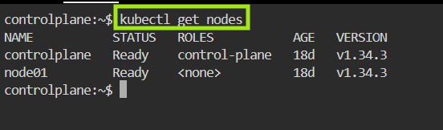
- Check the nodes

- Create a Namespace
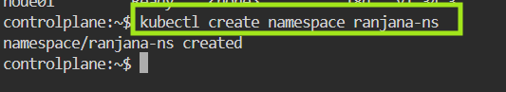

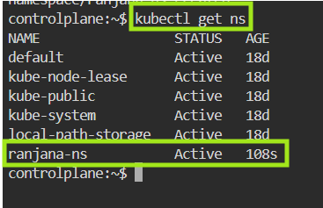
- Check the Namespace

- Create the Deployment yml file
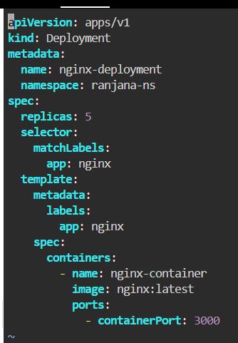

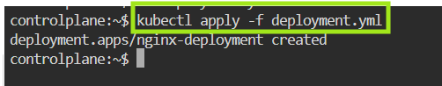
- Apply the Deployment

- Check the Deployment
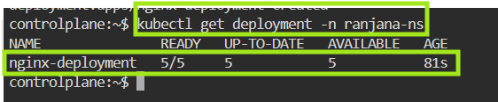

- Describe the Deployment
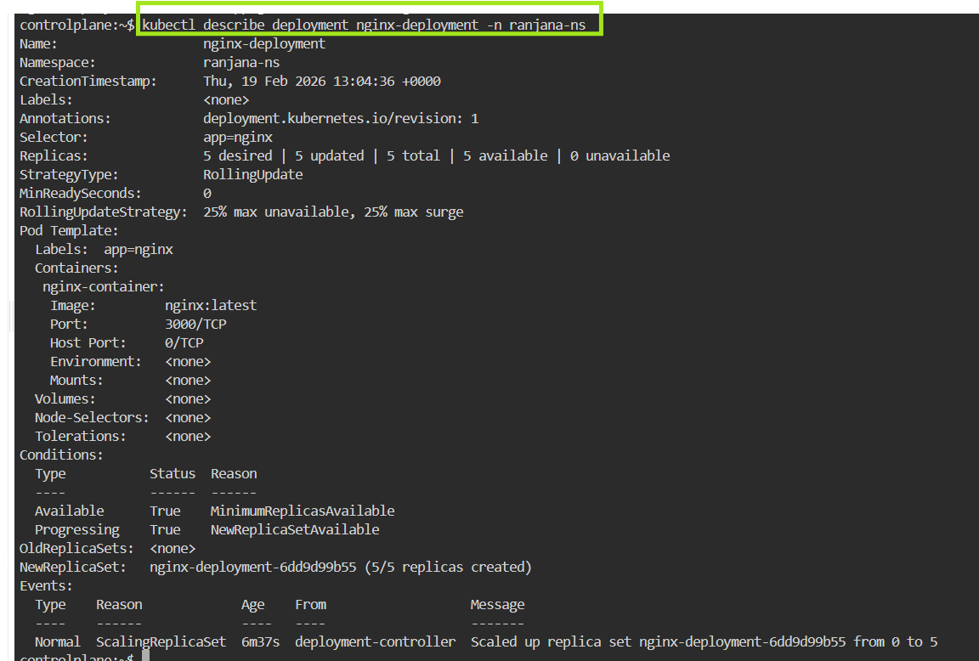
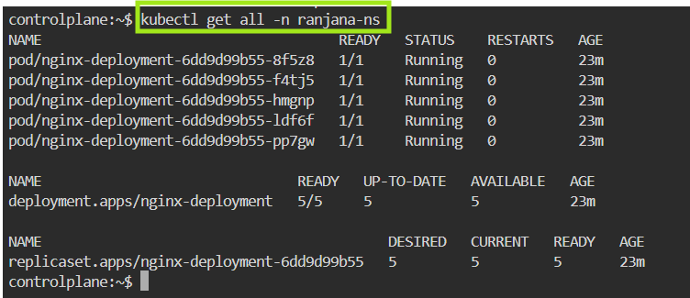
- Check all resources are running

- Describing one of the pod

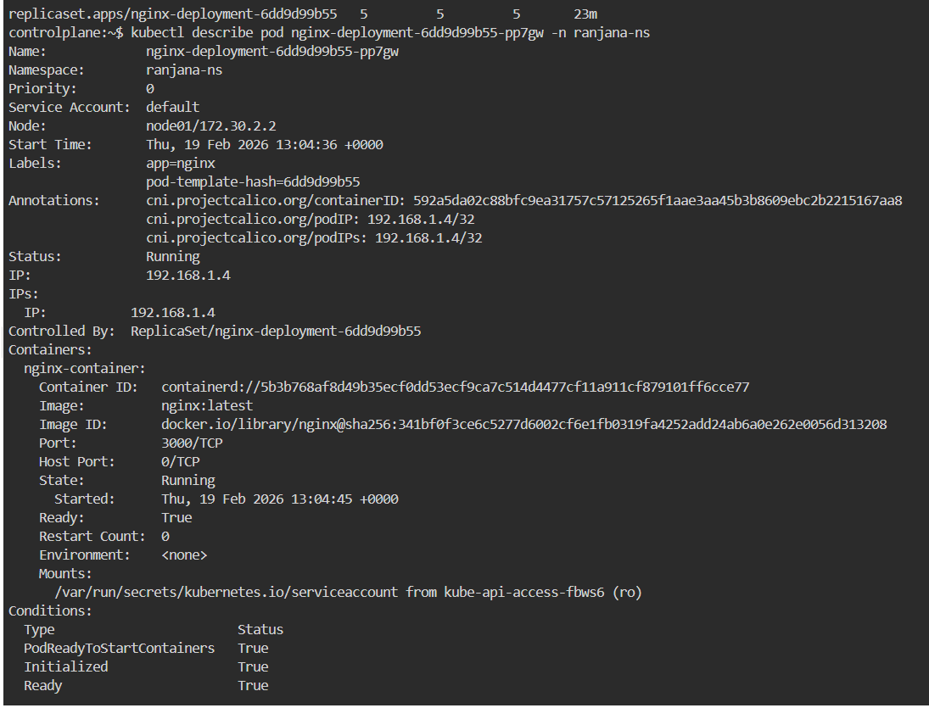
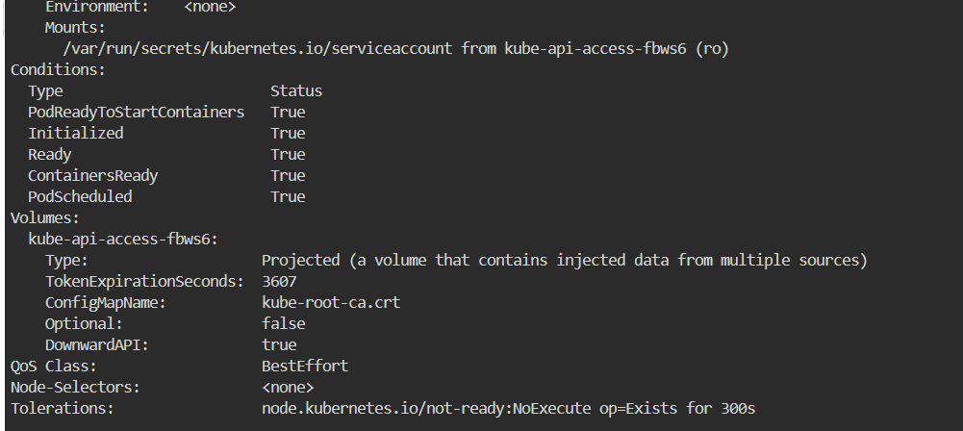

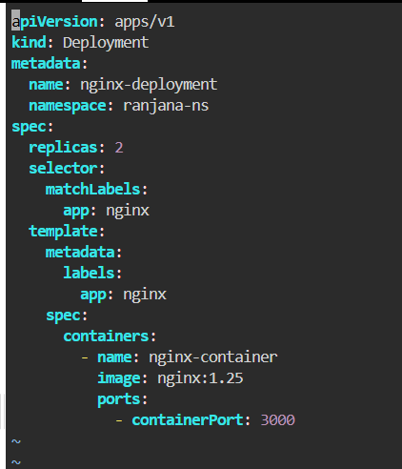
- Changes in the deployment

- Check the Deployment
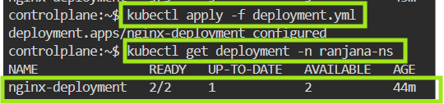

- Check rollout History
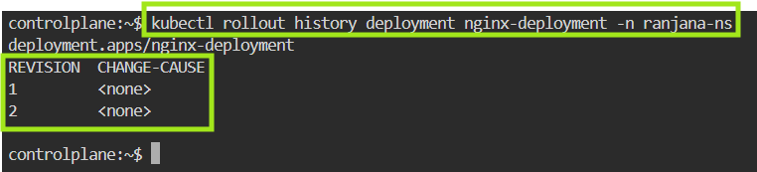
- Check rollout undo
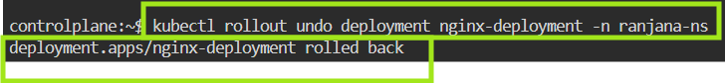

- Check rollout status
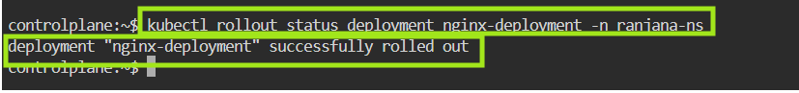

- Check all resources
