**Lab14 PHP: Database Connection**

1. Install the xampp server in your machine and if it already installed just go to **xampp -> htdocs** folder .

2. Create a new folder say **addemp** in the **htdocs** folder.

3. In this **addemp** folder create a new file say **index.php** and open it with Notepad++ or any other text editor. Write following code in index.php.

<!DOCTYPE html>

<html>

<head>

<style>

label{display:inline-block;width:100px;margin-bottom:10px;}

</style>

<title>Add Employee</title>

</head>

<body>

<form method="post" action="process.php">

<label>First Name</label>

<input type="text" name="first_name" />

<br />

<label>Last Name</label>

<input type="text" name="last_name" />

<br />

<label>Department</label>

<input type="text" name="department" />

<br />

<label>Email</label>

<input type="text" name="email" />

<br />

<input type="submit" value="Add Employee">

</form>

</body>

</html>

4. Now go to **xampp control pannel** and start the **Apache** and **MySQL** modules

5. Now to run your program enter the following url in the browser **http://localhost/addemp/index.php**.

6. Now to have a view of the inserted data just create a **new file** called as **process.php** in the same **addemp** folder . Write following code in "process.php".

<?php

include('database.php');

// create a variable

$first_name=$_POST['first_name'];

$last_name=$_POST['last_name'];

$department=$_POST['department'];

$email=$_POST['email'];

echo "$email";

//Execute the query

mysqli_query($connect,"INSERT INTO employees1(first_name,last_name,department,email)

VALUES('$first_name','$last_name','$department','$email')") or die(mysqli_error($connect)) ;

//"or die(mysqli_error($connect))" to check error message and Here, "employees1" is the table to be created in database

?>

7. To create a database connection we have to create new file say **database.php** in the same **addemp** folder. Write following code.

<?php

$connect=mysqli_connect('localhost','root','','test'); // Here test is database name and ‘’ for no password

echo "database_connected";

if(mysqli_connect_errno($connect))

{

echo 'Failed to connect';

}

?>

8.Create Database Name as **"test"** and create table as **"employee1"** as shown in figure below.

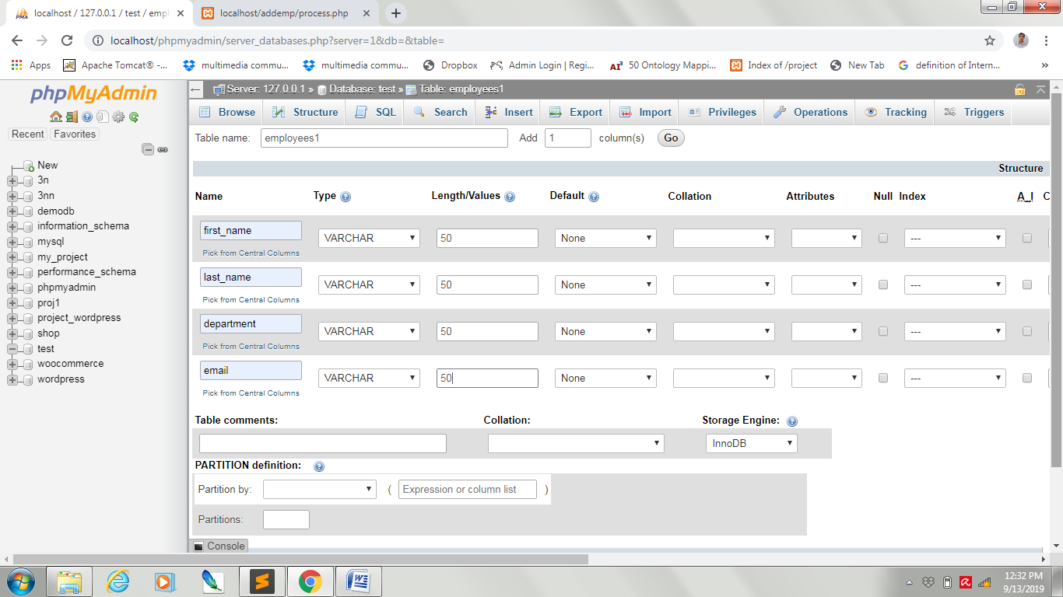

9. After creating the database connection , run the **index.php** file insert the data into it , this data will get added into your database which is present in the **phpmyadmin** of the **Xampp** i.e **http://localhost/phpmyadmin/.** Following fig will show the details.

