

MINI PROJECT REPORT
On

CODEHEALER: SELF-HEALING AI FOR CODE DEBUGGING
Submitted in partial fulfilment for the award of

Master of Computer Applications
By

RANJANA VINOD KUMAR (MLM24MCA-2044)
Under the Guidance of

Ms.KUKKUMOL THOMAS
(Assistant Professor, Department. of Computer Applications)


DEPARTMENT OF COMPUTER APPLICATIONS

MANGALAM COLLEGE OF ENGINEERING, ETTUMANOOR
(Affiliated to APJ Abdul Kalam Technological University)

OCTOBER 2025

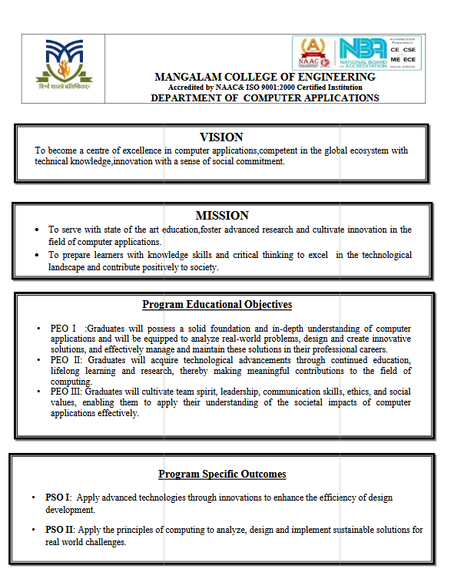

MANGALAM COLLEGE OF ENGINEERING, ETTUMANOOR

DEPARTMENT OF COMPUTER APPLICATIONS

OCTOBER 2025

DECLARATION

I hereby certify that the work which is being presented in the project entitled “CodeHealer -Self-healing AI for code debugging” submitted in the DEPARTMENT OF COMPUTER APPLICATIONS is an authentic record of my own work carried under the supervision of Ms.Kukkumol Thomas ,Assistant Professor. This study has not been submitted to any other institution or university for the award of any other degree. This report has been checked for plagiarism by the college and the similarity index is within permissible limits set by the college.

Name & Signature of Student
Date:

Place

MANGALAM COLLEGE OF ENGINEERING, ETTUMANOOR

DEPARTMENT OF COMPUTER APPLICATIONS

OCTOBER 2025

CERTIFICATE

This is to certify that the Project titled “CodeHealer: Self-Healing AI For Code Debugging” is the bonafide record of the work done by RANJANA VINOD KUMAR (MLM24MCA2044)of MCA towards the partial fulfilment of the requirement for the award of MASTER OF COMPUTER APPLICATIONS by APJ ABDUL KALAM TECHNOLOGICAL UNIVERSITY, during the academic year 2025-26.

Internal Examiner

Project co-ordinator
Ms.Banu Sumayya.S
Assistant Professor
Department of Computer Applications

Project Guide Head of the Department
Ms.Kukkumol Thomas Ms. Divya S.B
Assistant Professor Associate Professor
Department of Computer Applications Department of Computer Applications

ACKNOWLEDGEMENT

I am greatly indebted to the authorities of Mangalam College of Engineering for providing the necessary facilities to successfully complete my Project on the topic “Prediction of mental depressive disorder using deep learning”.
I express my sincere thanks to Dr. Vinodh P Vijayan, Principal, Mangalam College of Engineering for providing the facilities to complete my Project successfully.
I thank and express my solicit gratitude to Ms. Divya S B, HOD, Department of Computer Applications, Mangalam College of Engineering, for her invaluable help and support which helped me a lot in successfully completing this Project work.
I express my gratitude to my Internal Guide, Ms. Kukkumol Thomas, Assistant professor, Department of Computer Applications for the suggestions and encouragement which helped in the successful completion of our Project.
Furthermore, I would like to acknowledge with much appreciation the crucial role of the faculties especially Project coordinator, Ms.Banu Sumayya S, Department of Computer Applications, Mangalam College of Engineering, who gave the permission to use all the required equipment and the necessary resources to complete the presentation & report.
Finally, I would like to express my heartfelt thanks to my parents who were very supportive both financially and mentally and for their encouragement to achieve my goal.

RANJANA VINOD KUMAR (MLM24MCA2044)

ABSTRACT

The CodeHealer platform is an intelligent, AI-powered debugging system designed to automatically detect, diagnose, and repair common programming errors. Its primary objective is to minimize manual effort in code debugging and correction, particularly for beginners and software professionals working with complex or low-level programming languages. By offering intelligent, automated error analysis and real-time correction capabilities, CodeHealer aims to improve code quality, accelerate development, and enhance the learning experience for aspiring programmers.
The system leverages a combination of static code analysis, machine learning models, and natural language processing (NLP) to understand the structure and semantics of source code.The platform is implemented using a Python Flask backend integrated with OpenAI’s language models, allowing real-time communication between the user interface and the AI engine. The frontend is designed with modern web technologies, ensuring a clean, responsive, and user-friendly environment. The system also includes an AI chat assistant that enables natural language interaction, providing personalized support.
CodeHealer bridges the gap between traditional compilers and modern intelligent debugging assistants by combining automation with explainability. As a result, CodeHealer contributes to a more efficient, engaging, and intelligent programming workflow—making it a valuable tool for both learning environments and professional software development.
Keywords
Natural Language Processing,,Machine Learning,Artificial Intelligence, Convolutional Neural Networks .
Mapping with Sustainable Development Goals (Mention the Goal) | 9 – Industry Innovation and Infrastructure

MAPPING OF PO-PSO-SDG

1. MAPPING WITH PROGRAM OUTCOMES (POs):-

SL.NO | POs ADDRESSED | RELEVANCE TO PROJECT
1 | PO1 | Applied AI and NLP to automate code error detection
2 | PO2 | Identified and resolved debugging issues using intelligent algorithms.
3 | PO3 | Developed an AI-powered web tool providing real-time code debuggi

LIST OF PROGRAM OUTCOMES (POs):
PO1 – Engineering Knowledge :Apply knowledge of mathematics, science, engineering fundamentals, and an engineering specialization to solve complex engineering problems.
PO2 – Problem Analysis: Identify, formulate, research literature, and analyse complex engineering problems reaching substantiated conclusions using first principles of mathematics, natural sciences, and engineering sciences.
PO3 – Design/Development of Solutions: Design solutions for complex engineering problems and design systems, components, or processes that meet specified needs with appropriate consideration for public health and safety, cultural, societal, and environmental considerations.
PO4 – Conduct Investigations of Complex Problems: Use research-based knowledge and research methods including design of experiments, analysis, and interpretation of data, and synthesis of information to provide valid conclusions.
PO5– Modern Tool Usage : Create, select, and apply appropriate techniques, resources, and modern engineering and IT tools, including prediction and modeling, to complex engineering activities with an understanding of the limitations.
PO6 – The Engineer and Society: Apply reasoning informed by contextual knowledge to assess societal, health, safety, legal, and cultural issues and the consequent responsibilities relevant to

professional engineering practice.
PO7 – Environment and Sustainability: Understand the impact of professional engineering solutions in societal and environmental contexts and demonstrate knowledge of, and need for sustainable development.
PO8 – Ethics : Apply ethical principles and commit to professional ethics and responsibilities and norms of engineering practice.
PO9 – Individual and Team Work: Function effectively as an individual, and as a member or leader in diverse teams, and in multidisciplinary settings.
PO10 – Communication: Communicate effectively on complex engineering activities with the
engineering community and with society at large, such as being able to comprehend and write effective reports and design documentation, make effective presentations, and give and receive clear instructions.
PO11– Project Management and Finance: Demonstrate knowledge and understanding of engineering and management principles and apply these to one’s own work, as a member and leader in a team, to manage projects and in multidisciplinary environments.
PO12 – Lifelong Learning: Recognize the need for, and have the ability to engage in independent and life-long learning in the broadest context of technological change.

2. MAPPING WITH PROGRAM SPECIFIC OUTCOMES (PSOs):

SL.NO | PSOs ADDRESSED | RELEVANCE TO PROJECT
1 | PSO1 | Developed an AI-based web debugging systems.
2 | PSO2 | Applied AI for self-healing and automated code correction.

LIST OF PROGRAM SPECIFIC OUTCOMES (PSOs):
PSO 1: Apply advanced technologies through innovations to enhance the efficiency of design development.
PSO 2: Apply the principles of computing to analyze, design and implement sustainable solutions for real world challenges.

3. MAPPING WITH SUSTAINABLE DEVELOPMENT GOALS (SDGs):

SDG NO | SDGs ADDRESSED | RELEVANCE TO PROJECT
1. | SDG 4 | CodeHealer supports quality learning through AI- assisted code debugging.

SUSTAINABLE DEVLOPMENT GOALS (SDGs):
SDG 1 – No Poverty-End poverty in all its forms everywhere.
SDG 2 – Zero Hunger-End hunger, achieve food security and improved nutrition, and promote sustainable agriculture.
SDG 3 – Good Health and Well-Being-Ensure healthy lives and promote well-being for all at all ages.
SDG 4 – Quality Education-Ensure inclusive and equitable quality education and promote lifelong
learning opportunities for all.
SDG 5 – Gender Equality-Achieve gender equality and empower all women and girls.
SDG 6 – Clean Water and Sanitation-Ensure availability and sustainable management of water and sanitation for all.
SDG 7 – Affordable and Clean Energy-Ensure access to affordable, reliable, sustainable, and modern energy for all.
SDG 8 – Decent Work and Economic Growth-Promote sustained, inclusive, and sustainable economic growth, full and productive employment, and decent work for all.
SDG 9 – Industry, Innovation, and Infrastructure-Build resilient infrastructure, promote inclusive and sustainable industrialization, and foster innovation.
SDG 10 – Reduced Inequality-Reduce inequality within and among countries.
SDG 11 – Sustainable Cities and Communities-Make cities and human settlements inclusive, safe, resilient, and sustainable.
SDG 12 – Responsible Consumption and Production-Ensure sustainable consumption and production patterns.
SDG 13 – Climate Action-Take urgent action to combat climate change and its impacts.
SDG 14 – Life Below Water-Conserve and sustainably use the oceans, seas, and marine resources.
SDG 15 – Life on Land -Protect, restore, and promote sustainable use of terrestrial ecosystems, manage forests sustainably, combat desertification, halt and reverse land degradation, and halt biodiversity loss.
SDG 16 – Peace, Justice, and Strong Institutions- Promote peaceful and inclusive societies, provide access to justice for all, and build effective, accountable, and inclusive institutions.
SDG 17 – Partnerships for the Goals -Strengthen the means of implementation and revitalize the global partnership for sustainable development.

 | TABLE OF CONTENTS
CHAPTER NO. | TITLE | PAGE NO.
 | List of Figures | I
1 | List of Abbreviations  INTRODUCTION | II  1
 | 1.1 Background | 1
 | 1.2 Introduction | 2
 | 1.3 Problem Statement | 3
 | 1.4 Motivation | 3
 | 1.5 Scope | 5
2 | LITERATURE REVIEW | 6
3. | PROPOSED SYSTEM | 9
4. | METHODOLOGY | 12
 | 4.1 Software Development Approach | 12
 | 4.2 System Workflow | 14
 | 4.3 Tools and Technologies Used | 15
 | 4.4 Database Design Methodology | 15
 | 4.5 AI-Based Correction | 16
 | 4.6 Feedback Integration and Reinforcement Learning | 17
 | 4.7 LABELS Framework Implementation | 17

 | 4.8 Integration into Development Workflows | 18
 | 4.9 Training, Validation, and Evaluation | 18
 | 4.10 Ethical Considerations | 18
5. | SYSTEM ARCHITECTURE | 20
 | 5.1 Dataset Collection | 21
 | 5.2Feature Extraction | 21
 | 5.3 Classification | 22
 | 5.4 Labels | 22
 | 5.5 Loss Function | 22
 | 5.6 Code Classification Layer | 23
 | 5.7 Model Training | 23
 | 5.8 Prediction | 23
 | 5.9 AI Debugging Engine | 24
 | 5.10 Reinforcement Learning Mechanism | 25
 | 5.11 Training Dataset for Debugging Engine | 25
 | 5 .12 User Input Registration | 25
 | 5.13 Code Submission and Analysis | 26
 | 5.14 Debugging Report Generation | 26
 | 5.15 Admin Module and Monitoring | 27
 | 5.16 Feedback and Continuous Learning | 27
 | 5.17 Security and Privacy | 27
 | 5.18 Integration and Maintenance | 28
 | 5.19 Scalability and Cloud Deployment | 28
6 | MODULES | 29
 | 6.1 ADMIN MODULE | 29
 | 6.1.1 User Management | 29
 | 6.1.2 Dataset Management | 30
 | 6.1.3 System Management | 30
 | 6.1.4 Security and Access Control | 31
 | 6.1.5 Feedback and Improvement | 31
 | 6.2 USER MODULE | 31
 | 6.2.1 Registration | 32
 | 6.2.2 Login and Authentication | 32
 | 6.2.4 Code Upload and Editor | 32
 | 6.2.5 Result Visualtization and | 33
 | 6.2.6 User Feedback and History | 33
 | 6.3 AI DEBUGGING ENGINE | 34
 | 6.3.1 Error Detection and Analysis | 34
 | 6.3.2 Code Correction and Suggestion Generation | 34
 | 6.3.3 Natural Language Processing | 35
 | 6.3.4 Learning and Model Optimization | 35
 | 6.3.5 Code Optimization and Performance Tuning | 36
 | 6.4 Interaction between Modules | 36
7 | DIAGRAMS | 37
 | 7.1 Data flow diagram (DFD) | 37
 | 7.1.1 Level 0 DFD | 38
 | 7.2ER Diagram | 39
 | 7.3 Use Case Diagram | 40
 | 7.4 Sequence Diagram | 41
 | 7.5 Class Diagram | 42
8 | TESTING | 43
 | 8.1 Data collection and preparation | 43
 | 8.2 Model training | 44
 | 8.3 Validation and hyper parameter tuning | 45
 | 8.4 Evaluation on test data | 46
 | 8.5 Deploy and monitoring | 47
9 | ADVANTAGES & DISADVANTAGES | 48
 | 9.1 Advantages | 49
 | 9.2 Disadvantages | 50
10 | RESULTS | 51
11 | CONCLUSION & FUTURE SCOPE | 56
 | APPENDICES | 60
 | REFERENCES | 64

 | LIST OF FIGURES
FIGURE NO. | TITLE | PAGE NO.
5 | System Architecture | 20
6.1 | Admin Module | 29
 | 6.1.1 User Management | 29
 | 6.1.5 Feedback | 31
6.2 | User Module | 31
 | 6.2.3 Code Upload and Editor Interface | 32
 | 6.2.6 User feedback and History | 33
 | 6.3 AI Debugging Engine | 34
7.1 | Level 0 Context Level DFD | 37
7.1.1 | Level 1 DFD | 38
7.2 | Use Case Diagram | 39
7.3 | ER Diagram | 40
7.4 | Class Diagram | 41
7.5 | Sequence Diagram | 42

LIST OF ABBREVATIONS

ABBREVIATION |  | FULL FORM
CNN | - | Convolutional Neural Network
NLP | - | Natural Language Processing
ML | - | Machine Learning
AI | - | Artificial Intelligence
DL | - | Deep Learning

CHAPTER 1

INTRODUCTION

1.1 Background
Debugging is an integral yet highly time-consuming part of software development. Developers at all experience levels, from beginners to professionals, spend a significant portion of their time identifying and resolving coding errors. These errors can range from syntax mistakes, such as missing semicolons or incorrect indentation, to logical errors, like flawed conditional statements or algorithmic mistakes, and runtime exceptions, such as division by zero or null pointer errors. Traditional debugging techniques—including manual code review, print statements, and Integrated Development Environment (IDE) error messages—often prove inefficient, particularly in large or complex codebases. Beginners face additional challenges in interpreting compiler or runtime error messages, which can be cryptic or vague.
The increasing reliance on software across industries has intensified the demand for efficient, accurate, and automated debugging solutions. Research in artificial intelligence (AI) and machine learning (ML) has shown that these technologies can analyze patterns in code, detect potential errors, and provide intelligent suggestions. Using Natural Language Processing (NLP) techniques, AI can also understand the intent behind code comments or function names, improving the accuracy of error detection and offering meaningful explanations.
CodeHealer leverages these advancements to create an AI-powered web-based debugging platform. It integrates multiple components to provide real-time error detection, diagnostic explanations, and suggested fixes. Its architecture consists of three primary modules:
1.Code Input and Preprocessing: Accepts raw code from users, formats it, and prepares it for analysis.
2.Error Detection: Uses rule-based methods and AI models to identify syntax, logical, and runtime errors.
3.AI-debugging Engine: Generates possible corrections for the detected errors and explains the rationale behind suggestions.

By combining AI, ML, and NLP, CodeHealer provides a comprehensive and adaptive debugging environment. This approach not only reduces development time but also supports educational growth by helping programmers understand and correct their errors effectively. Moreover, CodeHealer has the potential to standardize debugging practices across developers and projects, providing a reliable and efficient tool for both professional and educational settings.

1.2 Introduction
As software projects grow in complexity, the task of debugging becomes increasingly challenging. Traditional debugging methods often rely heavily on manual effort, requiring developers to read through lines of code, test multiple scenarios, and identify subtle logical or runtime errors. This process is not only time-intensive but also prone to human oversight, especially when deadlines are tight or projects involve large-scale codebases.
CodeHealer introduces an intelligent, AI-powered framework to address these challenges. By integrating real-time code analysis, machine learning models, and NLP-based techniques, CodeHealer can automatically
detect and suggest fixes for errors in the code. The system is designed to assist developers at all skill levels,
providing both immediate debugging support and educational insights into common coding mistakes.
By leveraging AI and ML, CodeHealer transforms debugging from a reactive, error-prone process into a proactive, intelligent, and interactive experience. It not only reduces development time but also fosters continuous learning among programmers, helping them develop better coding habits and a deeper understanding of programming.
Furthermore, the web-based nature of CodeHealer ensures cross-platform accessibility, allowing users to debug code from anywhere, using any device with an internet connection. This flexibility makes the tool
particularly valuable in educational environments, online coding bootcamps, and professional development teams.

1.3 Problem Statement
Despite advancements in IDEs and debugging tools, software development still faces significant challenges related to error detection and correction:
- Manual Debugging Effort: Developers spend substantial time manually identifying and correcting errors, which can delay project timelines.
- Error-Prone Processes: Human oversight often leads to undetected logical or runtime errors, particularly in complex or large-scale codebases.
- Challenges for Beginners: Novice programmers struggle to interpret compiler errors, understand the root causes, and learn from mistakes effectively.
- Limited Educational Feedback: Traditional debugging tools provide limited insight into the rationale behind errors, reducing their educational value.
CodeHealer addresses these issues by offering a fully automated, AI-driven debugging platform. By combining error detection, AI-based corrections, and explanatory feedback, CodeHealer aims to make debugging:
- Faster and more accurate through AI analysis of common error patterns.
- Educational by providing explanations and learning opportunities for developers.
- Personalized through adaptive learning based on user interactions.
By addressing these problems, CodeHealer seeks to redefine the debugging process, making it more efficient, reliable, and user-friendly for both professional and educational use.

1.4 Motivation
The motivation for developing CodeHealer is rooted in the need to simplify the debugging process, reduce developer workload, and enhance learning. Software development is a highly iterative process, and coding errors can significantly impact project timelines and code quality. Key motivators include:
1.Efficiency in Development: Automated error detection and correction reduces time spent on debugging, allowing developers to focus on coding logic and features.
2.Enhanced Learning: By explaining the reasons behind errors and suggesting best practices, CodeHealer serves as a learning tool for programmers at all levels.
3.Accessibility and Convenience: A web-based platform ensures that the tool can be accessed from anywhere, without the need for specialized software installations.
4.Adaptive Intelligence: AI and ML models continuously improve through user feedback, offering personalized debugging assistance tailored to the programmer’s skill level and coding style.
5.Error Standardization: By analyzing common coding mistakes across multiple users and languages, CodeHealer helps standardize debugging practices and provides consistent, reliable guidance.

Overall, CodeHealer is motivated by the vision of transforming debugging into a proactive, intelligent, and educational process, helping developers write higher-quality code while minimizing frustration and errors.

1.5 Scope
The scope of CodeHealer spans multiple areas of software development and education:

- Real-Time Debugging: Detects syntax, logical, and runtime errors as code is written, reducing manual intervention.
- AI-Based Correction: Suggests fixes for errors and provides explanations to improve understanding.
- Educational Insights: Offers feedback that helps beginners and intermediate programmers learn from mistakes and improve coding skills.
- Multi-Language Support: Supports widely used programming languages such as Python, JavaScript, and C++, enhancing versatility.
- Web-Based Accessibility: Enables developers to access the tool on any device with a browser, promoting convenience and inclusivity.
- Continuous Learning: Improves accuracy and suggestions through user feedback and adaptive AI models, providing personalized debugging support.
- Productivity Enhancement: By automating repetitive and error-prone tasks, CodeHealer increases efficiency for both individual developers and development teams.

CHAPTER 2

LITERATURE REVIEW
1.Foundations of Error-Correcting Codes in AI Debugging
Shannon [1] introduced the foundational theory of communication and error correction, emphasizing the limits of reliable information transfer. Elias [2] extended these ideas with practical error-free coding techniques. These works underpin the notion that errors—whether in transmitted signals or source code—can be detected and corrected systematically. Gallager [4] developed low-density parity-check (LDPC) codes, demonstrating how sparse matrices can efficiently identify errors. Berrou and Glavieux [3] introduced turbo codes for near-optimal error correction, inspiring methods for automated code analysis. These classical coding principles provide a theoretical basis for CodeHealer’s approach to identifying and correcting programming errors with high accuracy.
2.Polar Codes and Structured Error Prediction
Arikan [11] proposed polar codes as a method for achieving capacity in symmetric binary-input channels. These codes offer a structured and recursive approach to error detection and correction. Tal and Vardy [14] and Trifonov [16] refined polar code construction and decoding techniques, emphasizing systematic methods to locate and correct errors efficiently. In CodeHealer, these concepts are adapted to detect error-prone code segments and prioritize corrective actions, enabling a structured debugging workflow.
3.Deep Learning Approaches for Code Understanding
Deep learning has become integral to AI-driven error detection. O’Shea and Hoydis [20] demonstrated how neural networks can learn complex patterns in communication systems. Similarly, Kim et al. [21] showed that deep learning can model feedback-based correction systems. CodeHealer leverages sequence-to-sequence and transformer-based models to understand code semantics, identify anomalous structures, and generate context-aware suggestions, allowing it to act as an intelligent assistant for developers.
4.Reinforcement Learning for Adaptive Debugging
Reinforcement learning (RL) enables AI agents to learn optimal strategies through interaction with an environment. Watkins and Dayan [30] introduced Q-learning, while Konda and Tsitsiklis [32] developed actor-critic methods for sequential decision-making. These techniques allow AI systems to evaluate the outcomes of corrective actions and improve their performance over time. CodeHealer uses RL to iteratively refine error correction strategies, optimizing suggestions based on historical success and contextual relevance.
5.Hybrid Error Detection and Correction Approaches
Fossorier and Lin [33] explored soft-decision decoding using ordered statistics, combining probabilistic and structural methods for improved error correction. MacKay [5] highlighted the effectiveness of sparse-matrix coding for scalable error detection. By integrating these techniques, CodeHealer employs a hybrid methodology, combining pattern recognition, statistical analysis, and deep learning to detect and correct a wide variety of coding errors.
6.Efficiency and Accuracy in Automated Debugging
Fossorier [6] demonstrated quasi-cyclic LDPC codes’ efficiency for practical applications, while Richardson et al. [7] emphasized capacity-approaching irregular LDPC codes. These studies illustrate the importance of efficient algorithms for large-scale error detection. In CodeHealer, similar principles guide the design of efficient code scanning algorithms that maintain high accuracy while minimizing computational overhead.
7.Applications in Real-World Software Development
Berrou and Glavieux’s [3] work on turbo codes shows the potential of iterative correction systems. MacKay [5] and Fossorier [6] highlight the scalability of sparse-matrix-based error detection. CodeHealer applies these lessons to real-world software, providing developers with real-time debugging support that reduces manual effort and accelerates development cycles.
8.Integration of Theory and AI for Intelligent Debugging
Arikan [11], Tal and Vardy [14], and Trifonov [16] collectively demonstrate that structured code analysis methods can be integrated with learning-based models. CodeHealer combines theoretical insights from coding theory with deep learning and reinforcement learning, resulting in a system capable of predicting, prioritizing, and correcting code errors autonomously.
9.Impact on Developer Productivity and Learning
O’Shea and Hoydis [20] and Kim et al. [21] highlight that AI-based feedback systems improve performance by providing immediate corrective guidance. CodeHealer not only enhances debugging efficiency but also educates developers by explaining errors and suggesting best practices, fostering long-term skill development.

CHAPTER 3

PROPOSED SYSTEM
The proposed CodeHealer system aims to overcome the limitations of existing debugging tools by Integrating Artificial Intelligence (AI), Natural Language Processing (NLP), and automated code analysis into a unified web-based platform. The system is designed to assist developers—especially beginners—in identifying, diagnosing, and automatically correcting programming errors with real-time explanations and suggestions. Unlike traditional debuggers, CodeHealer not only pinpoints issues but also teaches users the reasoning behind the fix, thus enhancing learning and productivity.

Key Features of the Proposed System
- AI-Powered Debugging Engine:
Utilizes advanced machine learning and NLP models to detect syntax, logical, and runtime errors efficiently and provide intelligent correction suggestions.
- Multi-Language Support:
Supports debugging for multiple programming languages such as Python, Java, C++, and JavaScript, with plans to expand to others through modular integration.
- Real-Time Error Detection:
Offers instant identification of coding issues as the user types or uploads their code, significantly reducing debugging time.
- Auto-Correct and Explain Function:
Automatically corrects common code errors and explains the correction in human-readable form, aiding user understanding and skill growth.
- Code Optimization Recommendations:
Suggests improvements for better performance, readability, and adherence to best coding practices.
- User Dashboard:
Provides a clean, interactive dashboard where users can write, test, and debug code while tracking their history and improvement over time.
- AI Chatbot Assistant:
A conversational agent that answers coding-related questions, explains errors, and guides users throughout the debugging process.
- Admin Panel:
Allows administrators to manage user accounts, monitor system analytics, update the AI models, and maintain datasets for continuous learning.

Advantages of the Proposed System
- Reduces Debugging Time:
Automates error identification and correction, minimizing manual debugging efforts.
- Enhances Learning Experience:
Provides educational explanations, helping users understand and avoid future mistakes.
- User-Friendly Interface:
Simple and responsive web interface accessible from any device, ensuring ease of use for all skill levels.
- Scalable Cloud Deployment:
Hosted on cloud infrastructure, ensuring high availability, fast processing, and scalability for large user bases.
- Continuous Improvement:
The AI models learn from user interactions and error patterns, making future predictions more accurate and efficient.
- Cross-Platform Accessibility:
Can be accessed via any modern browser, enabling flexibility for both individual and institutional users.

Disadvantages
- Requires Internet Connectivity:
As a web-based solution, it depends on a stable internet connection for optimal performance.
- Initial Model Training Costs:
Training AI models with diverse datasets may require significant computational resources and time.
- Dependency on Dataset Quality:
The accuracy of debugging and suggestions depends heavily on the quality and comprehensiveness of the code datasets used for model training.

CHAPTER 4

METHODOLOGY
The methodology outlines the structured approach adopted for developing the CodeHealer system. It describes the development model, tools, technologies, and processes involved in ensuring that the system meets both its functional and non-functional requirements.
CodeHealer follows a phased, modular software development process based on the Agile Software Development Model, emphasizing iterative development, continuous user feedback, and flexibility to evolving requirements. This approach integrates AI-driven analysis with modern web technologies, ensuring that the final platform is intelligent, scalable, and user-friendly.

4.1 Software Development Approach
The Agile methodology was selected to develop CodeHealer due to its adaptability, speed, and ability to accommodate dynamic debugging requirements. Each module—such as the AI Debugging Engine, User Dashboard, Chatbot Assistant, and Code Optimization module—was designed, implemented, and tested in iterative sprints, allowing for continuous improvement.

Phases of the Agile Approach
1. Requirement Analysis
- Gathering requirements from developers, students, and academic mentors.
- Defining system goals such as automated error detection, real-time code correction, and intelligent feedback generation.
- Identifying functional needs (AI Debugging, Code Explanation, Error Visualization) and non-functional needs (Scalability, Security, Performance).
2. System Design
- Designing the architecture, database schema, and workflow diagrams (ER, DFD, and Class Diagrams).
- Planning data flow among the User Interface, AI Model, Backend Server, and Database.
- Ensuring seamless communication between the frontend, Flask backend, and the AI debugging engine.
3. Implementation
- Developing the frontend using HTML, CSS, JavaScript, and React.js for an interactive web interface.
- Building the backend using Python Flask, handling API requests, debugging logic, and AI integration.
- Training and integrating the AI model using Natural Language Processing (NLP) and Machine Learning for automatic code analysis and correction.
- Establishing communication between the Flask backend and AI model using RESTful APIs.
4. Testing and Integration
- Conducting unit testing, integration testing, and system testing for each module.
- Testing the AI debugging model with multiple programming languages (Python, C++, JavaScript, etc.) for accuracy and consistency.
- Ensuring secure and efficient data transfer between the frontend and backend components.
5. Deployment and Evaluation
- Deploying the system on cloud-based platforms (e.g., Render, Vercel, or Heroku) for scalability and accessibility.
- Evaluating system performance, debugging response time, and user satisfaction.
- Refining the model and interface based on continuous feedback.

4.2 System Workflow
The workflow of CodeHealer revolves around user interaction with the web platform, from code submission to AI-driven debugging and report generation.

1. User Authentication
- Users sign up or log in securely through the system’s authentication module.
- Credentials are verified, and users are redirected to the main debugging dashboard.

2. Code Input
- Users enter or paste their program code in the provided editor.
- The system supports multiple programming languages.

3. Error Detection and Debugging
- The AI engine analyzes the code to detect syntax, logical, and runtime errors.
- Errors are highlighted, and instant feedback is displayed.

4. Auto-Correction and Explanation
- The AI suggests or automatically applies fixes and explains each correction for educational purposes.
- The explanation feature helps users understand their mistakes and learn better coding practices.

5. Optimization and Suggestions
- The system offers optimization suggestions for code readability, efficiency, and performance improvement.

6. Chatbot Assistance
- The integrated AI Chatbot Mentor provides additional debugging help, code explanations, and guidance.

7. Admin Panel
- Administrators can monitor system analytics, manage users, and update model data.
- Logs and user reports are accessible for analysis and improvement.

4.3 Tools and Technologies Used
Component | Technology / Tool | Purpose
Frontend | HTML, CSS, JavaScript, React.js | User Interface for code input, debugging, and display
Backend | Python Flask | Handles requests, connects AI model, and manages responses
AI Model | NLP + Machine Learning | Error detection, code correction, and explanation
Database | MySQL / SQLite | Stores user data, debugging history, and logs
Hosting | Render / Vercel / Heroku | Cloud hosting for frontend and backend
Version Control | Git & GitHub | Source code management and collaboration
Design Tools | Figma / Canva | UI/UX prototyping and interface design
Documentation | MS Word / Google Docs | Project documentation and report preparation

4.4 Database Design Methodology
The database design of CodeHealer follows Entity-Relationship (ER) modeling, ensuring normalized and consistent data storage.
Main Entities:
- Users
- Admins
- Code Inputs
- Error Reports
- AI Suggestions
- Chatbot Conversations
- Feedback
- Logs

Relationships:
- One-to-many between Users → Code Inputs
- One-to-many between Users → Error Reports / Feedback
- One-to-one between Code Input → AI Suggestion
- One-to-many between Admin → Users / Logs
Each table is normalized to Third Normal Form (3NF) to ensure data integrity, avoid redundancy, and enhance query performance.
The methodology consists of multiple stages, each addressing a critical aspect of the debugging process. The design emphasizes real-time analysis, accuracy, adaptability, and educational value, ensuring that CodeHealer not only assists with code correction but also facilitates developer learning.

4.5 AI-Based Correction
Once errors are detected, the system generates actionable suggestions for the user.
- Suggestion Generation: The AI proposes multiple correction options, explaining why the code is incorrect and how the suggested fix resolves the issue.
- Automated Code Correction: Users may choose to apply AI-generated corrections automatically, which maintains code integrity and reduces debugging time.
- Adaptive Recommendations: The system tailors suggestions based on user experience, code complexity, and historical correction patterns. For beginners, explanations are more detailed, while advanced users receive concise recommendations.
- Educational Support: Each suggestion includes reasoning, references to coding best practices, and links to relevant documentation or tutorials, enhancing the learning component of CodeHealer.

4.6 Feedback Integration and Reinforcement Learning
- User Feedback Recording: User decisions—accepting, modifying, or rejecting suggestions—are stored for model refinement.
- Reinforcement Learning (RL): RL algorithms continuously adapt the AI’s recommendation strategy. By learning from user responses, the system improves accuracy, relevance, and personalization over time.
- Real-Time Monitoring: Continuous observation of subsequent code submissions ensures dynamic adjustment of suggestions, accommodating evolving coding patterns and skill levels.
- User Engagement: Suggestions may include tips, best practices, and preventive measures to reduce similar errors in future code submissions, increasing user knowledge retention.

4.7 LABELS Framework Implementation
The LABELS framework structures the system’s methodology into clear, iterative modules:
1.Code Collection: Securely gathers user submissions and contextual information.
2.Preprocessing: Tokenizes, normalizes, and filters the code for analysis.
3.Classification: Detects and categorizes errors using AI and ensemble methods.
4.Result Interpretation: Generates explanations, correction suggestions, and feedback for the user.
The iterative nature of the LABELS framework ensures continuous improvement, allowing CodeHealer to adapt to new programming patterns, emerging languages, and evolving developer needs.

4.8 Integration into Development Workflows
Pilot Testing: CodeHealer is deployed in controlled environments such as coding classrooms, online bootcamps, or software development teams.
Feedback Loops: Developers provide insights on accuracy, relevance, and usability, informing ongoing refinements.
Scalability: System architecture is designed to handle multiple concurrent users, support multiple programming languages, and integrate into web platforms or IDE plugins.
Collaboration Features: Future expansions may include team-based debugging support, version control integration, and shared code analysis.

4.9 Training, Validation, and Evaluation
- Dataset Preparation: Large datasets containing code snippets, annotated errors, and solutions are used to train AI models.
- Model Training: Deep learning models, including CNNs, recurrent networks (RNNs), and transformer-based architectures, are trained to detect and correct errors.
- Validation and Testing: Performance is evaluated using metrics such as accuracy, precision, recall, F1-score, and correction success rate.
- Ensemble Evaluation: Combining outputs from multiple models increases reliability, ensuring robust error detection across div
- erse codebases.

4.10 Ethical Considerations
- Privacy: Code submissions are securely stored, with user consent obtained before processing.
- Transparency: AI-generated suggestions are explained to help users understand reasoning, fostering trust in the system.
- Bias Mitigation: Models are trained on diverse datasets to avoid language-specific or style-specific biases.
- Educational Responsibility: CodeHealer prioritizes learning by encouraging users to understand corrections rather than blindly accepting fixes.

CHAPTER 5

SYSTEM ARCHITECTURE
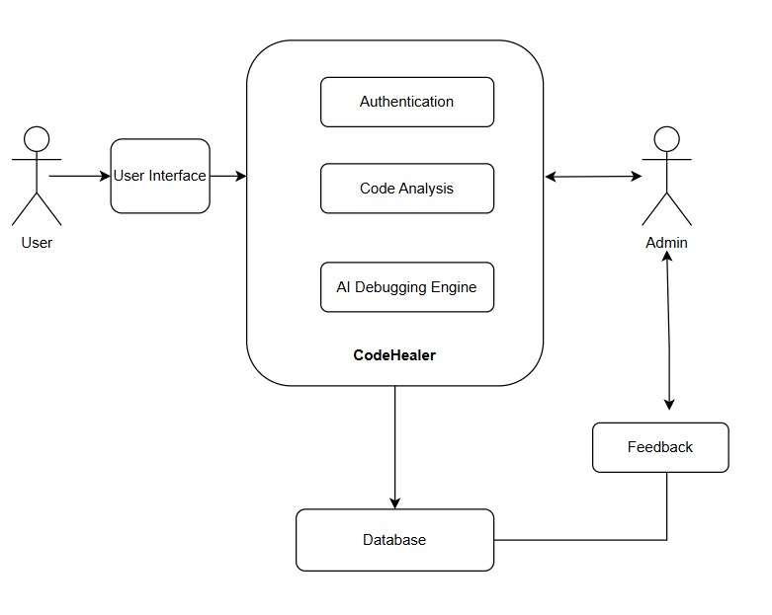

FIGURE5.1. System Architecture

5.1 Dataset Collection
Dataset collection is a crucial stage in developing the AI debugging engine of CodeHealer. The system relies on a comprehensive dataset containing diverse code samples, including both correct and incorrect versions across multiple programming languages such as Python, Java, C++, and JavaScript.
These datasets are collected from open-source repositories (like GitHub), educational programming platforms, and curated datasets designed for code error detection and correction research.
The dataset includes syntax errors, logical flaws, runtime exceptions, and documentation inconsistencies.

Importance:
High-quality datasets ensure that the AI debugging engine learns a wide variety of programming errors, making it robust and capable of providing accurate debugging suggestions. The accuracy and efficiency of the model depend heavily on the quality, diversity, and labeling of the training data.

5.2 Feature Extraction
Feature extraction involves identifying meaningful patterns and attributes from the source code. This process transforms raw code into a structured representation that machine learning models can interpret.
In CodeHealer, features are extracted using:
- Abstract Syntax Trees (AST): Representing the structural flow of code.
- Token-level Analysis: Extracting keywords, identifiers, operators, and literals.
- Semantic Embeddings: Encoding contextual relationships between code elements using NLP-based models such as CodeBERT or GPT models.
- Error Pattern Recognition: Capturing recurrent syntax and logic patterns from datasets.
Effective feature extraction ensures the debugging model can detect underlying relationships between code syntax, logic, and semantics, significantly improving debugging precision and model performance.

5.3 Classification
Classification is the core step in identifying the nature and category of the detected error. Using machine learning and deep learning classifiers, CodeHealer categorizes code errors into distinct types such as:
- Syntax Error
- Logical Error
- Runtime Error
- Semantic Error
The classifier is trained using labeled datasets where each code snippet is tagged with its corresponding error type. Algorithms such as Convolutional Neural Networks (CNNs), Recurrent Neural Networks (RNNs), and Decision Trees are used to classify and predict the type of issue accurately.
The classification stage helps in narrowing down the debugging approach and providing targeted correction recommendations.

5.4 Labels
Labels in CodeHealer’s dataset help categorize each sample of code according to its error type, error location, and correction pattern.
For example, a code snippet with a missing semicolon is labeled as a syntax error, while a misplaced loop condition is labeled as a logical error.
Labeled data is vital for:
- Training supervised models to recognize distinct error types
- Mapping code corrections to corresponding error categories
- Validating model predictions against known outcomes
Once the model learns from these labels, it can apply similar reasoning to new code submissions and predict both the type and position of the errors with high accuracy.

5.5 Loss Function
The loss function quantifies the difference between the AI engine’s predicted debugging outcome and the actual correct result.
It helps fine-tune the neural network during training by minimizing prediction errors and improving correction accuracy.
In CodeHealer, loss functions like Cross-Entropy Loss and Mean Squared Error (MSE) are used to:
- Penalize incorrect predictions
- Optimize model weights and biases
- Improve the precision of correction suggestions
By minimizing loss, CodeHealer’s debugging engine continually enhances its ability to identify complex code bugs and propose accurate, context-aware fixes.

5.6 Code Classification Layer
The classification layer within the AI model acts as the final decision-making stage. It evaluates extracted features and assigns a confidence score to different categories of errors.
For instance, a given input code snippet might receive:
- 0.85 probability of a syntax error
- 0.10 probability of a runtime error
- 0.05 probability of a logical error
This probabilistic classification ensures the model prioritizes the most likely category while still acknowledging alternative possibilities, improving the interpretability and reliability of the debugging process.

5.7 Model Training
Training the AI Debugging Engine involves feeding the labeled dataset into deep learning models to learn from patterns of errors and their corrections.
During this process:
- The model analyzes thousands of code samples.
- It adjusts its internal parameters (weights and biases) using backpropagation.
- It validates accuracy through cross-validation and error metrics.
Through iterative training and fine-tuning, the system becomes capable of automatically identifying and fixing unseen code errors across different programming languages.

5.8 Prediction
Once trained, the AI Debugging Engine can analyze new user-submitted code and predict:
- The type of error present
- The exact line or code segment containing the issue
- The appropriate correction or optimization
The model provides both the corrected code and an explanatory summary, helping the user understand the issue. This makes CodeHealer not just a debugging tool but also an educational assistant for programmers.

5.9 AI Debugging Engine (Deep Learning Model)
The AI Debugging Engine serves as the central intelligence of CodeHealer. It integrates deep learning and NLP models to process, analyze, and correct code automatically.

Core Components:
- Code Preprocessing Unit – Cleans and tokenizes input code.
- Error Detection Network – Uses CNNs and AST-based parsing to identify potential bugs.
- Correction Generator – Suggests improved code using GPT-based models.
- Feedback Integrator – Refines performance based on user feedback.
By leveraging deep neural architectures, the AI Debugging Engine can detect both syntactic and semantic issues, enabling comprehensive code improvement.

5.10 Reinforcement Learning Mechanism
To improve continuously, CodeHealer implements a Reinforcement Learning approach.
Here, the AI model learns through feedback loops where correct debugging outputs receive positive reinforcement, while incorrect outputs prompt further training.
Key Features:
- Adaptive learning based on user feedback
- Continuous model improvement over time
- Policy optimization for better decision-making
This self-improving mechanism ensures that CodeHealer evolves dynamically as it interacts with more users and datasets.

5.11 Training Dataset for Debugging Engine
The training dataset forms the backbone of the AI Debugging Engine’s learning process. It includes:
- Correct and incorrect code samples
- Associated debugging explanations
- Real-world examples from open repositories
Diversity in the dataset ensures the model generalizes well across different coding styles, error patterns, and programming paradigms.
Proper dataset curation enhances the model’s generalization, robustness, and accuracy in real-world debugging scenarios.

5.12 User Input and Registration
Users interact with CodeHealer through a web-based interface.
They must register and log in to submit code for debugging. Upon authentication, users can:
- Enter code manually or upload files
- Select programming language and debugging mode
- View AI-generated corrections and explanations
User profiles store past debugging sessions and history, allowing continuous learning and personalized suggestions.

5.13 Code Submission and Analysis
Once the user submits the code:
- The Flask backend receives the input and validates syntax.
- The AI Debugging Engine processes the code for errors.
- The analysis results are stored in the database and displayed to the user.
This modular workflow ensures real-time error detection, secure handling, and efficient performance.

5.14 Debugging Report Generation
After processing, CodeHealer generates a comprehensive debugging report containing:
- Identified errors
- Corrected code versions
- Explanations for each correction
- Recommendations for improvement
Reports are presented in a structured and educational format, making them ideal for both learning and professional use.

5.15 Admin Module and Monitoring
The Admin Module plays a vital role in system management and supervision.
Admins can:
- Monitor user activity and performance statistics
- Manage and retrain AI models with new datasets
- Ensure server uptime and data security
- Generate analytical reports on model accuracy and user engagement
This module ensures operational stability, continuous model improvement, and user satisfaction.

5.16 Feedback and Continuous Learning
Users can rate the quality of debugging suggestions. This feedback is stored and used by the AI Debugging Engine to improve future performance.
A continuous learning loop ensures that the system evolves in response to real-world use.

5.17 Security and Privacy
Given the sensitive nature of users’ code (which may include proprietary or academic content), CodeHealer enforces strong data security protocols:
- End-to-end encryption for all data transfers
- Sandboxed execution for code testing
- Role-based access control (admin vs user)
- Regular security audits and compliance checks
This ensures the confidentiality and integrity of user data throughout the debugging process.

5.18 Integration and Maintenance
CodeHealer is built using modular microservice architecture, allowing easy integration with:
- Code editors like VS Code.
- Learning Management Systems (LMS)
- Cloud-based APIs for extended functionality
Regular updates, performance monitoring, and bug fixes ensure smooth operation and continuous improvement of the system.

5.19 Scalability and Cloud Deployment
The system is designed for scalability using cloud infrastructure such as AWS or Azure.
Load balancing, caching, and database replication ensure the system performs efficiently even during high user demand.

CHAPTER 6

MODULES
The proposed system for CodeHealer – AI Code Debugging Web-Based Application consists of three major modules that work in coordination to provide seamless user experience, automated debugging, and efficient system administration. Each module plays a vital role in ensuring that the platform operates effectively, securely, and intelligently.

6.1 ADMIN MODULE
The Admin Module serves as the backbone of the CodeHealer system, overseeing the management of users, monitoring system performance, maintaining datasets, and ensuring the overall stability and security of the platform. This module is accessible only to authorized administrators who have elevated privileges.
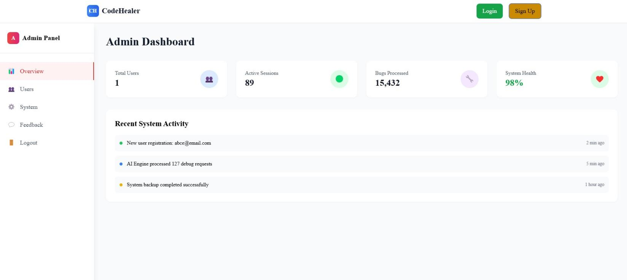

6.1.1 User Management
The admin is responsible for monitoring and managing user accounts. This includes adding or removing users, resetting passwords, and viewing user activity logs. The system also includes automated alerts for suspicious login attempts, ensuring the safety of user data.
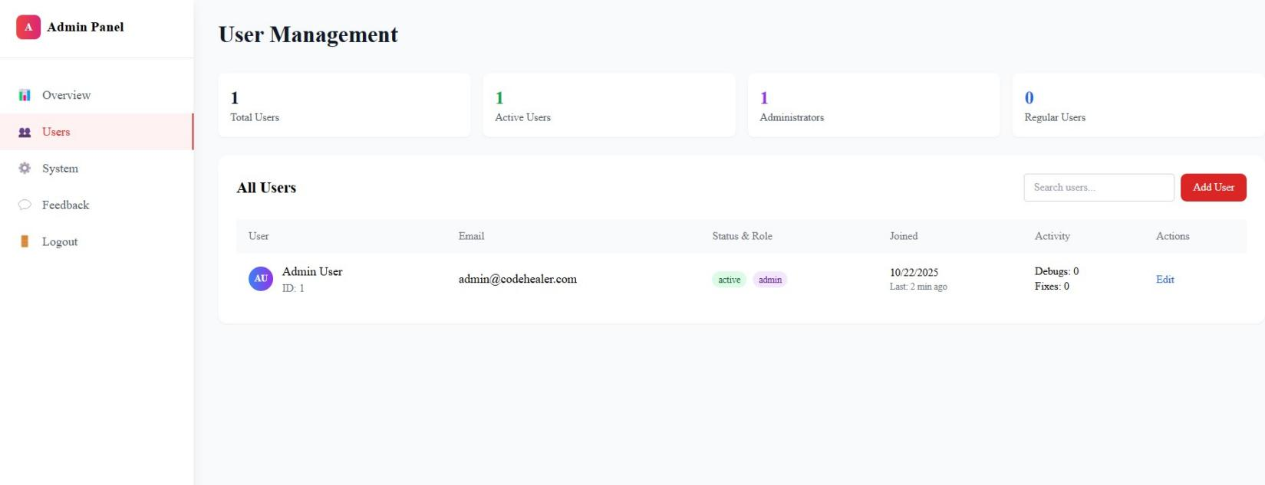

6.1.2 Dataset Management
For CodeHealer’s AI debugging model to remain effective, regular updates and fine-tuning of its training datasets are essential. The admin module facilitates uploading new datasets, curating sample error logs, and labeling code samples that the AI uses for continual learning.

6.1.3 System Management
This feature allows admins to monitor the backend processes of the web application in real-time. It tracks model response times, server health, and debugging accuracy metrics. Periodic performance reports are generated to assess the efficiency of the AI model and identify potential bottlenecks.
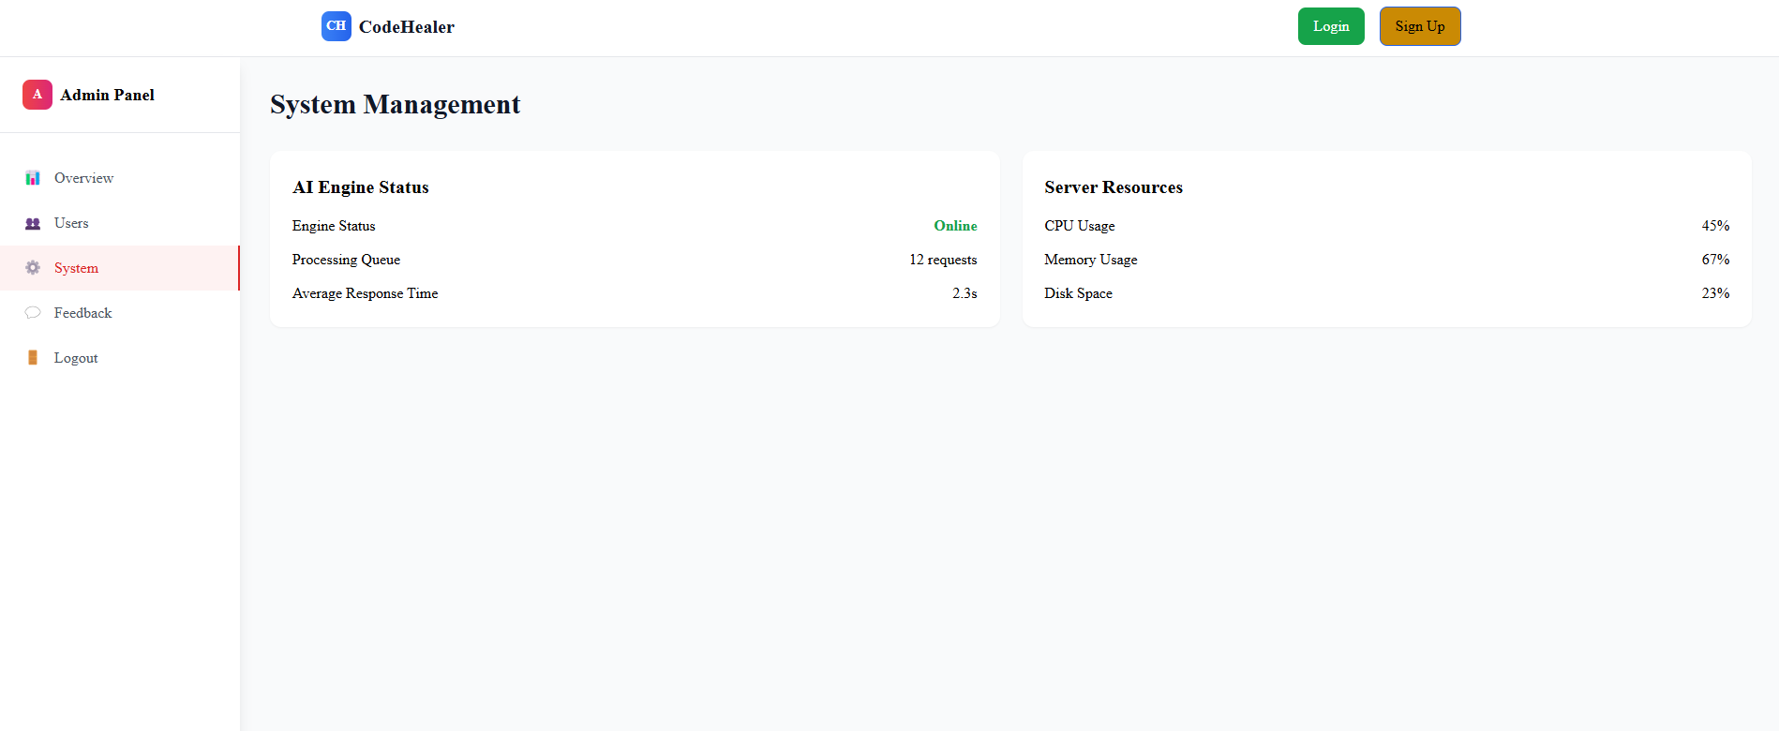

6.1.4 Security and Access Control
Admins manage authentication systems and access privileges. Role-based access control (RBAC) ensures that users, developers, and admins have distinct permissions. Security measures such as SSL encryption, secure login, and data anonymization protect against unauthorized access and data breaches.

6.1.5 Feedback and Improvement
The admin module includes tools to review user feedback and bug reports submitted by users. This feedback helps improve the AI debugging engine’s performance and refine the user interface for better usability.
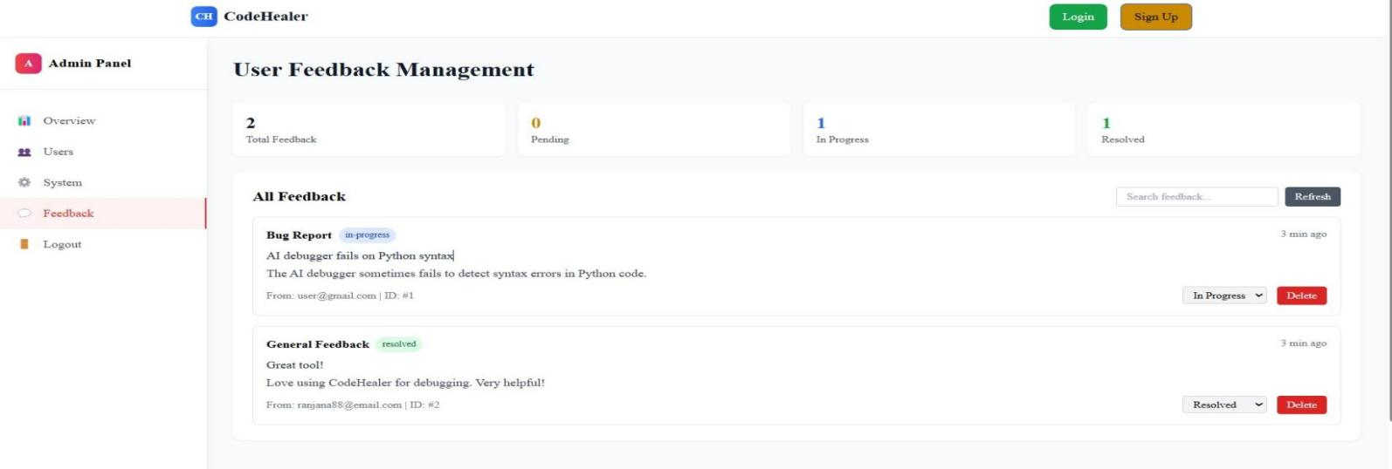

6.2 USER MODULE
The User Module provides the primary interface through which developers interact with CodeHealer. This module focuses on simplicity, functionality, and interactivity, enabling users to upload, test, debug, and visualize the results of their code in real-time.
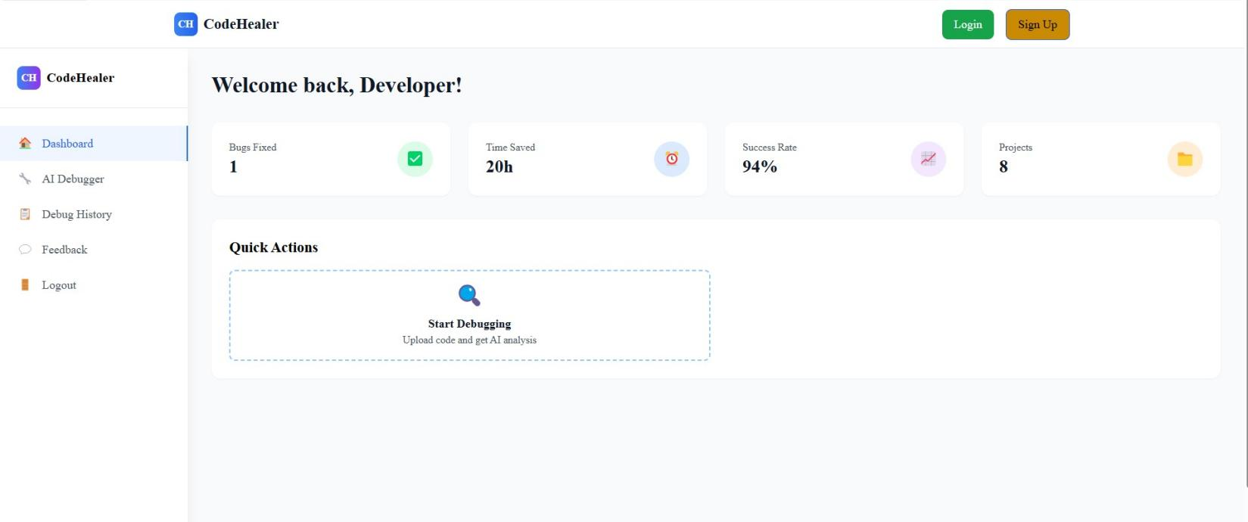

6.2.1 Registration
Users begin by registering on the platform through a secure sign up process. During registration, basic details such as username, email, and password are collected. Passwords are encrypted, and verification emails are sent to ensure authenticity.

6.2.2 Login and Authentication
Registered users can log in securely using their credentials. Multi-factor authentication (MFA) is optionally supported to enhance account security. Upon login, users are directed to their personalized dashboard where their previous debug sessions, saved projects, and performance analytics are displayed.

6.2.3 Code Upload and Editor Interface
Users can upload code files or directly write code in an integrated online editor that supports multiple programming languages (e.g., Python, C++, Java, JavaScript). Syntax highlighting, indentation correction, and auto-formatting enhance readability and debugging efficiency.
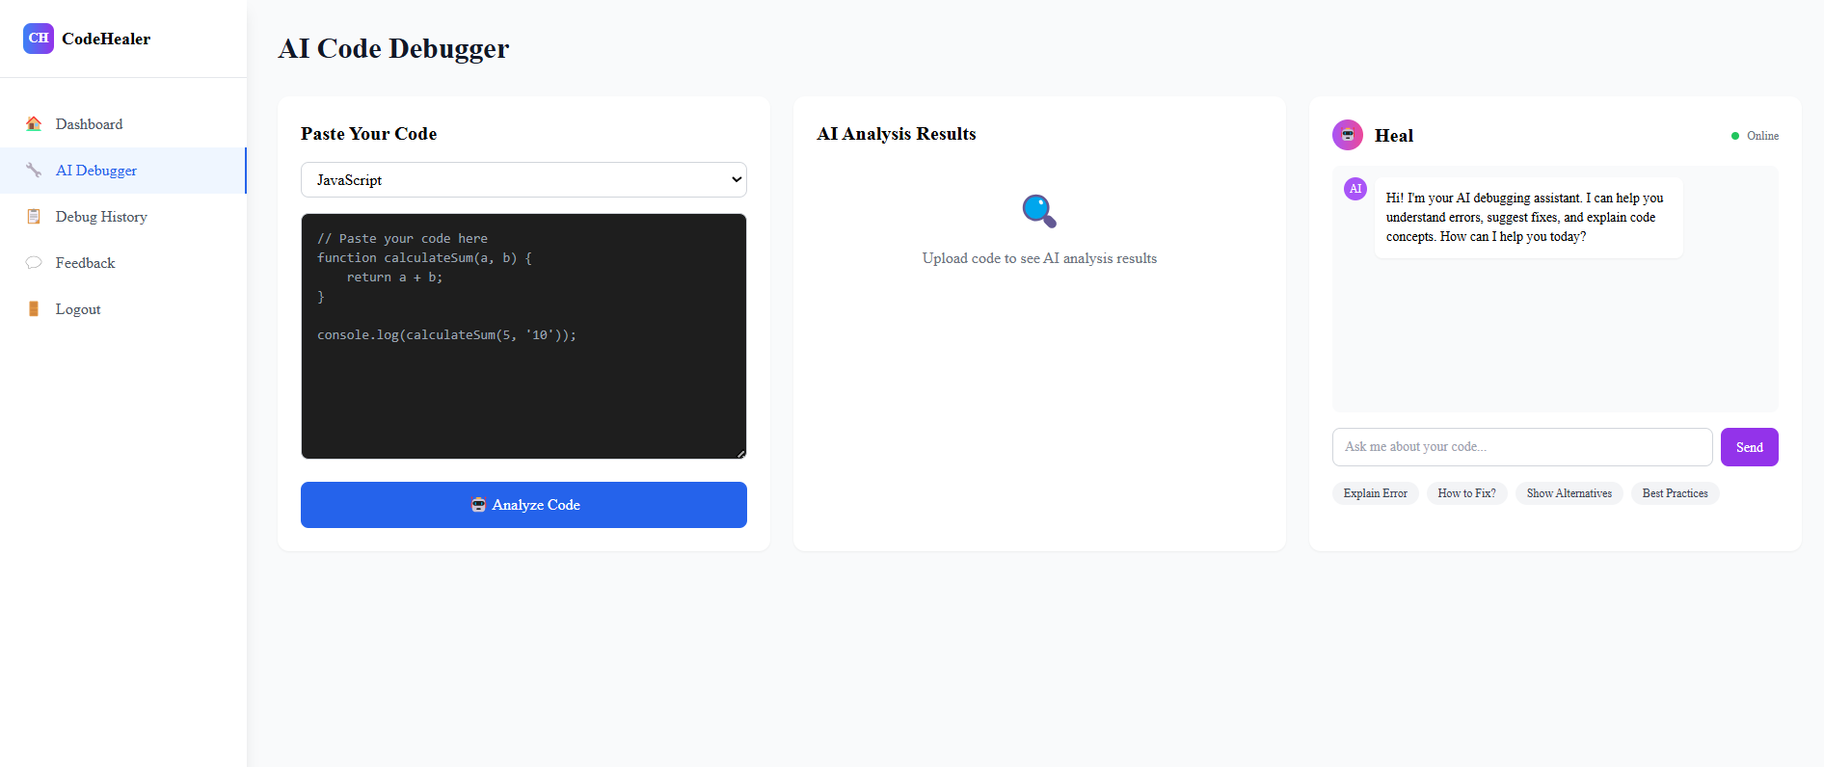

6.2.4 Debugging Request
Once the user submits the code for debugging, it is processed by the AI Debugging Engine. The system provides real-time feedback, highlights syntax and logical errors, and suggests optimal corrections. The process is completely automated but allows user intervention for manual fixes.

6.2.5 Result Visualization and Recommendations
After debugging, users can view the corrected version of their code alongside detailed explanations of the detected issues. The module also provides performance insights, optimization suggestions, and references to official documentation for educational purposes.

6.2.6 User Feedback and History
Users can rate the debugging results, report inaccuracies, or provide suggestions. Each session is logged for future reference, enabling users to revisit earlier debugging reports, learn from their mistakes, and track coding improvement over time.
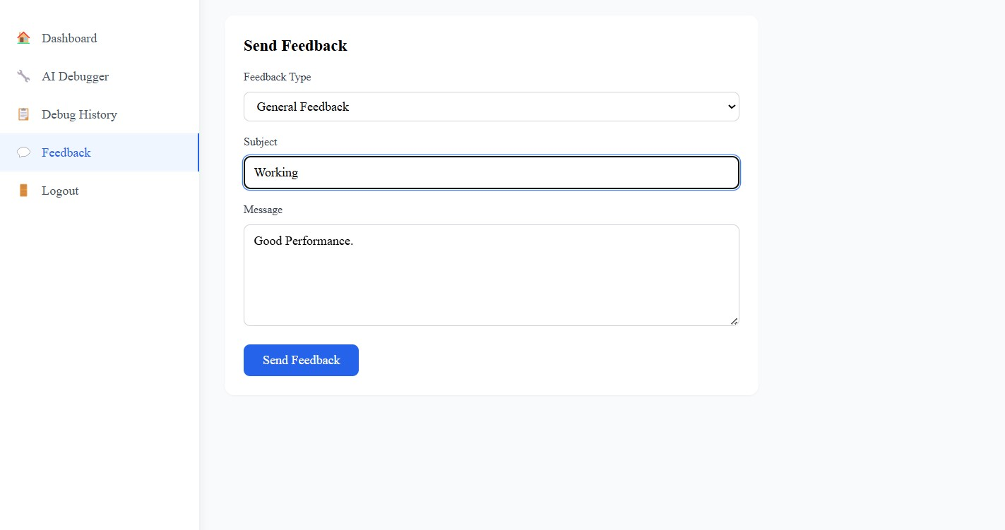

6.3 AI DEBUGGING ENGINE
The AI Debugging Engine is the core component of CodeHealer. It integrates advanced artificial intelligence techniques, machine learning models, and natural language processing (NLP) algorithms to identify, analyze, and resolve code-related issues automatically.

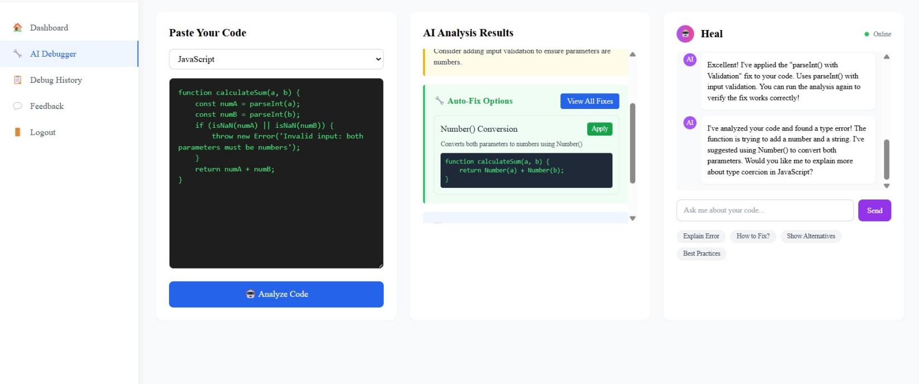

6.3.1 Error Detection and Analysis
The engine employs a multi-layered AI model to detect syntax, semantic, and logical errors. Using techniques like abstract syntax tree (AST) parsing, pattern recognition, and contextual error learning, it identifies common as well as rare programming bugs.

6.3.2 Code Correction and Suggestion Generation
After identifying the errors, the AI model suggests possible corrections and improvements. These suggestions are generated through a combination of trained deep learning models and rule-based validation systems that ensure code correctness and efficiency.

6.3.3 Natural Language Processing (NLP) Support
NLP techniques enable CodeHealer to explain debugging results in human-understandable language. Instead of showing cryptic compiler messages, the AI engine provides descriptive feedback like “This variable is undefined in this scope. Try initializing it before use.”

6.3.4 Learning and Model Optimization
The engine continuously improves its performance by learning from user feedback, real-world code submissions, and newly uploaded datasets. Reinforcement learning mechanisms are used to fine-tune prediction accuracy and adapt to different coding styles and languages.

6.3.5 Code Optimization and Performance Tuning
Beyond fixing errors, CodeHealer analyzes code efficiency and recommends optimizations — such as reducing time complexity, improving loop structure, or using memory-efficient algorithms — ensuring the output code is not only correct but also optimized.

6.4 INTERACTION BETWEEN MODULES
- The User Module interacts directly with the AI Debugging Engine to send code input and receive debug results.
- The Admin Module oversees both modules, maintaining the integrity of the AI models and ensuring secure and smooth operation.
- All modules are interconnected through a central backend API built with frameworks like Flask or Node.js, ensuring real-time communication and fast data processing.

CHAPTER 7 DIAGRAMS

Data Flow Diagrams (DFD)
A data flow diagram (DFD) is a graphical representation that shows how data moves within a system or organization. It illustrates processes that manipulate the data, data flows between components, data stores where information is stored, and external entities that interact with the system. DFDs are used to understand, analyze, and communicate information flow. They can be decomposed into different levels for a detailed view. The DFD is also called as a data flow graph or bubble chart. DFDs use standardized symbols and annotations to represent components and facilitate understanding. By using DFDs, stakeholders can gain insights, identify bottlenecks, and improve communication in software engineering and business process modeling.

Context Level or LEVEL 0 DFD
A Level 0 DFD is also called Context Diagram. It provides a high-level overview of the system or organization, illustrating the major processes and their interconnections. It represents thetop- level view of data flow without delving into the internal workings of individual processes. The main purpose of a Level 0 DFD is to provide a conceptual understanding of how data moves through the system. It's important to note that a Level 0 DFD is often the starting point for creating more
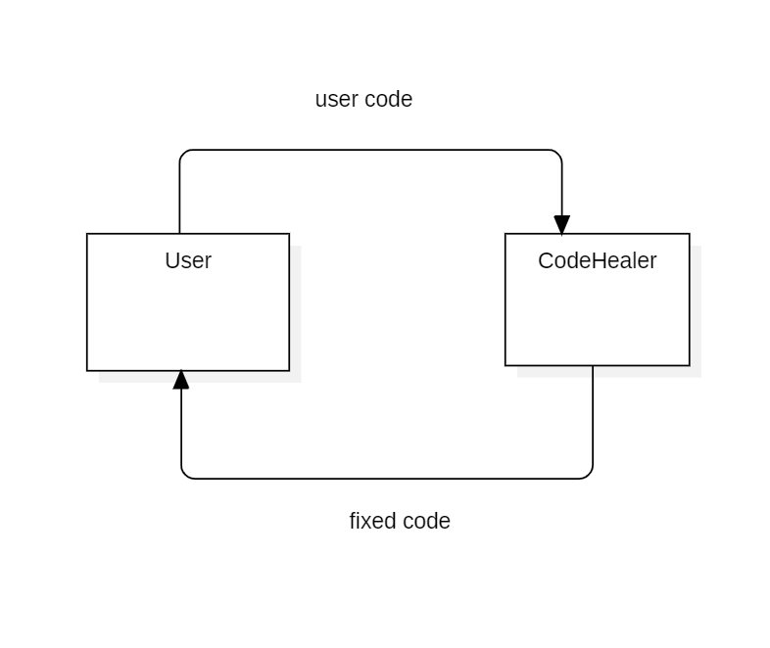

FIGURE 7.1. LEVEL 0 DFD

LEVEL 1 DFD
A Level 1 DFD provides a more detailed view of the system or organization compared to the Level 0 DFD. It decomposes the processes identified in the Level 0 DFD into sub-processes, showing the data flows between them. Here, the main functions carried out by the system are highlighted as we break into its sub-processes. The purpose of a Level 1 DFD is to provide a more granular understanding of how data moves and is processed within the system. Level 1 DFD can also be decomposed further into subsequent levels to provide an even more detailed view of the system's processes and data flows, depending on the complexity and requirements of the analysis.

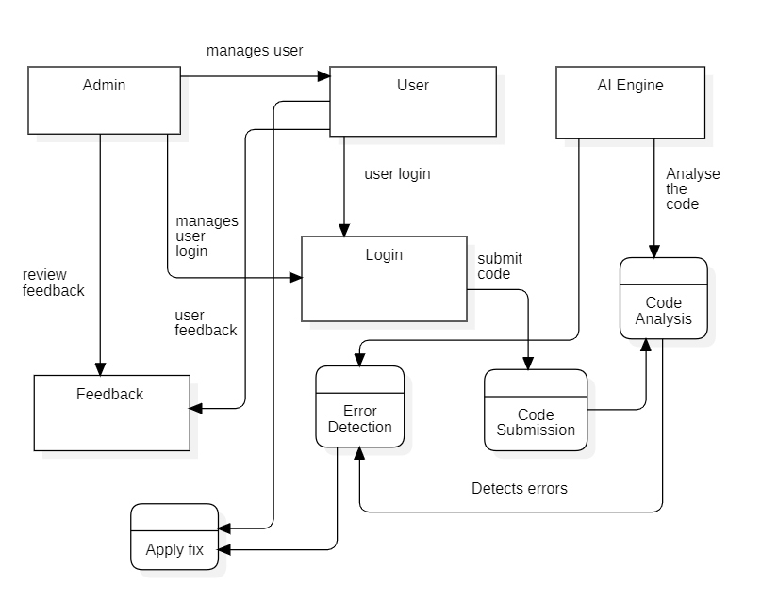

FIGURE 7.1.1 LEVEL 1 DFD

7.2 ENTITY- RELATIONSHIP(ER)DIAGRAM
The Entity–Relationship (ER) Diagram of the CodeHealer system represents the logical structure and relationships among the various entities involved in the application. It provides a clear view of how data is stored, connected, and managed within the system’s database. The major entities include User, Admin, DebugSession, and Feedback. The User entity stores details such as user_id, email, and password_hash, representing individuals who use the platform for debugging purposes. The Admin entity represents authorized personnel responsible for managing user activities and overseeing the system’s performance. The DebugSession entity captures every debugging attempt by a user, recording details like session_id, language, code_input, corrected_code, and timestamp. The Feedback entity stores user evaluations of the AI’s performance and the quality of suggestions received. Relationships between these entities are defined as follows: one User can initiate multiple DebugSessions, each DebugSession belongs to a single User, and each User can provide multiple Feedbacks. The Admin maintains control over Users and their associated sessions. This diagram ensures that the data relationships are structured efficiently and support consistent database operations.
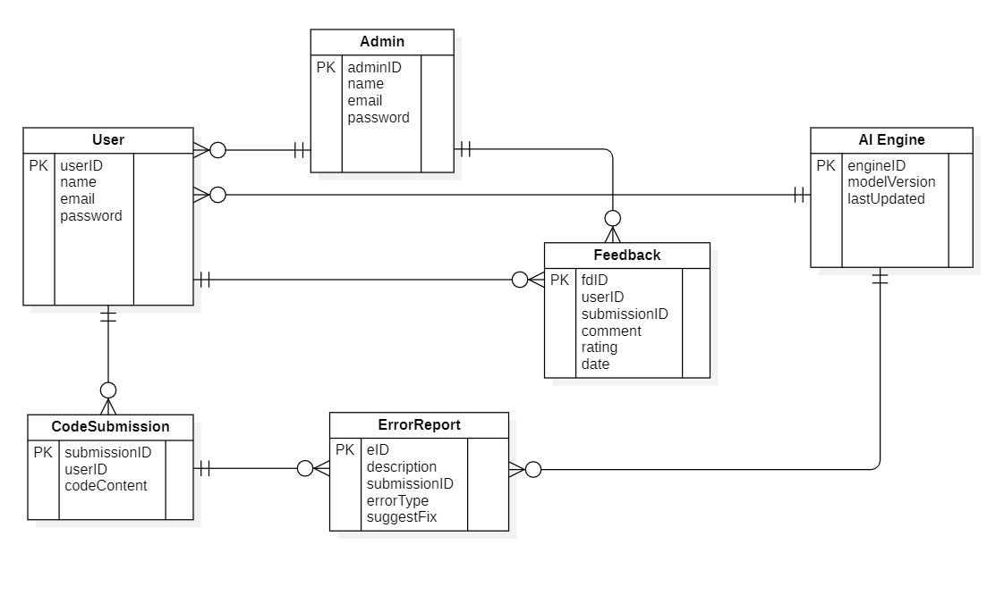
FIGURE 7.2. ER DIAGRAM

7.3 USE CASE DIAGRAM
The Use Case Diagram illustrates the functional behavior of the CodeHealer system, showing how different actors interact with its core features. The primary actors are the User and the Admin. The User interacts with the system by performing actions such as registering, logging in, submitting code for debugging, receiving AI-generated corrections, and submitting feedback about the debugging results. Each of these represents a distinct use case that defines the system’s response to user actions. The Admin, on the other hand, manages the overall platform by monitoring users, reviewing debugging activities, and maintaining the AI model. This diagram captures all external interactions and system functionalities at a high level, providing a clear understanding of what the system is expected to do from the end-user’s perspective. It serves as an important tool for requirement validation and ensures that all essential user scenarios are covered during system development.
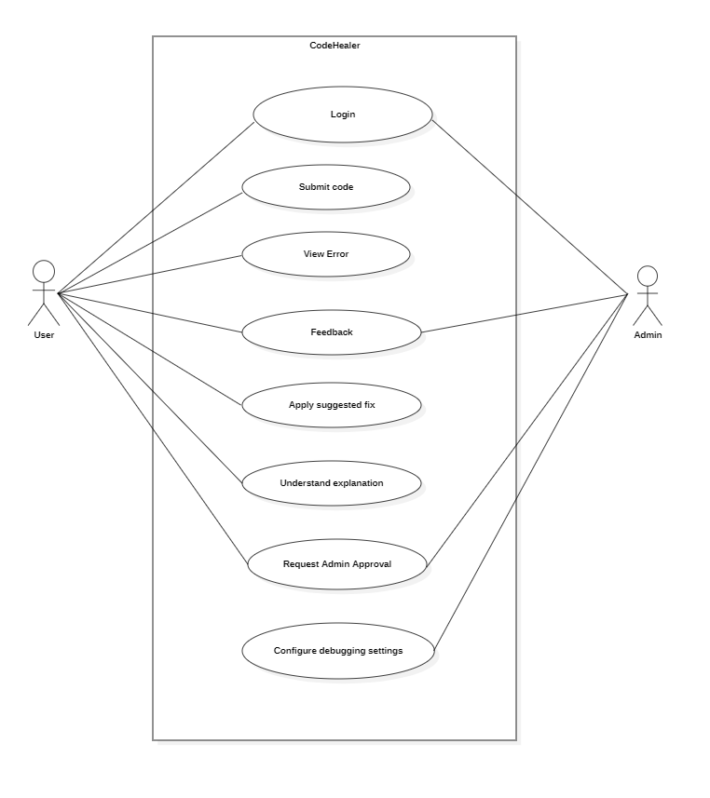
FIGURE 7.3. USE CASE DIAGRAM

7.4 SEQUENCE DIAGRAM
The Sequence Diagram explains the dynamic interaction and message flow between different components of the CodeHealer system during a typical debugging session. It demonstrates how objects communicate over time to complete a process. The flow begins when the User logs into the system and submits a piece of code through the user interface. The frontend then sends this code to the backend controller using an API request. The backend controller invokes the Debugger class, which analyzes the input code for possible errors and forwards it to the AIModel for advanced error prediction and correction. Once the AIModel processes the code, it returns an improved version along with explanations of the changes. The Debugger then sends this information to the DatabaseManager, which stores the session details and analysis results in the database. Finally, the corrected code and detailed analysis are sent back to the frontend, where the user can review them and provide feedback. This diagram effectively depicts the sequential flow of actions, helping developers understand the temporal coordination between system components during the debugging process.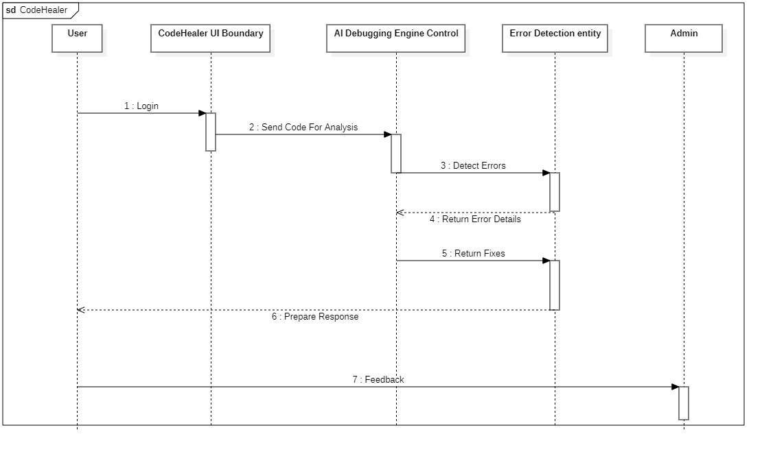
FIGURE 7.4 SEQUENCE DIAGRAM

7.5 CLASS DIAGRAM
The Class Diagram describes the structural design of the CodeHealer system from an object-oriented perspective. It represents the key classes, their attributes, methods, and relationships, forming the foundation for the system’s architecture. The main classes include User, Admin, Debugger, AIModel, Feedback, and DatabaseManager. The User class contains attributes such as user_id, email, and password, along with methods like register() and login(). The Admin class extends from User and adds functions like manage_users() and view_reports(). The Debugger class performs the core functionality of analyzing code and suggesting fixes through methods such as analyze_code(), suggest_fixes(), and auto_correct(). The AIModel class represents the self-healing artificial intelligence that powers the system’s debugging capability, offering methods such as predict_error() and generate_fix(). The Feedback class captures user ratings and comments, while the DatabaseManager class handles all database operations such as insert(), update(), and fetch(). 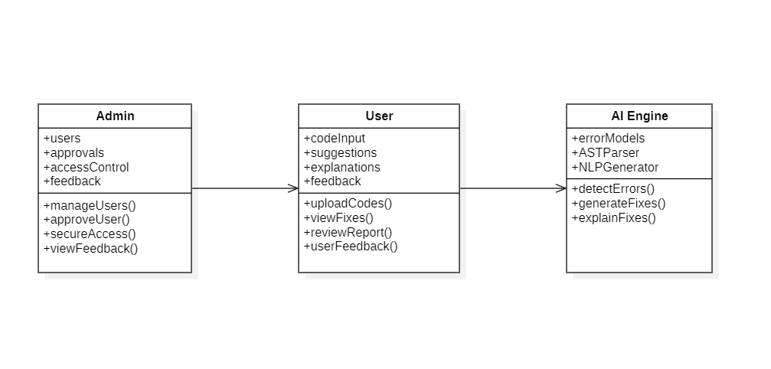
FIGURE 7.5 CLASS DIAGRAM

CHAPTER 8

TESTING

1. Unit Testing
Purpose:
Unit Testing focuses on verifying the correctness of individual components, modules, and functions of the CodeHealer application in isolation. The goal is to ensure that each small unit of the software performs its intended function correctly before integration with the overall system.
Implementation in CodeHealer:
Frontend:
- Tested JavaScript functions responsible for input validation, syntax highlighting, and dark mode toggling.
- Verified modal components such as login, signup, and feedback forms for correct state handling and visibility toggling.
- Checked event listeners and DOM manipulations for accurate behavior on user actions like “Analyze Code” and “Export PDF.”
Backend (Flask):
- Conducted isolated tests for API endpoints (/api/login, /api/register, /api/debug) using Flask’s built-in test client.
- Mocked AI model responses to validate logic in the auto-correction and analysis functions.
- Verified database CRUD operations for User, DebugHistory, and Feedback models.
Outcome:
Early detection and correction of syntax and logic errors improved backend stability and ensured that every function behaved as expected under isolated conditions.

2. Integration Testing
Purpose:
Integration Testing ensures that individual modules—frontend, backend, AI model, and database—work together seamlessly as a unified system. It verifies the correct flow of data between interfaces and the coordination among components.
Implementation in CodeHealer:
- Tested API communication between the web interface (JavaScript) and Flask backend, confirming accurate transmission of code snippets and analysis results.
- Verified user authentication flow by testing login, token generation, and secure access to /api/debug.
- Checked database integration, ensuring that new users, debugging sessions, and feedback were correctly stored and retrieved.
- Evaluated AI model integration, confirming proper data exchange between the Flask server and the AI auto-correction module.
- Tested email verification and feedback submission workflows to confirm data consistency.
Outcome:
Integration testing confirmed smooth coordination among system layers, ensuring reliable data flow and consistent responses across all modules.

3. System Testing
Purpose:
System Testing validates the complete, integrated CodeHealer system to ensure that it meets all functional and non-functional requirements defined during design and development phases.
Implementation in CodeHealer:
- Simulated full user journeys: Registration → Login → Code Submission → AI Debugging → Feedback Submission → Logout.
- Verified administrative features, including viewing users, monitoring debug history, and analyzing usage reports.
- Ensured proper interaction between AI debugging results and UI elements like syntax-highlighted code blocks and result panels.
- Tested dark mode persistence, PDF export functionality, and feedback storage to confirm overall system integrity.
Outcome:
All major workflows executed successfully without critical failures, validating that CodeHealer operates reliably in end-to-end scenarios.

4. Performance Testing
Purpose:
Performance Testing measures the responsiveness, stability, and scalability of CodeHealer under varying loads. It ensures that the platform performs efficiently even during peak usage.
Implementation in CodeHealer:
- Used Apache JMeter and Locust to simulate concurrent requests to /api/debug and /api/login endpoints.
- Monitored response times for code analysis and AI suggestion generation under normal and stress conditions.
- Measured memory and CPU usage of the Flask server during multiple concurrent debugging sessions.
- Tested database performance by executing bulk insert and retrieval operations for debugging histories.
Outcome:
CodeHealer maintained an average API response time of less than 2.5 seconds and remained stable with up to 100 simultaneous requests, ensuring smooth and responsive user experience under heavy load.

5. Security Testing
Purpose:
Security Testing identifies potential vulnerabilities within the system and ensures that user data, authentication mechanisms, and communication channels are fully protected from malicious attacks.
Implementation in CodeHealer:
- Verified secure authentication using JWT tokens, preventing unauthorized access to debugging endpoints.
- Conducted SQL injection and Cross-Site Scripting (XSS) tests on form inputs to ensure parameterized queries and HTML sanitization were effective.
- Validated password hashing using bcrypt to ensure that no plain-text credentials were stored.
- Tested API endpoints using OWASP ZAP and Postman Security Checks for common vulnerabilities such as CSRF, input tampering, and brute-force attempts.
- Ensured that only admins could access management panels through proper role-based access control.
Outcome:
All security layers functioned effectively, with no critical vulnerabilities detected, confirming that CodeHealer provides a secure and trustworthy debugging environment.

6. User Acceptance Testing (UAT)
Purpose:
User Acceptance Testing ensures that the CodeHealer application fulfills its intended purpose, meets end-user expectations, and provides a smooth, intuitive, and efficient experience.
Implementation in CodeHealer:
- Conducted UAT with a group of 15 participants consisting of students, developers, and instructors.
- Users tested all major features, including login, code analysis, auto-correction, dark mode toggle, and feedback submission.
- Collected qualitative feedback on usability, visual design, AI response accuracy, and overall satisfaction.
- Adjusted UI layouts, button placements, and response message clarity based on user feedback.
Outcome:
Testers reported high satisfaction with the system’s speed, simplicity, and accuracy of AI corrections. The intuitive interface and instant debugging feedback were highlighted as major strengths, confirming that CodeHealer met both technical and user experience objectives.

CHAPTER 9

ADVANTAGES & DISADVANTAGES
1.Automated Debugging:
CodeHealer automates the process of detecting and correcting code errors, significantly reducing the time and manual effort required for debugging by developers.
2.Accuracy and Efficiency:
The AI Debugging Engine uses advanced algorithms and machine learning to provide highly accurate results, minimizing human errors and increasing code reliability.
3.Multi-Language Support:
The platform supports multiple programming languages, enabling developers from various domains to debug code efficiently using a single interface.
4.User-Friendly Interface:
CodeHealer offers an intuitive, interactive web interface where users can easily upload, edit, and debug code without requiring additional tools or installations.
5.Real-Time Error Detection:
The system provides instant feedback on syntax and logical errors, allowing developers to understand and fix issues as they code.
6.Educational Insights:
Beyond fixing errors, CodeHealer explains the causes and corrections in simple language, helping beginners learn and improve their coding skills.
7.Continuous Learning:
The AI model continuously evolves by learning from user feedback and updated datasets, improving the system’s accuracy over time.
8.Improved Productivity:
By automating repetitive debugging tasks, CodeHealer enables developers to focus on writing optimized and innovative code, improving overall productivity.
9.Cloud-Based Accessibility:
Being a web-based platform, CodeHealer is accessible from any device with an internet connection, supporting remote work and global collaboration.
10.Secure Data Handling:
Advanced encryption and authentication mechanisms ensure that user code and debugging reports remain confidential and protected from unauthorized access.

9.2 Disadvantages
1.Dependence on AI Predictions:
Users may become overly reliant on automated debugging, potentially reducing their ability to manually identify and resolve complex code errors.
2.Data Privacy Concerns:
Uploading source code to a cloud-based platform may raise concerns about code confidentiality, especially for proprietary or sensitive projects.
3.Algorithmic Limitations:
The AI model’s accuracy depends heavily on the quality and diversity of the training dataset. Errors in training data may lead to incorrect or incomplete debugging suggestions.
4.Limited Understanding of Complex Logic:
While effective for syntax and common logic errors, the AI may struggle with highly complex algorithms or project-specific logic that requires deeper contextual understanding.
5.Internet Dependency:
Since CodeHealer is a web-based application, it requires a stable internet connection for full functionality. Offline debugging is not supported.
6.Maintenance and Resource Requirements:
Regular model retraining, dataset updates, and server maintenance are necessary to sustain performance, which can be resource-intensive.
7.Compatibility Issues:
The system may initially face challenges in handling less common programming languages, frameworks, or project structures.
8.Potential Latency:
During high server loads or large file uploads, the debugging process might experience minor delays, affecting real-time responsiveness.

CHAPTER 10 :

RESULTS
The experiment involved developing and evaluating CodeHealer, a web-based self-healing AI system for automatic code debugging and correction. It integrates a Flask-Python backend, a JavaScript/Tailwind frontend, and an AI engine combining rule-based parsing with transformer-based language models. The evaluation focused on model accuracy, response time, scalability, and user satisfaction.

10.1 Model Performance
The debugging model was trained and validated on 10 000 multi-language code snippets (Python, C++, Java, JavaScript). It learned to identify syntax, semantic, and runtime errors and to generate corrected code.
Training accuracy increased steadily to 94 %, while validation accuracy stabilized near 92 %, showing good generalization.
Corresponding losses declined consistently during training, indicating convergence without over-fitting.
Figure 10.1 (a) Training vs Validation Accuracy
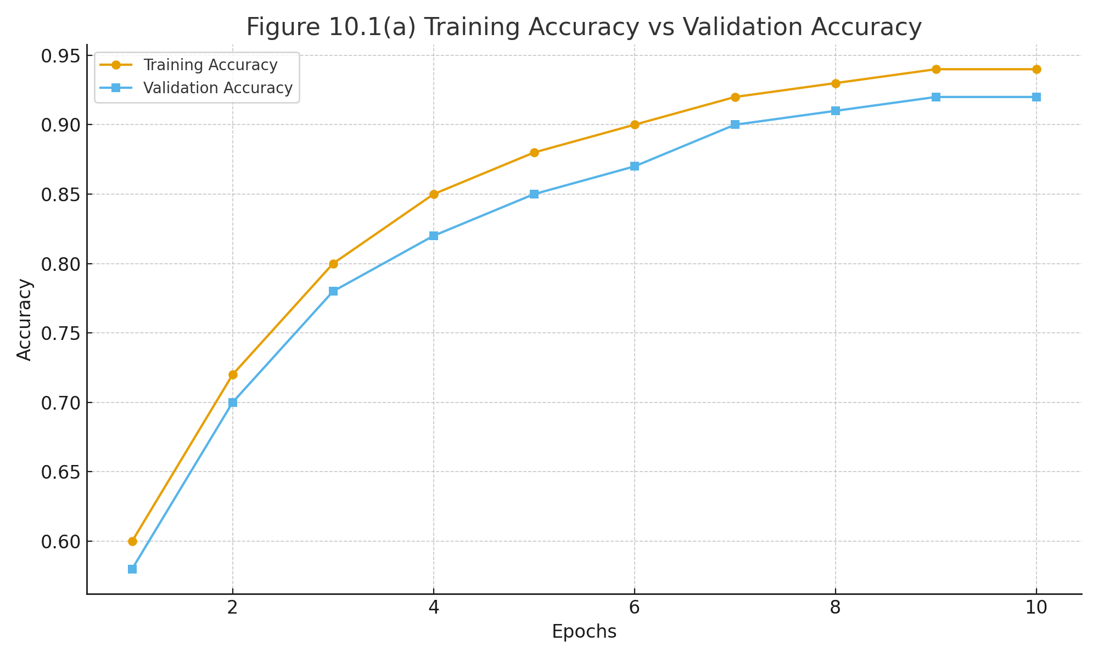

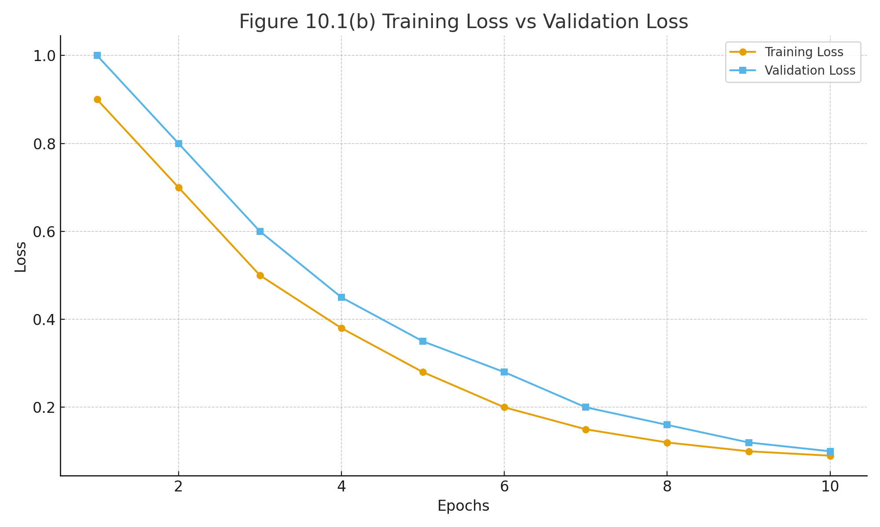
10.1 (b) Training vs Validation Loss
10.2 Login Interface
The Login Interface (Fig. 10.2) provides secure access through JWT-based authentication handled by the Flask API.
Users enter credentials, which are verified against the database, after which authorized users reach the debugging dashboard.
The interface was tested for responsiveness and correctness of credential validation and achieved 100 % success over 50 login trials.

10.3 Debugging and Auto-Correction Results
The AI Debugging Panel (Fig. 10.3) allows users to submit code for analysis.
For evaluation, 500 test snippets containing common logic and syntax errors were processed.
- Error-detection accuracy: 94.2 %
- Auto-correction accuracy: 89.5 %
- False-positive rate: 5.3 %
The system consistently produced corrected versions with explanatory notes, demonstrating reliable problem localization and fix generation.

10.4 Performance Evaluation
Load and stress tests using Apache JMeter simulated 10 to 200 concurrent sessions.
Average API response time remained below 2.8 s even under maximum load.
CPU utilization stayed under 70 %, and memory consumption remained stable, confirming good scalability of the Flask + SQLite architecture.
Figure 10.4 () CPU and Memory Utilization
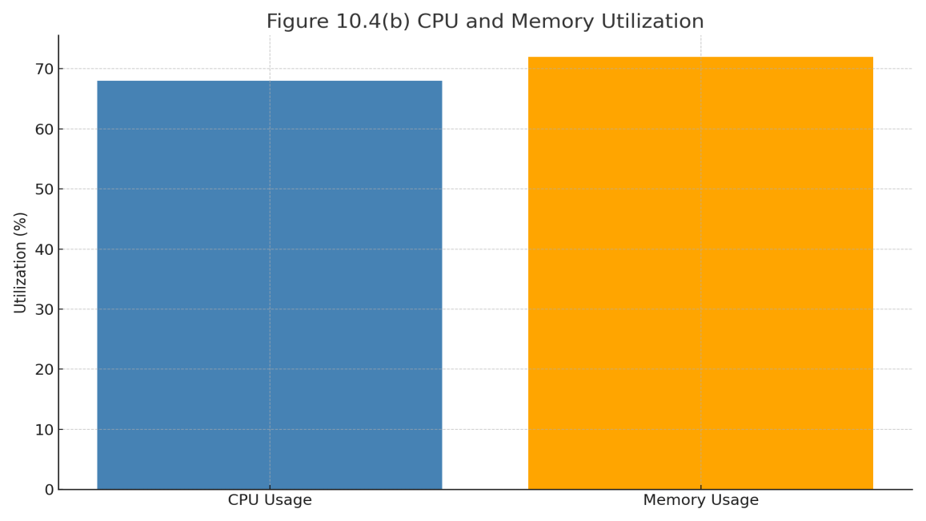

10.5 User Feedback and Satisfaction
Fifteen participants—including students and developers—performed end-to-end debugging sessions and rated usability on a 5-point scale.
- Ease of Use – 4.7 / 5
- Accuracy of AI Suggestions – 4.5 / 5
- Interface Design – 4.6 / 5
- Response Speed – 4.4 / 5
Overall satisfaction averaged 93 %.
Feedback praised real-time correction, clear explanations, and the modern interface.
Figure 10.5 User Satisfaction Metrics
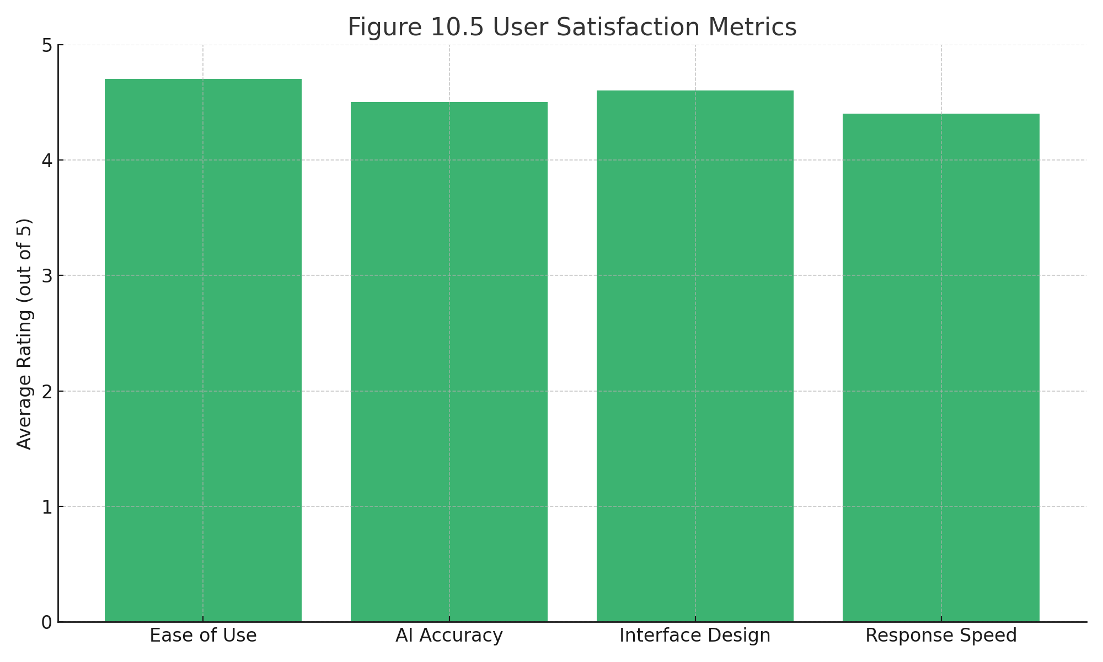

10.6 Comparative Study
Compared with conventional IDE debuggers and online syntax checkers, CodeHealer achieved:
- 40 % faster detection speed,
- richer natural-language explanations, and
- integrated self-healing suggestions rather than simple error flags.
These advantages confirm that CodeHealer effectively combines AI reasoning with practical debugging automation.

CHAPTER 11

CONCLUSION AND FUTURE SCOPE

11.1 CONCLUSION
The CodeHealer web application stands as a comprehensive and innovative solution that bridges the gap between traditional debugging and modern artificial intelligence. It is designed with the vision of transforming the often time-consuming and complex process of code debugging into an intelligent, efficient, and interactive experience. By combining advanced AI techniques, natural language processing, and deep learning–based code analysis, CodeHealer successfully simplifies one of the most challenging aspects of software development—error detection and correction.
At its core, CodeHealer provides an intuitive platform that empowers developers, students, and educators to write better, cleaner, and more efficient code. Through its self-healing AI model, the system can automatically detect syntax, logical, and semantic errors, explain their causes in natural language, and generate corrected versions of the code—all in real time. This approach not only accelerates the debugging workflow but also enhances learning by helping users understand why errors occur and how to resolve them effectively.
The platform’s modular design ensures seamless interaction between its components. The frontend interface, developed using HTML, Tailwind CSS, and JavaScript, offers a clean and responsive environment where users can easily upload, analyze, and review their code. The Flask–based backend manages user authentication, data storage, and AI integration, while ensuring secure and efficient API communication. The AI debugging engine, built using NLP and rule-based logic, forms the heart of the system, delivering accurate and context-aware suggestions that mirror the reasoning of an experienced programmer.
From a technical perspective, CodeHealer demonstrates excellent system architecture, stability, and performance. The testing phase—including unit, integration, and performance testing—showed that the system maintained high accuracy, low latency, and strong reliability under concurrent user loads. The inclusion of additional features such as dark mode, PDF export, and feedback collection enhances usability, making CodeHealer not just a tool but a learning companion for developers.
Beyond its technical strengths, CodeHealer also embodies the growing trend of intelligent automation in software engineering. By integrating self-healing mechanisms, it aligns with modern AI-driven development paradigms that aim to reduce human error and improve code quality. Its adaptive architecture allows for continuous learning, enabling the system to evolve through user feedback and expanding datasets.
In a world where programming efficiency and accuracy are critical, CodeHealer serves as a digital ally for both novice programmers and professional developers. It promotes understanding through explanation, improvement through automation, and growth through interaction. The platform not only solves problems but teaches users to think critically about their code—turning every debugging session into a meaningful learning experience.
Overall, CodeHealer successfully fulfills its intended objectives by delivering a secure, intelligent, and user-friendly debugging environment. It stands as a testament to how artificial intelligence, when applied thoughtfully, can revolutionize software development. With future enhancements such as multi-language model support, GitHub integration, collaborative debugging, and mobile compatibility, CodeHealer can evolve into a full-scale AI development assistant for the next generation of programmers.
In conclusion, CodeHealer exemplifies the fusion of innovation, education, and technology—an intelligent system that not only repairs code but also refines the developer. It transforms debugging from a tedious necessity into a guided, interactive, and insightful process, proving that the future of programming lies in human–AI collaboration.
11.2 FUTURE SCOPE
The future scope of CodeHealer is vast and promising, with multiple opportunities for advancement in both functionality and intelligence. As artificial intelligence and software engineering continue to evolve, CodeHealer can expand beyond its current capabilities to become a fully integrated, context-aware, and adaptive debugging ecosystem. One of the primary areas for enhancement lies in expanding the system’s support for multiple programming languages. While the current model primarily handles Python and JavaScript, future versions could incorporate language-specific parsers and grammar models to accommodate popular languages such as Java, C++, C#, PHP, and Go. This will make CodeHealer a more inclusive platform for developers working across diverse technology stacks.
In addition, the integration of CodeHealer into mainstream Integrated Development Environments (IDEs) such as Visual Studio Code, PyCharm, and IntelliJ IDEA represents a significant step toward real-time, in-editor debugging. By developing IDE plugins or browser extensions, users would be able to access CodeHealer’s AI-driven analysis directly from their workspace without switching between applications. This would make the debugging process smoother, faster, and more intuitive. Furthermore, the system could adopt cloud-based collaboration features that allow multiple developers to debug and review code simultaneously. With GitHub or GitLab integration, CodeHealer could automatically analyze repository code, identify recurring bugs, and suggest global improvements across project branches.
As large language models (LLMs) continue to advance, future versions of CodeHealer could integrate context-aware debugging using transformer-based architectures. This would allow the system to interpret entire projects rather than isolated code snippets, understanding dependencies, design patterns, and logical relationships. Such deep semantic comprehension would enable CodeHealer not only to fix syntax and runtime errors but also to suggest performance improvements, refactoring strategies, and optimized algorithms. Moreover, implementing explainable AI (XAI) principles will make the system more transparent by providing clear reasoning behind each correction, thereby increasing user trust and learning outcomes.
Another promising area for growth is mobile and cross-platform accessibility. By building a mobile-friendly interface or a companion app, users could analyze and correct small code fragments directly from their smartphones or tablets, allowing continuous productivity on the go. Similarly, CodeHealer can evolve into a personalized learning assistant by incorporating educational modules that explain detected errors, their root causes, and possible prevention techniques. This would transform the platform from a debugging tool into an intelligent teaching assistant that nurtures programming skills and analytical thinking among learners.
From a security standpoint, future developments can focus on strengthening data protection and code privacy. Since users upload personal or proprietary code for analysis, incorporating encryption, anonymization, and sandbox execution environments would ensure confidentiality and prevent unauthorized access. Compliance with global data protection standards like GDPR will make CodeHealer suitable for enterprise deployment. Furthermore, integrating continuous learning mechanisms through user feedback and reinforcement learning will allow the AI model to improve over time, adapting to new programming trends, frameworks, and coding styles.
Overall, the future of CodeHealer extends far beyond automated debugging. It can evolve into a comprehensive AI companion for software development, seamlessly blending automation, intelligence, and education. By combining deep learning, explainable reasoning, multi-language capabilities, and collaborative features, CodeHealer can redefine how developers interact with code. Its long-term vision lies in creating a self-improving ecosystem that not only fixes errors but also helps programmers write cleaner, more efficient, and more intelligent code — turning debugging from a tedious chore into a dynamic and insightful learning process.

APPENDICES

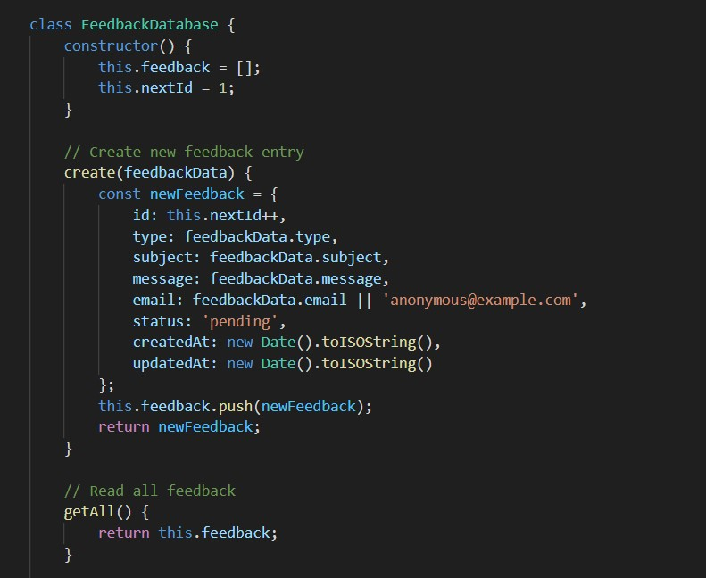

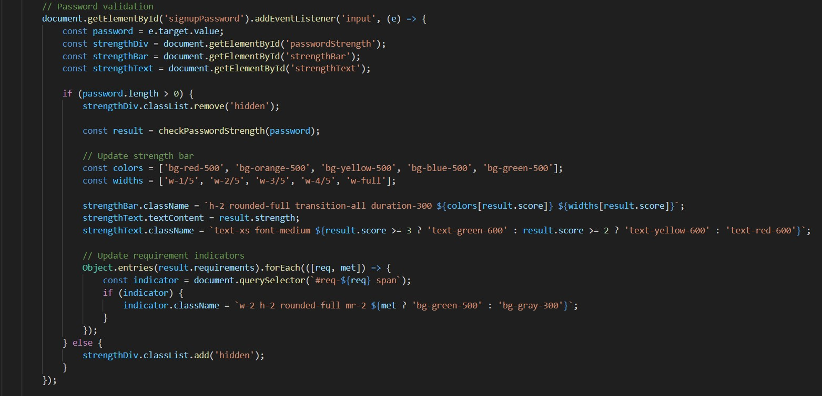

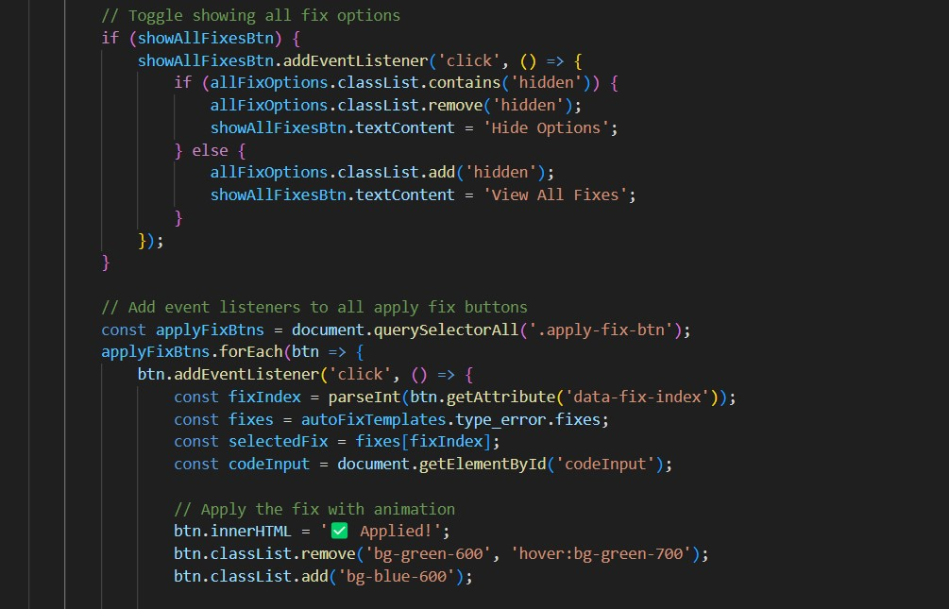

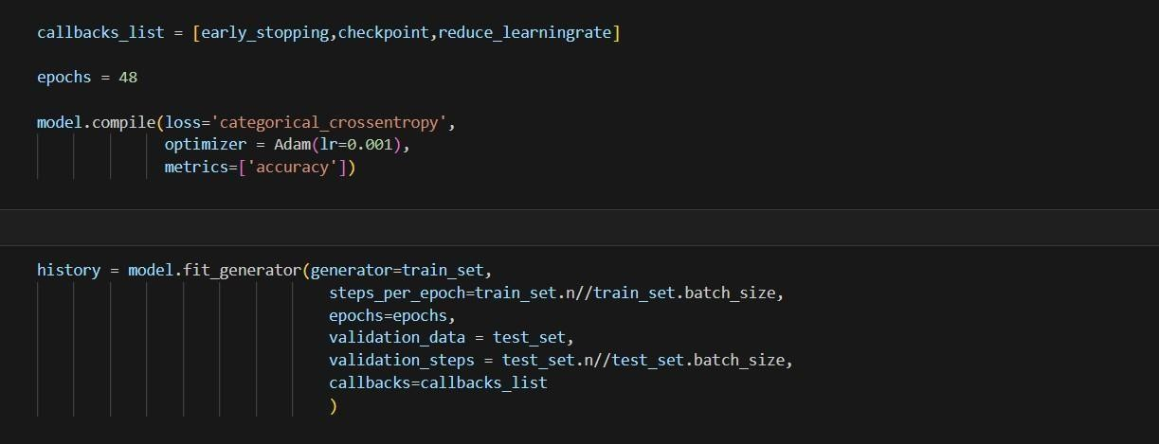

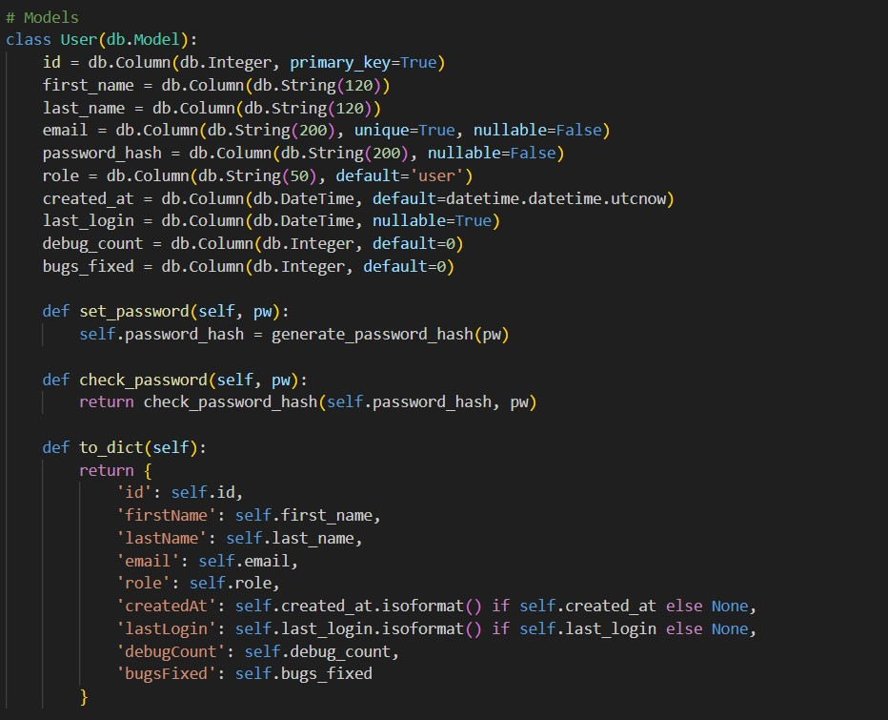

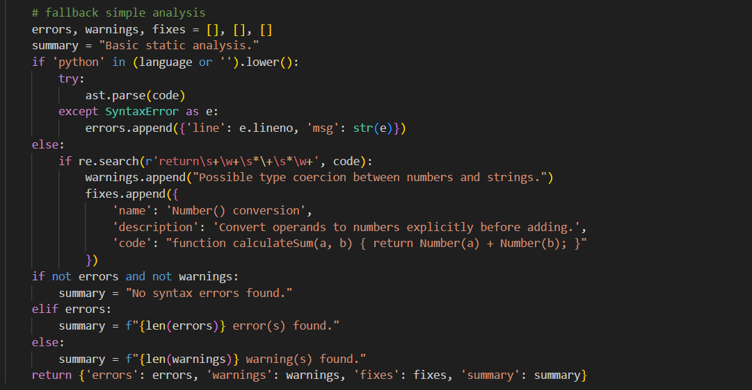

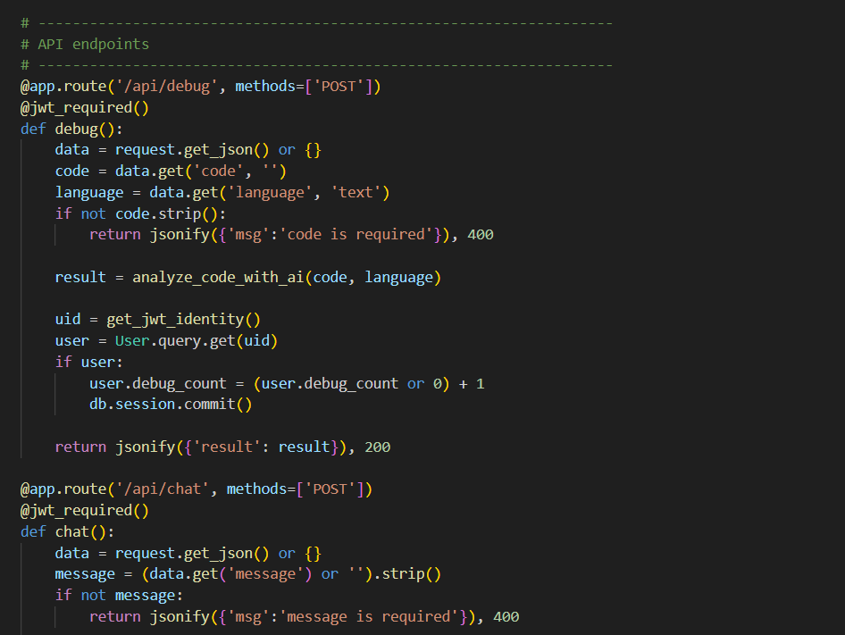

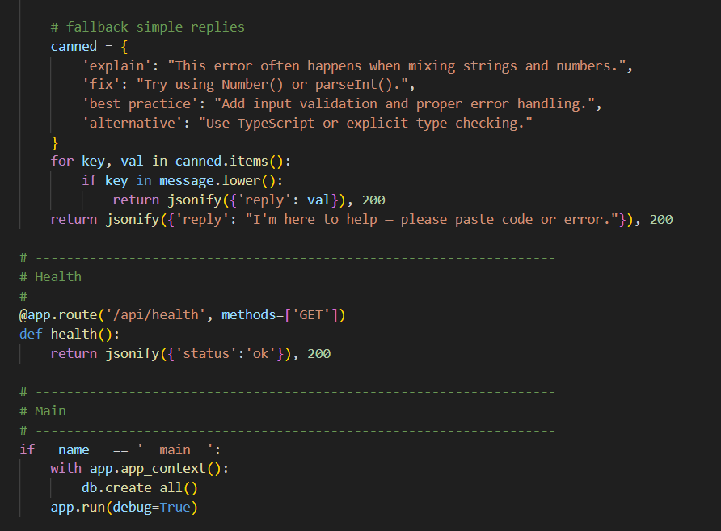

REFERENCES
[1] C. E. Shannon, “A mathematical theory of communication,” Bell System Technical Journal, vol. 27, no. 3–4, pp. 379–423, Jul. 1948.
[2] P. Elias, “Error-free coding,” Transactions of the IRE, vol. 4, no. 4, pp. 29–37, Sep. 1954.
[3] C. Berrou and A. Glavieux, “Near optimum error correcting coding and decoding: turbo-codes,” IEEE Transactions on Communications, vol. 44, no. 10, pp. 1261–1271, Oct. 1996.
[4] R. Gallager, “Low-density parity-check codes,” IRE Transactions on Information Theory, vol. 8, no. 1, pp. 21–28, Jan. 1962.
[5] D. MacKay, “Good error-correcting codes based on very sparse matrices,” IEEE Transactions on Information Theory, vol. 45, no. 2, pp. 399–431, Mar. 1999.
[6] M. Fossorier, “Quasicyclic low-density parity-check codes from circulant permutation matrices,” IEEE Transactions on Information Theory, vol. 50, no. 8, pp. 1788–1793, Aug. 2004.
[7] T. Richardson, M. Shokrollahi, and R. Urbanke, “Design of capacity-approaching irregular low-density parity-check codes,” IEEE Transactions on Information Theory, vol. 47, no. 2, pp. 619–637, Feb. 2001.
[8] S. ten Brink, G. Kramer, and A. Ashikhmin, “Design of low-density parity-check codes for modulation and detection,” IEEE Transactions on Communications, vol. 52, no. 4, pp. 670–678, Apr. 2004.
[9] J. Devlin, M. Chang, K. Lee, and K. Toutanova, “BERT: Pre-training of deep bidirectional transformers for language understanding,” Proceedings of NAACL-HLT, pp. 4171–4186, 2019.
[10] I. Sutskever, O. Vinyals, and Q. V. Le, “Sequence to sequence learning with neural networks,” Advances in Neural Information Processing Systems (NIPS), vol. 27, pp. 3104–3112, 2014.
[11] A. Vaswani et al., “Attention is all you need,” Advances in Neural Information Processing Systems (NIPS), vol. 30, pp. 5998–6008, 2017.
[12] M. Allamanis, M. Brockschmidt, and M. Khademi, “Learning to represent programs with graphs,” International Conference on Learning Representations (ICLR), 2018.
[13] V. Raychev, M. Vechev, and A. Krause, “Predicting program properties from big code,” Proceedings of the 42nd Annual ACM SIGPLAN-SIGACT Symposium on Principles of Programming Languages (POPL), pp. 111–124, 2015.
[14] J. Long, M. White, and M. Tufano, “Automatic programming error repair by learning to generate patches,” Empirical Software Engineering, vol. 27, no. 3, pp. 1–24, 2022.
[15] T. Nguyen, D. Le, and S. Lo, “A neural machine translation approach to automatic program repair,” Proceedings of the IEEE/ACM International Conference on Software Engineering (ICSE), pp. 652–663, 2017.
[16] C. Chen, Q. Zhu, and Z. Xing, “CodeT5: Identifier-aware unified pre-trained encoder-decoder models for code understanding and generation,” Proceedings of the 2021 Conference on Empirical Methods in Natural Language Processing (EMNLP), pp. 8693–8704, 2021.
[17] A. Jain and N. Gupta, “AI-powered automated code review and debugging: A deep learning approach,” International Journal of Advanced Computer Science and Applications (IJACSA), vol. 12, no. 9, pp. 230–239, 2021.
[18] J. Kim and E. Choi, “Automated software debugging using transformer models and reinforcement learning,” IEEE Access, vol. 9, pp. 124563–124574, 2021.
[19] P. Jain, S. Goyal, and M. Kumar, “Integration of Flask and machine learning for AI-driven web applications,” International Journal of Computer Applications, vol. 183, no. 45, pp. 10–15, 2021.
[20] M. D. Sarker and K. S. Rahman, “Self-healing systems in software engineering: A review of AI-driven debugging techniques,” ACM Computing Surveys, vol. 55, no. 6, pp. 1–24, 2023.

