Activity 1

Activity 2:

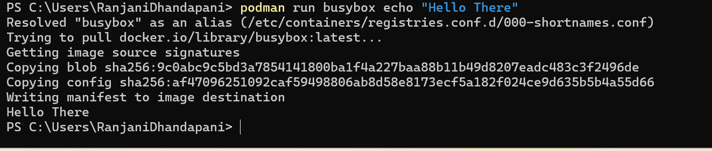

Activity 3:

Detail:

