JOVILRAPIDLEARN
LEARNING MANAGEMENT SYSTEM
PROJECT REPORT

Submitted by: Ranjani
Department: B.Sc Computer Science

1. Introduction
JovilRapidLearn is a web-based Learning Management System (LMS) that allows users to register, enroll in courses, learn through lessons, attempt quizzes, and receive certificates.

1.1 Objectives
• Provide structured learning
• Automate evaluation
• Generate certificates
• Improve user experience

2. System Overview
The system is built using HTML, CSS, JavaScript for frontend and Python Flask for backend with SQLite database.

3. Data Flow Diagrams
DFD Level 0
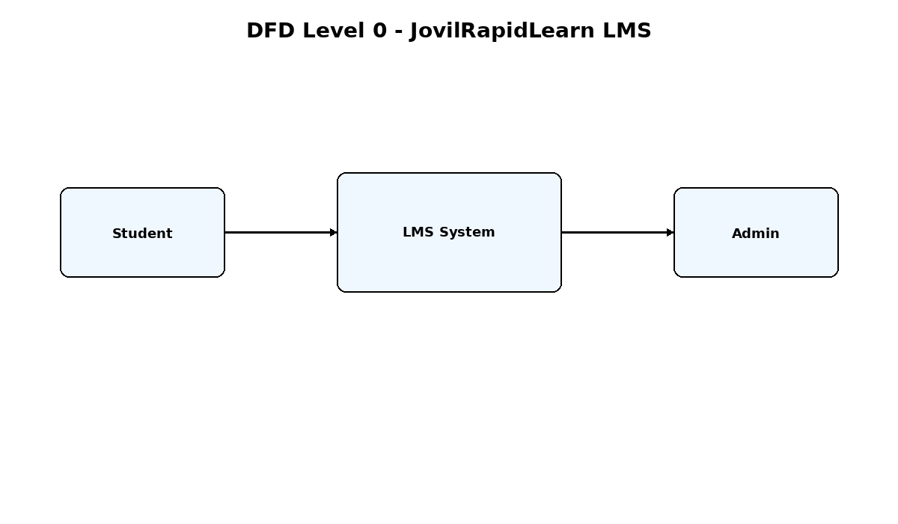
DFD Level 1
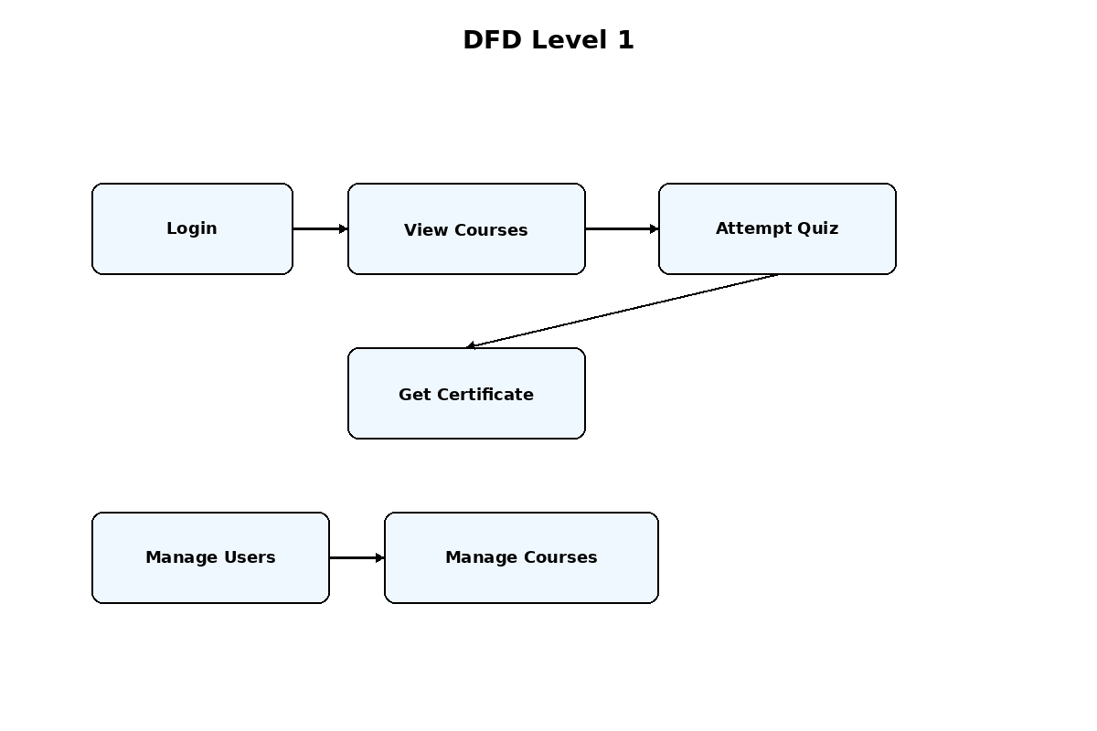

4. ER Diagram
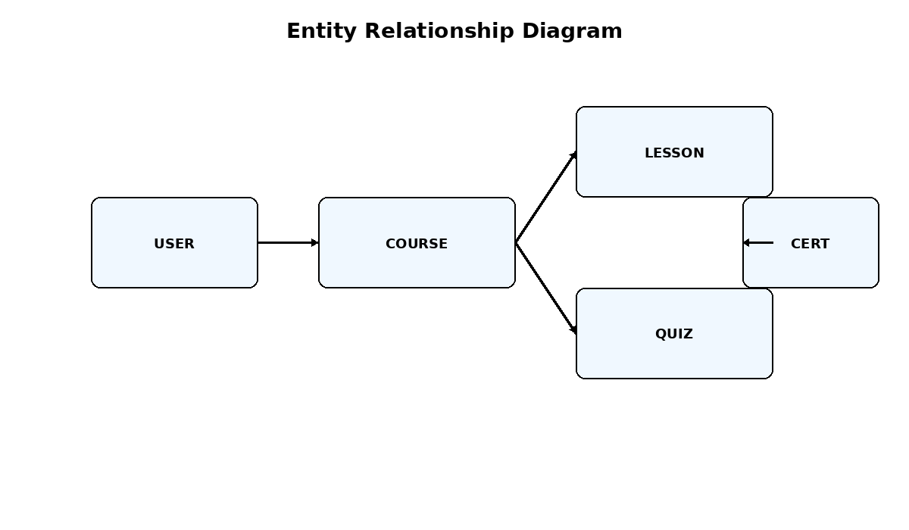

5. Flowchart
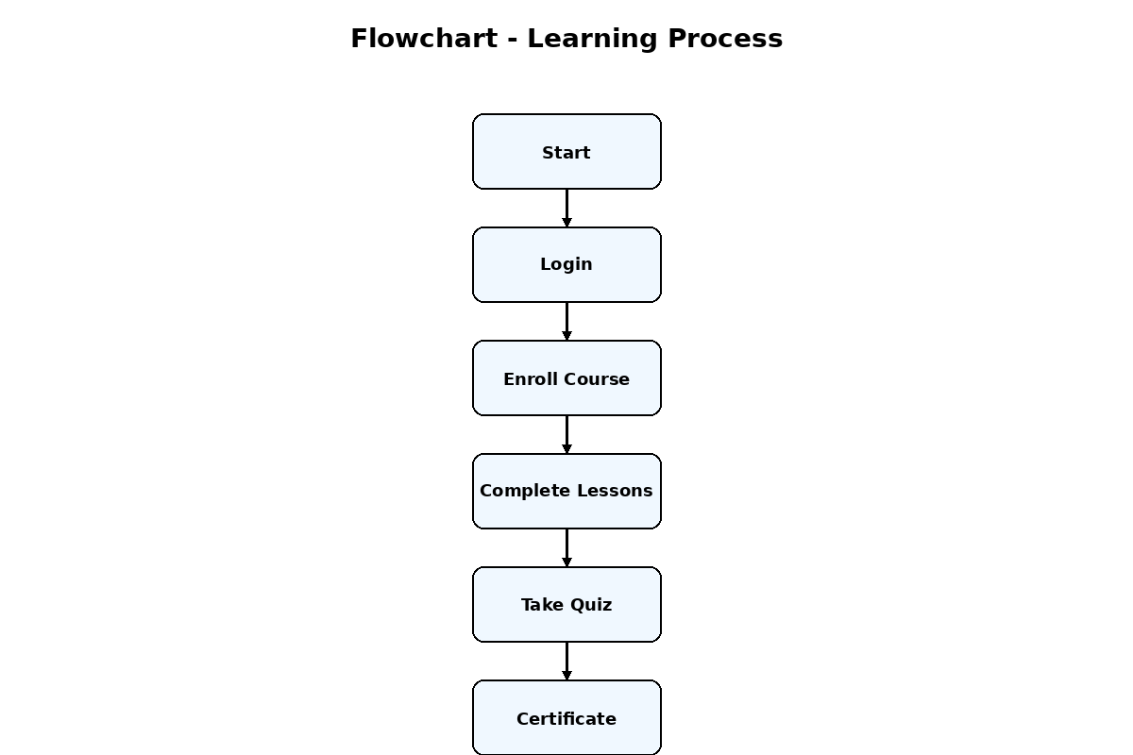

6. Modules
User Module, Course Module, Quiz Module, Certificate Module, Admin Module

7. Conclusion
The LMS provides an efficient and scalable platform for digital learning.

