**TRAFFIC MANAGEMENT DEVELOPMENT**

**Traffic Management:**

Traffic management refers to the practice of controlling and regulating the flow of vehicles and pedestrians on roads and streets to ensure safe and efficient transportation. It encompasses various strategies and techniques to manage traffic, prevent congestion, and enhance overall road safety. Traffic management can be carried out by government authorities, transportation agencies, and local municipalities, and it often involves the following components:

1. **Traffic Signals:** The installation of traffic signals at intersections to control the right of way for vehicles and pedestrians. Traffic signals use red, yellow, and green lights to indicate when each group should move.
2. **Traffic Signs:** The use of signs, such as stop signs, yield signs, speed limit signs, and directional signs, to communicate rules and provide information to drivers and pedestrians.
3. **Road Markings:** The application of road markings like lane lines, crosswalks, and other pavement markings to guide and organize traffic.
4. **Speed Limits:** Setting and enforcing speed limits on different road segments to maintain safety and prevent accidents. Speed limits may vary based on the road type and location.
5. **Traffic Enforcement:** Police officers or automated systems may enforce traffic laws, issuing citations for violations like speeding, running red lights, or illegal parking.
6. **Traffic Calming Measures:** These are strategies employed to reduce vehicle speeds and enhance safety in residential areas and school zones. Examples include speed bumps, chicanes, and narrowed lanes.
7. **Roundabouts:** Installing roundabouts (traffic circles) at intersections to improve traffic flow and reduce the likelihood of high-speed, T-bone accidents.
8. **Intelligent Transportation Systems (ITS):** Using technology to monitor and manage traffic in real-time. ITS can include traffic cameras, electronic message signs, and adaptive traffic signal systems.
9. **Public Transportation:** Promoting the use of public transportation as an alternative to individual vehicle travel, which can help reduce traffic congestion and improve air quality.
10. **Traffic Planning:** Developing long-term strategies for urban planning, including road design and public transportation networks, to accommodate future population growth and reduce congestion.
11. **Parking Management:** Implementing strategies to optimize parking, including time limits, pricing, and designated areas for parking.
12. **Traffic Education and Awareness:** Conducting public education campaigns to raise awareness about traffic rules, safety, and responsible driving.
13. **Pedestrian and Bicycle Infrastructure:** Designing and maintaining infrastructure to support walking and cycling, including crosswalks, sidewalks, bike lanes, and pedestrian signals.
14. **Emergency Response Planning:** Developing strategies for handling traffic during emergencies or major events to ensure the smooth movement of emergency vehicles.

Traffic management aims to strike a balance between the needs of various road users, including motorists, pedestrians, cyclists, and public transportation users. Effective traffic management can reduce congestion, decrease the risk of accidents, and improve the overall quality of life in urban and suburban areas.

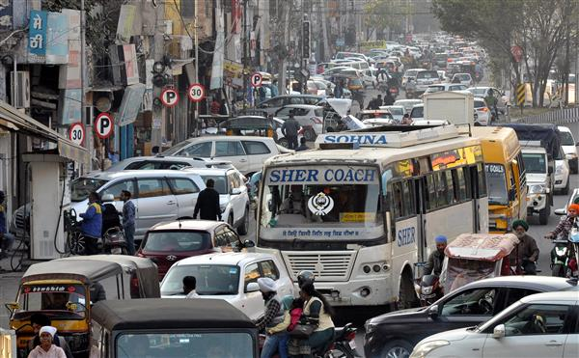

**Traffic Management Development:**

Traffic management development refers to the planning, design, and implementation of systems and strategies aimed at efficiently and safely controlling the flow of traffic on roads, highways, and urban areas. Effective traffic management is crucial for reducing congestion, enhancing road safety, and improving overall transportation efficiency. Here are some key aspects and strategies related to traffic management development:

1. Traffic Signals and Signs: The installation and maintenance of traffic signals, signs, and road markings play a fundamental role in directing and regulating traffic. This includes stop signs, yield signs, speed limit signs, and pedestrian crosswalks.
2. Traffic Signal Timing: Proper synchronization and timing of traffic signals can help reduce congestion and improve traffic flow. This often involves the use of technology to adjust signal timing based on real-time traffic conditions.
3. Traffic Management Software: Traffic management software and systems can provide real-time data on traffic conditions, enabling authorities to monitor and respond to congestion and incidents more effectively. These systems may use sensors, cameras, and other technology to gather data.
4. Public Transportation: Developing and promoting public transportation systems, such as buses and trains, can help reduce the number of private vehicles on the road, thereby reducing congestion and emissions.
5. Road Infrastructure: Improving and expanding road infrastructure, including the construction of new roads, bridges, and tunnels, can help alleviate traffic congestion in growing urban areas.
6. Traffic Calming Measures: In residential and urban areas, traffic calming measures like speed bumps, roundabouts, and narrower roads are often implemented to reduce vehicle speeds and enhance safety.
7. Intelligent Transportation Systems (ITS): ITS involves the integration of advanced technology to manage and optimize traffic. This can include real-time traffic monitoring, dynamic lane control, and electronic toll collection.
8. Parking Management: Managing parking facilities and pricing can influence traffic patterns by encouraging or discouraging the use of private vehicles in congested areas.
9. Carpooling and Ride-Sharing: Encouraging carpooling and promoting ride-sharing services can help reduce the number of vehicles on the road and lower congestion.
10. Urban Planning: Urban planning that promotes mixed land use, reduces urban sprawl, and encourages walkability and cycling can help reduce the need for extensive car travel.
11. Public Education and Awareness: Public education campaigns can inform drivers about traffic rules and the importance of responsible driving, safety, and reducing congestion.
12. Emergency Response: Efficient traffic management is crucial during emergencies. Authorities need to have strategies in place for rerouting traffic during accidents, natural disasters, or other incidents that disrupt normal traffic flow.
13. Environmental Considerations: Traffic management development should also consider environmental impacts, such as reducing emissions through the promotion of electric vehicles and sustainable transportation options.

Traffic management development is an ongoing process that involves collaboration between transportation authorities, urban planners, engineers, and technology specialists. The goal is to create safer, more efficient, and sustainable transportation systems that serve the needs of a growing and dynamic population.

