**Report of Submission**

I have developed my first application in Android Studio 2.2 and have named the application **Ranjan Jayapal’s First App**.

It contains the following:

* Main Activity
  + An EditText for user’s input
  + A Button to call the Second Activity
* DisplayMessageActivity
  + A TextBox for echoing the message

The title of the App says **Ranjan Jayapal’s First App**

I have run the application in an emulator and taken a video as well.

The emulator is a Nexus 5 AVD.

I have zipped the following files for submission:

* Android Studio Project inside a directory named **Ranjan Jayapal**
* Report of Submission named README.pdf
* Video containing the working of the application.

Below are the screenshots of the working application:

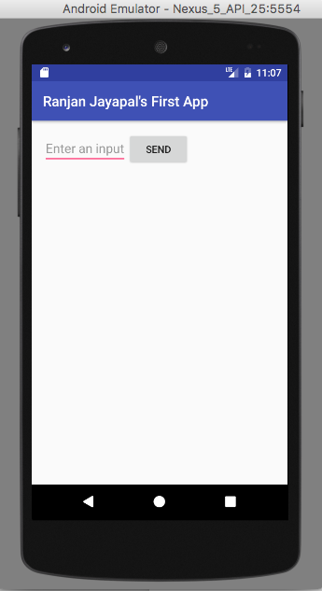

**Figure 1**

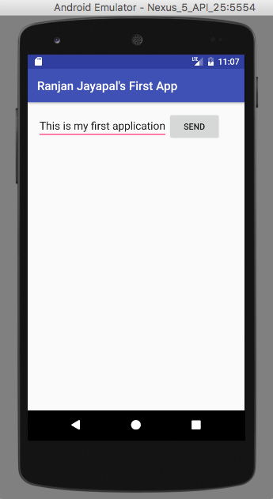

**Figure 2**

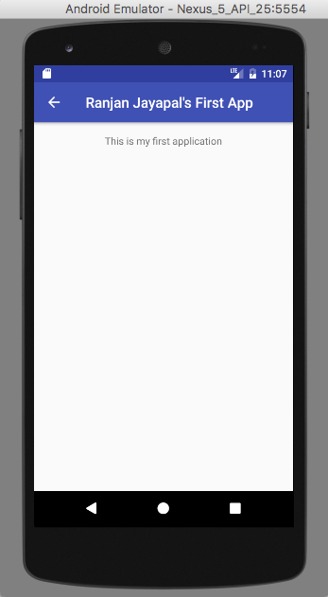

**Figure 3**

**\*\*This is the end of the report**