**1. In the below elements which of them are values or an expression? eg:- values can be integer or string and expressions will be mathematical operators.**

**Answer:**

**Operators: +, -, *, /**

**Values:** 'hello', -87.8, 6

**2. What is the difference between string and variable?**

**Answer:** A Variable is a store of information, and a String is a type of information you would store in a Variable. A String is usually words, enclosed with **""(quotes).**

Eg.: String x ="Welcome to iNeuron"

X is the Variable, and we declared it as a String, use the single = to assign the text to it.

**3. Describe three different data types.**

**Answer:**

|  |  |  |  |  |
| --- | --- | --- | --- | --- |
| **S.No.** | **Data Types** | **Examples** | **Explanation** | **Mutable/Immutable?** |
| 1 | **Strings** | "Hello!", "23.34" | Text - anything between  " "  becomes string | Immutable |
| 2 | **Integers** | 5364 | Whole numbers | Immutable |
| 3 | **Floats** | 3.1415 | Decimal Numbers | Immutable |

**4. What is an expression made up of? What do all expressions do?**

**Answer:** An expression is a combination of operators and operands that is interpreted to produce some other value. In any programming language, an expression is evaluated as per the precedence of its operators.

Note: An expression is a combination of values and operators. All expressions evaluate (that is, reduce) to a single value.

**i.) Constant Expressions:** These are the expressions that have constant values only. Eg.: x = 15 + 1.3 .

**ii.) Arithmetic Expressions:** An arithmetic expression is a combination of numeric values, operators, and sometimes parenthesis. The operators used in these expressions are arithmetic operators in Python: Addition (+), Subtraction (-), Multiplication (*), Division (/), Quotient (//), Remainder (%), Exponentiation (**).

**iii.) Integral Expressions:** These are the kind of expressions that produce only integer results after all computations and type conversions.

**iv.)** **Floating Expressions:** These are the kind of expressions which produce floating point numbers as result after all computations and type conversions.

**v.) Relational Expressions:** In these types of expressions, arithmetic expressions are written on both sides of relational operator (> , < , >= , <=). Those arithmetic expressions are evaluated first, and then compared as per relational operator and produce a Boolean output in the end. These expressions are also called Boolean expressions.

**vi.) Logical Expressions:** These are kinds of expressions that result in either True or False. It basically specifies one or more conditions. For example, (10 == 9) is a condition if 10 is equal to 9. As we know it is not correct, so it will return False.

**vii.) Bitwise Expressions:** These are the kind of expressions in which computations are performed at bit level.

**viii.) Combinational Expressions:** We can also use different types of expressions in a single expression, and that will be termed as combinational expressions.

**5. This assignment statements, like spam = 10. What is the difference between an expression and a statement?**

**Answer:** An expression evaluates to a single value. A statement does not.

Expression is made up of values, containers, and mathematical operators (operands) and the statement is just like a command that a python interpreter executes like print.

**6. After running the following code, what does the variable bacon contain? bacon = 22**

**bacon + 1**

**Answer:** Output : 23

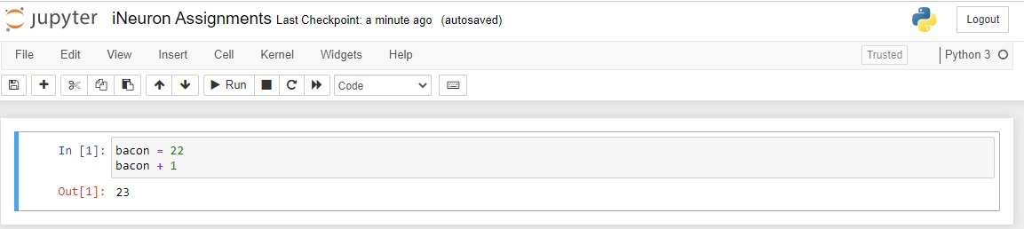

**7. What should the values of the following two terms be?**

**'spam' + 'spamspam'**

**'spam' * 3**

**Answer:** 'spamspamspam'

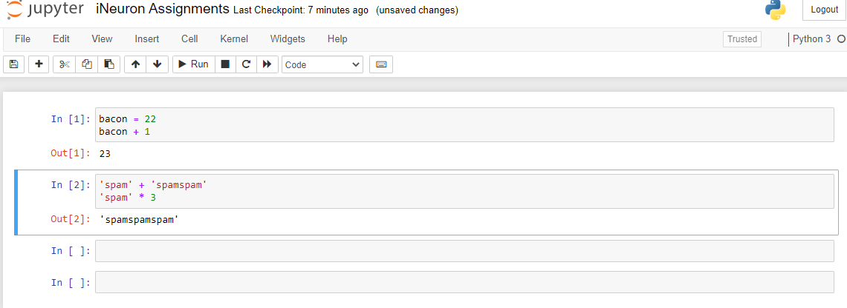

**8. Why is eggs a valid variable name while 100 is invalid?**

**Answer:** Variable names cannot begin with a number.

**9. What three functions can be used to get the integer, floating-point number, or string version of a value?**

**Answer:**  The int(), float(), and str() functions will evaluate to the integer, floating-point number, and string versions of the value passed to them.

**10. Why does this expression cause an error? How can you fix it?**

**'I have eaten ' + 99 + ' burritos.'**

**Answer:** The expression causes an error because 99 is an integer, and only strings can be concatenated to other strings with the + operator. The correct way is I have eaten ' + str(99) + ' burritos.'.