WEB322 Assignment 5

Assessment Weight:
9% of your final course Grade

Objective:
Build upon the code created in Assignment 4 by incorporating the Handlebars view engine to render our JSON data visually in the browser using .hbs views and layouts. Additionally, update our store-service module to support additional functionality.

Part 1: Getting Express Handlebars & Updating your views

Step 1: Install & configure Handlebars
- Use npm to install the "hbs" module (handlebars)
- Wire up your server.js file to use the new "express-handlebars" module, i.e.
  - "require" it as exphbs
  - add the app.engine() code using exphbs.engine({ … }) and the "extname" property as ".hbs"
  - call app.set() to specify the 'view engine'
- Inside the "views" folder, create a "layouts" folder
Example of the basic setup can be found here:
https://youtu.be/oKK4gehBJno
Example Code:
https://github.com/hscanlansen/Web322_Assignment_Files/tree/main/S24/express_handlebars_example

Step 2: Create the "default layout" & refactor about.html to use .hbs

- In the "layouts" directory, create a "main.hbs" file (this is our "default layout")
- Copy all the content of the "about.html" file and paste it into "main.hbs"
  - Quick Note: if your main.css link looks like this href="css/main.css", it must be modified to use a leading "/", ie href="/css/ main.css". This is due to the templates engine.
- Next, in your main.hbs file, remove all content INSIDE (not including) the single <div class="container">…</div> element and replace it with {{{body}}}
- Change the <title></title> attribute to remove "About" and change it to include your student name, ie "Homer Simpson's Store"
- Once this is done, rename about.html to about.hbs
- Inside about.hbs, remove all content EXCEPT what is INSIDE the single <div class="container">…</div> element (this should leave a single <div class="row">…</div> element containing two "columns", ie elements with class "col-md- …" and their contents)
- In your server.js file, change the GET route for "/about" to "render" the "about" view, instead of sending about.html
- Test your server - you shouldn't see any changes. This means that your default layout ("main.hbs"), "about.hbs" and server.js files are working correctly with the express-handlebars module.

Step 3: Update the remaining "addItem file to use .hbs

- Follow the same procedure that was used for "about.html", for the "addItem.html" file, i.e.
  - Rename the .html file to .hbs
  - Delete all content EXCEPT what is INSIDE the single <div class="container">…</div> element
  - Modify the corresponding GET route (i.e. "/items/add") to "res.render" the appropriate .hbs file, instead of using res.sendFile
- Test your server - you shouldn't see any changes, except for the fact that the "Add Item" menu item is no longer highlighted when we change routes (only "About" remains highlighted, since it is the only menu item within our main.hbs "default layout" with the class "active"

Step 4: Fixing the Navigation Bar to Show the correct "active" item

This step is not difficult, but can be trick to debug. First understand what our goal is. We would like to show a “bold” text on the nav-bar item that the user is currently on. We need to know which page the user is on, so that we can modify our HTML dynamically to include the “active” class in our Navbar list.

- To fix the issue we created by placing our navigation bar in our "default" layout, we need to make some small updates, including adding the following middleware function above your routes in server.js:
app.use(function(req,res,next){
let route = req.path.substring(1);
app.locals.activeRoute = "/" + (isNaN(route.split('/')[1]) ? route.replace(/\/(?!.*)/, "") : route.replace(/\/(.*)/, ""));
app.locals.viewingCategory = req.query.category;
next();
});

This will add the property "activeRoute" to "app.locals" whenever the route changes, i.e. if our route is "/store/5", the app.locals.activeRoute value will be "/store". Also, if the shop is currently viewing a category, that category will be set in "app.locals".
- Next, we must use the following handlebars custom "helper" (See the Week 6 notes for adding custom "helpers")"
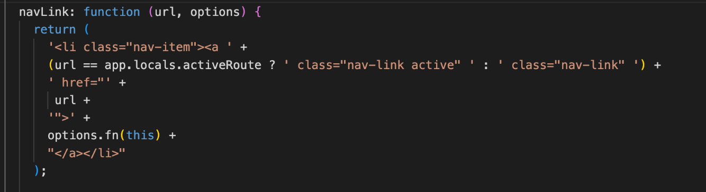
- Try to understand what is happening here. This basically allows us to replace all of our existing navbar links, i.e. <li><a href="/about">About</a></li> with code that looks like this {{#navLink "/about"}}About{{/navLink}}. T
The benefit here is that the helper will automatically render the correct <li> element add the class "active" if app.locals.activeRoute matches the provided url, ie "/about". So we are dynamically updating the navbar to include an “active” tag so the user can tell which tab they are on.
- Next, while we're adding custom "helpers" let's add one more that we will need later:
equal: function (lvalue, rvalue, options) {
if (arguments.length < 3)
throw new Error("Handlebars Helper equal needs 2 parameters");
if (lvalue != rvalue) {
return options.inverse(this);
} else {
return options.fn(this);
}
}

This helper will give us the ability to evaluate conditions for equality, ie {{#equals "a" "a"}} … {{/equals}} will render the contents, since "a" equals "a". It's exactly like the "if" helper, but with the added benefit of evaluating a simple expression for equality.
- Now that our helpers are in place, update all the navbar links in main.hbs to use the new helper, for example:
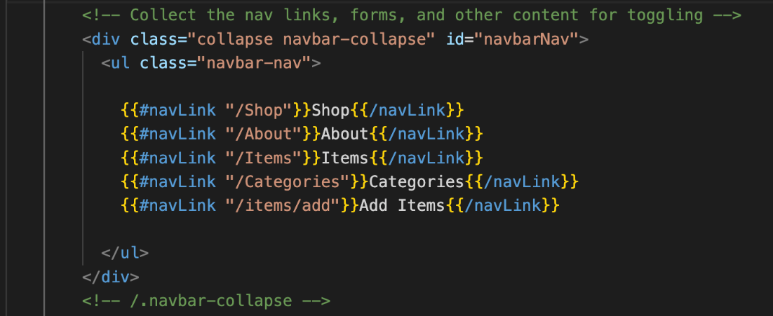
- Test the server again - you should see that the correct menu items are highlighted as you navigate between views.

Part 2: Updating the ItemsRoute & Adding a View

Rather than simply outputting a list of items using res.json, it would be much better to render the data in a table that allows us to filter the list using our existing req.params code.

Step 1: Creating a simple "Items list & updating server.js

- First, add a file "items.hbs" in the "views" directory
- Inside the newly created "items.hbs" view, add the html:
<div class="row">
<div class="col-md-12">
<h2>ItemsO/h2>
<hr />
<p>TODO: render a list of all item title values here</p>
</div>
</div>
- Replace the <p> element (containing the TODO message) with code to iterate over each item and simply render their title properties (you may assume that there will be a "items" array (see below).
- Once this is done, update your GET "/items" route according to the following specification
  - Every time you would have used res.json(data), modify it to instead use res.render("items", {items: data})
  - Every time you would have used res.json({message: "no results"}) - i.e. when the promise has an error (ie in .catch()), modify your code to use res.render("items", {message: "no results"});
- Test the Server - you should see the following page for the "/items" route:
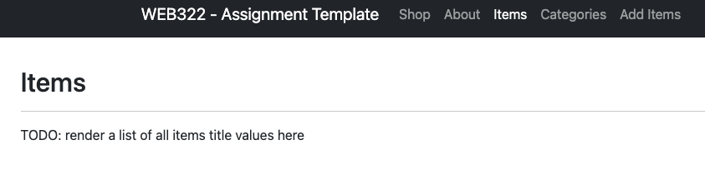

Step 2: Building the Table & Displaying the error "message"
- Update the items.hbs file to render all of the data in a table instead of a list, using the bootstrap classes: "table-responsive" (for the <div> containing the table) and "table" (for the table itself)
  - The table must consist of 5 columns with the headings: Item ID, Title, ItemDate, Price, Category and Published
  - Additionally, the Category values in the Category column must link to /items?category=category where category is the category id for the item for that row
- Beneath <div class="col-md-12">…</div> element, add the following code that will conditionally display the "message" only if there are no items (HINT: #unless items)
<div class="col-md-12 text-center">
<strong>{{message}}</strong>
</div>
- This will allow us to correctly show the error message from the .catch() in our route
- Test your server. How awesome is this?? Click on the CATEGORY LINK!! Because you made your filters in your ”controller”, you have now also completed a filter by category!

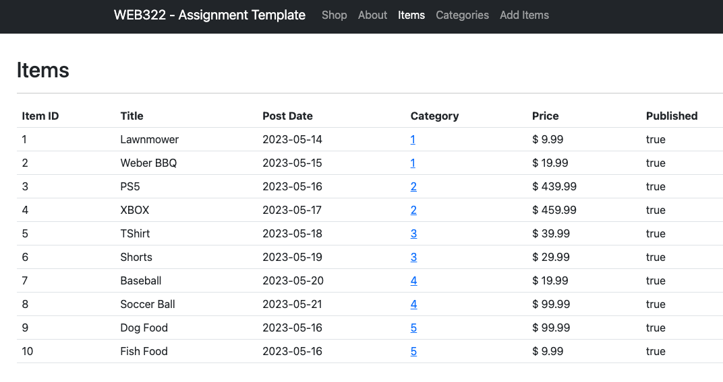

Part 3: Updating the Categories Route & Adding a View
Now that we have the "Item" data rendering correctly in the browser, we can use the same pattern to render the "Categories" data in a table:

Step 1: Creating a simple "Categories" list & updating server.js

- First, add a file "categories.hbs" in the "views" directory
- Inside the newly created "categories.hbs" view, add the html:
<div class="row">
<div class="col-md-12">
<h2>Categories</h2>
<hr />
<p>TODO: render a list of all category id's and categories here</p>
</div>
</div>
- Replace the <p> element (containing the TODO message) with code to iterate over each category and simply render their id and category values (you may assume that there will be a "categories" array (see below).
- Once this is done, update your GET "/categories" route according to the following specification
  - Instead of using res.json(data), modify it to instead use res.render("categories", {categories: data});
  - When the promise has an error (ie in .catch()), modify your code to use res.render("categories", {message: "no results"});
  - Test the Server - you should see the following page for the "/categories" route:
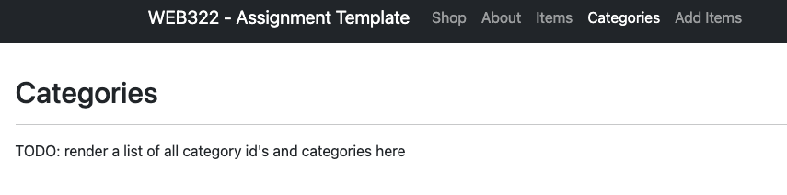

Step 2: Building the Table & Displaying the error "message"
  - Update the categories.hbs file to render all of the data in a table, using the bootstrap classes: "table-responsive" (for the <div> containing the table) and "table" (for the table itself)
  - The table must consist of 2 columns with the headings: Category ID and Category Name
- Additionally, if you click on either the cateogry id, or the category name, you'll be redirected to /items?category=X, where X is the category id for the category that was clicked
- Beneath <div class="col-md-12">…</div> element, add the following code that will conditionally display the "message" only if there are no categories (HINT: #unless categories)
<div class="col-md-12 text-center">
<strong>{{message}}</strong>
</div>
This will allow us to correctly show the error message from the .catch() in our route
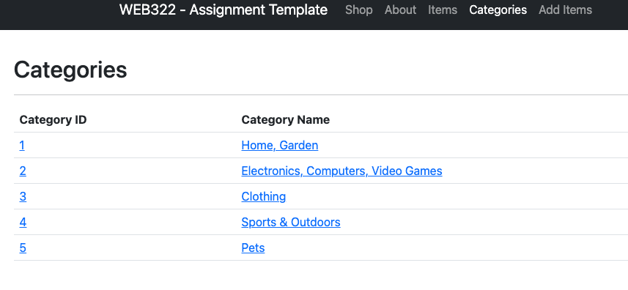

Part 4: Updating the Store Route & Adding a View
Step 1: Adding a new "Helper" to handle unsafe HTML in posts

- Before we start creating our new view, it is important to consider the possibility of unsafe <script></script> tags or other JavaScript code in the html for the blog post. If we want to be able to render html within the blog post, we must handle this situation. For this assignment, we will use a custom helper called safeHTML that removes unwanted JavaScript code from our post body string by using a custom package: strip-js (https://www.npmjs.com/package/strip-js)
  - First, run the command npm i strip-js
  - "require" it using the line: const stripJs = require('strip-js');
  - Add the custom helper:
safeHTML: function(context){
return stripJs(context);
}
  - You can now use this helper with the syntax:
{{#safeHTML someString}}{{/safeHTML}}
where someString may be your post body, for example

Our next JSON-to-Handlebars conversion task is related to showing the actual Store route. This one is slightly more complicated, as it will involve determining which is the "latest" items and displaying that, while also displaying links to the other items and categories in a sidebar.

Step 2: Updating the store-service.js module

- This view will be capable of filtering items by Category. However, we currently do not have a function that produces items that are both published and filtered by Category. As a result, we must add a new store-service function called getPublishedItemsByCategory(category)
  - This function works exactly as getPublishedItems() except that in addition to filtering by "item.published == true", you must also include category in the filter, i.e. "item.published == true && item.category == category"

Step 3: Creating the "Shop view & updating server.js

- First, add a file "shop.hbs" in the "views" directory
- Inside the newly created " shop.hbs" view, add the html from here (as a starting point):
https://github.com/hscanlansen/Web322_Assignment_Files/tree/main/S24/AS4/shop.hbs
- Before we start editing our new template, let's first get the data in place so that you can test it as you go:
  - Open server.js and replace your current app.get("/Shop") route with the code available here:
https://github.com/hscanlansen/Web322_Assignment_Files/tree/main/S24/AS4/shop-route.txt
NOTE: this code assumes that you reference your store-service.js using the variable itemData, i.e.
const itemData = require("./store-service");

- You should now be able to access information for:
  - The current item object using data.item
  - The current array of items using data.items
  - The current array of categories using data.categories
  - Potential error obtaining item using data.message
  - Potential error obtaining categories using data.categoriesMessage
- With this information, update your newly created shop.hbs according to the following specification:
  - Update the <h2> element at the start of the <article> to show the current itemtitle
  - Update the src attribute for "feature image" to show the current item featureImage
  - Replace the existing long "Lorem Ipsum" string (between the <br /><br /> … <br /><br /> elements) with the actual body of the current item using our new #safeHTML helper (see above)
  - Update the "Category:" value to show the current item category
  - Update the "Price:" value to show the current item price
  - Update the "Last Updated:" value to show the current item itemate
  - Update the Items list to show real items using data.items. Additionally:
    - Each "href" value must link to "/shop/id?category={{../viewingCategory}}" where id is the id value for the itemshown in the list. NOTE: ../viewingCategory will allow us to access the global "viewingCategory" value (set in our middleware function at the start of this assignment) and the "/shop" route will be created below.
    - The Items list (including the <h4>Items</h4> element) must not be visible if data.items is undefined or empty (HINT: #if data.items)
  - Update the Categories list to show real categories using data.categories. Additionally:
    - NOTE: Each "href" value must link to "/shop?category=id" where id is the id value for the category shown in the list
    - The Categories list (including the <h4>Categories</h4> element) must not be visible if data.categories undefined or empty (HINT: #if data.categories)
  - Finally, make sure that the entire <item>…</item> element is only visible if there is a item to show (HINT: #if data.item).
    - If there isn't a item to show, show data.message using either the following HTML:
<div class="col-md-12 text-center">
<h2>{{data.message}}</h2>
<p>Please try another Item / Category</p>
</div>
or something similar, if you prefer a different style or accompanying text

Part 5: Adding the Shop/:id Route
The last major piece of this assignment is to ensure that individual items can be rendered using the same layout as the main shop page. However, instead of displaying the latest item available / per category, we must instead show a specific item (by id).
This can be accomplished by adding a new route with the code available here:
https://github.com/hscanlansen/Web322_Assignment_Files/tree/main/S24/AS4
You will notice that its nearly identical to the app.get('/shop)… route, except instead of using the most recent items, we will instead use the item with the id obtained from the route parameter, id.

Part 6: Final Updates (setting ItemDate, redirecting to /shop & 404.hbs)
To ensure that any new items created will show up at the top of the shop, you must update the "addItem” method of your store-service module to ensure that the "itemate" field is correctly set when a new item is created. This can be accomplished by:
- Adding the property "itemDte" to your itemData object before you push it to the "items" array.
  - The value will be the current date formatted using the pattern YYYY-MM-DD (to match the existing format – NOTE: YYYY-M-D is fine as well, i.e. you don't need to worry about leading 0's)
Before we finish our assignment (if you haven't created a custom 404 page / converted it to handlebars yet), consider adding a "404.hbs" file that is rendered instead of a plain message. This will have the benefit of keeping the menu bar intact so that users can quickly get back to the content in the event of a 404 error.
Finally, as the last step before completing the assignment, update your default "/" route to redirect to "/shop" instead of "/about"

Part 7: Pushing to GitHub and Vercel
Once you are satisfied with your application, push to GitHub and deploy it to Vercel:
- Ensure that you have checked in your latest code using git (from within Visual Studio Code)
- Push commits to the same private web322-app GitHub repository either through the integrated terminal (git push) or through the button interface on Visual Studio Code (publish, sync, etc.)
- If set up correctly from Assignment 2, it will automatically be deployed to Vercel but if there are any problems, follow the Vercel guide for more details on pushing to GitHub and linking your app to Vercel for deployment
- IMPORTANT NOTE: Since we are using a free account on Vercel, we are limited to only 1 app.,

Assignment Submission:
- Add the following declaration at the top of your server.js file. It must match this exactly, so you must type it:
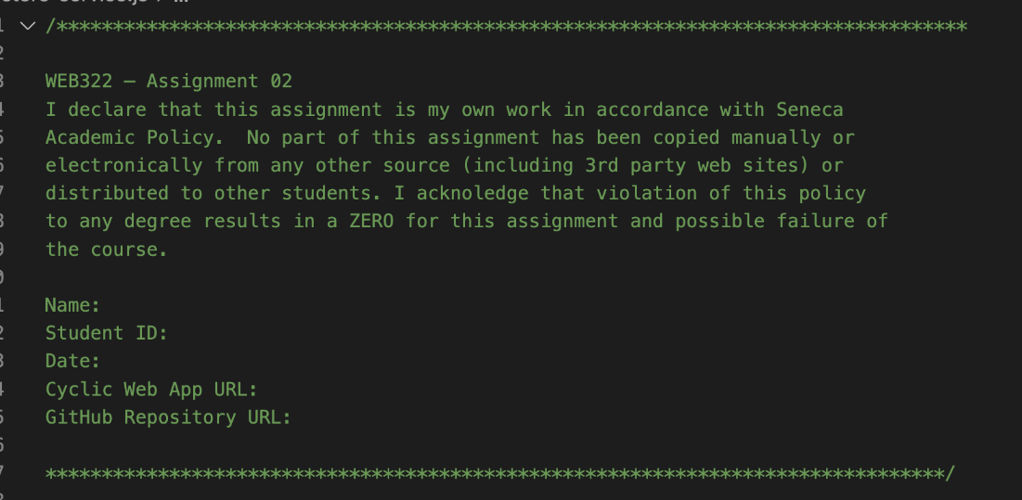

- Compress (.zip) your web322-app folder and submit the .zip file to My.Seneca under
Assignments -> Assignment 5

Important Note:
- Submitted assignments must run locally, i.e. start up errors causing the assignment/app to fail on startup will result in a grade of zero (0) for the assignment.

