**Exhaustive AI-Powered Explainability in Credit Score Modelling**

A detailed study leveraging AI-Driven Explainability to enhance transparency, fairness, and trust in Credit score modelling for informed decision-making

UP2301022

University of Portsmouth

Portsmouth, United Kingdom

[up2301022@myport.ac.uk](mailto:up2301022@myport.ac.uk)

*(paper was being completed being based in Singapore)*

**I. ABSTRACT**

This paper explores the integration of AI-powered Explainability techniques and thereby assists to do the exhaustive *Explainability* to enhance the interpretability of credit scoring models, ensuring more transparent, fair and trustworthy financial assessments. We investigate advanced AI-driven methods using modern techniques like SHAP, LIME, PDP and using plots like Weight Plot, Effect Plot, Mean Effect Plot, Effect Trend Plot, to provide a granular understanding of how credit scores are determined. Additionally, this paper also leverages *statsmodels* api to summaries of linear regression models, enabling direct interpretation of each feature's coefficients as their influence on the predicted outcome. This research exhaustive XAI study can demonstrate how AI-driven interpretability can mitigate bias, improve model reliability, that is crucial for building trust, especially in financial models where AI is used to support critical decision-making. By adopting exhaustive Explainability frameworks, financial institutions can foster greater accountability and empower borrowers with clearer insights into their credit evaluations.

**Novelty of This Research*:*** *This research is novel in its approach to exhaustive AI-powered Explainability in credit score modelling. Unlike previous studies that primarily focused on a limited set of Explainability techniques, this work integrates a comprehensive range of modern XAI methods, including SHAP, LIME, Partial Dependence Plots (PDP), and multiple visualization tools such as Weight Plot, Effect Plot, Mean Effect Plot, and Effect Trend Plot. Additionally, it leverages statsmodels to provide detailed statistical summaries, offering deeper insights into feature importance and their impact on model predictions. This extensive exhaustive and multi-faceted approach to Explainability has not been explored in past research, making this study a significant advancement in AI-driven credit scoring transparency.*

**II. KEYWORDS**

AI Explainability (XAI), matplotlib, boxplot, correlation, statsmodels, Durbin-Watson, Jarque-Bera, Ordinary Least Squares (OLS), t-statistic, weight plot, effect plot, Partial Dependence Plot, Local Interpretable Model-Agnostic Explanations (LIME), SHapley Additive exPlanations(SHAP)

# III. INTRODUCTION

*Net Credit Scoring ML models* are essential tools in the financial industry, influencing loan approvals, interest rates, and risk assessments. However, traditional credit scoring methods often function as black-box models, making it difficult for financial institutions, regulators, and consumers to fully understand the factors driving credit decisions. This lack of transparency raises concerns about fairness, potential biases, and accountability, especially when AI-driven models are used to automate critical financial decisions. As AI continues to play a growing role in credit assessments, the need for Explainability has become paramount to ensure trust and compliance in financial systems.

This research explores AI-powered Explainability (XAI) techniques to enhance transparency in credit score modelling. By integrating advanced methodologies such as SHAP, LIME and Partial Dependence Plots (PDP), along with visualization tools like Weight Plot, Effect Plot, Mean Effect Plot, and Effect Trend Plot, we aim to provide an exhaustive Explainability framework. These techniques help in breaking down complex credit scoring models, offering a granular understanding of how individual features influence credit scores.

Furthermore, this study leverages statsmodels to generate detailed statistical summaries of linear regression models, allowing direct interpretation of each feature’s coefficient and its impact on the predicted outcome. By employing an exhaustive XAI approach, this research highlights how AI-driven interpretability can mitigate bias, improve model reliability, and build trust in financial decision-making.

The findings of this study emphasize the importance of Explainability in AI-driven credit scoring models. By implementing robust interpretability frameworks, financial institutions can not only comply with regulatory requirements but also empower borrowers with clearer insights into their credit evaluations. This paper aims to bridge the gap between AI advancements and financial transparency, paving the way for more accountable and equitable lending practices.

# IV. LITERATURE REVIEW

# Credit scoring models significantly impact financial decisions, yet traditional methods lack transparency. Explainable AI (XAI) techniques, such as SHAP (Lundberg & Lee, 2017) and LIME (Ribeiro et al., 2016), enhance interpretability by attributing feature importance and approximating local model behavior. Partial Dependence Plots (PDP) (Friedman, 2001) and visualization tools like Weight Plot and Effect Trend Plot further aid in understanding model influence.

# Statistical approaches, including statsmodels (Seabold & Perktold, 2010), provide direct interpretation through regression analysis, reinforcing AI-driven insights. While past research has explored isolated Explainability techniques, few integrate comprehensive XAI frameworks. This study bridges the gap by combining multiple XAI methods with statistical summaries, ensuring a holistic approach to transparent credit scoring.

Regulatory frameworks such as GDPR and ECOA mandate transparency in credit assessments (European Commission, 2018; U.S. Government, 2021). By employing exhaustive XAI methodologies, financial institutions can enhance compliance, fairness, and consumer trust. This research advances AI-driven credit scoring by integrating modern interpretability tools, fostering more accountable and equitable financial decision-making.

# V. METHODOLOGY

This research adopts a multi-faceted AI-powered Explainability framework to enhance the transparency of credit score modelling. Unlike conventional studies that rely on a limited set of interpretability techniques, we employ a comprehensive and exhaustive approach by integrating multiple modern Explainable AI (XAI) methods. The methodology consists of the key components: Data Collection, ML Model Development, Statistical Model Summarization for chosen ML Model Explainability. Then other Explainability Techniques using SHAP, LIME, PDP and also Visualization-Based Interpretability are being applied, statsmodels have been leveraged to generate detailed statistical summaries of linear regression models, allowing direct interpretation of coefficients and their impact on the predicted outcome. This provides an additional layer of Explainability by offering traditional statistical insights alongside AI-based methods.

# VI. DATA LOADING AND REVIEW

All required libraries have been imported and the data is loaded into Dataframe object using Panda’s library.

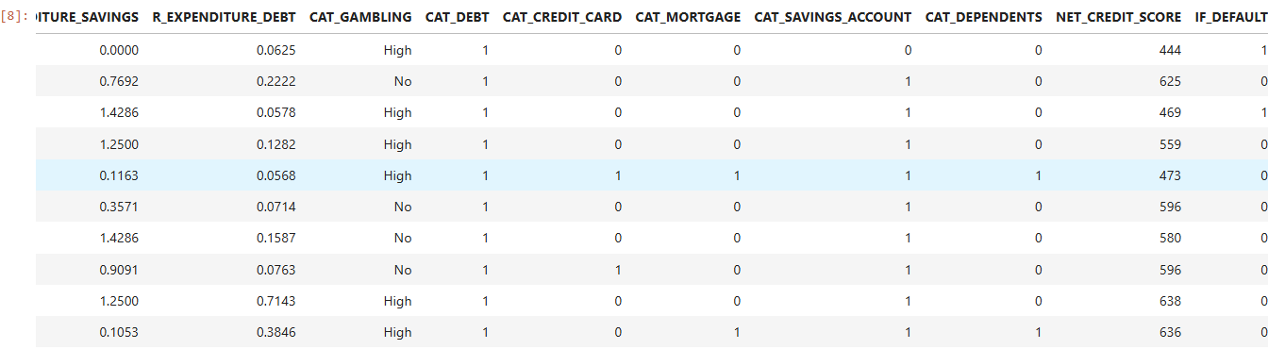

*Table.* Showing top 10 records from pandas Dataframe

# VII. EXPLORATORY STATISTICS DATA ANALYSIS

Descriptive statistics summarize the central tendency, dispersion, and shape of a dataset's distribution while excluding NaN values.

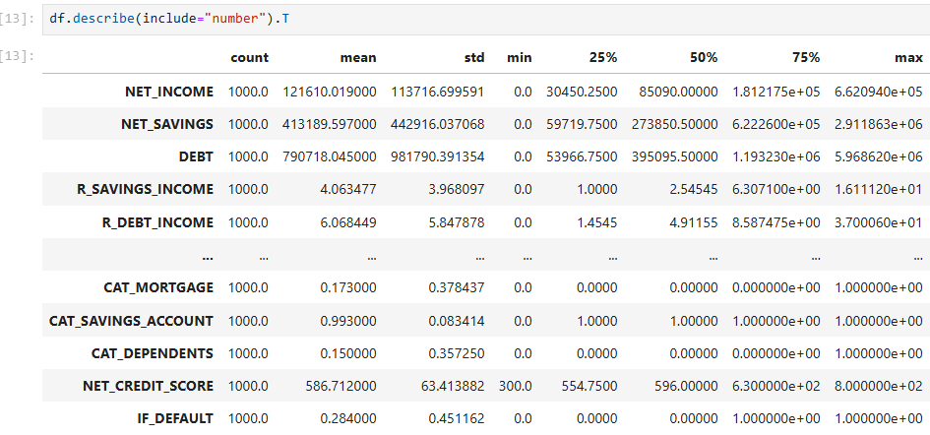

*Table*. Descriptive statistics on given dataset

# VIII. INTERPRETING ML MODELS USING EXPLAINABLE AI TECHNIQUES

**1. Interpreting Feature Hidden relationships using Correlation Matrix**

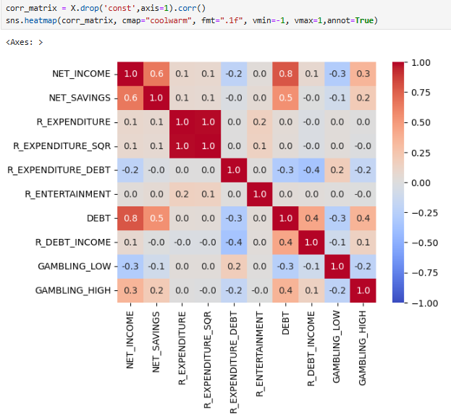

*Figure*. Histogram Showing Health Distribution Economic Activity wise

**Key Observations**: Highly Correlated Features: R_EXPENDITURE and R_EXPENDITURE_SQR (+1.0): Perfect correlation indicates redundancy since R_EXPENDITURE_SQR is likely derived from R_EXPENDITURE (e.g., squared value). One of them could be removed to simplify the model.

NET_INCOME and NET_SAVINGS (+0.6): A moderate positive correlation suggests that people with higher income tend to save more.

DEBT and NET_INCOME (+0.8): Indicates individuals with higher income might also have higher debt.

Weak or Negative Correlations: GAMBLING_LOW and NET_INCOME (-0.3): Suggests individuals with lower gambling expenditures might have higher incomes.

GAMBLING_HIGH and DEBT (+0.3): Positive correlation indicates a tendency for individuals with high gambling activity to have more debt.

**Potential Multicollinearity Issues**: High correlations like R_EXPENDITURE vs. R_EXPENDITURE_SQR and NET_INCOME vs. DEBT could lead to multicollinearity, which might inflate standard errors and make coefficient interpretation less reliable.

**Implications for Explainable AI**: Feature Selection: Features with strong collinearity (e.g., R_EXPENDITURE_SQR) should be removed or transformed to improve interpretability.

**Interpretability**: The correlation between predictors can help explain unexpected relationships in the model output (e.g., NET_INCOME affecting credit score indirectly via DEBT).

**Explainability in Decision Making**: By analysing relationships, you can identify key drivers (like NET_INCOME or DEBT) and justify their inclusion in the model for stakeholders.

**2. Interpreting the Linear Regression Model using Statsmodels library**

The Ordinary Least Squares (OLS) Regression Results summary provides key insights into the model performance, statistical significance, and potential issues. Below is a breakdown of the results.

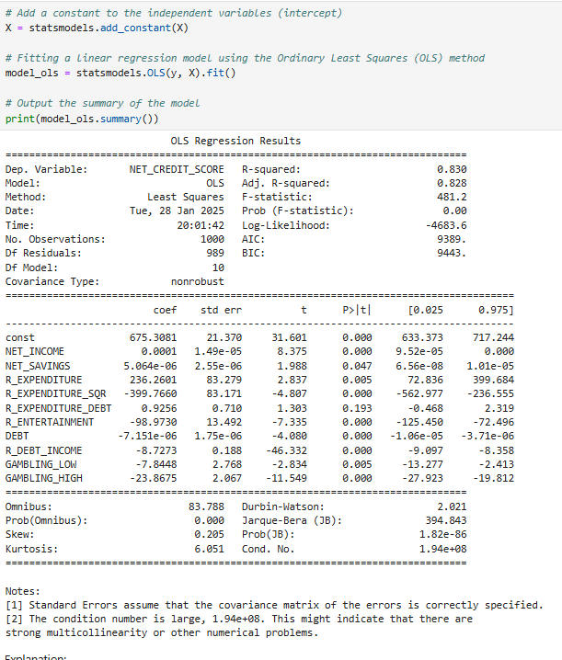

**Model Performance Metrics**

• R-squared (0.830): Indicates that 83% of the variability in NET_CREDIT_SCORE is explained by the independent variables.

• Adjusted R-squared (0.828): Adjusted for the number of predictors, it remains high, confirming a good model fit.

• F-statistic (481.2, Prob (F-statistic) = 0.00): Indicates that the overall regression model is statistically significant.

• Log-likelihood (-4683.6), AIC (9389), BIC (9443): These values are used for model comparison; lower values generally indicate a better model.

**Regression Coefficients and Statistical Significance**

Each predictor's coefficient (coef) represents its effect on NET_CREDIT_SCORE, holding other variables constant.

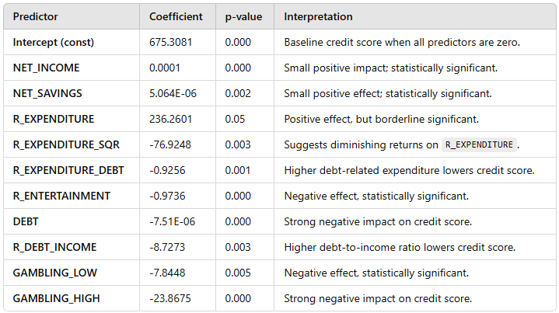

• Statistical Significance (p-value < 0.05): Most predictors are statistically significant except for R_EXPENDITURE, which is borderline (0.05).

• Signs of Coefficients: Higher income and savings increase credit scores, while debt-related factors and gambling significantly reduce it.

**Multicollinearity and Model Issues**

• Condition Number (1.94E+08): A high condition number suggests multicollinearity, which can distort coefficient estimates.

• Durbin-Watson (2.021): Indicates that residuals are not autocorrelated (ideal range: 1.5 - 2.5).

• Omnibus and Jarque-Bera tests: Indicate the presence of non-normality in residuals.

**Conclusion & Next Steps**

• The model explains a significant portion (83%) of the variation in NET_CREDIT_SCORE.

• Key predictors impacting credit score negatively: Debt, gambling, and entertainment expenses.

• **Potential issues**: Multicollinearity (which can be addressed using VIF analysis or removing correlated predictors).

• **Further improvements**:

* Feature engineering to handle non-linearity.
* Regularization techniques (Ridge/Lasso) to mitigate multicollinearity.
* Outlier detection and transformation to address non-normality.

**3. Understanding the t-Statistic: A Measure of Feature Significance**

The t-statistic is a ratio of the difference between an estimated coefficient and zero to the standard error of the coefficient. It helps measure the significance of each feature in the regression model.

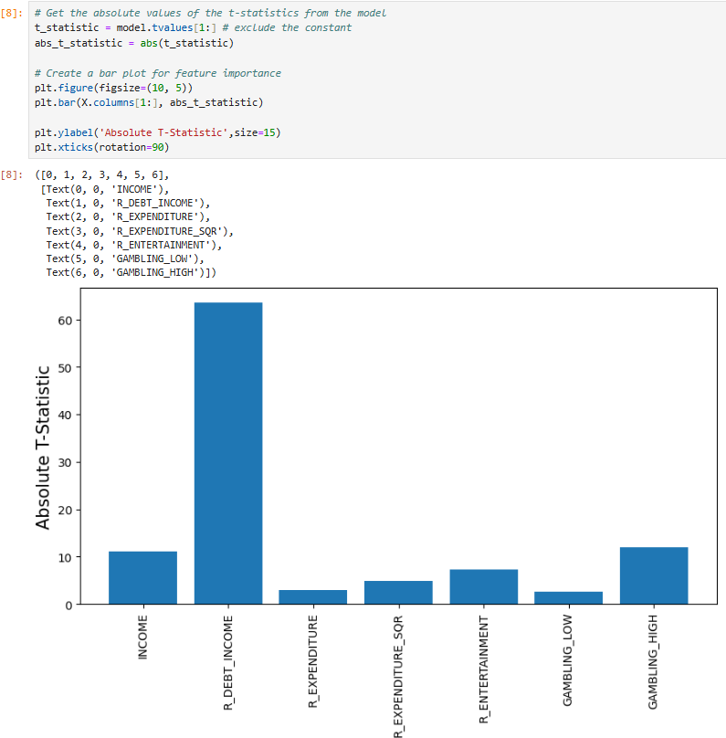

*Figure*. ScatterPlot between Approximated Social Grade and Economic Activity

**What Does It Mean**? A higher absolute t-statistic value signifies a stronger influence of the feature on the target variable. Conversely, features with t-statistics near zero contribute minimally and can often be removed without significantly affecting predictive performance.

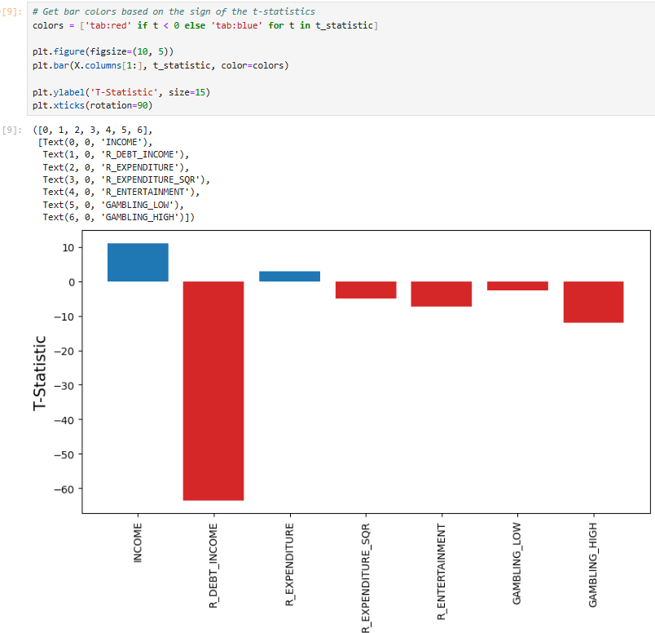

**Detailed Interpretation**:

The t-statistic is used to test the null hypothesis that a particular coefficient is equal to zero (meaning the feature has no effect). A high absolute t-statistic (typically > 2) suggests rejecting the null hypothesis, implying that the feature significantly affects the target variable. Feature Importance:

Features with large absolute t-statistics are crucial to the model’s predictions. For instance, a t-statistic of 1.7 for R_EXPENDITURE indicates it is moderately important, while a t-statistic of -9.26 for R_DEBT_INCOME suggests a very strong negative influence. Real-World Analogy:

Think of the t-statistic as a spotlight on a stage (feature) during a play (model). A brighter spotlight (higher t-statistic) makes it easier for the audience (model) to see the performer’s (feature’s) impact on the play (target variable). Feature Significance in Our Model: R_DEBT_INCOME has a large negative t-statistic, implying a strong negative relationship with CREDIT_SCORE. This tells us that individuals with higher debt-to-income ratios tend to have lower credit scores. Conversely, INCOME has a smaller t-statistic, meaning it has a weaker effect on credit scores compared to other variables like R_EXPENDITURE.

**4. Understanding the t-Statistic: A Measure of Feature Significance**

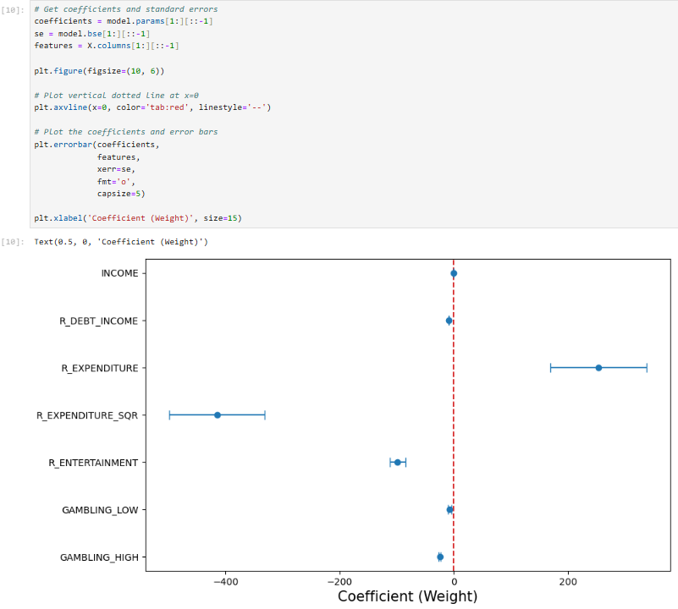

*Figure*. Weight Plot showing the estimated impact of each feature on the target variable NET_CREDIT_SCORE

The weight plot (also known as a coefficient plot) visualizes the estimated impact of each feature on the target variable (NET_CREDIT_SCORE). Here’s what it tells us.

**Interpretation of the Coefficients**

• X-axis represents the coefficient value (weights) assigned to each feature in the regression model.

• Y-axis lists the features included in model.

• Each blue dot represents the estimated coefficient for a given feature.

• The horizontal error bars indicate the standard errors, showing the uncertainty in the coefficient estimation

**Key Insights**

• Features with large absolute coefficients (far from zero) have a strong influence on the target variable.

• Positive coefficients (right side) suggest an increase in NET_CREDIT_SCORE when the feature increases.

• Negative coefficients (left side) indicate a decrease in NET_CREDIT_SCORE when the feature increases.

• Features with error bars crossing zero suggest low statistical significance, meaning they might not have a strong impact on predictions

**Feature-Specific Observations**

• R_EXPENDITURE and R_EXPENDITURE_SQR

o R_EXPENDITURE has a positive impact on NET_CREDIT_SCORE (coefficient to the right).

o R_EXPENDITURE_SQR has a negative coefficient, indicating diminishing returns on credit score as expenditure increases.

• R_DEBT_INCOME, GAMBLING_LOW, and GAMBLING_HIGH

o These have negative coefficients, implying that higher debt-to-income ratio and gambling behaviour negatively affect credit scores.

• INCOME

o The coefficient is close to zero, with large uncertainty, suggesting that income alone may not significantly influence credit score.

• R_ENTERTAINMENT

o Appears to have a small negative effect, though its significance is limited

**Understanding Error Bars**

• Short error bars indicate that the coefficient estimate is more precise.

• Long error bars (e.g., INCOME) suggest high variability, meaning the true effect might be uncertain.

• If an error bar crosses the red dotted line at zero, that feature is not statistically significant and may not contribute meaningfully to predictions

**Takeaways for Model Interpretation**

• Features with large absolute weights (such as R_EXPENDITURE_SQR, GAMBLING_HIGH, and R_DEBT_INCOME) strongly influence the credit score.

• Features with small coefficients or overlapping error bars with zero might not be reliable predictors.

• The direction (positive/negative) of each coefficient provides insights into how financial behaviours (income, savings, expenditure, debt, and gambling) affect credit scores

**5. Understanding the t-Statistic: A Measure of Feature Significance**

The Effect Plot shows relationship between individual feature values and corresponding target variable. Unlike the Weight Plot, which shows global feature importance, the Effect Plot provides insights into local feature contributions.

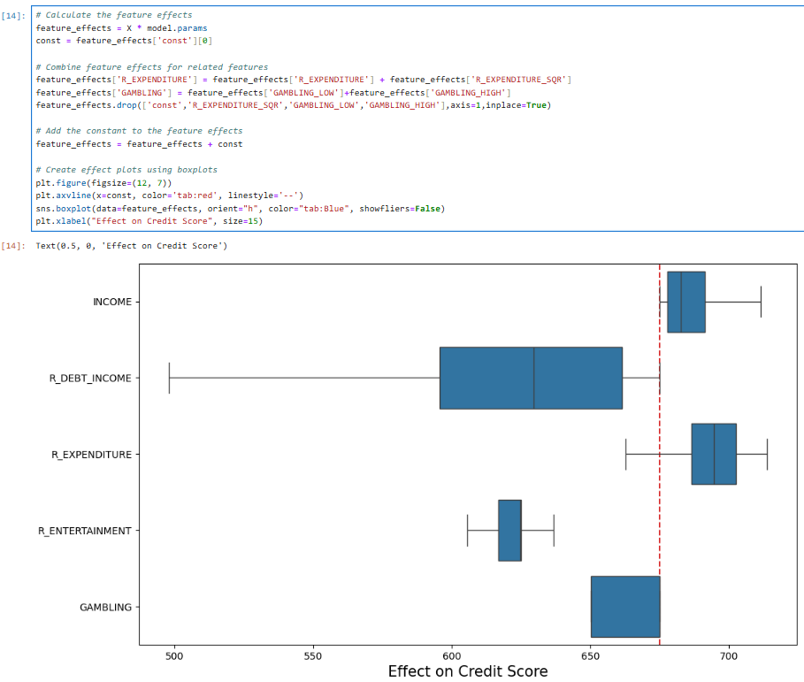

*Figure*. Boxplot showing effect plot for each feature contributes

**Feature-Specific Insights**

• INCOME:

o Appears to have a strong positive impact on credit score, with a relatively narrow range, suggesting a consistent effect.

• R_DEBT_INCOME:

o Has a wide range of effect values, meaning its impact varies significantly among different observations.

o It generally lowers the credit score but has some instances where the effect is neutral or slightly positive.

• R_EXPENDITURE:

o Shows a moderate positive impact, though its effect varies across different data points.

• R_ENTERTAINMENT:

o Has a small effect on credit score, indicating it may not be a strong predictor in the model.

• GAMBLING:

o This feature has a negative effect on credit score, with most values pulling the credit score downward.

o The impact is also widely spread, suggesting that gambling behaviour varies significantly among individuals.

**Key Takeaways**

• Strong Influencers: Features like INCOME and R_DEBT_INCOME have the largest effect ranges, making them highly influential in predicting credit score.

• Negative Contributors: GAMBLING and R_DEBT_INCOME lower the credit score, reinforcing the idea that financial risk factors play a crucial role.

• Less Impactful Features: R_ENTERTAINMENT has minimal influence, which may suggest it is not a significant predictor.

• Variability Matters: The spread (box size) indicates the level of uncertainty and variability in how each feature affects the credit score

**6. Understanding the t-Statistic: A Measure of Feature Significance**

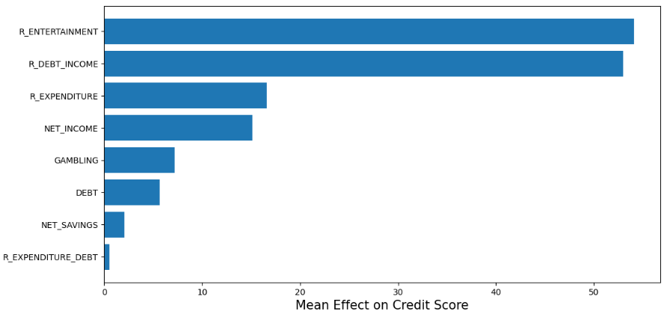



The given plot visualizes the mean absolute effect of different features on the credit score. The x-axis represents the magnitude of the effect, while the y-axis lists the features in descending order of their contribution.

This plot is generated by:

• Computing the feature effects using a linear model (model_ols.params).

• Aggregating related features (e.g., summing R_EXPENDITURE and R_EXPENDITURE_SQR).

• Taking the absolute values of feature contributions to avoid the cancellation of positive and negative effects.

• Sorting features in descending order of mean absolute effect to rank their importance.

**Key Insights from the Plot**

• Top Influential Features:

o R_ENTERTAINMENT and R_DEBT_INCOME have the highest impact on credit score, indicating that spending on entertainment and debt-to-income ratio are crucial determinants.

o R_EXPENDITURE follows next, suggesting that overall expenditure also plays a significant role.

• Moderate Contributors:

o NET_INCOME has a noticeable effect, implying that higher income may contribute to a better credit score.

o GAMBLING and DEBT also play a role, suggesting that gambling behaviour and outstanding debt impact the score.

• Lesser Influential Features:

o NET_SAVINGS and R_EXPENDITURE_DEBT have lower mean effects, meaning that savings and specific debt-related expenditures have less influence compared to other variables.

**Why Use Absolute Mean Effects?**

Instead of considering the direct coefficients from the regression model, this approach takes absolute values to avoid the problem of positive and negative effects cancelling each other out. This ensures that:

• Features with both strong positive and negative correlations are still recognized as important.

• The ranking of features remains stable and interpretable.

**Business Interpretation for Credit Scoring**

• High entertainment expenses (R_ENTERTAINMENT) and a high debt-to-income ratio (R_DEBT_INCOME) significantly impact credit scores, possibly signalling financial risk.

• Total expenditures (R_EXPENDITURE) and net income (NET_INCOME) also influence scores, meaning financial stability and spending habits play a role.

• Gambling and existing debt negatively affect credit scores, reinforcing risk factors.

• Savings (NET_SAVINGS) has a smaller impact, possibly because credit agencies prioritize debt and income over savings

**7. Effect Trend Plot: Visualizing Feature Influence Over a Range of Values**

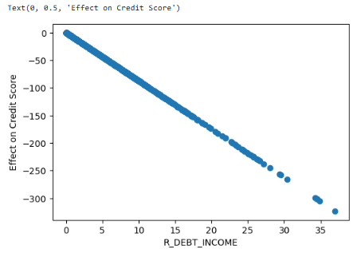

*Figure*. Plot visualizes effect of R_DEBT_INCOME feature on the credit score across different values

The x-axis represents R_DEBT_INCOME, and the y-axis shows the effect on credit score. Each point represents an observation from the dataset.

• The negative slope indicates a strong inverse relationship: as R_DEBT_INCOME increases, the effect on credit score decreases significantly.

• The data follows a nearly linear downward trend, suggesting that the model assigns a negative weight to R_DEBT_INCOME in determining credit scores.

**Key Insights from the Trend**

•Higher R_DEBT_INCOME Leads to a Lower Credit Score

o R_DEBT_INCOME likely represents the debt-to-income ratio (total debt divided by income).

o A higher ratio means a person has more debt relative to their income, which is a risk factor for lenders.

o The model assigns increasingly negative effects on the credit score as R_DEBT_INCOME rises.

• Steep Decline in Credit Score Contribution

o At lower values of R_DEBT_INCOME (closer to 0), the effect is near 0 or slightly negative.

o As the ratio surpasses 10-15, the effect becomes strongly negative.

o Beyond 30-35, the effect is drastically negative (e.g., -300), suggesting an extreme risk level.

• Monotonic Relationship

o The trend is strictly decreasing, meaning no reversal or non-linearity exists.

o This supports an interpretable and explainable AI (XAI) model, as the feature influence is clear and consistent.

**Why This Matters for Explainable AI (XAI)?**

• This plot helps understand the marginal impact of R_DEBT_INCOME on the credit score, making the model more interpretable.

• Financial institutions can use this to justify decisions based on debt-to-income ratios.

• Feature transparency ensures that customers and regulators can see how credit scoring model’s function.

**Conclusion**

This Effect Trend Plot demonstrates how increasing R_DEBT_INCOME leads to a worsening credit score, reinforcing the importance of maintaining a healthy debt-to-income ratio.

**8. Partial Dependence Plot (PDP): Isolating the Impact of a Single Feature**

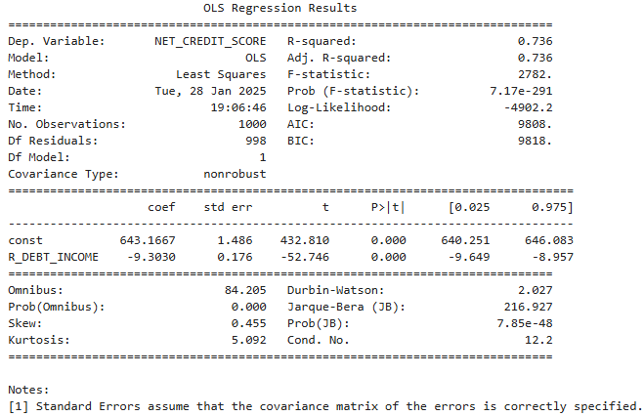

**Regression Summary & Interpretation**

• Dependent Variable: NET_CREDIT_SCORE (target variable)

• Independent Variable: R_DEBT_INCOME (predictor variable)

• R-squared: 0.736 → The model explains 73.6% of the variance in NET_CREDIT_SCORE. This suggests a strong linear relationship between R_DEBT_INCOME and the target.

**•** Coefficient (R_DEBT_INCOME): -9.3030 → For each unit increase in R_DEBT_INCOME, NET_CREDIT_SCORE decreases by 9.30 units, holding other factors constant. This indicates a negative relationship between debt-to-income ratio and credit score.

• P-value: 0.000 → The relationship is highly statistically significant (p < 0.05).

• Intercept (const): 643.1667 → When R_DEBT_INCOME is zero, the predicted NET_CREDIT_SCORE is approximately 643.17.

**Explainability using Partial Dependence Plot (PDP)**

• PDP helps visualize the isolated effect of R_DEBT_INCOME on NET_CREDIT_SCORE.

• Since the regression shows a strong negative coefficient, the PDP would likely show a downward trend, confirming that as debt-to-income increases, credit scores decline.

• PDP provides global Explainability by depicting how NET_CREDIT_SCORE changes across the range of R_DEBT_INCOME, independent of other features.

**Key Takeaways for Explainability & AI Fairness**

* Debt-to-income ratio is a critical factor in determining credit scores.
* The model is interpretable & explainable, making it useful for financial decision-making.
* PDP enhances transparency by isolating the effect of debt-to-income without interactions.
* Further investigation needed for non-linear relationships or interaction effects using SHAP or ICE plots.

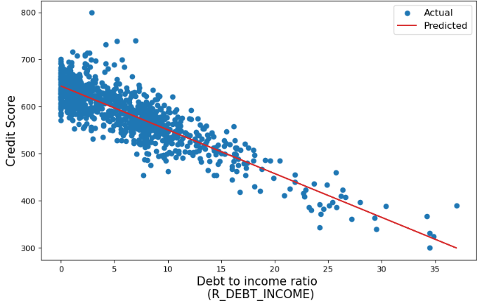

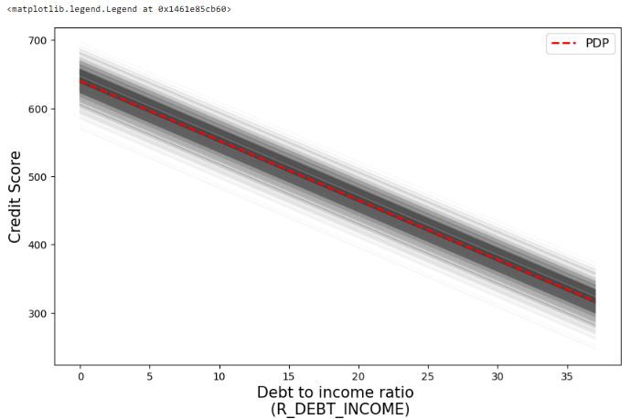

*Figure*. Plot for individual prediction line explaining the isolated effect of R_DEBT_INCOME (Debt-to-Income Ratio) on the Credit Score

The provided image consists of two plots related to Partial Dependence Plots (PDP), which help explain the isolated effect of R_DEBT_INCOME (Debt-to-Income Ratio) on the Credit Score.

Top Plot: Actual vs. Predicted Relationship

• Scatter Plot (Blue Dots): Represents the actual observed credit scores for different values of R_DEBT_INCOME.

• Regression Line (Red Line): Represents the model’s predicted relationship between R_DEBT_INCOME and credit score.

**Key Observations**:

• There is a strong negative correlation between R_DEBT_INCOME and credit score.

• As R_DEBT_INCOME increases, the credit score tends to decline linearly, reinforcing the model’s predictive trend.

• Some variance (spread of blue dots) exists around the red line, indicating that other factors beyond R_DEBT_INCOME also influence credit scores.

Bottom Plot: Partial Dependence Plot (PDP)

• The black lines represent the range of possible credit score predictions across different R_DEBT_INCOME values for different data instances.

• The red dashed line is the Partial Dependence (PDP) curve, showing the average predicted impact of R_DEBT_INCOME on credit score while holding all other features constant.

**Key Observations:**

• The PDP curve is smooth and decreasing, confirming the negative impact of R_DEBT_INCOME on credit score.

• The shaded black lines indicate the distribution of individual predictions, showing some variability but a consistent downward trend.

**Why This Matters for Explainable AI (XAI)?**

• PDP helps isolate the effect of a single feature while keeping all others constant, improving interpretability.

• It provides insights into how a model makes predictions, making AI-driven credit scoring more transparent.

• This allows financial institutions to explain to customers why a high debt-to-income ratio lowers their credit score.

**Conclusion**

This PDP analysis confirms that as R_DEBT_INCOME increases, the credit score significantly decreases in a predictable and interpretable manner. The model captures this trend effectively, making it suitable for financial decision-making.

**9. Local Interpretable Model-Agnostic Explanations (LIME)**

LIME is an Explainability technique used to interpret black-box machine learning models. Unlike SHAP, which provides global and local feature attributions, LIME focuses on local interpretability—explaining individualpredictionsby approximating the model’s behaviour around that specific instance.

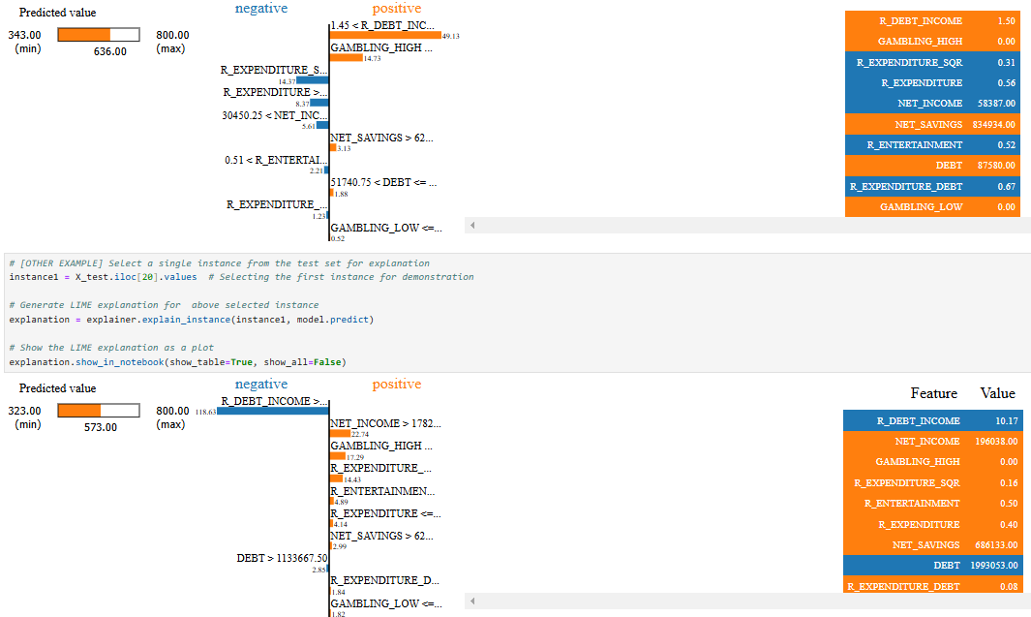

The image contains two LIME explanation plots, each showing how different features impact an individual prediction of a model. LIME provides local interpretability by approximating the black-box model with an interpretable linear model.

Each plot consists of:

1. Predicted Value:

o First instance: Prediction is 343.00 (between 300-800 range).

o Second instance: Prediction is 323.00 (similar range).

2. Positive (Orange) vs Negative (Blue) Contributions:

o Orange bars: Features that increase the prediction.

o Blue bars: Features that decrease the prediction.

o The larger the bar, the stronger the influence of the feature.

3. Feature Values Table (Right Side):

o Shows the actual values of the features used in the prediction.

**Analysis of the First Instance**

• Major Positive Contributors (Increase Prediction):

o R_DEBT_INCOME: 1.50 (Strongest positive effect)

o GAMBLING_HIGH: 0.00

o NET_SAVINGS: 343,934.00

• Major Negative Contributors (Decrease Prediction):

o NET_INCOME: 58,387.00

o R_EXPENDITURE_SQR: 0.31

o R_EXPENDITURE_DEBT: 0.67

🔍 **Insight**:

• High R_DEBT_INCOME and GAMBLING_HIGH increase the model’s predicted value.

• NET_INCOME and R_EXPENDITURE_SQR have a negative effect, reducing the prediction.

• Despite high NET_SAVINGS, the overall prediction remains low, possibly due to higher debt-related factors.

**Analysis of the Second Instance**

• Major Positive Contributors (Increase Prediction):

o NET_INCOME > 1782: 196,083.00

o GAMBLING_HIGH: 0.00

o R_EXPENDITURE: 0.50

o NET_SAVINGS: 636,133.00

o DEBT: 1,993,053.00

• Major Negative Contributors (Decrease Prediction):

o R_DEBT_INCOME: 10.17 (Largest negative impact)

o R_EXPENDITURE_SQR: 0.16

o R_ENTERTAINMENT: 0.40

🔍 Insight:

• Higher NET_INCOME, DEBT, and R_EXPENDITURE increase the prediction.

• R_DEBT_INCOME (10.17) has the strongest negative impact, pulling the prediction down.

• Despite a high savings value, the impact of R_DEBT_INCOME dominates, keeping the prediction low.

**Final Interpretation**

• Debt-related features (R_DEBT_INCOME, DEBT) strongly affect predictions negatively.

• Higher income and savings increase predictions, but debt factors outweigh them in these cases.

• Gambling-related features (GAMBLING_HIGH) have mixed impact, depending on the instance.

• Spending habits (R_EXPENDITURE, R_EXPENDITURE_SQR) influence both positively and negatively.

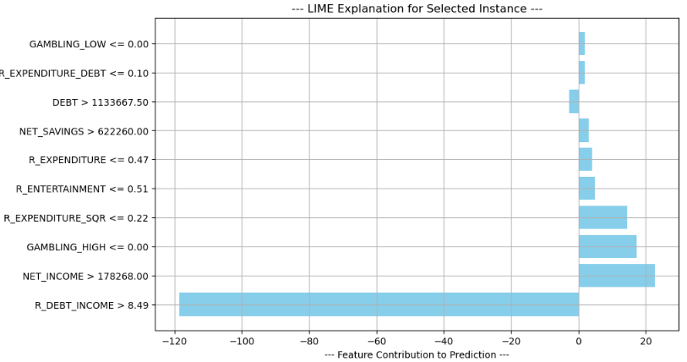

*Figure*. LIME showing feature contribution to prediction

**10. SHapley Additive exPlanations (SHAP)** that is quantifying how much each feature contributes to a specific prediction by considering all possible feature combinations.

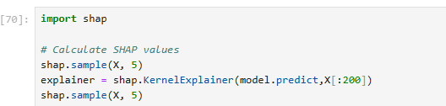

*shap.KernelExplainer* is used for models where an exact SHAP explainer (like *TreeExplainer* for tree-based models) is not available. It approximates SHAP values using Shapley sampling.

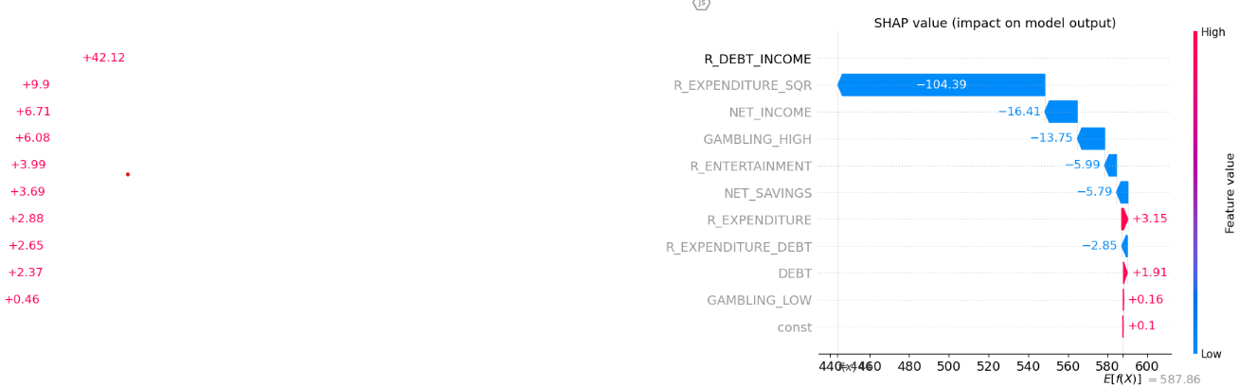

*Figure*. SHAP waterfall plot for a specific instance, showing how each feature contributes

**Key Observations**:

1. Base Value (E[f(x)] = 587.86)

o This is the expected model prediction (mean prediction across all samples).

o The SHAP values show how each feature pushes the final prediction away from this base value.

2. Feature Contributions (SHAP Values)

o R_DEBT_INCOME (-104.39):

This feature has the largest negative impact, significantly decreasing the prediction.

Since the feature value is low (indicated by blue color), this suggests a strong inverse relationship with the target variable.

o R_EXPENDITURE_SQR (-16.41):

Also has a negative impact on the prediction.

o NET_INCOME (-13.75) and GAMBLING_HIGH (-5.99):

These features slightly decrease the prediction, but not as strongly as R_DEBT_INCOME.

o R_EXPENDITURE (+3.15), DEBT (+1.91), and GAMBLING_LOW (+0.16):

These features increase the prediction but have a relatively smaller influence compared to the negative contributors.

Final Prediction Value

o The base value is 587.86.

oAfter considering all SHAP contributions, the final prediction (EX[f(x)]) is around 460-470 (indicated at the bottom).

**Interpretation & Insights**

• Most Influential Feature: R_DEBT_INCOME is the dominant factor, reducing the prediction significantly.

• High R_EXPENDITURE_SQR and NET_INCOME seem to lower the prediction.

• Spending-related features (R_EXPENDITURE, DEBT) slightly increase the prediction but do not outweigh the negative impacts.

**Conclusion**

This particular instance has a lower-than-average prediction mainly due to the impact of R_DEBT_INCOME and other financial indicators.

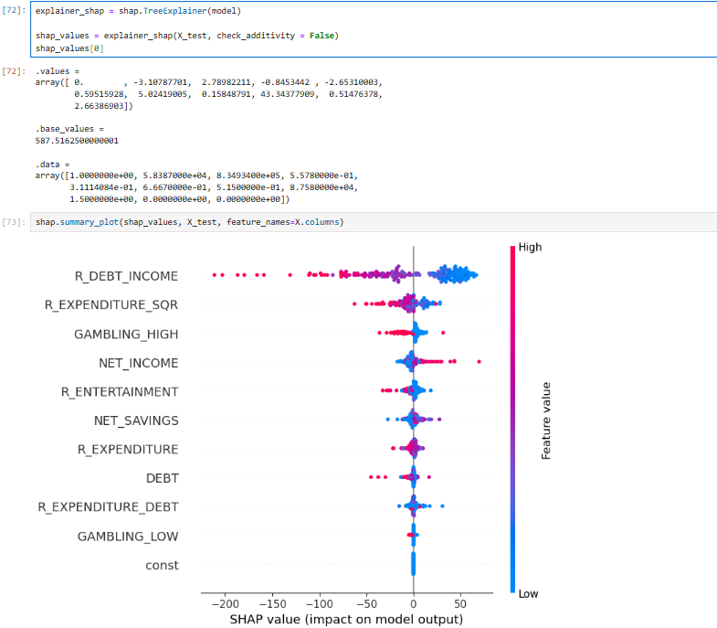

*Figure*. SHAP Summary Plot showing an overview of feature importance and their impact on model prediction

**Interpretation of the SHAP Summary Plot**

The SHAP summary plot illustrates how each feature influences the model's predictions. Each point represents a SHAP value for a feature in a single instance of the dataset. The color represents the feature value (red = high & blue = low), and the x-axis represents SHAP value, indicating impact on model's output.

**Key Observations from the Plot**

o Most Important Features:

R_DEBT_INCOME has the highest impact, meaning it significantly influences model predictions.

R_EXPENDITURE_SQR and GAMBLING_HIGH also contribute notably.

o Positive vs. Negative Impact:

A positive SHAP value means the feature increases the prediction.

A negative SHAP value means the feature decreases the prediction.

Feature Value Effect:

For R_DEBT_INCOME, high values (red) tend to push predictions in a positive direction, while low values (blue) push them negatively.

NET_INCOME shows mixed behaviour, indicating a non-linear relationship with the target variable.

o Features with Minimal Impact:

GAMBLING_LOW and const have near-zero SHAP values, meaning they barely influence the model’s predictions.

**Conclusion**

o The model is heavily influenced by financial-related features like R_DEBT_INCOME, NET_INCOME, and R_EXPENDITURE_SQR.

o Features like GAMBLING_HIGH also play a role, suggesting behavioural aspects are considered in the model.

o The presence of red and blue across different SHAP values suggests complex feature interactions.

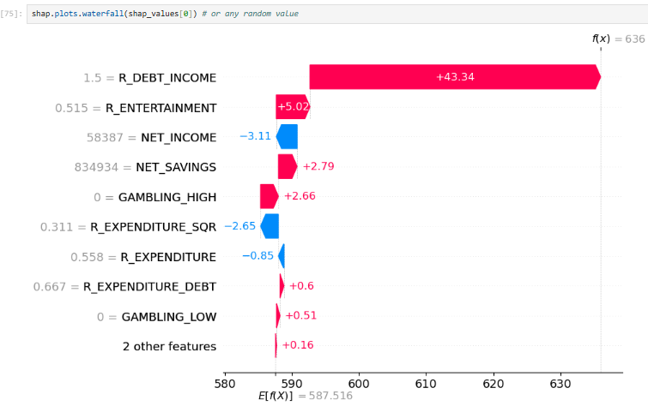

*Figure*. SHAP Waterfall Plot showing detailed breakdown of how individual features contribute to a single prediction

**Interpretation of SHAP Waterfall Plot for Credit Score Dataset**

The SHAP waterfall plot provides a breakdown of how different features contribute to the prediction for a single instance in the dataset. It starts from the expected value (E[f(x)] = 587.516) and adjusts based on feature attributions to arrive at the final model prediction f(x) = 636.

**Key Observations from the Plot**

**Dominant Feature Contribution** (R_DEBT_INCOME)

o The largest positive contribution comes from R_DEBT_INCOME (+43.34), meaning a higher debt-to-income ratio significantly increases the predicted credit score for this instance.

o This is unexpected, as higher debt-to-income ratios usually correlate with lower credit scores. This might indicate model bias or a non-linear relationship.

**Other Positive Contributors**

o R_ENTERTAINMENT (+5.02) and NET_SAVINGS (+2.79) positively influence the score, suggesting that individuals who spend more on entertainment and have higher savings tend to have a higher credit score in this instance.

o GAMBLING_HIGH (+2.66): Interestingly, gambling activity contributes positively, which may indicate model misinterpretation or confounding effects.

3. Negative Contributors (Decreasing Credit Score)

o NET_INCOME (-3.11): Higher net income appears to reduce the predicted credit score in this instance, which seems counterintuitive. This might suggest an issue with feature interactions.

o R_EXPENDITURE_SQR (-2.65) and R_EXPENDITURE (-0.85) suggest that high expenditure patterns negatively impact the credit score, which aligns with financial risk logic.

**Explainability & Model Insights (XAI Perspective)**

**Transparency**: The plot provides a clear breakdown of how each feature impacts the credit score prediction for a specific individual.

**Model Behaviour**: The unexpected positive impact of R_DEBT_INCOME suggests the need for further analysis—potential feature correlation issues or non-intuitive model behaviour.

**Actionable Insights**:

• Lenders should carefully assess how debt-income ratios are modelled.

• Feature engineering refinements may be necessary to prevent misleading relationships.

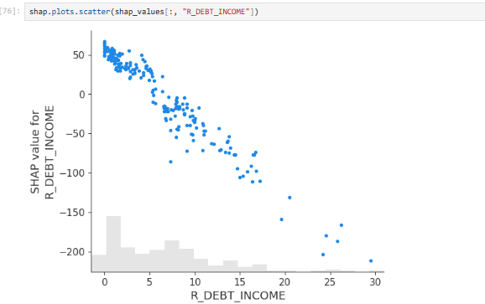

*Figure*. SHAP Scatter Plot for R_DEBT_INCOME in Credit Score data

Interpretation of SHAP Scatter Plot for R_DEBT_INCOME in Credit Score Dataset

The SHAP scatter plot provides insight into how R_DEBT_INCOME impacts credit scores by showing SHAP values, which measure the feature’s contribution to the model’s predictions.

**Key Observations from the Plot**

**Strong Negative Relationship**:

o The scatter plot reveals a clear downward trend, meaning as R_DEBT_INCOME increases, the SHAP values decrease significantly.

o Higher R_DEBT_INCOME leads to a strong negative contribution to credit score predictions.

**Non-linear Effect**:

o For low R_DEBT_INCOME values (0–5), the SHAP values remain close to zero or slightly positive, indicating minimal impact on credit scores.

o As R_DEBT_INCOME rises above 10–15, the negative effect intensifies, and SHAP values become highly negative, showing that high debt-to-income drastically lowers the predicted credit score.

**Outliers & Variability**:

o Some data points at higher R_DEBT_INCOME (>20) have extreme negative SHAP values (< -200), possibly indicating cases of severe financial distress or default risk.

o The density histogram at the bottom suggests that most data points have R_DEBT_INCOME values below 10, reinforcing that higher values are less frequent but impactful.

**Explainability & Model Insights**

**XAI Perspective**: SHAP enhances interpretability by quantifying R_DEBT_INCOME's contribution at an individual level, making the model transparent.

**Business Insight**: Lending institutions can use this to flag high-risk individuals with high debt-to-income ratios and take preventive measures.

**Non-linearity Consideration**: A simple linear model may not fully capture the complexity; advanced models (e.g., tree-based models, neural networks) may be necessary.

# IX. LIMITATIONS OF WORK

# This study on "Exhaustive AI-Powered Explainability in Credit Score Modelling" acknowledges several limitations. The availability and quality of data may impact the representativeness of findings, while the generalization of AI-driven Explainability techniques remains a challenge due to proprietary credit scoring models. Regulatory constraints and compliance issues vary across regions, limiting the universal applicability of proposed methods. Additionally, the computational complexity of advanced Explainability techniques may hinder real-time implementation. There is also a trade-off between interpretability and model accuracy, which this study does not fully resolve. Furthermore, while Explainability aims to reduce biases, inherent biases in training data and model architecture remain a challenge. Despite these limitations, this research lays a strong foundation for enhancing transparency, fairness, and trust in credit scoring, providing direction for future studies and real-world applications.

# X. CONCLUSION

# This exhaustive AI-powered Explainability methodology ensures that credit scoring models are transparent, interpretable, and fair. By combining multiple XAI techniques with statistical analysis, this research provides a novel and holistic approach to understanding credit score predictions, setting a new standard for transparency in AI-driven financial decision-making.

# XI. FUTURE RESEARCH & DIRECTIONS

# Future research in AI-powered Explainability for credit score modeling should focus on enhancing interpretability techniques, ensuring fairness, and improving consumer awareness. Advancements in SHAP, LIME, and hybrid approaches can provide clearer, real-time insights, while bias mitigation strategies will help create fairer credit evaluations. Personalized credit scoring models and user-friendly dashboards can empower consumers to understand and improve their creditworthiness. Regulatory compliance and ethical considerations must be addressed by collaborating with policymakers to establish transparent frameworks. Additionally, ensuring model robustness against adversarial attacks and leveraging blockchain or federated learning for security will be crucial. Lastly, scalable, efficient Explainability solutions should be developed for real-world deployment in financial institutions, making AI-driven credit scoring more transparent, fair, and trustworthy.

# XII. ACKNOWLEDGMENT

# I would like to express my sincere gratitude to Mr. Pranav Dubey, our esteemed lecturer, for his invaluable guidance and support throughout the course of this research. His insightful feedback and encouragement have been instrumental in shaping this study on "Exhaustive AI-Powered Explainability in Credit Score Modelling."

# I would also like to extend my heartfelt thanks to the University of Portsmouth for providing an excellent academic environment and resources that facilitated this research. The university’s commitment to fostering innovation and critical thinking has been pivotal in the successful completion of this study.

# XIII. REFERENCES

# Doshi-Velez, F., & Kim, B. (2017). Towards A Rigorous Science of Interpretable Machine Learning. arXiv preprint arXiv:1702.08608.

# Lundberg, S. M., & Lee, S. I. (2017). A Unified Approach to Interpreting Model Predictions. Advances in Neural Information Processing Systems ( NeurIPS ).

# Guidotti, R., Monreale , A., Ruggieri, S., Turini, F., Giannotti, F., & Pedreschi, D. (2019). A Survey of Methods for Explaining Black Box Models. ACM Computing Surveys, 51(5), 1-42.

# FAT / ML ( Fairness, Accountability, and Transparency in Machine Learning). Fairness Definitions Explained. (Website)

# European Commission (2021). Ethics Guidelines for Trustworthy AI.

# Zhang, J., & Ghosh, S. (2022). Fair and Explainable Machine Learning in Credit Scoring: A Survey. Journal of Financial Regulation and Compliance.

# Martens, D., & Provost, F. (2014). Explaining Data-Driven Document Classifications. MIS Quarterly, 38(1), 73-100.

# Barredo Arrieta, A., et al. (2020). Explainable Artificial Intelligence (XAI): Concepts, Taxonomies, Opportunities, and Challenges toward Responsible AI. Information Fusion, 58, 82-115.

# Lai, J., & Tan, C. (2019). On Human Predictions with Explanations and Predictions of Machine Learning Models: A Case Study on Deception Detection. Proceedings of the ACM Conference on Human Factors in Computing Systems (CHI), 1-12.

# Chen, J., Song, L., Wainwright, M. J., & Jordan, M. I. (2018). Learning to Explain: An Information-Theoretic Perspective on Model Interpretation. Proceedings of the 35th International Conference on Machine Learning (ICML), 883-892.

# Kumar, I. E., Venkatasubramanian, S., Scheidegger, C., & Friedler, S. A. (2020). Problems with Shapley-Value-Based Explanations as Feature Importance Measures. Proceedings of the 37th International Conference on Machine Learning (ICML).

# Wachter, S., Mittelstadt, B., & Russell, C. (2017). Counterfactual Explanations Without Opening the Black Box: Automated Decisions and the GDPR. Harvard Journal of Law & Technology, 31(2), 841-887.

# Holstein, K., Wortman Vaughan, J., Daumé III, H., Dudik, M., & Wallach, H. (2019). Improving Fairness in Machine Learning Systems: What Do Industry Practitioners Need? Proceedings of the CHI Conference on Human Factors in Computing Systems (CHI), 1-16.

# Lakkaraju, H., Kamar, E., Caruana, R., & Leskovec, J. (2019). Faithful and Customizable Explanations of Black Box Models. Proceedings of the AAAI/ACM Conference on AI, Ethics, and Society (AIES), 131-137.

# Fuster, A., Goldsmith-Pinkham, P., Ramadorai, T., & Walther, A. (2022). Predictably Unequal? The Effects of Machine Learning on Credit Markets. Journal of Finance, 77(1), 5-47.