* What is JavaScript?

JavaScript is a scripting language used to create and control dynamic website content

* What is JavaScript Used For?  
  + Adding interactivity to websites—yup, if you want a website to be more than a static page of text, you’ll need to do some JavaScripting
  + Developing mobile applications—JavaScript isn’t just for websites…it’s used to create those apps you have on your phone and tablet as well
  + Creating web browser based games—Ever played a game directly from your web browser? JavaScript probably helped make that happen
  + Back end web development—yeah, JavaScript is MOSTLY used on the front end of things, but it’s a versatile enough scripting language to be used on back end infrastructure, too.
* What is Vanilla JavaScript?

Vanilla JavaScript is the JavaScript language “as is” without using any tools to make the coding process easier or more efficient.

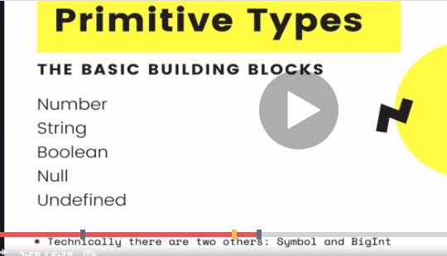  
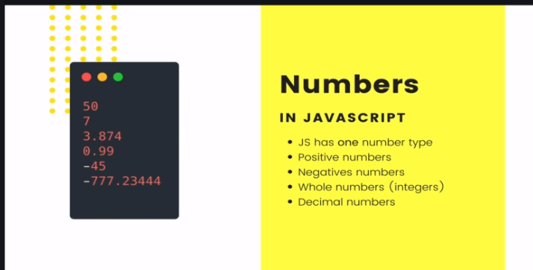  
  
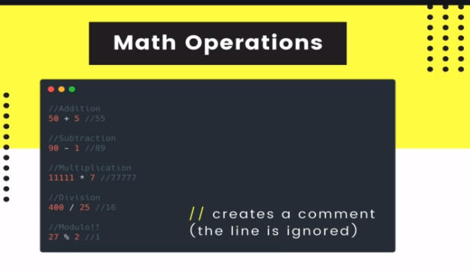

* What is NaN ?   
    
  The NaN property represents "Not-a-Number" value. This property indicates that a value is not a legal number.  
  The NaN property is the same as the Number.Nan property.  
  [isNaN()](https://www.w3schools.com/jsref/jsref_isnan.asp) global function to check if a value is a NaN value, first it converts the passing argument to Number then it checks is valid number or not, for the empty string it consider as a ZERO so it should be false in case of empty string.