**General information**

* Visual Studio 2017, VB.Net
* MS SQL 2008R2 (primary db name: WeeWatch_db; file db name: WeeWatch_File01_db)
* This is a project with heavy data entry – lots of fields and relationship

**Programming Notes – General**

* Logging
  + System level error: need to be able to log exemption error (TRY .. CATCH) and have graceful exit path
  + General operational logging
    - Logging of major operation (ie: add/edit/delete) – by who, when and where in the code/project/application
    - Logging of user errors and/or other managed errors (who/when/where)
    - The idea is to provide a good audit logging
* Minimize the use of session variables whenever possible – better to user parameters to go between pages – encrypting the query string between pages is a good practice
* Good practice of using correct data type
  + Ie: money should be using decimal type;
* Commenting code is required for readability and traceability
* Always perform proper validation before major operation – think about “Pre-condition” and “Post-condition”
* Eliminate / minimize the “Post-Back” effect by use of AJAX or alike

**Kick Start Project**

* Keep in mind, we will be sending you final screen layout and design in the near future. So all of your HTML / ASPX front end works at this points needs to be flexible; with the knowledge that you need to re-adjust and apply new style to it in the near future
* **You will be creating the following**
  + ***Children listing page***
    - A data grid show the following data:
      * Child first name, last name, DOB, age in “months”, primary contact phone, primary contact name, primary contact email
      * Each row should be clickable to “edit” the children information
        + Edit will open up ***children details page*** (not pop-up) -
    - The grid should have a filter (search) on top for keyword search on both lastname and firstname
    - See Appendix-A for what I mean here… just for reference
  + ***Children Details Page***
    - Tab 1- children info
      * Ability to view and update all the children fields
      * ***See appendix-B for the fields***
      * Need to be mindful about the data type:
        + Date should use datepicker
        + Phone number should use mask (xxx) xxx-xxxx
        + When asking for number, textbox should only accept number
    - Tab 2 – File upload page
      * Each child will have number of files (uploaded document) related to the child
      * Create a page, listing all the uploaded file related to the child
      * File needs to be uploaded and save to database as binary object (we do not keep the file in file folder)
        + Use a separate (different) database (ie: WeeWatch_File01_db) to store file

**APPENDIX A – LISTING PAGE SAMPLE (for reference only)**

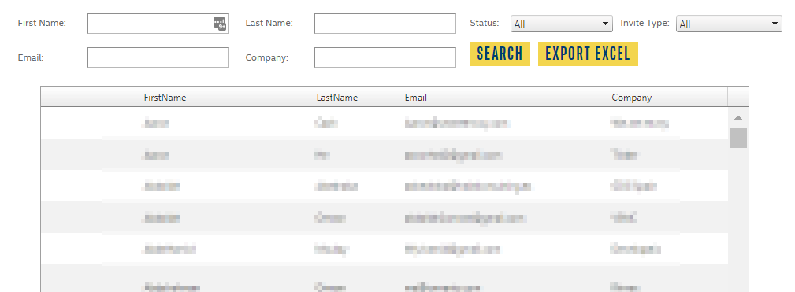

**APPENDIX B - FIELDS FOR CHILDREN DETAILS**

|  |  |  |  |
| --- | --- | --- | --- |
|  | **FIELD** | **TYPE** | **COMMENTS** |
|  | Child’s Last Name | Open alpha |  |
|  | First Name | Open alpha |  |
|  | Gender | Pick list or radio button | Male, Female |
|  | Birth date | Numeric | Standard fixed format ie. Month/day/yr or day/month/yr |
|  | Status | Pick List | Lead, in progress, active, inactive (need to be able to move a child to inactive and back to active) |
|  | Street Address |  | (Fields are: Address1, Unit #, City, Province, PostalCode) |
|  | Child Type | Pick List | Wee Watch, Own, Private |
|  | Provider | Pick List | Source: Active Provider Profiles (Field that you can search active Providers, and once “assigned” can be viewed when you search a child) |
|  | ~~2~~~~nd~~ ~~Provider~~ | ~~Pick List~~ | ~~Source: Active Provider Profiles~~ |
|  |  | | |
|  | **Parent 1 Information** (choose a field that says same address as child? And it auto populates) | | |
|  | Last Name | Open alpha |  |
|  | First Name | Open alpha |  |
|  | Private | Check box | Or yes/no (this indicator, we’d like to be able to run a report where we see any Private parents to remove them from the generation of email lists) – Or do something that generates from the child type |
|  | Gender | Pick list or radio button | Male, Female |
|  | Relation to child | Pick List | Mother, Father, Grandparent, other with open text |
|  | Street Address | Open alpha/numeric |  |
|  | Unit # /Apt # | Open alpha/numeric |  |
|  | City | Open alpha |  |
|  | Province | Pick list |  |
|  | Postal Code | Open alpha/numeric |  |
|  | Home Phone | Numeric |  |
|  | Work Phone | Numeric | With separate field for EXT |
|  | Cell Phone | Numeric |  |
|  | Email | Alpha/numeric |  |
|  | Primary email | Check box |  |
|  | Comments | Open field | 200 characters |
|  | Special Custody | Open field | 200 characters |
|  | Same address as Child | Check box | Prefills info or greys out the address fields |
|  | Admit Another Child Button |  | Ability to copy address of 1st child and parents |
|  | **Parent 2 information** | | |
|  | All same fields as first parent |  |  |
|  | Same address as child | Radio button or check box | Ability to copy address of 1st child and parents |
|  | **Siblings** | | |
|  | Sibling name | Open alpha | Should have space to add multiple siblings |
|  | Sibling Age | Open numeric |  |
|  | Sibling Gender | Pick list or radio button | Male, Female |
|  | Contacts | See notes above in general requests |  |
|  | **Emergency Contacts** | | |
|  | Contact 1 Name | Open alpha |  |
|  | Contact 1 Phone Number | Alpha/numeric |  |
|  | Contact 1 email | Alpha/numeric |  |
|  | Contact 1 Address |  |  |
|  | Relationship | Open text |  |
|  | Contact 2 Name | Alpha/numeric |  |
|  | Contact 2 Phone | Alpha/numeric |  |
|  | Contact 2 email | Alpha/numeric |  |
|  | Contact 2 address | Alpha numeric |  |
|  | Relationship | Open text |  |
|  | Contact 3 Name | Open alpha |  |
|  | Contact 3 Phone Number | Alpha/numeric |  |
|  | Contact 3 email | Alpha/numeric |  |
|  | Contact 3 Address |  |  |
|  | Relationship | Open text |  |
|  | Contact 4 Name | Alpha/numeric |  |
|  | Contact 4 Phone | Alpha/numeric |  |
|  | Contact 4 email | Alpha/numeric |  |
|  | Contact 4 address | Alpha numeric |  |
|  | Relationship | Open text |  |