
TRIBHUVAN UNIVERSITY
INSTITUTE OF ENGINEERING
PULCHOWK CAMPUS
An Adaptive Overcurrent Protection Scheme for Dual-Setting Directional Recloser and Fuse Coordination in Unbalanced Distribution Networks With Distributed Generation
BY:
Jhala Nath Kafle
(081MSPSE009)
A PROJECT REPORT SUBMITTED IN PARTIAL FULFILLMENT OF THE REQUIREMENTS FOR THE MASTER'S DEGREE IN POWER SYSTEM ENGINEERING
DEPARTMENT OF ELECTRICAL ENGINEERING
OCTOBER, 2026

COPYRIGHT
The author has agreed that the Library, Department of Electrical Engineering, Pulchowk Campus, Institute of Engineering may make this report freely available for inspection. Moreover, the author has agreed that permission for extensive copying of this project report for scholarly purpose may be granted by the supervisor who supervised the project work recorded herein or, in his or her absence, by the Head of the Department wherein the project report was done. It is understood that recognition will be given to the author of this report and to the Department of Electrical Engineering, Pulchowk Campus, Institute of Engineering in any use of the material of this project report. Copying or publication or the other use of this report for financial gain without approval of the Department of Electrical Engineering, Pulchowk Campus, Institute of Engineering and the author’s written permission is prohibited.
Request for permission to copy or to make any other use of the material in this report in whole or in part should be addressed to:
Head
Department of Electrical Engineering
Pulchowk Campus, Institute of Engineering
Lalitpur, Nepal

ABSTRACT
The recloser–fuse coordination of distribution networks with distributed generation (DG) can be lost when conventional overcurrent protection is used, because the DG changes the magnitude and the direction of the fault current seen by the protective devices. This project studies a protection coordination strategy based on a dual-setting directional recloser (DSDR) for the fuse-saving scheme of an unbalanced distribution network. The mid-line recloser is given independent forward and reverse settings, so that it coordinates with the lateral fuses for faults on both sides of it. The strategy is implemented on the IEEE 13-node test feeder in DIgSILENT PowerFactory with a synchronous DG, the characteristics of commercial recloser relays and fuses, unbalanced load-flow and short-circuit studies, and an electromagnetic-transient simulation of the reclosing sequence. The results show that the DG makes the fuses operate before the fast operation of a conventional recloser, increasingly so as the DG penetration rises, and that the dual-setting directional recloser, together with a revision of the fuse sizes, restores the fuse-saving coordination in the zone between the grid and the DG. They also show the limits of the strategy: the dial range of the recloser and the DG infeed to faults beyond the recloser.
Keywords: distributed generation, dual-setting directional recloser, fuse saving, recloser–fuse coordination, IEEE 13-node feeder, DIgSILENT PowerFactory.

TABLE OF CONTENTS
COPYRIGHT ii
ABSTRACT iii
TABLE OF CONTENTS iv
LIST OF FIGURES vii
LIST OF TABLES viii
LIST OF SYMBOLS AND ABBREVIATIONS x
CHAPTER ONE: INTRODUCTION 1
1.1 Background 1
1.2 Problem Statement 1
1.3 Objectives 1
1.3.1 General Objective 1
1.3.2 Specific Objectives 2
1.4 Scope of the Study 2
1.5 Significance of the Study 2
1.6 Limitations of the Study 2
1.7 Organization of the Report 3
CHAPTER TWO: LITERATURE REVIEW 4
2.1 Recloser–Fuse Protection of Distribution Feeders 4
2.2 Impact of Distributed Generation and Directional Adaptive Protection 4
2.3 Relay and Fuse Characteristics 4
2.4 Related Research and Data Used 4
2.5 Method Followed and Research Gap 5
CHAPTER THREE: METHODOLOGY 6
3.1 Research Methodology 6
3.2 Model Setup in DIgSILENT PowerFactory 7
3.3 Load Flow Analysis 7
3.4 Recloser Pickup Current 7
3.5 Short-Circuit Analysis 7
3.6 Mathematical Formulation of the DSDR 7
3.6.1 Forward Fast and Delayed Operating Time 7
3.6.2 Forward Pickup Current and Constraints 8
3.6.3 Fuse Characteristic and Coefficient 8
3.6.4 Series Fuses 8
3.6.5 Reverse Operating Times, Pickup and Constraints 9
3.7 Device Characteristics Used in the Model 9
3.7.1 R1: GE IAC77B801A 9
3.7.2 R2: GE/Alstom CDG34 9
3.7.3 Fuses 10
3.8 Coordination Criteria 10
3.9 Design Procedure 10
CHAPTER FOUR: SYSTEM MODELING AND SIMULATION SETUP 12
4.1 DIgSILENT PowerFactory Environment 12
4.2 IEEE 13-Node Feeder Model 12
4.3 Source and Feeder 13
4.4 Distributed Generation Model 13
4.5 Recloser Model 14
4.6 Fuse Model 14
4.7 Fault Model 15
4.8 Measurement and Data Acquisition 16
4.9 Simulation Cases 16
CHAPTER FIVE: RESULTS OBTAINED 17
5.1 Load-Flow Results 17
5.2 Branch Currents and Fault Levels 18
5.3 Recloser Pickup Currents and Settings 18
5.4 Short-Circuit Results With and Without DG 18
5.5 Fuse Coefficients 19
5.6 Conventional Coordination Without DG 20
5.7 Coordination With DG and a Conventional R2 21
5.8 DSDR Settings and Fuse Revision 23
5.9 Coordination With the DSDR 24
5.10 Operating Times With the DSDR 26
5.11 Single Setting Against Dual Setting on Selected Faults 27
5.12 Time-Sequence Check 29
5.13 Time-Domain Verification 30
5.14 Verification With the Relay and Fuse Models of PowerFactory 32
5.15 Sensitivity of the Result to the Margin 32
5.16 Effect of the DG Penetration Level 32
5.17 Results Summary 36
CHAPTER SIX: DISCUSSION 37
6.1 Effect of DG on Fault Current 37
6.2 Effect of Fault Current Direction 37
6.3 Performance of the Conventional Protection 37
6.4 Performance of the DSDR 37
6.5 Limits Reached by the Devices 37
6.6 Engineering Implication 38
CHAPTER SEVEN: CONCLUSION AND FUTURE WORK 39
7.1 Conclusion 39
7.2 Major Findings 39
7.3 Contributions of the Present Work 40
7.4 Future Work 40
REFERENCES 41
APPENDIX A: COMPLETE COPY OF THE REFERENCE PAPER 42
APPENDIX B: IMPLEMENTATION FORMULAS 43
APPENDIX C: COMPARISON WITH THE REFERENCE PAPER 44
Basis of Comparison 44
Base-Case Comparison 45
Fault-Current Magnitude Difference 45
Fuse and Coordination Comparison 45
Operating-Time Comparison (Table IV) 45
Central Finding Comparison 45
Tables of the comparison 46
DG penetration (Fig. 7 of the paper) 50

LIST OF FIGURES
Figure 3.1 Flowchart of the recloser–fuse coordination method with the DSDR. 6
Figure 4.1 IEEE 13-node feeder with the reclosers R1 and R2, the fuses and the DG at node 692. 12
Figure 5.1 LG fault at 611: R2 forward, fuses F684 and F671-2; CTI = +143 ms. 21
Figure 5.2 LLG fault at the middle of 692–675 through 1 Ω; CTI = +127 ms. 21
Figure 5.3 Coordination status with DG, without the DSDR. 22
Figure 5.4 LL fault at 646 through 1 Ω: R1 with F646 and F632; CTI = +200 ms. 22
Figure 5.5 LL fault at 645 through 1.5 Ω, conventional R2. 23
Figure 5.6 Three-phase fault at 10 per cent of line 632–633, conventional R2; CTI = $-83$ ms, the fuse melts first. 23
Figure 5.7 The two setting groups of R2: reverse (DG contribution, faults towards 632) and forward (grid contribution, faults beyond 671), each with one fault of the model. 24
Figure 5.8 Coordination status with DG and the DSDR. 25
Figure 5.9 Bolted LL fault at 646: R2 reverse setting with F646 and F632; CTI = +328 ms. 25
Figure 5.10 Bolted LL fault at 646: R1 with F646 and F632; CTI = +226 ms. 26
Figure 5.11 Three-phase fault at 10 per cent of line 632–633: single setting (left, CTI = $-22$ ms) and dual setting (right, CTI = +16 ms). 28
Figure 5.12 LG fault at 646: the single-setting R2 does not pick up the reverse current (left); the reverse group does (right, CTI = +661 ms). 29
Figure 5.13 Time-sequence check of all 39 cells, single against dual setting. 30
Figure 5.14 Time-domain current at node 632 for an LL (a–c) fault at 684 through 0.2 Ω : without DG (top) and with DG (bottom). 31
Figure 5.15 Percentage variation of the CTI with DG penetration (outer ring 671, inner ring 633). 33
Figure 5.16 Currents through the fuse (grid and DG share), the recloser (grid share) and from the DG, and the resulting CTI, against DG penetration. 34
Figure 5.17 Time–current characteristics at all penetration levels: fuse operating points (squares) and recloser operating points (circles). 34
Figure 5.18 Node 633, fuse F633 and R1, at each penetration level, with the short-circuit currents, operating times and CTI. 35
Figure C.1 CTI against DG penetration: this study (left) and the values read from the paper’s Fig. 7 (right). 51

LIST OF TABLES
Table 4.1 Parameters of the synchronous DG in the PowerFactory model. 13
Table 4.2 Recloser settings. For R2 the fast plug is half and the delayed plug equal to $1.25 Inom$, because the CDG curve starts at twice the plug setting. 14
Table 4.3 Fuses and their sizes (A055C, E-rated). Bold: changed by the fuse revision with the DG. 15
Table 4.4 Simulation cases. 16
Table 5.1 Bus voltages from the unbalanced load flow, without and with the DG. 17
Table 5.2 Load current at the reclosers (largest phase; + is forward, away from the grid). 17
Table 5.3 Rated, minimum and maximum fault current of the protected branches without DG. XFM1 HV side: 4.16 kV currents for a fault on the 0.48 kV side. 18
Table 5.4 Maximum fault current and recloser currents without and with the DG (+ forward, $-$ reverse). 19
Table 5.5 Fuse coefficients, eq. (3.7), $ai=-1.8$. Size and $tMMT$: fuse of the design without DG at the same current. 20
Table 5.6 Coordination status with DG and a conventional R2. ✓ exists, ✗ does not exist, – not applicable. 22
Table 5.7 Coordination status with DG and the revised fuses: single-setting R2 against dual-setting R2. 24
Table 5.8 Recloser operating times with the DSDR, DG in service. 26
Table 5.9 Fuse times with the DSDR, DG in service. Margin = $tMMT$ minus the last fast trip (R2 for faults below R2; the later of R1 and R2 reverse above it). Nodes 632, 671 and 680 are on the main feeder and have no fuse. 27
Table 5.10 Nine faults with the DG in service: single-setting against dual-setting R2, same fuses. 27
Table 5.11 Three-phase fault at 10 per cent of line 632–633: currents, settings and operating times. 28
Table 5.12 LG fault at 646 (phase c): currents, settings and operating times. 29
Table 5.13 Reclosing sequence of the EMT simulation. 31
Table 5.14 CTI against DG penetration, conventional protection. 33
Table 5.15 Largest bolted fault current at each node (A) against DG penetration. 35
Table 5.16 Load flow, pickups by eq. (3.3) and lowest fault current through each recloser against DG penetration. $​*$: below the start of the recloser’s curve with the fixed settings (not detected). 36
Table 5.17 Summary of the coordination results. 36
Table C.1 Comparison of the results with the reference paper. 44
Table C.2 DG parameters: reference paper (Table I) against the PowerFactory model. 46
Table C.3 Branch currents: model against Table II of the paper. XFM1 HV side: the model values are 4.16 kV currents for a fault on the 0.48 kV side, so this row is not comparable. 47
Table C.4 Maximum fault current, DG out: IEEE benchmark, this study and the paper’s Table II. Deviations are relative to the benchmark. 48
Table C.5 Fuse coefficients against Table III of the paper. “$bi$ rev.”: index $i$ counted from the source, which reproduces the paper’s values in R1’s zone. 48
Table C.6 Recloser operating times against Table IV of the paper. 49
Table C.7 Fuse times against Table IV of the paper. 49
Table C.8 Coordination status with DG and a conventional R2: model against the paper’s Fig. 14. 50
Table C.9 Reclosing sequence of the EMT simulation against the paper’s Fig. 10. 50
Table C.10 CTI shares against DG penetration: this study and the paper’s Fig. 7. 51

LIST OF SYMBOLS AND ABBREVIATIONS
Symbols
$$I_{f}$$ | Fault current seen by a protection device
$$I_{p}$$ | Pickup current of a recloser
$$I_{s}$$ | Plug (current) setting of the CDG relay
$$I_{nom}$$ | Rated (load) current
$$M$$ | Multiple of pickup, $I_{f}/I_{p}$
$TDS$, $TMS$ | Time-dial / time-multiplier setting
$t_{F}$, $t_{D}$ | Fast and delayed operating time of a recloser
$t_{MMT}$, $t_{TCT}$ | Minimum-melting and total-clearing time of a fuse
$A$, $B$, $n$ | Constants of the inverse-time curve
$a_{i}$, $b_{i}$ | Coefficients of the fuse characteristic
$k$, $l$, $m$ | Index of the recloser, of a downstream and of an upstream fault location
$z$, $i$ | Number of series fuses in the fault path; position of a fuse in it
$$Z_{f}$$ | Fault impedance
$X_{d}$, $X_{d}^{'}$, $X_{d}^{″}$ | Direct-axis synchronous, transient and subtransient reactance
$X_{q}$, $X_{q}^{'}$, $X_{q}^{″}$ | Quadrature-axis reactances
$$R_{a}$$ | Armature resistance
Abbreviations
CT | Current Transformer
CTI | Coordination Time Interval
DG | Distributed Generation
DSDR | Dual-Setting Directional Recloser
EMT | Electromagnetic Transient (simulation)
LG | Line-to-Ground fault
LL | Line-to-Line fault
LLG | Line-to-Line-to-Ground fault
LLL | Three-Phase fault
MMT | Minimum Melting Time
OLF | Overload Factor
PD | Protection Device
PF | DIgSILENT PowerFactory
R1 | Feeder-Head Recloser
R2 | Mid-Line Recloser (the DSDR)
RMS | Root Mean Square
SBDG | Synchronous-Based Distributed Generator
TCC | Time-Current Characteristic
TCT | Total Clearing Time
TDS | Time Dial Setting
TMS | Time Multiplier Setting

CHAPTER ONE: INTRODUCTION

1.1 Background
Overcurrent protection of radial distribution networks is traditionally coordinated on the assumption that the fault current flows from the substation towards the loads. A recloser upstream of a fuse first operates on a fast characteristic, to clear a temporary fault before the fuse melts, and then on a delayed characteristic, to let the fuse clear a permanent fault. This fuse-saving arrangement only works while the fuse curve lies between the two recloser curves over the whole range of fault currents.
Distributed generation changes this. A DG downstream of a recloser feeds current towards a fault upstream of it, so the recloser carries current in the reverse direction, and a fuse between the two sources carries the sum of both contributions while each recloser carries only one. The current seen by a protection device then depends on the fault location, the topology and the DG, and a single fixed setting is no longer suitable for both directions.
The dual-setting directional recloser (DSDR) addresses this by giving the mid-line recloser separate pickup and time-dial settings for the forward and for the reverse direction. This project implements the DSDR method of [1] on the IEEE 13-node feeder in DIgSILENT PowerFactory and evaluates it.

1.2 Problem Statement
The problem addressed is the loss of recloser–fuse coordination caused by the change of fault-current magnitude and direction when a DG is connected. A conventional scheme that is coordinated without DG may lose the fuse-saving property in the zone between the grid and the DG. The project investigates whether the DSDR method restores the coordination in an independently built model that uses the real characteristics of the protection devices.

1.3 Objectives

1.3.1 General Objective
To build and validate a DIgSILENT PowerFactory implementation of the DSDR protection-coordination method on the IEEE 13-node test feeder, with and without distributed generation.

1.3.2 Specific Objectives
- Build and verify the IEEE 13-node feeder with its recloser and fuse protection.
- Perform unbalanced load-flow and short-circuit studies for all fault types and phase combinations.
- Calculate the recloser pickup currents, time dials and the fuse coefficients with the method’s equations.
- Establish the conventional recloser–fuse coordination without DG.
- Connect the 4.05 MVA synchronous DG at node 692 and quantify the change of the fault currents and of their direction at the reclosers.
- Classify the coordination with DG for a conventional recloser R2.
- Design the forward and reverse settings of R2 as a DSDR and classify the coordination again and determine the operating times.
- Verify the reclosing sequence in the time domain.
- Study how the coordination degrades as the DG penetration rises from 0 to 100 per cent.

1.4 Scope of the Study
The study covers the IEEE 13-node feeder: unbalanced load flow, LG, LL, LLG and LLL faults at twelve fault locations, pickup and time-dial calculation, fuse coordination, the DSDR forward and reverse settings, the coordination classification with and without the DSDR, and one EMT simulation. The IEEE 34-node feeder is outside the completed work.

1.5 Significance of the Study
The study gives a reproducible implementation of a protection-coordination method for feeders with DG in a tool that utilities use. It shows what the method achieves when the real relay dials and fuse sizes are respected, and it separates the contribution of the dual setting from the contribution of the fuse revision.

1.6 Limitations of the Study
- The method leaves the settings of R2, the fuse sizes, the source impedance and the fault type of each operating-time case open. These were chosen; every choice and its
basis is listed in Section 4.8.
- The library model of the CDG34 relay is not directional. The two setting groups are modelled as separate relay units and the direction is assigned from the fault location.
- Coordination is judged with a zero-margin criterion (the fuse must not start to melt before the fast trip). Section 5.15 shows how the result changes with a breaker time and a fuse margin.
- The DG penetration study (Section 5.16) uses one DG location (692) and keeps the protection of the design without DG at every level.
- The IEEE 34-node feeder has not been modelled.

1.7 Organization of the Report
Chapter One introduces the problem and the objectives. Chapter Two reviews the literature on the protection concepts and the method followed. Chapter Three gives the method and its equations. Chapter Four describes the PowerFactory model, the DG, the protection devices and the simulation cases. Chapter Five presents the results. Chapter Six discusses the findings and their limits. Chapter Seven gives the conclusions and the future work. The comparison with the reference paper is in Appendix C.

CHAPTER TWO: LITERATURE REVIEW

2.1 Recloser–Fuse Protection of Distribution Feeders
Distribution feeders are protected by reclosers and fuses with inverse-time characteristics: the operating time falls as the multiple of the pickup current rises, so the device nearest the fault acts first and the upstream devices act as backup [2]. The pickup fixes where the characteristic starts and the time dial scales the operating time; real relays offer only discrete taps and a limited dial range. In the fuse-saving scheme the recloser’s fast curve must lie below the minimum-melting curve of the fuse, so that a temporary fault is cleared without blowing the fuse, and its delayed curve above the total-clearing curve, so that the fuse isolates a permanent fault. Fuses in series must be selective: the fuse nearer the fault clears before the upstream fuse starts to melt.

2.2 Impact of Distributed Generation and Directional Adaptive Protection
A DG raises the current through the fuses and can reverse the current through a recloser. The recloser and the fuse then no longer carry the same current, and a scheme that was coordinated without DG may let the fuse melt before the fast trip [3]. A directional element distinguishes the direction of the fault current, and adaptive protection changes the settings with the state of the network. The dual-setting directional recloser (DSDR) combines both: it holds a forward and a reverse setting group and selects one from the direction of the current, without communication [1].

2.3 Relay and Fuse Characteristics
Inverse-time relay curves are given by standard equations [2] or by the manufacturer’s own equation or table; the GE IAC and the CDG series follow their manufacturer’s curves, in which the time is the time dial multiplied by a function of $M=I_{f}/I_{p}$ [4]. A fuse is described by its minimum-melting time (MMT), when the element starts to melt, and its total-clearing time (TCT), when the arc is extinguished.

2.4 Related Research and Data Used
A classification technique decides for each fault whether recloser–fuse coordination with DG exists [3]. A benchmark overcurrent protection scheme for the IEEE 13-node feeder [5], with device types and fuse sizes, is given in [6]; the published short-circuit
currents of the IEEE test feeders [7] are used here to validate the fault levels, and the relay curves are those of the manufacturers’ manuals [4]. Because the feeder is unbalanced, all calculations are made per phase and keep only the phases that exist at each node.

2.5 Method Followed and Research Gap
The study follows the adaptive overcurrent protection scheme with a DSDR of [1]: its equations for the forward and reverse operating times, pickups, fuse coefficients and setting constraints, and its flowchart for the design sequence. The reference reports that the DSDR restores coordination in every case, but it does not publish the DSDR settings, and its fuse curves differ from its own fuse equation. The gap addressed here is an independent implementation in PowerFactory with the real relay curves, dial ranges and fuse sizes, which shows how much of the improvement comes from the dual setting and where the method reaches the limits of the devices.

CHAPTER THREE: METHODOLOGY

3.1 Research Methodology
The work follows the flowchart of the reference method [1], shown in Figure 3.1 as it is implemented. It has three stages: (A) the conventional scheme without DG, (B) the same settings with the DG connected, and (C) R2 as a dual-setting directional recloser with the fuse revision of the method.
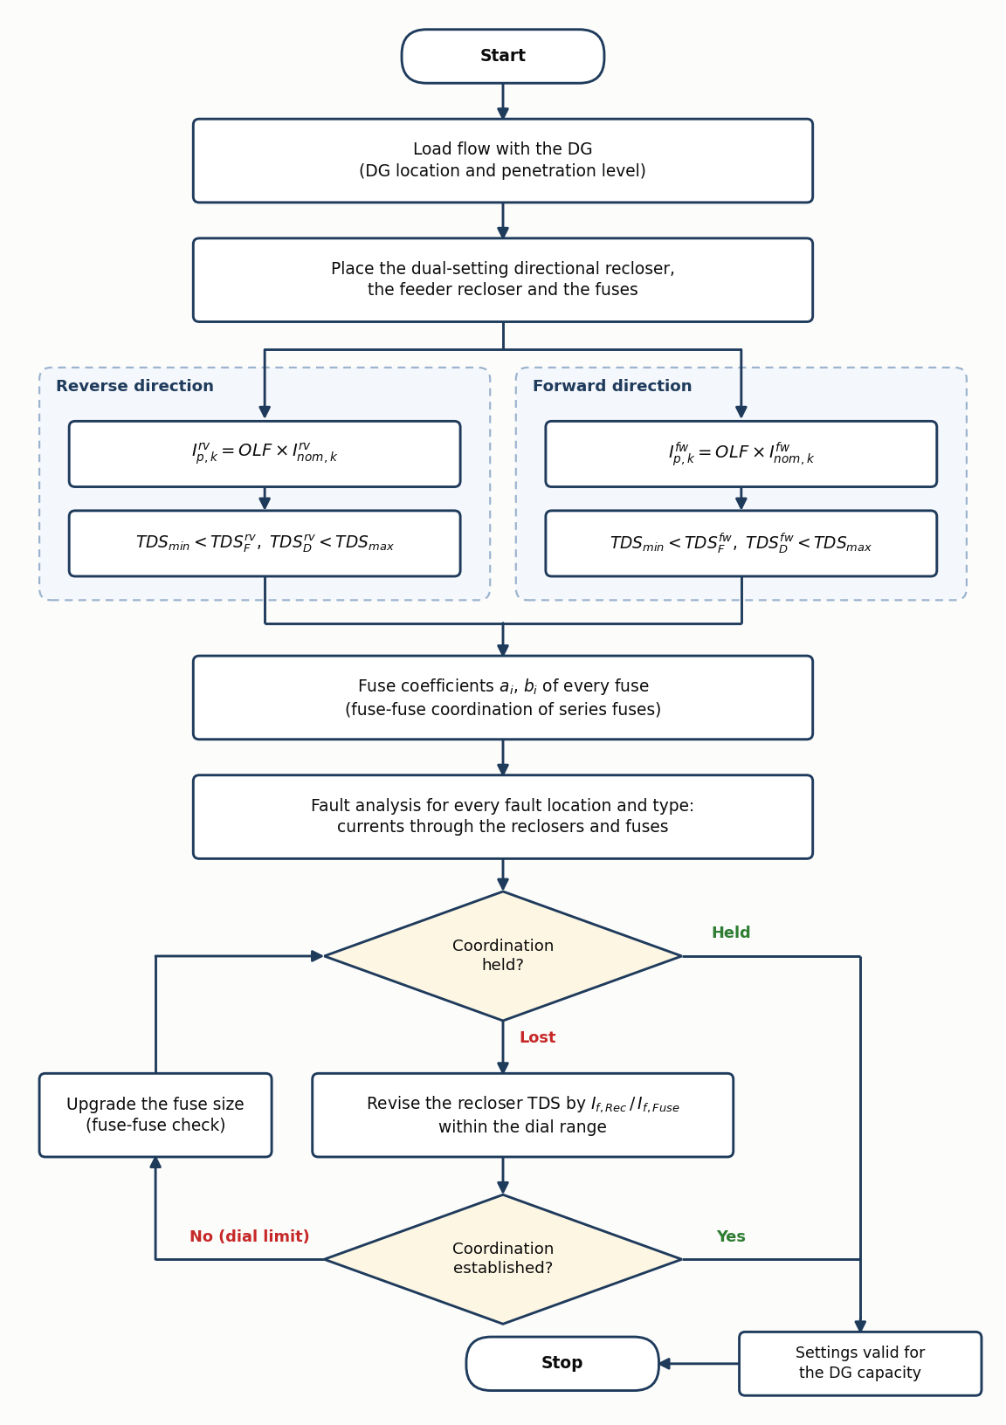
Figure 3.1 Flowchart of the recloser–fuse coordination method with the DSDR.

3.2 Model Setup in DIgSILENT PowerFactory
The study is carried out in DIgSILENT PowerFactory 2021 SP2 [8]. The feeder is the IEEE 13-node model of the DIgSILENT example library; its lines, loads and regulator taps were checked against the IEEE data. The study case that includes the 115/4.16 kV, 5 MVA substation transformer is used, because it reproduces the IEEE short-circuit benchmark [7].

3.3 Load Flow Analysis
The load flow is the unbalanced three-phase AC load flow of PowerFactory. It gives the rated current of every protected branch (largest phase), the bus voltages per phase, and the current and its direction at the two reclosers with and without the DG.

3.4 Recloser Pickup Current
The method uses an overload factor of 1.25 [1]. The pickup is 1.25 times the rated current of the protected branch, eq. (3.3), and is then set on the nearest available tap of the relay.

3.5 Short-Circuit Analysis
Short circuits are calculated with the complete method of PowerFactory, which starts from the pre-fault load flow. LG, LL, LLG and LLL faults are applied at every node for every phase combination that exists there, with the DG out and in. The maximum fault current of a branch is a bolted fault at its nearest node; the minimum is an LG fault through 3 Ω at its farthest node [1]. The current through R1, R2, every fuse and every branch of Table 5.3 is stored for each fault.

3.6 Mathematical Formulation of the DSDR
The equations below are those of the reference method [1].

3.6.1 Forward Fast and Delayed Operating Time
$$t_{k,l,F}^{fw}=TDS_{k,F}^{fw}\left[\frac{A_{k}^{fw}}{{\left(I_{f,l}/I_{p,k}^{fw}\right)}^{n_{k}^{fw}}-1}+B_{k}^{fw}\right] (3.1)$$
$$t_{k,l,D}^{fw}=TDS_{k,D}^{fw}\left[\frac{A_{k}^{fw}}{{\left(I_{f,l}/I_{p,k}^{fw}\right)}^{n_{k}^{fw}}-1}+B_{k}^{fw}\right] (3.2)$$
The fast and the delayed operation of recloser $k$ for a fault at location $l$ use the same curve with two time dials. $I_{f,l}$ is the fault current through the recloser and $I_{p}$ its pickup.

3.6.2 Forward Pickup Current and Constraints
$$I_{p,k}^{fw}=OLF×I_{nom,k}^{fw} (3.3)$$
$$TDS_{k,min}<TDS_{k,F}^{fw}, TDS_{k,D}^{fw}<TDS_{k,max} (3.4)$$
$$I_{p,k,min}<I_{p,k}^{fw}<I_{p,k,max} (3.5)$$
The pickup lies above the load current and below the minimum fault current of the zone; the dials must stay inside the range of the device.

3.6.3 Fuse Characteristic and Coefficient
$$logt_{fuse,i}=a_{i}logI_{f,i}+b_{i} (3.6)$$
$$b_{i}=log​\left[\frac{t_{k,F}^{fw}+t_{k,D}^{fw}}{2}\right]-a_{i}logI_{f,i} (3.7)$$
with $a_{i}=-1.8$. Equation (3.7) places a single fuse midway between the fast and the delayed time at the calibration current.

3.6.4 Series Fuses
$$t_{TCT, i}≤0.75 t_{MMT, i+1} (3.8)$$
$$b_{i}=log​\left[t_{k,F}^{fw}+\frac{i\left(t_{k,D}^{fw}-t_{k,F}^{fw}\right)}{z+1}\right]-a_{i}logI_{f,i} (3.9)$$
where $z$ is the number of series fuses in the fault path and $i=1$ is the fuse closest to the fault. Equation (3.9) divides the window between the two recloser times among the series fuses.

3.6.5 Reverse Operating Times, Pickup and Constraints
$$t_{k,m,F}^{rv}=TDS_{k,F}^{rv}\left[\frac{A_{k}^{rv}}{{\left(I_{f,m}/I_{p,k}^{rv}\right)}^{n_{k}^{rv}}-1}+B_{k}^{rv}\right] (3.10)$$
$$t_{k,m,D}^{rv}=TDS_{k,D}^{rv}\left[\frac{A_{k}^{rv}}{{\left(I_{f,m}/I_{p,k}^{rv}\right)}^{n_{k}^{rv}}-1}+B_{k}^{rv}\right] (3.11)$$
$$I_{p,k}^{rv}=OLF×I_{nom,k}^{rv} (3.12)$$
$$TDS_{k,min}<TDS_{k,F}^{rv}, TDS_{k,D}^{rv}<TDS_{k,max} (3.13)$$
$$I_{p,k,min}<I_{p,k}^{rv}<I_{p,k,max} (3.14)$$
Here $m$ is a fault location upstream of the recloser. The reverse current is the contribution of the DG, and the reverse pickup is based on the reverse load current that flows when the DG exports towards the substation.

3.7 Device Characteristics Used in the Model
The model uses the time–current curves of the PowerFactory library types of the protection devices.

3.7.1 R1: GE IAC77B801A
The operating time of R1 follows the GE IAC extremely inverse characteristic. The manufacturer gives it as $t=M_{TDS} [A+B/(M-C)+D/(M-C)^{2}+E/(M-C)^{3}]$ with $A=0.004$, $B=0.638$, $C=0.620$, $D=1.787$ and $E=0.246$ [4]. With the constants of the PowerFactory library type (the same values to four digits) the curve is
$$t=TDS\left[0.004+\frac{0.6379}{M-0.62}+\frac{1.7872}{(M-0.62)^{2}}+\frac{0.2461}{(M-0.62)^{3}}\right], M=\frac{I_{f}}{I_{p}}, (3.15)$$
valid from $M=1.5$ to $M=40$. For 4219 A, for example, it gives 0.096 s (fast, TDS 0.5) and 1.926 s (delayed, TDS 10).

3.7.2 R2: GE/Alstom CDG34
The CDG extremely inverse characteristic is a manufacturer’s table of time against $M=I_{f}/I_{s}$ for time multipliers from 0.1 to 1.0. It starts at twice the plug setting and is
interpolated on log-log axes:
$$t=t_{1}{\left(\frac{t_{2}}{t_{1}}\right)}^{f}, f=\frac{ln(M/M_{1})}{ln(M_{2}/M_{1})}. (3.16)$$
The table is not defined below a multiplier of 0.1, so 0.1 is the fastest setting of this relay.

3.7.3 Fuses
The fuses are Gould-Shawmut A055C (5.5 kV, E-rated) with their minimum-melting and total-clearing curves. The fuse times are read from these curves at the current through the fuse with the same interpolation as eq. (3.16). The straight line of eq. (3.6) is used only to compute the coefficients of Table 5.5.

3.8 Coordination Criteria
A fault cell is classified as coordination exists when all of the following hold:
$$t_{MMT}(I_{fuse})>t_{F} \text{for every recloser that feeds the fault through the fuse,} (3.17)$$
$$t_{TCT}(I_{fuse})<t_{D} \text{for the same reclosers,} (3.18)$$
together with the series-fuse condition of eq. (3.8) and a margin of at least 10 cycles between the delayed curves of R2 and R1. A cell (node and fault type) is held only if every phase combination of that fault type is held. The fuse and each recloser are evaluated at their own currents, because with DG they differ.

3.9 Design Procedure
The flowchart of Figure 3.1 is applied in these steps.
- Run the load flow without DG and set the recloser pickups from the rated currents.
- Run the short-circuit study for the minimum and maximum fault currents of each section.
- Set the dials: R1 at TDS 0.5 and 10; R2 fast at its lowest dial, delayed 10 cycles below R1.
- Calculate the fuse coefficients and check the installed fuses, including the series fuses.
- Classify the coordination without DG and revise the fuses until every case is held.
- Connect the DG with the settings unchanged and classify again.
- Set the reverse pickup and the reverse dials of R2 as a DSDR.
- Revise the dials and, where a dial limit is reached, the fuse sizes until the cases are held.
- Classify the coordination with the DSDR and determine the operating times.
- Verify with PowerFactory’s own relay and fuse models and the EMT simulation.

CHAPTER FOUR: SYSTEM MODELING AND SIMULATION SETUP

4.1 DIgSILENT PowerFactory Environment
The model is the project IEEE13 DSDR Fuse Coordination in PowerFactory 2021 SP2. Load flows use the unbalanced AC method, short circuits the complete method, and the time-domain study the EMT simulation with a step of 0.1 ms. The relays and fuses are modelled with the PowerFactory library types of the actual devices.

4.2 IEEE 13-Node Feeder Model
Figure 4.1 shows the feeder with its protection devices. The feeder has the voltage regulator at the substation, overhead and cable sections, the 4.16/0.48 kV transformer XFM-1, spot and distributed loads, and two capacitors. The middle part of the distributed load on line 632–671 is placed behind a short lateral (node DL) so that a fault there lies below its fuse.
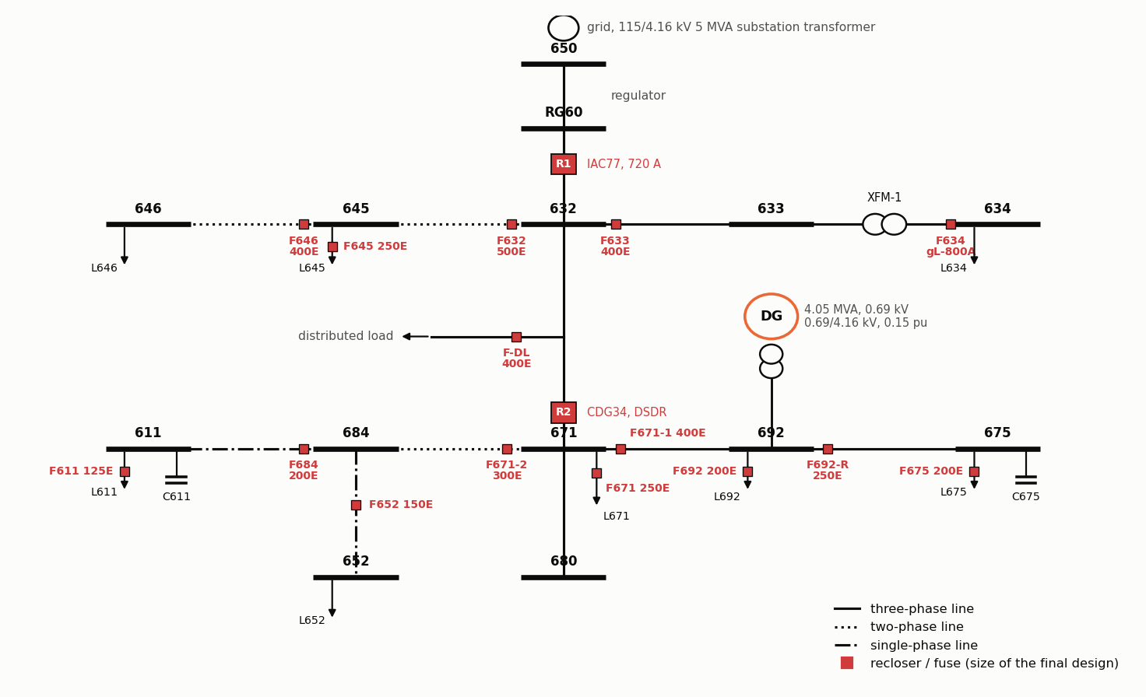
Figure 4.1 IEEE 13-node feeder with the reclosers R1 and R2, the fuses and the DG at node 692.

4.3 Source and Feeder
The source is an external grid at 115 kV behind the 5 MVA, 115/4.16 kV substation transformer ($u_{k}=8.06percent$). With this source the fault currents agree with the IEEE benchmark [7] within about 2 per cent at every node. The alternative study case with a stiff 4.16 kV source overstates the fault levels by 20 to 65 per cent and is not used. The regulator taps are fixed at +10, +8 and +11.

4.4 Distributed Generation Model
The DG is a 4.05 MVA, 0.69 kV synchronous machine connected to node 692 through a 0.69/4.16 kV transformer with a leakage reactance of 0.15 p.u. It is modelled with the standard synchronous-machine model of PowerFactory, round rotor, with the short-circuit data of Table 4.1 (values read back from the model). In the load flow the machine delivers 3.24 MW and controls its terminal voltage to 1.0 p.u.
Table 4.1 Parameters of the synchronous DG in the PowerFactory model.
Parameter | Symbol | Value | Unit
Leakage reactance | $$X_{l}$$ | 0.05 | pu
Stator resistance | $$R_{a}$$ | 0.0014 | pu
d-axis synchronous reactance | $$X_{d}$$ | 1.4 | pu
d-axis transient reactance | $$X_{d}^{'}$$ | 0.231 | pu
d-axis subtransient reactance | $$X_{d}^{″}$$ | 0.118 | pu
d-axis transient open-circuit time constant | $$T_{d0}^{'}$$ | 5.5 | s
d-axis subtransient open-circuit time constant | $$T_{d0}^{″}$$ | 0.05 | s
q-axis synchronous reactance | $$X_{q}$$ | 1.372 | pu
q-axis transient reactance | $$X_{q}^{'}$$ | 0.8 | pu
q-axis subtransient reactance | $$X_{q}^{″}$$ | 0.118 | pu
q-axis transient open-circuit time constant | $$T_{q0}^{'}$$ | 1.25 | s
q-axis subtransient open-circuit time constant | $$T_{q0}^{″}$$ | 0.19 | s
Mechanical starting time | $$M=2H$$ | 1.5 | s
DG rating | $$S_{n}$$ | 4.05 | MVA
DG voltage | $$U_{n}$$ | 0.69 | kV
Step-up transformer, HV side | $$U_{HV}$$ | 4.16 | kV
Step-up transformer leakage reactance | $$x_{T}$$ | 0.15 | pu

4.5 Recloser Model
R1 is at the feeder head (RG60–632). R2 is on line 632–671 at the 671 end; it is the DSDR, because with the DG at 692 it carries forward current for faults at 671 and beyond and reverse current for faults towards 632. Table 4.2 gives the settings. The forward and the reverse group of R2 are four relay units of the CDG34 library type on two current transformers.
Table 4.2 Recloser settings. For R2 the fast plug is half and the delayed plug equal to $1.25 I_{nom}$, because the CDG curve starts at twice the plug setting.
Recloser | Relay, CT | $$1.25 I_{nom}$$ | Setting | Dial fast / delayed
R1 forward | GE IAC77B801A, 900/5 | 734.6 A | tap 4 A = 720 A | TDS 0.5 / 10
R2 forward | CDG34, 1000/5 | 587.5 A | plug 300 A / 600 A | TMS 0.1 / 1.0
R2 reverse | CDG34, 500/5 | 315.3 A | plug 150 A / 300 A | TMS 0.1 / 1.0

4.6 Fuse Model
Table 4.3 lists the fifteen fuses. The starting size is the size drawn in the figures of the reference paper where a figure shows the fuse (the fuse bands were digitised and matched to the A055C library curves within 2 per cent), otherwise the size of the benchmark scheme [6]. The last two columns are the sizes after the fuse revision of the method without DG and with the DSDR.
Table 4.3 Fuses and their sizes (A055C, E-rated). Bold: changed by the fuse revision with the DG.
Fuse | Location | Start | No DG | DSDR | Source of the starting size
F632 | lateral 632–645, at 632 | 400E | 400E | 500E | Ref. [1], Figs. 12, 15, 16
F633 | lateral 632–633, at 632 | 250E | 250E | 400E | Benchmark scheme [6], Table V
F634 | XFM-1, 0.48 kV side | gL-800A | gL-800A | gL-800A | Benchmark scheme [6], Table V
F645 | load at 645 | 250E | 250E | 250E | Benchmark scheme [6], Table V
F646 | line 645–646, at 645 | 300E | 300E | 400E | Ref. [1], Figs. 11, 15, 16
F-DL | distributed-load lateral on 632–671 | 250E | 250E | 400E | Benchmark scheme [6], Table V
F671 | load at 671 | 250E | 250E | 250E | Benchmark scheme [6], Table V
F671-1 | 671–692 (switch), at 671 | 300E | 300E | 400E | Ref. [1], Fig. 9
F692 | load at 692 | 200E | 200E | 200E | Benchmark scheme [6], Table V
F692-R | cable 692–675, at 692 | 250E | 200E | 250E | Ref. [1], Fig. 9
F675 | load at 675 | 200E | 200E | 200E | Benchmark scheme [6], Table V
F671-2 | lateral 671–684, at 671 | 300E | 300E | 300E | Ref. [1], Fig. 8
F684 | line 684–611, at 684 | 200E | 200E | 200E | Ref. [1], Fig. 8
F611 | load at 611 | 125E | 125E | 125E | Benchmark scheme [6], Table V
F652 | cable 684–652, at 684 | 150E | 150E | 150E | Benchmark scheme [6], Table V

4.7 Fault Model
Faults are applied at the nodes 632, 633, 634, 645, 646, DL, 671, 692, 675, 680, 684, 611 and 652. Only the fault types that the phases of a node allow are applied, for example LL and LLG on phases b–c at 645 and 646, and LG only at 611 and 652. This gives 39 node/fault-type cells. Selected faults through a fault impedance are added for the time–current figures.

4.8 Measurement and Data Acquisition
For every fault the phase currents through R1, R2 and each fuse are read from the short-circuit result. The operating current of a device is its largest phase current. The forward direction is away from the grid; R2 sits at the 671 end of its line, where PowerFactory counts the current positive into the line, so its values are multiplied by $-1$. The following modelling choices were made:
- the source: the IEEE benchmark substation transformer, with the complete short-circuit method;
- R1: tap 4 A on a 900/5 current transformer, i.e. a pickup of 720 A;
- R2: all settings of Table 4.2, derived from eqs. (3.3) and (3.12);
- the operating-time cases of Table 5.8: bolted LLL faults, LL at two-phase nodes, LG at single-phase nodes;
- the EMT study: a reclosing dead time of 0.2 s and a breaker time of three cycles.

4.9 Simulation Cases
Table 4.4 Simulation cases.
Case | DG | Faults | Purpose
Load flow | out / in | – | Rated currents, voltages, direction at R1 and R2
Maximum faults | out / in | All nodes, LG/LL/LLG/LLL, all phase combinations, bolted | Classification, Tables II–IV
Minimum faults | out / in | LG through 3 Ω at all nodes | $I_{f,min}$, pickup check
Figure faults | in | Selected faults, bolted and through a fault impedance | Time–current figures
EMT | out / in | LL a–c at 684 through 0.2 Ω | Reclosing sequence
Penetration | 0–100 % | LLL at 633, LL at 684, all nodes | CTI, fault levels and pickups against DG size

CHAPTER FIVE: RESULTS OBTAINED

5.1 Load-Flow Results
Table 5.1 gives the bus voltages with and without the DG. Without DG the lowest voltage is 0.971 p.u. (phase c at 611). The DG raises the voltages of the loaded phases a and c at node 671 and beyond by about 0.03 to 0.05 p.u.
Table 5.1 Bus voltages from the unbalanced load flow, without and with the DG.
 | Without DG (p.u.) |  |  | With DG (p.u.)
Bus | A | B | C | A | B | C
650 | 0.9981 | 1.0170 | 0.9979 | 1.0084 | 1.0200 | 1.0057
RG60 | 1.0605 | 1.0679 | 1.0665 | 1.0715 | 1.0710 | 1.0748
632 | 1.0187 | 1.0616 | 1.0142 | 1.0482 | 1.0640 | 1.0361
633 | 1.0158 | 1.0588 | 1.0124 | 1.0454 | 1.0611 | 1.0344
634 | 0.9918 | 1.0406 | 0.9936 | 1.0221 | 1.0430 | 1.0161
645 | – | 1.0540 | 1.0106 | – | 1.0563 | 1.0325
646 | – | 1.0522 | 1.0085 | – | 1.0546 | 1.0304
DL | 1.0028 | 1.0666 | 0.9939 | 1.0407 | 1.0685 | 1.0221
671 | 0.9877 | 1.0722 | 0.9753 | 1.0334 | 1.0738 | 1.0094
692 | 0.9877 | 1.0722 | 0.9753 | 1.0334 | 1.0738 | 1.0094
675 | 0.9809 | 1.0767 | 0.9729 | 1.0271 | 1.0781 | 1.0072
680 | 0.9877 | 1.0722 | 0.9753 | 1.0334 | 1.0738 | 1.0094
684 | 0.9859 | – | 0.9732 | 1.0315 | – | 1.0074
652 | 0.9811 | – | – | 1.0265 | – | –
611 | – | – | 0.9712 | – | – | 1.0055
Table 5.2 shows the load current at the two reclosers. With the DG the current through R2 reverses: 252.2 A flows from 671 towards 632. This reverse load current is the basis of the reverse pickup, eq. (3.12).
Table 5.2 Load current at the reclosers (largest phase; + is forward, away from the grid).
Device | Without DG (A) | Direction | With DG (A) | Direction
R1 | $$+587.7$$ | forward | $$+284.9$$ | forward
R2 | $$+470.0$$ | forward | $$-252.2$$ | reverse

5.2 Branch Currents and Fault Levels
Table 5.3 gives the rated current of every protected branch from the unbalanced load flow, the minimum fault current (LG through 3 Ω at the farthest node of the branch’s section) and the maximum fault current (bolted, nearest node). The largest fault current at the feeder head is 4.73 kA; the fault levels agree with the IEEE 13-node short-circuit benchmark within about 2 per cent.
Table 5.3 Rated, minimum and maximum fault current of the protected branches without DG. XFM1 HV side: 4.16 kV currents for a fault on the 0.48 kV side.
Branch | $I_{nom}$ (A) | $I_{f,min}$ (kA) | $I_{f,max}$ (kA)
RG60–632 | 587.7 | 1.07 | 4.73
632–633 | 81.0 | 0.76 | 4.1
632–645 | 143.1 | 0.73 | 3.42
632–671 | 470.0 | 0.88 | 3.39
XFM1-HV side | 81.0 | 0.08 | 1.81
XFM1-LV side | 706.4 | 0.71 | 15.67
645–646 | 66.1 | 0.73 | 3.11
671–692 | 229.7 | 0.74 | 3.39
671–684 | 71.1 | 0.66 | 2.66
671–680 | 0.0 | 0.64 | 2.93
692–675 | 205.9 | 0.74 | 3.15
684–611 | 71.1 | 0.68 | 1.86
684–652 | 63.0 | 0.66 | 1.87

5.3 Recloser Pickup Currents and Settings
With the rated currents of Table 5.3, eq. (3.3) gives 734.6 A for R1 and 587.5 A for R2 forward. The settings actually applied are those of Table 4.2. Without DG both pickups are below the lowest minimum fault current of their zones (1074 A and 879 A).

5.4 Short-Circuit Results With and Without DG
Table 5.4 gives the largest fault current at each node and the current through the two reclosers. The DG raises the fault current at every node, by 38 per cent at 632 and by 64 per cent at 671. For faults at 632, 633, 645, 646 and DL the current through R2 becomes negative: R2 then carries only the DG contribution, 1.1 to 2.0 kA, in the reverse direction, while R1 still carries the grid contribution.
Table 5.4 Maximum fault current and recloser currents without and with the DG (+ forward, $-$ reverse).
 |  | $I_{f,max}$ at the fault (A) |  | Through R1 (A) |  | Through R2 (A)
Bus | Fault | no DG | DG | no DG | DG | no DG | DG
632 | LLL ABC | 4735 | 6526 | $$+4735$$ | $$+4734$$ | $$+0$$ | $$-1813$$
633 | LLL ABC | 4102 | 5426 | $$+4162$$ | $$+3970$$ | $$+66$$ | $$-1500$$
634 | LLL ABC | 15671 | 17608 | $$+2034$$ | $$+1611$$ | $$+298$$ | $$-618$$
645 | LLG BC | 3418 | 4341 | $$+3528$$ | $$+3330$$ | $$+478$$ | $$-1262$$
646 | LLG BC | 3112 | 3854 | $$+3192$$ | $$+3000$$ | $$+475$$ | $$-1135$$
671 | LLL ABC | 3390 | 5564 | $$+3413$$ | $$+3412$$ | $$+3390$$ | $$+3391$$
692 | LLL ABC | 3390 | 5564 | $$+3413$$ | $$+3412$$ | $$+3390$$ | $$+3391$$
675 | LLL ABC | 3151 | 5022 | $$+3202$$ | $$+3090$$ | $$+3174$$ | $$+3050$$
680 | LLL ABC | 2930 | 4460 | $$+3006$$ | $$+2789$$ | $$+2976$$ | $$+2757$$
684 | LLG AC | 2655 | 4107 | $$+2836$$ | $$+2669$$ | $$+2744$$ | $$+2651$$
652 | LG A | 1874 | 2239 | $$+2094$$ | $$+1795$$ | $$+2059$$ | $$+1761$$
611 | LG C | 1857 | 2236 | $$+2084$$ | $$+1814$$ | $$+1991$$ | $$+1718$$
DL | LLL ABC | 3946 | 5902 | $$+3959$$ | $$+3954$$ | $$+1$$ | $$-1972$$

5.5 Fuse Coefficients
Table 5.5 gives the fuse coefficients of eq. (3.9), with $i=1$ for the fuse closest to the fault. The last columns give the installed fuse and its melting time at the same current; it is much shorter than the time the equation asks for, because real fuse curves are steeper than the slope $-1.8$.
Table 5.5 Fuse coefficients, eq. (3.7), $a_{i}=-1.8$. Size and $t_{MMT}$: fuse of the design without DG at the same current.
Fuse | $I_{f}$ (A) | $$i/z$$ | $t_{F}$ (s) | $t_{D}$ (s) | $t_{fuse}$ (s) | $$b_{i}$$ | Size | $t_{MMT}$ (s)
F632 | 3418 | 2/2 | 0.133 | 2.670 | 1.824 | 6.62 | 400E | 0.512
F633 | 4102 | 1/1 | 0.100 | 2.008 | 1.054 | 6.53 | 250E | 0.102
F634 | 15671 | 1/2 | 0.439 | 8.772 | 3.217 | 8.06 | gL-800A | 0.021
F645 | 3418 | 1/2 | 0.133 | 2.670 | 0.979 | 6.35 | 250E | 0.158
F646 | 3112 | 1/2 | 0.156 | 3.115 | 1.142 | 6.35 | 300E | 0.273
F-DL | 3946 | 1/1 | 0.106 | 2.130 | 1.118 | 6.52 | 250E | 0.112
F671 | 3390 | 1/1 | 0.054 | 1.601 | 0.827 | 6.27 | 250E | 0.161
F671-1 | 3390 | 3/3 | 0.054 | 1.601 | 1.214 | 6.44 | 300E | 0.218
F692 | 3390 | 1/2 | 0.054 | 1.601 | 0.569 | 6.11 | 200E | 0.094
F692-R | 3151 | 2/3 | 0.057 | 1.829 | 0.943 | 6.27 | 200E | 0.112
F675 | 3151 | 1/3 | 0.057 | 1.829 | 0.500 | 6.00 | 200E | 0.112
F671-2 | 2655 | 3/3 | 0.069 | 2.572 | 1.946 | 6.45 | 300E | 0.428
F684 | 1857 | 2/3 | 0.113 | 5.778 | 2.946 | 6.35 | 200E | 0.465
F611 | 1857 | 1/3 | 0.113 | 5.778 | 1.530 | 6.07 | 125E | 0.120
F652 | 1874 | 1/2 | 0.112 | 5.660 | 1.961 | 6.18 | 150E | 0.207

5.6 Conventional Coordination Without DG
With the starting fuse sizes 35 of the 39 cells are coordinated. The four lost cells are the faults at 675, where the series fuses F692-R (250E) and F671-1 (300E) are not selective: F692-R does not clear the fault early enough before F671-1 starts to melt. The fuse revision of the method changes F692-R to 200E, after which all 39 cells are coordinated. Figures 5.1 and 5.2 show two cases: R2’s fast curve lies below the fuses and its delayed curve above them. In every time–current plot of this chapter the dotted lines carry each operating point to the time axis with its operating time. The arrow at the fuse current gives the coordination time interval $CTI=t_{MMT}-t_{F}$ (green when positive, red when the fuse melts first) and the margin $t_{D}-t_{TCT}$ by which the fuse clears before the delayed trip.
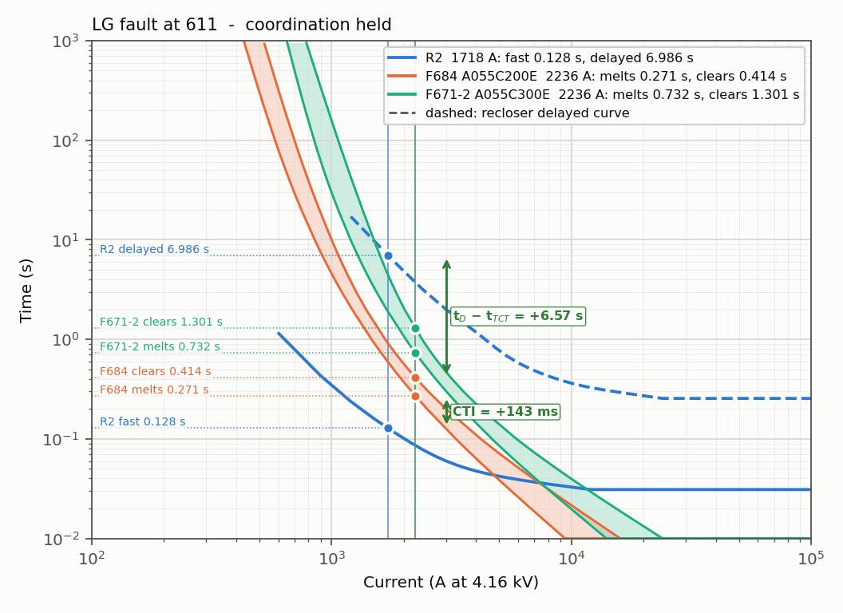
Figure 5.1 LG fault at 611: R2 forward, fuses F684 and F671-2; CTI = +143 ms.
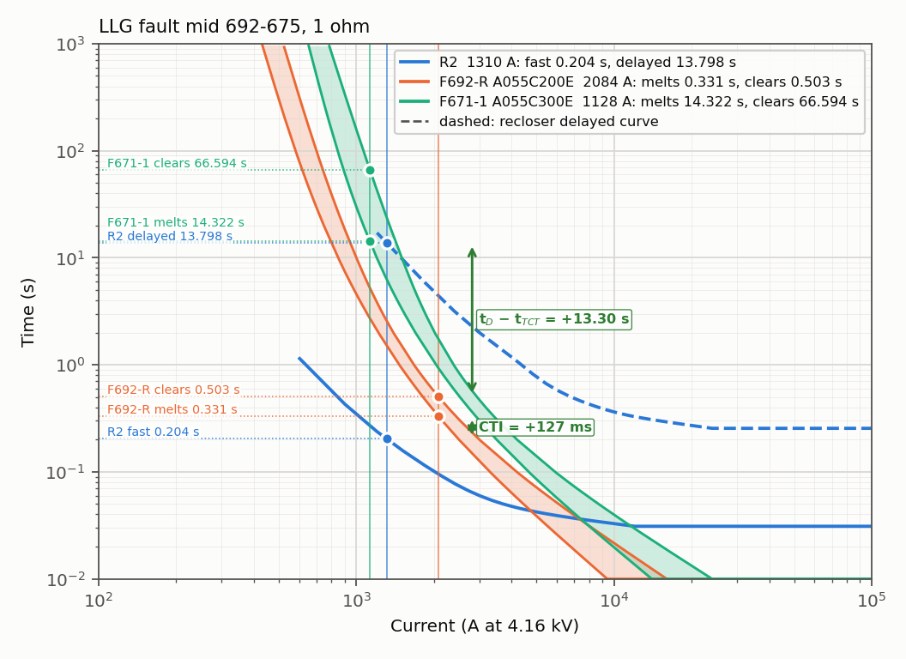
Figure 5.2 LLG fault at the middle of 692–675 through 1 Ω; CTI = +127 ms.

5.7 Coordination With DG and a Conventional R2
With the DG connected and the settings unchanged, coordination is held in 24 of 39 cells (Table 5.6, Figure 5.3). The lost cells are at 633, 645, 646, DL and 675: the fuse now carries the grid and the DG current and melts before the fast trip, and for some LG faults the single-setting R2 does not pick up the reverse DG current at all. At 633 and DL the fuses have almost no margin even without DG, so every fault type is lost there.
Table 5.6 Coordination status with DG and a conventional R2. ✓ exists, ✗ does not exist, – not applicable.
Fault | 632 | 633 | 645 | 646 | DL | 671 | 692 | 675 | 680 | 684 | 611 | 652
LG | ✓ | ✗ | ✗ | ✗ | ✗ | ✓ | ✓ | ✓ | ✓ | ✓ | ✓ | ✓
LL | ✓ | ✗ | ✓ | ✗ | ✗ | ✓ | ✓ | ✗ | ✓ | ✓ | – | –
LLG | ✓ | ✗ | ✓ | ✗ | ✗ | ✓ | ✓ | ✗ | ✓ | ✓ | – | –
LLL | ✓ | ✗ | – | – | ✗ | ✓ | ✓ | ✗ | ✓ | – | – | –
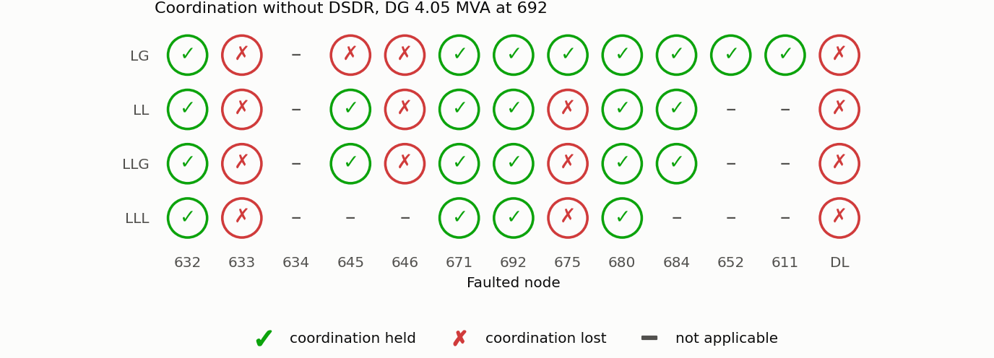
Figure 5.3 Coordination status with DG, without the DSDR.
Figures 5.4 to 5.6 show three cases with the conventional R2.
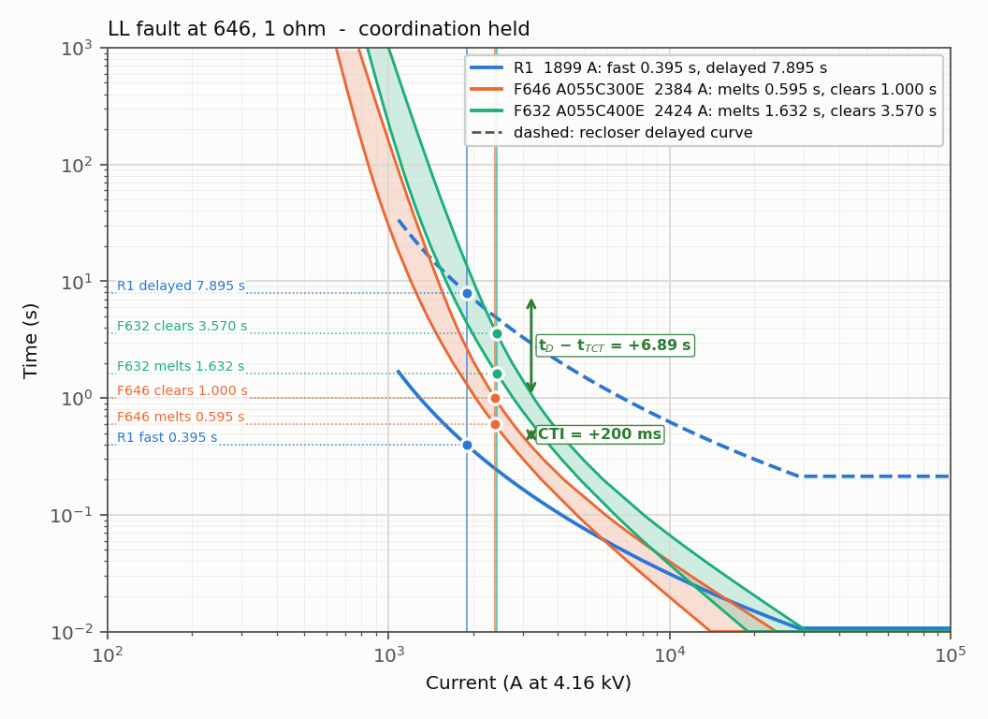
Figure 5.4 LL fault at 646 through 1 Ω: R1 with F646 and F632; CTI = +200 ms.
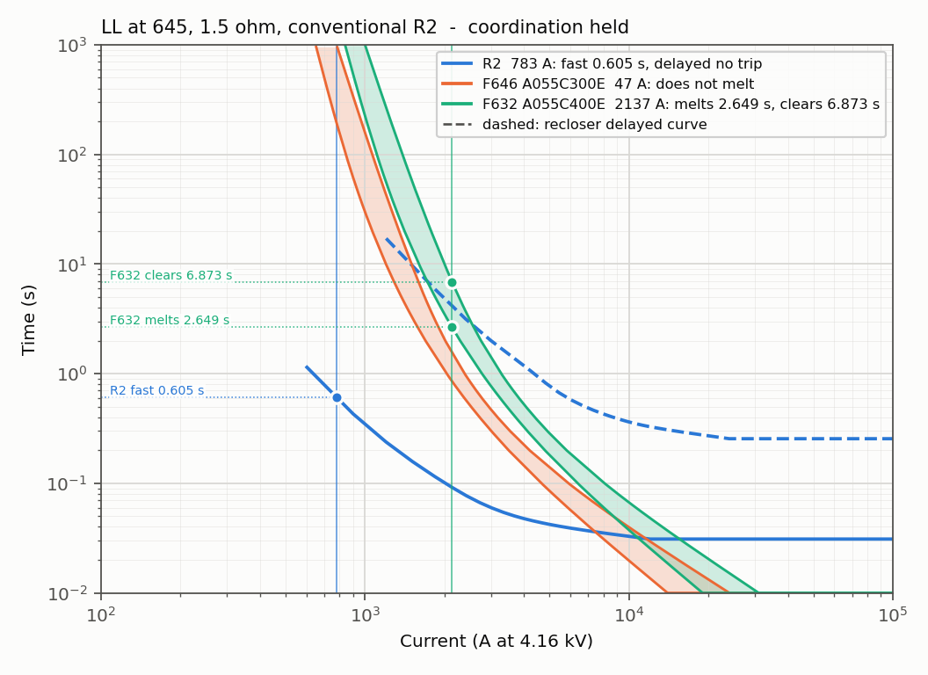
Figure 5.5 LL fault at 645 through 1.5 Ω, conventional R2.
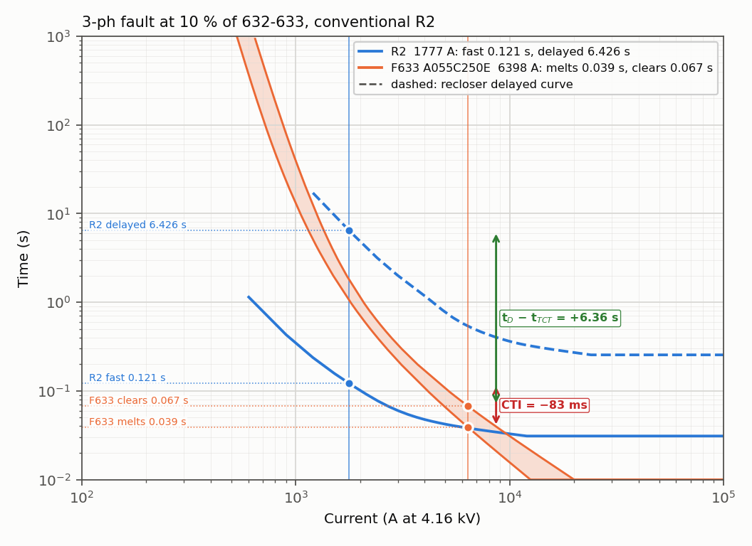
Figure 5.6 Three-phase fault at 10 per cent of line 632–633, conventional R2; CTI = $-83$ ms, the fuse melts first.

5.8 DSDR Settings and Fuse Revision
The reverse load current of R2 is 252.2 A, so eq. (3.12) gives a reverse pickup of 315.3 A. The reverse group is set on a 500/5 current transformer with plugs of 150 A (fast) and 300 A (delayed) and the same time multipliers 0.1 and 1.0 (Figure 5.7). Step 8 of the method (revising the dials) could not improve any lost case, because R1 is already at both ends of the IAC dial range (0.5 and 10) and R2 at both ends of the CDG table (0.1 and 1.0). Step 9 (revising the fuses) was therefore needed: F632 to 500E; F633, F646, F-DL and
F671-1 to 400E; F692-R to 250E (Table 4.3).
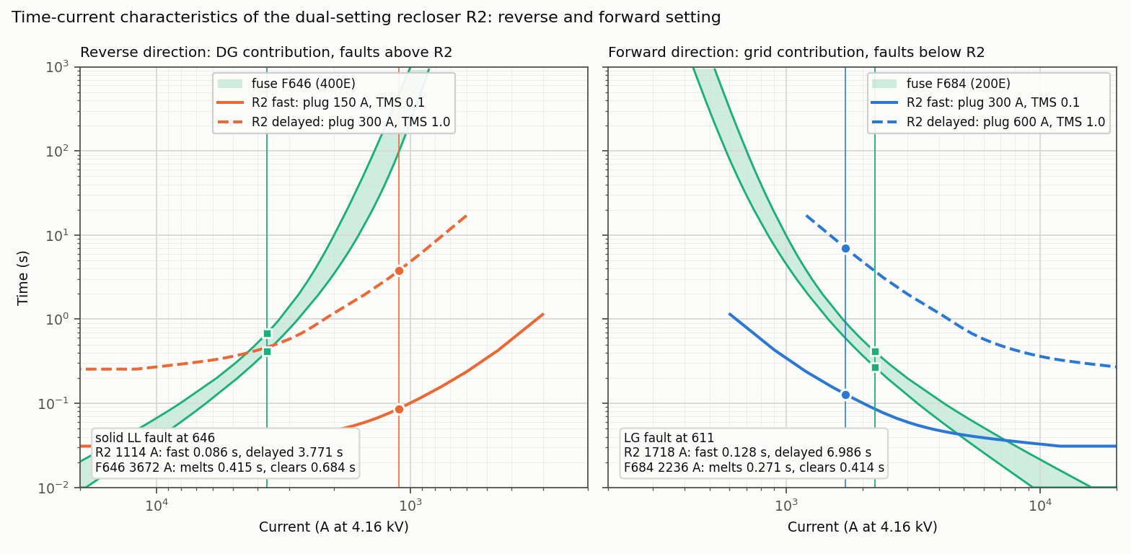
Figure 5.7 The two setting groups of R2: reverse (DG contribution, faults towards 632) and forward (grid contribution, faults beyond 671), each with one fault of the model.

5.9 Coordination With the DSDR
With R2 as a DSDR and the revised fuses, coordination is held in 38 of 39 cells (Table 5.7, Figure 5.8). With the same fuses and a single-setting R2 only 31 cells are held. The dual setting itself therefore restores seven cells: all four fault types at 633, and the LG faults at 645, 646 and DL.
The cell that remains lost is the LG fault at 692. F671-1 must be 400E to stay selective with F692-R, but it then clears after R2’s delayed trip (7.6 s against 4.0 s), and R2’s delayed dial is already at its maximum.
Table 5.7 Coordination status with DG and the revised fuses: single-setting R2 against dual-setting R2.
Fault, R2 | 632 | 633 | 645 | 646 | DL | 671 | 692 | 675 | 680 | 684 | 611 | 652
LG, single setting | ✓ | ✗ | ✗ | ✗ | ✗ | ✓ | ✗ | ✓ | ✓ | ✓ | ✓ | ✓
LG, dual setting | ✓ | ✓ | ✓ | ✓ | ✓ | ✓ | ✗ | ✓ | ✓ | ✓ | ✓ | ✓
LL, single setting | ✓ | ✗ | ✓ | ✓ | ✓ | ✓ | ✓ | ✓ | ✓ | ✓ | – | –
LL, dual setting | ✓ | ✓ | ✓ | ✓ | ✓ | ✓ | ✓ | ✓ | ✓ | ✓ | – | –
LLG, single setting | ✓ | ✗ | ✓ | ✓ | ✓ | ✓ | ✓ | ✓ | ✓ | ✓ | – | –
LLG, dual setting | ✓ | ✓ | ✓ | ✓ | ✓ | ✓ | ✓ | ✓ | ✓ | ✓ | – | –
LLL, single setting | ✓ | ✗ | – | – | ✓ | ✓ | ✓ | ✓ | ✓ | – | – | –
LLL, dual setting | ✓ | ✓ | – | – | ✓ | ✓ | ✓ | ✓ | ✓ | – | – | –
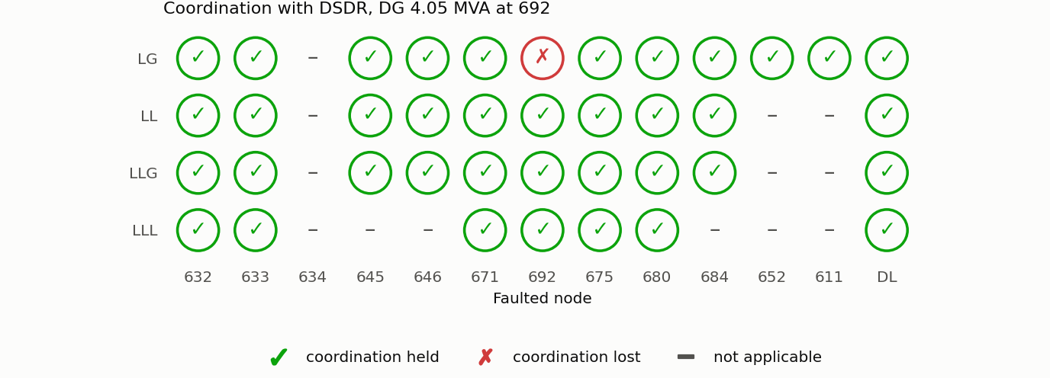
Figure 5.8 Coordination status with DG and the DSDR.
Figures 5.9 and 5.10 show a bolted LL fault at 646. The fuses carry 3.67 kA. R2 carries 1.11 kA in reverse and trips on its reverse fast curve in 0.086 s, before F646 melts (0.415 s).
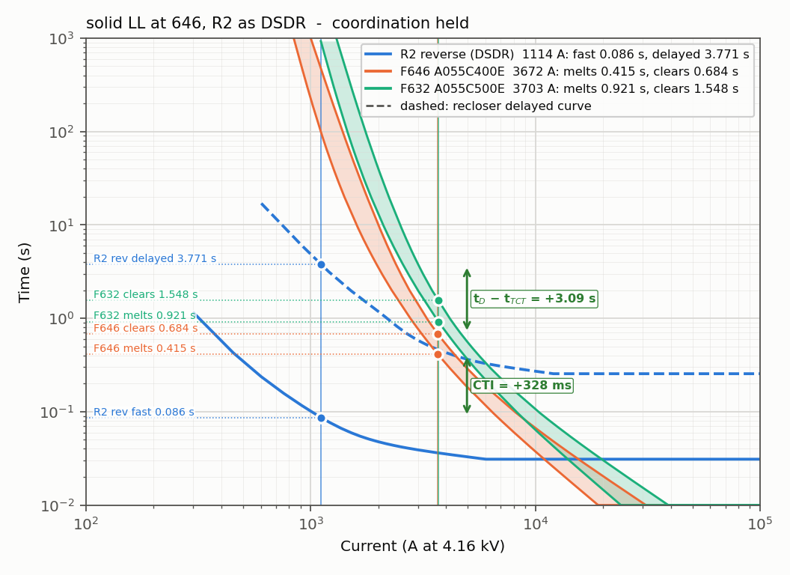
Figure 5.9 Bolted LL fault at 646: R2 reverse setting with F646 and F632; CTI = +328 ms.
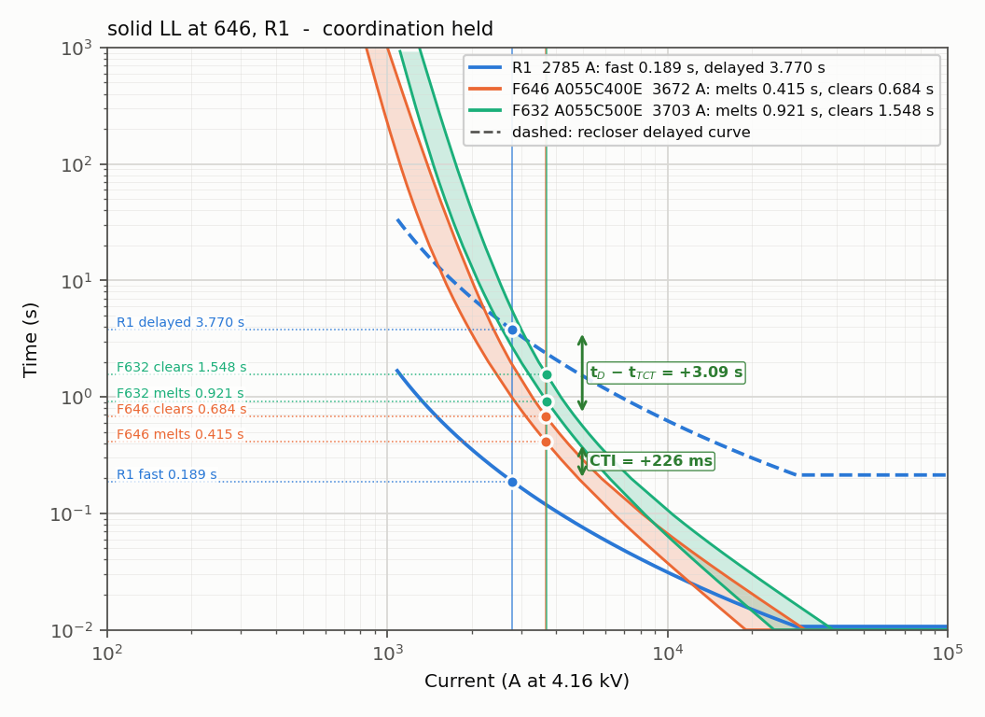
Figure 5.10 Bolted LL fault at 646: R1 with F646 and F632; CTI = +226 ms.

5.10 Operating Times With the DSDR
Tables 5.8 and 5.9 give the operating times with the DSDR. R1 operates forward for every node. R2 operates in reverse for the nodes upstream of it and forward for the nodes downstream. The fuse time is the minimum-melting time of the fuse nearest to the fault at the current through that fuse. In all nine rows with a fuse it is longer than the last fast trip; the smallest margins are 6 ms at 675 and 15 ms at DL and 652.
Table 5.8 Recloser operating times with the DSDR, DG in service.
 |  | $$I_{R1}$$ | R1 fast | R1 delayed | $$I_{R2}$$ |  | R2 fast | R2 delayed
Node | Fault | (A) | (s) | (s) | (A) | Dir. | (s) | (s)
632 | LLL | 4734 | 0.081 | 1.627 | 1813 | rev | 0.051 | 1.416
633 | LLL | 3970 | 0.106 | 2.111 | 1500 | rev | 0.060 | 2.001
645 | LL | 3124 | 0.155 | 3.095 | 1232 | rev | 0.075 | 3.002
646 | LL | 2785 | 0.189 | 3.770 | 1114 | rev | 0.086 | 3.771
DL | LLL | 3954 | 0.106 | 2.123 | 1972 | rev | 0.048 | 1.213
671 | LLL | 3412 | 0.134 | 2.677 | 3391 | fwd | 0.054 | 1.600
692 | LLL | 3412 | 0.134 | 2.677 | 3391 | fwd | 0.054 | 1.600
675 | LLL | 3090 | 0.158 | 3.152 | 3050 | fwd | 0.059 | 1.941
684 | LL | 2543 | 0.222 | 4.437 | 2543 | fwd | 0.072 | 2.813
680 | LLL | 2789 | 0.188 | 3.761 | 2757 | fwd | 0.066 | 2.381
611 | LG | 1814 | 0.435 | 8.709 | 1718 | fwd | 0.128 | 6.986
652 | LG | 1795 | 0.446 | 8.919 | 1761 | fwd | 0.123 | 6.570

Table 5.9 Fuse times with the DSDR, DG in service. Margin = $t_{MMT}$ minus the last fast trip (R2 for faults below R2; the later of R1 and R2 reverse above it). Nodes 632, 671 and 680 are on the main feeder and have no fuse.
 |  |  |  | $$I_{fuse}$$ | $$t_{MMT}$$ | $$t_{TCT}$$ | Last fast | Margin
Node | Fault | Fuse | Size | (A) | (s) | (s) | trip (s) | (s) | Status
633 | LLL | F633 | 400E | 5426 | 0.149 | 0.235 | 0.106 | $$+0.043$$ | held
645 | LL | F632 | 500E | 4191 | 0.613 | 0.970 | 0.155 | $$+0.458$$ | held
646 | LL | F646 | 400E | 3672 | 0.415 | 0.684 | 0.189 | $$+0.226$$ | held
DL | LLL | F-DL | 400E | 5902 | 0.121 | 0.193 | 0.106 | $$+0.015$$ | held
692 | LLL | F671-1 | 400E | 3391 | 0.525 | 0.891 | 0.054 | $$+0.471$$ | held
675 | LLL | F692-R | 250E | 5022 | 0.065 | 0.106 | 0.059 | $$+0.006$$ | held
684 | LL | F671-2 | 300E | 3963 | 0.148 | 0.230 | 0.072 | $$+0.076$$ | held
611 | LG | F684 | 200E | 2236 | 0.271 | 0.414 | 0.128 | $$+0.143$$ | held
652 | LG | F652 | 150E | 2239 | 0.138 | 0.193 | 0.123 | $$+0.015$$ | held

5.11 Single Setting Against Dual Setting on Selected Faults
Table 5.10 compares the two settings of R2 on nine faults with the same (revised) fuses: the six faults of the figures above and three cells of the classification. Figures 5.11 and 5.12 show two of the diagrams.
Table 5.10 Nine faults with the DG in service: single-setting against dual-setting R2, same fuses.
 |  |  | $$Z_{f}$$ | $$I_{R1}$$ | $I_{R2}$ (A), | R1 fast | R2 fast (s) |  | Fuse: melts | Fuse saving
# | Figure | Fault | ($Ω$) | (A) | direction | (s) | single | dual | (s) | single | dual
01 | Fig. 8 | LG fault at 611 | 0 | 1814 | 1718 (fwd) | 0.435 | 0.128 | 0.128 | F684 200E: 0.271 | held | held
02 | Fig. 9 | LLG fault at the middle of 692-675 | 1 | 1445 | 1310 (fwd) | 0.742 | 0.204 | 0.204 | F692-R 250E: 0.618 | held | held
03 | Fig. 11 | LL fault at 646 | 1 | 1899 | 847 (rev) | 0.395 | 0.500 | 0.131 | F646 400E: 1.734 | lost | lost
04 | Fig. 12 | LL fault at 645 | 1.5 | 1694 | 783 (rev) | 0.507 | 0.605 | 0.149 | F632 500E: 9.129 | lost | lost
05 | Fig. 13 | 3-phase fault at 10 % of 632-633 | 0 | 4645 | 1777 (rev) | 0.084 | 0.121 | 0.052 | F633 400E: 0.100 | lost | held
06 | Figs. 15, 16 | LL fault at 646 | 0 | 2785 | 1114 (rev) | 0.189 | 0.278 | 0.086 | F646 400E: 0.415 | held | held
07 | Fig. 14 / 17 cell | LG fault at 646 (phase c) | 0 | 2359 | 469 (rev) | 0.255 | no trip | 0.396 | F646 400E: 1.057 | lost | held
08 | Fig. 14 / 17 cell | LG fault at 633 (phase b) | 0 | 2874 | 644 (rev) | 0.178 | 0.974 | 0.210 | F633 400E: 0.502 | lost | held
09 | Fig. 14 / 17 cell | LG fault at 692 (phase a) | 0 | 2197 | 2182 (fwd) | 0.293 | 0.089 | 0.089 | F671-1 400E: 2.842 | lost | lost
In cases 5, 7 and 8 the dual setting restores the fuse saving: the reverse group picks up a DG current that the forward group does not see (case 7: 469 A) or sees only slowly.
Cases 3, 4 and 9 are lost with both settings; they are limits of the fuse revision and of the dial range, not of the direction. Cases 3 and 4 are faults through impedance: the larger fuses that are needed for the bolted faults are too slow for these lower currents. Cases 5 and 7 are shown in detail in Figures 5.11 and 5.12; Tables 5.11 and 5.12 list their currents, settings and operating times.
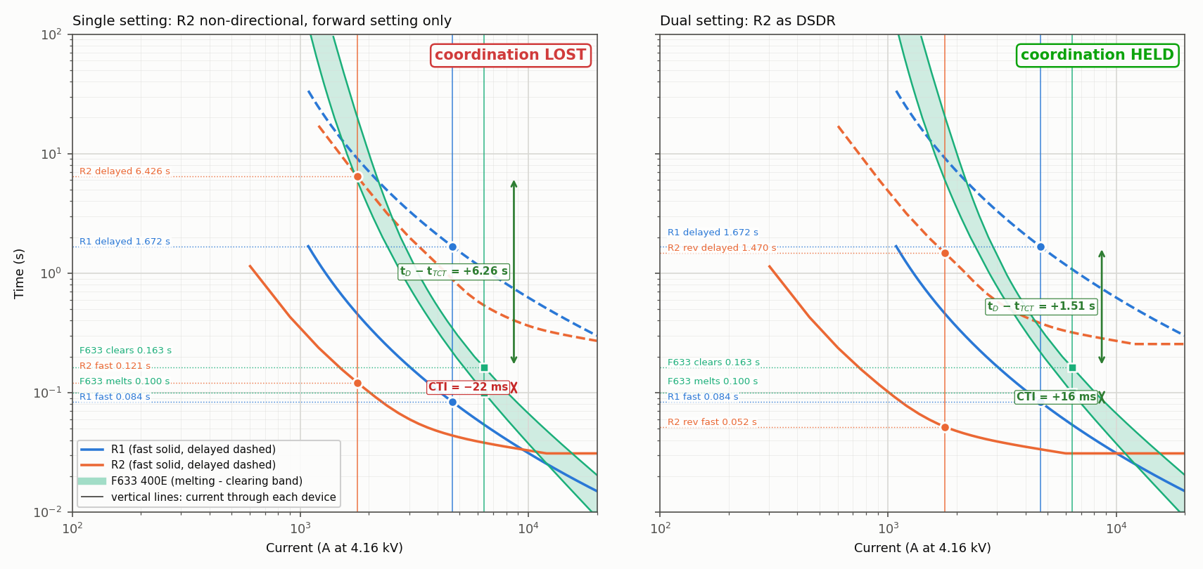
Figure 5.11 Three-phase fault at 10 per cent of line 632–633: single setting (left, CTI = $-22$ ms) and dual setting (right, CTI = +16 ms).
Table 5.11 Three-phase fault at 10 per cent of line 632–633: currents, settings and operating times.
Quantity | Single setting | Dual setting (DSDR)
Fault | 3-phase fault at 10 % of 632-633, LLL, phases a-b-c
Fault impedance $Z_{f}$ | 0 Ω (bolted)
Fault-path current (F633) | 6398 A
Current through R1, direction | 4645 A, forward (RG60 $→$ 632), grid contribution
Current through R2, direction | 1777 A, REVERSE (671 $→$ 632), DG contribution only
R2 setting applied (fast / delayed) | FORWARD: plug 300/600 A, starts 600/1200 A, TMS 0.1/1.0 | REVERSE: plug 150/300 A, starts 300/600 A, TMS 0.1/1.0
R1 fast / delayed | 0.084 s / 1.672 s | 0.084 s / 1.672 s
R2 fast / delayed | 0.121 s / 6.426 s | 0.052 s / 1.470 s
Primary fuse melts / clears | F633 400E: 0.100 s / 0.163 s | F633 400E: 0.100 s / 0.163 s
Backup fuse melts | - | -
Fuse saving | LOST: F633 melts (0.100 s) before R2 fast (0.121 s) | HELD
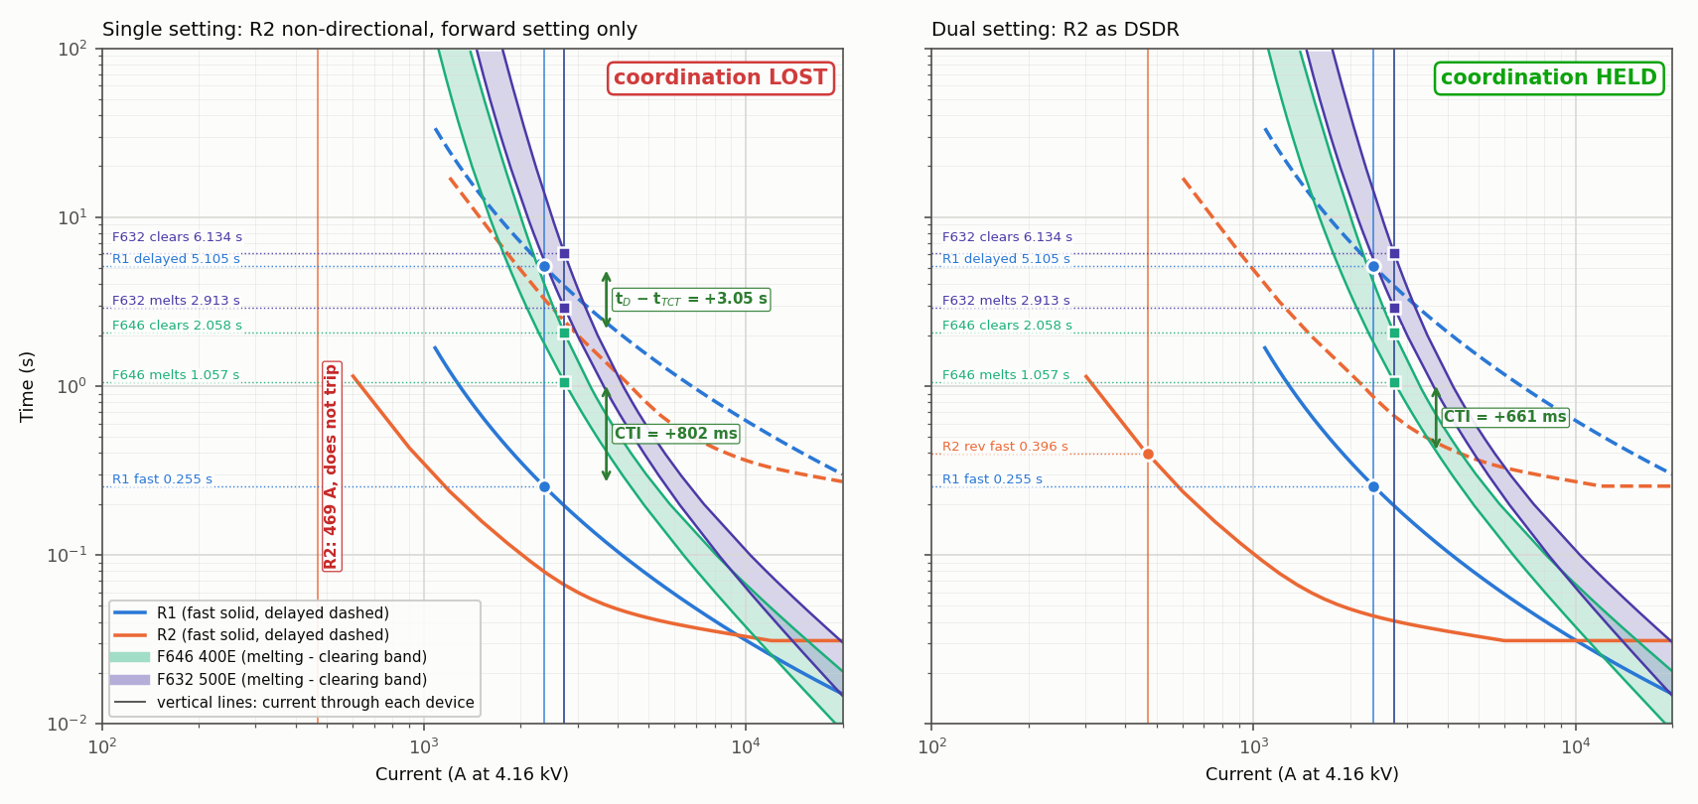
Figure 5.12 LG fault at 646: the single-setting R2 does not pick up the reverse current (left); the reverse group does (right, CTI = +661 ms).
Table 5.12 LG fault at 646 (phase c): currents, settings and operating times.
Quantity | Single setting | Dual setting (DSDR)
Fault | LG fault at 646 (phase c), LG, phases C
Fault impedance $Z_{f}$ | 0 Ω (bolted)
Fault-path current (F646) | 2732 A
Current through R1, direction | 2359 A, forward (RG60 $→$ 632), grid contribution
Current through R2, direction | 469 A, REVERSE (671 $→$ 632), DG contribution only
R2 setting applied (fast / delayed) | FORWARD: plug 300/600 A, starts 600/1200 A, TMS 0.1/1.0 | REVERSE: plug 150/300 A, starts 300/600 A, TMS 0.1/1.0
R1 fast / delayed | 0.255 s / 5.105 s | 0.255 s / 5.105 s
R2 fast / delayed | no trip / no trip | 0.396 s / no trip
Primary fuse melts / clears | F646 400E: 1.057 s / 2.058 s | F646 400E: 1.057 s / 2.058 s
Backup fuse melts | F632 500E: 2.913 s | F632 500E: 2.913 s
Fuse saving | LOST: R2 does not pick up (469 A) | HELD

5.12 Time-Sequence Check
The classification above uses the strict rule that every recloser must trip before the fuse starts to melt. A time-sequence check follows each fault in time instead: the fuse heats with the current that still flows after each recloser opens. For the 18 cells upstream of R2 the strict rule gives 11 cells held with the single setting and 18 with the dual setting; the time sequence gives 15 and 18 (Figure 5.13). The three cells that the DSDR restores in the time sequence as well are the LG faults at 633, 645 and 646, where the single-setting R2 never
trips on a reverse current of about 0.5 to 0.6 kA. For the 21 cells downstream of R2 the DG at 692 feeds the fault directly, with no recloser in its path, and the result is the same for both settings.
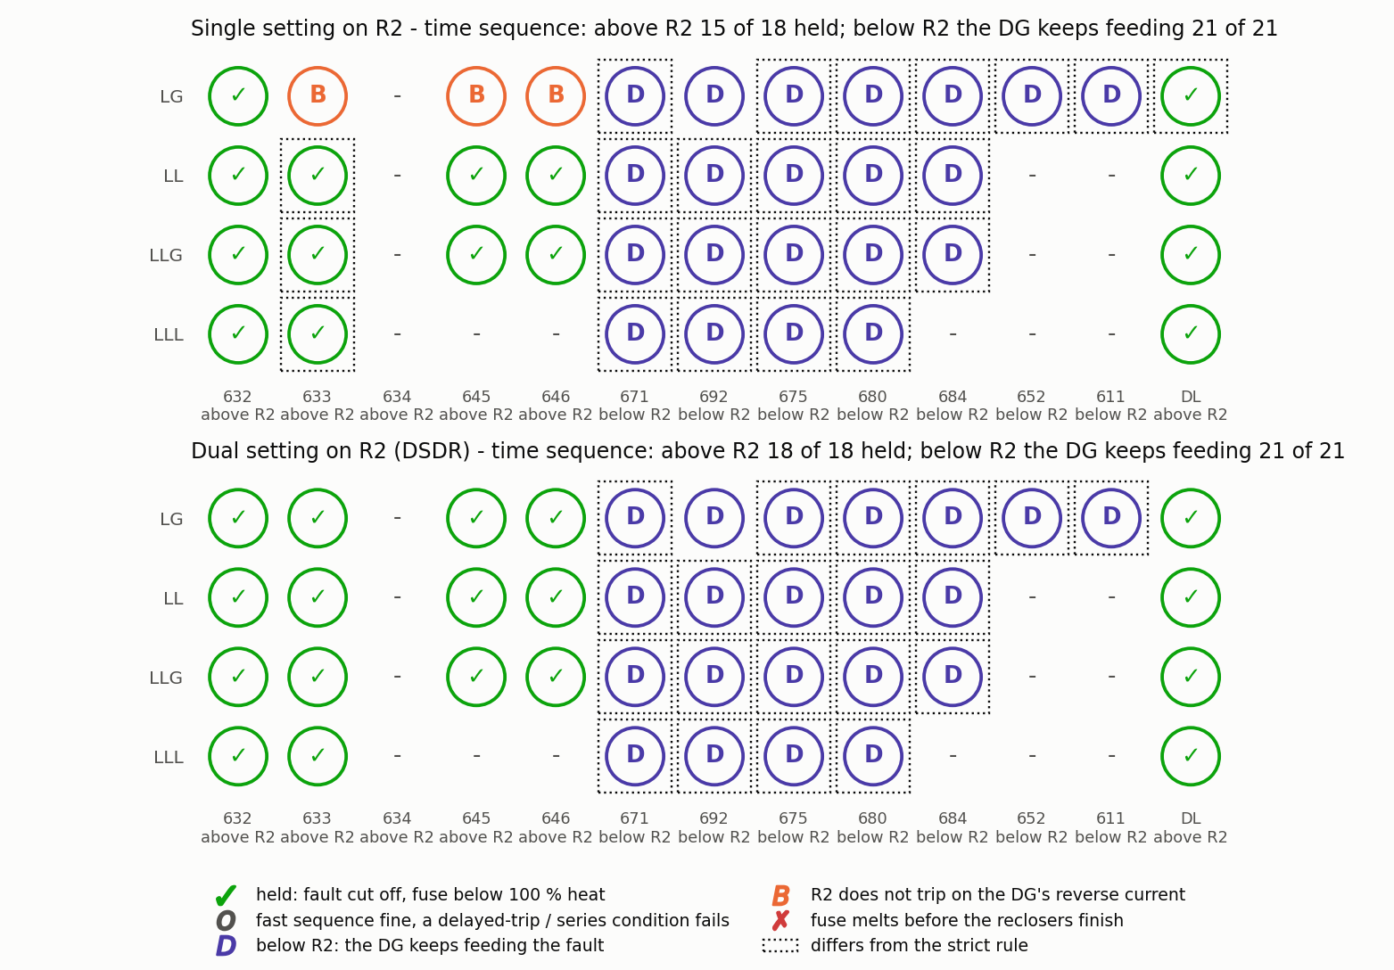
Figure 5.13 Time-sequence check of all 39 cells, single against dual setting.

5.13 Time-Domain Verification
Figure 5.14 is the EMT simulation of an LL (a–c) fault at 684 through 0.2 Ω with the conventional settings. The recloser trips follow R2’s fast curve applied to the simulated current, and the fuse F671-2 (300E) melts when the accumulated heating $∑Δt/t_{MMT}(I)$ reaches one. Without DG the two fast shots use 45 per cent of the melting heat, the fuse survives both and then clears the permanent fault. With the DG the fuse melts at the end of the second fast shot, because the DG keeps feeding the fault while R2 is open (Table 5.13). The feeder current at node 632 is 557 / 588 A RMS (phases a / c) before the fault and 2362 / 2719 A during it, with peaks of 3338 / 3842 A.
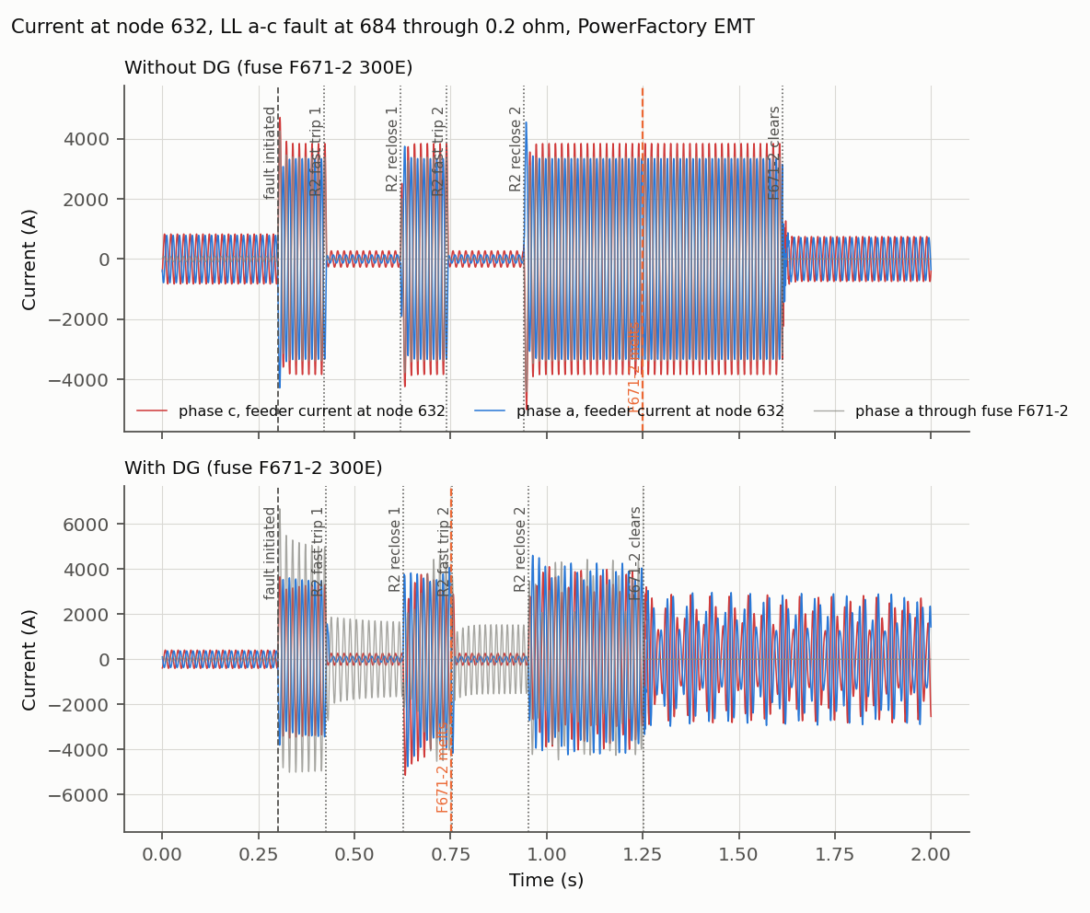
Figure 5.14 Time-domain current at node 632 for an LL (a–c) fault at 684 through 0.2 Ω : without DG (top) and with DG (bottom).
Table 5.13 Reclosing sequence of the EMT simulation.
Event (time in s) | DG out | DG in
Fault initiated | 0.30 | 0.30
R2 fast trip 1 | 0.420 | 0.426
R2 reclose 1 | 0.620 | 0.626
R2 fast trip 2 | 0.740 | 0.753
R2 reclose 2 | 0.940 | 0.953
Fuse F671-2 melts | 1.248 | 0.752
Fuse operation / clears | 1.613 | 1.253
Fuse heat after the fast shots | 45 % | 105 %

5.14 Verification With the Relay and Fuse Models of PowerFactory
The operating times of Chapter Five are calculated from the time–current curves of the devices. As a check, the settings were entered into the relay and fuse elements of the model, and PowerFactory itself calculated the tripping time of every device for every fault, for the conventional and for the DSDR settings. Over 1896 operating times the largest deviation is 1.22 per cent.

5.15 Sensitivity of the Result to the Margin
The 38 held cells are obtained with a zero margin. If the breaker interrupting time of three cycles is added to the fast trip, 31 cells are held; if in addition a safety margin is kept on the fuse melting time, 26 cells are held. The pickups are a second limit: with the DG, the lowest LG fault current through 3 Ω is 577 A at R1 and 368 A at R2, below the pickups of 734.6 A and 587.5 A, because the DG supplies part of the fault.

5.16 Effect of the DG Penetration Level
To see how the conventional coordination degrades as the DG grows, seven separate PowerFactory projects were made, copies of the model with the DG at 692 set to 0, 10, 25, 37, 50, 75 and 100 per cent of 4.05 MVA. The machine, its step-up transformer and its active and reactive power are scaled together, so the per-unit data of Table 4.1 stay the same; at 0 per cent the DG is out of service. Every model keeps the conventional protection of the design without DG (single-setting R2, fuses of the design without DG), and all operating times are PowerFactory’s own relay and fuse calculations. Two fuse–recloser pairs are followed: fuse F633 against R1 for a three-phase fault at 633 (R1’s zone), and the lateral fuse F671-2 at node 671 against R2 for a line-to-line fault at 684 (R2’s zone). The coordination time interval is
$$CTI=t_{MMT}(\text{fuse})-t_{F}(\text{recloser}), (5.1)$$
and, for the doughnut chart of Figure 5.15, each level’s share of the ring, $CTI \%=100×CTI/∑|CTI|$ over the seven levels, so that each ring adds up to 100 per cent.
Table 5.14 CTI against DG penetration, conventional protection.
 |  | Node 633: F633 and R1 (LLL) |  |  |  | Node 671: F671-2 and R2 (LL at 684)
DG (%) | MVA | $I$ fuse / R1 (A) | $t_{MMT}$ / $t_{F}$ (s) | CTI (ms) | ring % | $I$ fuse / R2 (A) | $t_{MMT}$ / $t_{F}$ (s) | CTI (ms) | ring %
0 | 0.00 | 4102 / 4162 | 0.102 / 0.098 | $$+4$$ | $$+2.1$$ | 2574 / 2711 | 0.470 / 0.067 | $$+403$$ | $$+26.0$$
10 | 0.41 | 4256 / 4142 | 0.094 / 0.099 | $$-5$$ | $$-3.1$$ | 2715 / 2681 | 0.401 / 0.068 | $$+333$$ | $$+21.5$$
25 | 1.01 | 4478 / 4111 | 0.083 / 0.100 | $$-17$$ | $$-9.6$$ | 2926 / 2636 | 0.323 / 0.069 | $$+254$$ | $$+16.4$$
37 | 1.50 | 4648 / 4088 | 0.077 / 0.101 | $$-24$$ | $$-13.9$$ | 3094 / 2598 | 0.277 / 0.070 | $$+207$$ | $$+13.4$$
50 | 2.02 | 4824 / 4062 | 0.071 / 0.102 | $$-31$$ | $$-17.9$$ | 3276 / 2557 | 0.237 / 0.072 | $$+166$$ | $$+10.7$$
75 | 3.04 | 5140 / 4015 | 0.062 / 0.104 | $$-42$$ | $$-24.2$$ | 3623 / 2511 | 0.184 / 0.073 | $$+110$$ | $$+7.1$$
100 | 4.05 | 5426 / 3970 | 0.055 / 0.106 | $$-51$$ | $$-29.2$$ | 3963 / 2543 | 0.147 / 0.072 | $$+75$$ | $$+4.9$$
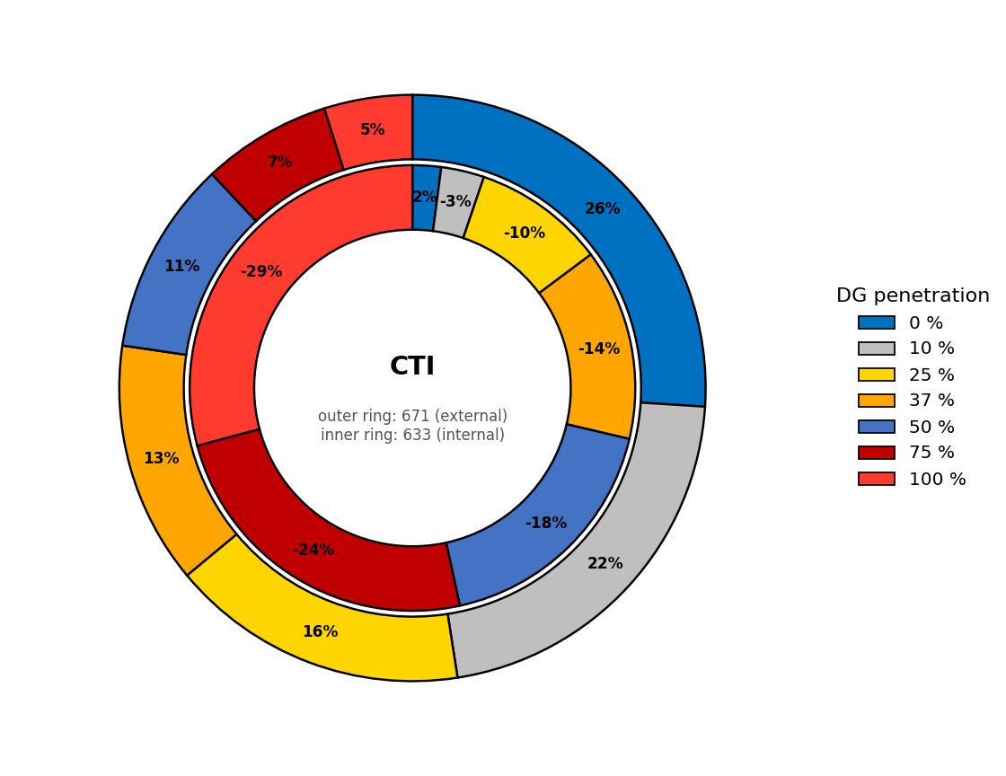
Figure 5.15 Percentage variation of the CTI with DG penetration (outer ring 671, inner ring 633).
At node 633 the fuse current rises from 4102 A to 5426 A while R1’s current falls from 4162 A to 3970 A; the CTI falls from $+4$ ms to $-51$ ms. At node 671 the fuse current rises from 2574 A to 3963 A while R2’s current stays at about 2543 A; the CTI falls from $+403$ ms to $+75$ ms. The mechanism is the same at both nodes (Figure 5.16): the fuse lies between the fault and both sources and carries the grid share and the DG share, while the recloser carries only the grid share, which even falls slightly because the DG holds up the voltage of the network during the fault. A fuse curve is steep, so the extra current shortens its melting time much more than the lower current lengthens the recloser’s time, and the CTI decreases. At 633 the margin is only a few milliseconds without DG and is lost from about 4 per cent penetration; at 671 the margin is large and stays positive up to 100 per cent.
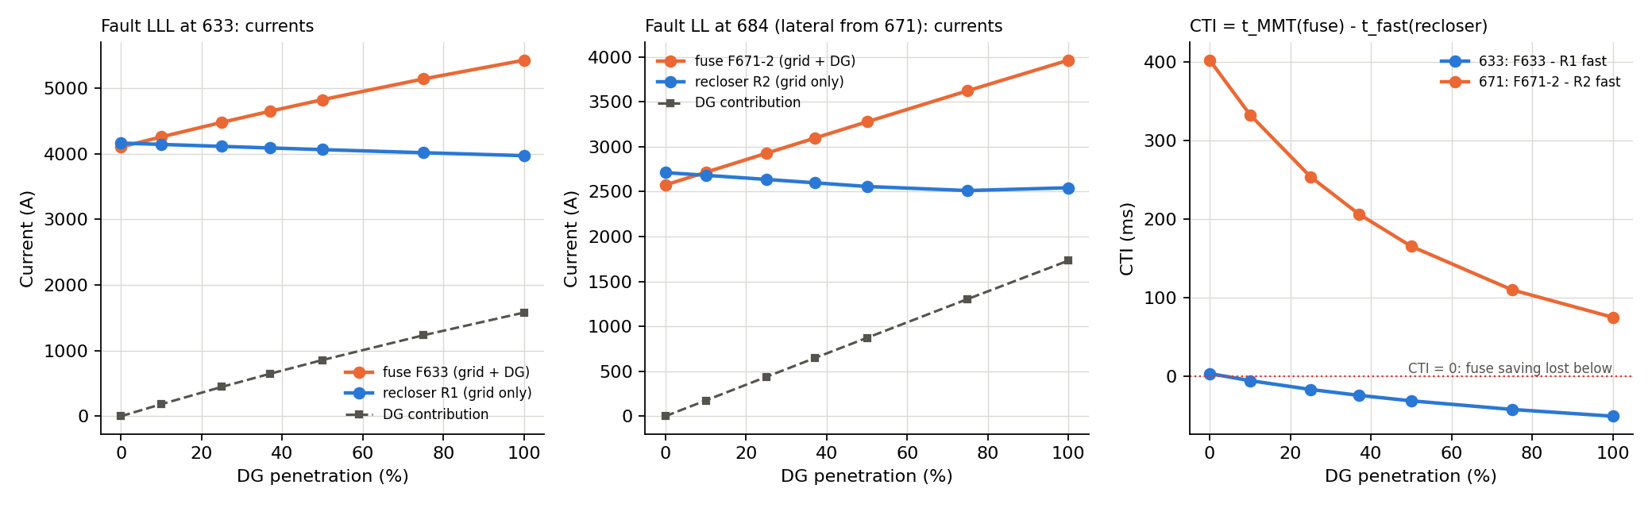
Figure 5.16 Currents through the fuse (grid and DG share), the recloser (grid share) and from the DG, and the resulting CTI, against DG penetration.
Figure 5.17 shows the same on the time–current characteristics: the curves are fixed because the settings are not changed, the recloser’s operating point stays where it is, and the fuse’s operating point moves to a higher current and a shorter time with every step. Figure 5.18 gives node 633 level by level, with the vertical short-circuit lines of the fuse and the recloser currents, the operating times and the CTI.
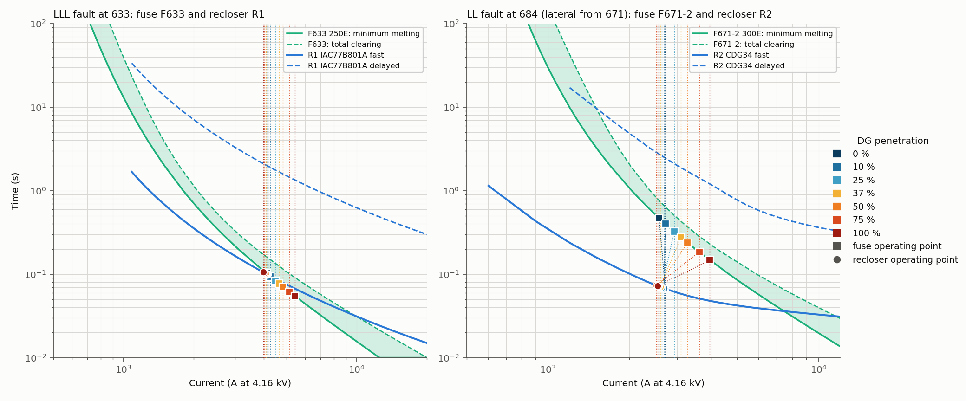
Figure 5.17 Time–current characteristics at all penetration levels: fuse operating points (squares) and recloser operating points (circles).
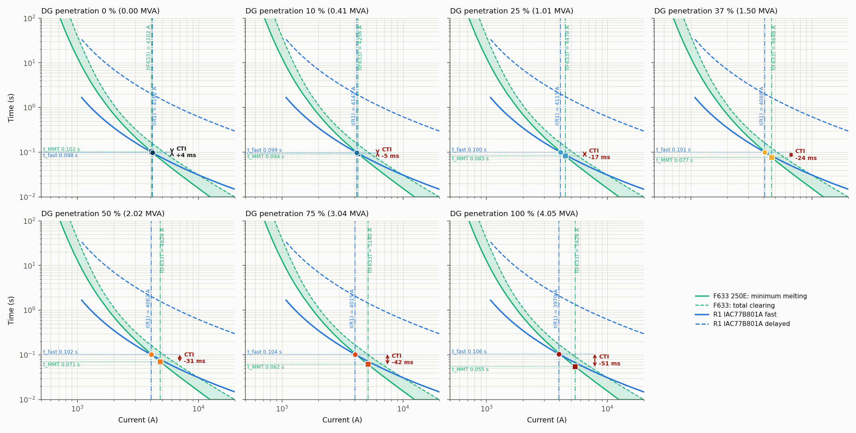
Figure 5.18 Node 633, fuse F633 and R1, at each penetration level, with the short-circuit currents, operating times and CTI.
The fault level rises at every node (Table 5.15), most near the DG (671, 692, 675: about $+60$ per cent) and least behind the 4.16/0.48 kV transformer (634) and on the single-phase laterals. The current through the reclosers does not rise with it.
Table 5.15 Largest bolted fault current at each node (A) against DG penetration.
Node | Fault | 0 % | 25 % | 50 % | 75 % | 100 % | Change
632 | LLL ABC | 4735 | 5227 | 5690 | 6123 | 6526 | $$+38 \%$$
633 | LLL ABC | 4102 | 4478 | 4824 | 5140 | 5426 | $$+32 \%$$
634 | LLL ABC | 15671 | 16307 | 16828 | 17257 | 17608 | $$+12 \%$$
645 | LLG BC | 3418 | 3685 | 3932 | 4149 | 4341 | $$+27 \%$$
646 | LLG BC | 3112 | 3332 | 3528 | 3701 | 3854 | $$+24 \%$$
671 | LLL ABC | 3390 | 3919 | 4461 | 5010 | 5564 | $$+64 \%$$
692 | LLL ABC | 3390 | 3919 | 4461 | 5010 | 5564 | $$+64 \%$$
675 | LLL ABC | 3151 | 3612 | 4087 | 4557 | 5022 | $$+59 \%$$
680 | LLL ABC | 2930 | 3322 | 3711 | 4091 | 4460 | $$+52 \%$$
684 | LLG AC | 2655 | 3027 | 3395 | 3756 | 4107 | $$+55 \%$$
652 | LG A | 1874 | 1983 | 2080 | 2164 | 2239 | $$+19 \%$$
611 | LG C | 1857 | 1973 | 2074 | 2161 | 2236 | $$+20 \%$$
DL | LLL ABC | 3946 | 4454 | 4952 | 5436 | 5902 | $$+50 \%$$
The load flow changes as well (Table 5.16). The DG supplies part of the load locally, so the load current through both reclosers falls, the voltages rise, and the power through R2
reverses between 75 and 100 per cent. By eq. (3.3) the pickups would have to fall with the penetration; with the fixed settings (R1 720 A, its curve starting at 1080 A; R2 fast curve starting at 600 A) the reclosers no longer detect the weakest faults (LG through 3 Ω) in their zones, R2 from just above 50 per cent.
Table 5.16 Load flow, pickups by eq. (3.3) and lowest fault current through each recloser against DG penetration. $​^{*}$: below the start of the recloser’s curve with the fixed settings (not detected).
 | DG P | R1 load | R2 load | R2 | $$V_{671,a}$$ | R1 $1.25 I_{nom}$ | R2 $1.25 I_{nom}$ | R1 lowest | R2 lowest
DG (%) | (MW) | (A) | (A) | flow | (p.u.) | (A) | (A) | 3 $Ω$ fault (A) | 3 $Ω$ fault (A)
0 | 0.00 | 587.7 | 470.0 | forward | 0.988 | 734.6 | 587.5 | 1074$​^{*}$ | 878
10 | 0.32 | 543.1 | 430.1 | forward | 0.994 | 678.9 | 537.6 | 1018$​^{*}$ | 821
25 | 0.81 | 480.7 | 372.2 | forward | 1.002 | 600.9 | 465.2 | 937$​^{*}$ | 738
37 | 1.20 | 434.8 | 328.6 | forward | 1.009 | 543.5 | 410.8 | 874$​^{*}$ | 673
50 | 1.62 | 389.9 | 285.3 | forward | 1.015 | 487.4 | 356.6 | 809$​^{*}$ | 606
75 | 2.43 | 321.2 | 222.4 | forward | 1.025 | 401.5 | 278.0 | 689$​^{*}$ | 483$​^{*}$
100 | 3.24 | 284.9 | 252.2 | reverse | 1.033 | 356.1 | 315.2 | 577$​^{*}$ | 368$​^{*}$
The penetration study therefore shows the two ways in which fixed settings fail as the DG grows: the fuse saving is lost because the fuse speeds up while the recloser does not, and the sensitivity is lost because the currents through the reclosers fall. Both are reasons for settings that adapt to the DG, which is what the dual-setting directional recloser provides.

5.17 Results Summary
Table 5.17 Summary of the coordination results.
Stage | Cells held (of 39)
A. No DG, starting fuse sizes | 35
A. No DG, after the fuse revision (F692-R to 200E) | 39
B. DG connected, conventional R2 | 24
B. DG connected, no-DG fuses, R2 as DSDR | 25
C. DG connected, revised fuses, conventional R2 | 31
C. DG connected, revised fuses, R2 as DSDR | 38
C. The same settings and fuses with the DG out of service | 37
The dual setting alone, with the fuses of the design without DG, restores one cell (24 to 25). Together with the fuse revision it restores fourteen (24 to 38), seven of which need the dual setting.

CHAPTER SIX: DISCUSSION

6.1 Effect of DG on Fault Current
The DG raises the fault current at every node, most near its connection point (671 and 692: from 3.39 to 5.56 kA). The fuses carry this higher current and melt faster, while R1 carries about the same grid current as before. The margin between the fuse and the fast trip, which is small even without DG, disappears.

6.2 Effect of Fault Current Direction
For faults at 632, 633, 645, 646 and DL the current through R2 is reverse and consists only of the DG contribution. Its magnitude (0.5 to 2.0 kA) is much lower than the forward fault currents for which the forward group is set. A forward group with plugs of 300 and 600 A responds slowly to these currents, or not at all for LG faults.

6.3 Performance of the Conventional Protection
With the conventional single setting the scheme keeps coordination at the nodes on the main feeder and loses it on the fused laterals of R1’s zone and at 675. The loss depends on the location and on the fault type; it is not a uniform failure of the feeder.

6.4 Performance of the DSDR
The reverse group, with half the plug settings, trips for every reverse fault before the fuse melts once the fuses are revised. The result of 38 cells against 31 with the same fuses isolates its contribution. Without the fuse revision the improvement is one cell only: at 633 and DL the fuses of the design without DG melt in 0.05 to 0.16 s with the DG, before R1’s fast trip (0.11 to 0.18 s), and no setting of R2 can change R1’s time. The DSDR is therefore necessary but not sufficient.

6.5 Limits Reached by the Devices
R1’s dials are the two extremes of the IAC range, and the CDG table ends at 0.1 and 1.0. The method’s dial revision has no room. The fuse revision creates a conflict between the two states of the network: the larger fuses that are needed with the DG are too slow for two cells without it, and for the faults through impedance. Fuse sizes cannot adapt to the
DG state. For faults downstream of R2 the fuse saving relies on the DG’s own protection disconnecting it during the dead time, which is not part of the method.

6.6 Engineering Implication
Adaptive directional protection is justified where a DG is downstream of a mid-line recloser. To apply it, the engineer must check the dial range of the actual relay, revise the fuse sizes for the DG state, verify the pickup against the reduced minimum fault current with DG, and provide for the DG infeed to faults beyond the recloser.

CHAPTER SEVEN: CONCLUSION AND FUTURE WORK

7.1 Conclusion
The DSDR method of [1] was implemented on the IEEE 13-node feeder in DIgSILENT PowerFactory with the real characteristics of the protection devices. The feeder model agrees with the IEEE short-circuit benchmark within about 2 per cent. Without DG the conventional scheme is coordinated in all 39 cells. With the 4.05 MVA DG at node 692 and a conventional R2, coordination is held in 24 cells. With R2 as a DSDR and the fuse revision of the method it is held in 38 cells; with the same fuses and a single setting in 31. The dual-setting directional recloser therefore restores the coordination in the zone between the grid and the DG, with the qualification that the result depends on the fuse revision and that one cell and the faults downstream of R2 remain open.

7.2 Major Findings
- Fault levels at the IEEE 13-node benchmark (feeder head 4.73 kA).
- R1: pickup 720 A, TDS 0.5 / 10, GE IAC extremely inverse curve.
- R2 forward: plugs 300 / 600 A, TMS 0.1 / 1.0; R2 reverse: plugs 150 / 300 A, TMS 0.1 / 1.0; reverse pickup by eq. (3.12) 315.3 A.
- With DG the load current at R2 reverses (252 A) and R2 carries 1.1 to 2.0 kA in reverse for upstream faults.
- Coordination: 39 cells without DG; 24 with DG and a conventional R2; 38 with the DSDR.
- The dual setting restores seven cells with the revised fuses and one cell without the revision.
- The LG fault at 692 cannot be coordinated within the dial range of R2.
- With rising DG penetration and fixed settings the CTI falls at both studied nodes (633: from about $+4$ to $-51$ ms; 671: from $+403$ to $+75$ ms), the fault level rises by up to 64 per cent, and R2 stops detecting the weakest fault of its zone above about 50 per cent.
- PowerFactory’s own relay and fuse models confirm the operating times within 1.22 per cent.
- In the EMT simulation the fuse survives the two fast shots without DG and melts at 1.25 s; with DG it melts during the second fast shot.

7.3 Contributions of the Present Work
- A reproducible PowerFactory implementation of the method: one command rebuilds the model and all results.
- Separation of the effect of the dual setting from the effect of the fuse revision.
- Identification of the limits of the method: dial range, DG-in against DG-out fuse sizes, DG infeed downstream of the recloser, and sensitivity of the pickups with DG.
- A time-domain verification and a verification with the relay models of the tool.

7.4 Future Work
Future work may include the extension of the study to the IEEE 34-node test feeder, an explicit directional element for R2, a classification with a practical margin (breaker time and a fuse margin), a recloser with a wider dial range or with user-defined curves, a setting-group change triggered by the DG state, the disconnection logic of the DG during the reclosing dead time, the sensitivity to fault impedance, inverter-based generation, and hardware-in-the-loop tests.

REFERENCES
[1] M. Yousaf, A. Jalilian, K. M. Muttaqi, and D. Sutanto, “An adaptive overcurrent protection scheme for dual-setting directional recloser and fuse coordination in unbalanced distribution networks with distributed generation,” IEEE Transactions on Industry Applications, vol. 58, no. 2, pp. 1831–1842, Mar./Apr. 2022, doi: 10.1109/TIA.2022.3146095.
[2] G. Benmouyal et al., “IEEE standard inverse-time characteristic equations for overcurrent relays,” IEEE Transactions on Power Delivery, vol. 14, no. 3, pp. 868–872, Jul. 1999.
[3] A. Naiem, Y. Hegazy, A. Abdelaziz, and M. Elsharkawy, “A classification technique for recloser-fuse coordination in distribution systems with distributed generation,” IEEE Transactions on Power Delivery, vol. 27, no. 1, pp. 176–185, Jan. 2012.
[4] GE Multilin, 735/737 Feeder Protection Relay – Instruction Manual, manual P/N 1601-0048-DK (GEK-106291F), Markham, ON, Canada, 2010, Ch. 5: Overcurrent Curves (IAC curves).
[5] W. H. Kersting, “Radial distribution test feeders,” IEEE Transactions on Power Systems, vol. 6, no. 3, pp. 975–985, Aug. 1991.
[6] M. Yousaf, K. M. Muttaqi, and D. Sutanto, “Overcurrent protection scheme for the IEEE 13-node benchmark test feeder with improved selectivity,” in Proc. IEEE Power & Energy Society General Meeting, 2020, doi: 10.1109/PESGM41954.2020.9281529.
[7] W. H. Kersting and G. Shirek, “Short circuit analysis of IEEE test feeders,” in Proc. IEEE PES Transmission and Distribution Conference and Exposition, 2012.
[8] DIgSILENT GmbH, PowerFactory 2021 User Manual, Gomaringen, Germany, 2021.

APPENDIX A: COMPLETE COPY OF THE REFERENCE PAPER
The complete reference paper [1] is attached as a separate, unchanged PDF copy in accordance with the requirement of the department. It is not reproduced inside this document.

APPENDIX B: IMPLEMENTATION FORMULAS
The operating times are evaluated with the following expressions, where $M=I_{f}/I_{p}$ for R1 and $M=I_{f}/I_{s}$ for R2.
R1 (IAC): &t=TDS0.004+0.6379M-0.62+1.7872(M-0.62)2+0.2461(M-0.62)3 (B.1)R2 (CDG table): &t=t1t2t1f, f=ln(M/M1)ln(M2/M1) (B.2)Fuse (curve points): &t=t1t2t1f, f=ln(I/I1)ln(I2/I1) (B.3)Fuse saving: &tMMT(Ifuse)>tF, tTCT(Ifuse)<tD (B.4)Series fuses: &tTCT, i≤0.75 tMMT, i+1 (B.5)Fuse heating (EMT): &j​ΔtjtMMT(Ij)=1 ⇒ the fuse melts (B.6)
Worked example, node 633, three-phase fault, DG in service. R1 carries 3970 A: $M=3970/720=5.514$, $M-0.62=4.894$, bracket $=0.004+0.1303+0.0746+0.0021=0.2111$, so $t_{F}=0.5×0.2111=0.106$ s and $t_{D}=10×0.2111=2.111$ s. R2 carries 1500 A in reverse: fast, $M=1500/150=10.0$, table 0.060 s; delayed, $M=1500/300=5.0$, table 2.0 s. The fuse F633 (400E) carries 5426 A, the sum of both contributions: its curve points are 4800 A at 0.2 s and 6392 A at 0.1 s, $f=ln(5426/4800)/ln(6392/4800)=0.428$, $t_{MMT}=0.2×{0.5}^{0.428}=0.149$ s. The fuse outlasts the last fast trip (0.106 s) by 0.043 s.

APPENDIX C: COMPARISON WITH THE REFERENCE PAPER
This appendix compares the results of Chapter Five with the values printed in the reference paper [1] or read from its figures.

Basis of Comparison
The comparison uses only values that the paper prints or that can be read from its figures. The model was not tuned to match the paper; differences are stated and explained from the evidence in the model.
Table C.1 Comparison of the results with the reference paper.
Aspect | This project | Reference paper | Assessment
Rated branch currents | within 2 % | Table II | Very good
Fault levels | IEEE benchmark, feeder head 4.73 kA | 5.41 kA, some branches higher | Lower
R1 worked example (4219 A) | 0.096 / 1.926 s | 0.097 / 1.932 s | Very good
Recloser curves | IAC77B801A and CDG34 library curves | Same devices | Same
Fuse coefficients, series fuses of R1’s zone | within 0.05 with reversed index | Table III | Index reversed in the paper
DG model | Dynamic synchronous machine, Table I data | Synchronous machine | Same
Coordination with DG, conventional R2 | 24 of 39 held; 29 cells agree | 30 of 39 held (Fig. 14) | Good
Coordination with the DSDR | 38 of 39 held | 39 of 39 held (Fig. 17) | Good; one cell at the dial limit
Fuse current, LL at 646 | 3.67 kA | 3.64 kA (Fig. 15) | Very good
R2 reverse current, LL at 646 | 1.11 kA | 1.54 kA | Lower
Table IV, R1 times | 12 to 78 % slower (652: 34 % faster) | Table IV | Follows the fault levels
Table IV, R2 and fuse times | assumed R2 settings, revised fuses | settings not published | Not comparable in detail
EMT sequence, fuse operation | melts 1.25 s, clears 1.61 s | 1.21 s (Fig. 10) | Close if 1.21 s is melting
IEEE 34-node feeder | not modelled | validated | Remaining work

Base-Case Comparison
The rated currents test the feeder model independently of the protection and of the DG. Their agreement within 2 per cent shows that the topology, the loads and the regulator are implemented as in the paper.

Fault-Current Magnitude Difference
The maximum fault currents of the feeder branches are 4 to 60 per cent below the paper’s Table II. The model was validated against the published IEEE short-circuit results instead, which it meets within about 2 per cent. The paper’s values cannot all be correct: 6.73 kA on 632–633 and 7.83 kA on 692–675 exceed its own 5.41 kA at the feeder head. The two worked cases of the paper illustrate the remaining difference: R2 carries 1718 A for the LG fault at 611 (paper: 1974 A) and 1114 A in reverse for the LL fault at 646 (paper: 1542 A).

Fuse and Coordination Comparison
The paper’s Table III could be reproduced only with the series index reversed. The fuse times in the paper’s figures do not follow its fuse equation: for F646 at 3.6 kA the figure shows about 0.18 s, the equation with Table III gives 1.85 s. The figures match A055C library fuses, and the sizes change between figures (F646 is 200E in Fig. 12 and 300E in Figs. 11 and 16). The model therefore uses library fuse curves throughout.

Operating-Time Comparison (Table IV)
The R1 equation and settings reproduce the paper’s worked example, so the difference of the R1 times comes from the fault currents. In every row of the paper the delayed time of R1 is 20 times the fast time, the ratio of the dials 10 and 0.5, which confirms the dials. For R2 the paper prints no settings and the ratio of its two times is not constant, so the R2 times and the fuse times of the model are the result of the stated method and cannot be matched to the paper row by row.

Central Finding Comparison
The central finding of the paper is reproduced: the DG makes a conventional scheme lose coordination in the zone between the grid and the DG, and a dual-setting directional R2 restores it there. The model adds two qualifications. The dual setting needs the fuse revision
to be effective; and it does not help for faults downstream of R2, which the DG feeds directly.

Tables of the comparison
Table C.2 DG parameters: reference paper (Table I) against the PowerFactory model.
Parameter | Symbol | Paper | Model | Unit
Leakage reactance | $$X_{l}$$ | 0.05 | 0.05 | pu
Stator resistance | $$R_{a}$$ | 0.0014 | 0.0014 | pu
d-axis synchronous reactance | $$X_{d}$$ | 1.4 | 1.4 | pu
d-axis transient reactance | $$X_{d}^{'}$$ | 0.231 | 0.231 | pu
d-axis subtransient reactance | $$X_{d}^{″}$$ | 0.118 | 0.118 | pu
d-axis transient open-circuit time constant | $$T_{d0}^{'}$$ | 5.5 | 5.5 | s
d-axis subtransient open-circuit time constant | $$T_{d0}^{″}$$ | 0.05 | 0.05 | s
q-axis synchronous reactance | $$X_{q}$$ | 1.372 | 1.372 | pu
q-axis transient reactance | $$X_{q}^{'}$$ | 0.8 | 0.8 | pu
q-axis subtransient reactance | $$X_{q}^{″}$$ | 0.118 | 0.118 | pu
q-axis transient open-circuit time constant | $$T_{q0}^{'}$$ | 1.25 | 1.25 | s
q-axis subtransient open-circuit time constant | $$T_{q0}^{″}$$ | 0.19 | 0.19 | s
Mechanical starting time | $$M=2H$$ | 1.5 | 1.5 | s
DG rating | $$S_{n}$$ | 4.05 | 4.05 | MVA
DG voltage | $$U_{n}$$ | 0.69 | 0.69 | kV
Step-up transformer, HV side | $$U_{HV}$$ | 4.16 | 4.16 | kV
Step-up transformer leakage reactance | $$x_{T}$$ | 0.15 | 0.15 | pu

Table C.3 Branch currents: model against Table II of the paper. XFM1 HV side: the model values are 4.16 kV currents for a fault on the 0.48 kV side, so this row is not comparable.
 | $I_{nom}$ (A) |  |  | $I_{f,min}$ (kA) |  | $I_{f,max}$ (kA)
Branch | model | paper | dev. % | model | paper | model | paper | dev. %
RG60–632 | 587.7 | 587.1 | $$+0.1$$ | 1.07 | 1.24 | 4.73 | 5.41 | $$-13$$
632–633 | 81.0 | 81.1 | $$-0.1$$ | 0.76 | 0.72 | 4.1 | 6.73 | $$-39$$
632–645 | 143.1 | 143.3 | $$-0.1$$ | 0.73 | 0.93 | 3.42 | 4.25 | $$-20$$
632–671 | 470.0 | 478.2 | $$-1.7$$ | 0.88 | 1.08 | 3.39 | 4.52 | $$-25$$
XFM1-HV side | 81.0 | 81.1 | $$-0.1$$ | 0.08 | 0.73 | 1.81 | 6.48 | $$-72$$
XFM1-LV side | 706.4 | 704.7 | $$+0.2$$ | 0.71 | 0.59 | 15.67 | 18.76 | $$-16$$
645–646 | 66.1 | 64.9 | $$+1.8$$ | 0.73 | 0.84 | 3.11 | 3.64 | $$-15$$
671–692 | 229.7 | 229.3 | $$+0.2$$ | 0.74 | 0.78 | 3.39 | 3.69 | $$-8$$
671–684 | 71.1 | 70.9 | $$+0.3$$ | 0.66 | 0.69 | 2.66 | 3.47 | $$-23$$
671–680 | 0.0 | 0.0 | – | 0.64 | 0.59 | 2.93 | 6.25 | $$-53$$
692–675 | 205.9 | 205.9 | $$+0.0$$ | 0.74 | 0.71 | 3.15 | 7.83 | $$-60$$
684–611 | 71.1 | 70.8 | $$+0.4$$ | 0.68 | 0.63 | 1.86 | 1.93 | $$-4$$
684–652 | 63.0 | 63.1 | $$-0.2$$ | 0.66 | 0.66 | 1.87 | 2.67 | $$-30$$
The maximum fault currents of the model are lower than those of the paper’s Table II. To decide which values are right, both are compared in Table C.4 with the IEEE 13-node short-circuit benchmark [7], as quoted by the same authors in [6]. The model agrees with the benchmark within 2 per cent at 10 of the 11 nodes (largest difference 4.7 per cent), while the paper’s values lie 4 to 151 per cent above it. Two of the paper’s values, 6.73 kA on 632–633 and 7.83 kA on 692–675, even exceed its own 5.41 kA at the feeder head, which is not possible in a radial feeder without DG. The lower fault levels of this study are therefore those of the IEEE benchmark, not an error of the model.
Table C.4 Maximum fault current, DG out: IEEE benchmark, this study and the paper’s Table II. Deviations are relative to the benchmark.
 | IEEE benchmark | This study |  | Reference paper
Node | (kA) | If,max (kA) | dev. % | If,max of branch (kA) | dev. %
632 | 4.80 | 4.74 | $$-1.3$$ | 5.41 | $$+12.7$$
633 | 4.15 | 4.10 | $$-1.1$$ | 6.73 | $$+62.2$$
645 | 3.41 | 3.42 | $$+0.2$$ | 4.25 | $$+24.6$$
646 | 3.05 | 3.11 | $$+2.0$$ | 3.64 | $$+19.3$$
671 | 3.35 | 3.39 | $$+1.2$$ | 4.52 | $$+34.9$$
692 | 3.35 | 3.39 | $$+1.2$$ | 3.69 | $$+10.1$$
675 | 3.12 | 3.15 | $$+1.0$$ | 7.83 | $$+151.0$$
680 | 2.91 | 2.93 | $$+0.7$$ | 6.25 | $$+114.8$$
684 | 2.62 | 2.66 | $$+1.3$$ | 3.47 | $$+32.4$$
652 | 1.79 | 1.87 | $$+4.7$$ | 2.67 | $$+49.2$$
611 | 1.85 | 1.86 | $$+0.4$$ | 1.93 | $$+4.3$$

Table C.5 Fuse coefficients against Table III of the paper. “$b_{i}$ rev.”: index $i$ counted from the source, which reproduces the paper’s values in R1’s zone.
Fuse | $I_{f}$ (A) | $$i/z$$ | $t_{F}$ (s) | $t_{D}$ (s) | $t_{fuse}$ (s) | $$b_{i}$$ | $b_{i}$ rev. | paper | Size | $t_{MMT}$ (s)
F632 | 3418 | 2/2 | 0.133 | 2.670 | 1.824 | 6.62 | 6.35 | 6.38 | 400E | 0.512
F633 | 4102 | 1/1 | 0.100 | 2.008 | 1.054 | 6.53 | 6.53 | 6.83 | 250E | 0.102
F634 | 15671 | 1/2 | 0.439 | 8.772 | 3.217 | 8.06 | 8.33 | 8.32 | gL-800A | 0.021
F645 | 3418 | 1/2 | 0.133 | 2.670 | 0.979 | 6.35 | 6.62 | 6.65 | 250E | 0.158
F646 | 3112 | 1/2 | 0.156 | 3.115 | 1.142 | 6.35 | 6.62 | 6.67 | 300E | 0.273
F-DL | 3946 | 1/1 | 0.106 | 2.130 | 1.118 | 6.52 | 6.52 | 6.54 | 250E | 0.112
F671 | 3390 | 1/1 | 0.054 | 1.601 | 0.827 | 6.27 | 6.27 | 6.08 | 250E | 0.161
F671-1 | 3390 | 3/3 | 0.054 | 1.601 | 1.214 | 6.44 | 6.00 | 5.85 | 300E | 0.218
F692 | 3390 | 1/2 | 0.054 | 1.601 | 0.569 | 6.11 | 6.39 | 6.13 | 200E | 0.094
F692-R | 3151 | 2/3 | 0.057 | 1.829 | 0.943 | 6.27 | 6.27 | 6.14 | 200E | 0.112
F675 | 3151 | 1/3 | 0.057 | 1.829 | 0.500 | 6.00 | 6.44 | 6.19 | 200E | 0.112
F671-2 | 2655 | 3/3 | 0.069 | 2.572 | 1.946 | 6.45 | 6.01 | 5.87 | 300E | 0.428
F684 | 1857 | 2/3 | 0.113 | 5.778 | 2.946 | 6.35 | 6.35 | 6.15 | 200E | 0.465
F611 | 1857 | 1/3 | 0.113 | 5.778 | 1.530 | 6.07 | 6.52 | 6.19 | 125E | 0.120
F652 | 1874 | 1/2 | 0.112 | 5.660 | 1.961 | 6.18 | 6.47 | 6.17 | 150E | 0.207

Table C.6 Recloser operating times against Table IV of the paper.
 |  | $$I_{R1}$$ | R1 fast (s) | R1 delayed (s) | $$I_{R2}$$ |  | R2 fast (s) | R2 delayed (s)
Node | Fault | (A) | model / paper | model / paper | (A) | Dir. | model / paper | model / paper
632 | LLL | 4734 | 0.081 / 0.070 | 1.627 / 1.398 | 1813 | rev | 0.051 / 0.045 | 1.416 / 0.514
633 | LLL | 3970 | 0.106 / 0.094 | 2.111 / 1.880 | 1500 | rev | 0.060 / 0.052 | 2.001 / 0.706
645 | LL | 3124 | 0.155 / 0.105 | 3.095 / 2.095 | 1232 | rev | 0.075 / 0.087 | 3.002 / 1.659
646 | LL | 2785 | 0.189 / 0.128 | 3.770 / 2.555 | 1114 | rev | 0.086 / 0.103 | 3.771 / 2.046
DL | LLL | 3954 | 0.106 / 0.087 | 2.123 / 1.733 | 1972 | rev | 0.048 / 0.076 | 1.213 / 1.402
671 | LLL | 3412 | 0.134 / 0.105 | 2.677 / 2.091 | 3391 | fwd | 0.054 / 0.068 | 1.600 / 1.113
692 | LLL | 3412 | 0.134 / 0.115 | 2.677 / 2.307 | 3391 | fwd | 0.054 / 0.072 | 1.600 / 1.258
675 | LLL | 3090 | 0.158 / 0.121 | 3.152 / 2.414 | 3050 | fwd | 0.059 / 0.074 | 1.941 / 1.332
684 | LL | 2543 | 0.222 / 0.125 | 4.437 / 2.507 | 2543 | fwd | 0.072 / 0.075 | 2.813 / 1.394
680 | LLL | 2789 | 0.188 / 0.137 | 3.761 / 2.747 | 2757 | fwd | 0.066 / 0.079 | 2.381 / 1.555
611 | LG | 1814 | 0.435 / 0.326 | 8.709 / 6.523 | 1718 | fwd | 0.128 / 0.146 | 6.986 / 4.385
652 | LG | 1795 | 0.446 / 0.676 | 8.919 / 13.525 | 1761 | fwd | 0.123 / 0.143 | 6.570 / 9.370

Table C.7 Fuse times against Table IV of the paper.
 |  |  |  | $$I_{fuse}$$ | $t_{MMT}$ (s) |  | $$t_{TCT}$$ | Last fast | Margin
Node | Fault | Fuse | Size | (A) | model | paper | (s) | trip (s) | (s) | Status
633 | LLL | F633 | 400E | 5426 | 0.149 | 0.163 | 0.235 | 0.106 | $$+0.043$$ | held
645 | LL | F632 | 500E | 4191 | 0.613 | 0.276 | 0.970 | 0.155 | $$+0.458$$ | held
646 | LL | F646 | 400E | 3672 | 0.415 | 0.181 | 0.684 | 0.189 | $$+0.226$$ | held
DL | LLL | F-DL | 400E | 5902 | 0.121 | 0.248 | 0.193 | 0.106 | $$+0.015$$ | held
692 | LLL | F671-1 | 400E | 3391 | 0.525 | 0.175 | 0.891 | 0.054 | $$+0.471$$ | held
675 | LLL | F692-R | 250E | 5022 | 0.065 | 0.185 | 0.106 | 0.059 | $$+0.006$$ | held
684 | LL | F671-2 | 300E | 3963 | 0.148 | 0.205 | 0.230 | 0.072 | $$+0.076$$ | held
611 | LG | F684 | 200E | 2236 | 0.271 | 0.417 | 0.414 | 0.128 | $$+0.143$$ | held
652 | LG | F652 | 150E | 2239 | 0.138 | 0.233 | 0.193 | 0.123 | $$+0.015$$ | held

Table C.8 Coordination status with DG and a conventional R2: model against the paper’s Fig. 14.
Fault | 632 | 633 | 645 | 646 | DL | 671 | 692 | 675 | 680 | 684 | 611 | 652
LG (model) | ✓ | ✗ | ✗ | ✗ | ✗ | ✓ | ✓ | ✓ | ✓ | ✓ | ✓ | ✓
LG (paper) | ✓ | ✓ | ✗ | ✓ | ✓ | ✓ | ✓ | ✓ | ✓ | ✓ | ✓ | ✓
LL (model) | ✓ | ✗ | ✓ | ✗ | ✗ | ✓ | ✓ | ✗ | ✓ | ✓ | – | –
LL (paper) | ✓ | ✓ | ✗ | ✗ | ✓ | ✓ | ✓ | ✓ | ✓ | ✓ | – | –
LLG (model) | ✓ | ✗ | ✓ | ✗ | ✗ | ✓ | ✓ | ✗ | ✓ | ✓ | – | –
LLG (paper) | ✓ | ✗ | ✗ | ✗ | ✓ | ✓ | ✓ | ✗ | ✓ | ✓ | – | –
LLL (model) | ✓ | ✗ | – | – | ✗ | ✓ | ✓ | ✗ | ✓ | – | – | –
LLL (paper) | ✓ | ✗ | – | – | ✓ | ✓ | ✓ | ✗ | ✓ | – | – | –

Table C.9 Reclosing sequence of the EMT simulation against the paper’s Fig. 10.
Event (time in s) | Paper (read off Fig. 10) | Model, DG out | Model, DG in
Fault initiated | 0.30 | 0.30 | 0.30
R2 fast trip 1 | $≈$0.46 | 0.420 | 0.426
R2 reclose 1 | $≈$0.65 | 0.620 | 0.626
R2 fast trip 2 | $≈$0.80 | 0.740 | 0.753
R2 reclose 2 | $≈$1.00 | 0.940 | 0.953
Fuse F671-2 melts | – | 1.248 | 0.752
Fuse operation / clears | 1.21 | 1.613 | 1.253
Fuse heat after the fast shots | – | 45 % | 105 %

DG penetration (Fig. 7 of the paper)
The paper’s Fig. 7 gives the CTI at nodes 633 and 671 as shares of a doughnut chart. The trend is the same in both: the CTI falls monotonically as the penetration rises. At 671 the shares of the first four levels are close to the paper’s. The levels at which the CTI changes sign differ: in the paper both nodes cross zero at about 40–50 per cent; in this study 633 crosses at about 4 per cent and 671 does not cross up to 100 per cent. The crossing depends on the starting margin, which depends on fuse sizes and settings that the paper does not publish.
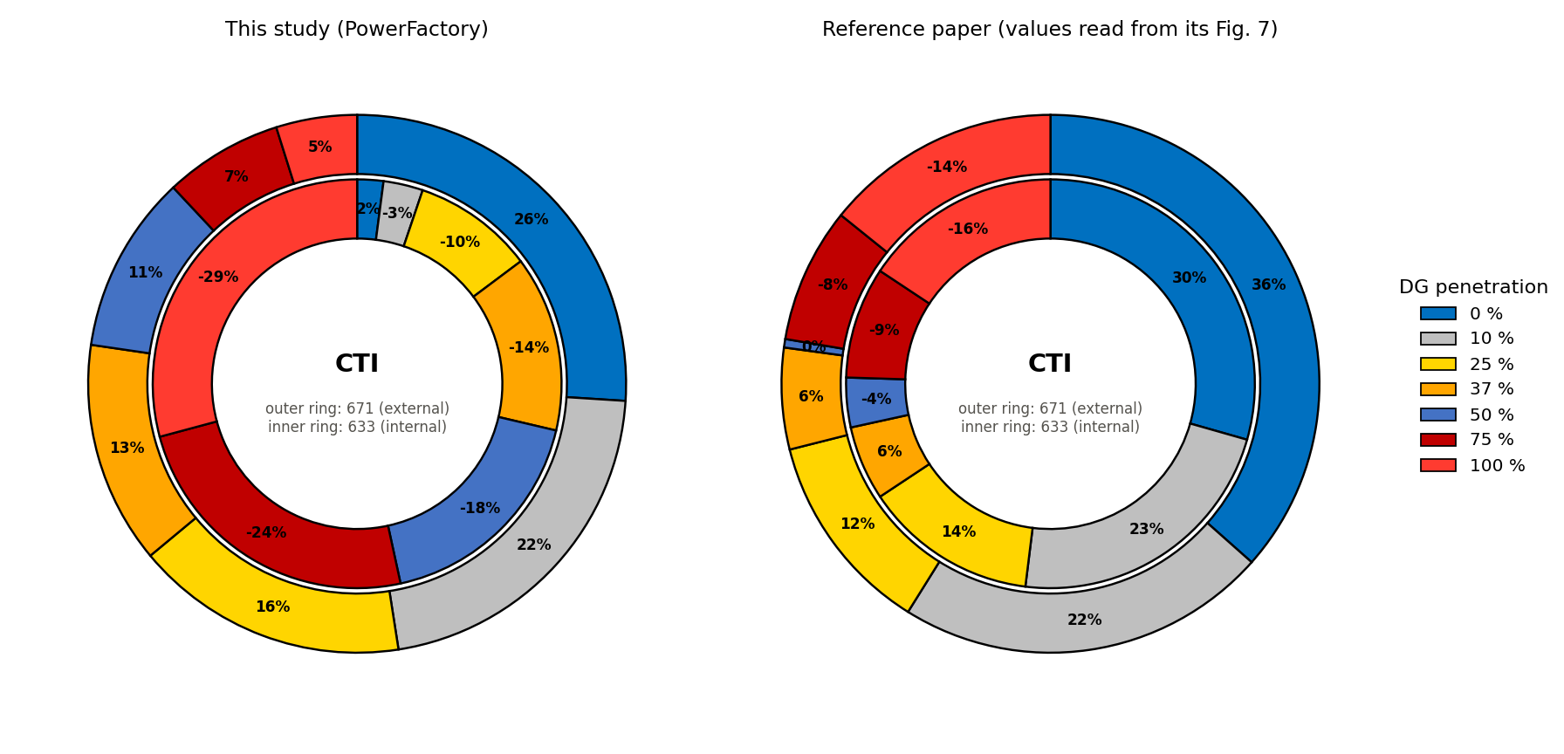
Figure C.1 CTI against DG penetration: this study (left) and the values read from the paper’s Fig. 7 (right).
Table C.10 CTI shares against DG penetration: this study and the paper’s Fig. 7.
 | Node 633 (ring %) |  | Node 671 (ring %)
DG (%) | this study | paper | this study | paper
0 | $$+2.1$$ | $$+30$$ | $$+26.0$$ | $$+36$$
10 | $$-3.1$$ | $$+23$$ | $$+21.5$$ | $$+22$$
25 | $$-9.6$$ | $$+14$$ | $$+16.4$$ | $$+12$$
37 | $$-13.9$$ | $$+6$$ | $$+13.4$$ | $$+6$$
50 | $$-17.9$$ | $$-4$$ | $$+10.7$$ | $$+0$$
75 | $$-24.2$$ | $$-9$$ | $$+7.1$$ | $$-8$$
100 | $$-29.2$$ | $$-16$$ | $$+4.9$$ | $$-14$$

