README:

- This project implements a database-backed feature flag engine supporting:
  - Global defaults
  - User-level overrides
  - Group-level overrides
    - Deterministic precedence rules:
User → Group → Global
- Built using ASP.NET Web API with a clear separation between:
- API controllers
- Domain services
- Data access abstraction
- Persistence via Entity Framework
  - How to Run Prerequisites
    - Visual Studio 2017+
    - .NET Framework (matching project)
    - SQL Server / LocalDB
To test functionality Go to Web.config and update connection string here
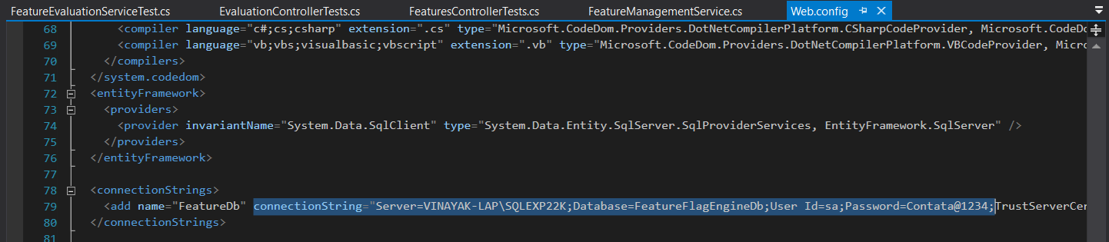
- After adding changes in the connection string above run
Update-Database in Package Manager Console, this command will create DB and respective tables.
- 📡 API Endpoints
  - POST /api/features
  - GET /api/features
  - PUT /api/features/{name}/global
  - POST /api/features/{name}/users/{userId}
  - DELETE /api/features/{name}/users/{userId}
  - POST /api/features/{name}/groups/{groupName}
  - DELETE /api/features/{name}/groups/{groupName}
- Evaluation
  - GET /api/evaluate/{feature}?userId=123&groupName=beta

- Test Case
  - Unit tests are implemented using MSTest + Moq.
    - Feature evaluation precedence logic
    - Feature management mutations
    - Validation and error handling
- Need to work ahead
  - No authentication/authorization
  - No UI/dashboard
  - Synchronous EF for simplicity
  - Single group per user assumption
  - Async EF APIs

Testing Scenario via postMan

- http://localhost:54123/api/features : Post : Create checkout feature
{
"name": "checkout",
"state": false,
"description": "New checkout flow"
}
- http://localhost:54123/api/features : Get
- http://localhost:54123/api/evaluate/checkout : Get :
- http://localhost:54123/api/features/checkout/groups/beta : Post: Create beta group
{
"state": true
}
- http://localhost:54123/api/evaluate/checkout?groupName=beta: Get
- http://localhost:54123/api/features/checkout/users/test123 : Post
{
"state": false
}
- http://localhost:54123/api/evaluate/checkout?userId=test123&groupName=beta : Get: User Wins as User has false state but group is true but according to precedence rule we will get state false.
- http://localhost:54123/api/features/checkout/users/test123 : Delete : User
- http://localhost:54123/api/evaluate/checkout?userId=u123&groupName=beta : Get
Here we have a group but no users. That's why we are going to get state true now.
- http://localhost:54123/api/features/checkout/groups/beta: Delete: Group
- http://localhost:54123/api/evaluate/checkout: Get
Now we will going to get the state of Feature directly
- NEGATIVE TESTS
  - http://localhost:54123/api/evaluate/TestFeature: Get
"Feature 'TestFeature' does not exist."

  - http://localhost:54123/api/features: Post
{
"name": "checkout",
"state": false,
"description": "New checkout flow"
}
"Feature 'checkout' already exists.",

