**STATEMENT OF WORK No. 1**

**Optimal Resource Allocation for Virtual Network Function (VNF) VMs in Network Functions Virtualization (NFV)**

**A Joint Research Project Between**

**Dell**

**and**

**INDIAN INSTITUTE OF TECHNOLOGY- MADRAS (IIT- MADRAS)**

THIS STATEMENT OF WORK No. 1 (“SOW”): is entered into as of by and between the **INDIAN INSTITUTE OF TECHNOLOGY- MADRAS (IIT- MADRAS**  (“University”), and Dell Products L.P., a Texas limited partnership (“Dell”), is effective as of October 1st, 2015 (“Effective Date”).

This SOW is governed by the University Program Joint Collaboration Agreement (“Agreement”), between Dell and University dated_____________________________________, and is fully incorporated therein. In the event of a conflict between the terms of the Agreement and the provisions of this SOW, this SOW shall govern and control. All terms used in this SOW and not otherwise defined herein will have the same meaning as in the Agreement.

# Background

Network Functions Virtualization (NFV) is an information systems architecture concept in which network functions such as load balancing, firewall, intrusion detection, virtual-private network, WAN acceleration, and carrier functions like content distribution (CDN), radio access (RAN), converged voice and data networks like Evolved Packet Core (EPC), IP-based multi-media subsystems (IMS), and radio-to-Internet gateways (GGSN) are implemented completely in software running in a virtual environment comprising commodity components such as x86 servers and hypervisors. The advantages to this approach over traditional appliance models delivered using physical network architecture are: reduced cost, the ability to construct services and configure/reconfigure them dynamically, and the ability to combine them (called “chaining”) to create composite services (*e.g.*, VPN with load-balancing). A reasonably complete introduction can be found here: <http://en.wikipedia.org/wiki/Network_Functions_Virtualization>

The European Telecommunications Standards Institute (ETSI) is one organization that has made substantial progress in this vein. Dell is currently a participant in the ETSI NFV activity, which is described here: <http://www.etsi.org/index.php/technologies-clusters/technologies/nfv>. We adopt ETSI’s nomenclature to discuss and explain NFV concepts.

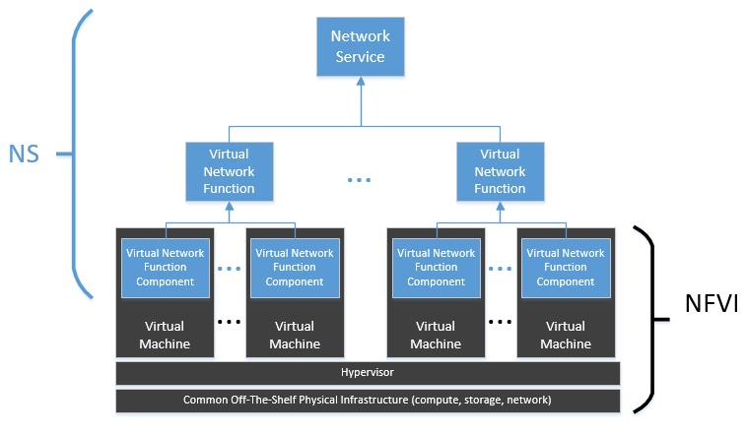In NFV, a Network Service (NS) is the top-level deliverable – a functionally complete set of nodes that can participate meaningfully in a network forwarding graph just as a physically-staged service would. Each NS comprises one or more VNFs, which in turn are composed of one or more VNF Components (VNFC). The VNFCs map one-to-one with the execution container supported by the underlying Network Function Virtualization Infrastructure (NFVI). Without loss of generality, and as is found in current best practice, these containers are usually virtual machines running in a hypervisor environment on top of commodity hardware. A common interpretation of this abstraction hierarchy is shown in *Figure 1*.

*Figure 1-Common Interpretation of NFV Network Service architecture*

*Figure 1* applies to the architecture of the NS once constructed. It does not speak to the means by which the NS was created and configured, nor does it show the relationship of this particular NS to others in a forwarding graph. To fully realize the value of NFV, NS lifecycles must be managed and automated, and a large part of standardization work is directed at this problem. ETSI refers to the domain as Management and Orchestration (MANO).

As shown below in *Figure 2*, MANO introduces several new entities to facilitate the management framework discussion. The contents of the dashed box compose the MANO itself:

* NFV Orchestrator (NFVO): Manages Network Service lifecycles. The NFVO also has state information for the service catalog, VNF catalog, set of currently instantiated objects, and what resources are available (to support NFVO planning algorithms).
* VNF Manager (VNFM): Manages the lifecycle of VNFs the NFVO has requested. VNF Vendors often provide this management front-end to their VNFs, although “generic” VNF Managers may eventually emerge with the proper standards. In current implementations, there are often many VNFMs depending on how many different vendors and instances of VNFs are deployed.
* Virtualized Infrastructure Manager (VIM): Translates VNFM requests to the underlying virtual infrastructure (VNFI). In practice, this is the software provided by the virtualization or cloud vendor to manage the environment (OpenStack, vSphere API, AWS API, etc.).

There are also pre-existing Operational and Business Support Systems, and an Element Management System already found in telco infrastructures, with which VNFs must interact. The Element Manager (EM) is responsible for security, configuration, fault detection and remediation, and metering (billing) of network elements.

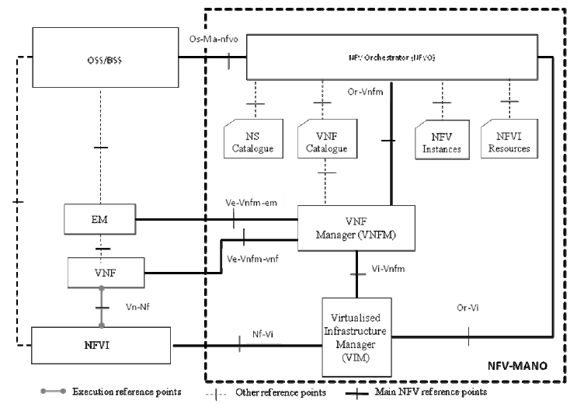

*Figure 2- ETSI MANO Architecture (V1.1.1)*

*Figure 2* calls out six specific interfaces that MANO uses to implement communication between the components participating in the orchestration, with the OSS/BSS being the origin of the orchestrated actions:

* Os-Ma-nfvo: The NFVO receives directives from the OSS/BSS systems to standup and teardown services as the business objectives dictate. The NFVO also provides information to the OSS/BSS regarding current configuration, usage, and other operational details of interest.
* Or-Vnfm: The NFVO calls the VNFM to offload the lifecycle management of a single VNF instance. That instance, and potentially other VNF instances, compose a network service that the NFVO manages. There may in practice be many VNFMs, so the Nfvo-Vnfm could be a 1-to-many pattern.
* Ve-Vnfm-em: For EMs that are aware of NFV, this interface enables communication between the EM and the VNFM for coordinating their actions in many aspects of the VNF lifecycle.
* Ve-Vnfm-vnf: VNFMs manage VNFs across this interface. Since VNFMs typically manage many VNF instances, this is a 1-to-many pattern.
* Vi-Vnfm: To instantiate a VNF, a VNFM must interact with the virtual infrastructure to create the virtual machine, configure it, and start it. This interface is heavily dependent upon the underlying infrastructure technology (OpenStack, VMware, Amazon, Microsoft, etc.)
* Nf-Vi: This is the interface the VIM uses to manage the NFVI. In practice, this is a combination of IPMI, SNMP, and hypervisor APIs that virtualization and cloud software address.
* Or-Vi: This interface allows the NVFO to directly interrogate the VIM for resource planning purposes, and for synchronizing the artifact catalogs with image libraries (virtual machine images).

# Project Objectives

## Overview

In the NFV setup, the intermediary network functions such as NAT, Firewall, DNS, etc. are virtualized (called as Virtualized Network Functions (VNF)) and composed as service chains. A VNF may in turn be composed of one or more VMs (called VNF Components or VNFCs), connected together with data paths, which together perform the defined network function.

Traditional resource allocation schemes take into account CPU and memory constraints while instantiating the VMs on physical servers but do not necessarily take into account impact on network communication due to the placement of VMs. In NFV environment, achieving bandwidth efficiency and reducing latency among VNFs/VNFCs are key objectives and hence it is useful to place the VMs constituting a service chain “close” enough and avoid unnecessary consumption of the network bandwidth. In the case of VNF chains stretched across more than one data center, the resource allocation technique should be optimal with respect to the use of network bandwidth across the WAN. At the same time, constraints like policies that restrain certain VM+VNF sub-chains to a certain data center because of either (a) data source affinity or (b) other policies such as security or administrative concerns should be satisfied.

The primary goal of this project is to explore tools & techniques that enable data center service providers to utilize their compute, storage & network resources optimally even while meeting the performance objectives of hosted services. There are two major scenarios to be considered for optimization:

1. When all the communicating end-points and intermediate nodes are targeted to be placed inside a single data center, called as **Intra-Data Center Optimization** scenario.
2. When some of the communicating end-points and intermediate nodes are stretched across more than one data center, called as **Inter-Data Center** **Optimization** scenario.

## Research Objectives & Considerations

* The algorithm should have “online” characteristics i.e. recommend VNF placement at the time of instantiation of a service/service chain and not as offline design/planning process; the algorithm’s time and space complexity should be reasonable to enable deployment in medium to large scale data centers.
* The algorithm should adapt to changing load & demands in the data center, reclaim & reallocate unused/inefficiently used resources. The cost and desirability of migration of VNF/VNFCs as well as their high availability requirements should be considered when reallocating resources for an existing virtualized network service or its component instances. Predictive analytics techniques could be explored for load estimation as appropriate.
* The algorithm should consider the fact that different data centers may use different metrics for calculating the network cost. For e.g., while one DC may be interested in minimizing the no of hops in the data path between components of a service chain, a different DC may be interested in ensuring that instances of a particular service or client are spread as far apart as feasible (“anti-affinity” scenario).
* The resource allocation scheme should also be concerned with allocating appropriate links to the VNF chains such that congestion is avoided in the network. When network bandwidth is used both in the intra-DC and the inter-DC case, attention should be paid to flow placement on the appropriate links in the form of traffic engineering that places the flows to avoid congestion to the maximum extent possible. Relevant flow placement algorithms should be studied and pursued in this regard. Appropriate data plane and control plane constructs that perform this role should be studied and best practices adopted as part of the solution.
* The algorithm should also operate under a policy constrained environment wherein policies could specify business rules, resource usage constraints and security considerations. The goal should be to integrate into a policy specification language that already exists rather than inventing one from ground up as far as possible. This could mean adding to the capability of the language if the one already existing lacks certain capabilities. This is particularly true in the case of the inter-Data-Center case where policies and constraints play an important role in the placement of the VNF chains.
* The challenges in integrating the placement algorithm into Management and Orchestration (MANO) software components should be identified and dealt with. Some of the key questions to consider are:
  + What are the changes/extensions required to existing Virtualized Infrastructure manager (VIM) or any other components of MANO stack to support the new placement algorithm?
  + What are the software components that need to participate in providing input data to the placement algorithm and/or be made aware of the results of the placement algorithm? What are the software interfaces through which these interactions take place?
  + How does the algorithm or the interfaces impact mechanisms/architecture for service functions chaining?
  + How does the algorithm extend to scenarios where alternate VM technologies are used (such as Linux Containers/Dockers)?

An example formulation taking into consideration a few of the above considerations are listed in Exhibit A, under Pre-existing IP of Dell.

## Approach

The research project shall encompass the following major activities:

1. Survey to consist of an extensive, thorough survey of the NFV landscape as it relates to resource allocation schemes, including existing algorithms/implementations (from VNF/VNFM/NFVO vendors, open source projects), in-progress standards activities (if any), and published research. How different are VNF placement implementations?
2. Formulation of one or more placement policies with procedures in various topologies.
   1. Consequent simulation of these placement procedures in order to evaluate their suitability when compared to existing state of the art if any.
   2. Simulation of these algorithms as compared with each other.
   3. Consequent evaluation of these algorithms one against the other and with any pre-existing state of the art.
3. Integration of the placement algorithm with open source orchestration tools (OpenStack, OPNFV are the recommended platforms) to enable a meaningful proof-of-concept for VNF placement algorithms. Ideally, the PoC has customer (telco) visibility and feedback.
4. Additional stable code of a quality that can be contributed to open source community

# Structure

## Sponsorship and Oversight

The work is being co-sponsored Dell Research Division and Dell Enterprise Solutions Group. Sankar Nagarajan will represent Dell as main coordinator and contact for all Dell participants and stakeholders. Dr. Krishna Sivalingam, chair of the IIT-M Division of Computer Science, will function as the primary investigator (PI) and will be the main coordinator and contact for all IIT-M participants and stakeholders.

## Team Composition

The IIT-M team will consist of Dr. Krishna Sivalingam as PI, plus one full-time MS/PhD student / research assistant.

The Dell team will consist of Wenjing Chu, Distinguished Engineer, Dell Research as lead along with Ramki Krishnan, Distinguished Engineer, Dell Networking Office of the CTO and Balaji Venkat Venkataswami & Safina Devi from Dell Networking Chennai and will provide the technical backing and ongoing direction for the IIT-M team.

## Duration

The project is scheduled to run for 12 consecutive months, beginning September 1, 2015.

## Sponsor Provided Materials

Dell will provide the research grant to fund the project for the scheduled duration as per terms specified in Section 6 of the Agreement. Dell will make available access to the engineering experts and technologists required to explain Dell technology and open source assets to the IIT-M team as needed. Other materials, such as NFV sandboxes (Dell lab systems with OpenStack or similar software, and VNF products from cooperating vendors) will be provided as deemed necessary.

## Meeting Cadences

The core team of researchers (IITM Professors, IITM students, Wenjing, Ramki, Balaji) will meet at a minimum bi-weekly to review progress. Other meetings will be scheduled as needed. Three executive readouts will be scheduled with Executive leadership of Dell Research and Dell Networking organizations.

## Summary of Deliverables

The IIT Madras team will deliver the following by the close of the project. The “Milestones and Deliverables” chart in the following section gives details on what is expected, and when.

* Written survey report addressing the research objectives. Specifically, this report should include at a minimum: a) a literature and industry survey with both summary and detailed information about implementations and standards efforts; b) architectural diagrams and explanatory text; c) extended narrative and supporting diagrams organized in the manner best suitable to conveying the findings.
* Formulated VNFC Placement algorithms along with their simulation reports and Evaluation reports. Detailed architectural explanations of the algorithms, and how it maps to implementations and standards (if any) discovered in the survey step above. This can be reported in an addendum or companion report to the survey report.
* Initial proof-of-concept code for a VNF placement algorithm / algorithms integrated with an open source framework such as OpenStack or OPNFV
* At least one submitted refereed conference or journal paper co-authored by Dell and IIT-Madras.
* Interim and final presentations to Dell stakeholders.

## Milestones & Schedule:

|  |  |  |
| --- | --- | --- |
| **Month** | **Milestones** | **Deliverables** |
| September 2015 | * Team in place * Survey commences |  |
| October 2015 |  | * Initial survey report draft |
| November 2015 |  | * Final survey document |
| December 2015 | * Executive Stakeholder Review * Formulation of possible VNF placement algorithms |  |
| January 2015 | * Prototype coding begins | * Formulation and Simulation Report of VNF placement algorithms |
| March 2016 | * Demo/PoC objectives locked down | * Partial/functional code for one or more VNF placement algorithms |
| April 2016 | * Executive Stakeholder Review * Functionally complete code | * Rough demo of code as it fits in one of the interfaces as determined. |
| May 2016 | * Begin drafting paper for publication |  |
| Jun - Aug 2016 | * Executive Stakeholder Review | * Completely functional demo * Refined code ready for contribution * Final draft of research publication with line-of-sight to publication venues |

# Intellectual Property – To be vetted by Legal

Attached hereto as Exhibit A is a list of the intellectual property the parties intend to develop or create pursuant to this SOW (the “Project IP”) and key existing IP that are relevant to this project scope. Exhibit A shall be amended from time to time incorporating new IP that is developed or other Pre-Existing IP from Dell or IIT-M that are incorporated into the Project IP.

Dell will not retain rights to the IP generated by this project, as the software code developed under this SOW (and algorithm expressed in the code) will become part of the OPNFV / other relevant open source project pursuant to Section 3.13 of the Agreement. The survey results will be submitted for publication in academic journals.

TBA -

# Nonrecurring Engineering Expenses

Subject to Section 4 of the Agreement, Dell shall pay to the University the following amount to reimburse the University for the non-recurring engineering expenses incurred by it:

Not to Exceed: INR tbd

Payment Schedule: TBD

**Notwithstanding the milestones listed above, this SOW shall commence on and expire on**

IN WITNESS WHEREOF, the parties hereto have duly executed this SOW by their respective duly authorized officers to be effective as of the Effective Date as first written above.

**DELL PRODUCTS L.P.**  INDIAN INSTITUTE OF TECHNOLOGY- MADRAS

By: By:

Title: Title:

Date: Date:

Exhibit A: Project Intellectual Property

Pre-Existing IP of Dell

* “VM Resource Allocation in Network Function Virtualization” by Wenjing Chu, Balaji Venkat, Safina Devi N
* “Policy Based Smart Placement – Towards a Agile, Elastic, Scalable and Energy Efficient NFV” by Ramki Krishnan, Anoop Ghnawani, Snigs Mukhopadyay, Mohinish Anumala

Project IP

* Algorithm for Placement of VNFs in NFV Environment – Design & Software Implementation

References

**OpenStack Summit, Vancouver, May 2015**

* Helping Telcos go Green and save Opex via Policy; Link to video: [https://www.openstack.org/summit/vancouver-2015/summit-videos/presentation/helping-telcos-go-green-and-save-opex-via-policy](https://www.google.com/url?q=https://www.openstack.org/summit/vancouver-2015/summit-videos/presentation/helping-telcos-go-green-and-save-opex-via-policy&sa=D&sntz=1&usg=AFQjCNEt8bC4lrX71hpAq_UaTIwMefSNYA)

**IEEE CCNC 2015**

* “An open NFV and cloud architectural framework for managing application virality behavior”, D. Krishnaswamy, R. Krishnan, D. Lopez, P. Willis, A. Qamar

**IEEE MMTC E-Letter Special Issue , July 2015**

* Invited Article on “Caching of Viral Content in NFV Architecture” in– joint with BT, Telefonica and IBM Research

**ETSI NFV Meeting, July 2015**

* Presentation on Constraint-based placement PoC <http://nfvwiki.etsi.org/index.php?title=Constraint_based_Placement_and_Scheduling_for_NFV/Cloud_Systems>

**IEEE NFV-SDN Conference in SFO, Nov. 2015**

* Paper submitted - “Optimizing Energy Usage for NFV Systems: Challenges and New Directions”

**IRTF NFVRG Drafts**

* <https://datatracker.ietf.org/doc/draft-krishnan-nfvrg-policy-based-rm-nfviaas/>
* <https://datatracker.ietf.org/doc/draft-norival-nfvrg-nfv-policy-arch/>