CA-3 · Foundation of Agentic AI
Reading the Rig
Agentic AI for Daily Drilling Reports: finding non-productive time with a LangGraph multi-agent system
Project report · Proof of concept
Rahul Narkhede (24070126146)
Ranjan Verma (24070126149)

TY B.Tech AI-ML, Division B
Symbiosis Institute of Technology, Pune
October 2026

Repository: https://github.com/ranjanvrma/rig-sight
Live demo: https://rig-sight.onrender.com/
All data in this project is synthetic. This is a classroom proof of concept, not a certified engineering or safety system.

Contents
Abstract 3
1. Introduction and domain background 3
1.1 Why oil and gas drilling 3
1.2 The Daily Drilling Report 3
1.3 Non-productive time 3
2. Problem statement 4
3. Existing process and identified inefficiencies 4
4. Proposed solution and objectives 4
5. Requirements and technology stack 5
5.1 Functional requirements 5
5.2 Technology stack 5
6. System architecture and data flow 5
7. Agent roles and orchestration 8
8. Data model, synthetic dataset and reference files 8
8.1 Shared state (DDRState) 8
8.2 Synthetic dataset 9
9. Implementation details 9
10. Deterministic tools and model usage 10
11. Critic validation, retries and human-in-the-loop review 10
12. Web interface 11
12.1 Deployment 11
12.2 Screens 11
13. Testing methodology and test cases 15
14. Evaluation results 16
14.1 Interpretation 16
15. Limitations and responsible use 17
16. Future enhancements 17
17. Conclusion 17
References 18
Appendix A. How to run 18

Abstract
Every drilling rig sends a Daily Drilling Report (DDR) each morning, and most of it is free text typed by the crew. Hours that are paid for but do not move the well forward, called non-productive time (NPT), hide inside those sentences, so they are rarely totalled and lessons are lost between wells. This project builds a working proof of concept in which a team of LangGraph agents reads a DDR, plans the work, looks up reference data and past incidents, computes every number with deterministic Python tools, checks its own output with a Critic that can send work back with specific feedback, and pauses for a drilling engineer to approve or reject an evidence-backed insight report. A hosted language model (openai/gpt-oss-20b on Groq's free tier) is used only to label log lines; a keyword classifier is the fallback and is always reported as such.
On 15 synthetic reports with a known answer key, the full graph had a mean NPT error of 0.07 h per report, got every planted NPT line's category right (100%), caught both deliberately planted log errors (2/2) and produced time logs that add to 24 h in 15/15 reports. A single-prompt chatbot using the same model had a mean error of 0.57 h, and its time log added to 24 h in 13/15 reports. The one remaining error is the model counting a routine flow check as NPT; the engineer review step corrects it with one comment. 58 automated tests cover the tools, the Critic, retries, human review, malformed input, the model fallback and the web API.

1. Introduction and domain background

1.1 Why oil and gas drilling
Drilling and completing wells takes 40 to 50 percent of an offshore operator's capital spend (Source 9), and a drillship cost close to $400,000 a day in late 2025 (Source 10), roughly $16,000 for every hour the well does not progress. Operators that tracked lost time closely cut NPT from about 16 percent to 9 percent within a year (Source 9). The industry has also started buying agentic AI: in 2025 ADNOC awarded AIQ a $340 million contract to deploy agentic systems across more than 28 fields (Source 11), while the SPE ATCE 2026 programme openly asks how far agents can be trusted with operational decisions (Source 4). That combination, real money and an open question of trust, makes the domain a good fit for an agentic proof of concept with a human in the loop.

1.2 The Daily Drilling Report
A DDR covers the previous 24 hours: an hour-by-hour time log, depth drilled, bit and mud data, weather, crew on board and the cost of the day. The IADC has been reworking the format so that activities are tracked in more detail (Source 2). Most of the time log is free text, for example:
06:00-08:30 Drilled 12-1/4 in hole from 2,450 m to 2,610 m
08:30-14:00 POOH, MWD tool stopped sending data
14:00-16:00 Waited on weather, wind above crane limit
The second and third lines are both lost time, but nothing in the report adds them up.

1.3 Non-productive time
NPT is rig time that is paid for while the well does not move forward. In a study of wells on the Lobo trend, stuck pipe and lost circulation alone made up about 74 percent of NPT (Source 1); other common causes are tool failure, waiting on weather, waiting on equipment and well control (Source 3). This project uses those six categories.

2. Problem statement
How can a drilling engineer get a reliable, evidence-backed account of lost time from every daily drilling report without reading each one line by line?
Reports arrive every day from many rigs as free text. The account must give exact hours per NPT category, show which report line each claim comes from, compare progress and cost with plan, suggest a likely cause from past events, and leave the final decision to the engineer.

3. Existing process and identified inefficiencies
- Manual reading. An engineer reads each report by eye; with many rigs this does not scale.
- Small losses are not totalled. Half an hour here and there is never added up across a day or a well.
- Inconsistent labels. Different people classify the same event differently, so trends are unreliable.
- No memory. Causes and fixes from past wells are not reused, so the same failure returns on the next well.
- Data errors pass unnoticed. Gaps, overlaps and typos in the time log are not checked systematically.
- A plain chatbot does not fix this. One prompt and one answer: the model has to read and count, cannot check itself and gives no proof. Section 14 measures this.

4. Proposed solution and objectives
A LangGraph multi-agent system in which each agent has one job and all of them share one state. The guiding rule is "the model reads, Python counts": the language model only interprets free text, and every number is computed by a tool so the Critic can check it exactly.
Objectives
- Ingest a DDR, parse its time log and plan the processing tasks.
- Look up the well plan, NPT categories, daily budget and similar past incidents.
- Classify every activity as productive or one of six NPT categories, with a confidence score.
- Compute total hours, NPT by category, rate of penetration (ROP), depth against plan and cost against budget with deterministic tools.
- Validate the result with a Critic, retry with specific feedback when the problem is fixable, and report unfixable source-data errors instead of repairing them silently.
- Draft an insight report that separates observed data, inferred causes, validation results and suggested actions, with a source line for every NPT claim.
- Pause for the engineer to approve, or reject with a comment that the system acts on.
- Measure accuracy against a known answer key and compare with a single-prompt chatbot on the same model.

5. Requirements and technology stack

5.1 Functional requirements
Table 1. Functional requirements and the code that meets them
ID | Requirement | Where it is met
F1 | Ingest a synthetic DDR (file or pasted text) | ingest_report, custom report in the web app
F2 | Parse time-log entries; report malformed lines and invalid timestamps | parse_time_log
F3 | Plan the processing tasks | planner
F4 | Research well plan, NPT codes, budget, past incidents | research + lookup tools
F5 | Classify productive vs NPT activities | classify_activities (LLM or mock)
F6 | Deterministic totals, NPT, ROP, depth variance, cost | sum_hours, calc_rop, depth_vs_plan, cost_vs_budget
F7 | Real orchestration | route() over DDRState, conditional edges
F8 | Critic validation | critic
F9 | Retry with feedback, limited | fix_hints, MAX_RETRIES = 3
F10 | Evidence-backed insight report | report_writer
F11 | Human approve / reject with comments | human_review, interrupt()
F12 | UI with agent activity, results, charts, evidence, review | web app: api.py + web/
F13 | Clean, NPT and planted-error test cases | data/, tests/
F14 | Honest fallback when no LLM is available | llm.py mock, 'labelled by' in every report

5.2 Technology stack
Table 2. Technology stack
Layer | Choice | Why
Language | Python (tested on 3.14 and 3.11) | Course requirement; rich tooling
Orchestration | LangGraph 1.2 (StateGraph, ToolNode, interrupt, checkpointer) | Explicit state graph with loops, tools and human pause
Messages / tools | LangChain Core 1.6 | Tool schemas and tool messages for the ToolNode
Language model | Groq API with openai/gpt-oss-20b (hosted, free tier) | No paid API; runs on any machine, including the free web server
Fallback | Keyword classifier built from npt_codes.json | Demo keeps working without a model
Storage | SQLite (incident memory, LangGraph checkpoints) | Built into Python
UI | FastAPI + plain HTML, CSS and JavaScript | Simple to run and explain; no build step
Testing | pytest (58 tests), FastAPI TestClient | Repeatable checks

The model runs at Groq, not on the laptop or the web server, so any machine with an internet connection can run the system, including the free Render web server (512 MB of memory). The team's first design used a local model through Ollama (llama3.1:8b, then qwen2.5:3b on a 4 GB GPU); it was replaced by Groq so that the online demo uses a real language model too.

6. System architecture and data flow
The design is hub and spoke (Figure 1). The Orchestrator sits in the middle, reads the shared state and decides which agent works next. Every agent hands back to the Orchestrator; agents never call each other. Reference data, incident memory and the checkpointer live outside the graph. The web app starts a run, streams every node's update and resumes the graph when the engineer decides.
A normal run, step by step:
- The web app calls app.stream(initial_state, thread_id). ingest_report reads the file and parses the header.
- The Orchestrator sends the state to the Planner, which writes the task list.
- Research looks up the well plan, budget, NPT codes and similar incidents. Missing data becomes a warning.
- The Executor asks the ToolNode to parse the time log, then to classify activities and run the four maths tools in parallel, then totals NPT by category in Python.
- The Critic checks the result. A fixable FAIL goes back to the Executor with structured fix hints (at most three times); a PASS, an unfixable FAIL or used-up retries go to report_writer.
- report_writer drafts the Daily Insight Report. human_review calls interrupt() and the graph stops.
- The engineer approves (END) or rejects with a comment; a rejection clears the work and the Executor re-runs with the engineer's line overrides.
Figure 1, on the next page, shows the full architecture and the numbered data flow.

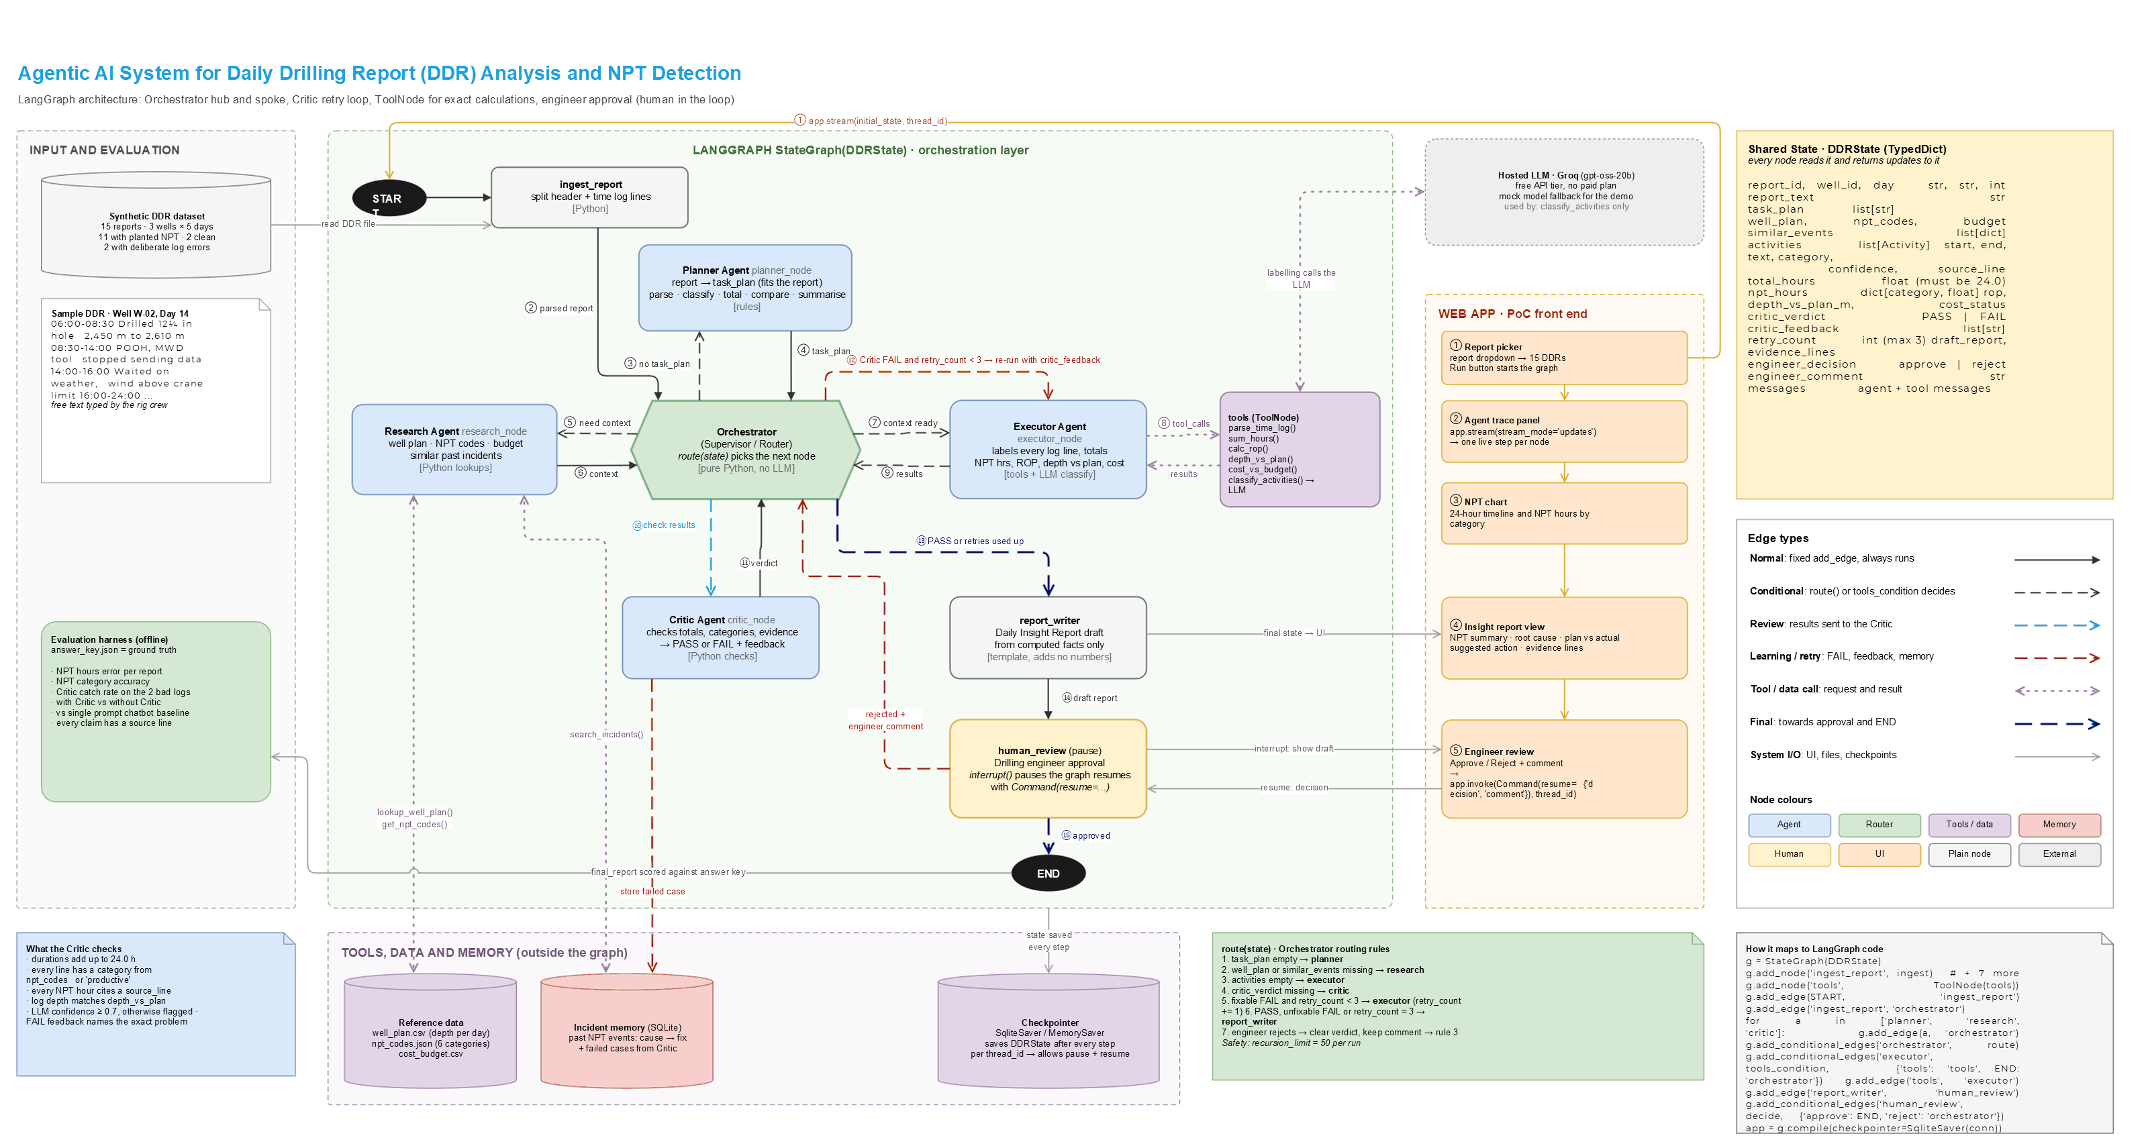
Figure 1. Architecture of the system (the team's design diagram)
The diagram is the team's design, updated to match the final code (rule-based Planner, recursion_limit 50, a web app as the front end, and Groq as the language model). Two details are simplified in the drawing: classification runs as one classify_activities tool over all lines, the Critic also checks gaps, overlaps, unparseable lines and the header (Section 11), and an unfixable FAIL also goes straight to report_writer.

7. Agent roles and orchestration
Table 3. Agent roles
Role | Node | Responsibility | Uses the LLM?
Orchestrator | orchestrator + route() | Reads DDRState and picks the next node | No (plain Python)
Planner | planner | Task list that adapts to the report: REMARKS present, drilling lines, depth, cost | No (rules)
Research | research | Well plan, budget, NPT codes, similar past incidents | No
Executor | executor + tools | Drives the six tools over three visits and totals NPT | Through classify only
Critic | critic | Hard checks, specific feedback, decides whether a retry can help, logs failed cases | No
Report writer | report_writer | Insight report from computed facts | Optional rephrase, off by default
Engineer | human_review | Approve, or reject with a comment | Human

Routing rules in route(), checked top to bottom (the first match wins):
1. no task_plan -> planner
2. no well_plan or similar_events -> research
3. activities is None -> executor
4. no critic_verdict -> critic
5. FAIL, retryable and retry_count < 3 -> executor (with fix_hints)
6. otherwise (PASS, unfixable FAIL, retries used) -> report_writer -> human_review
7. engineer rejects -> activities and verdict cleared, overrides kept -> rule 3
The Orchestrator is code rather than a model because routing only needs simple checks on the state; code is predictable, free, testable and easy to explain. recursion_limit is 50. Measured step counts are 16 for a normal report, 24 with one retry and 32 for the worst case (the Critic failing every time), which still reaches the engineer.

8. Data model, synthetic dataset and reference files

8.1 Shared state (DDRState)
Table 4. Main fields of the shared state
Field(s) | Type | Meaning
report_id, well_id, day, report_text, header | str, int, dict | Which report and its parsed header
task_plan | list[str] | Planner output
well_plan, budget, npt_codes, similar_events | dict, list | Research output
reference_warnings | list[str] | Missing or unreadable reference data
activities | list[dict] | None | One item per log line: start, end, hours, text, category, confidence, source_line, labelled_by, note
parse_issues | list[dict] | Malformed lines and invalid timestamps
total_hours, npt_hours, total_npt, rop, depth_vs_plan_m, cost_status | float, dict | Tool results
critic_verdict, critic_feedback, critic_warnings, critic_retryable | str, list, bool | Critic output
fix_hints, retry_count, attempts | list, int, list | Retry loop state and history
draft_report, evidence_lines | str, list[int] | Report writer output
overrides, engineer_decision, engineer_comment | dict, str | Human review
trace, messages | list | UI trace and agent / tool messages for the ToolNode

8.2 Synthetic dataset
data/generate_data.py writes every file. Each line is written together with its true label, so the answer key does not depend on the agents' parser or classifier. Real DDRs are confidential, which is a second reason to use synthetic data.
Table 5. The 15 reports (3 wells × 5 days; 2 clean)
Type | Reports | Notes
Clean days | W-01 D10, W-03 D11 | No NPT
Planted NPT | 11 reports | All six categories: tool failure, stuck pipe, lost circulation, waiting on weather, waiting on equipment, well control
Planted error: hidden line | W-02 D14 | 20:30-21:00 entry only in REMARKS, so the log adds to 23.5 h
Planted error: overlap | W-03 D13 | Two lines overlap by 30 min, so the log adds to 24.5 h
Trap | W-03 D14 | 'Waited on cement (WOC)' is planned work, not NPT

Reference files: well_plan.csv (planned end-of-day depth), cost_budget.csv (daily budget per well), npt_codes.json (six categories with crew keywords), incidents.sqlite (nine past incidents with cause and fix, plus empty tables for Critic failed cases and engineer decisions) and answer_key.json (true label per line, NPT hours, depth against plan and ROP). The app works on a copy of the memory database in runtime/, so using the demo never changes the committed data.
WELL W-02 DAY 14 DEPTH 2,610 m COST USD 418,000
00:00-06:00 Drilled 12-1/4 in hole from 2,300 m to 2,450 m
06:00-08:30 Drilled 12-1/4 in hole from 2,450 m to 2,610 m
08:30-14:00 POOH, MWD tool stopped sending data
14:00-16:00 Waited on weather, wind above crane limit
16:00-20:30 Tested BOP as per schedule
21:00-24:00 Slipped and cut drill line, serviced rig
REMARKS: 20:30-21:00 Waited on tong repair before slip and cut
Report W-02 Day 14 (above). The true answer is 24.0 h logged and 8.0 h NPT: tool failure 5.5 h, waiting on weather 2.0 h, waiting on equipment 0.5 h; 40 m behind plan; ROP 36.5 m/h.

9. Implementation details
Table 6. Repository modules
File | Contents
graph.py | DDRState, the eight nodes, route(), graph build, run helper
tools.py | Executor tools (ToolNode) and Research lookups; all arithmetic
llm.py | The only place a model is called: Groq client, mock classifier, summary, chatbot baseline
memory.py | SQLite incident memory, failed cases, engineer feedback, runtime copy
api.py, web/ | Web app: FastAPI server (API + pages) and the front end
evaluate.py | Scores the 15 reports in three configurations
data/generate_data.py | Writes the dataset, answer key and reference files
tests/ | 58 pytest tests

The Executor shows how tool use works with LangGraph. On its first visit it writes an AIMessage with a parse_time_log tool call; tools_condition sends it to the ToolNode, which returns a ToolMessage. On the second visit it issues five tool calls at once (classify_activities, sum_hours, calc_rop, depth_vs_plan, cost_vs_budget). On the third visit it reads the results, totals NPT by category in Python and writes a plain message, so tools_condition hands control back to the Orchestrator.
Engineer comments are turned into line overrides: a comment such as "line 6 is planned, not NPT" becomes {"6": "productive"}, and the re-run labels that line as set by the engineer (confidence 1.0, labelled by 'engineer').

10. Deterministic tools and model usage
Table 7. Tools
Tool | What it does
parse_time_log | Splits HH:MM-HH:MM lines into activities with source line numbers. Malformed lines and impossible or reversed times are returned as issues, never guessed at. REMARKS are read only to fill a gap the Critic named; an overlap the Critic named is trimmed. Both changes are noted on the activity and shown in the report.
classify_activities | Labels each activity (LLM or mock) with a category and confidence; engineer overrides win
sum_hours | Total logged hours (must be 24.0)
calc_rop | Metres drilled ÷ drilling hours from 'Drilled ... from X m to Y m' lines
depth_vs_plan | End depth minus planned depth; null when either is unknown
cost_vs_budget | Day cost against the daily budget
lookup_well_plan, get_npt_codes, search_incidents | Research lookups; missing files or rows return null and a warning

The language model is used in one place by default, with a second place available but switched off:
- classify_activities: reads one log line and returns a category and a confidence score as JSON. Invalid output falls back to the mock for that line, and the line records which one was used.
- report_writer (off by default, RIG_LLM_SUMMARY=1): may rephrase the computed facts into a short summary. A guard discards any summary containing a number that is not in the computed facts. During testing with the team's earlier local model (qwen2.5:3b, since replaced), the model kept every number but attached them to the wrong categories (it wrote that waiting on weather and waiting on equipment took "3.5 hours, 2 hours respectively" when the facts were 2.0 h and 3.5 h). A number guard cannot detect that, so the template summary is the default. The report states which was used.
The model never does arithmetic. It labels all lines of a report in one request. When no Groq key is set, or a request fails, the app uses the mock and says so in the top bar, in every activity ('labelled_by') and in the report ('Lines labelled by: mock').

11. Critic validation, retries and human-in-the-loop review
Table 8. What the Critic checks
Check | On failure
Header present and valid | FAIL, not retryable (source error)
Every time-log line parseable, times valid | FAIL, not retryable; line marked in red in the UI
At least one valid entry | FAIL
Logged hours add to 24.0 | FAIL
No gaps between activities | FAIL + gap hint (Executor reads REMARKS for that window)
No overlaps | FAIL + overlap hint (Executor trims the later line, noted for the crew)
Every activity has a valid category | FAIL
Every NPT claim's text is on its cited source line | FAIL
NPT total equals the sum of the NPT lines | FAIL
Deepest drilled depth equals the header depth | FAIL
Model confidence ≥ 0.7 | Warning shown to the engineer (not a FAIL)

A FAIL is retried only when the Critic has a new hint for the Executor to try; otherwise the draft goes to the engineer with the unresolved problems listed. This avoids three identical retries on an error only the rig crew can fix, and it keeps source errors visible instead of hiding them. Every FAIL is also written to the failed_cases table in memory.
Human review uses LangGraph's interrupt(): the graph stops inside human_review with its state saved by the checkpointer, and the UI resumes it with Command(resume={decision, comment}) on the same thread_id. Approve ends the run. Reject clears the activities and the verdict, keeps the comment and its overrides, and sends the work back through the Executor and the Critic before the engineer sees it again. Every decision is stored.

12. Web interface
The interface is a web app. A small FastAPI server (api.py) runs the graph and streams every agent step to one page written in plain HTML, CSS and JavaScript (no build step). It has four pages: Analyse, Evaluation, Memory and Architecture, with a light and a dark theme.

12.1 Deployment
The application is deployed on Render at https://rig-sight.onrender.com/, built from the main branch of the GitHub repository and started with uvicorn api:app; a push to main redeploys it. On the hosted app (Groq, openai/gpt-oss-20b), W-02 Day 14 gives 8.0 h NPT: the Critic fails the 23.5 h first pass and the retry recovers the missing half hour.
- Model: the hosted app calls Groq (openai/gpt-oss-20b) with a key stored as a Render environment variable; the key never reaches the browser. Without a key it falls back to the mock keyword classifier, and the top bar and every report say so.
- Results: the Evaluation page shows the committed Groq and mock results.
- State: memory and checkpoints are written to temporary server storage. They are lost when the app restarts, sleeps or redeploys, and are shared by everyone using it at the same time.
- Use: the hosted app and a local run behave the same; both use the same Groq model.

12.2 Screens
All screenshots below were taken from the application running locally with the Groq model (openai/gpt-oss-20b).
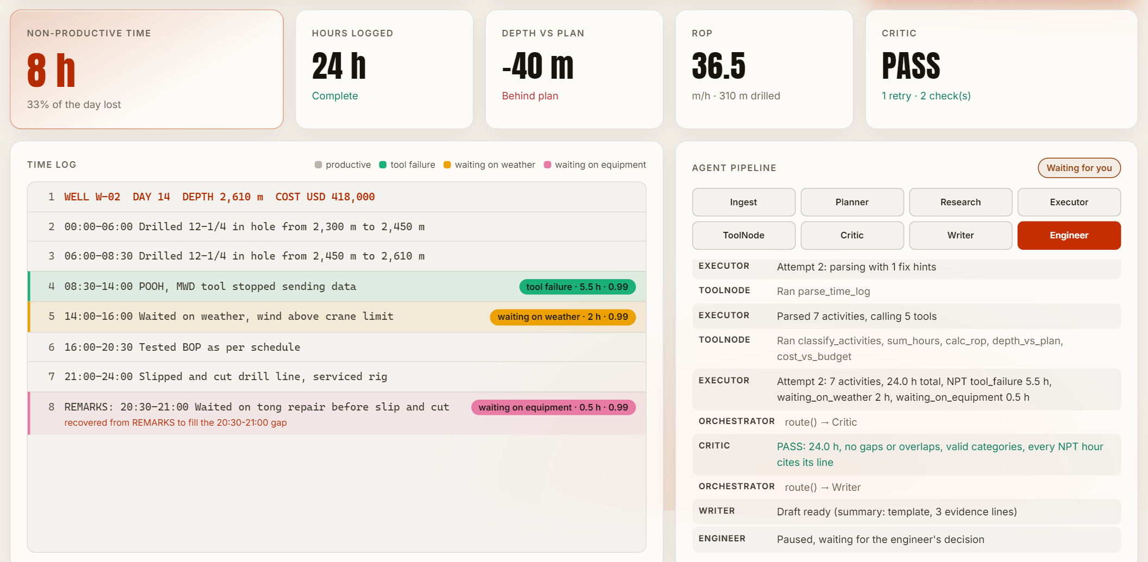
Figure 2. W-02 Day 14 after the first run: KPI tiles, the time log with NPT lines labelled (category · hours · confidence) and the line recovered from REMARKS, and the agent pipeline including the retry
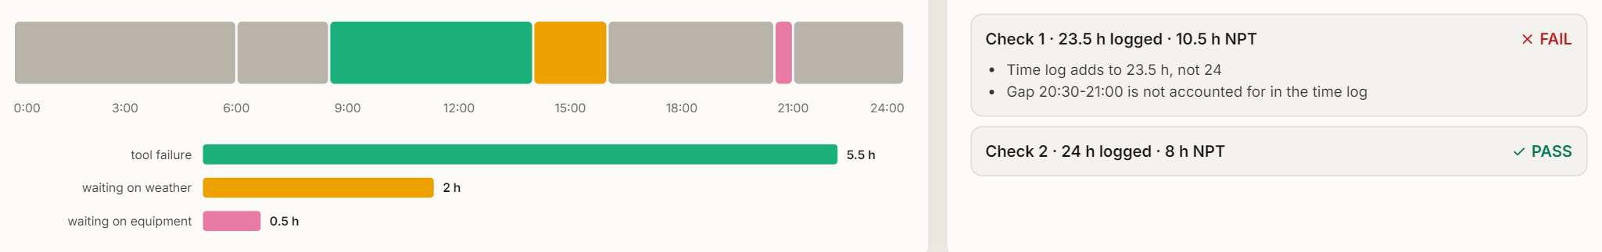
Figure 3. Where the 24 hours went (timeline and NPT by category) and the Critic's checks: FAIL on the 23.5 h first pass, PASS after the retry
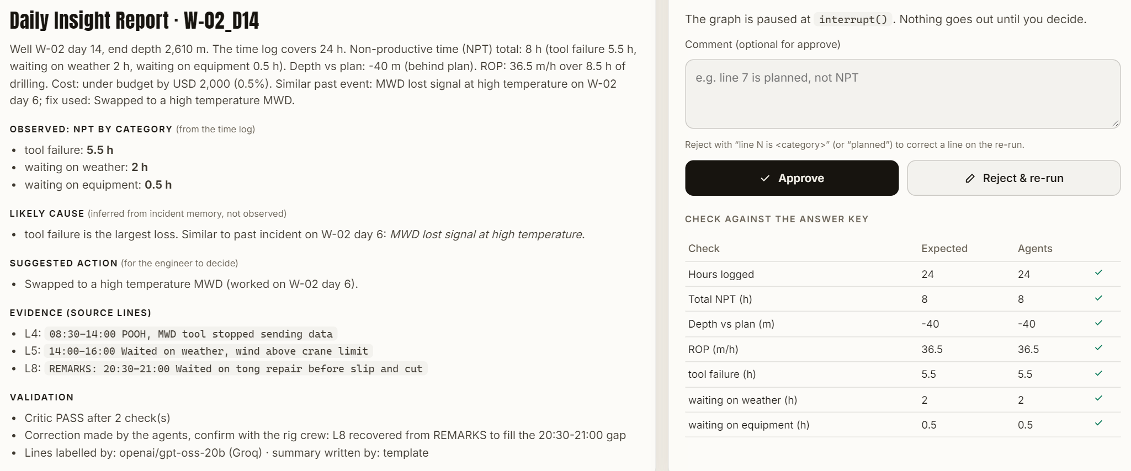
Figure 4. The Daily Insight Report for W-02 Day 14, the engineer review panel and the check against the answer key: every row matches
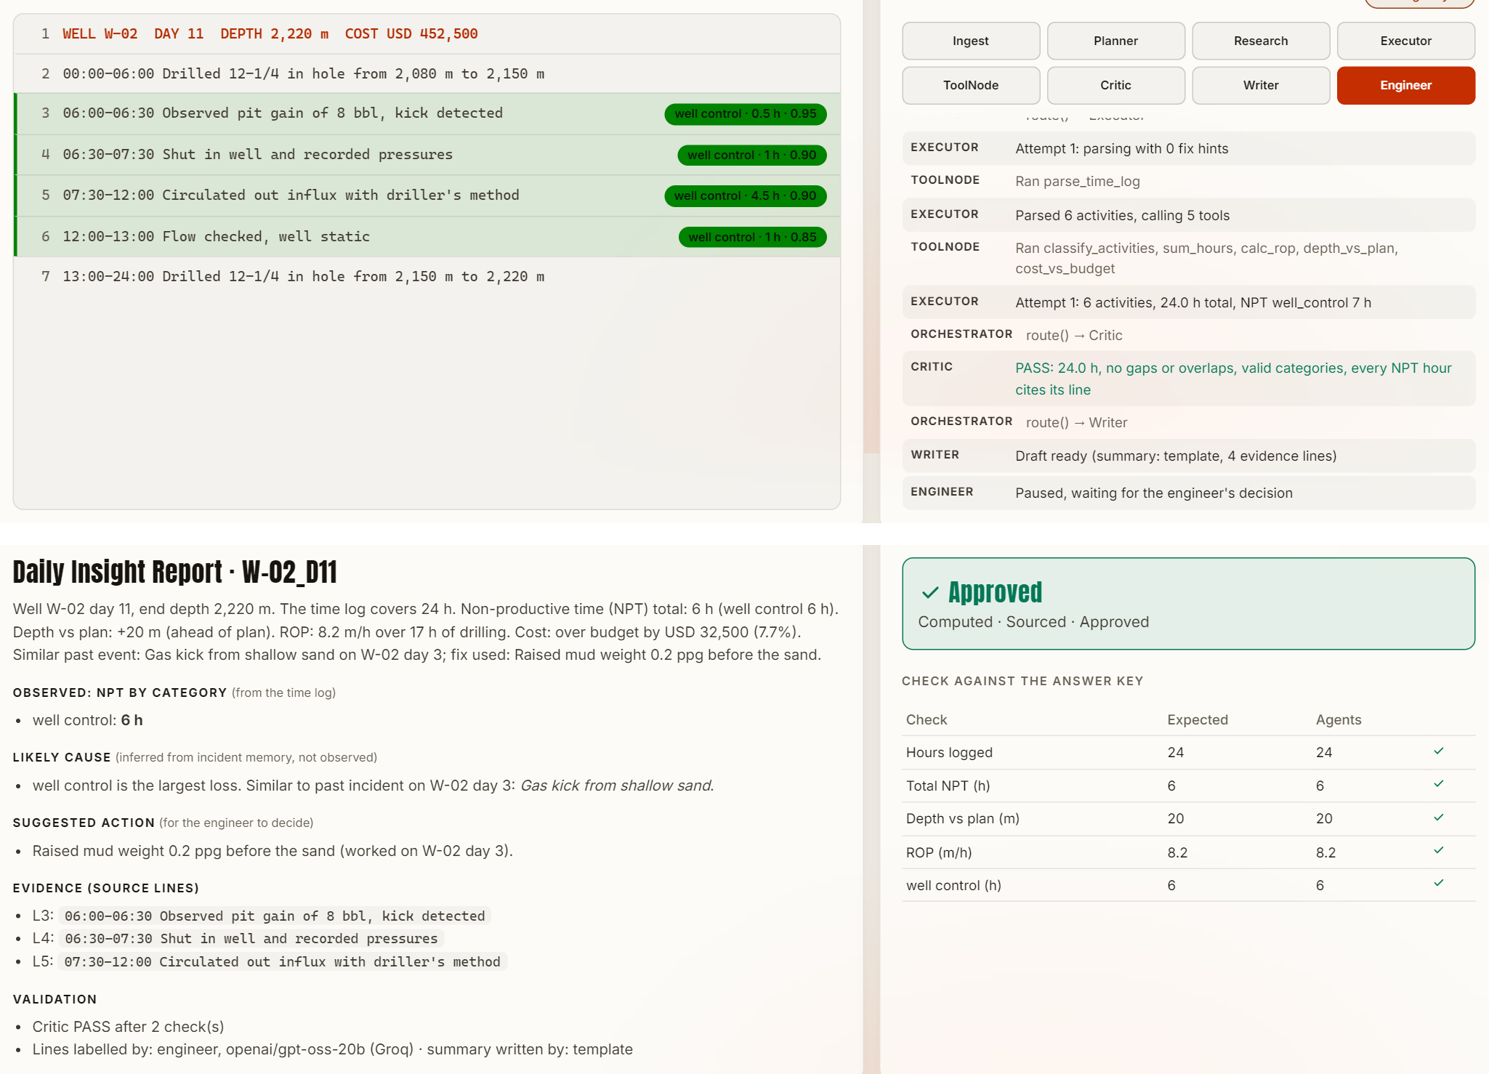
Figure 5. W-02 Day 11: the model labels line 6 (a routine flow check, 1 h) as well control, so the draft says 7 h. The engineer rejects with 'line 6 is planned, not NPT', the graph re-runs and the approved report shows 6 h, matching the answer key
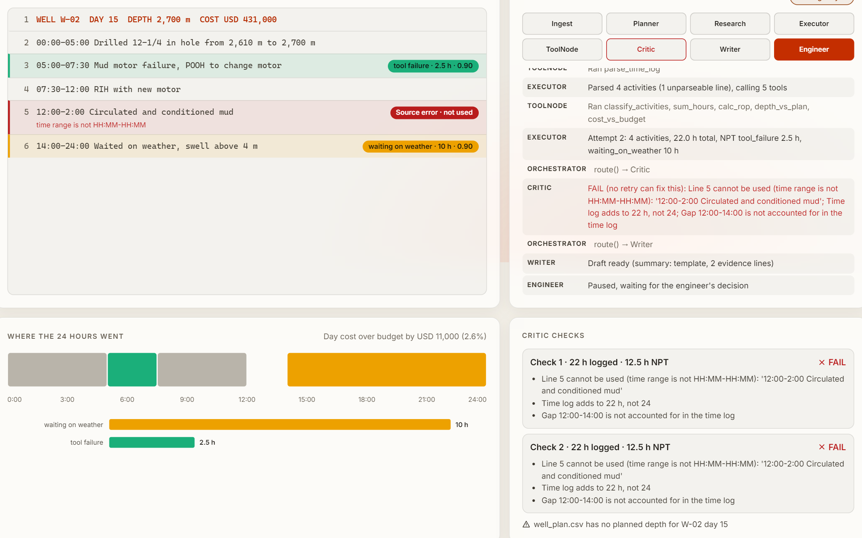
Figure 6. A pasted report with an invalid time range (12:00-2:00). The line is marked as a source error and left unrepaired. The Critic tries one retry for the 12:00-14:00 gap the bad line leaves, finds nothing to fix and stops (not three retries)
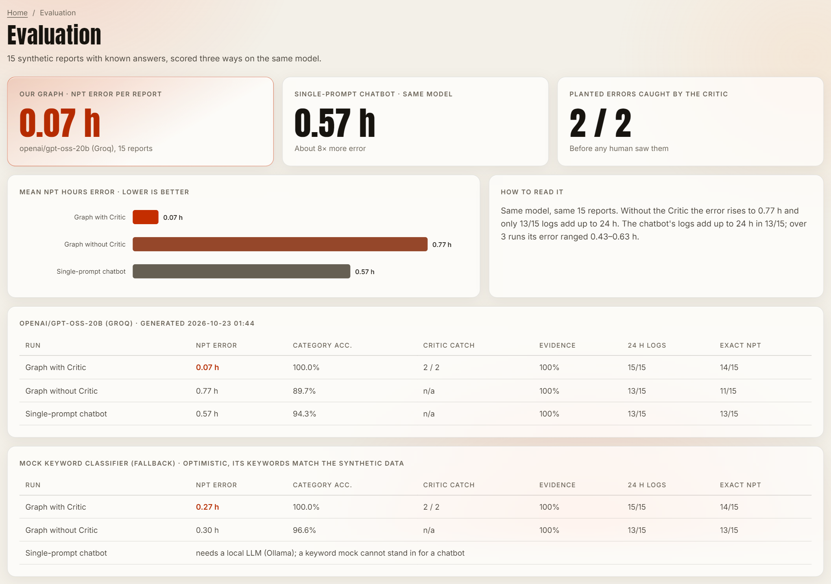
Figure 7. Evaluation page with the saved results for the Groq model and the mock
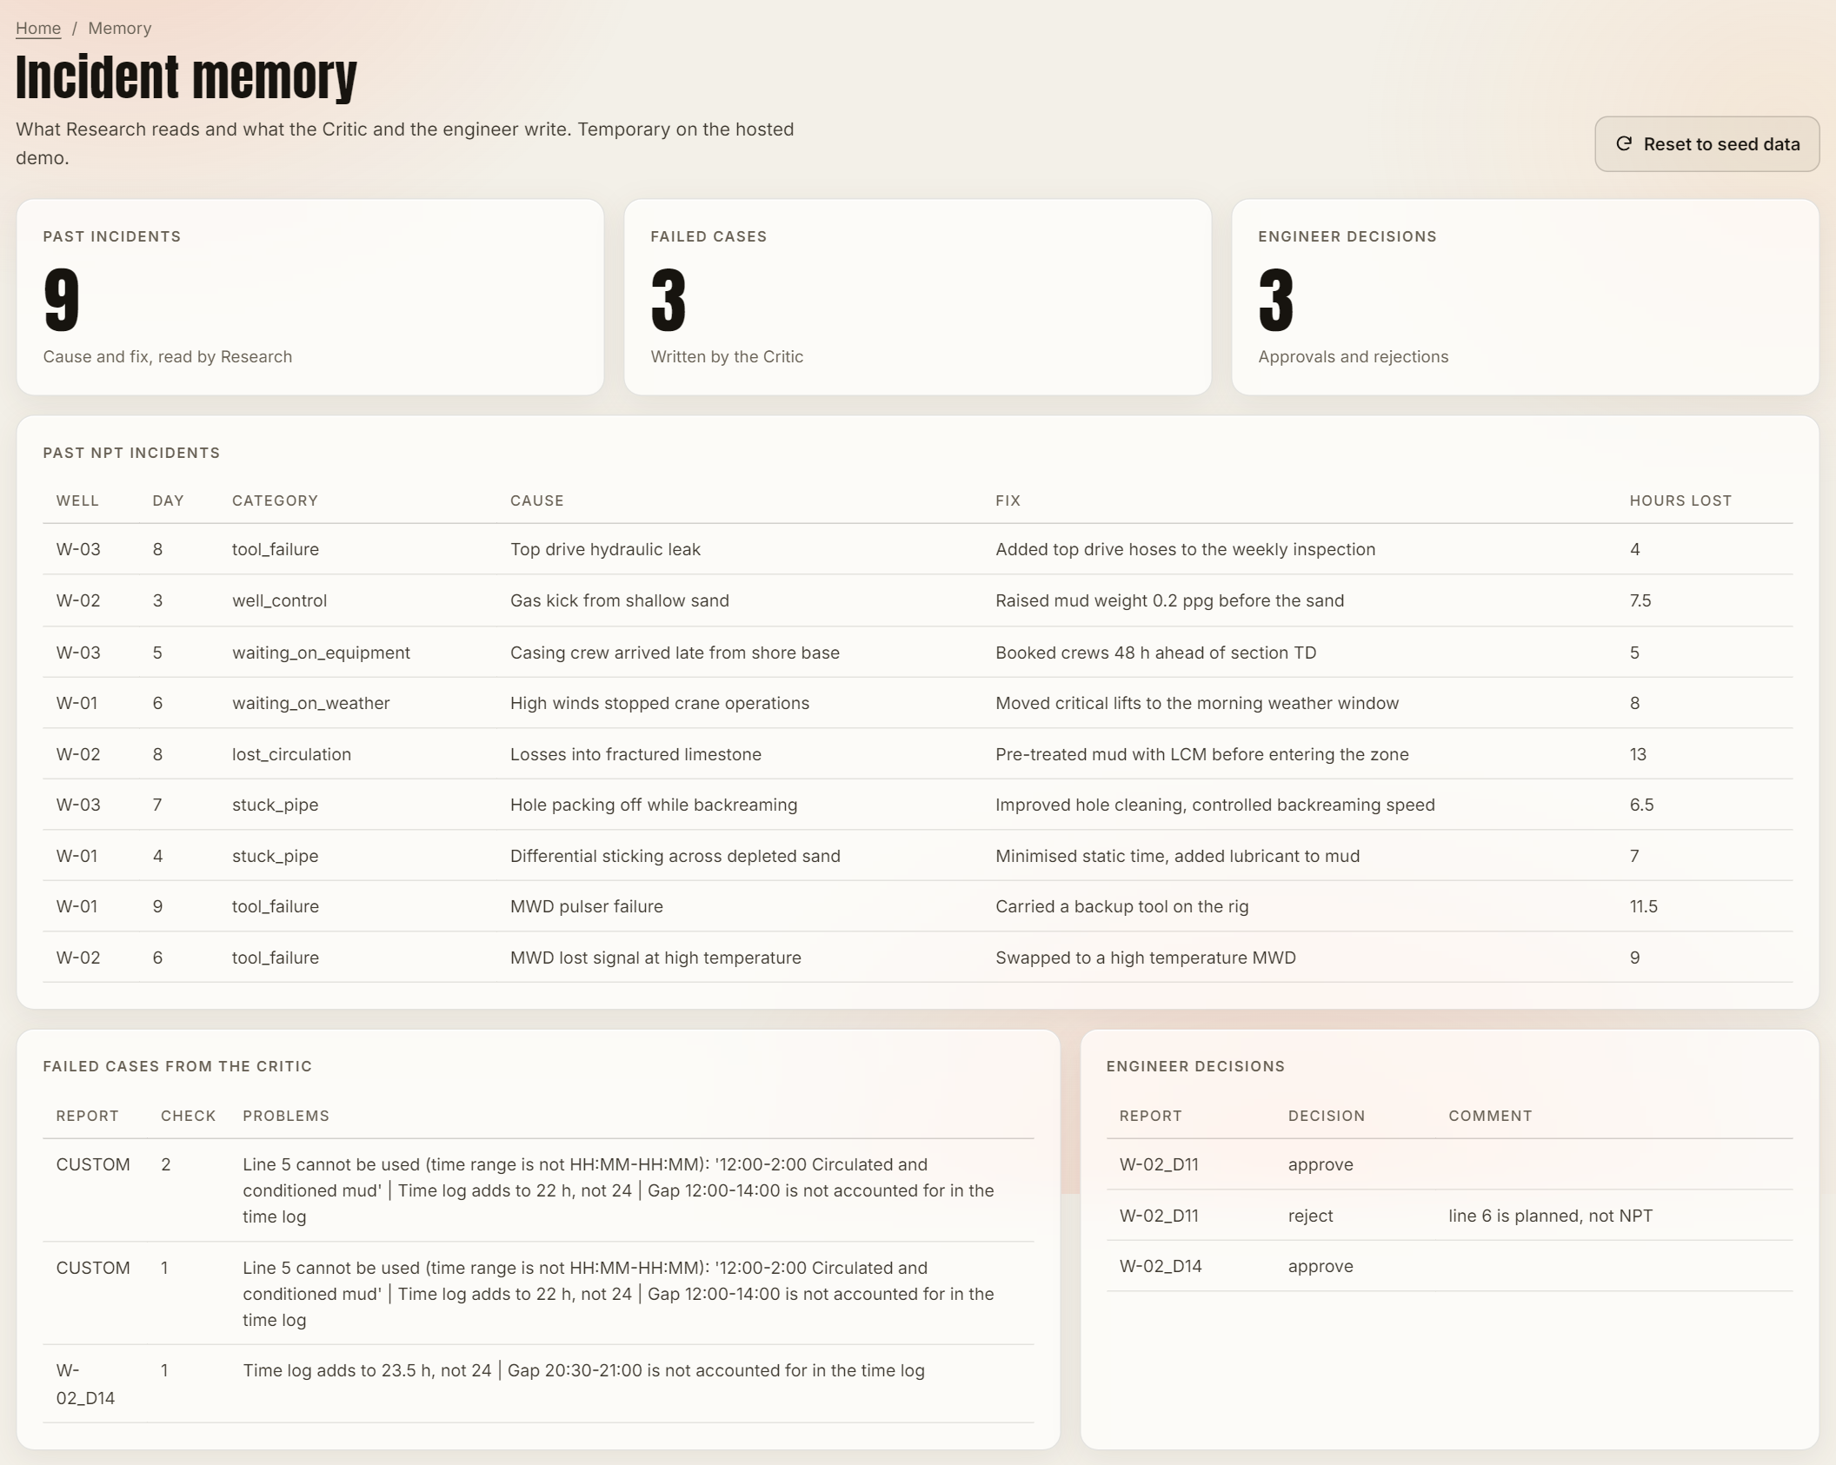
Figure 8. Memory page: seed incidents, failed cases written by the Critic and the engineer's decisions from the runs above

13. Testing methodology and test cases
Automated tests are in tests/ and run with python -m pytest. All 58 pass. They use the mock classifier and a temporary memory database, so they are deterministic and do not touch the committed data or a running model.
Table 9. Automated tests
File | What is tested
test_tools.py | Header parsing; time-log parsing; malformed lines, wrong format, impossible and reversed times reported as issues; REMARKS read only with a gap hint; overlap trimming with a note; sums, ROP, depth and cost; missing, invalid and unknown reference data
test_graph.py | All 15 reports: 24 h, Critic PASS, depth and ROP equal to the answer key, every NPT claim on its own line, NPT total equals the NPT lines. Mock exact on 14/15 (the WOC trap flagged as low confidence). Clean day. Critic catches the hidden line and the overlap and the retry fixes them, with the correction disclosed. Failed cases stored. No-Critic ablation. Approve ends the graph. Reject with an override re-runs and corrects. Invalid timestamp, missing header, empty log and unknown well handled. Worst case stops after 3 retries and still reaches the engineer. Mock reported as mock. LLM summary with an invented number rejected; one with only computed numbers kept. Groq: no key falls back to the mock; one request per report; a failed request falls back to the mock
test_dataset.py | Dataset shape (15 reports, 2 clean, 2 planted errors, all six categories), answer key consistency, generator reproducible byte for byte
test_api.py | Web API: a run streams each agent step and pauses for review; approve, reject with an override, custom report, bad input, per-page titles and descriptions, 404, robots.txt and sitemap, security headers, input limits, rate limit

Evaluation (evaluate.py) runs the same 15 reports through three configurations with the same model: the full graph, the graph without the Critic (route goes straight from the Executor to the report writer), and a single-prompt chatbot that is asked for NPT hours by category, the total hours and the line numbers it used. The chatbot prompt contains no example numbers, so it is not nudged towards an answer.

14. Evaluation results
Metrics:
- NPT hours error: mean of |predicted NPT − true NPT| per report, in hours.
- Category accuracy: planted NPT lines given the right category ÷ all planted NPT lines. The chatbot does not give a category per line, so a cited line counts as correct if its true category is among those it reported (in its favour).
- Critic catch rate: planted-error reports the Critic failed on the first pass ÷ 2.
- Evidence rate: NPT claims whose cited source line really contains the claimed text ÷ all NPT claims.
- Logs adding to 24 h; reports with exact NPT; false NPT lines (productive lines claimed as NPT).
Table 10. Results on the 15 reports with openai/gpt-oss-20b on Groq (2026-10-23 01:44)
Run (gpt-oss-20b) | NPT error | Category acc. | Critic catch | Evidence | 24 h logs | Exact NPT | False NPT
Graph with Critic | 0.07 h | 100% | 2 / 2 | 100% | 15/15 | 14/15 | 1
Graph without Critic | 0.77 h | 89.7% | n/a | 100% | 13/15 | 11/15 | 2
Single-prompt chatbot | 0.57 h | 94.3% | n/a | 100% | 13/15 | 13/15 | 0.7 (mean of 3 runs)

Table 11. Results with the mock fallback (no chatbot baseline: a keyword mock cannot stand in for a chatbot)
Run (mock keyword classifier) | NPT error | Category acc. | Critic catch | Evidence | 24 h logs | Exact NPT
Graph with Critic | 0.27 h | 100% | 2 / 2 | 100% | 15/15 | 14/15
Graph without Critic | 0.30 h | 96.6% | n/a | 100% | 13/15 | 13/15

14.1 Interpretation
- The agent graph is about eight times more accurate than a chatbot on the same model (0.07 h against 0.57 h), and every one of its logs adds to 24 h. The chatbot's totals were off on 2 of 15 reports, which is why arithmetic is kept in Python.
- The Critic caught both planted errors (2/2) and the retry fixed them. Without it, W-02 D14 reports 23.5 h and W-03 D13 reports 24.5 h, so only 13 of 15 logs add to 24 h and the error rises from 0.07 h to 0.77 h.
- The one remaining error is W-02 D11: the model counts a 1-hour 'flow checked, well static' after a kick as well control; the answer key calls it productive. The engineer fixes it with one reject comment (Figure 5). This is the main argument for keeping a human in the loop.
- Model output varies between runs even at temperature 0. In some runs the model labels the planned 'slipped and cut drill line' (W-02 D14, 3 h) as NPT with high confidence, so the 0.7 confidence floor does not flag it; the engineer corrects it the same way.
- Repeatability: the chatbot was run three times in the same evaluation; its mean error was 0.63 h, 0.63 h and 0.43 h (the table shows the mean).
- LLM summaries misattribute numbers: see Section 10. This was found from a real screenshot of the app with the earlier local model, and is why the summary is a template by default.
- Prompt change, reported openly: the first Groq run scored 1.83 h, because the model called the trips out of and back into the hole to fix a failure 'productive'. One sentence with the standard NPT definition ('time spent recovering from a failure is NPT') was added to both our prompt and the chatbot's, so the comparison stays fair. It is a general rule, not tuned to individual reports.

15. Limitations and responsible use
- Synthetic data only: 15 reports, three wells, one report format and six NPT categories. Results on real, messier reports would be lower.
- The model sometimes labels routine or planned work as NPT with high confidence, so confidence alone is not a safe filter. The online model needs a Groq key and an internet connection, and the free tier has per-minute and per-day limits. The mock classifier only knows its keywords, and its accuracy is optimistic because the keywords and the synthetic reports share a vocabulary.
- The parser expects HH:MM-HH:MM entries. Other formats are reported as errors rather than understood.
- Overlap trimming is a guess about which line is wrong; it is disclosed in the report for the crew to confirm.
- Engineer overrides apply to that run; they are stored but not yet learned from.
- The likely cause is inferred from similar past incidents, not observed, and is labelled as such.
- This is not a certified engineering or safety tool. Every report needs an engineer's approval, and the system never sends anything on its own.

16. Future enhancements
- Live rig data feeds (for example WITSML) and many wells at once.
- Learning from engineer corrections, for example as few-shot examples drawn from the engineer_feedback table.
- A larger or fine-tuned model for classification, evaluated on a held-out set.
- A morning NPT alert to the drilling team and trends across wells: recurring causes and cost per category.
- MCP connectors so the agents can read company systems (the DDR database, maintenance logs) directly.
- Support for the IADC standard DDR fields instead of free text only (Source 2).

17. Conclusion
Reading the Rig shows that an agentic workflow, rather than a single prompt, is what makes a free language model reliable for this task. Splitting the job into planning, research, tool-based execution and self-checking, with a human approval step built into the graph, gave exact and traceable numbers on every synthetic report, caught every planted data error, and left the engineer with one clear, quick correction instead of a page of free text to read. Every number is computed by Python, every flag is sourced to a report line, and every report is approved by a person.

References
[1] A. Mohammed, I. Abolle-Okoyeagu and C. J. Okeke. A Comparative Analysis of the Trouble Time for Conventional and Casing Drilling Wells: A Case Study on the Lobo Trend. International Journal of Science and Technology, 1(11), 2012. rgu-repository.worktribe.com
[2] Daily Drilling Report Overhaul Aims to Provide Standard Framework for More Detailed Activity Tracking. Drilling Contractor (IADC), May/June 2020. drillingcontractor.org
[3] A. Ortner. Differential Stuck Pipe Events: Development of Digital Best Practices for NPT Prevention. Master's thesis, Montanuniversität Leoben, 2020. pureadmin.unileoben.ac.at
[4] From Copilot to Co-Worker: Is Oil & Gas Ready to Trust Agentic AI to Execute Operational Decisions? SPE ATCE 2026 Technical Program. atce.org
[5] LangGraph Documentation. LangChain. docs.langchain.com
[6] Groq API Documentation. console.groq.com/docs
[7] FastAPI Documentation. fastapi.tiangolo.com
[8] LangChain Documentation. docs.langchain.com
[9] G. Aerts, A. Brun and M. Jerkø. How to Achieve 50 Percent Reduction in Offshore Drilling Costs. McKinsey & Company, May 2015. mckinsey.com
[10] J. Pallanich. 2026 Offshore Challenge: Softening Demand Puts the Brakes on Day Rates. Journal of Petroleum Technology (SPE), November 2025. jpt.spe.org
[11] AIQ Announces $340 Million Contract From ADNOC for Deployment of Agentic AI. Journal of Petroleum Technology (SPE), May 2025. jpt.spe.org
[12] OpenAI. gpt-oss-20b model card. openai.com

Appendix A. How to run
Source code: https://github.com/ranjanvrma/rig-sight
Online, without installing anything (Groq model; the mock is used only if the key is missing or a call fails): https://rig-sight.onrender.com/https://rig-sight.onrender.com/
Locally:
pip install -r requirements-dev.txt
python data/generate_data.py # optional: rebuild the dataset
python -m pytest # automated tests
python -m uvicorn api:app --port 8000 # the web app: http://127.0.0.1:8000
# put GROQ_API_KEY=... in a .env file # optional: the real model (free key at console.groq.com)
python evaluate.py # writes results/metrics_<backend>.json

