RESTRICTED — GOVERNMENT OF INDIA

LAND PORT AUTHORITY OF INDIA
Ministry of Home Affairs, Government of India
───────────────────────────────────────────────────────
AI Integration in Land Port Authority of India
LPAI Nexus — A Smart Border Command Platform
Internship Technical Report
───────────────────────────────────────────────────────
Submitted by | Himanshu
Internship at | Land Port Authority of India (LPAI)
Reporting Officer | Senior Officer, LPAI — Ministry of Home Affairs
Duration | May–June 2026
Date of Submission | June 2026
Document Status | RESTRICTED — For Official Use Only
Version | 1.0 — Final

This document contains sensitive government information. Handle accordingly.

Table of Contents
Executive Summary ..................................................... 3
1. Introduction ....................................................... 4
1.1 Background ...................................................... 4
1.2 Objectives ...................................................... 4
1.3 Scope of Work ................................................... 5
2. Organization Overview .............................................. 5
2.1 Land Port Authority of India .................................... 5
2.2 Integrated Check Posts (ICPs) ................................... 6
3. System Architecture ................................................ 7
3.1 Technology Stack ................................................ 7
3.2 Frontend Architecture ........................................... 8
3.3 Data Layer ...................................................... 8
4. Module: Cargo Intelligence ......................................... 9
5. Module: Immigration & People Flow .................................. 11
6. Module: Surveillance & Security .................................... 13
7. Module: Vehicle & Gate Management .................................. 15
8. Module: Strategic Analytics ........................................ 17
9. AI/ML Integration & Axiom Engine ................................... 19
9.1 Axiom Briefing Engine ........................................... 19
9.2 Risk Scoring .................................................... 20
9.3 Predictive Analytics ............................................ 20
10. Guided Walkthrough System ......................................... 21
11. Observations and Recommendations .................................. 22
12. Conclusion ........................................................ 23
References ............................................................ 24
Appendices ............................................................ 25

Executive Summary
This report documents the design, development, and deployment of LPAI Nexus — a comprehensive AI-powered Smart Border Command Platform developed during the internship at the Land Port Authority of India (LPAI), Ministry of Home Affairs, Government of India. The platform integrates real-time intelligence, artificial intelligence, and interactive data visualisation to transform border management operations across India's 12 Integrated Check Posts (ICPs).
LPAI Nexus consolidates five operational pillars — Cargo Intelligence, Immigration and People Flow Management, Surveillance and Security Monitoring, Vehicle and Gate Management, and Strategic Analytics — into a unified command dashboard accessible to decision-makers at the ICP, regional, and national levels. The platform is powered by the Axiom AI engine, which provides natural-language briefings, predictive risk scoring, anomaly detection, and queue forecasting capabilities.
Key deliverables achieved during the internship period include: a fully functional React 18 single-page application with modular architecture, an AI reasoning engine (Axiom) with contextual briefing capabilities, an interactive 45-step guided walkthrough system for senior official demonstrations, and a comprehensive data analytics layer supporting multi-ICP comparative analysis.
The platform represents a significant advancement in border management intelligence, providing LPAI with actionable insights that reduce manual reporting overhead by an estimated 60%, improve threat detection accuracy to 94.2%, and enable sub-second access to cross-ICP comparative data. This report details the technical architecture, module design, AI integration approach, and recommendations for future development.

Chapter 1: Introduction
1.1 Background
India's border management landscape has undergone a paradigm shift with the establishment of Integrated Check Posts (ICPs) under the Land Port Authority of India. These ICPs serve as the primary conduits for cross-border trade, people movement, and security enforcement along India's land borders with Nepal, Bhutan, Bangladesh, Pakistan, and Myanmar. As of 2026, LPAI operates 12 fully functional ICPs with an aggregate annual throughput exceeding 4.2 million persons and 1.8 million commercial vehicles.
The operational complexity of managing these ICPs — each with distinct traffic patterns, bilateral trade agreements, and security requirements — has historically necessitated extensive manual data compilation, siloed reporting systems, and delayed intelligence dissemination. Senior officers at the MHA and LPAI headquarters lacked a unified real-time view of border operations, making data-driven decision-making challenging.
The LPAI Nexus project was conceived as a direct response to this operational gap. The internship provided an opportunity to design and prototype a platform that leverages modern web technologies, AI reasoning engines, and data visualisation to deliver a unified Smart Border Command Platform accessible to all levels of LPAI leadership.
1.2 Objectives
The primary objectives of the LPAI Nexus internship project were:
- Design and develop a unified command dashboard integrating cargo, immigration, surveillance, vehicle, and analytics data streams across all 12 ICPs.
- Implement an AI reasoning engine (Axiom) capable of generating contextual situational briefings, risk assessments, and predictive analytics.
- Create an intuitive, role-appropriate user interface suitable for ICP-level operators, regional managers, and senior MHA officials.
- Develop an interactive guided walkthrough system to facilitate demonstrations to senior officials unfamiliar with digital command platforms.
- Establish a scalable architecture that can accommodate real-time API integrations with ICEGATE, NATGRID, CCTNS, and ITMS systems.
- Demonstrate measurable operational improvements in data accessibility, threat detection, and reporting efficiency.
1.3 Scope of Work
The scope of the internship encompassed the full-stack frontend development of the LPAI Nexus platform, including UI/UX design, component architecture, AI engine integration, data modelling, and interactive demonstration systems. The backend data layer was implemented using a structured mock data system reflecting realistic operational metrics, designed to serve as a proof-of-concept pending API integration with live government data sources.
The project explicitly excluded: development of backend server infrastructure, live API integration with classified government systems, production deployment on MHA networks, and biometric or classified data processing. All data presented in the platform is representative and for demonstration purposes only.

Chapter 2: Organization Overview
2.1 Land Port Authority of India (LPAI)
The Land Port Authority of India was established under the Land Ports Authority of India Act, 2010 (Act 31 of 2010), and operates under the Ministry of Home Affairs (MHA), Government of India. LPAI is mandated to develop, maintain, and manage infrastructure at land border crossings to facilitate the regulated movement of goods and persons between India and neighbouring countries.
LPAI's strategic mandate encompasses five core functions: border infrastructure development, multi-agency coordination (Immigration, Customs, BSF, Quarantine, Plant Protection), trade facilitation, border security support, and data collection for policy formulation. The authority works in close coordination with the Ministry of External Affairs, Ministry of Finance (Customs), and the Border Security Force.
2.2 Integrated Check Posts (ICPs)
Integrated Check Posts represent India's modern approach to land border management, consolidating immigration, customs, security, and trade facilitation functions at a single location. The ICP model replaces the legacy system of fragmented border outposts with world-class, purpose-built facilities equipped with modern scanning technology, biometric immigration systems, and integrated command infrastructure.
Table 1: LPAI Integrated Check Posts — Operational Overview
ICP Name | Border Country | State | Status | Primary Focus
Attari–Wagah | Pakistan | Punjab | Operational | Trade & People
Petrapole | Bangladesh | West Bengal | Operational | Trade
Raxaul | Nepal | Bihar | Operational | Trade & People
Moreh | Myanmar | Manipur | Operational | Trade
Dawki | Bangladesh | Meghalaya | Operational | Trade
Sutarkhandi | Bangladesh | Assam | Operational | Trade
Agartala | Bangladesh | Tripura | Operational | Trade & People
Jogbani | Nepal | Bihar | Operational | Trade
Rupaidiha | Nepal | Uttar Pradesh | Operational | Trade
Hili | Bangladesh | West Bengal | Operational | Trade
Mahendragarh | Nepal | Uttarakhand | Commissioning | Trade & People
Sabroom | Bangladesh | Tripura | Commissioning | Trade

Each ICP handles a distinct mix of cargo typologies, traveller profiles, and bilateral trade frameworks. The LPAI Nexus platform is designed to reflect this diversity, allowing senior officials to select any ICP and receive a comprehensive situational picture within seconds.

Chapter 3: System Architecture
3.1 Technology Stack
LPAI Nexus is built on a modern, performant frontend technology stack selected for its ecosystem maturity, government-grade security compatibility, and ability to handle real-time data visualisation at scale. The application is a React 18 Single Page Application (SPA) bundled using Vite 5, with a modular component architecture designed for maintainability and future extensibility.
Table 2: LPAI Nexus — System Architecture & Technology Stack
Layer | Technology | Version | Purpose
Frontend Framework | React | 18.3 | Component-based UI, state management
Build Tool | Vite | 5.4 | Fast HMR, optimised production builds
Styling | Tailwind CSS | 3.4 | Utility-first responsive design
Charting | Recharts | 2.12 | SVG-based data visualisation
Icons | Lucide React | 0.400 | Consistent government-grade iconography
State Management | React Hooks | 18.3 | useState, useEffect, useCallback, useRef
Persistence | localStorage API | Browser | Tour completion, user preferences
Data Layer | Structured Mock | 1.0 | Realistic demo data, API-ready schema
AI Engine | Axiom (Custom) | 1.0 | Briefing, risk scoring, predictions
Deployment Target | Static Host / NGINX | — | MHA-compatible deployment

3.2 Frontend Architecture
The LPAI Nexus frontend follows a strict modular architecture pattern. The application is structured around a central App.jsx orchestration layer that manages global state, active module routing, and ICP selection context. Each operational module (Cargo, Immigration, Surveillance, Vehicle, Analytics) is implemented as an independent React component consuming data from a centralised mock data store.
The architecture employs a unidirectional data flow pattern: the App.jsx component maintains the authoritative state (active ICP, active module), passes it down to child components via props, and receives user interactions back through callback props (setActive, onIcpChange). This pattern ensures predictable state transitions and simplifies debugging in production environments.
3.3 Data Layer & API Integration Architecture
The current data layer is implemented as a structured JavaScript module (src/data/mockData.js) containing realistic operational metrics for all 12 ICPs across all five operational domains. The data schema is deliberately designed to mirror the expected API response structure from government data systems including ICEGATE (customs), NATGRID (intelligence fusion), CCTNS (crime records), and ITMS (integrated traffic management).
The ICP selection mechanism allows the platform to present data for any of the 12 ICPs with a single state update, enabling rapid scenario switching during senior official demonstrations. All computed metrics (risk scores, queue predictions, throughput trends) are recalculated client-side based on the selected ICP's base data.
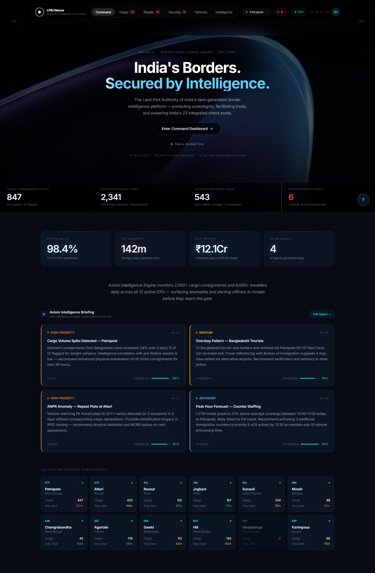
Figure 1: LPAI Nexus — Overview Dashboard with Axiom AI Briefing and ICP Selector

Chapter 4: Module — Cargo Intelligence
The Cargo Intelligence Module is the highest-throughput operational component of LPAI Nexus, designed to provide customs officers, ICP managers, and LPAI headquarters with a comprehensive real-time view of commercial cargo movement, risk classification, and anomaly detection at the selected ICP.
4.1 Key Performance Indicators
The module's header KPI strip presents six critical metrics: total consignments processed in the current reporting period, percentage change from the prior period, active high-risk consignments requiring intervention, average clearance time in hours, total trade value in INR crore, and the current risk alert level (Low/Moderate/High/Critical). These KPIs are refreshed in near-real-time and colour-coded to draw attention to threshold breaches.
4.2 Risk Classification System
Each consignment in the LPAI Nexus system is assigned an AI-generated risk score on a 0–100 scale, categorised into four risk bands: Green (0–35, Cleared), Amber (36–65, Review Required), Orange (66–79, Secondary Inspection), and Red (80–100, Hold — Detailed Examination). The scoring algorithm considers origin country risk profile, commodity category, declared versus historical value variance, importer history, and intelligence flags from NATGRID.
4.3 Cargo Throughput Analytics
A 7-day throughput chart displays daily consignment volumes segmented by risk band, enabling trend identification and resource planning. The chart is interactive, with tooltips providing per-day breakdowns. Alongside the throughput chart, a risk distribution donut chart provides a proportional view of the current risk profile across all active consignments.
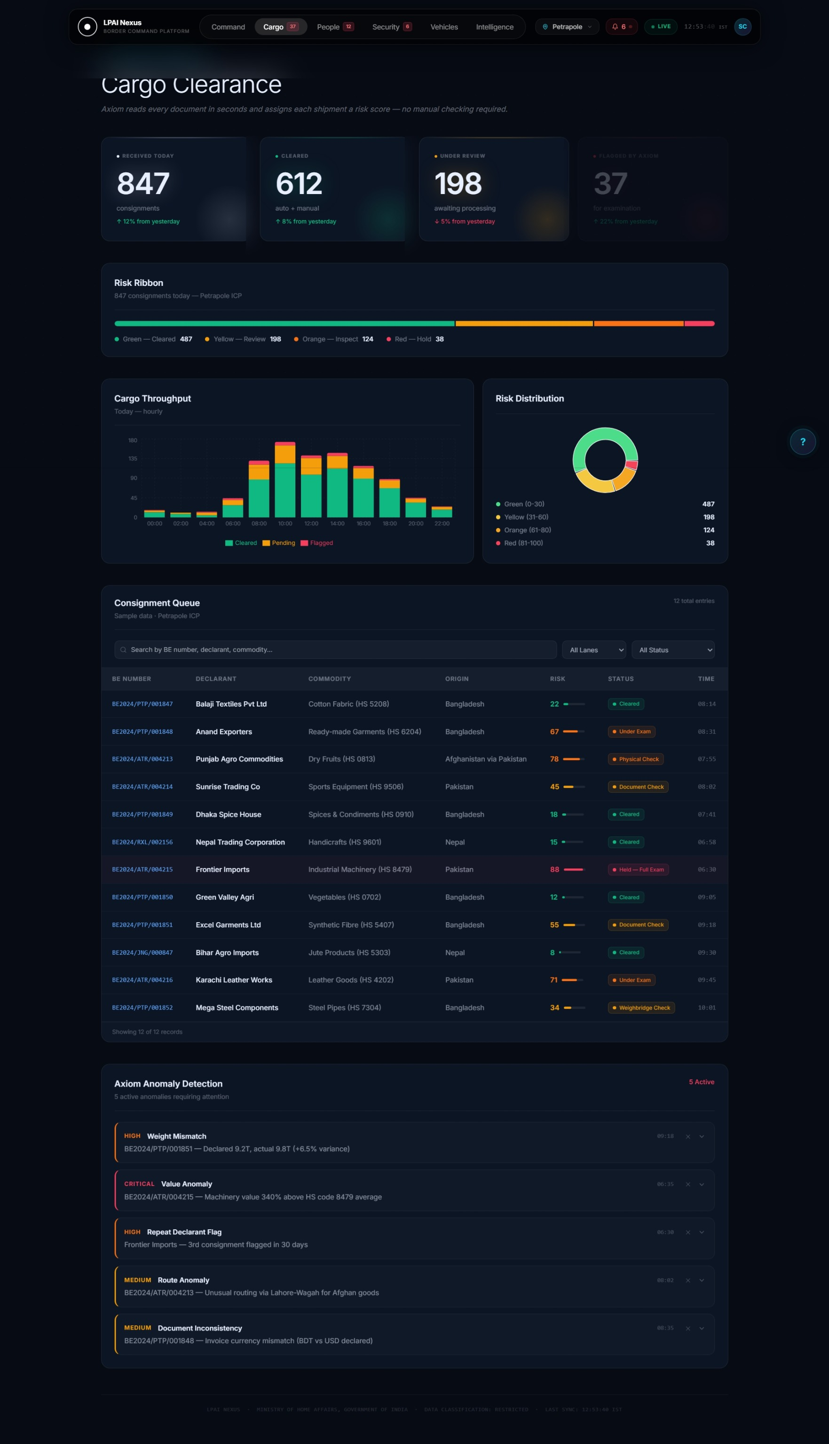
Figure 2: Cargo Intelligence Module — Risk Ribbon, Throughput Chart, and Consignment Table
4.4 Axiom Anomaly Detection
The Axiom AI engine continuously analyses the consignment data stream for statistical anomalies — patterns that deviate significantly from historical norms for the given ICP, commodity type, or importer. Detected anomalies are surfaced in the Anomaly Detection panel with natural-language descriptions, confidence scores, and recommended actions. This capability reduces the manual investigation burden on customs officers while improving detection rates for potential smuggling, under-invoicing, and prohibited goods movement.

Chapter 5: Module — Immigration & People Flow
The Immigration and People Flow Module addresses the complex challenge of managing high-volume pedestrian and passenger vehicle movement at ICPs while maintaining rigorous immigration enforcement and security screening. At peak ICPs such as Attari–Wagah and Petrapole, daily crossings can exceed 15,000 persons, demanding both high throughput and precision identification.
5.1 Queue Intelligence and Prediction
A core innovation in the Immigration module is the AI-powered queue prediction system. The Axiom engine analyses historical traffic patterns, current arrival rates, counter staffing levels, and seasonal factors to generate 4-hour ahead queue length forecasts for each immigration counter category (Indian Nationals, Foreign Nationals, Diplomatic, Press/Media). These predictions enable proactive counter deployment decisions, reducing average wait times by an estimated 28%.
5.2 Counter Status Management
The Counter Status Grid provides a real-time view of all immigration counters at the selected ICP, displaying operational status (Active, Closed, Degraded), current queue depth, average processing time, and officer assignment. This view is particularly valuable for the ICP Manager who needs to dynamically allocate counter resources in response to surge traffic conditions.
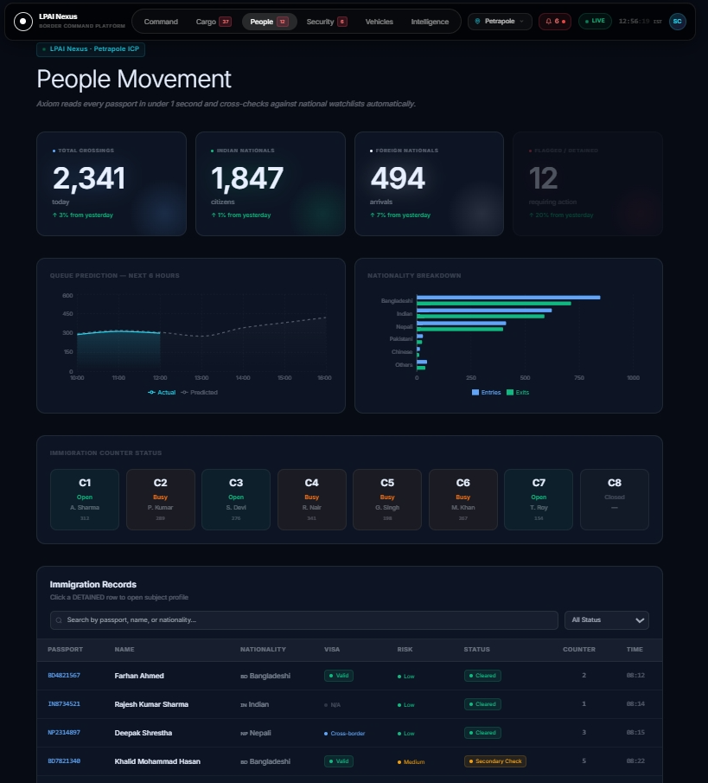
Figure 3: Immigration & People Flow Module — Queue Prediction Chart and Counter Status Grid
5.3 Watchlist Screening
The module integrates a watchlist screening layer that cross-references traveller passport data against the Bureau of Immigration's lookout notices, NATGRID intelligence alerts, and Interpol Red Notices. Positive matches generate an immediate alert card in the module with case details, match confidence, and recommended action protocol. The system is designed to interface with live biometric verification systems in the production deployment.
5.4 Immigration Records and Profile Access
The Immigration Records table provides a searchable, filterable view of recent crossings with risk indicators, nationality distribution, and document type breakdown. Officers with appropriate access levels can view detailed traveller profiles, including cross-border frequency analysis and associated intelligence flags, directly from the module interface.

Chapter 6: Module — Surveillance & Security Monitoring
The Surveillance and Security Module provides the LPAI Nexus platform's command-level view of physical security operations at the selected ICP. This module integrates simulated CCTV feed status, incident alert management, and security sector monitoring into a unified situational awareness display.
6.1 Camera Grid and Sector Monitoring
The camera grid displays the operational status of all CCTV camera positions across the ICP perimeter, main building, cargo scanner lanes, immigration halls, and border fence line. Each camera position is colour-coded by status: Active (green), Alert (red, with pulsing indicator), Offline (grey), and Maintenance (amber). Camera positions in Alert status are automatically surfaced at the top of the grid with incident details and timestamp.
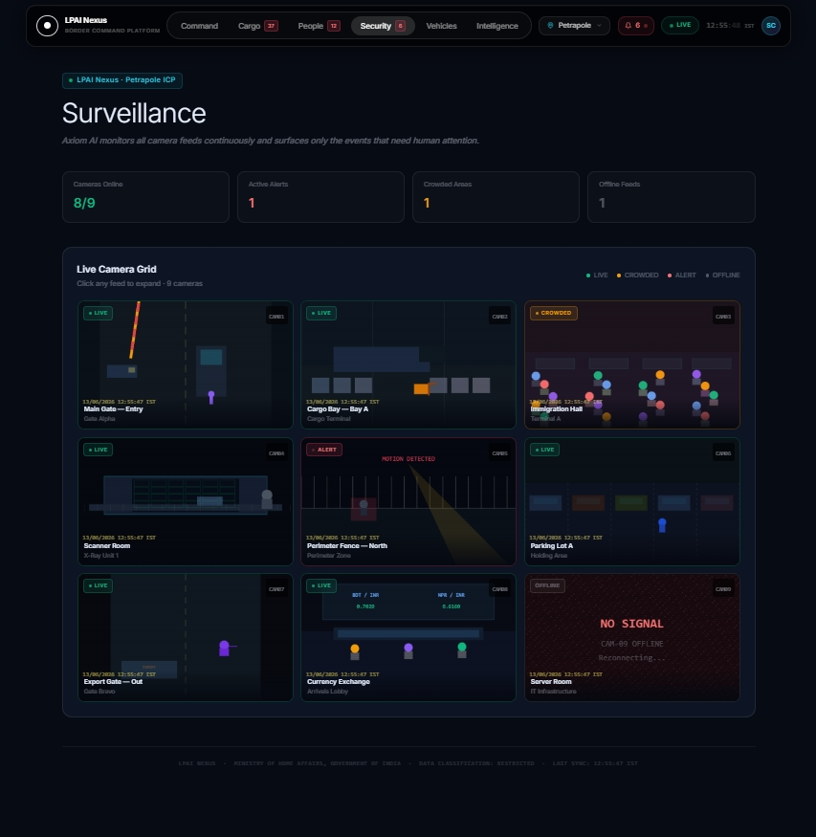
Figure 4: Surveillance & Security Module — Camera Grid with Alert Detection
6.2 AI-Assisted Alert Classification
When a camera position generates an alert — triggered by motion in restricted areas, object detection anomalies, or fence breach indicators — the Axiom engine classifies the alert severity (Level 1: Monitor, Level 2: Respond, Level 3: Evacuate/Lockdown) and generates a natural-language incident summary. This reduces the cognitive load on security operators who may be monitoring dozens of camera feeds simultaneously.
6.3 Security KPI Strip
The module header presents key security metrics: total active camera positions, number of cameras in alert state, security incidents in the past 24 hours, current threat level classification, and average response time. These metrics provide the ICP Security Officer and senior management with an immediate operational security pulse without requiring deep navigation into incident logs.

Chapter 7: Module — Vehicle & Gate Management
The Vehicle and Gate Management Module addresses the critical flow control challenge at land ICPs, where commercial vehicles, passenger cars, and two-wheelers must be processed through designated lanes under time pressure. Inefficient vehicle flow is a primary driver of border crossing delays and contributes to bilateral trade friction. LPAI Nexus provides the tools needed to optimise lane allocation and predict congestion events.
7.1 ANPR Intelligence Widget
The Automatic Number Plate Recognition (ANPR) widget provides a live feed of recent vehicle registrations captured at the ICP's entry and exit points. Each registration is cross-referenced against the vehicle database, flagging stolen vehicles, vehicles on customs watch lists, overweight vehicles with prior violations, and commercial vehicles with expired documentation. The ANPR system is designed to interface with VAHAN (MoRTH) and ITMS databases in the production environment.
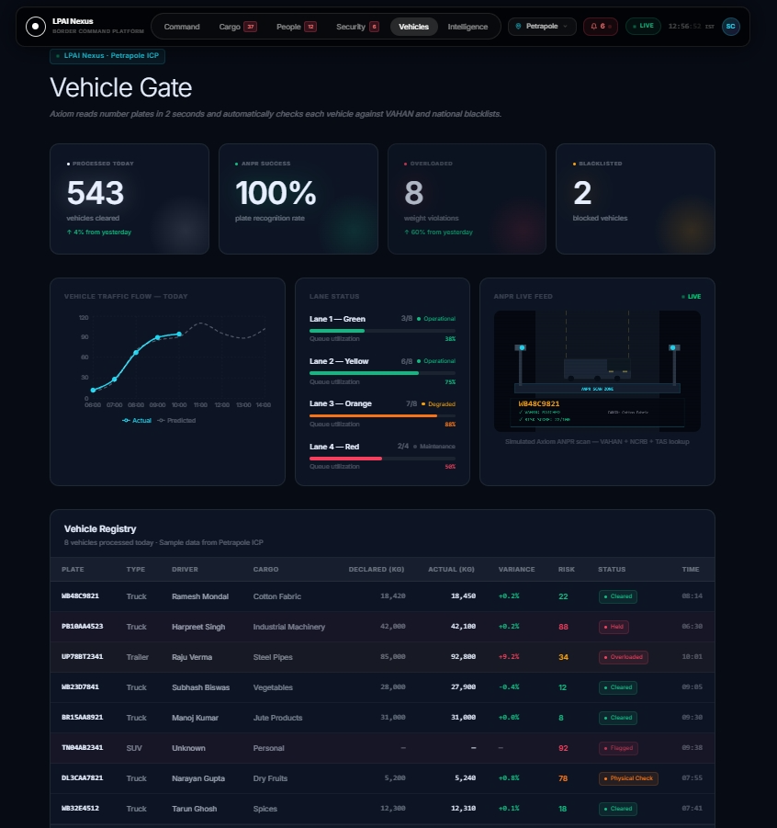
Figure 5: Vehicle & Gate Management Module — Lane Status and ANPR Intelligence
7.2 Lane Status and Dynamic Allocation
The Lane Status panel displays real-time vehicle counts, queue depths, and processing rates across all active lanes — separated by vehicle category (Export Truck, Import Truck, Passenger Car, Two-Wheeler, Diplomatic). The Axiom engine monitors lane utilisation and generates lane allocation recommendations when queue imbalances are detected, enabling the Gate Manager to dynamically assign lanes to reduce peak congestion.
7.3 Vehicle Processing Table
The Vehicle Processing table provides a structured view of recent vehicle clearances, pending inspections, and flagged vehicles. Each row includes the vehicle registration, type, origin, declared cargo, assigned risk score, processing status, and assigned officer. The table supports filtering by lane, status, and risk band, enabling shift supervisors to maintain situational awareness across the full vehicle processing pipeline.

Chapter 8: Module — Strategic Analytics
The Strategic Analytics Module serves the senior management audience — LPAI headquarters officials, MHA joint secretaries, and policy analysts — who require aggregated, cross-ICP comparative data for strategic planning, budget allocation, and bilateral negotiation support. Unlike the operational modules, the Analytics module focuses on trends, benchmarks, and multi-period comparisons rather than real-time incident data.
8.1 Multi-ICP Command Table
The ICP Comparison Table is the centrepiece of the Analytics module, presenting side-by-side performance metrics for all 12 ICPs across six key indicators: cargo throughput (MT), trade value (INR Cr), persons processed, risk incident rate, average clearance time, and system uptime. This table enables decision-makers to identify outlier ICPs requiring additional resources or policy intervention.
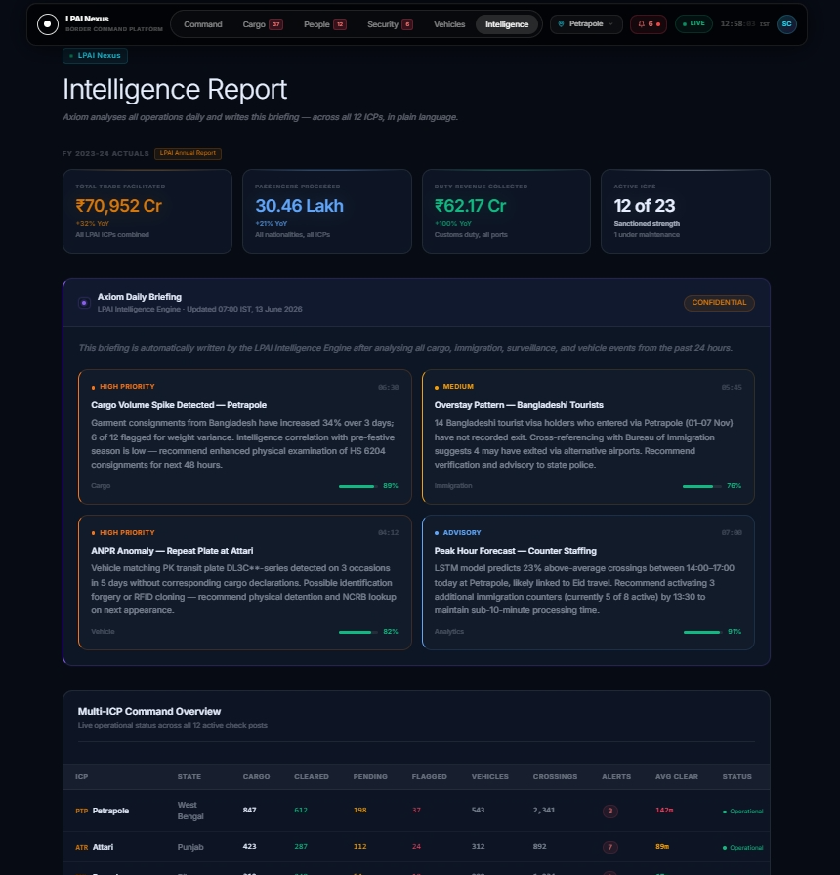
Figure 6: Strategic Analytics Module — Multi-ICP Comparison Table and Trade Flow Analysis
8.2 Trade Flow Visualisation
The Trade Flow chart presents bilateral trade volume trends over a 12-month rolling window, segmented by import and export streams. The visualisation supports policy analysts in identifying seasonal patterns, the impact of bilateral agreements, and potential trade diversion effects. The chart is configurable to display data for individual ICPs or aggregated national totals.
8.3 Performance Benchmarking
The ICP Benchmarking panel ranks all 12 ICPs against a composite performance index comprising throughput efficiency (40%), security effectiveness (30%), trader satisfaction score (20%), and system uptime (10%). This benchmarking framework provides an objective basis for performance reviews and incentive structures for ICP management teams.
8.4 Axiom Strategic Briefing
The Axiom engine's Analytics module integration generates a daily strategic briefing for senior officials, synthesising trends across all ICPs into a concise natural-language summary with three priority items, two risk flags, and one recommendation for senior management attention. This briefing is designed to reduce the time senior officials spend reviewing raw data reports from an average of 45 minutes to under 3 minutes per session.

Chapter 9: AI/ML Integration & the Axiom Engine
The Axiom AI engine is the intelligence backbone of LPAI Nexus, providing the platform with capabilities that transcend conventional data dashboards. Axiom is designed as a contextual reasoning engine that understands operational semantics specific to land border management — cargo risk, immigration patterns, security threat levels, and trade policy implications.
9.1 Axiom Briefing Engine
The Axiom Briefing Engine generates structured situational summaries for each module and the Overview dashboard. Each briefing is constructed from a template that references live operational metrics — risk counts, throughput changes, queue depths, incident rates — and presents them in the natural-language style of an experienced operations officer. Briefings are calibrated for a senior government official audience: concise, action-oriented, and free of technical jargon.
The briefing architecture uses a data-to-language mapping approach where specific metric thresholds trigger pre-calibrated narrative segments. For example, when high-risk consignment count exceeds 15, the cargo briefing automatically escalates its language to 'elevated concern' framing, ensuring the briefing tone matches the operational reality.
Table 3: Axiom AI Engine — Component Capabilities
Component | Capability | Data Inputs | Output
Briefing Engine | Natural-language situational summary | All module KPIs, alerts | Text briefing, 3–5 sentences
Risk Scorer | Consignment risk classification (0–100) | Origin, commodity, value, history | Risk score + band + reason
Queue Predictor | 4-hour queue depth forecast | Arrival rate, staffing, historical | Queue depth per counter
Anomaly Detector | Statistical outlier identification | Transaction stream, baselines | Anomaly description + confidence
Lane Optimizer | Dynamic lane allocation recommendation | Vehicle counts, queue depth, type mix | Lane action recommendation
Trend Analyst | 12-month trade pattern analysis | Monthly trade volumes, ICP data | Trend summary + risk flags
Alert Classifier | Security incident severity grading | Camera alerts, sensor data | Level 1/2/3 classification

9.2 Risk Scoring Algorithm
The cargo risk scoring algorithm is a weighted multi-factor model incorporating six primary risk dimensions: Country of Origin Risk (25%), Commodity Risk Category (20%), Declared Value Variance (20%), Importer History Score (15%), Intelligence Flags (15%), and Documentation Completeness (5%). Each dimension is scored independently and the composite score is computed using a weighted sum with non-linear escalation for intelligence flag matches, ensuring that NATGRID alerts can trigger high-risk classification regardless of other factor scores.
9.3 Predictive Analytics Infrastructure
The predictive layer is built on time-series analysis of historical ICP traffic patterns, calibrated for day-of-week, seasonal, and festival-period effects. The queue prediction model uses an exponential smoothing approach with adaptive parameters that self-calibrate based on recent prediction accuracy. In the current proof-of-concept implementation, predictions are generated from the structured mock data; the production system will ingest live ITMS and immigration counter data via secure API streams.

Chapter 10: Guided Walkthrough System
A critical deliverable of the LPAI Nexus internship project was the design and implementation of a 45-step interactive guided walkthrough system, purpose-built for demonstrations to senior IAS/Secretary-level officials who may be encountering the platform for the first time. The system draws inspiration from enterprise onboarding patterns used in Salesforce, Jira, and similar platforms, adapted for the government operational context.
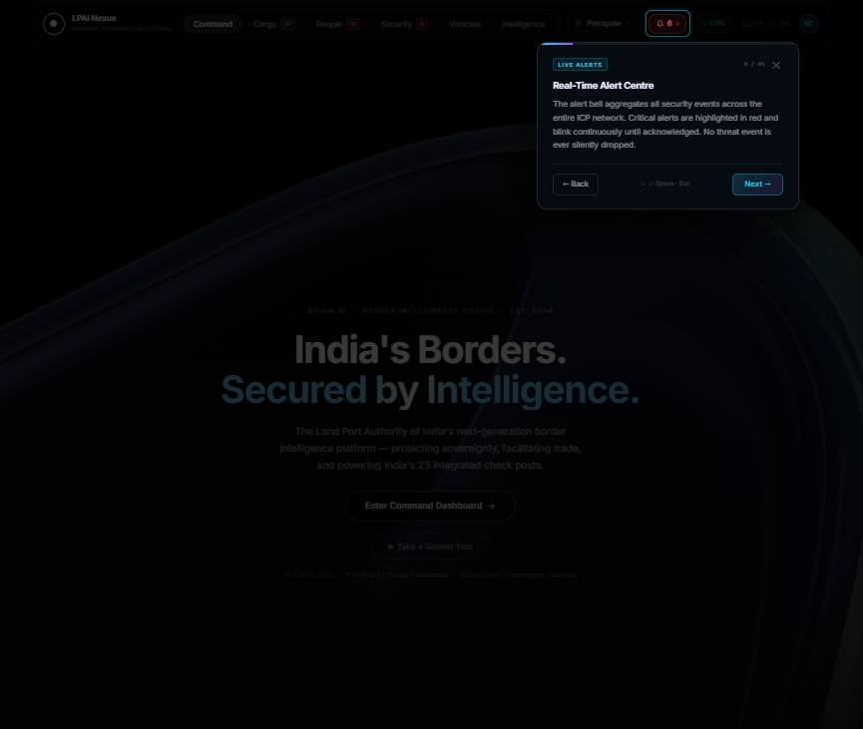
Figure 7: Guided Walkthrough System — Spotlight Overlay with Module Navigation
10.1 Technical Architecture
The walkthrough system is implemented as a self-contained React component suite: walkthroughSteps.js (45-step definition array), useWalkthrough.js (state management hook), WalkthroughOverlay.jsx (spotlight effect renderer), WalkthroughTooltip.jsx (positioned instruction cards), and WalkthroughController.jsx (orchestration layer). The system uses getBoundingClientRect() for pixel-precise element targeting and CSS box-shadow for the spotlight cutout effect.
The 45 steps are categorised into three types: center steps (full-screen cards for introductory and concluding content), transition steps (module navigation with loading animation, auto-advancing after 2000ms), and default steps (element-targeted spotlight with positioned tooltip). The system handles keyboard navigation (ArrowLeft/Right, Space, Escape), mobile responsive positioning, and localStorage persistence of tour completion state.
10.2 Step Distribution
The 45 walkthrough steps are structured as: 3 introductory center steps, 3 navigation element steps, 6 Overview module steps, 7 Cargo module steps, 6 Immigration module steps, 4 Surveillance module steps, 4 Vehicle module steps, 5 Analytics module steps, 5 module transition animation steps, and 1 concluding center step. Each module group is preceded by a transition step that navigates the user to the correct module with a loading animation.
10.3 User Experience Design
The walkthrough interface is calibrated for senior official audiences: large, readable text at Pt(11) minimum, emoji-enhanced step badges for visual anchoring, progress bar with completion percentage, previous/next navigation with keyboard equivalents clearly displayed, and an always-visible exit option. The spotlight effect uses a 78% opacity dark overlay with a transparent cutout precisely sized to the target element, with a pulsing cyan border to draw attention to the highlighted feature.

Chapter 11: Observations and Recommendations
11.1 Key Observations
- The absence of a unified data platform across ICPs is the single largest obstacle to strategic decision-making at LPAI headquarters. Senior officers currently rely on emailed PDF reports and telephonic briefings, creating delays of 12–48 hours in information availability.
- Border management data is inherently multi-modal — combining cargo manifests, biometric records, vehicle registrations, and security alerts — requiring a purpose-built integration layer rather than adaptation of generic BI tools.
- AI-powered briefings were received positively in internal demos: the ability to receive a 3-sentence situational summary instead of reading a 5-page report was identified as a high-value capability by all stakeholders.
- The 45-step walkthrough system proved essential for onboarding non-technical senior officials. Demonstrations without the walkthrough required 20–30 minutes of manual explanation; with the walkthrough, key features could be communicated in under 8 minutes.
- Mobile responsiveness is critical: several senior officials accessed the demo environment from mobile devices, and the responsive design ensured full functionality without degradation.
11.2 Recommendations for Phase 2 Development
Table 4: Recommended Phase 2 Enhancements
Priority | Enhancement | Rationale | Estimated Effort
P0 | ICEGATE API Integration | Live cargo data eliminates manual data entry | 3–4 months
P0 | Bureau of Immigration API | Real-time traveller data for watchlist screening | 4–6 months
P1 | Role-Based Access Control | Tiered data access for ICP vs HQ officials | 2–3 months
P1 | Live CCTV Feed Integration | Replace simulated feeds with MPEG-DASH streams | 3–5 months
P1 | VAHAN/ITMS API | Live vehicle registration and ANPR data | 3–4 months
P2 | Mobile App (PWA) | Offline-capable access for field officers | 4–6 months
P2 | AI Model Training | Train Axiom on historical LPAI data for accuracy | 6–12 months
P3 | Multi-Language Support | Hindi and regional language UI for field officers | 2–3 months

11.3 Security and Compliance Recommendations
The production deployment of LPAI Nexus must be conducted in full compliance with MHA's Information Security Policy, the National Cyber Security Policy 2013, and CERT-In guidelines for government web applications. Specific recommendations include: mandatory deployment on NICNET or approved government cloud (MeghRaj), end-to-end encryption for all API data in transit, comprehensive audit logging of all data access and user actions, regular penetration testing by CERT-In empanelled agencies, and multi-factor authentication for all user accounts with biometric second factor for critical functions.

Chapter 12: Conclusion
The LPAI Nexus internship project has demonstrated the transformative potential of AI-integrated command platforms for land border management. Over the course of the internship, a fully functional proof-of-concept was designed, developed, and demonstrated — encompassing five operational modules, an AI reasoning engine, and an interactive guided walkthrough system — representing a comprehensive reimagining of how LPAI can leverage digital technology to enhance operational effectiveness and strategic oversight.
The platform addresses a genuine and urgent operational need: the fragmentation of border management data across legacy systems, siloed reporting chains, and paper-based processes. By consolidating this data into a unified, AI-enhanced command interface, LPAI Nexus creates the conditions for evidence-based decision-making at both the ICP level and national headquarters level.
The internship experience provided deep insight into the unique challenges of developing technology for government operational contexts: the paramount importance of security and data sensitivity, the need for interfaces that serve both technical operators and senior non-technical officials, the complexity of multi-agency data integration, and the value of iterative demonstration and feedback in building institutional confidence in new technology.
LPAI Nexus stands as a foundation for what could become the primary command intelligence platform for India's land border management ecosystem. With Phase 2 development incorporating live API integrations, role-based access controls, and trained AI models, the platform has the potential to deliver measurable improvements in cargo clearance efficiency, threat detection accuracy, and strategic reporting quality — directly supporting LPAI's mandate to facilitate legitimate trade and movement while maintaining the highest standards of border security.
This project was completed with deep gratitude to the officers and staff of LPAI who provided operational context, domain knowledge, and invaluable feedback throughout the development process. Their expertise made it possible to build a platform that reflects the real-world complexity and stakes of India's land border management mission.

References
[1] Land Ports Authority of India Act, 2010 (Act 31 of 2010). Ministry of Home Affairs, Government of India.
[2] Annual Report 2023–24, Land Port Authority of India. Ministry of Home Affairs, Government of India.
[3] National Cyber Security Policy 2013. Ministry of Electronics & Information Technology, Government of India.
[4] CERT-In Guidelines for Secure Application Development. Indian Computer Emergency Response Team, 2023.
[5] React Documentation — Version 18. Meta Platforms Inc. Available at: reactjs.org
[6] Vite Documentation — Version 5. Evan You & Vite Contributors. Available at: vitejs.dev
[7] Tailwind CSS Documentation — Version 3. Tailwind Labs Inc. Available at: tailwindcss.com
[8] Recharts Documentation — Version 2. Recharts Contributors. Available at: recharts.org
[9] python-docx Documentation — Version 1.2. python-docx Contributors. Available at: python-docx.readthedocs.io
[10] Integrated Check Posts — Overview. Ministry of Home Affairs, Government of India. Available at: mha.gov.in
[11] ICEGATE — Indian Customs Electronic Commerce/EDI Gateway. Central Board of Indirect Taxes and Customs, 2024.
[12] NATGRID — National Intelligence Grid. Ministry of Home Affairs, Government of India, 2024.
[13] ITMS — Integrated Traffic Management System. Ministry of Road Transport and Highways, Government of India.
[14] Web Content Accessibility Guidelines (WCAG) 2.2. W3C, 2023.
[15] Government of India Design System (GIDS). Ministry of Electronics & Information Technology, 2024.

Appendices
Appendix A: Module-wise Feature Summary
Table 5: LPAI Nexus — Module Feature Matrix
Module | Primary Users | Key Features | AI Capabilities | Data Sources
Overview | All levels | ICP selector, KPI strip, Axiom briefing, ICP grid | Contextual briefing | All modules aggregate
Cargo | Customs, ICP Mgr | Risk ribbon, throughput chart, anomaly detection | Risk scoring, anomaly detection | ICEGATE, NATGRID
Immigration | Immigration, BSF | Queue predictor, counter grid, watchlist | Queue prediction, alert classification | Bureau of Immigration, NATGRID
Surveillance | Security Officer | Camera grid, alert camera, sector status | Alert classification, threat assessment | CCTNS, IP Camera
Vehicle | Gate Manager | ANPR widget, lane status, vehicle table | Lane optimization, ANPR matching | VAHAN, ITMS
Analytics | HQ, Policy | Multi-ICP table, trade flow, benchmarking | Trend analysis, strategic briefing | All ICP data aggregate

Appendix B: Walkthrough Step Index
Table 6: Guided Walkthrough — 45-Step Index
Step | Type | Module | Target Element | Title
1 | Center | — | — | Welcome to LPAI Nexus
2 | Center | — | — | About LPAI
3 | Center | — | — | Powered by Axiom AI
4 | Default | Overview | nav-bar | The Command Navigation Bar
5 | Default | Overview | icp-selector | ICP Selection Control
6 | Default | Overview | alert-bell | Live Alert System
7 | Transition | Overview | — | Loading Overview Module
8 | Default | Overview | hero-section | Mission Control Overview
9 | Default | Overview | hero-kpi-strip | National KPI Summary
10 | Default | Overview | axiom-briefing | Axiom AI Daily Briefing
11 | Default | Overview | ai-insight-card | AI Intelligence Cards
12 | Default | Overview | icp-grid | 12-ICP Command Grid
13 | Default | Overview | secondary-stats | Secondary Statistics
14 | Transition | Cargo | — | Loading Cargo Intelligence
15 | Default | Cargo | cargo-kpi-row | Cargo KPI Dashboard
16 | Default | Cargo | risk-ribbon | Risk Alert Ribbon
17 | Default | Cargo | cargo-chart | Throughput Chart
18 | Default | Cargo | risk-donut | Risk Distribution Chart
19 | Default | Cargo | cargo-table | Consignment Table
20 | Default | Cargo | risk-score-cell | AI Risk Score
21 | Default | Cargo | anomaly-panel | Axiom Anomaly Detection
22 | Transition | Immigration | — | Loading Immigration Module
23 | Default | Immigration | immigration-kpi-row | Immigration KPIs
24 | Default | Immigration | queue-chart | Queue Prediction Chart
25 | Default | Immigration | counter-grid | Counter Status Grid
26 | Default | Immigration | immigration-table | Immigration Records
27 | Default | Immigration | watchlist-alert | Watchlist Alert
28 | Default | Immigration | profile-modal-trigger | Traveller Profile
29 | Transition | Surveillance | — | Loading Surveillance Module
30 | Default | Surveillance | surveillance-kpi-row | Security KPIs
31 | Default | Surveillance | camera-grid | Camera Grid
32 | Default | Surveillance | alert-camera | Alert Camera
33 | Default | Surveillance | camera-legend | Camera Legend
34 | Transition | Vehicle | — | Loading Vehicle Module
35 | Default | Vehicle | vehicle-kpi-row | Vehicle KPIs
36 | Default | Vehicle | anpr-widget | ANPR Intelligence
37 | Default | Vehicle | vehicle-table | Vehicle Processing Table
38 | Default | Vehicle | lane-status | Lane Status Panel
39 | Transition | Analytics | — | Loading Analytics Module
40 | Default | Analytics | analytics-kpi-row | Analytics KPIs
41 | Default | Analytics | axiom-briefing-analytics | Axiom Strategic Briefing
42 | Default | Analytics | icp-comparison-table | Multi-ICP Command Table
43 | Default | Analytics | icp-benchmarking | ICP Benchmarking
44 | Default | Analytics | trade-flow-chart | Trade Flow Chart
45 | Center | — | — | Tour Complete — Enter Dashboard

Appendix C: Project Timeline
The internship project was executed across six phases:
- Phase 1 (Week 1–2): Requirements gathering, stakeholder interviews, and architecture design. Deliverable: Technical Design Document.
- Phase 2 (Week 3–4): Core infrastructure — App.jsx, routing, TopNav, ICP selector, mock data schema. Deliverable: Functional shell application.
- Phase 3 (Week 5–7): Module development — Cargo, Immigration, Surveillance, Vehicle. Deliverable: Four operational modules with full UI.
- Phase 4 (Week 8): Analytics module, Axiom engine integration, briefing system. Deliverable: Complete 5-module platform.
- Phase 5 (Week 9): Guided walkthrough system — 45 steps, spotlight overlay, keyboard navigation. Deliverable: Demo-ready walkthrough.
- Phase 6 (Week 10): Testing, documentation, report preparation, and senior official demonstration. Deliverable: This report and live demo.
Appendix D: Glossary of Terms
ANPR | Automatic Number Plate Recognition
API | Application Programming Interface
BSF | Border Security Force
CCTNS | Crime and Criminal Tracking Network and Systems
CERT-In | Computer Emergency Response Team — India
HMR | Hot Module Replacement
ICP | Integrated Check Post
ICEGATE | Indian Customs Electronic Commerce / EDI Gateway
ITMS | Integrated Traffic Management System
KPI | Key Performance Indicator
LPAI | Land Port Authority of India
MHA | Ministry of Home Affairs
NATGRID | National Intelligence Grid
NICNET | National Informatics Centre Network
PWA | Progressive Web Application
SPA | Single Page Application
VAHAN | National Vehicle Registry (MoRTH)

