Features

Prosody:
- Interspeech 2009 Emotion Challenge Feature set (192 prosodic features)
- Praat features
- pitch, intensity, voicing probability, duration x (
Linguistic Features:
- Hedges
- Academic Words
- Meta Words
- Like
- "sortOf"
- "kindOf"
- "iGuess" "iThink" "aLittle"
- [415] "maybe" "possibly" "probably"
- [418] "speeddate" "flirt" "event"
- [421] "dating" "rating" "work"
- [424] "program" "phd" "research"
- [427] "professor" "advisor" "finish"
- [430] "like" "iMean" "youKnow"
- [433] "uh" "um" "syll_word"
- [436] "syll_turn"
- LIWC

How many factors to use for prosodic features?

We'll try 6
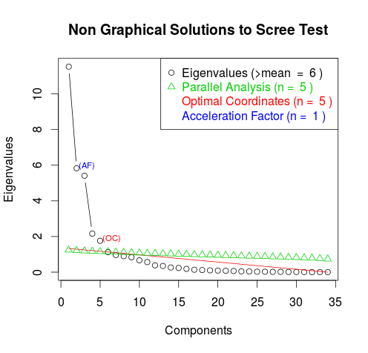

Factor Analysis :

Jurafsky Features

openSMILE factors

Self Vs. Other Features:
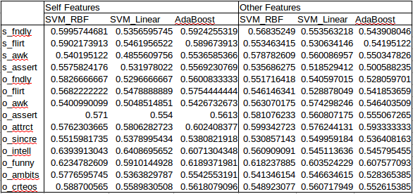
Here, we note that in general, when distinguishable, “self features” outperform “other features.” This makes intuitive sense when considering the following idea. The “true” intelligence (sincerity, funniness, etc.) of the speaker gets represented in the speaker's prosody, speech content, physical appearance, etc. The listener then rates the speaker based on these features. Some of the listener's thoughts about the speaker

Interestingly, we have all 4 combinations for the first 4 labels. We have significant results for our own prosodic features being better predictors of our self-perception of friendliness than our partner's prosodic features for our self-perception of friendliness, as it to be expected. We also have a significant result that self-features are better at predicting others' ratings of our friendliness than others' features are. (58 vs. 52, p ~ 0.05). While we have significant differences between “self features” and “other features” for many labels, for some labels, such as awkwardness and funniness, there is very little difference. One hypothesis is that both of these labels are marked by laughter from both parties.

Performance with both self and other prosodic factors

