Features

Prosody:
- Interspeech 2009 Emotion Challenge Feature set (192 prosodic features)
- Praat features
- pitch, intensity, voicing probability, duration x (
Linguistic Features:
- Hedges
- Academic Words
- Meta Words
- Like
- "sortOf"
- "kindOf"
- "iGuess" "iThink" "aLittle"
- [415] "maybe" "possibly" "probably"
- [418] "speeddate" "flirt" "event"
- [421] "dating" "rating" "work"
- [424] "program" "phd" "research"
- [427] "professor" "advisor" "finish"
- [430] "like" "iMean" "youKnow"
- [433] "uh" "um" "syll_word"
- [436] "syll_turn"
- LIWC

How many factors to use for prosodic features?

Looks like 5
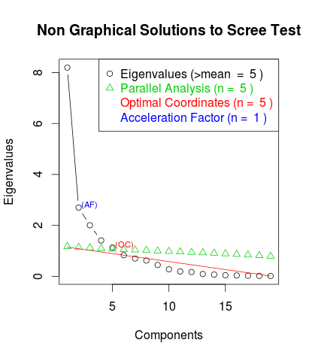

Factor Analysis :

