Eureka server -> It’s server registry

Orthodox ways -> this is tight coupled as we need to remember the concerned urls exactly

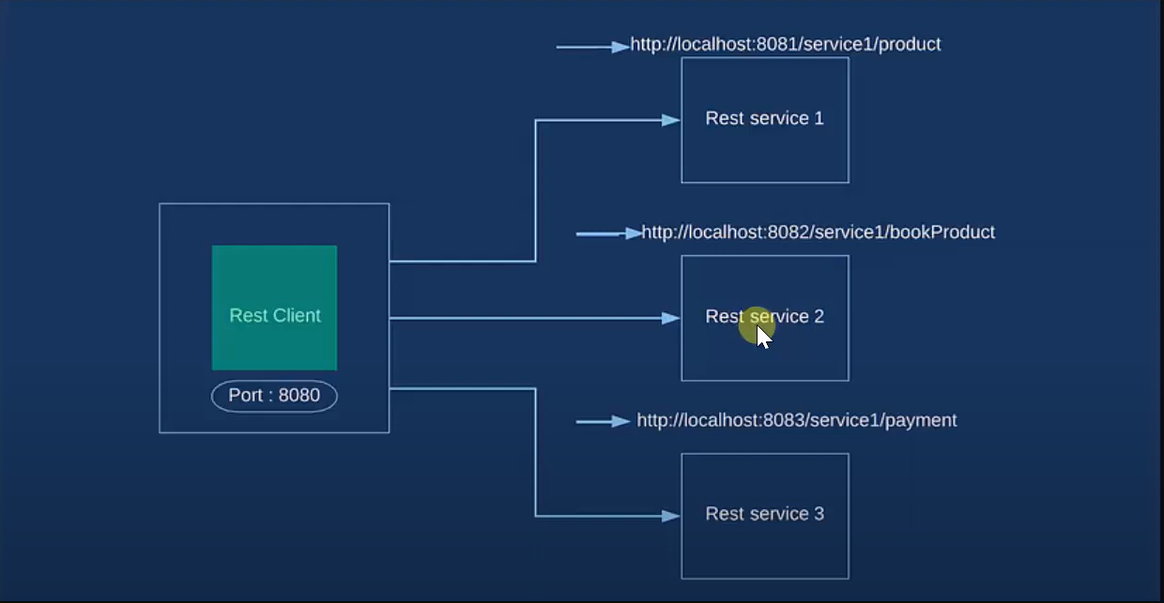

Microservices -> using eureka server, we register all the service which we need to use for our client

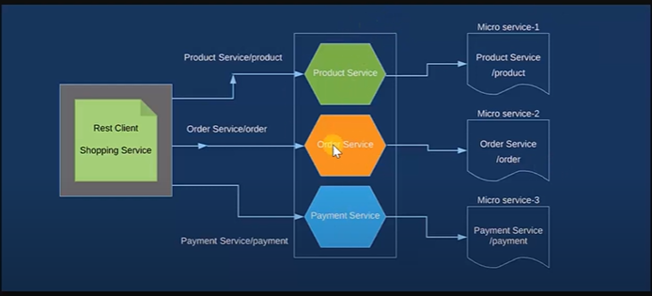

To make eureka server -> need to eureka server dependency in pom.xml

Need to annotate eureka serer config class with @EnableEurekaServer

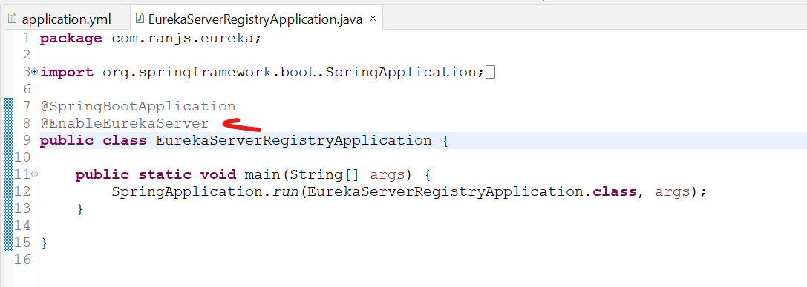

Create yml file in resource folder:-



And start the springbootapplication

Hit localhost:portno/

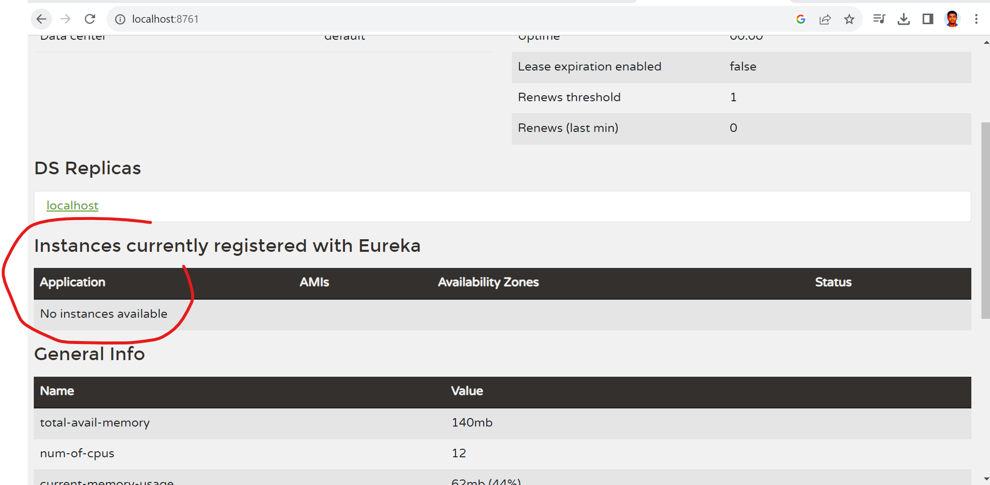

Initially no instance available, once we register some services they will reflect there.

To register service with eureka server -> need to add eureka discovery client in pom.xml

Need to add eureka client dependency in each service.

Need to annotate the each service config file with @EnableDiscoveryClient

Earlier we annotate with @ EnableEurekaClient but now @EnableDiscoveryClient.

Add yml file in individual service like :-



Note: - **before starting individual service, ensure eureka service registry is running already**.

Now we can see the service which we register in registered with service registry: -

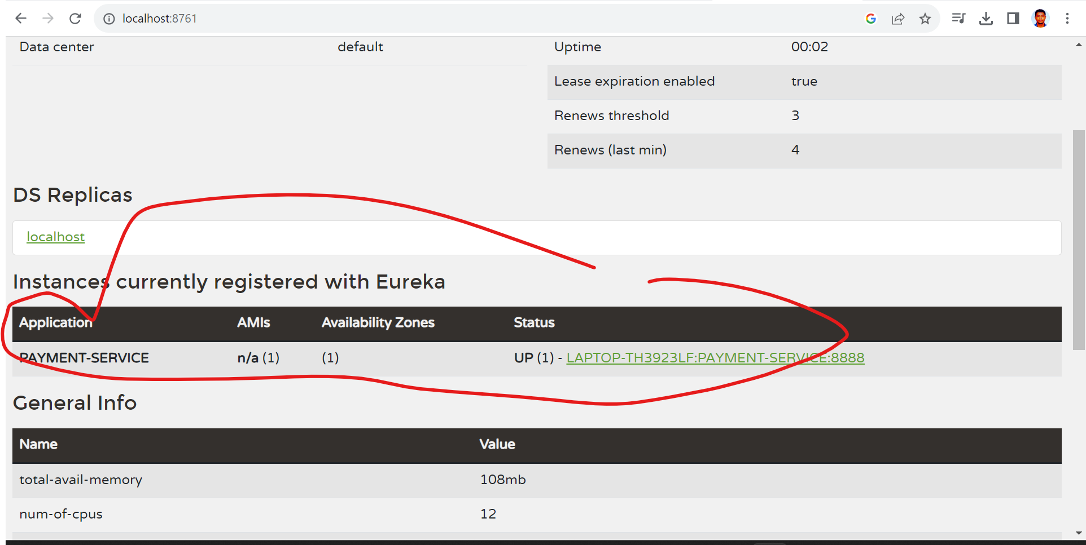

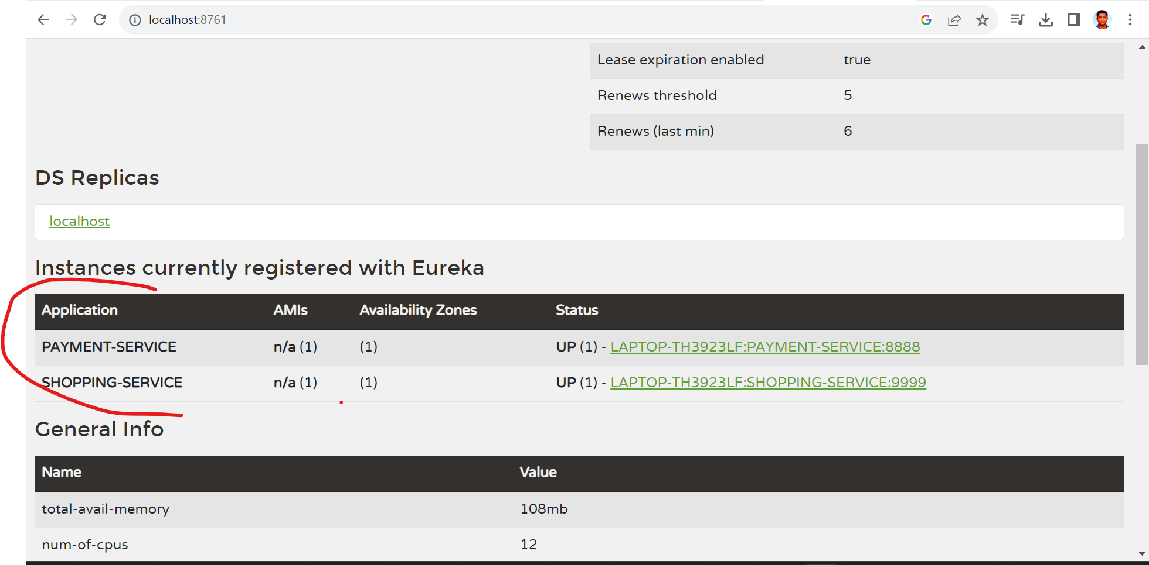

Old urls were:-

<http://localhost:8888/>..... & http://localhost:9999/....

So, our new urls will be

<http://PAYMENT-SERVICE:8888/>..... & <http://SHOPPING-SERVICE:9999/>....

<http://localhost:9999/amazon-payment/4999>

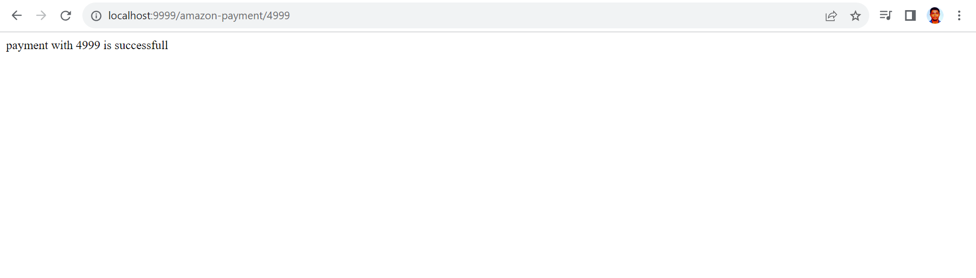

So, working fine.

Ref:- <https://www.youtube.com/watch?v=irBEdp7XlSQ&list=PLVz2XdJiJQxz3L2Onpxbel6r72IDdWrJh&index=2>