**Client side load balancing using Spring cloud Ribbon**

**How to perform load balancing using spring cloud ribbon?**

**Load balancing means distributing incoming request to multiple servers and so, we need deploy multiple instances on multiple servers. So that request will be redirect to particular instance.**

**Here, requests are coming on same appl and as it’s getting more popular, it will get more response and lets say we have designed this application only to handle 10k requests.**

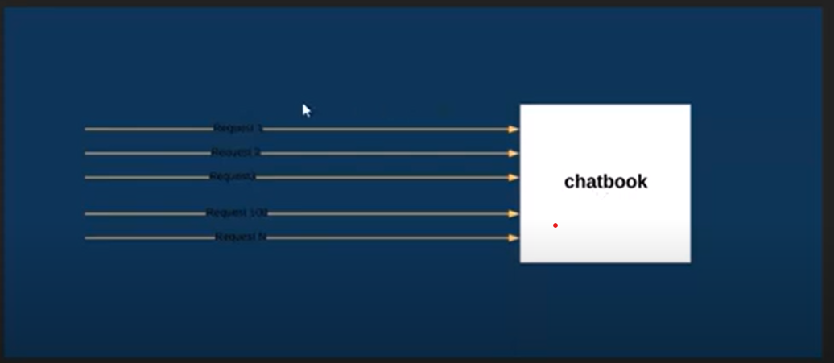

So, we deployed chatbook on multiple server.

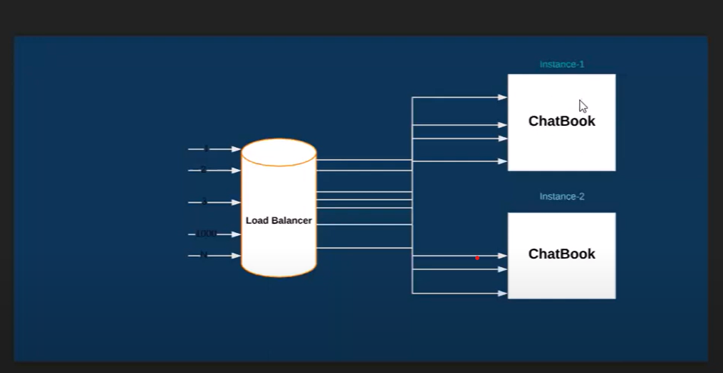

Load Balancer will redirect different requests to different instances of an application.

There are multiple load balancing algorithm like

1.Round Ribbon i.e sequential request distribution means request1 will to Instance1, request2 will go to instance2 … so on.. This is default algo.

2.Least Connection

3.IP Hash – based on ip address we will redirect to particular instance.

Create chatbook application with server.port = 8081 in application.properties

Now, create multiple instances of this appl.

->1. go to run configurations

->2. Duplicate -create duplicate instance of existing one

->3. open argument tab

->4. add the line : -Dserver.port=8082 -Dspring.profiles.active=production

Repeat above steps as create few more n run at 8083 port no.

Let’s say we have 3 instances which run at port no. 8081, 8082, and 8083.

<http://localhost:8081/chatbook-application/chat>

<http://localhost:8082/chatbook-application/chat>

<http://localhost:8083/chatbook-application/chat>

now, Create a more application

user-app

now, in dependency add **web and ribbon**. Here, we r doing load balancing in client side. So adding ribbon load balancing dependency in client app which is user-app.

Note: ribbon is deprecated and can’t find dependency in spring initializer.

So, we have **Spring Cloud LoadBalancer** as alternative.

To use ribbon, we hv to use <version>2.0.2.RELEASE</version>

Version of springboot and

<properties>

<project.build.sourceEncoding>UTF-8</project.build.sourceEncoding>

<project.reporting.outputEncoding>UTF-8</project.reporting.outputEncoding>

<java.version>1.8</java.version>

<spring-cloud.version>Finchley.RC2</spring-cloud.version>

</properties>

<dependency>

<groupId>org.springframework.cloud</groupId>

<artifactId>spring-cloud-starter-netflix-ribbon</artifactId>

</dependency>

localhost:9090/invoke/ -- will o/p from multiple instance at multiple times.

Conclusion :- getting lots of issue cuz of ribbon is supported by old version of spring as unable to start springbootapplication as well/.

Ref:- <https://www.youtube.com/watch?v=ueyVjOnDHYQ&list=PLVz2XdJiJQxz3L2Onpxbel6r72IDdWrJh&index=4>