**The Big Apple Filming Trail**

New York City is considered one of the greatest cities in the whole world having a cinematic identity that touches upon all walks of life. Some of the most iconic movies, television series, documentaries, short films, dramas, theatres, etc. have all revolved around this bustling metropolis. Being a movie buff for ages, specially a NYC romcom fan (which I’m sure many of us are ☺) and an immigrant who grew up listening to stories and learning about NYC from a distance through different entertainment mediums, it was an exciting idea of finally getting an opportunity to analyze the statistics and probably maximize the chances of stumbling upon on a random shoot. (Question like where to go?). This was made possible by the data hosted at the NYC Open Data portal [1].

NYC Open Data portal provides details regarding filming data permits for various NYC locations for the period between 2014 – 2019 (~42K records). Typically permits are required when asserting the exclusive use of city property, like a sidewalk, a street, or a park [2]. The Office of Film, Theatre, and Broadcasting issues permits to productions filming on location in the City of New York and provides free police assistance, free parking privileges and access to most exterior locations free of charge. We have the following details in hand for analysis:

* Event Type – Type of event (Theatre Load In, Load Out, Shooting, Rigging, DCAS Permit, etc.)
* Start Date – Activity scheduled to begin (MM/DD/YYYY HH:MM:SS AM/PM)
* End Date – Activity scheduled to be completed (MM/DD/YYYY HH:MM:SS AM/PM)
* Entered Date – Permit request submission date (MM/DD/YYYY HH:MM:SS AM/PM)
* Parking Locations – Locations of request to hold parking in advance for permitted filming activity.
* Borough – First borough of activity for the day
* Category – Commercial, Documentary, Film, Music Video etc.
* Subcategory – More specific description of production as selected by the permit applicant
* Zip Codes – First zip code of production activity
* Country of project origin – Domestic or International

Several interesting insights can be gathered by effectively visualizing this data. Thanks to the proliferation of social media, people are always on the hunt for “Instagrammable” locations specially in a place like NYC. By visual analysis, we should be able to come up with interesting statistics which can be used for generating tourist attraction or help local residents anticipate chaos during peak time, the possibilities are endless. Some of the suggested ways this data can be visually explored are as follows:

* Most popular filming locations. Change of preferences over the years. [Map, Barcharts, Trend lines]
* Busiest shooting times in a day. Breakdown in terms of individual categories and subcategories. [Barcharts, Heatmaps]
* Parking statistics. Most popular parking locations in a borough reserved for filming days. [Barcharts]
* Busiest times of the day when a shoot takes place. [Barcharts]
* International/Foreign film shooting statistics in the city. [Barcharts]
* Different categories and subcategories of filming. Relative comparison. [Diverging Charts]
* Different types of events and time reserved for the same.
* The new upcoming spots where shooting is taking place (apart from Manhattan). [Map]
* Maximum share of filming location borough wise [Bar Chart, Area Chart]

Tableau is equipped with a range of tools which can be extensively used to visually explore this dataset. So, what are we waiting for, let the reel roll and have some fun together! ☺

In continuation to the pitch presented above, let us try and evaluate the following query and build one complete and compelling visualization:

1. **Which are the popular filming locations in NYC? Plot the locations on a map using circle shape as indicator. Size of the circle on the map will indicate higher popularity.**

**Exploratory Visual Analysis (EVA)**

Exploratory steps in analyzing and building the visualization are as follows:

**Step 1:** Around ~10 records had no valid zip code tagged against the location (#, NA, 83 etc.). These instances were removed from the input file. No further data cleaning done for the dataset.

**Step 2:** Map created based on Longitude (generated) and Latitude (generated). ZipCode(s) dimension is mapped in the Detail marks card.

**Step 3:** Number of records (measure) is used to pinpoint the filming locations on the map. Circle shape is chosen to denote the same.

**Step 4:** Size on the Marks card is used to indicate the size of the circle based on number of records tagged against that particular location.Appropriate and relevant tooltip text is formatted for every circle.

**Step 5:** Borough dimension is dragged to color marks card for highlighting different borough locations in different color.

**Step 6:** Boroughs are labelled using Label Marks card for clarity.

**Step 7:** From Map Layers option, “Dark” style is chosen along with zip code boundaries for better visual encoding and clarity.

**Step 8:** The entire view is filtered on borough, which keeps Bronx, Brooklyn, Manhattan, Queens and Staten island.

**Step 9:** Appropriate title and relevant caption is inserted for the visualization. Title formatting is kept consistent with map background.

**Conclusion**

Brooklyn (Kings county) emerges as the most popular filming location followed by a location in long island (Queens). From the map it appeared that Manhattan had a dense concentration of filming locations spread across midtown and downtown. Manhattan, Brooklyn and Queens have the maximum presence of shooting spots as evident from the map. The final visual is attached here for reference (zoom to view):

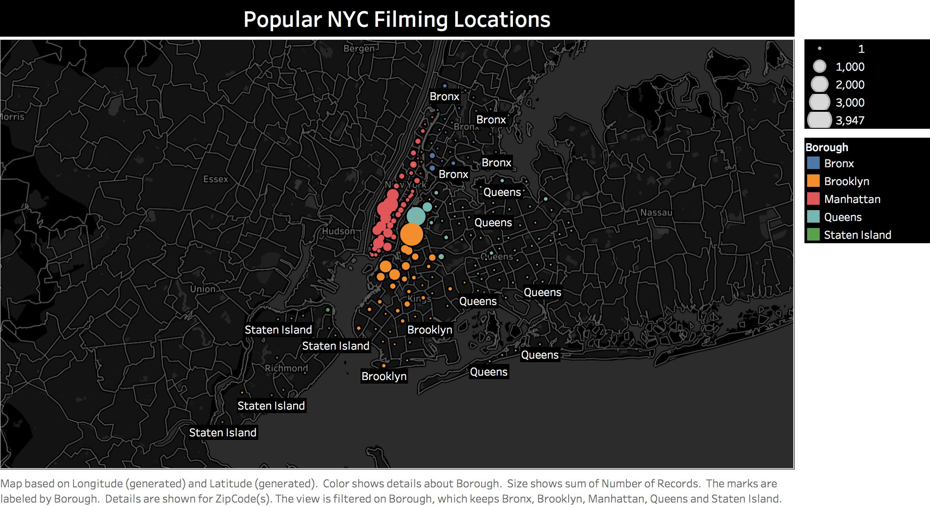

1. <https://data.cityofnewyork.us/City-Government/Film-Permits/tg4x-b46p>
2. <https://www1.nyc.gov/site/mome/permits/when-permit-required.page>